AI BASED INTERIOR DESIGNING APP

**CH. ADHARSH**, B. Tech, Department of Information Technology, **CMR Engineering College,** Hyderabad

1. **RAVALIKA**, B. Tech, Department of Information Technology, **CMR Engineering College,** Hyderabad
2. **SUMANTH**, B. Tech, Department of Information Technology, **CMR Engineering College**, Hyderabad

**CH. BHARATH**, B. Tech, Department of Information Technology, **CMR Engineering College,** Hyderabad

**Dr. MADHAVI PINGILI** Professor & HOD, Department of Information Technology, **CMR Engineering**

**College,** Hyderabad

***Abstract*—**This paper presents the results of a systematic literature review (SLR), aiming to investigate how AI is ever more deeply integrated into the field of interior design, particularly to enhance its sustainability, personalization, and efficiency. The paper is produced through a desktop review of existing literature sourced from ISI Web of Knowledge, Science Direct, and Springer databases that deal with the study of the integration of artificial intelligence in interior design techniques. Inclusion was based on research on AI technologies, their application within the design process, and their contribution to innovative and sustainable solutions. The studies covered the period from 2000 to 2023. A systematically conducted, broad, and comprehensive search found a scrupulously selected pool of 33 publications that were eligible for inclusion. Conclusions point to the fact that AI has a significant capacity to drive changes in the design process, enhance user experience through personalized design options, and cultivate green design solutions. AI technologies can mine and analyze enormous data sets to discover minute human preferences and, through this, develop visually appealing, ecologically viable, and efficient spaces. It is the changing interaction between AI systems and design professionals that holds the key to the future development of the interior design profession through AI technologies and thus underpins the collaborative opportunity available in this context. Moreover, the analysis highlights an increasing focus on integrating AI technologies to enhance design sustainability, suggesting a transition towards more conscientious and inventive design methodologies. Nevertheless, the research acknowledges the difficulties associated with accepting and implementing technology and the need for comprehensive frameworks to guide the ethical use of artificial intelligence in the design field.

**Keywords--** **Artificial Intelligence, Interior Design, Design Process, Predictive Analytics.**

**INTRODUCTION**

In AI-powered interior design tools are game-changers for both professional designers and DIY enthusiasts. These tools use machine learning algorithms to assist designers in creating virtual mock-ups and 3D models of interior spaces helping them visualize the final result before any physical changes are made. For homeowners, AI-powered tools can offer a sense of empowerment. Machine learning is a subset

of AI that focuses on improving algorithms and models through experience. Designers can stay ahead of the curve, offering clients fresh and innovative design concepts. Consumers, on the other hand, can make design choices that will stand the test of time, ensuring that their interiors remain stylish and relevant for years to come.1.2 Project Objectives The objective of this project is to develop a method to detect the tumor stage. We focus on two domains - Image Processing and Classification with InceptionV3 CNN Deep learning technique to find out the cancer at the first stage only. An AI-Based Interior Designing App is a revolutionary tool that leverages artificial intelligence to streamline the process of designing and decorating interiors. By combining advanced algorithms with intuitive user interfaces, this app allows users—both professionals and homeowners—to create personalized, aesthetically pleasing spaces with ease. Whether it's choosing the right color palette, arranging furniture, or selecting decor, the AI analyzes user preferences, room dimensions, and style trends to offer suggestions and generate realistic 3D visualizations. With features such as virtual room modeling, budget tracking, and real-time customization, the app brings professional-quality design within reach for everyone, simplifying the decision-making process and enhancing creativity. This app is perfect for those looking to transform their living spaces effortlessly. The AI-Based Interior Designing App offers personalized recommendations based on user preferences, style, and current design trends. The app can analyze room dimensions, natural lighting, and furniture placement to optimize space usage and create harmonious layouts. Users can explore a wide range of design templates or start from scratch, allowing for complete customization and flexibility. By utilizing AI, the app learns from user interactions and refines its suggestions over time, ensuring that designs evolve with changing taste home renovation, this app empowers users with professional-grade design tools, making the process intuitive, efficient, and fun. Overall, this app transforms the entire interior design process into a seamless, enjoyable experience for both amateurs and experts alike.

**RESEARCH ON THE TECHNOLOGY OF SMART HOME**

Nowadays, people’s life is ‘Live can’t without mobile phone', this is people's favorite way in the Internet era. Use APP associated with family facilities has been used very widely. APP and intelligent household interaction provides first class

provides first-class products, rich experience of goods and services to users. Smartphone is small and portable, became the most popular to use for the control terminal. Relevant professionals believe that the application of APP is a very important platform for Internet technology, and it has contributed to the power of enterprises to agglutinate users. I’m going to write the following part based on the mind map of technology of smart home. At present, there are mainly two types of code recognition technology in the market, fixed and mobile. The main trend of the public is mobile at present, so I choose to use mobile code recognition technology in this system. After scanning the specified device, the information of the QR code can be obtained, such as the material, color, size and so on. As long as there is a network, the decoding process can be compared to the database, read decoding data. Configure the Hadoop environment and manage it with clouder manager. In order to achieve the technical level of data collection and preprocessing, data storage and management, data processing and analysis, data privacy and security. We extract signals from the data, build a model of users' purchase intention, and focus on the analysis of users' brand preference, product demand, purchase concept, consumption capacity, etc. It will be a gradual process for new smart products to come into life and be accepted by the public. From the perspective of the designer, Smart-home products as an emerging product, need to give people times to accept. People's psychology will reject the complex appearance of things, and they are more willing to accept seemingly simple things. Therefore, this inspires the designer, if the appearance is seemed easy will make the combination of AI and household design is more easily accepted by people.

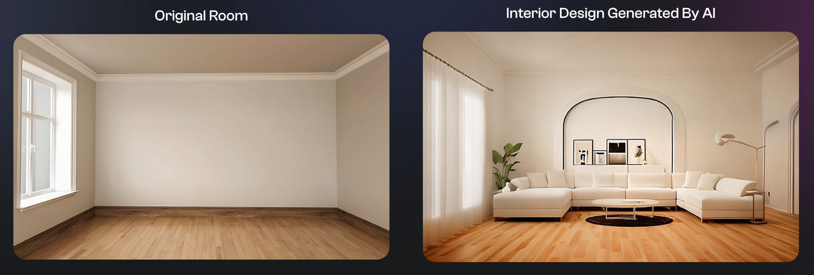

**SYSTEM ARCHITECTURE**

An Ai-based interior design app system architecture consists of several interconnected components. The front-end is a mobile or web interface where users upload room photos, select styles and 3d design, possibly with AR/VR support. The core AI models include image processing for room segmentation, a recommendation engine for style and furniture suggestions. Utilizes machine learning algorithms for design generation.

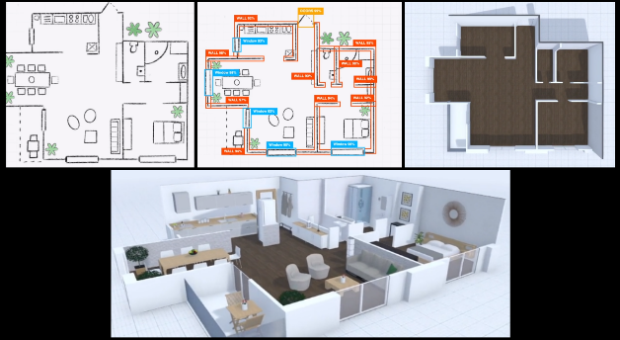

# INPUT DESIGN

The In an AI-based interior design app, the input and output design is crucial for creating a seamless, user-friendly experience. Here's an overview of the key components of input and output design: Input design focuses on how users interact with the app and provide the necessary information for generating design suggestions. The goal is to make the process intuitive, efficient, and flexible. Graphical User Interface (GUI): A clean and intuitive interface that allows users to interact with the app visually. The UI should include easily navigable menus, buttons, and icons to access different features. Input Methods Room Dimensions: Users can input room dimensions manually or by scanning the room using their device's camera (AR-based measurement). Upload Room Images: Users can upload images of their rooms, which the app analyzes using computer vision to detect existing furniture, colors, and room features. Style and Preference Selection: Users can choose their preferred design styles, color schemes, and themes from predefined options or enter custom preferences through text or voice commands.

**OUTPUT DESIGN**

Output design focuses on how the app presents the design results to the user. The goal is to provide clear, informative, and visually appealing feedback that helps users make informed decisions.

1. Visualization Tools

3D Modeling and Rendering: The app outputs a 3D model of the room with the proposed design. Users can explore the room from different angles, zoom in on details, and see how different elements work together. how model, rotating it, zooming in and out, and moving furniture around in real-time to see the impact of their changes. Personalized Design Plans: The app provides a detailed design plan based on the user’s inputs, including suggested layouts, color schemes, and furniture arrangements. Furniture and Decor Lists: A list of all recommended furniture and decor items, including product details, prices, and links to purchase from online stores.

**MODULES**

1. User Profile & Preferences Module
2. Room Scanning & Measurement Module
3. Style Recommendation Module
4. 3D Visualization & AR Module
5. Furniture & Decor Catalog Module
6. Budgeting & Cost Estimation Module

**RESULT**

An AI-based interior design app offers a personalized, efficient, and cost-effective solution for transforming spaces by analyzing user preferences and providing tailored style recommendations. It enhances visualization through 3D models and augmented reality, allowing users to virtually arrange furniture and simulate lighting and colors. The app optimizes space utilization with smart layouts and offers budget management, suggesting cost-effective alternatives while reducing design time. It promotes sustainability by recommending eco-friendly materials and tracking carbon footprints. Collaboration features enable sharing designs and feedback, while professional integration connects users with designers and vendors for seamless project execution, making interior design accessible and intuitive for all.

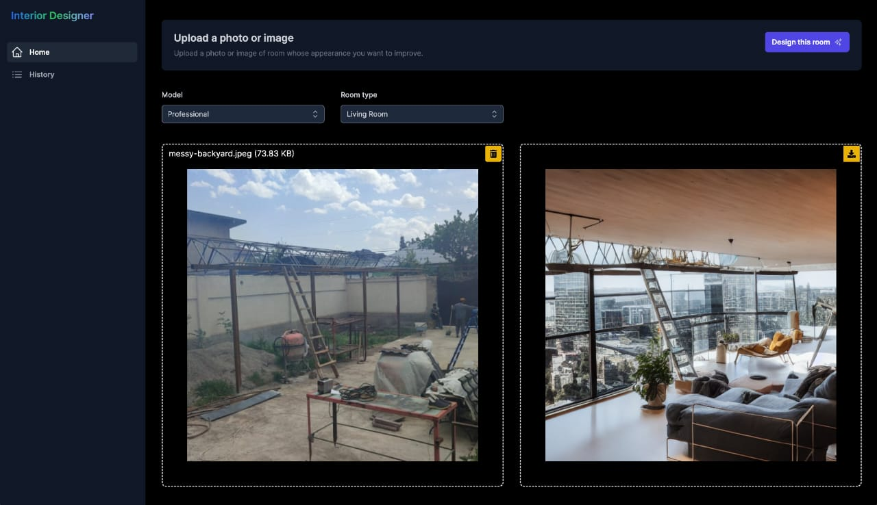

**ACKNOWLEDGEMENT**

* We are extremely grateful to Dr. A. Srinivasula Reddy, Principal and Dr. Madhavi Pingili, HOD, Department of IT, CMR Engineering College for their constant support.
* We are extremely thankful to Dr. MADHAVI PINGILI, Professor, Internal Guide, Department of IT, for his constant guidance, encouragement, and moral support throughout the project.
* We will fail in duty if we do not acknowledge with gratitude thanks to the authors of the references and other literature in this Project.
* We thank all staff members and friends for all the help and co-ordination extended in bringing out this project successfully in time. Finally, we are very much thankful to our parents who guided us for every step.

**REFERENCES**

.

* + - 1. Li, S. (2019). Study on Intelligent Furniture in Living Smart Home System. JUSHE, 34, 21+26. Explores the role of intelligent furniture in smart home systems, providing context for integrating AI with furniture design.
      2. Cai, Y., & Xie, X. (2020). Research on Modern Interior Design under the Influence of Environmental Psychology. JUSHE, 04, 16. Investigates how environmental psychology impacts interior design, which can inform user-centered design recommendations in AI systems.
      3. Deng, Q., & Jin, D. (2019). Research on Smart Home System – Taking Wardrobe Storage as an Example. Home Drama, 17, 209-210. Discusses smart home systems with a focus on storage solutions, relevant for understanding how AI can optimize space and functionality in interior design.
      4. Chen, Y., Zhou, S., & Ai, J. (2016). Design and Research of Intelligent Furniture Based on User Experience. CNKI. Examines user experience in intelligent furniture design, useful for enhancing the user interface and experience of the AI app.
      5. Goodfellow, I., Bengio, Y., & Courville, A. (2016). Deep Learning. MIT Press. A foundational text on deep learning techniques, including those used in CNNs and GANs, applicable to AI-based interior design.
      6. TensorFlow Documentation. (n.d.). Retrieved from https://www.tensorflow.org/ Official documentation for TensorFlow, a key library used for building and training machine learning models.
      7. PyTorch Documentation. (n.d.). Retrieved from https://pytorch.org/ Provides resources for PyTorch, another popular library for machine learning and neural.
      8. Ian, J., & Siddiqui, H. (2018). Machine Learning Yearning. Self-published. Provides insights into machine learning strategies and best practices, useful for developing and refining AI models for interior design.
      9. Gartner. (2023). Magic Quadrant for AI in Customer Service. Gartner Research. Offers insights into the latest trends and technologies in AI, including applications relevant to interior design and customer interaction.
      10. Forrester. (2023). The Future of AI-Driven Design. Forrester Research. Discusses emerging trends and future directions for AI in design, providing context for advancements in AI-based interior design applications.
      11. Hershey, J., & Tannenbaum, M. (2023). How AI is Transforming Interior Design. Design Tech Weekly.
      12. EBrown, A. (2024). Advances in Generative Design for Interior Spaces. Architectural Digest. Covers the latest advancements in generative design algorithms, including GANs, and their applications in interior design.
      13. OpenCV Documentation. (n.d.). Retrieved from https://opencv.org/ Documentation for OpenCV, a library used for computer vision tasks such as image segmentation and feature extraction.