EMBEDDING ARTIFICIAL INTELLIGENCE FOR PERSONAL VOICE ASSISTANT USING NLP

Mrs. S. Maria Sobana1, M.Ramachandran2, , R.K.Rajkumar3 , M.Rajkumar4 , S.Siddarthan5

*1(Assistant Professor, Computer Science and Engineering, K.L.N. College of Engineering, Sivagangai, Tamilnadu, India)*

*2,3,4,5(Final Year Students, Computer Science and Engineering, K.L.N. College of Engineering, Sivagangai, Tamilnadu, India)*

*Corresponding Author: Email:mariasobana@gmail.com*

|  |  |
| --- | --- |
| Howtocitethispaper:Y. Mrs. S.Maria Sobana1, M.Ramachandran2 , R.K.Rajkumar3 , M.Rajkumar4, S.Siddarthan5 ,Embedding Artificial Intelligence for Personal Voice Assistance using NLP  IJIRE-VXIX,YYYY  Copyright © 2022 by author(s) and  5th Dimension Research Publication  This work is licensed under the Creative Commons Attribution International License  (CC BY 4.0). <http://creativecommons.org/licenses/by/4.0/> | **Abstract:** *The voice assistance is an software which is able to provide a detailed response as a voice based output according to an instruction in a prompt. To seamless integration of quick responses to queries and up-to-date weather information enhances daily routines, promoting efficiency and convenience. To achieve these capabilities, technologies like NLTK, pyttsx3, and speech recognition libraries play a pivotal role. To summarize, the convergence of these tools is gradually transforming the futuristic concept of an indispensable personal assistant into an attainable reality. AI technologies have revolutionized digital assistant interactions, but as they integrate into daily life, addressing bias, ambiguity, and ethics becomes crucial.*  ***Key Word****: Integration; Convergence; Futuristic; Indispensable;* |

1. **INTRODUCTION**

Chatgpt is most widely used communication media among all the methods, especially in the business world. With the boom in internet technologies, the communication has become a lot easier. Internet is considered as the vault of innovation, technologies and information. Numerous networking and social media sites. The most conventional way of online communication is e-Chatgpt. It is estimated that there are more than 4.5 Billion Chatgpt accounts. By the end of 2020, this figure in estimated to rise up to 5.9Billion, which is a improvement of over 29.5%. There are 2.586B Chatgpt clients overall along with both business and purchaser clients as per along these lines, Chatgpt remains as the accepted standard for delivering note worthy communication. For utilizing these offices of Internet each individual require visual ability.

1. **OBJECTIVE**

The main objective is to detect the Chatgpt on Speech using technique. AI technologies enable proactive personal assistants, but they face challenges such as bias, ambiguity, and ethics. These issues affect both text and voice assistants, requiring better contextual and ethical understanding. AI technologies have revolutionized digital assistant interactions, but as they integrate into daily life, addressing bias, ambiguity, and ethics becomes crucial. In the AI personal assistant realm, enhancing context and ethics is vital for responsible and inclusive service.

## III. LITERATURE SURVEY

**1.A brief overview of Chat GPT:**

Service where the visually impaired person could read and send Chatgpt by their own without the help of others. We have eliminated all these concepts and overcome all difficulties faced. The Voice Chatgpt is a System which helps the users and handicapped people by users. In Voice Chatgpt there is no requirement to remember location of keys on the keyboard to access Chatgpt easily and efficiently. It provides a voice based Chatgpting and type characters using traditional Braille keywords available to them. It uses speech recognition application which provides an efficient voice input method for Chatgpting devices for users. It is also useful for handicapped and illiterate people.

**2.An Interactive Chatgpt For Visually Impaired:**

Web accessibility stands as the inclusive practice of creating web based applications that can be used by people of all kind. When web applications are perfectly prototyped, implemented, and edited, all sort of users can have mutual license to information functionality also that can be facilitated without reducing the usability of the application for normal users. The very basic and important need for using the internet is accessing Chatgpt. Micro systematic applied research has been done on how a visually challenged user can have an access to his Chatgpt.

**IV. EXISTINGSYSTEM**

AI chatbots often display inadvertent biases and are challenged by handling ambiguity. Voice assistants like Siri and Alexa broaden the spectrum of human-computer interaction, fostering ongoing advancements in AI technology. AI chatbots today grapple with biases and ambiguity, while voice assistants such as Siri and Alexa expand interactive possibilities, driving continuous innovation in the field.

**V. PROPOSEDSYSTEM**

Enhance Chatgpt by integrating a voice assistant for natural language voice input and output. The system will provide multimodal interactions, maintain contextual awareness, and offer specific voice assistant skills. It will prioritize privacy and security, and a user- friendly interface will enable seamless conversations between users and both ChatGPT and the voice assistant.

**VI.ARCHITECTURE DIAGRM**

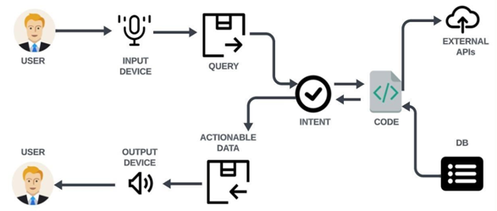

## VII. SYSTEM OVERVIEW

**A) Speech-To-Text:**

The systems obtain speech at run time through a microphone and with the help of speech-to-text converter the speech gets converted into text. Speech-to-text converter recognize the speech analyzed the sounds you make by filtering what you say then it digitized it to a format it can read. Python platforms are used here to develop this. Our speech to-text system directly obtain and converts speech to text. It can add-on other larger systems, giving users a different choice for data entry. Analog speech signal must first be sampled at time and amplitude axes, or digitized.

**B) Command Analyzer:**

Command analyzers, also known as command parsers or command interpreters, are programs or components of programs that interpret and execute commands given by the user. They are commonly used in command-line interfaces (CLIs), chatbots, voice assistants, and other interactive systems.

**C) Text-To-Speech:**

The new voice capability is powered by a new text-to-speech model, capable of generating human-like audio from just text and a few seconds of sample speech. We collaborated with professional voice actors to create each of the voices.  Prompts can be very helpful for correcting specific words or acronyms that the model often misrecognizes in the audio.

**D) Connect Various API:**

Determined which external APIs or services needed to integrate with the voice assistant.  Obtained API keys, authentication tokens, or credentials required to access the selected APIs. Modified the voice assistant's code to include functions or modules that can interact with the chosen APIs.  Implemented error handling to provide appropriate responses or guidance to users.

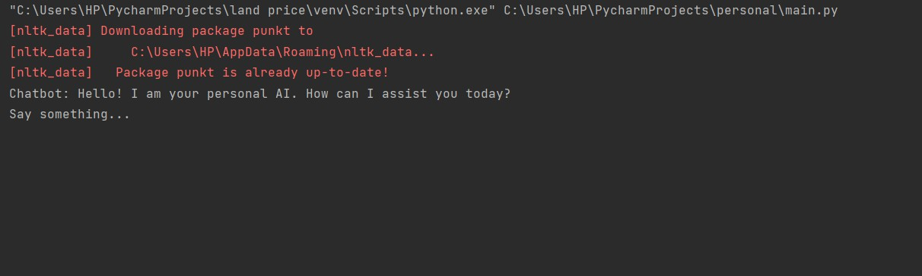

## FIG 7.1 Starting AI Page

Fig 7.1: Shows a Starting AI Page, The AI page serves as the gateway to our AI-powered virtual assistant. When you land on this page, you'll be greeted by our friendly AI with the words, "Hello! I am your personal AI, How can I assist you."It's your chance to engage in a conversation with an intelligent virtual assistant. This welcoming screen sets the stage for a seamless interaction with AI technology. Simply start by saying something, and let the AI assist you with your queries and tasks.

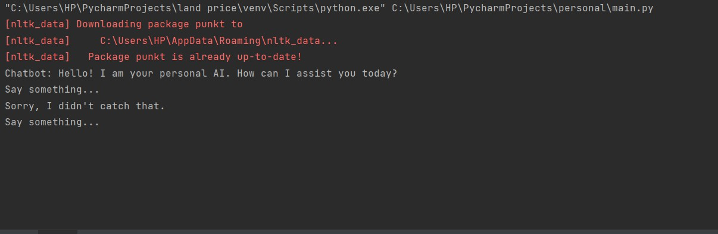

## Fig 7.2 Request Page

Fig7.2: Shows Request Page, In the event that our AI doesn't catch your voice, it politely responds with, "I didn't catch that."It's like having a conversation with a patient friend who asks you to repeat your thoughts. Our AI strives to ensure clear and accurate communication, and it's always ready for your next attempt. You'll find a helpful and understanding partner in our AI, making communication effortless and stress-free. Don't worry, give it another go, and our AI will be right here to assist you.

## Screenshot 2023-10-04 212416

## FIG 6.3 Response Page

Fig6.3: Shows Response Page, when you inquire about today's weather in Madurai, our AI springs into action. It connects to a trusted weather API to fetch the latest and most accurate weather report. You'll receive a detailed weather update for Madurai, including temperature, humidity, wind speed, and more. Our AI ensures you're well-prepared for the day ahead, rain or shine. Whether you're planning an outdoor adventure or just curious about the weather, our AI has you covered.

**References**

*[1]. “A brief overview of ChatGPT”: Jingingliu, Kang+liu, Qinglonghan, Shizuhe , siqisun, Tianyu wu, Yang tang, vol.10,no.5 may2023, CAA Journal of automaticasinca, Its tendency to produce inaccurate or incomprehensible texts in the midst of generating plausible and compelling responses.*

*[2]. “An Interactive Chatgpt For Visually Impaired” BendreM.R.., ChavhanSwapnil, JagtapNilesh, Pawan Alai, and In International Journal of Emerging Technology and Advanced Engineering (IJETAE).*

*[3]. “Voice based Chatgpt system for users”: Voice Based Chatgpt Application" Deeksha, Priya, Raina , Rahul Anwani, Usha Santuramani, R.L, International Journal of Computer Science and Information Technologies, Vol. 6 (3)*

*[4]. “Voice Based Search Engine and Web page Reader”, Ummuhanysifa U.NizarBanu P K, In International Journal of Computational Engineering Research.*

*[5]. “Bayesian Separation with Sparsity Promotion in Perceptual Wavelet Domain for Speech Enhancement and Hybrid Speech Recognition”.” G. Anusha, V. Jeevitha R. Shanmathi, G. Shoba. In International Journal of Advanced Research in Computer and Communication Engineering.*

*[6]. Bendre M.R. , Chavhan Swapnil , Jagtap Nilesh, Pawan Alai, and “Voice Based System in Desktop and Mobile Devices for Users People”. In International Journal of Emerging Technology and Advanced Engineering (IJETAE).*

*[7]. Nizar Banu , Ummuhanysifa U. P K “Voice Based Search Engine and Web page Reader”. In Internationa Journal of Computational Engineering Research (IJCER).*

*[8]. G. Anusha , V. Jeevitha , R. Shanmathi , G. Shoba . “AN Interactive Chatgpt for Visually Impaired”. In International Journal of Advanced Research in Computer and Communication Engineering.*