**STOCK SIGHT**

Thenmozhi S R1, Sakthivel N, MCA., M.Phil.,2

*1Department of MCA, Adhiyamaan College of Engineering (Autonomous), Hosur.*

*2Department of MCA, Adhiyamaan College of Engineering (Autonomous), Hosur.*

*Corresponding Author: thenmozhi8511@gmail.com*

|  |
| --- |
| ***Abstract:*** Stock Sight aspires to serve as a beacon of knowledge and insight, equipping stakeholders with a powerful forecasting tool capable of deciphering emerging market trends, predicting future stock prices, and optimizing investment strategies. By harnessing the latent potential of time series analysis, the project seeks to empower investors and financial professionals with the foresight and understanding necessary to navigate the dynamic and ever-evolving landscape of the stock market effectively. Through meticulous attention to detail and a commitment to excellence, "Stock Sight" emerges as an indispensable resource in the pursuit of financial success and prosperity. As "Stock Sight" progresses, it embarks on the development and evaluation of an array of sophisticated time series forecasting models, each meticulously tailored to discern and predict future stock prices with precision. Drawing upon methodologies such as Autoregressive Integrated Moving Average (ARIMA), Seasonal ARIMA (SARIMA), and Long Short-Term Memory (LSTM) networks, the project meticulously trains and optimizes these models using historical data. Through the rigorous application of robust evaluation metrics and comprehensive validation techniques such as cross-validation, "Stock Sight" meticulously assesses the effectiveness of each model, ensuring only the most reliable and accurate predictions are presented. Ultimately, "Stock Sight" aspires to serve as a beacon of knowledge and insight, equipping stakeholders with a powerful forecasting tool capable of deciphering emerging market trends, predicting future stock prices, and optimizing investment strategies. By harnessing the latent potential of time series analysis, the project seeks to empower investors and financial professionals with the foresight and understanding necessary to navigate the dynamic and ever-evolving landscape of the stock market effectively. Through meticulous attention to detail and a commitment to excellence, "Stock Sight" emerges as an indispensable resource in the pursuit of financial success and prosperity.  ***Key Word****:*Stock; Forecasting; Analysis; Trends; Predictions; Investments; Professionals; Foresight |

1. **Introduction**

The stock price prediction system project represents a significant innovation within the financial technology sector, aiming to provide users with advanced tools for making informed investment decisions. This platform emphasizes active user engagement and collaboration, enabling investors to leverage cutting-edge algorithms and data analytics to forecast stock prices more accurately. By focusing on user participation in refining predictive models and sharing insights, the project fosters a dynamic and collaborative environment for market analysis. Defining the target audience is a crucial aspect of the project, as it allows for tailored customization to meet the specific needs of investors. By understanding users' demographics, investment preferences, risk tolerance, and trading habits, the system can provide personalized recommendations and insights. This approach not only enhances the user experience but also increases the system's effectiveness in delivering relevant and actionable information to investors. The project's goals are centered around providing accurate predictions, empowering users with educational resources, ensuring data security and privacy, and fostering a collaborative community of investors. These goals serve as guiding principles throughout the development process, shaping the system's features and functionalities to align with the overarching purpose of empowering investors with the tools and knowledge they need to succeed in the stock market. Through a combination of advanced technology, user-centric design, and a commitment to collaboration, the stock price prediction system aims to stand out as a valuable resource in the financial technology landscape.

1. **PROJECT MODULES**

In the realm of stock market prediction, the project is driven by a core objective: to develop a user-friendly platform that caters to the diverse needs of investors and financial analysts. In an era where stock market analysis spans from individual traders to institutional investors, the platform aims to provide a seamless space for data analysis, prediction modeling, and investment strategies. Recognizing the pivotal role of stock market prediction in decision-making and portfolio management, the website prioritizes user accessibility, aiming to empower investors with actionable insights and informed decision-making capabilities. Beyond serving as a mere prediction tool, the project envisions itself as a comprehensive ecosystem for financial analysis and investment management. Through innovative modules and features, the platform aims to streamline the entire process of stock market prediction, from data collection and analysis to portfolio optimization and risk management. By fostering collaboration, knowledge-sharing, and community engagement, the project seeks to create a supportive environment where investors can exchange ideas, learn from each other, and collectively navigate the complexities of financial markets. The modules within the platform are designed to handle various aspects of the stock market prediction process, including data collection, predictive modeling, algorithm development, and user interaction. Each module is tailored to provide users with intuitive interfaces, powerful analytical tools, and secure data handling capabilities. By integrating advanced algorithms, machine learning techniques, and interactive visualization tools, the platform aims to empower users with the insights and resources they need to succeed in the dynamic and competitive world of stock market investing.

1. Data Acquisition
2. Data Preprocessing
3. Model Development
4. Model Evaluation
5. Visualization

**Software Requirements**

Web Development Framework : Streamlit

Data Processing and Analysis : Pandas, NumPy

Machine Learning Framework : Keras

Data Visualization : Matplotlib

Web Scraping and Data Retrieval : yfinance

Data Preprocessing : scikit-learn (sklearn)

## Existing System

The landscape of financial analysis was less structured, with investors resorting to traditional methods and manual data analysis for making investment decisions. During this early phase, investors would rely on basic market analysis tools and financial reports to assess stock performance and identify potential investment opportunities. These rudimentary methods lacked the sophistication and predictive capabilities characteristic of modern stock prediction systems. In the absence of dedicated prediction platforms, investors had to rely on fundamental analysis techniques and technical indicators to gauge market trends and make informed decisions. This approach required a deeper understanding of financial markets and technical analysis principles, as investors were responsible for interpreting market data and identifying potential trading opportunities. Compared to contemporary stock prediction systems like "Stock Sight," these early methods offered limited predictive power and lacked the comprehensive analysis and visualization features that modern investors rely on for effective decision-making.

1. **Result**

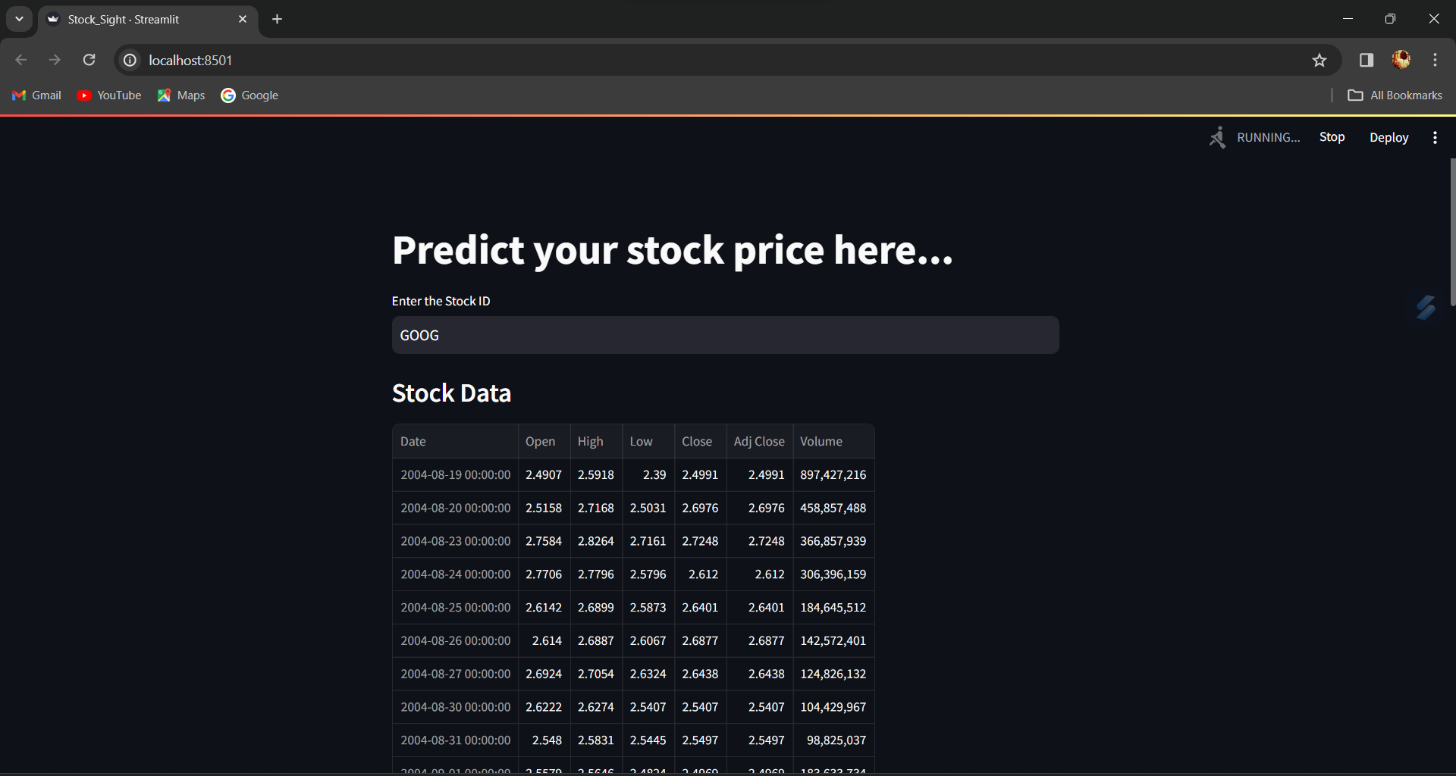

Landing Page

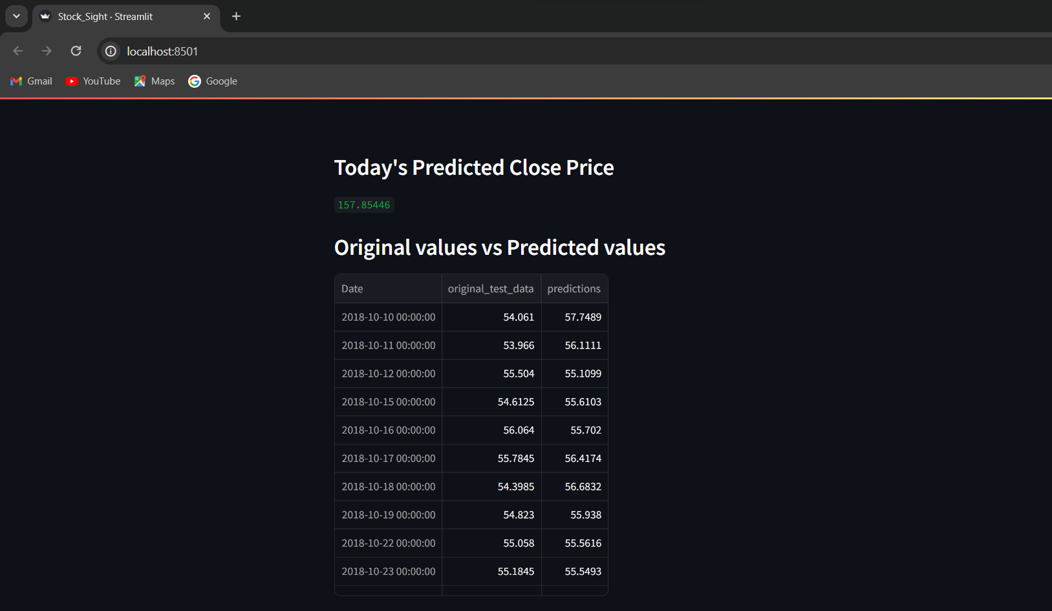

Prediction of the current day

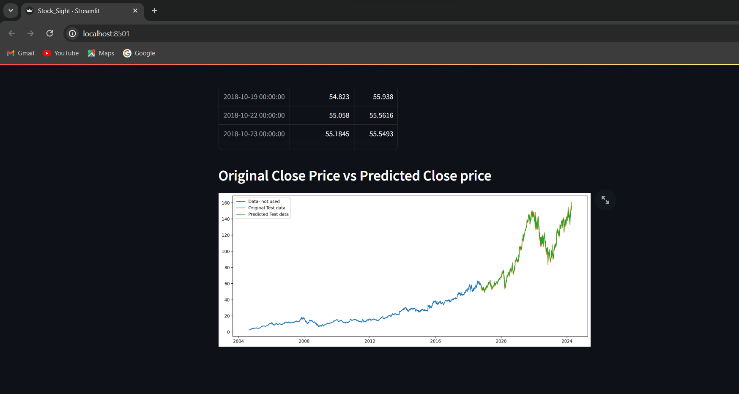

Results

1. **Advantages of proposed system**

* User-Friendly Interface: The "Stock Sight" project offers a streamlined and intuitive user interface through Streamlit, simplifying the process of stock price prediction for users of all proficiency levels.
* Interactive Visualization: By leveraging Matplotlib, users can visualize historical stock data alongside moving averages, enabling them to gain deeper insights into market trends and patterns.
* Real-Time Data: Integration with the Yahoo Finance API ensures that users have access to up-to-date and accurate stock market data, facilitating timely decision-making.
* Predictive Modeling: The utilization of a pre-trained Keras model enables accurate prediction of the next day's stock price based on historical data, empowering users to anticipate market movements.
* Customizable Inputs: Users can input their preferred stock symbols, allowing for personalized predictions tailored to specific investment interests and preferences.
* Efficient Data Processing: The project efficiently preprocesses and analyzes historical stock data, including calculating moving averages, to provide users with actionable insights and predictions.
* Accessibility: The web-based platform ensures that users can access the "Stock Sight" project from anywhere with an internet connection, enhancing accessibility and convenience.
* Educational Value: The project offers educational benefits by allowing users to explore stock market prediction techniques and understand the fundamentals of data analysis and modeling.
* Decision Support: By providing users with accurate predictions and visualizations, "Stock Sight" serves as a valuable tool for decision support, aiding investors in making informed investment decisions.
* Continuous Improvement: The project can be continually updated and enhanced with additional features and improvements, ensuring its relevance and usefulness in the ever-changing landscape of stock market analysis.

1. **Conclusion**

In conclusion, the Stock Sight project embodies a significant endeavour aimed at providing users with a comprehensive and intuitive platform for stock market analysis and decision-making. Throughout the project lifecycle, from inception to implementation, meticulous planning, diligent execution, and seamless collaboration have been the guiding principles. By harnessing cutting-edge technologies, robust methodologies, and industry best practices in software development, we have successfully delivered a platform that caters to the diverse needs of investors, traders, and financial enthusiasts. The Stock Sight platform empowers users with real-time market data, sophisticated predictive analytics, and user-friendly tools to make informed investment decisions and navigate the intricacies of the stock market landscape with confidence. From intuitive user interfaces to powerful backend algorithms, every aspect of the platform has been crafted with the end user in mind, ensuring accessibility, reliability, and usability at every turn.

**References**

1. "Python Crash Course, 2nd Edition" by Eric Matthes - Published in 2019
2. "Mastering Streamlit: Building Data Apps" by Adrien Treuille - Published in 2021
3. "Python for Data Analysis" by Wes McKinney - Published in 2017
4. "Python Data Science Handbook" by Jake VanderPlas - Published in 2016
5. "Deep Learning with Python" by François Chollet - Published in 2017
6. "Matplotlib for Python Developers" by Sandro Tosi - Published in 2017
7. "Hands-On Financial Trading with Python" by Artem Deza and James Ma Weiming - Published in 2018
8. "Introduction to Machine Learning with Python" by Andreas C. Müller and Sarah Guido - Published in 2016
9. https://docs.streamlit.io/
10. <https://pandas.pydata.org/docs/>
11. https://numpy.org/doc/stable/
12. <https://keras.io/api/>
13. https://matplotlib.org/stable/contents.html
14. https://pypi.org/project/yfinance/
15. https://scikit-learn.org/stable/documentation.html