**WEATHER FORECASTING**

Shabeena R1, Sakthivel N, MCA., M.Phil.,2

*1Department of MCA, Adhiyamaan College of Engineering (Autonomous), Hosur.*

*2Department of MCA, Adhiyamaan College of Engineering (Autonomous), Hosur.*

*Corresponding Author: shabeenariyaz1617@gmail.com*

|  |
| --- |
| ***Abstract:*** My Project is on implementation of a weather forecasting using python and machine learning. real-time weather data from locations across the world. Through Python scripting, the project generates accurate forecasts for diverse regions, providing essential meteorological parameters such as temperature, wind speed, humidity, and weather conditions. Weather forecasting plays a crucial role in various aspects of human life, from planning outdoor activities to making strategic decisions in sectors like agriculture, transportation, and emergency management. In this project, we explore the application of Python programming language in weather forecasting, employing both open-source libraries and APIs to access and analyze weather data. Through this project, we aim to demonstrate the versatility of Python in harnessing weather data for forecasting purposes, showcasing its capabilities in data retrieval, analysis, visualization, and predictive modelling. By empowering users with accessible tools and methodologies, we envision a future where weather forecasting becomes more accurate, reliable, and actionable, contributing to informed decision-making and enhanced societal resilience in the face of changing weather patterns. Weather forecasting is the scientific process of predicting atmospheric conditions at a specific location and time. It involves the collection and analysis of data from various sources, such as satellites, weather stations, and radar systems. This data is then input into numerical weather prediction models, which use mathematical equations to simulate the behavior of the atmosphere. Advances in technology, such as high-performance computing and machine learning, have significantly improved the accuracy and reliability of weather forecasts. These predictions are crucial for a wide range of applications, including agriculture, disaster management, transportation, and daily planning, helping to mitigate the impacts of severe weather events and enhance societal preparedness and safety. Despite significant progress, challenges remain due to the inherently chaotic nature of the atmosphere, which limits the precision of long-term forecasts.  ***Key Word****:**Weather*; Forecasting; Analysis; Trends; Climate; Prevention; Professionals; Foresight |

1. **Introduction**

Weather forecasting is a cornerstone of modern meteorology, playing a critical role in various sectors ranging from agriculture and transportation to disaster management and daily life planning. The process involves the systematic collection and interpretation of atmospheric data from a myriad of sources including ground-based weather stations, satellites, and radar systems. These data points are then integrated into sophisticated numerical weather prediction (NWP) models, which simulate atmospheric dynamics using advanced mathematical algorithms. The evolution of weather forecasting has been significantly driven by technological advancements. High-performance computing has enhanced the capability and resolution of NWP models, while machine learning techniques are increasingly being employed to refine and improve forecast accuracy. As a result, modern weather forecasts are more precise and reliable than ever before, providing critical information that helps mitigate the impacts of severe weather events and supports a wide range of socio-economic activities. Despite these advancements, weather forecasting remains a complex and challenging field. The inherently chaotic nature of the atmosphere imposes fundamental limits on the accuracy of long-term forecasts. This journal aims to explore the latest developments in weather forecasting, examining the methodologies, technologies, and challenges that define the field. Through this exploration, we seek to provide a comprehensive understanding of current capabilities and future directions in weather prediction, highlighting its essential role in enhancing societal resilience and safety.

1. **PROJECT MODULES**

A weather forecasting project can be systematically organized into several key modules. The first module, Data Collection and Ingestion, involves gathering atmospheric data from sources such as ground-based weather stations, satellites, and radars, and interfacing with external data providers. Following this, the Data Processing and Cleaning module ensures the accuracy and usability of the data by removing noise, handling missing values, and converting the data into suitable formats. The core of the project, the Numerical Weather Prediction (NWP) Models module, uses advanced mathematical models to simulate atmospheric conditions and generate forecasts. To enhance accuracy, the Machine Learning and AI Enhancement module employs historical data to train algorithms that refine predictions. The Forecast Visualization and Dissemination module then presents this data through user-friendly interfaces, including charts, maps, and interactive dashboards, and implements notification systems for severe weather alerts. The Verification and Validation module ensures the reliability of forecasts by comparing predictions with actual weather outcomes and refining models based on feedback. Efficient Data Storage and Management is crucial for handling the vast amounts of data involved, utilizing robust database systems. Additionally, the User Training and Support module provides comprehensive documentation, training programs, and technical support to end-users. Finally, the Research and Development module focuses on continuous innovation, integrating new technologies and collaborating with meteorological organizations to advance forecasting capabilities. This structured approach ensures a comprehensive and effective weather forecasting system.

1. User Authentication Module
2. Data Retrieval Module
3. Data processing Module
4. Forecasting Model Module
5. Data visualization Module

**Software Requirements**

Web Development Framework : Streamlit

Data Processing and Analysis : Pandas, NumPy

Machine Learning Framework : Keras

Data Visualization : Matplotlib

Web Scraping and Data Retrieval : OpenWeatherApp

Data Preprocessing : scikit-learn (sklearn)

## Existing System

The existing weather forecasting system is a sophisticated and multi-faceted process that integrates a wide range of data sources and advanced technologies to predict atmospheric conditions. At the core of this system is the extensive network of data collection instruments, including ground-based weather stations, satellites, radars, and ocean buoys, which provide real-time and historical weather data. This raw data undergoes rigorous processing and cleaning to ensure its accuracy and suitability for further analysis. Numerical Weather Prediction (NWP) models, such as the Global Forecast System (GFS) and the European Centre for Medium-Range Weather Forecasts (ECMWF), utilize this data to simulate the atmosphere and generate weather forecasts. These models are initialized with current atmospheric conditions and run on high-performance computing systems to predict weather patterns. Machine learning techniques are increasingly employed to enhance these predictions, leveraging historical data to improve forecast accuracy. The processed forecast data is then visualized through various tools, including maps, charts, and interactive dashboards, making it accessible and understandable for a wide range of users. Dissemination occurs via multiple platforms, such as websites, mobile apps, and alert systems, ensuring timely delivery of weather information.

1. **Result**

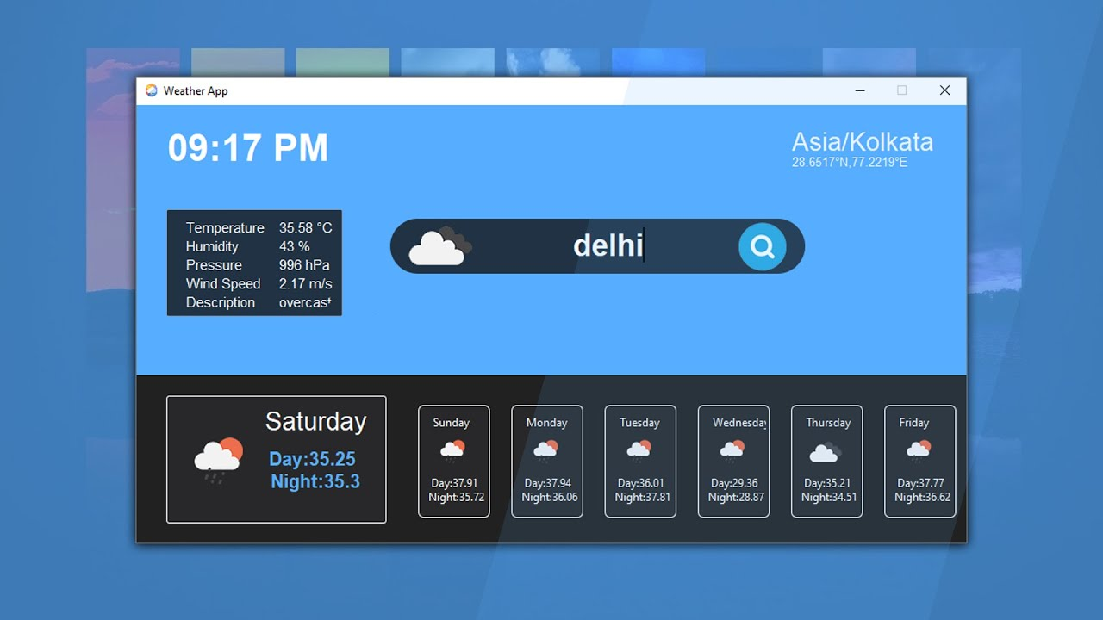

Results

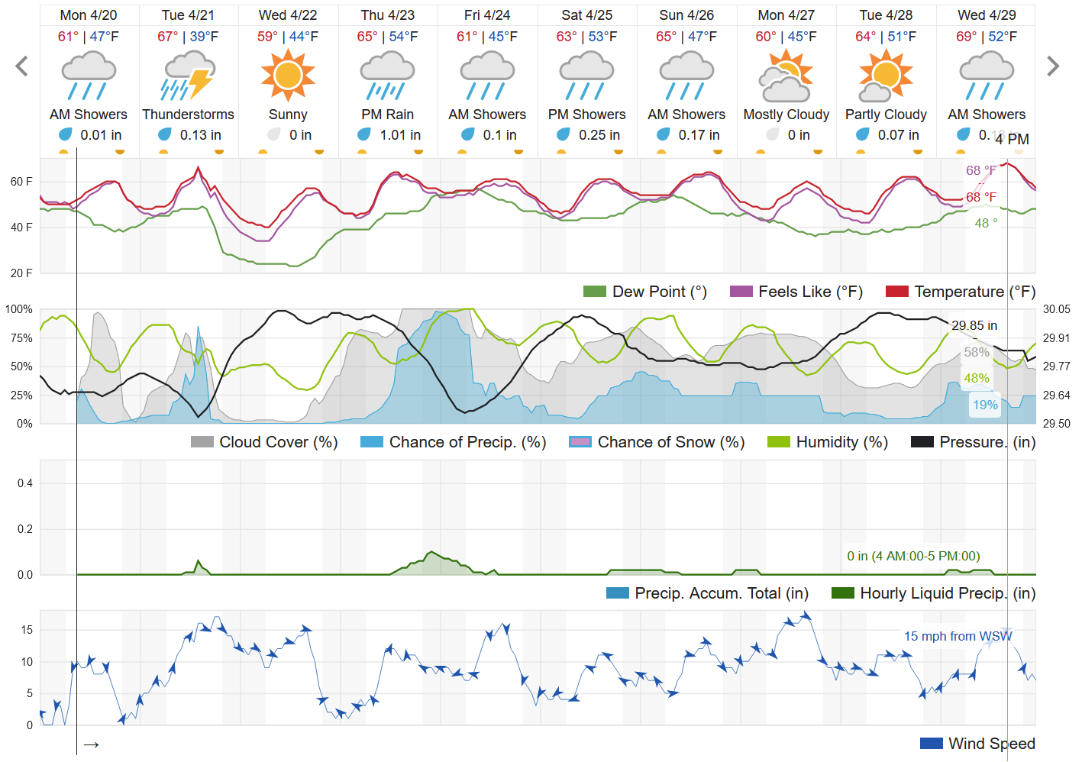

Graphical format of weather

1. **Advantages of proposed system**

* Early warnings for severe weather events allow timely evacuations and preparations, reducing injury and loss of life.
* Informed decisions about planting, irrigation, and harvesting optimize crop yields and minimize losses.
* Transportation Efficiency: Improved planning and management of aviation, shipping, and ground transportation routes enhance safety and efficiency.
* Assists in managing energy resources and infrastructure, especially for renewable energy sources like wind and solar power.
* Enables effective mobilization of resources and coordination of emergency response efforts.
* Helps individuals and businesses plan outdoor activities and events.
* Reduces weather-related disruptions in various industries, leading to cost savings and increased productivity.
* Aids in tracking and understanding climate change and environmental conditions.
* Improves the allocation of resources in sectors such as water management and public health.
* Supports scientific research and advancements in meteorology and related fields.
* Communities and businesses can prepare better for upcoming weather conditions, reducing economic losses and enhancing resilience.
* Helps in predicting and managing health issues related to weather changes, such as heatwaves, cold spells, and air quality.
* Improves risk assessment and management, aiding in the pricing of insurance policies and claims processing.
* Assists in planning and operations, ensuring safety and efficiency in various military activities.
* Provides crucial information for tourism planning, enhancing visitor experiences and safety.
* Helps in scheduling construction activities, avoiding delays and protecting equipment and workers from adverse weather.
* Supports the conservation and management of wildlife habitats and fisheries by predicting weather patterns that affect ecosystems.
* Aids in the effective management of water resources, including reservoirs, rivers, and irrigation systems.
* Facilitates international cooperation and data sharing among meteorological and climate research organizations.
* Enhances public knowledge and awareness about weather and climate, promoting informed decision-making.
* Supports efforts to protect natural resources and biodiversity by forecasting and mitigating the impacts of extreme weather.
* Assists in designing resilient urban infrastructure that can withstand severe weather conditions.
* Improves logistics and supply chain operations by anticipating weather-related disruptions.
* Ensures the safety and success of outdoor sports and events by providing reliable weather information.
* Protects and manages telecommunications infrastructure by predicting weather conditions that might affect operations.

1. **Conclusion**

In conclusion, modern weather forecasting systems are indispensable tools that significantly enhance our ability to predict and respond to atmospheric conditions. By leveraging advanced technologies such as high-performance computing and machine learning, these systems provide accurate and timely weather forecasts that are crucial for public safety, agricultural productivity, transportation efficiency, energy management, and disaster preparedness. They offer substantial socio-economic benefits, reducing risks and costs associated with adverse weather while supporting a wide range of activities from recreational planning to military operations. As technology continues to evolve, the precision and reliability of weather forecasts are expected to improve further, enabling even more effective management of weather-related challenges and contributing to greater resilience and sustainability in various sectors. The ongoing advancements and innovations in weather forecasting underscore its critical role in enhancing our ability to navigate and thrive in a world increasingly impacted by climatic variability and extreme weather events.

**References**

1. "Python Crash Course, 2nd Edition" by Eric Matthes - Published in 2019
2. "Python for Data Analysis" by Wes McKinney - Published in 2017
3. "Python Data Science Handbook" by Jake VanderPlas - Published in 2016
4. "Deep Learning with Python" by François Chollet - Published in 2017
5. "Matplotlib for Python Developers" by Sandro Tosi - Published in 2017
6. “[Weather Forecasting in India”: A Review - ResearchGate](https://www.researchgate.net/publication/321137908_Weather_Forecasting_in_India_A_Review) 2017
7. "Introduction to Machine Learning with Python" by Andreas C. Müller and Sarah Guido - Published in 2016
8. https://docs.streamlit.io/
9. <https://pandas.pydata.org/docs/>
10. https://numpy.org/doc/stable/
11. <https://keras.io/api/>
12. https://matplotlib.org/stable/contents.html
13. https://pypi.org/project/openweatherapp/