**International Journal of Innovative Research in Engineering**

*Volume 4, Issue 3(May-June 2023), PP: 583-587.*

*www.theijire.com* ***ISSN No: 2582-8746***

**Water Pollution Monitoring Using RC Boat**

**Anandavelu.K1, Mahabubadsha.A2, Gopalakrishnan.A3, Jagan.P4, Jagadeeshwaran.K5**

*1Professor, Department of mechanical Engineering, MRK Institute of technology, Tamilnadu, India.*

*2Assistant professor, Department of mechanical Engineering, MRK Institute of Technology, Tamilnadu India.*

*3,4,5 UG Final year, Department of mechanical Engineering, , MRK Institute of Technology, Tamilnadu, India.*

|  |  |
| --- | --- |
| **How to cite this paper:**  Anandavelu.K1, Mahabubadsha.A2, Gopalakrishnan.A3, Jagan.P4, Jagadeeshwaran.K5, “Water Pollution Monitoring Using RC Boat”,  IJIRE-V4I03-583-587.    https://www.doi.org/10.59256/ijire.20230403123  Copyright © 2023 by author(s) and  5th Dimension Research Publication.  This work is licensed under the Creative Commons Attribution International License  (CC BY 4.0). <http://creativecommons.org/licenses/by/4.0/> | ***Abstract:*** *Water is considered as a basic need for human in their daily life. It is needed in different situations including, at home, in agriculture, in industry and manufactures, in hospital etc. To survive in a good life the quality of water should be monitored on highly level frequently and efficiently. Water pollution can be caused by different factors including large number of people who move from rural environment to urban (as long as the city get more rising number of people the waste management become an issue therefore these can provoke pollution in environment), more industries that provide different kind of waste, erosion etc. Unsafe water could lead to different diseases such as diarrhea, cholera, cancer. Generally, the quality of fresh water is described by chemical, biological and physical content and methods used in monitoring the quality of water usually were Water Sampling, Test Sampling and Investigative Analysis. But these methods are performed by the scientists in laboratories, and are found that they are slow. In this project we proposed an affordable system design for monitoring the quality of waterremotely in river by using technology known as Internet of Things (IOT) and this technology provides the required results in real time. A prototype was designed and developed with the use of hardware component together with the software program for implementing this project. ESP32 microcontroller is used in this project data from the ph sensor, Turbidity sensor and Temperature sensor were directly send to the thingspeaks server for further investigation.*  ***Key Word:*** *IoT; Remote monitoring; Water Quality; PH Sensor; Microcontroller.* |

**I.INTRODUCTION**

This chapter sheds light on the background and motivation, problem statement, study objectives (general objectives and specific objectives), scope of the study, significance of the study and how the work is organized from the beginning up to the end. Background and motivation: Monitoring the quality of water refers to controlling the level of physical, chemical and biological parameters that are contained in water reservoir or tank various activities to survive [1].Therefore water quality can be understood as the appropriate range of variables which limit water usage[2]. Most of infectious diseases are caused by contaminated water which leads to millions of deaths every year. The incapacity of not having enough power for distributing water with quality to all people in real time is the key which can different illness [3]. Generally, several transmitted diseases like hepatitis, cholera, typhoid, paratyphoid etc. are caused by drinking unsafe water [4]. Some factors of having low quality of water include, pollutions, mining, too much fertile contained in the soil, erosion, etc. [5]. A number of developing countries including India use traditional method to monitor the quality of water, this involves the collection of water sample from different locations. These water samples are then tested in the laboratory using the analytical technologies. Such approaches are time consuming and give appreciation results and also the cost is high and offer low measurement accuracy [6]. There are so many devices used for measuring the quality of water those are Dr. Meter TDS- 3C Water Quality, Sunny Water Tester, and Water Quality Meter by Generic, Play X-STORE Water Quality Meter, APEC Water Systems Digital Meter and Started Filte time without delay , it provides interface to monitor and operate remotely from anywhere and anytime and save human job[9].The proposed project focuses on monitoring the quality of water stored in those tanks remotely with the application of Wireless Sensor Network (WSN). Various sensors that are used comprise pH which measures the concentration of hydrogen ions and it shows the acidity or alkalinity of water and neutral. pH is measured in the range from 0 up to 14 pH, drinking water is scaled between 6.5-8.5pH, at 7pH water is neutral, less than 7pH water has acid, more than 7pH water has alkaline. Another sensor is the turbidity sensor which measures the level of suspended particles in water which is invisible and normal water should be ranged between 0-5NTU (Nephelometric Turbidity Unit). So higher the turbidity or pH in water the more risk of diarrhea, cholera and others diseases comes[10]. The system also uses Arduino UNO as a microcontroller to allow data collected from the sensors to be processed, node MCU ESP8266 for sending data to Thing Speak. This system provides the way for monitoring the quality of water based on the use of Thing Speak platform which can analyze and visualize data by using MATLAB. Here all sensed parameters have to be uploaded to the Think Speak and the system has to send an email message notification to the technician of WASAC automatically through IFTTT protocol once the abnormal parameters are sensed[11]. Some modern countries such as in India have this system of monitoring quality of water remotely by using system like Eco -Mapper, Robotic Fish and Digital Camera placed into the riversor lakes.

# II.MATERIAL AND METHODS

In this chapter we reviewed works of different authors in the area of water quality monitoring? We discussed about their different technologies that have been used, types of microcontrollers used, the communication protocols used, where the data should be stored. We discussed also the standard specification guideline for potable that have printed out by world health organization (WHO).

**Indian Standard:** In its edition made in 2018 has developed the standards about potable water that should be followed by all indian standard specification drinking water in order guarantee the delivery of safe and quality of drinking water for human . This edition shows the characteristics of the microbiological and that of physico-Chemical parameters that should be measured in water for maintaining its quality and show the standard limits (SL) for pollutants that can affect safety and water quality of drinking water for each parameter.

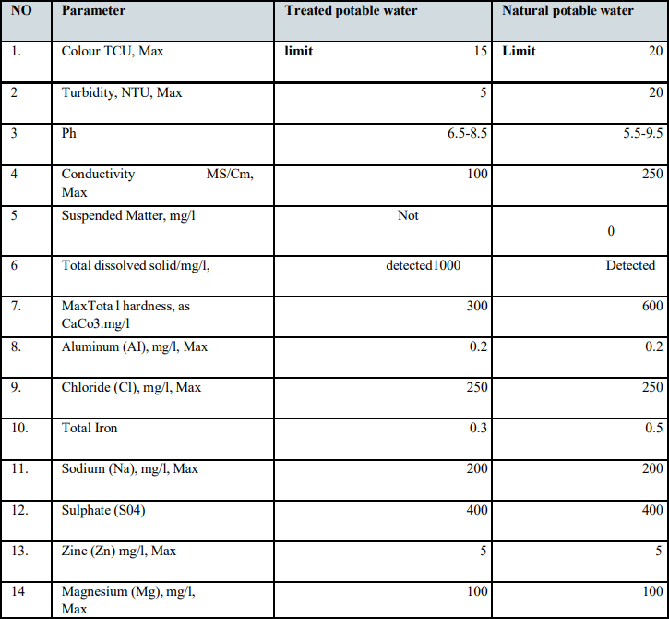

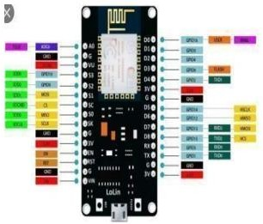**Definition of Terms:** In this thesis there are technical terms that should be explained more. Those are Node Mculolin v3 ESP8266, IOT. Thing Speak, pH sensor, turbidity sensor, water quality/potable water.

**Thing Speak:** Thing Speak is defined as a Web Service (REST API) that lets you gather and store sensor data in the cloud and develop Internet of Things applications. It is an IOT analytics platform service that is used for collecting and storing sensed data to the cloud and it is mostly work with an internet of things application. Thing Speak also provide a service that allow someone to perform online analysis[25]. The sensed data can be sent to Thing Speak from any hardware that can communicate using a REST API. REST in full words is representational state transfer, and API is Application Programming Interface. In this thesis The Thing Speak API as an open-source interface which listens to incoming data, 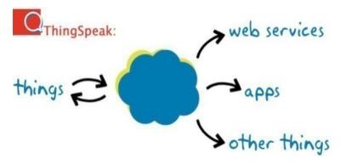timestamps it, and outputs it for both human users (through visual graphs) and machines (through easily parse-able code).

**PH sensors:** Normally we define pH as a combination of two different terms, those are p which belong to mathematics and H which belong to chemistry. The alphabet p written in lower case in mathematics represent the negative logarithm coefficient, and alphabet H written in capital letter represent the concentration of hydrogen ion. Measuring pH is essential as it helps in judging the level L. acidity or alkalinity in a certain aqueous solution [27]. The formula is pH=-log [H], where H is hydrogen ion concentration and it is expressed in gram mole/litter or simply H+/

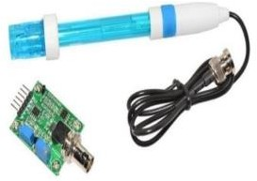

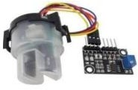**Turbitity sensor:** Turbidity is defined as the amount of cloudiness in the water. Turbidity is caused by many factors such as silt, mud, sand, bacteria, germs and chemical hasten .Turbidity is usually measured in nephelometric turbidity units (NTU)[32]. The turbidity sensor is based on transmission and 90◦ scattering variations with the total suspended particles in a solution.

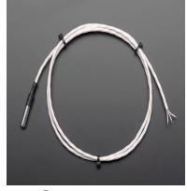**Temperature sensors:** This is a pre-wired and waterproofed version of the DS18B20 sensor made with a PTFE wire cable. Handy for when you need to measure something far away, or in wet conditions. The sensor in this housing can be used up to the sensor's 125 °C limit. Because the sensor signal is digital, you don't get any signal degradation even over long.

**III.RESULT**

### **Procedure to install:**

* **Mobile Phone:** This is the communication device that the technician will use for receiving a message.
* **Breadboard:** The purpose of the breadboard is to make quick electrical connections between components.
* **ESP32:** Arduino IDE is used to program ESP32. It is open-source software that is mainly used for writing and compiling the code into the ESP32 Module. Data from Sensors were read and sent to thing speak server by ESP32.
* **Thing Speak:** Currently, Thing Speak is an IoT platform which permits someone to gather, visualize, analyze live data and react according to it. Thing Speak is an open source application initially launched in 2010 by a Bridge. It facilitates one to build IoT systems without need of setting up extra servers. The data collection is done using REST API or MQTT. MQTT is written as a Message Queuing Telemetry Transport and it a protocol used for exchanging messages among devices. It is often used in IOT[42]. The data analysis and visualization are done using MATLAB analytics.

### **Step1: Creating a channel in Thing Speak:**

**Step2: By clicking my sensor we get:**

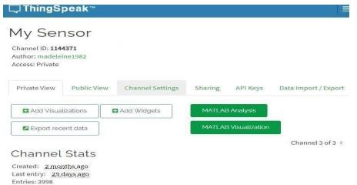

### **Step3: Click on API Key in the tab for viewing the Write API key and Read API Key:**

* Collect data in private channels
* Share data with public channels
* Restful and MQTT APIs
* MATLAB analytics and visualizations
* Event scheduling
* Alerts
* App integrations

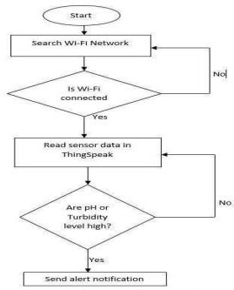

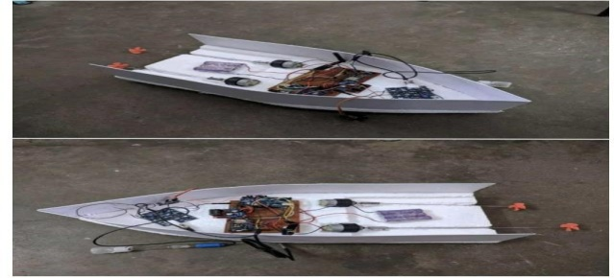 The flowchart shows that on the part of network, it is necessary to check if the network is available. If it is yes, the system will send the sensed data to Thing Speak; if it is No return back to the search wi-fi. When the data of pH or Turbidity are high, the system sends alert notification to the technician through IFTTT.

# IV.DISCUSSION

### **Tamil Nadu Pollution Control Board (TNPCB):**

Tamil Nadu pollution control board (TNPCB) was constituted by the Government of Tamil Nadu on 27th February,1982 in pursuance of the Water Prevention and Control of Pollution Act, 1974 (Central Act 6 of 1974). Increasing the pace of industrialization in Tamil Nadu its need to monitoring pollution level continuously. In the 3 industries are required to provide pollution control measures to meet the standards prescribed by the board. In the 16 board field officers are inspect the industries continually with some pollution control measures provide by the industries sewage, trade effluent and emissions. For effective monitoring industries are categorized as Red, Orange, Green and White according to their pollution level. Also in the industries has been classified a large, medium and small scale based on the gross fixedassets of the industry. And depending upon the category and size industries are monitored periodically. The various legislations are created by the government to control the water pollution. Water pollution control legislations with which the TNPCB is concerned are given below. Most of the legislations are implements directly by the TNPCB and some of other legislations implemented by deportments of the government. •The water (prevention and control of pollution) act, 1974 as amended in 1978 & 1988. •Tamil Nadu water (prevention and control of pollution) rules, 1983. •The water (prevention and control of pollution) cess act, 1977, as amended in 1991 and 2003. •The water (prevention and control of pollution) cess rules, 1978 as amended in 1992. •Coastal Regulation Zone notification, 2011. •The Solid Wastes Management Rules, 2016. MAJOR CAUSES OF WATER POLLUTION It can be classified under two broad categories. • Point source: which occurs when harmful substance are emitted directly into the body of water. • Non-point source: which occurs when harmful substances are emitted directly into a body of water and ‘nonpoint source’ which delivers pollutants indirectly through transport or environmental change. Important Driving Forces The following are considered to be the major driving forces of water pollution. 1. Urbanization 2. Industrialization Impact of water pollution in Tamil Nadu INDUSTRIAL POLLUTION In Tamil Nadu have a more than 3000 industrial units are classified under highly polluting or red category industry. In the red category industries total effluent generated around 6 lakh liters per day of which more than 5 lakh liters (85%) of total effluent generated by large scale industries. About 400 units discharge directly into rivers; of particular concern are the tanneries which are located in Vellore, Kancheepuram, Dindigul and Erode districts. The effluents have caused serious problems in the Palar basin. Similarly, there are a large number of textile bleaching and dyeing units in Tiruppur, Erode, and Karur, which have contaminated the Noyyal, Amaravathy and other water bodies. In majority of effluents come from main five industrial complexes in Tamil Nadu: Manali/Ennore, Ranipet, Cuddalore, Mettur and Tuticorin areas placed chemical, petro-chemical and other industries. These complexes have also become more environmental hotspots. There are cement units, distilleries, sugar, sago, paper, dairying, electroplating, chemical and fertilizers (Agro chemicals), mining industries, ores/ mineral processing industries and a variety of other industries which are water consuming and also generate large quantities of effluent. Some of the industries have also provided the treated effluent for irrigation with some degree of success. COASTAL POLLUTION The major activities that are responsible for coastal pollution in Tamil Nadu are discharge and disposal of untreated domestic and industrial wastes, discharges of coolant waters, harbour activities such as dredging, cargo handling, dumping of ship wastes, spilling of cargo’s 3 chemicals and metal ores, fishing activities etc.

# V.CONCLUSION

In this study we provide an affordable system for monitoring the quality of water quality and this system can be applicable in different area and it cover a large distance. In this thesis also we address the issue of remote water quality monitoring based on IOT (Internet of Things) via a prototype system. The system is provided by the hardware device ESP32. Two sensors, pH sensor and Turbidity sensor, temperature sensor and Jumper wires. The sensed parameters are analyzed through the Thing Speak and data were stored in server . The prototype methodology was used for achieving the required results.

# References

1. *Roy, “Hydro-Informatics Engineering (Ce) Water Quality Analysis : anIntroduction,” no. January, pp. 201–205, 2019.*
2. *M. Meybeck, E. Kuusisto, A. Mäkelä, and E. Mälkki, “Chapter 2 - WATERQUALITY,” 1996.*
3. *R. Shevale, “IOT Based Real time water Monitoring System for Smart City,” Int. J.Innov. Sci. Res. Technol., vol. 3, no. 4, pp. 246–251, 2018.*
4. *0M. Pal, Y. Ayele, A. Hadush, S. Panigrahi, and V.J. Jadhav, “Public Health HazardsDue to Unsafe Drinking Water,” Air Water Borne Dis., vol. 7, no. June, pp. 1–6, 2018, doi:10.4172/2167-7719.1000138.*
5. *V. Madhavireddy and B. Koteswarrao, “Smart Water Quality Monitoring SystemUsing Iot Technology,” Int. J. Eng. Technol., vol. 7, no. 4.36, p. 636, 2018, doi: 10.14419/ijet.v7i4.36.24214.*
6. *K. K. Warhade, “Water Quality Monitoring System for Water Tanks of HousingSociety,” vol. 9, no. 7, pp. 1078, 2017.*
7. *P. D. Anuradha T, Bhakti, Chaitra R, “IoT Based Low Cost System for Monitoringof Water Quality in Real Time,” Int. Res. J. Eng. Technol., vol. 5, no. 5, p.1658, 2018.*
8. *J. Gowthamy, C. R. Reddy, P. Meher, S. Shrivastava, and G. Kumar, “Smart WaterMonitoring System using IoT,” Int. Res. J. Eng. Technol., vol. 05, no. 10, p.1170, 2018.*
9. *J. Gowthamy, C. R. Reddy, P. Meher, S. Shrivastava, and G. Kumar, “Smart WaterMonitoring System using IoT,” Int. Res. J. Eng. Technol., vol. 05, no. 10, p. 1170, 2018.*