**“Analysis of Pedestrian Steel Bridge subjected the Seismic Load and Wind Load using Damper at different Span.”**

**Mr. Siddhesh R. Nagapure1**, **Prof. Kirti Padmawar 2**

1Student of M.TECH Department of Structural Engineering, BIT College Bamni Ballarpur

*Siddheshnagapure29@gmail.com*

2Professor of Department of structural Engineering, BIT College Bamni Ballarpur State Maharashtra, India

kirtipadmawar@gmail.com

|  |
| --- |
| *Abstract:* - *A Pedestrian steel truss bridge model was created by using structural analysis by software. With the similar loading and support condition the 3D model was analyzed for different span like 20m, 25m,30m the basic significance has been given decreases the response of structure member by providing damper at different span I section Girder, steel plate thickness. Steel girder and M40 grade of concrete is used for column section in Etab software. The dynamic loading caused by moving pedestrian and earthquake and wind load.**Excessive vibration in footbridges usually occurs when they are subjected to rhythmic dynamic loads caused by human activities like walking and running. In order to mitigate the human induced vibrations in footbridges, an increase in the damping ratio is often suggested as the most economical approach. Tuned mass dampers have been widely used for this purpose; however, their installation and maintenance costs are high. This has encouraged researchers to examine the efficiency of the other types of dampers. Viscoelastic dampers have been successfully employed for vibration mitigation of structures against wind and earthquake loads.*  ***Key Word****:*Pedestrian Steel Bridge, Dampers, structural Analysis , software |

1. **Introduction**

Pedestrian Bridge also called footbridge were used hundred years ago. Footbridge provides a safe movement of pedestrian over a urban roads, highways, slopes and hilly area. Asymmetrical loads cause the structure to behave in more complex ways.

Modern Footbridges are more and more sensitive to variable load created by moving pedestrians. There are several reasons for that. Very often there is no place for piers long span are only feasible solutions. The dynamic problems of footbridges have been subject of recent studies. Periodic load from pedestrian and wind can accelerate a pedestrian bridge which can be dangerous for structure itself. due to seismic load the it’s a big challenge to footbridges now a days.

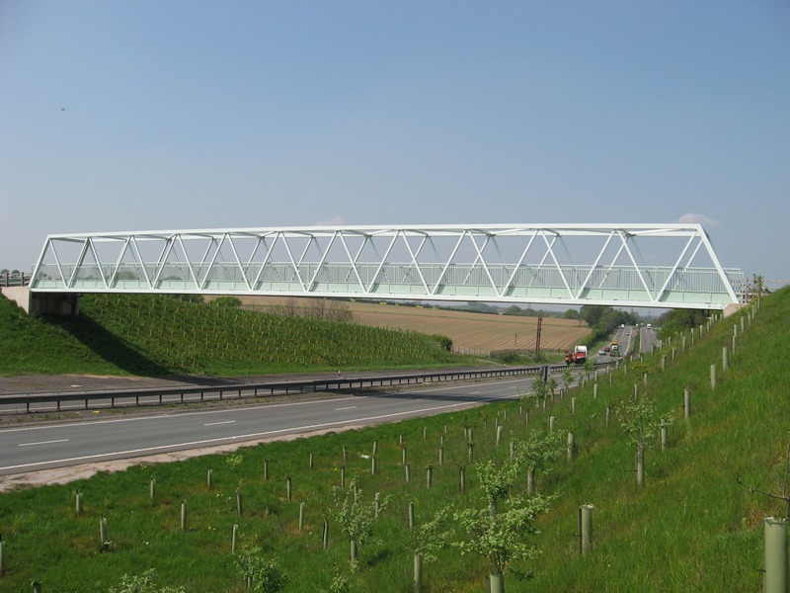

Fig.1

The dynamic problems of footbridges have been subject of recent studies. main reason of new engineering challenges related to footbridges; these bridges can fail due to low excitation energy also.

Periodic load from pedestrian and wind load can accelerate a bridge to the level which can be dangerous for structure itself. Viscoelastic damper is very essential use for pedestrian bridge, its low cost of maintenance as compare to tune mass damper and fluid viscous damper. the research efforts have been focused on the comfort ability resulting from human walking and aerodynamic properties On the other hand, the safety of the bridges subjected to earthquake excitations should also be strictly guaranteed In high-risk seismic zones, the earthquake may become the most critical factor that determines the structural configurations bridges with irregular arrangements are generally more vulnerable to seismic excitations, which has been evident by failures and damage of bridges observed in recent major earthquake.

Steel is widely accepted as primary structural material in pedestrian bridge there are established standard for design and fabrication, providing confidence in specifying steel. Most steel pedestrian bridges are built using shop fabricated truss system.

Whether it’s an urban or rural city park or busy highway overpass we design and analysis every pedestrian bridge to enhance the landscape aesthetically and environmentally and stable the pedestrian bridge due to various dynamic load as well pedestrian load acting on this structure.

1. **Literature Review**

**1. Title-** Behaviour of pedestrian steel bridge subjected to seismic load

**Location-** Karnataka, India (2018)

**Name of Author-** Devaraju T.S, Shridhara Y

In this research, Main aim of study is to analyses the behavior of pedestrian steel suspension bridge structure under dynamic walking loads. This paper is thus basically a Analyzing the 10m, 15m, 20m span of pedestrian steel bridge structure deflection shear force and bending moment values are zero for load combination of dead load and live load

As per IS: 1893-2002 code of practice loads are applied in the combination of dead load, pedestrian load and earthquake in two directions. After analyzing the pedestrian steel bridge structure in 3D model for different span 10m, 15m and 20m results of displacement, shear force in two directions and bending moment in two directions are presented in this project.

**2.Title-** Control of vibrations of common pedestrian bridge in Jordan using tuned mass Dampers

**Location-** Jordan (2020)

**Author-** Mohammed A. Alhassan

In this research paper, the focus of study is directed towards the study was conducted to investigate the effect of human induced vibration on common simply supported steel footbridges in Jordan.

With the help of this paper, we have understood

After attaching the TMD to footbridge the fundamental vibration of frequency was decreased to 1.146 Hz which is less than the minimum value of range walking frequency 2.4 Hz.

**3. Title-** Design and construction of pedestrian bridge at Kharghar Navi Mumbai.

**Location-** Kharghar Navi Mumbai (2013)

**Author-** Umesh Rajshirake

In this paper the Kharghar Skywalk Bridge is a two-span cable stay bridge which provides grade separated pedestrian facility between various institutes, residential areas, and railway station. The bridge is designed considering visual interest feature of the part of Kharghar node which is planned and maintained by the state-owned agency.

It is a trend to provide a pedestrian bridge as a architecturally appealing structure along with purpose of transit the pedestrian traffic. These slender structures need to be analyzed and designed for the various dynamic loadings. In this particular project, the structural system is provided in such way that the peak acceleration due to foot vibration is within the specified limit of 5% .

**4. Title-** Effect of Ground Motion Orientation on Seismic Responses of an Asymmetric Stress Ribbon Pedestrian Bridge.

**Location-** China (2022)

**Author-** Yi Zhang

Stress Ribbon Bridge uses ribbon in high tension to transfer loads and exhibits geometric nonlinearity under dynamic earthquake excitations. A typical double-span asymmetric stress ribbon pedestrian bridge was introduced as a prototype, and nonlinear time history analysis was performed to investigate the effect of ground motion orientation on the structural responses

study investigated the variation in response quantities of a two-span asymmetric stress ribbon bridge subjected to bidirectional and tridirectionally earthquake ground motions changed with the direction.

## Problem Statement:

## To Analysis the pedestrian Steel bridge by subjecting the dynamic load with the viscoelastic damper at different span.

Analysis the bridge by subjecting wind load, taken height of deck bridge above 10m.

control the vibration of pedestrian steel bridge by providing viscoelastic damper at different span.

1. **Objectives:**

The main aim of this projects is to control or minimization the vibration of pedestrian steel bridge and provide stable the structure after subjecting the seismic and wind load providing damper at different span.

1. To analyses the pedestrian steel truss bridge considering the seismic and wind load.
2. To providing the viscoelastic damper at different span and compare the results with damper and without damper.
3. To Analysis the steel deck bridge.
4. To calculate the results from using Etab software and minimization or control the vibration of foot steel bridge using viscoelastic damper.

## Methodology:

1. Modeling the footbridge on Etab software.

The pedestrian steel bridge modeling on Etab software. considering the steel deck bridge, the height of deck pedestrian bridge is 12m. the steel plate thickness considering 100mm. truss type pedestrian bridge is taken for analysis and design.

20m,25m,30m span are consider for analysis the pedestrian steel bridge, I section steel girder are use.

The M40 grade of concrete are used for pedestrian bridge piers.

1. Loading cases:

As per IS code provision various IS code use for pedestrian bridge.

Mostly IS 875-part 1 dead load, the loading value ca be taken from this IS code, live load value taken from IS code 875 part 2 and wind load value can be taken from IS code 875 part 3, as per IS code 875 part 3 the wind load is acting on any structure if the height of any structure is more than 10m, and in this project the pedestrian bridge height Is taken the 12m that is considering the wind load and analysis the footbridge at Etab software.

The location of steel pedestrian bridge is considering the zone IV. Use the earthquake IS code 1893-2002. The earthquake loading act on structure both direction, the direction X and Z direction.

1. Model the viscoelastic damper:

After the validation of the model of the footbridge, the next step is to validate the damper model. The viscoelastic damper employs two layers of rubber with are of 1200mm2 (60mm*20mm) and a thickness of 5 mm for both layers.

1. Calculation the bending moment, shear forces and torsional moment due to seismic, wind, dead and live load of pedestrian.
2. The nonlinear time history analysis carried out on the pedestrian steel bridge using Indian standards code of practice.
3. The comparison of result obtained from the analysis of pedestrian bridge and conclusion.

Gives an idea about the future scope for research.



**Fig.2**

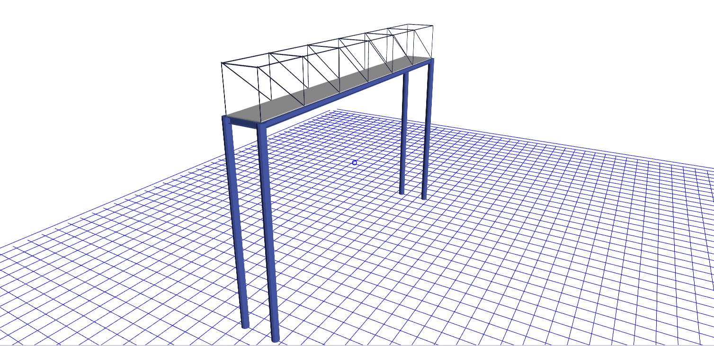

**Fig. 3**

**References:**

1. Devraj T.S Shridhar y “behavior of pedestrian steel bridge subjected to seismic load. Volume: 05 issue June 2018
2. Mohammad A. Alhassan Rajai Z Al-Rousan “control of vibration of common pedestrian bridge in Jordan using tuned mass dampers.
3. Umesh Rajshirake Design and construction of pedestrian bridge Navi Mumbai Kharghar.
4. Yi Zhang “Effect of Ground Motion Orientation on Seismic Responses of an Asymmetric Stress Ribbon Pedestrian Bridge”.
5. Deyuan Deng1,2 *, Zhijian Wang3, Xiaoqing Zhang4 and Hongxin Lin5

“Experimental Investigation on pedestrian walking load in steel footbridge”.

Footbridge Design for pedestrian induced vibration.

1. Sabina piras “Footbridge Design for pedestrian induced vibration”.
2. Hassan Mazloum Vibration Behavior of Pedestrian Bridges with Different Construction Systems.