**Smart Distribution Board with Microcontroller-based Safety Device**

Muhammed Haroon1, Mubarak Dawood2, Nandhana Mohan3, Stella Mary Benil4 *, Dr. Manoj Kumar T5

*1,2,3,4B.Tech, Electrical and Electronics Engineering, St.Thomas College of Engineering And Technology (STCET), Chengannur, Kerala, India*

*5Associate Professor, Department of Electrical and Electronics Engineering, St. Thomas College of Engineering & Technology, India*

*Corresponding Author: stellamarybenil@gmail.com*

|  |
| --- |
| ***Abstract:*** *The Smart Safety Device for Distribution Boards is an innovative IoT-based solution to enhance electrical safety and efficiency in residential and commercial settings. An inventive Internet of Things (IoT) solution to improve electrical safety and efficiency in home and business settings is the Smart Safety Device for Distribution Boards. This system offers real-time insights and proactive management of electrical systems by integrating problem detection, remote control, and sensor-based monitoring. One of this device's primary functions is sensor-based monitoring, which makes use of voltage and current sensors to continually monitor electrical factors like temperature, voltage levels, and current consumption. Furthermore, sophisticated algorithms examine sensor data to identify possible problems including overcurrent, ground faults, and temperature anomalies. These defects are then instantly alerted to users through visual and auditory cues. Moreover, the system allows for remote access via a mobile application and real-time monitoring of energy usage, which is shown on an LCD screen and helps users optimize energy use. To protect electrical components and maintain safety, the system automatically shuts down in case of serious defects or when energy usage is above predetermined levels. Additionally, by integrating the gadget with the Blynk platform, customers can use a smartphone or tablet to operate electrical devices, receive notifications, and remotely monitor sensor data. All things considered, the distribution boards' Smart Safety Device offers a complete solution to improve electrical safety, maximize energy economy, and facilitate remote control of electrical systems. It gives consumers more access and control over their electrical infrastructure by utilizing IoT technologies, thereby improving safety, dependability, and affordability.*  ***Key Words****:* *Smart Safety Device, IoT-based solution, electrical safety, sensor-based monitoring, fault detection, remote control, cost-effectiveness.* |

1. **Introduction**

A distribution board is a part of an electrical supply system that separates an electrical power source into subsidiary circuits and provides a protective fuse or circuit breaker for each circuit in a shared enclosure. It is also referred to as a panel board, breaker panel, or electrical panel. It acts as the primary electrical wiring distribution point and is commonly found in residential, commercial, and industrial structures. In order to ensure the safe and effective distribution of electricity to the numerous outlets, appliances, and equipment within the building, the distribution board assists in regulating and safeguarding the electrical supply. A smart distribution board is a more sophisticated distribution board that combines smart features and Internet of Things (IoT) technologies to improve efficiency and usefulness. Sensors, communication modules, and intelligent control systems are usually integrated to improve the monitoring and management of electrical distribution. Smart distribution boards have the ability to monitor energy consumption in real-time, identify anomalies or defects, and give remote control through web interfaces or smartphone apps. With the help of these capabilities, users can increase safety, maximize energy efficiency, and remotely control and conveniently operate electrical systems. To improve electrical safety and efficiency, a smart distribution board with a microcontroller-based safety device integrates Internet of Things (IoT) capabilities with microcontroller capability. Within the distribution board container, this sophisticated system incorporates sensors, communication modules, and a microcontroller-based safety mechanism. In order to identify any potential problems or anomalies, the microcontroller-based safety device continuously analyzes electrical parameters like current, voltage, and temperature. When something is detected, the gadget uses sophisticated algorithms to examine the information and initiate the necessary safety procedures, such as cutting the circuit or sounding an alarm to notify consumers. The smart distribution board also provides remote control capabilities via web interfaces or smartphone apps, and it enables real-time monitoring of energy consumption. Users can remotely control the distribution board from any location with internet access, get comprehensive insights into the operation of their electrical system, and get alerts when there are any problems.

Overall, the integration of a microcontroller-based safety device with IoT technology in a smart distribution board provides comprehensive protection, efficiency, and convenience for residential, commercial, and industrial electrical systems.

1. **Components**

For manufacturing a smart distribution board with a microcontroller-based safety device, several components are required.

**1. Microcontroller:** Because of their small size, low power consumption, and versatility, microcontrollers are widely utilized in embedded applications such as consumer electronics, automotive systems, industrial automation, and Internet of Things devices. They can carry out a variety of autonomous functions, including processing data from sensors, interacting with other devices, controlling the operation of electronic devices, and executing preprogrammed instructions. Microcontrollers are essential to current technology because they can manage real-time operations and communicate with the outside world. Microcontrollers such as Arduino, Raspberry Pi, or custom-designed microcontrollers for specific applications can be used.

**2. Sensors:** Mainly two sensors are used which are the current sensor and voltage sensor. It operates by identifying the magnetic field that a conductor's current creates. Electrical current can be measured using current transformers or Hall-effect current sensors. A voltage sensor is a tool used in circuits to gauge the difference in electrical potential between two places. It functions by transforming the voltage into an electrical signal that is proportionate and simple to monitor and handle. To measure electrical voltage, voltage sensors or voltage dividers are used.

**3.Communication Modules**: In embedded systems, a small, multipurpose part for wireless communication is a Wi-Fi module, like the ESP8266 or ESP32. These modules give different applications simple access to wireless networking.  
Because of its low power consumption, abundance of features, and affordability, the ESP8266 and ESP32 are well-liked options. They have the ability to link to Wi-Fi networks, which enables internet access and communication between devices. They also allow for seamless integration with various microcontrollers and sensors because of their compatibility with a variety of protocols and interfaces.

4. **Safety Devices**: Circuit breakers and relays are used. Circuit breakers are protective devices designed to automatically interrupt electrical circuits in the event of overcurrent, short circuit, or other electrical faults. They act as safety mechanisms to prevent damage to electrical equipment, wiring, and appliances, as well as to mitigate the risk of fire and electric shock. MCBs (Miniature Circuit Breakers) or RCCBs (Residual-Current Circuit Breakers) are employed to protect against overcurrent and ground faults. Relays are electromechanical switches that are used to control the operation of electrical circuits remotely. They consist of an electromagnet and a set of contacts that open or close when the electromagnet is energized.

**5. Power Supply:** AC-DC power supply which Converts AC voltage to DC voltage to power the microcontroller and other components and step-down voltage regulators to provide stable voltage levels to the microcontroller and sensors.

**6. Display and Interface:** Consists of an LCD screen for displaying real-time data and system status, LED indicators for visual indication of system status and alarms and push buttons for user interaction and control.

**7. Enclosure and mounting hardware:** A distribution board enclosure is a protective housing used to contain and organize electrical components within a distribution board. It provides a secure and insulated environment for the distribution board's internal components, ensuring safety and reliability in electrical installations. Enclosure to house the PCB assembly and other components securely. Mounting rails are Rails for mounting the PCB assembly and other components inside the enclosure. Terminal blocks: Screw terminals for connecting wires and cables to the distribution board.

**8. Passive Components:** Resistors, capacitors, and inductors are the passive components for filtering, voltage regulation, and signal conditioning. Custom-designed PCB (Printed Circuit Board) is used to mount and interconnect all components effectively.

**9. Software and Programming Tools:** Software tools such as Arduino IDE or Raspberry Pi IDE for programming the microcontroller and Custom firmware to control the operation of the microcontroller, sensors, and safety devices.

**10. Documentation and Labels:** Documentation providing instructions for installation, operation, and maintenance. Labels indicating safety warnings, operating instructions, and component identification.

These components form the basis of a smart distribution board with a microcontroller-based safety device. Depending on the specific requirements and functionalities, additional components may be needed for customization and integration.

1. **Manufacturing Process**

The manufacturing process of a smart distribution board with a microcontroller-based safety device typically involves several steps:

**Design and Prototyping:** Engineers and designers create the schematic and layout design of the distribution board, including the integration of the microcontroller-based safety device.Prototyping may involve creating initial models to test functionality and feasibility.

**Component Procurement:** Procurement specialists source all necessary components, including microcontrollers, sensors, communication modules, circuit breakers, switches, and enclosure materials.Components are sourced from reliable suppliers and checked for quality and compatibility.

**PCB Manufacturing:** The printed circuit board (PCB) design, based on the schematic, is sent to a manufacturer for production.PCBs are fabricated using specialized equipment and techniques to ensure accuracy and reliability.

**Assembly:** Components are assembled onto the PCB according to the design specifications.Surface-mount technology (SMT) and through-hole assembly processes may be used depending on the component types and board design.

**Programming and Testing:** The microcontroller is programmed with the necessary firmware to control the safety device and communicate with other components.Each unit undergoes rigorous testing to ensure functionality, safety, and compliance with relevant standards. Testing may include electrical performance testing, functionality testing, and stress testing.

**Enclosure Assembly:** The PCB assembly is installed into the enclosure, which may include mounting rails, terminal blocks, and other hardware. Wiring connections are made between the PCB and external terminals within the enclosure.

**Final Inspection and Quality Control:** Each assembled unit undergoes a final inspection to check for defects, proper assembly, and alignment. Quality control measures are implemented to ensure consistency and reliability across all units.

**Packaging and Shipping:** The finished smart distribution boards are packaged securely to prevent damage during transit.

Units are labeled and prepared for shipping to distributors, wholesalers, or end customers.

Throughout the manufacturing process, adherence to industry standards and regulations is essential to ensure the safety and reliability of smart distribution boards with microcontroller-based safety devices. Collaboration between engineers, designers, procurement specialists, and quality control teams is crucial to delivering high-quality products that meet customer expectations.

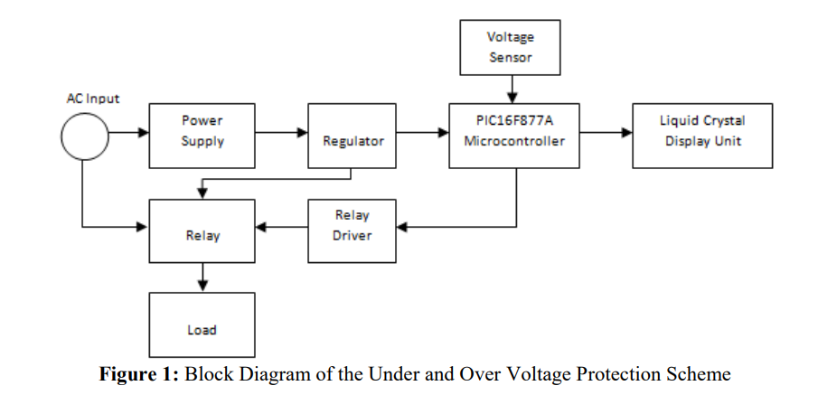

Block Diagram of Smart Distribution Board with Microcontroller-based safety device

Wifi Module

(ESP 8266)

Sensors

(Voltage, Current, and Temperature sensors)

LCD

I2C Display Adapter

Microcontroller

ATmega 328P

Regulator

IC 7805

1. **Conclusion**

In conclusion, the development and manufacturing of the smart distribution board with a microcontroller-based safety device represent a significant advancement in electrical distribution technology. Through the integration of IoT capabilities and intelligent safety features, this project has demonstrated the potential to enhance electrical safety, efficiency, and control in residential, commercial, and industrial settings.

**References**

1. Design of a Smart Distribution Panel board Using IoT Connectivity and Machine Learning Techniques by Mahmoud Shaban and Mohammed F. Alsharekh
2. Implementation of Microcontroller Based Electrical Distribution Monitoring and Control System" by K. K. Shukla and P. K. Sharma.
3. Smart Distribution Board with Automatic Power Factor Correction and Energy Monitoring System" by K. Palanivel and S. Prathap.
4. Development of Microcontroller Based Protection System for Distribution Transformers" by M. S. El-Moursy, M. S. El-Hefnawi, and A. F. Zobaa.
5. Smart Distribution Boards for Energy Management in Buildings" by I. Lloret-Gallego, J. Lloret-Gallego, and J. García-Hernández.
6. A Smart Distribution Board for Sustainable Energy Management in Smart Homes" by A. V. Bhonsle, S. K. Pathan, and S. S. Jain.
7. Microcontroller Based Distribution Transformer Monitoring and Control System" by G. M. Choudhary and A. A. Chavan.