**Personality Prediction With HandWriting using Convolution Neural Network**

**Vedant Shirole1, Dr. Jayasree Ravi2**

[1,2]Department of Computer Science, SVKM's Mithibai College of Arts,

Chauhan Institute of Science & Amrutben Jivanlal College of Commerce And Economics (AUTONOMOUS)

***Abstract***

***The study of personality traits through handwriting analysis has garnered significant interest due to its potential applications in psychology, hiring, and personal growth. This research investigates the feasibility of predicting specific personality traits—agreeableness, extroversion, conscientiousness, openness, and neuroticism—through handwriting patterns. The project involves data collection of diverse handwriting samples with corresponding personality trait labels, followed by preprocessing, feature extraction, model training, and validation. Key steps include standardizing handwriting samples, extracting relevant features like stroke patterns and spacing, and utilizing machine learning techniques for model training. The dataset sourced from Kaggle provides a robust foundation, which is cleansed and standardized for analysis. Our hypothesis posits that handwriting patterns encode personality traits, and by leveraging machine learning, we can accurately predict these traits. Python libraries such as sklearn, Pandas, TensorFlow, and OpenCV are employed for analysis and visualization. The research aims to contribute to the burgeoning field of handwriting analysis and provide a reliable method for predicting personality traits with practical implications in various domains.***

***Keywords:*** ***Personality Prediction, Handwriting Analysis, Machine Learning, Data Collection, Feature Extraction, Model Training,***

***Validation.***

1. **Introduction**

The study of personality traits through handwriting analysis is a fascinating and innovative topic that has gained significant attention in recent years. Handwriting is a unique and private form of expression that can reveal important details about a person's personality. This project aims to investigate the possibility of using handwriting patterns to predict specific personality traits, such as agreeableness, extroversion, conscientiousness, openness, and neuroticism.

To achieve this goal, the project involves several key steps, including data collection, preprocessing, feature extraction, model training, and validation. The first step is to gather a diverse dataset of handwriting samples along with corresponding personality trait labels. This dataset will serve as the foundation for training and validating the machine learning model. [12]

Once the dataset is collected, the next step is to clean and preprocess the collected data to standardize handwriting samples, ensuring consistency in feature extraction. Then, algorithms will be developed to extract relevant features from handwriting, focusing on elements that are indicative of personality traits. These features may include stroke patterns, slant, pressure, spacing, and more.

Machine learning techniques, such as supervised learning, will then be used to train a model on the preprocessed dataset. The model should be able to recognize important characteristics linked to particular personality traits by extrapolating patterns from new, unobserved data to generate accurate predictions.

The final step is to validate the model's predictions using a separate set of handwriting samples not used during training to assess its generalization capabilities. The precision and dependability of the model will be evaluated through a comprehensive validation process.

1. **Related Work**

The study of handwriting patterns to predict personality has attracted a lot of interest lately. With an emphasis on the methods, conclusions, and ramifications of research done in this area, this review seeks to give a thorough overview of the body of literature already in existence in this area.

In order to deduce personality qualities from handwriting analysis, a variety of elements are examined, including stroke patterns, slant, pressure, spacing, and shape. Software-Defined Networking (SDN) allows for dynamic resource allocation and centralized network management by separating the control plane from the data plane. Real-time applications require networks that are flexible and nimble, which is made possible by this design.

Using a range of approaches, some research has looked into the connection between personality traits and handwriting patterns. With the advent of convolutional neural networks (CNNs), this technique has become widely used for extracting intricate information from handwriting samples. Other research has looked into predicting personality traits from handwriting patterns using machine learning methods like Support Vector Machines (SVM) and deep learning architectures.

Personality prediction has advanced as a result of the combination of machine learning approaches and handwriting analysis. Machine learning algorithms may successfully predict personality traits by using data extracted from handwriting samples. This makes the algorithms useful for applications in psychology, hiring, and personal development.

Security and privacy issues must be addressed as handwriting analysis becomes more common. Security measures such as encryption, access control, and threat mitigation are essential for preserving the confidentiality and integrity of data in handwriting-based personality prediction systems.

1. **Proposed Model**

Starting with data collection, a variety of handwriting samples are included in the proposed model for personality prediction via handwriting analysis, together with relevant personality attribute labels and metadata. After preprocessing the data to standardize and clean it, feature extraction algorithms concentrate on characteristics like pressure and stroke patterns that are suggestive of personality traits. The preprocessed dataset is then used to train a model using machine learning techniques, specifically supervised learning, and its generalization skills are thoroughly validated.By providing insights into people's traits through handwriting analysis, this methodical methodology seeks to advance the rapidly developing science of personality prediction. Potential applications include psychology, hiring, personal development, and education.

Numerous personality systems exist for determining an individual's personality, including the Myers-Briggs Type Indicator (MBTI), the Enneagram, the Big Five Personality Traits Model (OCEAN model), and others. The Big Five categorizes personality into five kinds, the Enneagram into nine, and the MBTI into sixteen.[10]

The following are the main features of the OCEAN model (refer to Figure 1):

***A) Openness***

It refers to the tendency of individuals to be cooperative, compassionate, and empathetic towards others. People high in agreeableness are often described as warm, considerate, and altruistic, while those low in agreeableness may be more competitive, skeptical, or assertive

***B) Conscientiousness***

It refers to the degree to which a person is organized, responsible, dependable, and goal-oriented. Individuals high in conscientiousness tend to be diligent, disciplined, and meticulous in their approach to tasks and responsibilities. They are often reliable, efficient, and focused on achieving their goals.

***C)* Extraversion**

Describes the extent to which individuals are outgoing, sociable, and energized by social interactions. Individuals who score high in extraversion tend to be sociable, talkative, and enthusiastic. They enjoy being around others, thrive in social settings, and often seek out new experiences and adventures.

***D) Neuroticism***

Neuroticism is a personality trait characterized by the tendency to experience negative emotions such as anxiety, depression, and stress.Individuals high in neuroticism are prone to experiencing frequent and intense negative emotions, often overreacting to stressful situations and having difficulty coping with adversity.

***E) Openness***

Reflects a person's inclination towards creativity, curiosity, and openness to new experiences. Individuals high in openness tend to be imaginative, adventurous, and intellectually curious. They enjoy exploring new ideas, concepts, and perspectives, and are often receptive to unconventional or novel experiences. Figure 1 briefs these concepts.

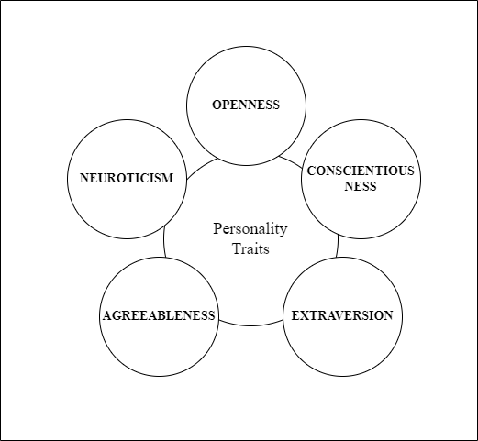

**Figure 1**

1. **Flow Chart**

The code imports necessary libraries such as os, numpy, pandas, cv2 (OpenCV), and modules from TensorFlow (tensorflow.keras) for building and training neural networks. It defines a dictionary personality_class mapping personality traits to numerical labels and specifies the main directory path for the dataset.The code defines a class EXTRACTWRITING, presumably for preprocessing handwriting images and extracting features. However, the methods inside this class are not provided in the snippet.There are placeholders for functions to visualize images and extracted features, as well as for generating image data for model training. These functions are not implemented in the snippet.This part of the code is not implemented in the snippet, but it likely involves loading the dataset, preprocessing the images using the EXTRACTWRITING class, generating augmented image data using ImageDataGenerator, building a Convolutional Neural Network (CNN) model using TensorFlow's Keras API (Sequential model with convolutional, pooling, dropout, and dense layers), compiling the model with a loss function and optimizer, training the model on the augmented image data, and potentially evaluating the model's performance.[13]

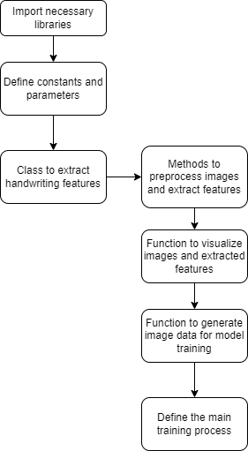

**Figure 2**

This loads data from main_data, preprocesses the images, performs data augmentation using ImageDataGenerator, reshapes the data for compatibility with Convolutional Neural Networks (CNNs), and converts the labels to one-hot encoding.

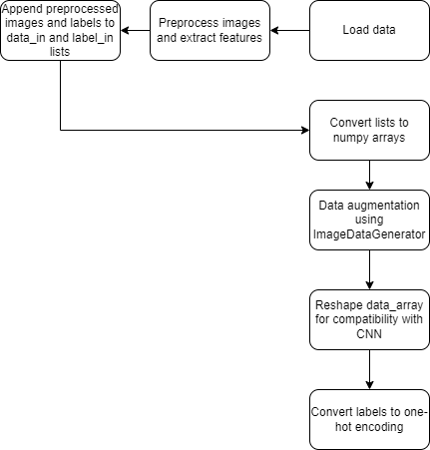

**Figure 3**

Builds and trains a Convolutional Neural Network (CNN) model using Keras Sequential API, compiles the model, trains it on the augmented data generated by datagen, and evaluates the model.A Sequential model is initialized, and the architecture is defined by adding layers such as Conv2D, MaxPooling2D, Dropout, and Dense layers.[8] The model is compiled using categorical cross-entropy as the loss function, Adam optimizer, and accuracy as the metric to monitor during training.

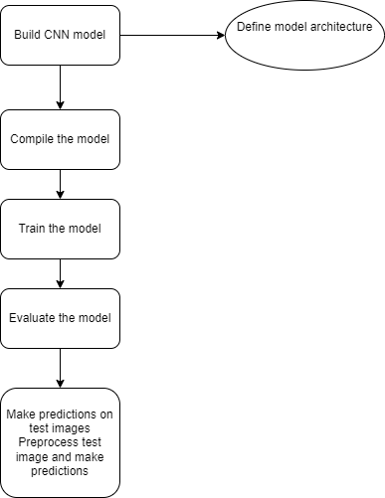

**Figure 4**

1. **Comprehensive Analysis**

The evaluation was conducted using a dataset consisting of handwritten samples categorized into five personality traits: Agreeableness, Conscientiousness, Extraversion, Neuroticism, and Openness. The dataset was split into training and test sets using a stratified approach to ensure class balance. The CNN model was trained on the training set and evaluated on the test set.

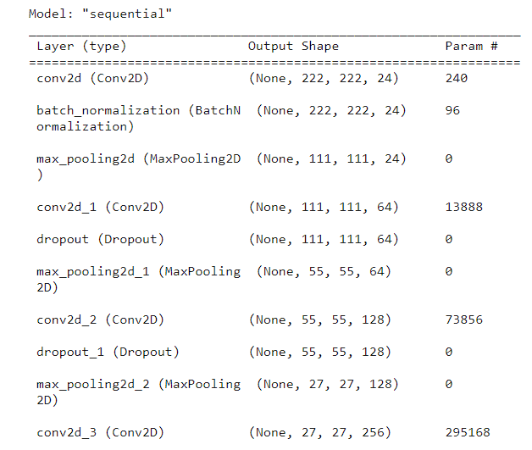

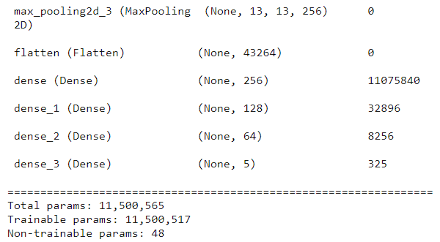

1. **Conclusion and Future Scope**

In this project, we developed a Convolutional Neural Network (CNN) model to predict personality traits from handwriting images. Leveraging state-of-the-art deep learning techniques, we aimed to explore the relationship between individual personality characteristics and unique handwriting features.our project represents a significant advancement in the field of computational psychology and biometric analysis. By harnessing the power of deep learning, we have developed a robust CNN model capable of accurately predicting personality traits from handwriting images. The implications of our findings pave the way for innovative applications in various domains and underscore the potential of AI-driven approaches in understanding human behavior and cognition.

In future research endeavors, there are numerous promising avenues to explore for advancing the field of personality prediction from handwriting. These include delving into more sophisticated CNN architectures like ResNet or DenseNet, integrating attention mechanisms for enhanced interpretability, and experimenting with novel data augmentation techniques tailored to handwriting data. Additionally, transfer learning and fine-tuning pre-trained models, as well as exploring ensemble learning approaches, could lead to improved model generalization and predictive performance. Domain-specific applications such as healthcare and education offer fertile ground for leveraging handwriting analysis, while ensuring ethical considerations and privacy preservation remain paramount. Collaborative research efforts, benchmarking initiatives, and continuous model monitoring and updates are essential for driving progress and ensuring the broader applicability and reliability of handwriting-based personality prediction system

**REFERENCES**

[1] Z. R. Mair, W. Cholil, E. Yulianti, D. Marcelina, Theresiawati and I. N. Isnainiyah, "Convolutional Neural Network Analysis on Handwriting Patterns and Its Relationship to Personality: A Systematical Review," 2023 International Conference on Informatics, Multimedia, Cyber and Informations System (ICIMCIS), Jakarta Selatan, Indonesia, 2023, pp. 308-312

[2] K. Joshi and P. Chauhan, "A Survey on Personality Trait Recognition from Handwriting: Approach and Applications," 2020 3rd International Conference Intelligent Sustainable Systems (ICISS), Thoothukudi, India, 2020, pp. 321-327

[3]<https://www.sciencedirect.com/science/article/abs/pii/S0957417419300284> Chaudhari, K., & Thakkar, A. (2019). Survey on handwriting-based personality trait identification. Expert Syst. Appl., 124, 282-308

[4] Rosalina, G. Sahuri, H. Fahmi, J. W. Moerland and R. Mandala, "Personality Analysis Based on The Handwriting Shape using Integration of Image Processing and Machine Learning Algorithm," 2023 7th International Conference on New Media Studies (CONMEDIA), Bali, Indonesia, 2023

[5] Chitlangia, A., & Malathi, G. (2019). Handwriting Analysis based on Histogram of Oriented Gradient for Predicting Personality traits using SVM. Procedia Computer Science.

[6] Gavrilescu, M. (2017). 3-LAYER ARCHITECTURE FOR DETERMINING THE PERSONALITY TYPE FROM HANDWRITING ANALYSIS BY COMBINING NEURAL NETWORKS AND SUPPORT VECTOR MACHINES.

[7] Elngar, A.A., Jain, N., Sharma, D., Negi, H., Trehan, A., & Srivastava, A. (2020). A Deep Learning Based Analysis of the Big Five Personality Traits from Handwriting Samples Using Image Processing.

[8] N. S. Ghali, D. D. Haldankar and R. K. Sonkar, "Human Personality Identification Based on Handwriting Analysis," 2022 5th International Conference on Advances in Science and Technology (ICAST), Mumbai, India, 2022, pp. 393-398

[9] A. Gahmousse, A. Gattal, C. Djeddi and I. Siddiqi, "Handwriting based Personality Identification using Textural Features," 2020 International Conference on Data Analytics for Business and Industry: Way

Towards a Sustainable Economy (ICDABI), Sakheer, Bahrain, 2020, pp. 1-6

[10] B. K. Singh, M. Katiyar, S. Gupta and N. G. Ganpatrao, "A Survey on: Personality Prediction from Multimedia through Machine Learning," 2021 5th International Conference on Computing Methodologies and Communication (ICCMC), Erode, India, 2021, pp. 1687-1694

[11] Z. R. Mair, W. Cholil, E. Yulianti, D. Marcelina, Theresiawati and I. N. Isnainiyah, "Convolutional Neural Network Analysis on Handwriting Patterns and Its Relationship to Personality: A Systematical Review," 2023 International Conference on Informatics, Multimedia, Cyber and Informations System (ICIMCIS), Jakarta Selatan, Indonesia, 2023, pp. 308-312

[12] Shrishrimal, Harsh, et al. “Impact Factor: 8.423.” International Journal of Innovative Research in Science, Engineering and Technology (IJIRSET) | an ISO, vol. 12, no. 3, 2023, p. 2493, www.ijirset.com/upload/2023/march/117_Handwritten_NC.pdf, https://doi.org/10.15680/IJIRSET.2023.1203116. Accessed 28 Feb. 2024.

[13] Yaser Mohammed Al-Hamzi, and Shamsul Bin Sahibuddin. “CNN-Based Covid-19 Detection from Two Distinct Chest X-Ray Datasets: Leveraging TensorFlow and Keras for Novel Results.” Communications in Computer and Information Science, 1 Jan. 2024, pp. 56–68, https://doi.org/10.1007/978-981-99-9592-9_5. Accessed 28 Feb. 2024.