**A Comprehensive Usage Pattern Analysis of Shared E-scooters in Urban Mobility**

Gürkan Çelik 1,2,*, Ümit Deniz Uluşar 3, Murat Alper Başaran 4

*1(Electrical and Electronics Engineering Department, Akdeniz University, Türkiye)*

*2(Computer Engineering Department, Alanya Alaaddin Keykubat University, Türkiye)*

*3(Computer Engineering Department, Akdeniz University, Türkiye)*

*4(Industrial Engineering Department, Alanya Alaaddin Keykubat University, Türkiye)*

* Corresponding Author: *gurkancelik@akdeniz.edu.tr*

|  |
| --- |
| ***Abstract:****Shared transportation systems are increasingly playing a pivotal role in urban mobility. Micro-mobility solutions, in particular, have become essential as people seek fast, convenient ways to travel during their daily routines, avoid the hassles of parking their personal vehicles, and face challenges accessing public transportation at their preferred times or locations. Among the emerging shared transportation options, station-less electric scooters (e-scooters) have gained global popularity due to their ease of parking, environmental benefits, cost savings, and ability to alleviate traffic congestion. As a potential solution to first and last-mile problems, academic studies on e-scooter technology are expanding. This study analyzes data from a shared station-less e-scooter service operating in Türkiye to explore how weather-related parameters influence users’ behavior. Additionally, it offers an innovative perspective on geographic and regional variations in users’ behavior by comparing findings with studies from different cities and countries presented in the literature. This research also provides valuable insights for mobility service providers and city planners seeking to optimize shared transportation systems.*  ***Keywords****: Shared e-scooter, log records, micromobility, user behavior, trip patterns* |

1. **Introduction**

The proportion of the global population residing in cities has risen significantly, from 30% in 1950 to 55% in 2018. According to the United Nations Habitat World Cities Report 2022, this figure is projected to reach 68% by 2050. The transportation sector accounts for approximately one-quarter of global greenhouse gas emissions, with reliance on fossil fuels exacerbating environmental issues such as air pollution, acid rain, and climate change [[1]](https://www.zotero.org/google-docs/?nLCcvY). Eco-friendly transportation solutions such as electric vehicles, hybrid vehicles, bicycles, walking, public transport, and micro-mobility options help mitigate the environmental impacts of the transportation sector. However, rapid urbanization has led to challenges like traffic congestion and environmental pollution, exposing the limitations of traditional transportation methods. For decades, individual vehicles, taxis, and public transportation have been the primary options, but technological advancements have introduced innovative alternatives to address these growing urban demands [[2]](https://www.zotero.org/google-docs/?jBDfSG).

Advancements in smart city solutions and the proliferation of IoT devices have introduced innovative solutions into our daily lives [[3]](https://www.zotero.org/google-docs/?u9yc5t). Environmentally friendly, lightweight, and practical transportation options, such as micro-mobility vehicles have an increasing significance. Shared e-scooters were first introduced in the United States in 2017. Companies like Bird, Lime, and Spin, which initially launched in San Francisco, quickly gained popularity in many American cities. Within less than a decade, shared e-scooters have been used in metropolitan areas worldwide [[4]](https://www.zotero.org/google-docs/?Ps7cEk).

In Türkiye's rapidly urbanizing and densely populated metropolitan cities, where traffic congestion is a significant issue, shared e-scooter systems emerge as a viable alternative solution for transportation, similar to their adoption worldwide. By examining the dynamics of micro-mobility in Türkiye, this study offers original and practical insights for urban planners and mobility service providers within the local context.

Shared transportation systems operate on a similar logic, regardless of the type of vehicle used. These systems typically include a mobile application that allows users to view vehicle locations. There are two main types: station-based systems, which share station locations, and stationless/free-floating/dockless systems, which provide real-time vehicle locations. The app also facilitates rentals and payments. First users download the application, register, and log into the system to rent. The app then displays nearby vehicles on a map, enabling users to rent the one close to their locations. Figure 1 illustrates the generic steps of all shared transportation systems, regardless of vehicle type.



**Figure 1.** Steps performed by users before riding

1. **Literature**

Many studies in the literature have examined the usage statistics of shared vehicles and analyzed patterns they exhibit under different conditions. Noland analyzed one year of data on shared transport vehicles with different modes (dockless e-scooters, free-floating e-bikes, and docked bicycles) in Austin, Texas. The study correlated usage characteristics (number of rides, duration, and distance) with various weather parameters (wind speed, temperature, precipitation, and relative humidity). The weather parameters analyzed in this study were found to impact all three modes of transport. Specifically for e-bikes, both riding distance and riding duration decreased in low temperatures, and windy, or rainy weather. However, in some cases, bad weather conditions showed a positive correlation with utilization, possibly due to traffic congestion. It is suggested that more detailed studies be conducted to derive more insights [[5]](https://www.zotero.org/google-docs/?QJsOoo).

Campbell et al. enhanced their study by incorporating environmental impacts, such as air quality, which had not been previously examined, as well as various types of characterized data, such as surveys, regarding the choice to use shared bicycle and e-bike systems. By analyzing users’ concern patterns specific to China, they found that socio-demographic characteristics were not significant factors, whereas air quality exhibited an inverse relationship with the usage of the system [[6]](https://www.zotero.org/google-docs/?tNdExB).

Younes et al. analyzed stationless e-scooter and docked bike-sharing systems, examining environmental and economic variables such as gas prices, local events or disturbances, day of the week, and hour of the day, alongside weather parameters. They studied data from six different companies in the USA for six months and categorized users into three groups. The findings indicated that fluctuations in gas prices influence the riding behavior of all user groups [[7]](https://www.zotero.org/google-docs/?5t9BHQ).

Reck et al. analyzed several new parameters across four different modes of shared transport, including vehicle charging status, vehicle density, hour of day, price, distance traveled, and altitude differences during rides. Their findings indicated that users in Zurich adjusted their modes of transport based on the hour of day (particularly during commuting hours) and the distance traveled. Additionally, they observed a fundamental relationship between fleet density and utilization; however, once density exceeded a certain threshold, a plateau effect emerged [[8]](https://www.zotero.org/google-docs/?QFIfYP).

Abouelela et al. investigated spatiotemporal hourly and daily usage patterns in five North American cities (Minneapolis (MN), Austin (TX); Chicago (IL), Calgary (AB), Louisville (KY)) and observed that demand patterns tend to be consistent across cities. By analyzing riding characteristics such as speed, duration, and distance, they identified empirical consistency among the five cities, although these characteristics varied temporally within each city. This variation was attributed to exogenous weather factors, including temperature, wind speed, precipitation, and snow; infrastructure elements such as cycle lanes, pavements, and shared cycle stations; and sociodemographic variables, including gender, age, and income. [[9]](https://www.zotero.org/google-docs/?lQ3mz8).

Gebhart and Noland investigated the influence of weather on the usage patterns of the Washington DC bike-sharing system. Their study established correlations between hourly usage statistics and weather variables, including snow, temperature, humidity levels, precipitation, fog, and wind. The findings by statistical models provided the reciprocal effects of user numbers and usage duration. Furthermore, they examined the characteristics of trips originating from locations within walking distance of metro stations during hours of metro operation. Notably, the research explored whether the metro served as an alternative to cycling during unfavorable weather conditions [[10]](https://www.zotero.org/google-docs/?uVE2YS).

Hasan and Sisiopiku examined the travel patterns of shared e-scooter users in Birmingham, Alabama. Their analysis revealed that peak hourly rides occurred between 21:00 and 22:00, with daily rides peaking on Saturdays. Furthermore, the findings indicated that the highest usage rates were observed in densely populated areas with educated and high-income residents. This case study offers valuable insights into the transportation preferences of Birmingham's residents and provides critical information for city planners in Birmingham and other medium-sized cities to optimize micro-mobility options [[11]](https://www.zotero.org/google-docs/?yBpb1C).

Mathew et al. conducted a six-month study on e-scooter usage in Indianapolis to investigate the impact of weather. By analyzing surface temperature, precipitation, snow, and wind speed, the researchers discovered that although the number of rides declined by over 80% during the winter months, the average trip distance and duration showed minimal reduction, contrary to expectations. Additionally, the findings revealed that user riding behavior was more influenced by sub-freezing temperatures and snowfall compared to rainfall [[12]](https://www.zotero.org/google-docs/?ZX6vQk).

This study is just one of the few studies that examine the use of shared e-scooters in Türkiye. It provides a comprehensive analysis by incorporating additional insights and presenting detailed graphs of various parameters.

1. **Data and Method**

In most shared transportation systems, data is collected from mobile phones and IoT devices installed on the transportation vehicles, including information such as location (via GPS), speed, distance, and duration [[13]](https://www.zotero.org/google-docs/?0uyw3U) [[14]](https://www.zotero.org/google-docs/?BCDB8w). To ensure consistent analysis and efficient fleet operations, these two data sources are utilized. For instance, real-time location data from GPS and vehicle performance metrics are cross-referenced to verify accuracy and optimize route planning.

The data used in this study includes both ride-related information—such as start and end times, locations, total duration, distance, average speed, and costs—and user-submitted data collected through the rental mobile application, including location and time telemetry. Location telemetry, also referred to as log records, is captured usually every 10 seconds, recording data from the moment users launch the mobile application until the ride is completed. The data for this study was provided by a shared e-scooter service operating in various cities and towns across Türkiye [[15]](https://www.zotero.org/google-docs/?fY52vv) and consists of trip data and user location telemetry collected between August 2022 and December 2023.

The weather parameters incorporated into the dataset were obtained from the Meteorological Data Information System (MEVBIS) provided by the Turkish General Directorate of Meteorology (MGM). As the most authorized and reliable public institution for national meteorological data collection and monitoring, MGM offers high-quality data on temperature, humidity, wind speed, and precipitation. Multiple sensors within each region enable validation of meteorological data, ensuring accuracy even when data from the nearest station is incomplete or inaccurate. In summary, MGM's status as a state institution, coupled with its rigorous standards and frequent data collection, makes its meteorological data an ideal source for scientific studies [[16]](https://www.zotero.org/google-docs/?vzZL83).

To safeguard both company secrets and user data, the raw data from the database underwent a comprehensive anonymization process to protect users' personal information. Data anonymization and privacy practices are fundamental to the ethical and scientific standards of this study. During this process, direct personal identifiers (e.g., first name, last name, phone number) were entirely removed from the dataset. Additionally, user identifier numbers were replaced with system-assigned IDs, ensuring privacy while maintaining data traceability. The figures presented in this article were generated using Python's Matplotlib and Seaborn libraries.

1. **Result**

According to records from the shared e-scooter company, 46% of registered users did not take any rides, indicating a significant proportion of inactive accounts. This may be because users downloaded the application to familiarize themselves with the system and registration process but decided not to use it, potentially due to dissatisfaction with the system or vehicles. Among the 54% of users who completed at least one ride, the average number of rides was 12.78, the average number of log records was 748.05 minutes, and the median distance traveled was 1.4 kilometers. Additionally, Table 1 provides the descriptive statistics of rides, log records, and logs per trip.

**Table 1.** Descriptive statistics of data

|  |  |  |  |  |
| --- | --- | --- | --- | --- |
| **Feature** | **Mean** | **Standard Deviation** | **Skewness** | **Median** |
| **Trip Count** | 12.78 | 32.16 | 9.40 | 3 |
| **Log Count** | 748.05 | 1977.24 | 14.42 | 242 |
| **Log Per Trip** | 97.37 | 193.87 | 36.37 | 54.33 |
| **Distance Per Trip** | 1.4 km | 222.43 | 205.48 | 1.34 |
| **Duration Per Trip** | 5 min | 10.34 | 10.71 | 5 |

Table 2 presents the percentage distribution of trips by duration. It indicates that 36% of trips last between 0-1 minutes (e.g., rides that end within a minute of starting). The remaining trips are distributed as follows: 27% last 2-3 minutes, 28% last 4-9 minutes, and 9% exceed 10 minutes. Notably, 63% of users tend to take shorter trips (0-3 minutes) on average. As trip duration increases, the frequency of longer trips declines.

**Table 2.** Trip rental duration groups and percentages

|  |  |
| --- | --- |
| **Trip Duration (min)** | **Ride Count Percentage (%)** |
| 0-1 | 36 |
| 2-3 | 27 |
| 4-9 | 28 |
| 10+ | 9 |

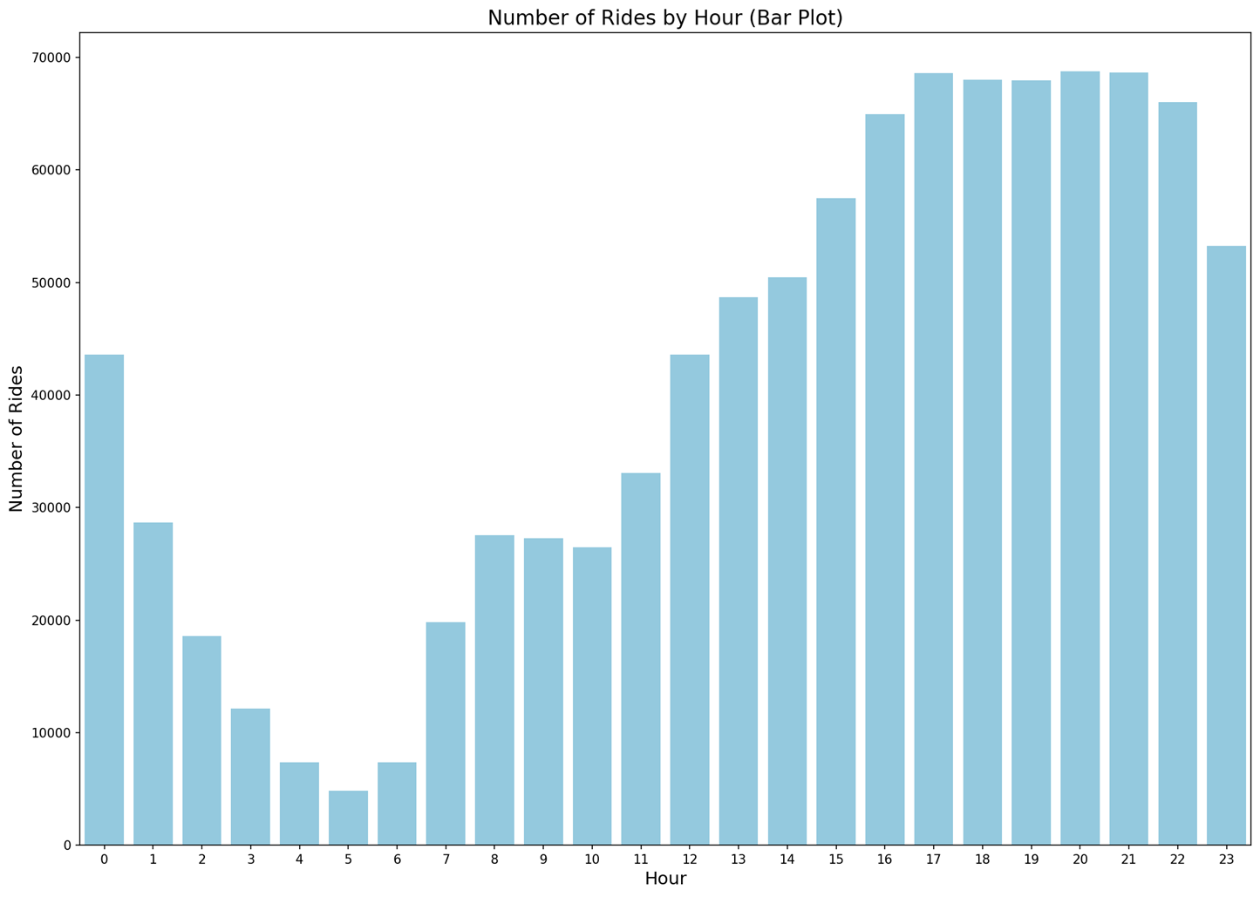

**Figure 2.** Ride counts by hour from 0 to 23

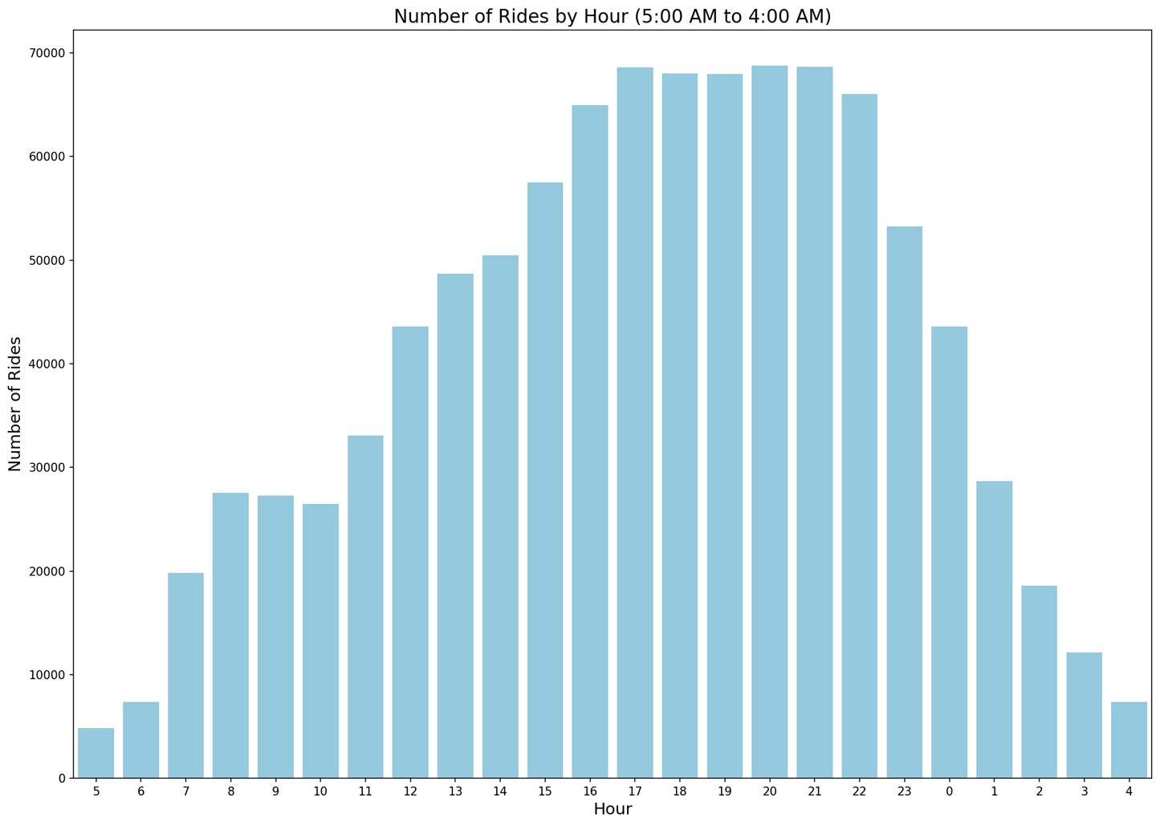

**Figure 3.** Ride counts by hour from 5 to 4

Figure 2 illustrates the number of rides by hour in the classic hour-based display, which is commonly used in the literature. Figure 3 presents an adjusted version of Figure 2, showing data from 5 am to 11 pm to more accurately represent the actual distribution. Ride counts reach their minimum around 4-5 am, steadily increase until 5 pm, stabilize at their peak between 5 pm and 10 pm, and then sharply decline until 4 am.

Figure 4 provides a boxplot and Figure 5 presents heatmap visualizations of trip rental duration by hour. The boxplot illustrates the number of trip rentals for each hour of the day and displays the average and median rental durations (6.81 and 5 minutes, respectively). It also highlights the presence of outliers, suggesting that rider behaviors vary significantly throughout the day. In contrast, the heatmap reveals changes in rental duration preferences, showing that riders tend to take shorter trips between 6 am and 10 am. After 10 am, rental durations gradually increase.

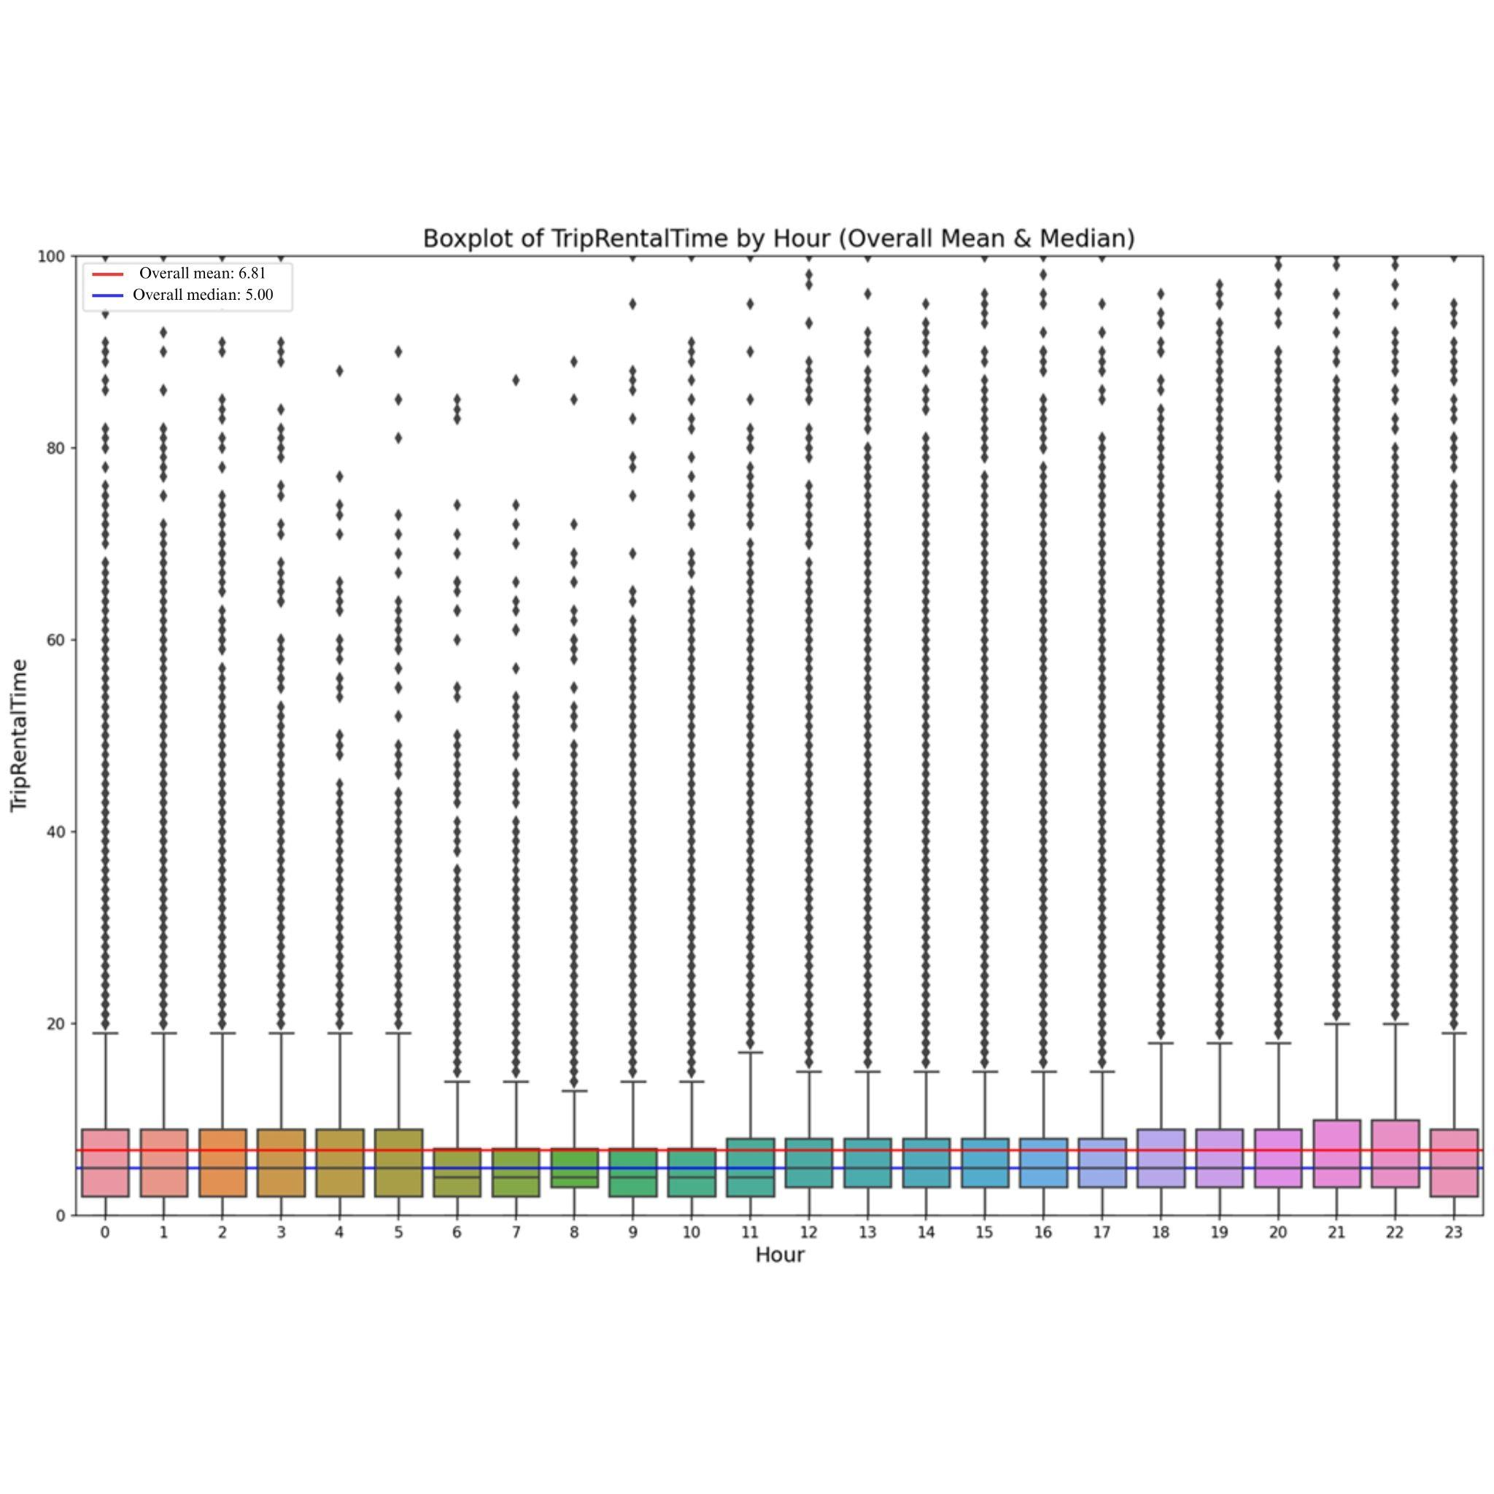

**Figure 4.** Boxplot of trip rental time by hour

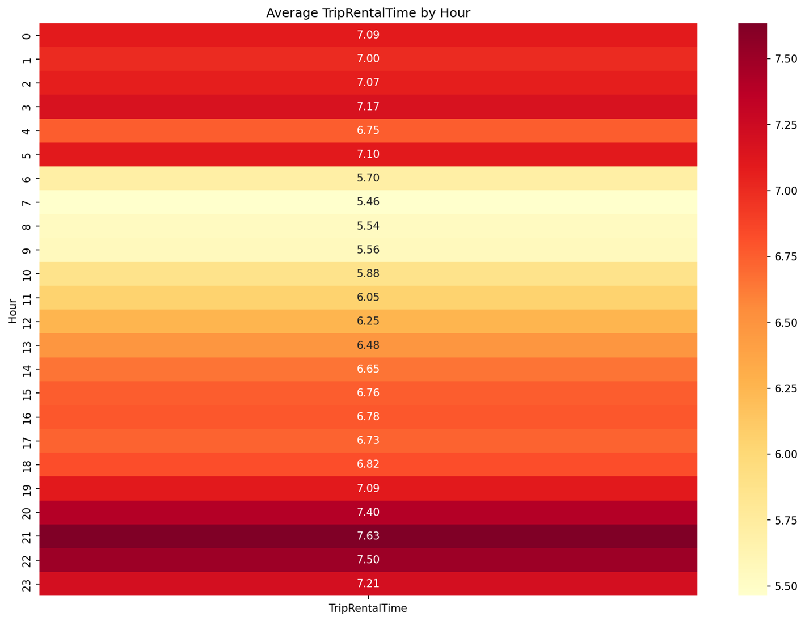

**Figure 5.** Heatmap of trip rental time by hour

Figure 6 provides a boxplot and Figure 7 presents heatmap visualizations of the average rental duration of scooters by the days of the month. The boxplot reveals a high number of outliers in relation to the mean rental duration. The first 10 days of the month, with the exception of the second day, show a noticeable increase in longer rental durations. This trend is also observed around the middle of the month, as well as on the 20th-21st and 28th days. This pattern is likely correlated with salary payments, as private sector employees in Türkiye typically receive their wages at the beginning of the month, while public sector employees are paid mid-month.

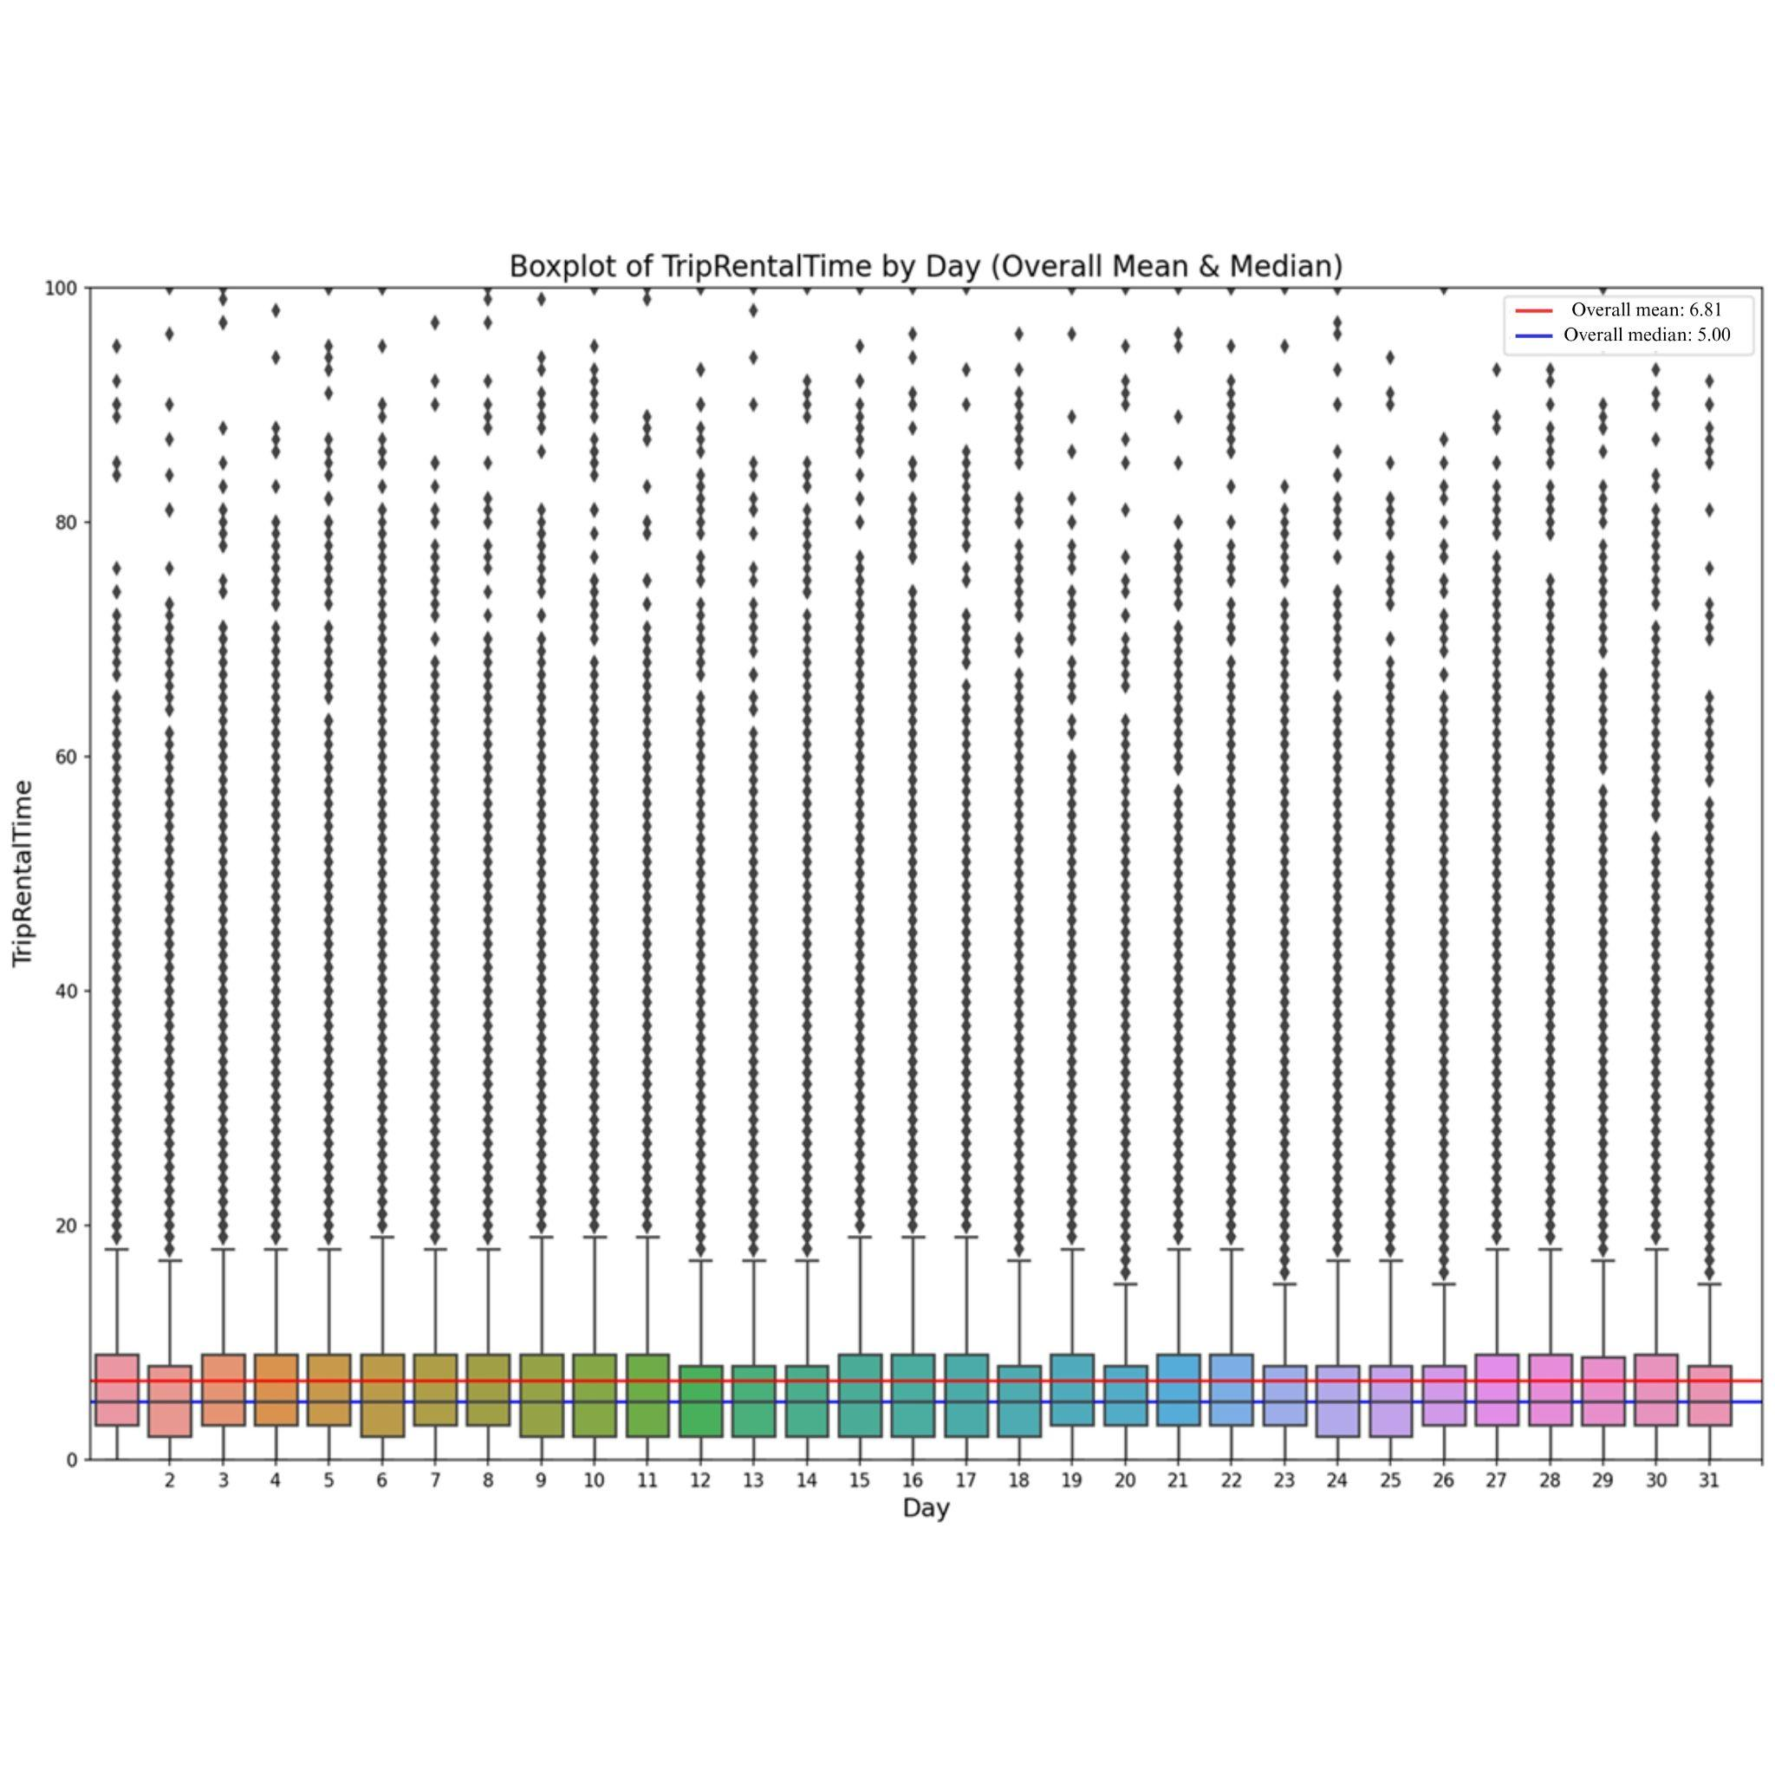

**Figure 6.** Boxplot of trip rental time by day

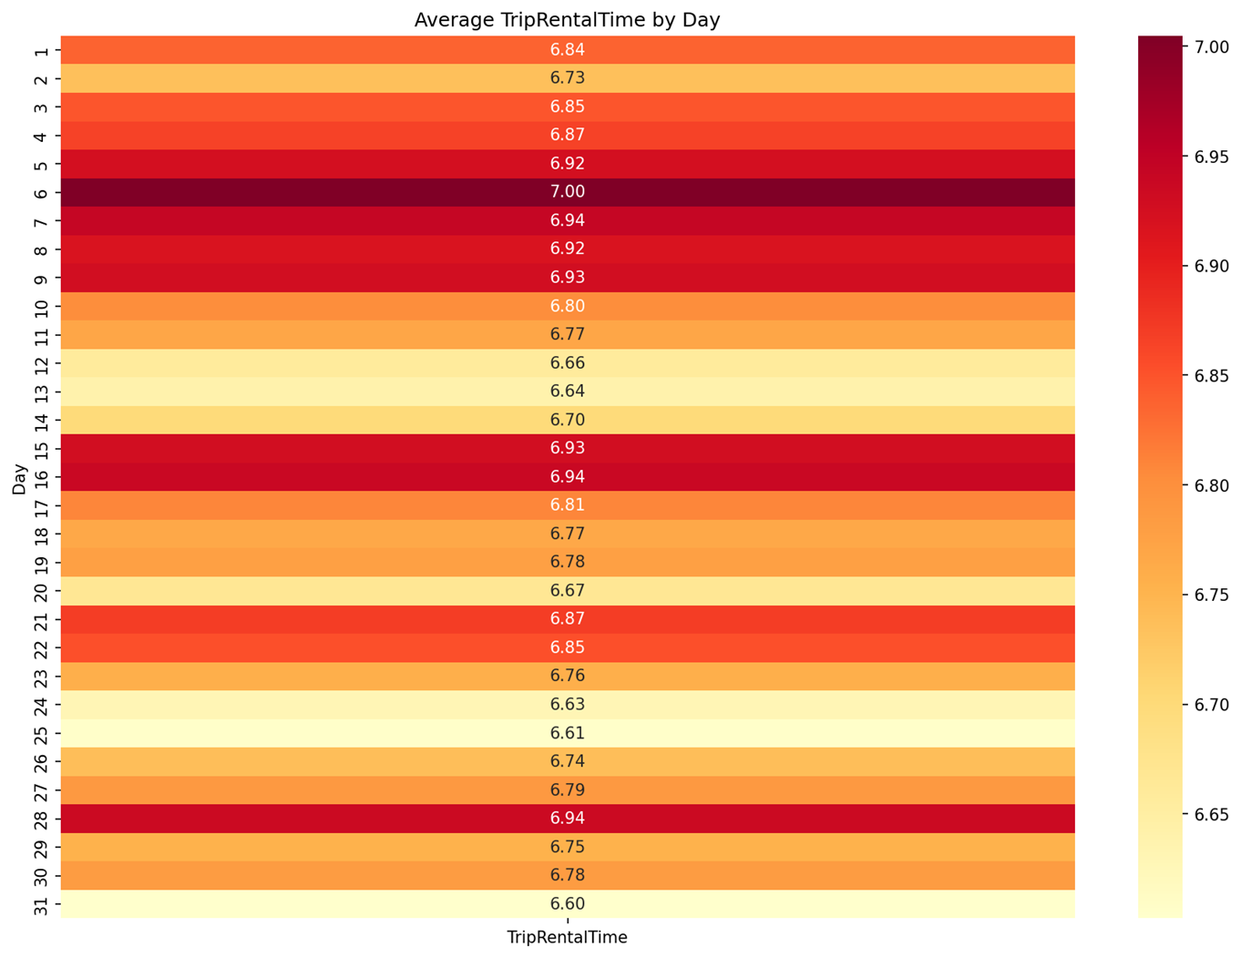

**Figure 7.** Heatmap of trip rental time by day

Figure 8 provides a boxplot, and Figure 9 presents heatmap visualizations of the average rental durations by month. The boxplot highlights fluctuations in monthly rental durations and reveals a significant number of outliers. Notably, there is substantial variability in rental durations across different months. The heatmap identifies the months with the highest rental durations, showing that the first half of the year generally has longer rental durations compared to the latter half, except for October. This suggests that rental durations tend to be shorter during hotter months and longer during relatively cooler months.

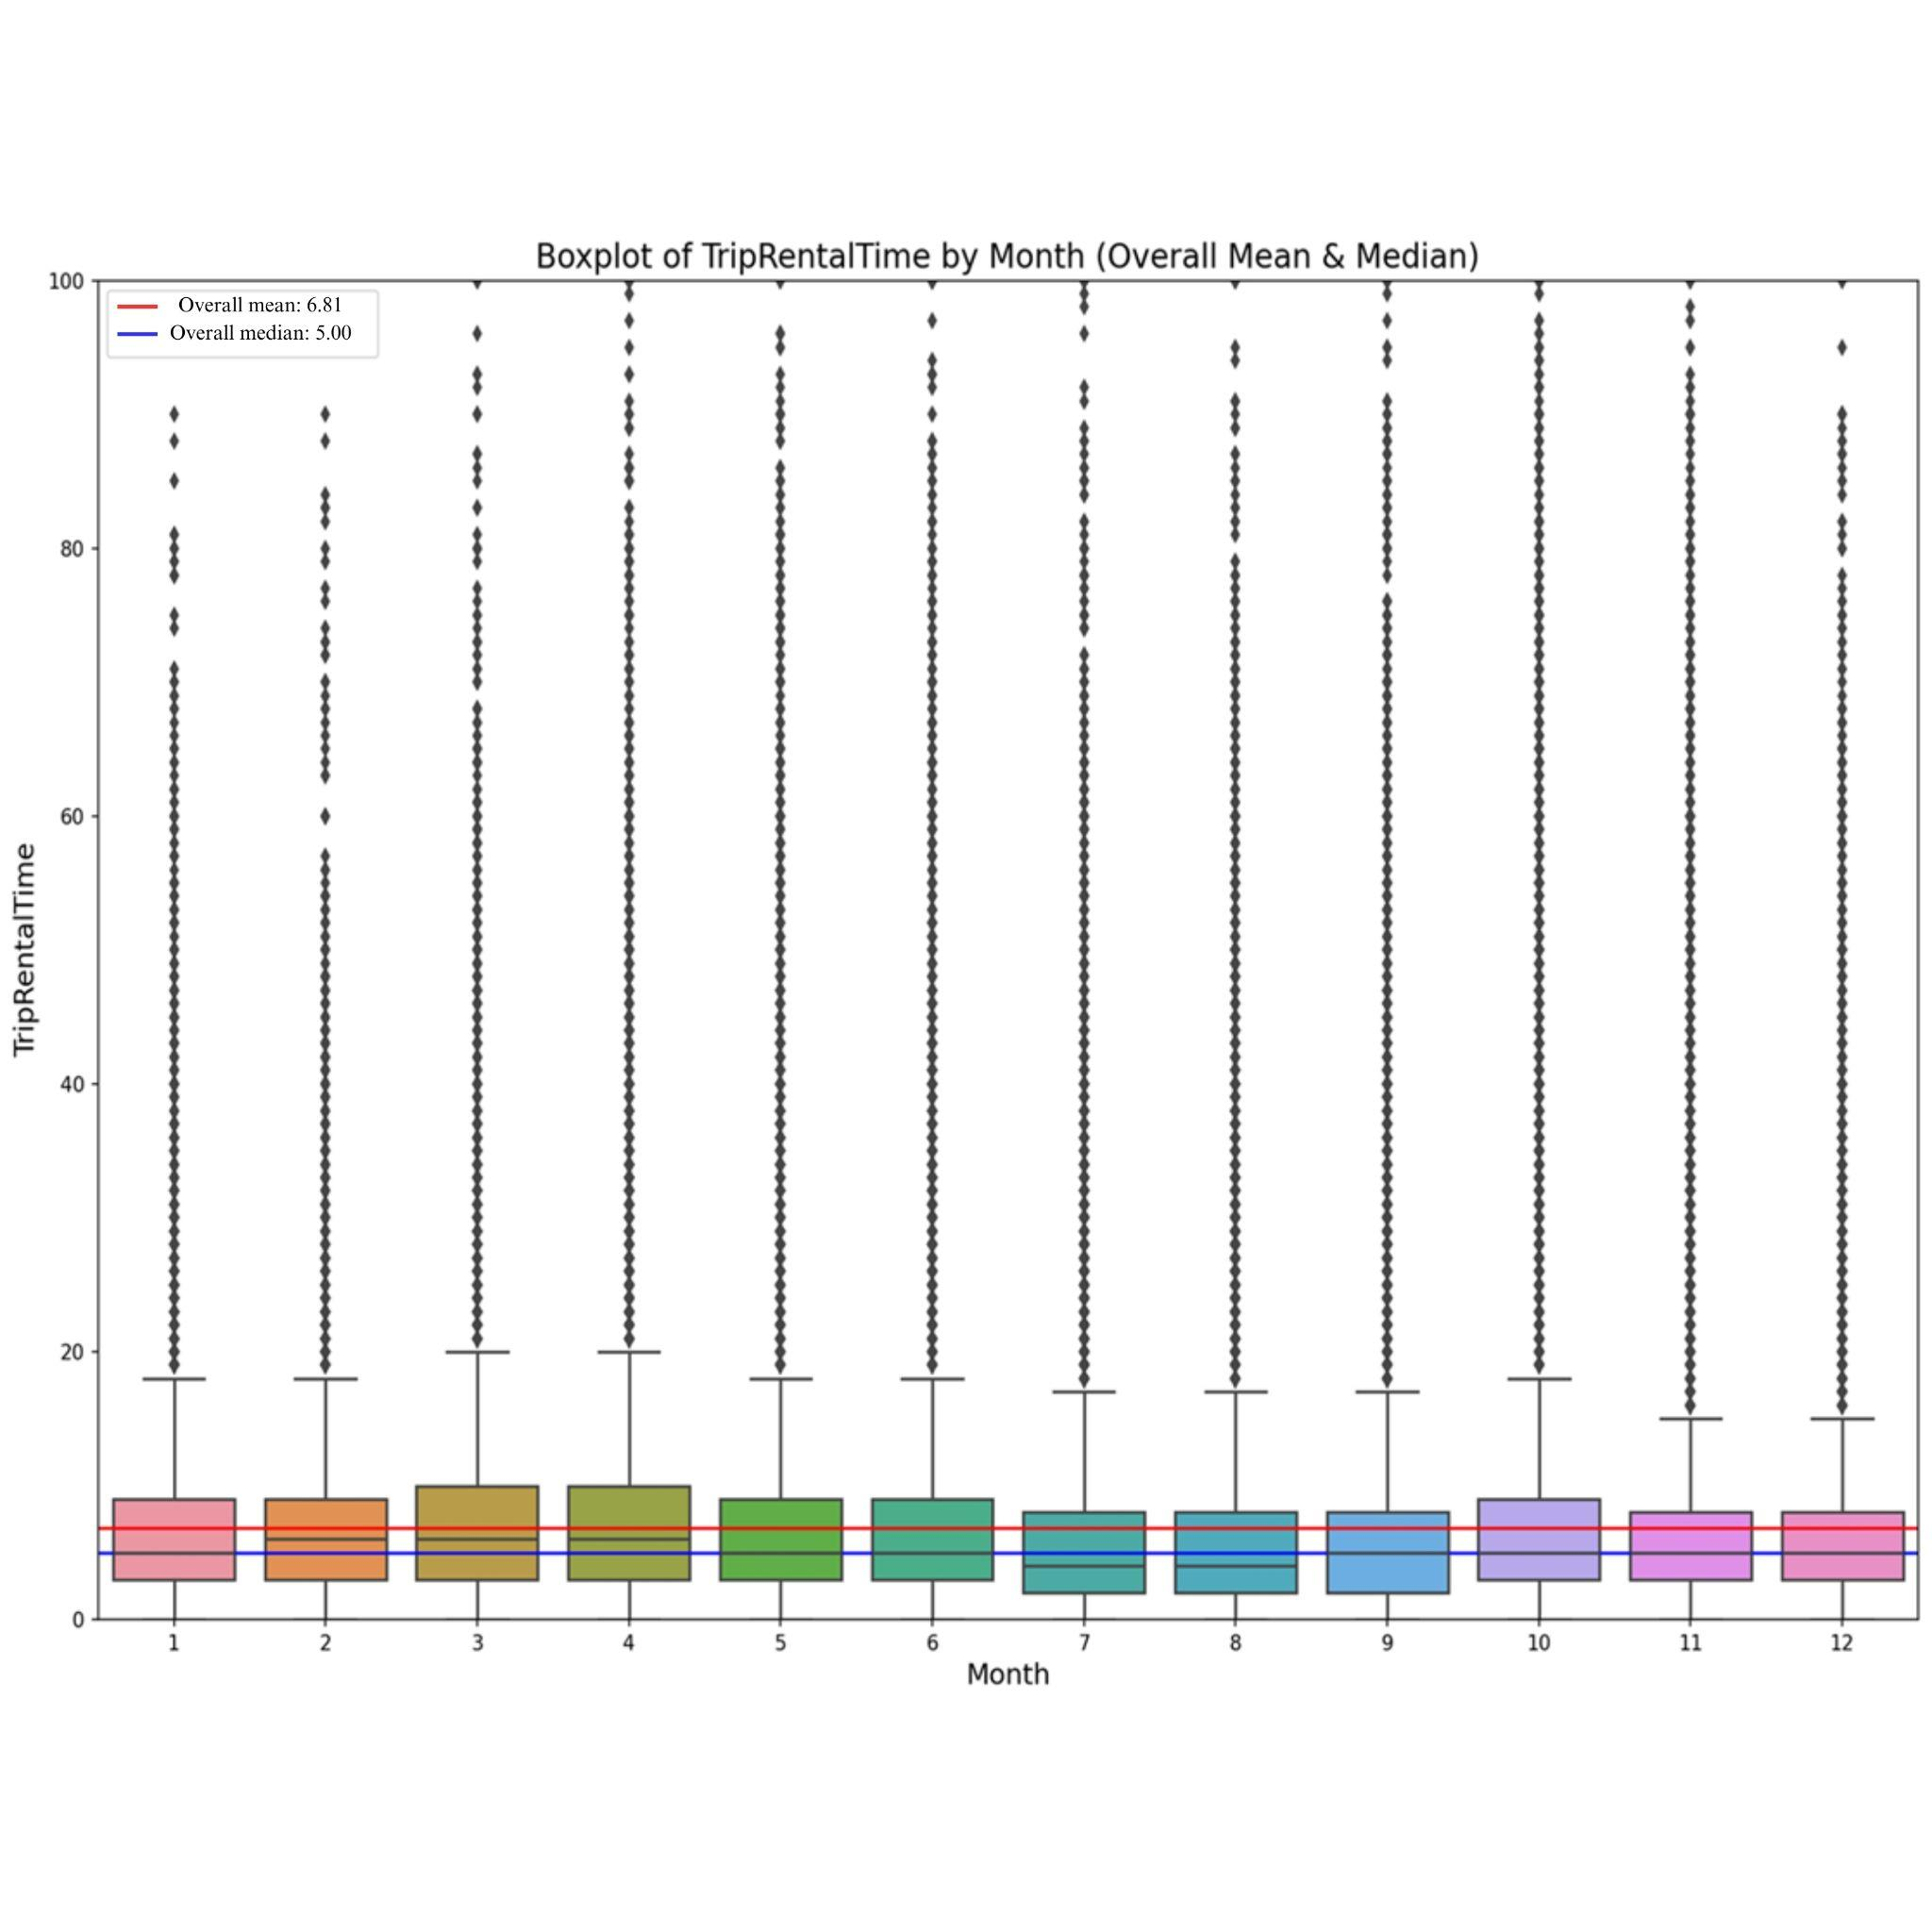

**Figure 8.** Boxplot of trip rental time by month

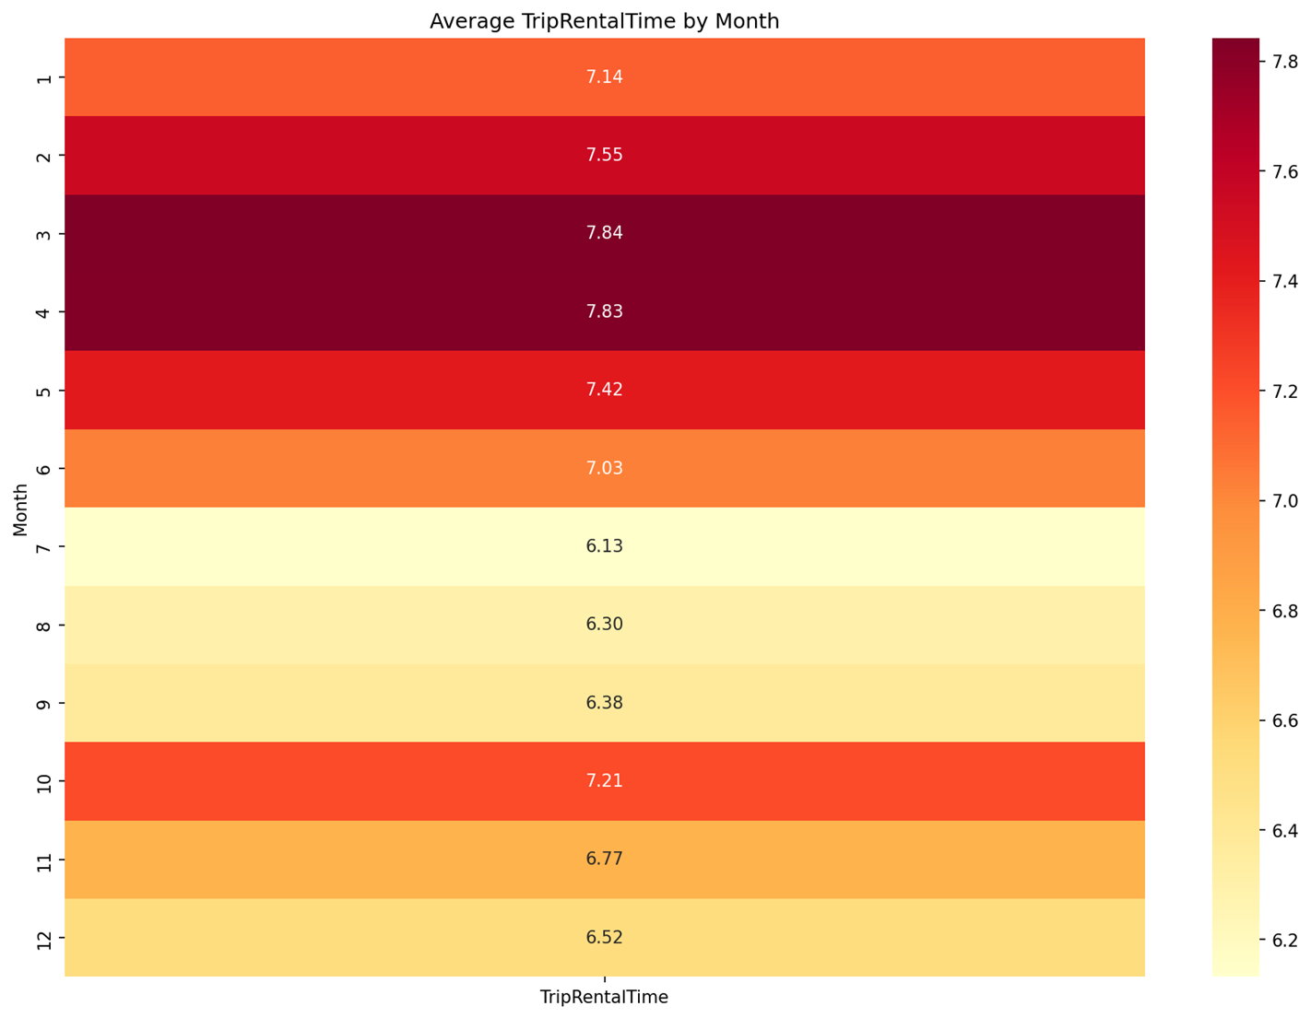

**Figure 9.** Heatmap of trip rental time by month

Figure 10 provides a boxplot, and Figure 11 presents heatmap visualizations of the average rental durations by season. The results indicate that spring has the highest average trip rental duration at 7.64 minutes, while summer records the lowest at 6.45 minutes. Fall and winter exhibit moderate average durations of 6.81 and 6.78 minutes, respectively.

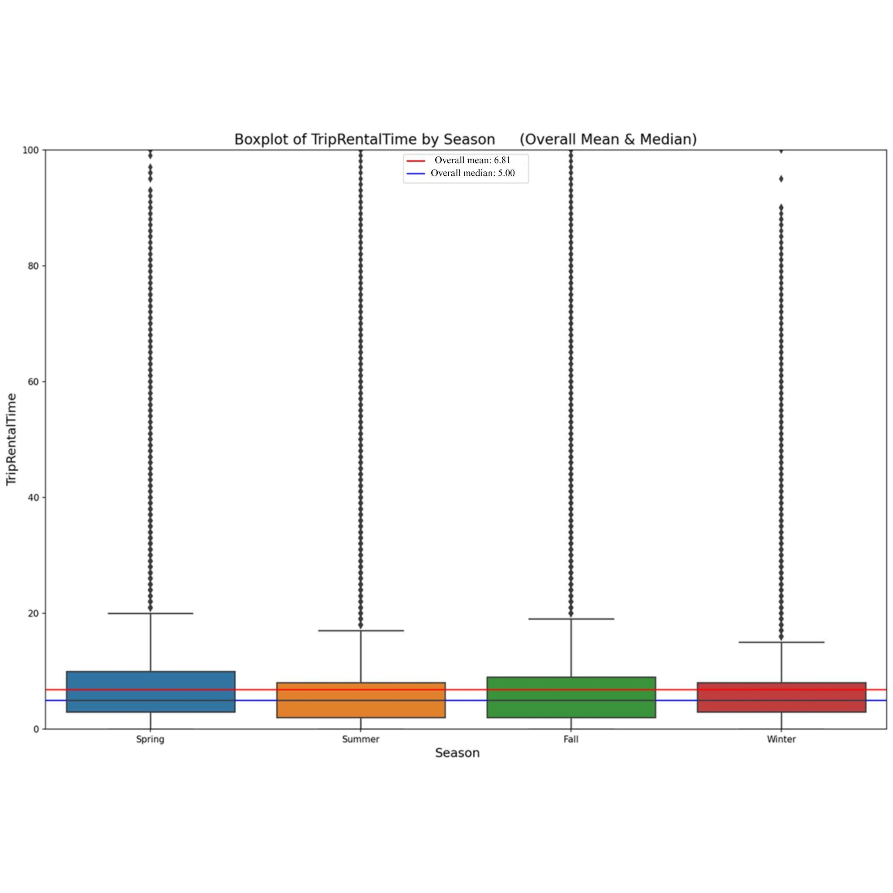

**Figure 10.** Boxplot of trip rental time by season

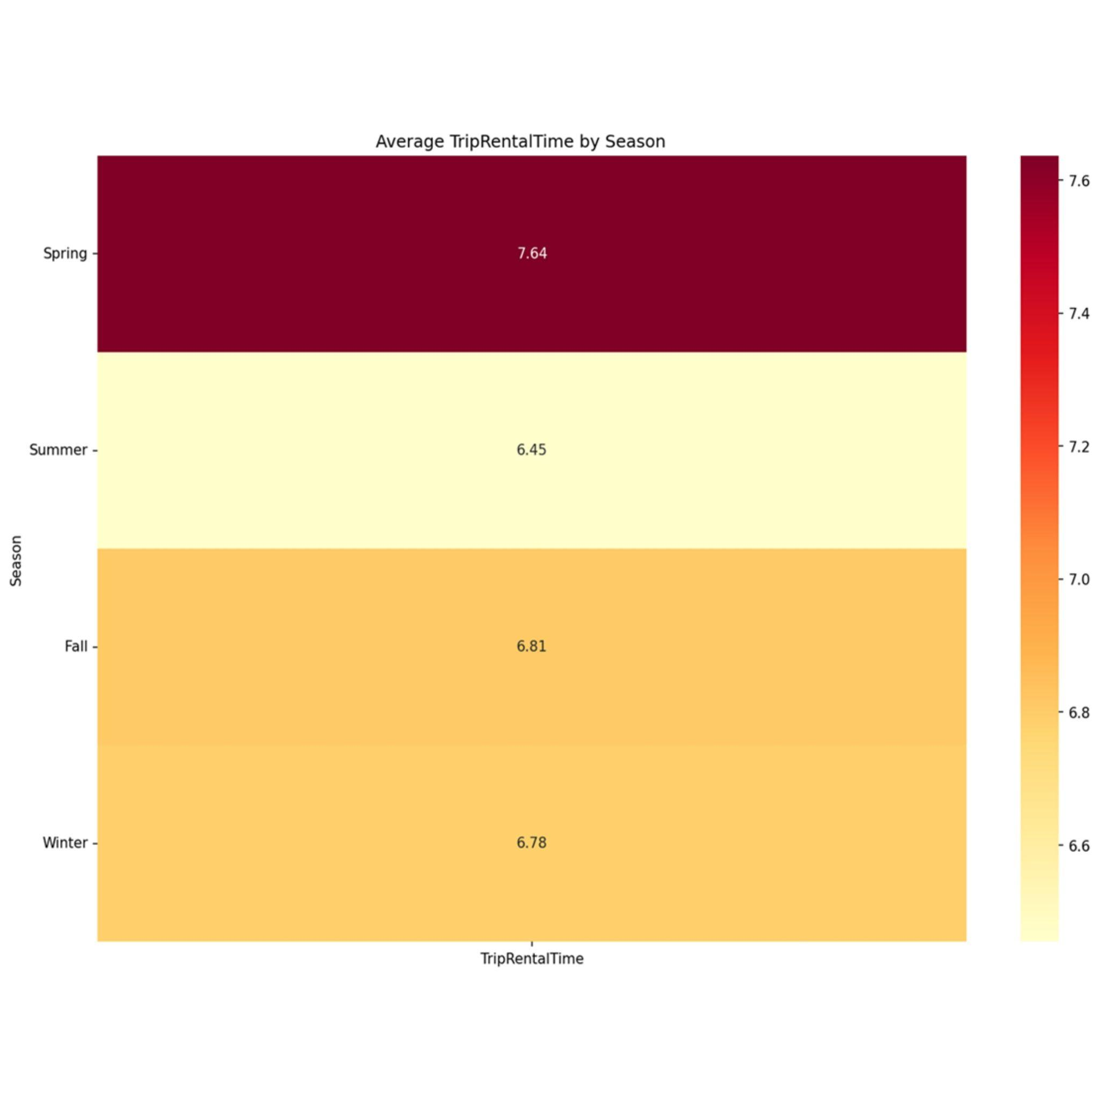

**Figure 11.** Heatmap of trip rental time by season

Figure 12 provides a boxplot, and Figure 13 presents heatmap visualizations of the average rental durations by weekday. Monday through Thursday exhibit similar patterns, likely reflecting commuting behaviors for work or school. In contrast, rental durations increase on Friday, Saturday, and Sunday, with Sundays showing the longest average rental durations, suggesting a shift toward leisure-oriented usage on weekends.

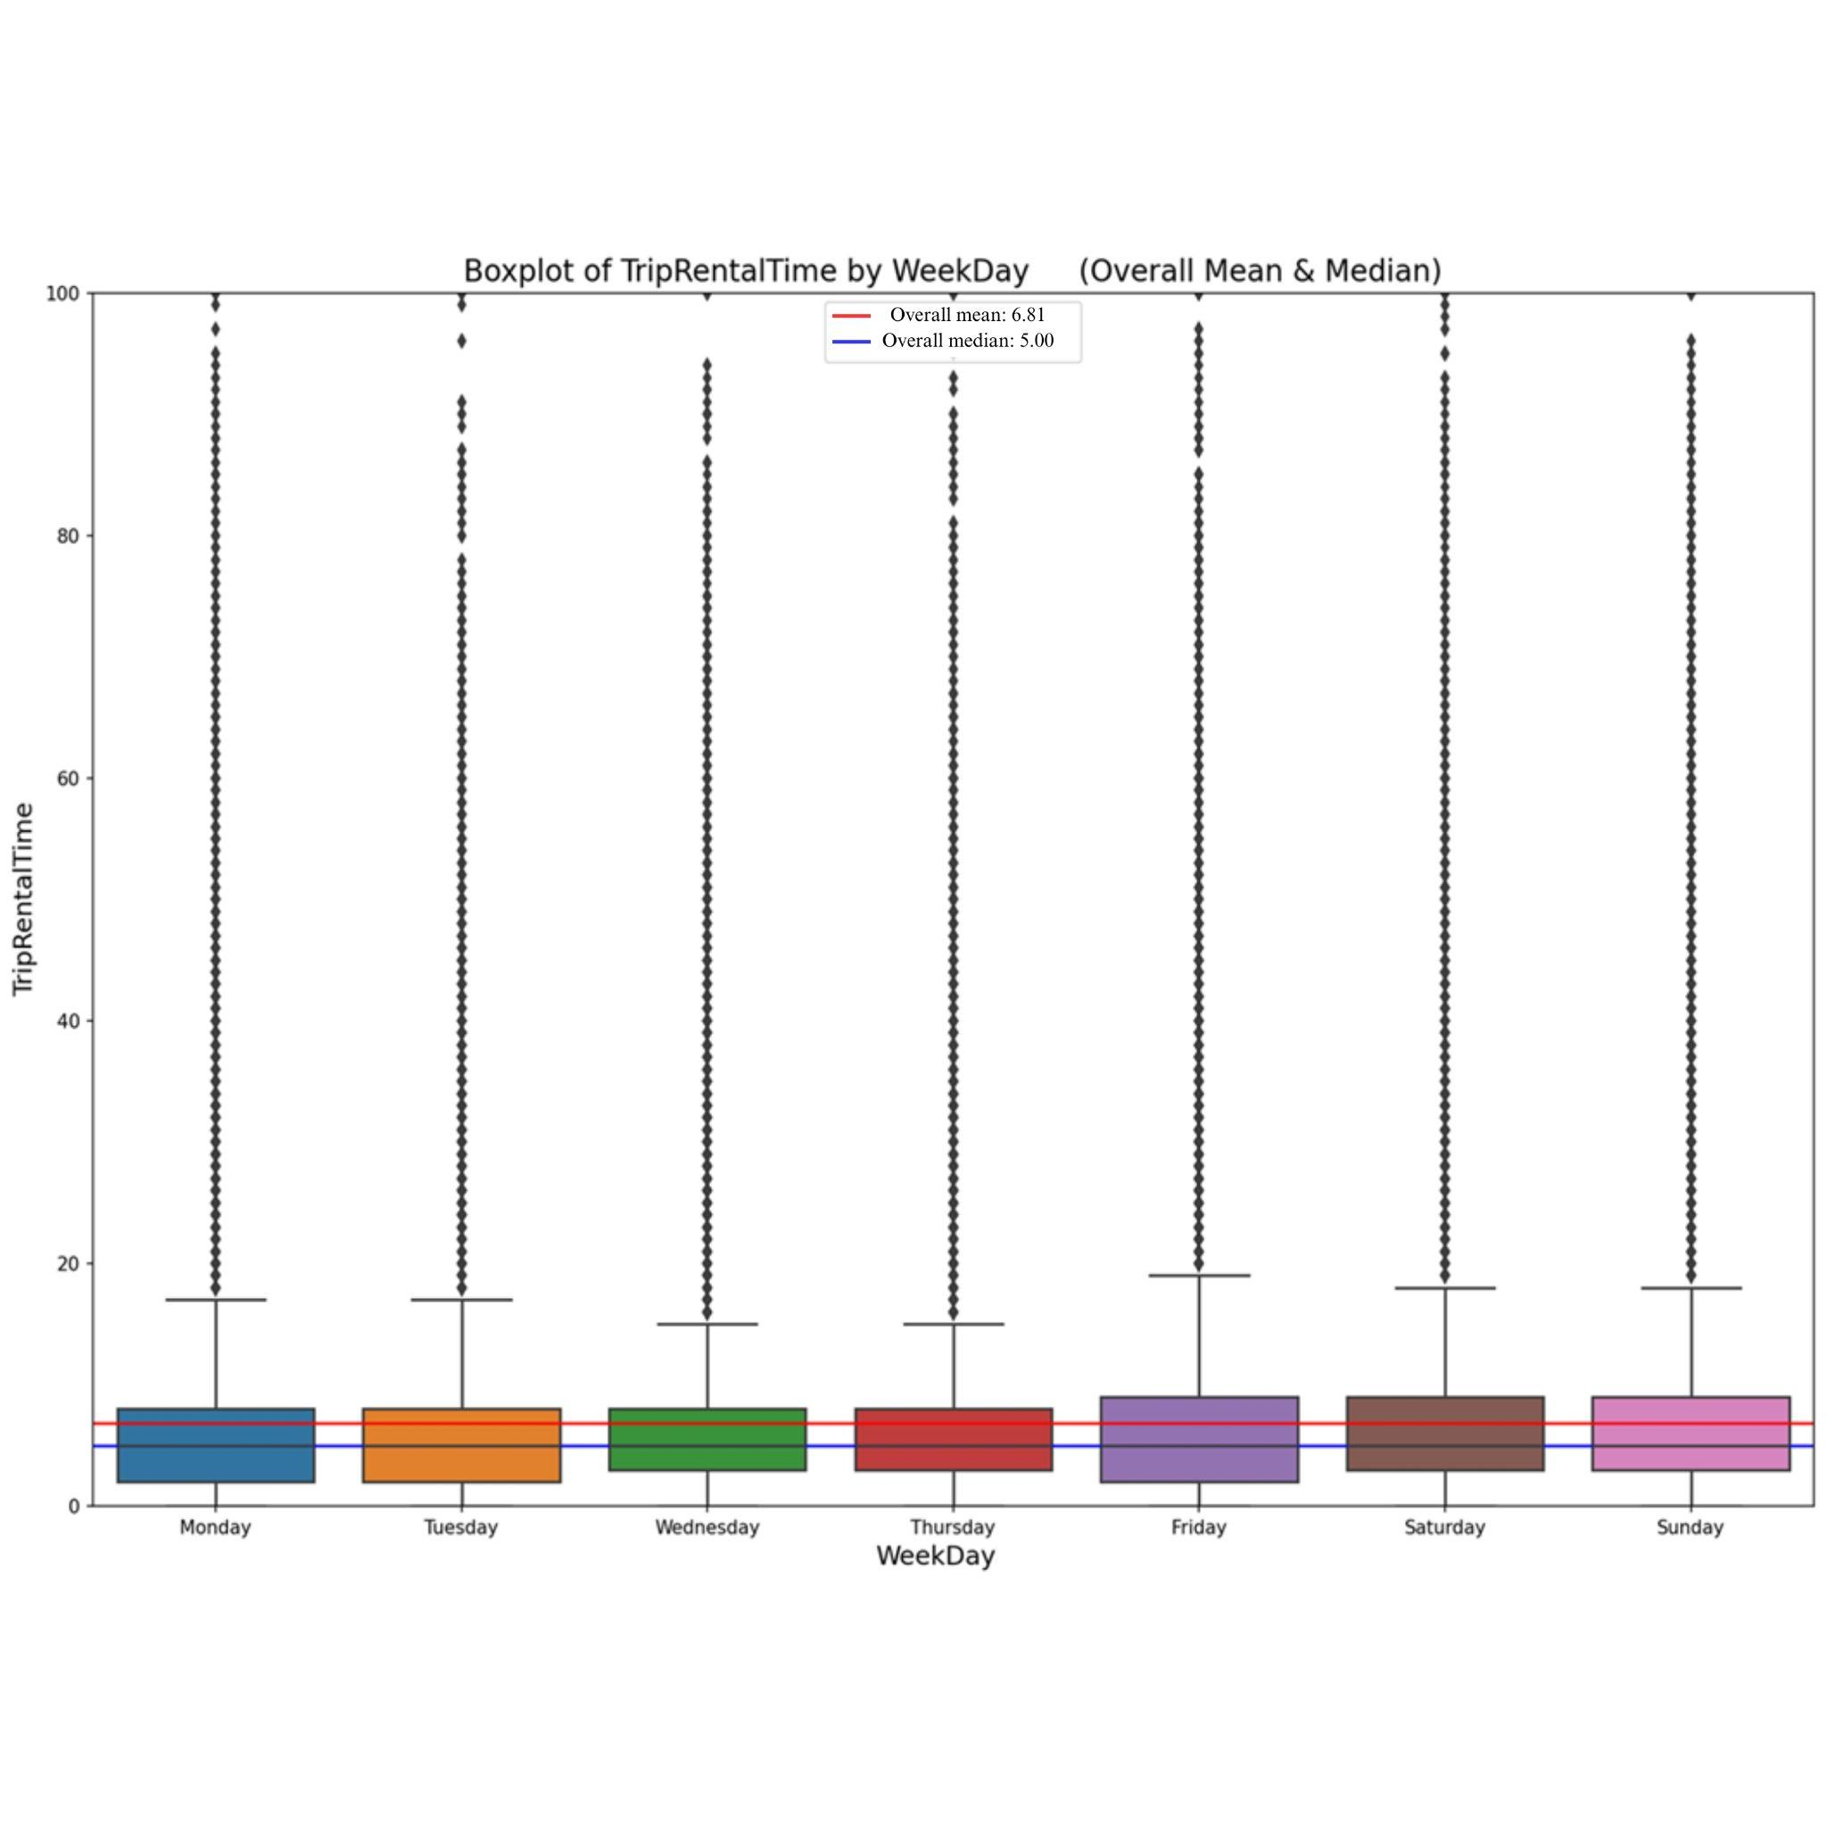

**Figure 12.** Boxplot of trip rental time by weekday

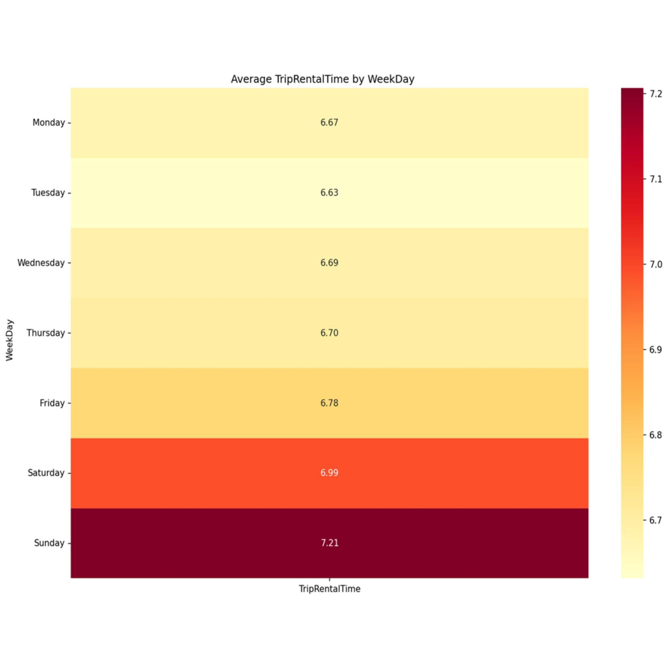

**Figure 13.** Heatmap of trip rental time by weekday

Figure 14 examines the relationship between wind speed and rental duration across the entire dataset. The results show that most trips last less than 20 minutes, regardless of wind speed. However, as wind speed increases, the number of trips decreases, suggesting that higher wind speeds discourage users from taking longer rides. Similarly, Figure 15 explores the impact of precipitation on trip duration. While rental durations can be significantly higher in the absence of precipitation, sharp declines in trip durations occur during rainy conditions, demonstrating that users are highly sensitive to precipitation when making rental decisions.

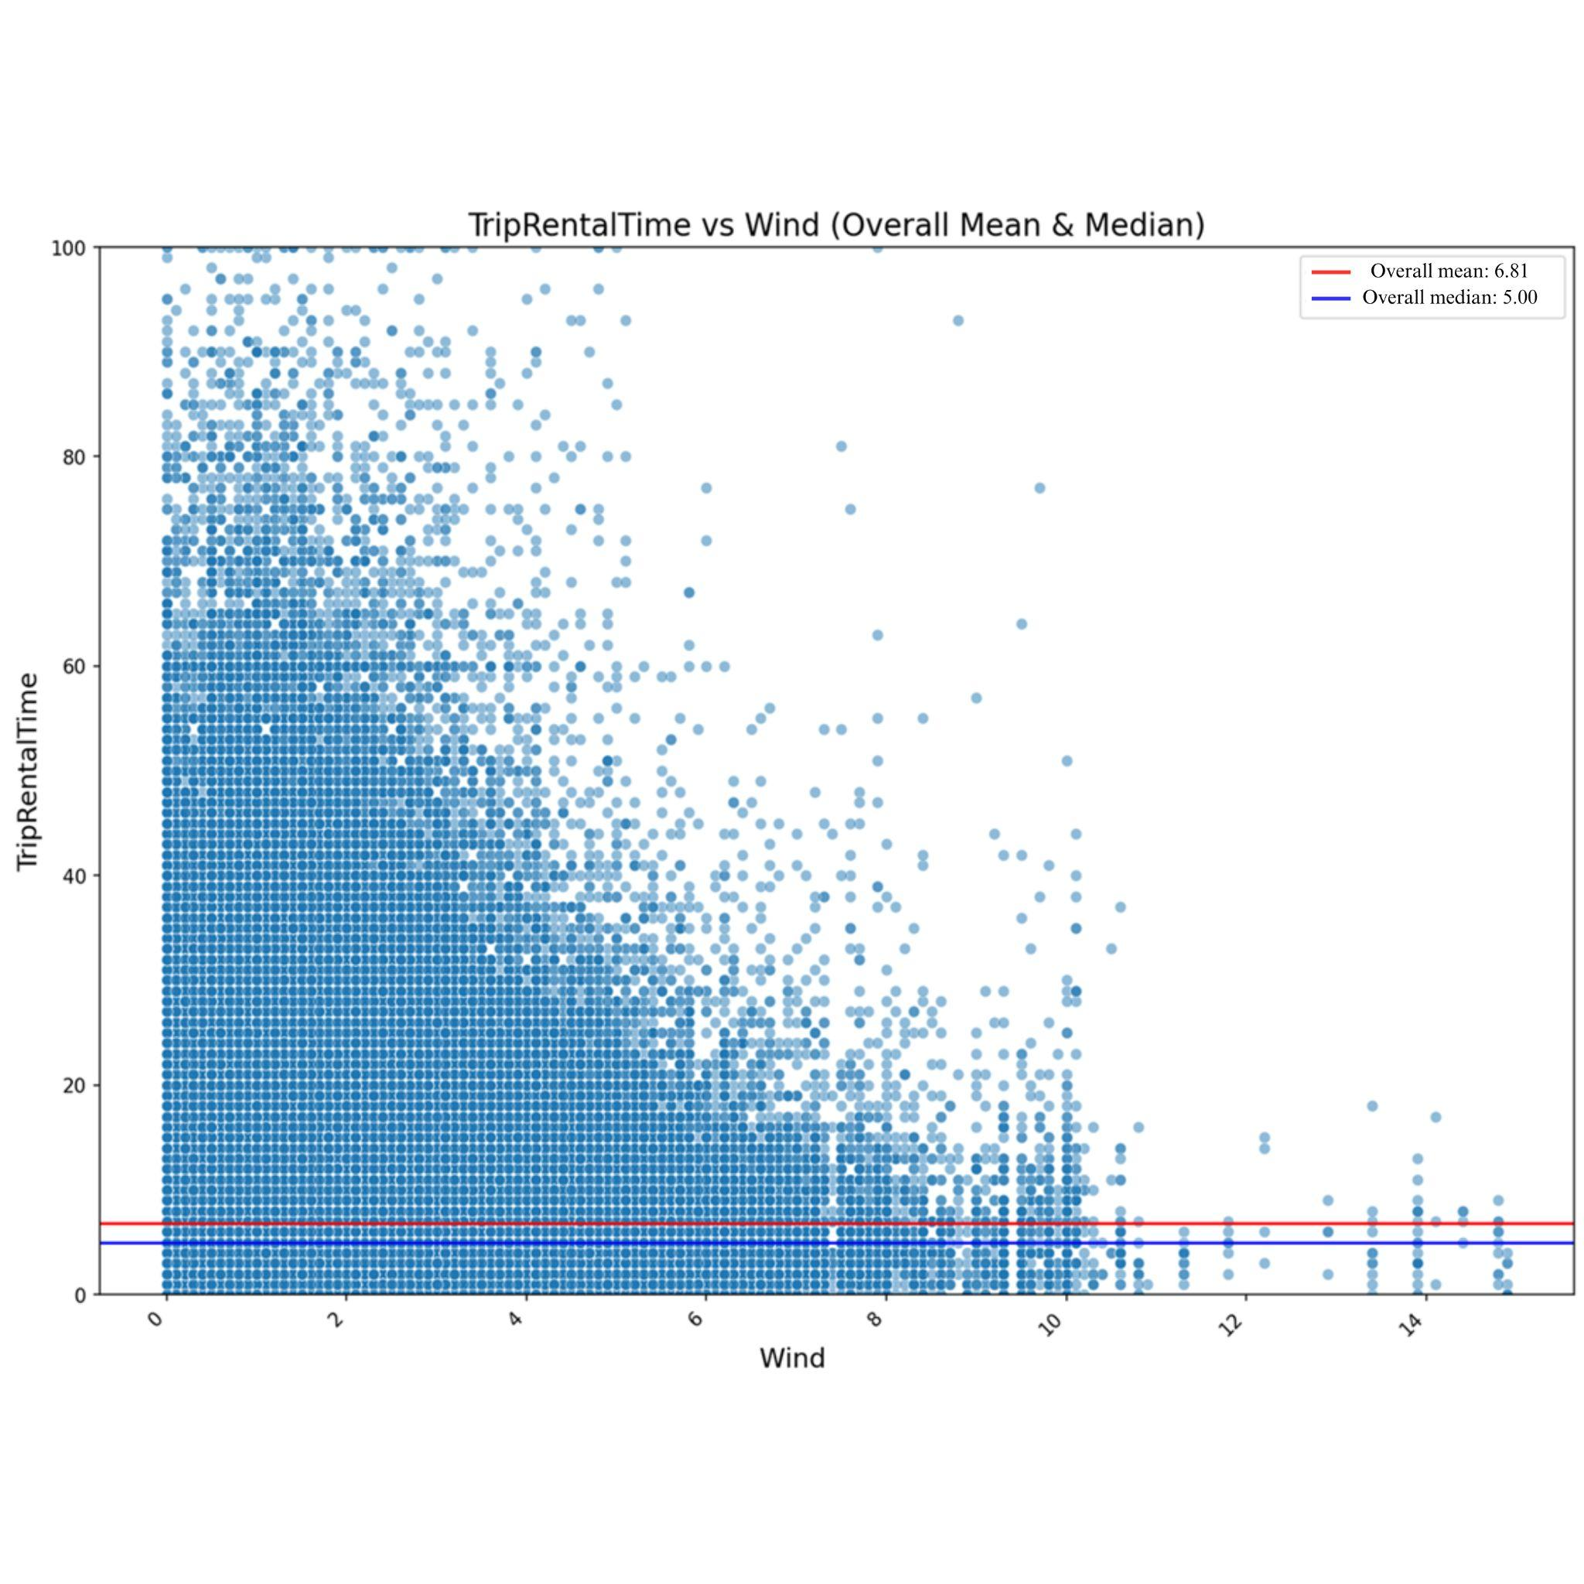

**Figure 14.** Trip rental time by windspeed

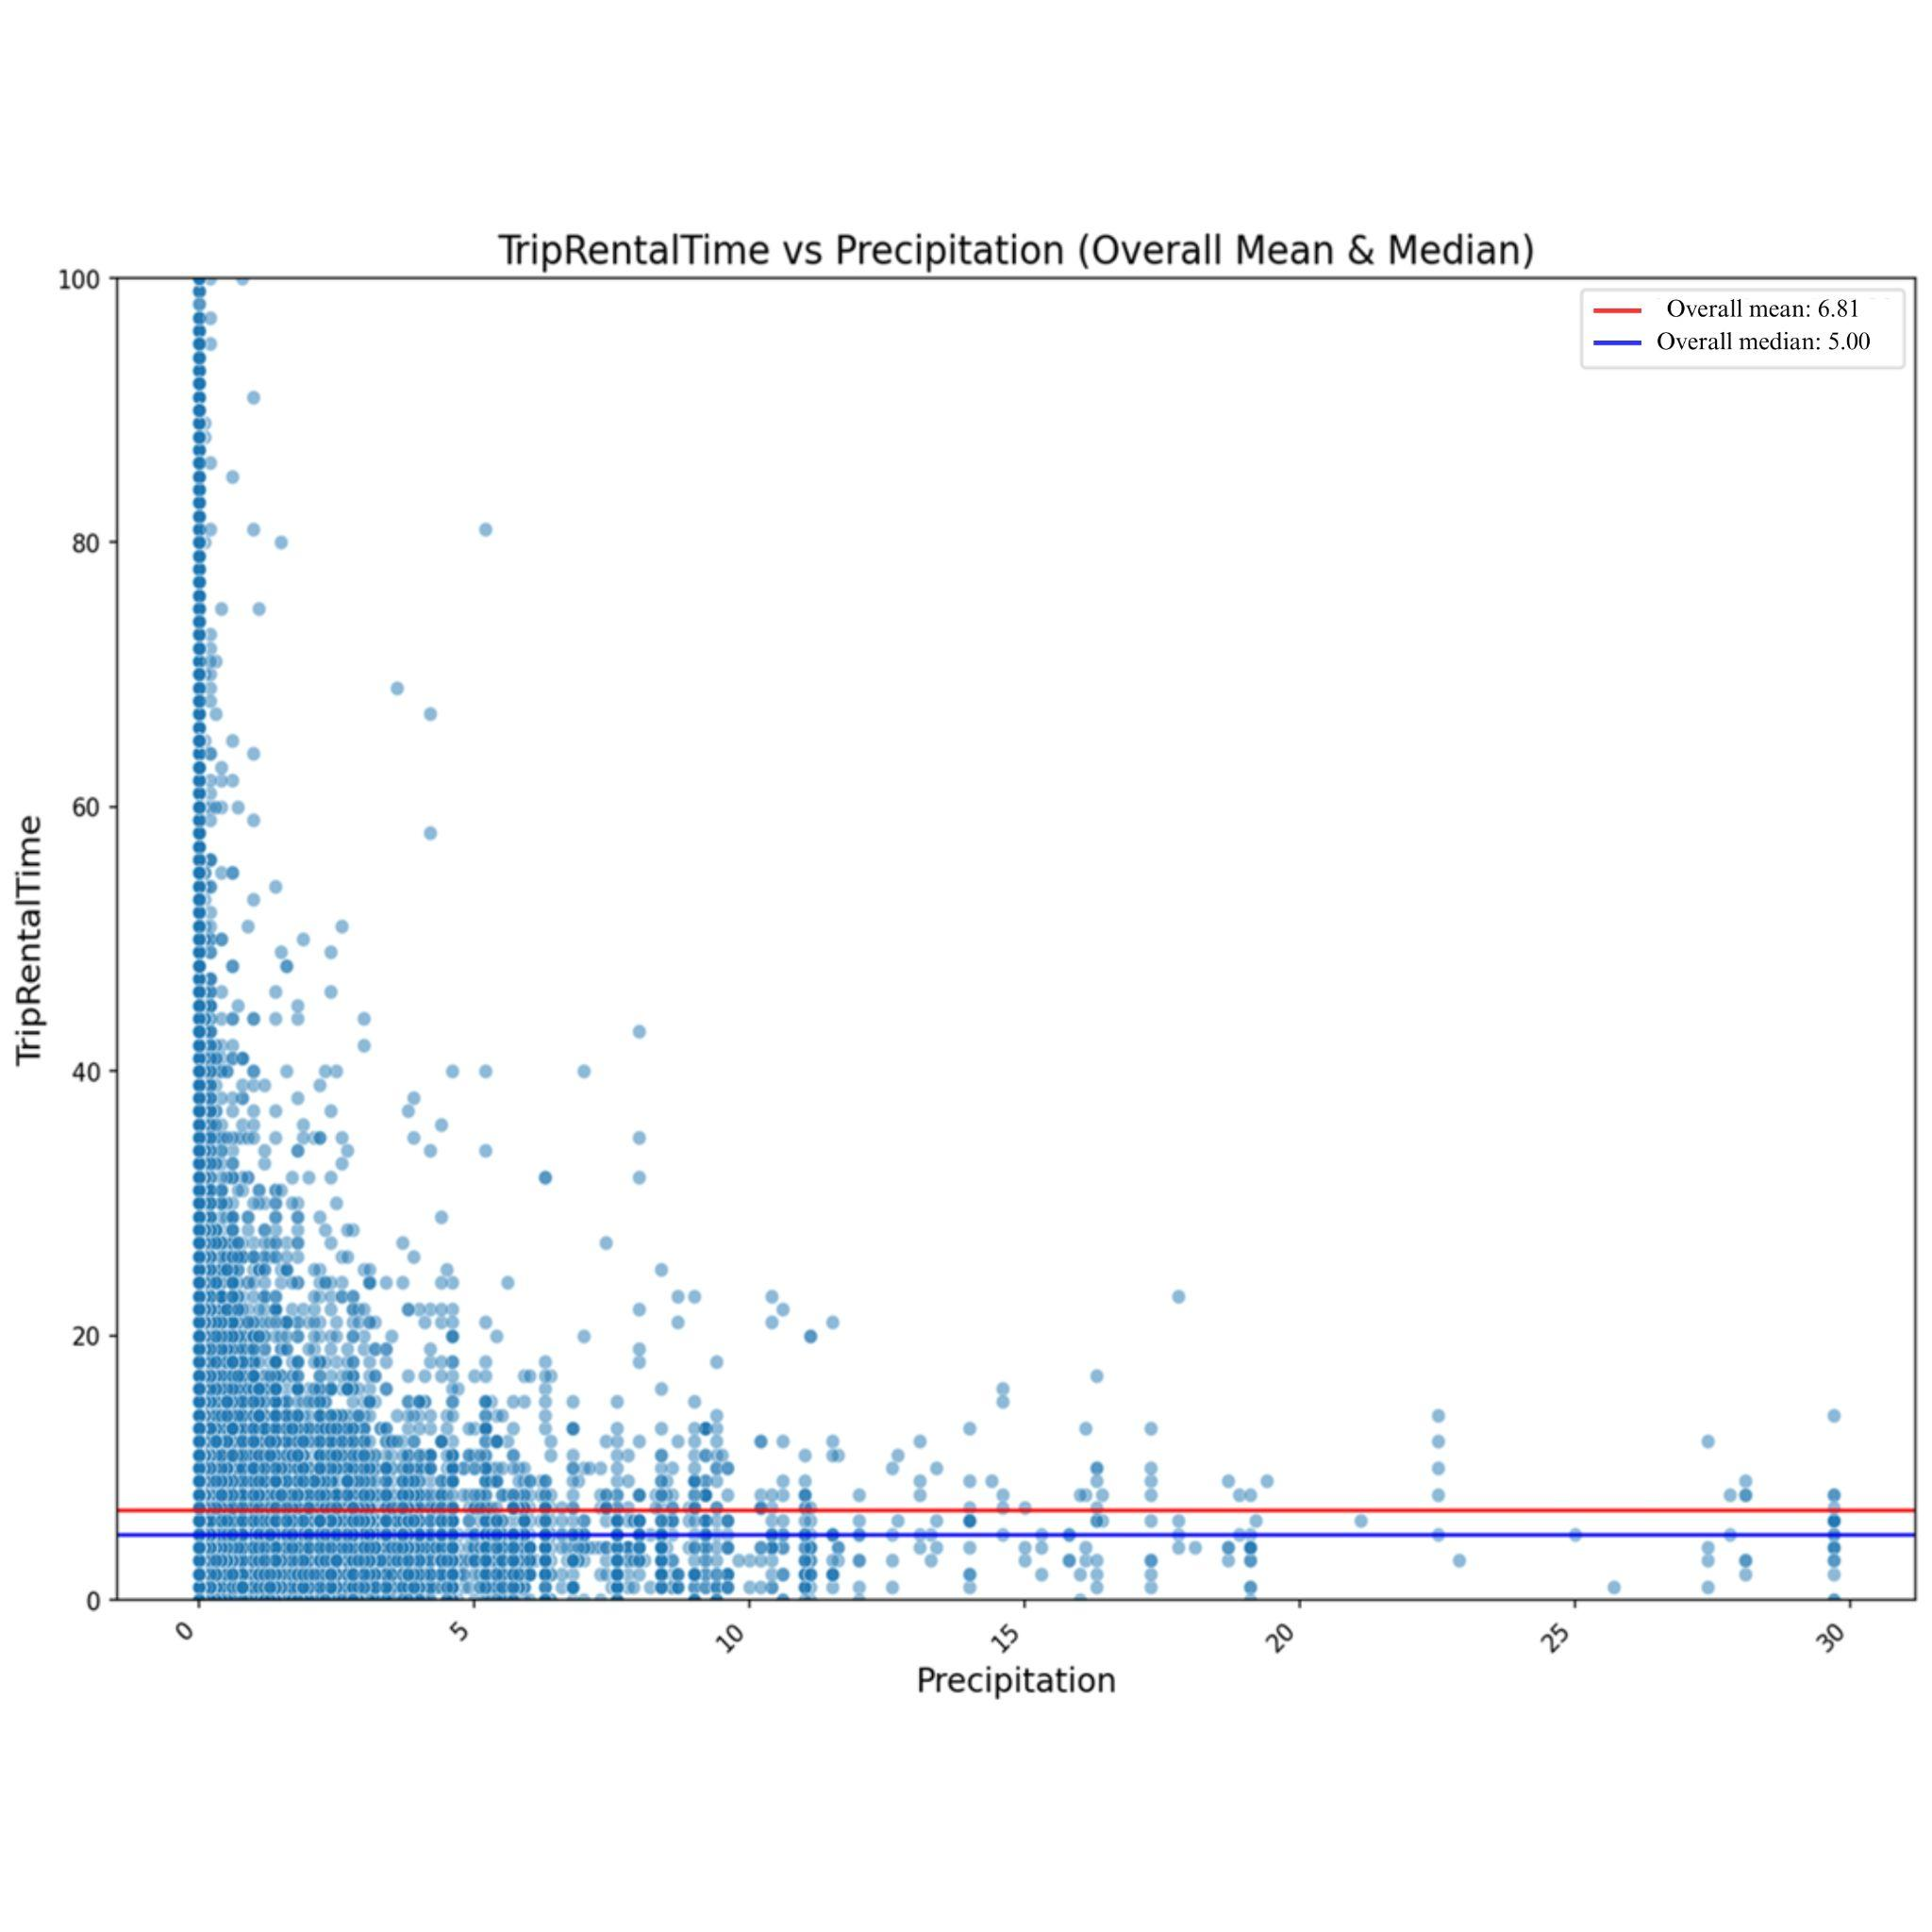

**Figure 15.** Trip rental time by precipitation

Figure 16 examines temperature and Figure 17 shows humidity factors on trip duration. Most trip durations are concentrated between 0 and 20 minutes across all temperature groups, with a dense cluster of data points forming a roughly normal distribution. The dataset contains outliers that show that some drivers still take longer trips under adverse conditions (such as when the weather is very hot or very cold) compared to the majority of other users. However, the highest number of rentals occurs in mid-temperature ranges, suggesting that temperature has a limited overall impact on rental durations, though this may not be fully evident in the graph due to the dataset's scale. Conversely, colder temperatures tend to reduce rental durations. It is evident that moderate temperatures encourage rentals more than extreme low or high temperatures. Also, it was concluded that humidity did not have a significant effect on users' behavior.

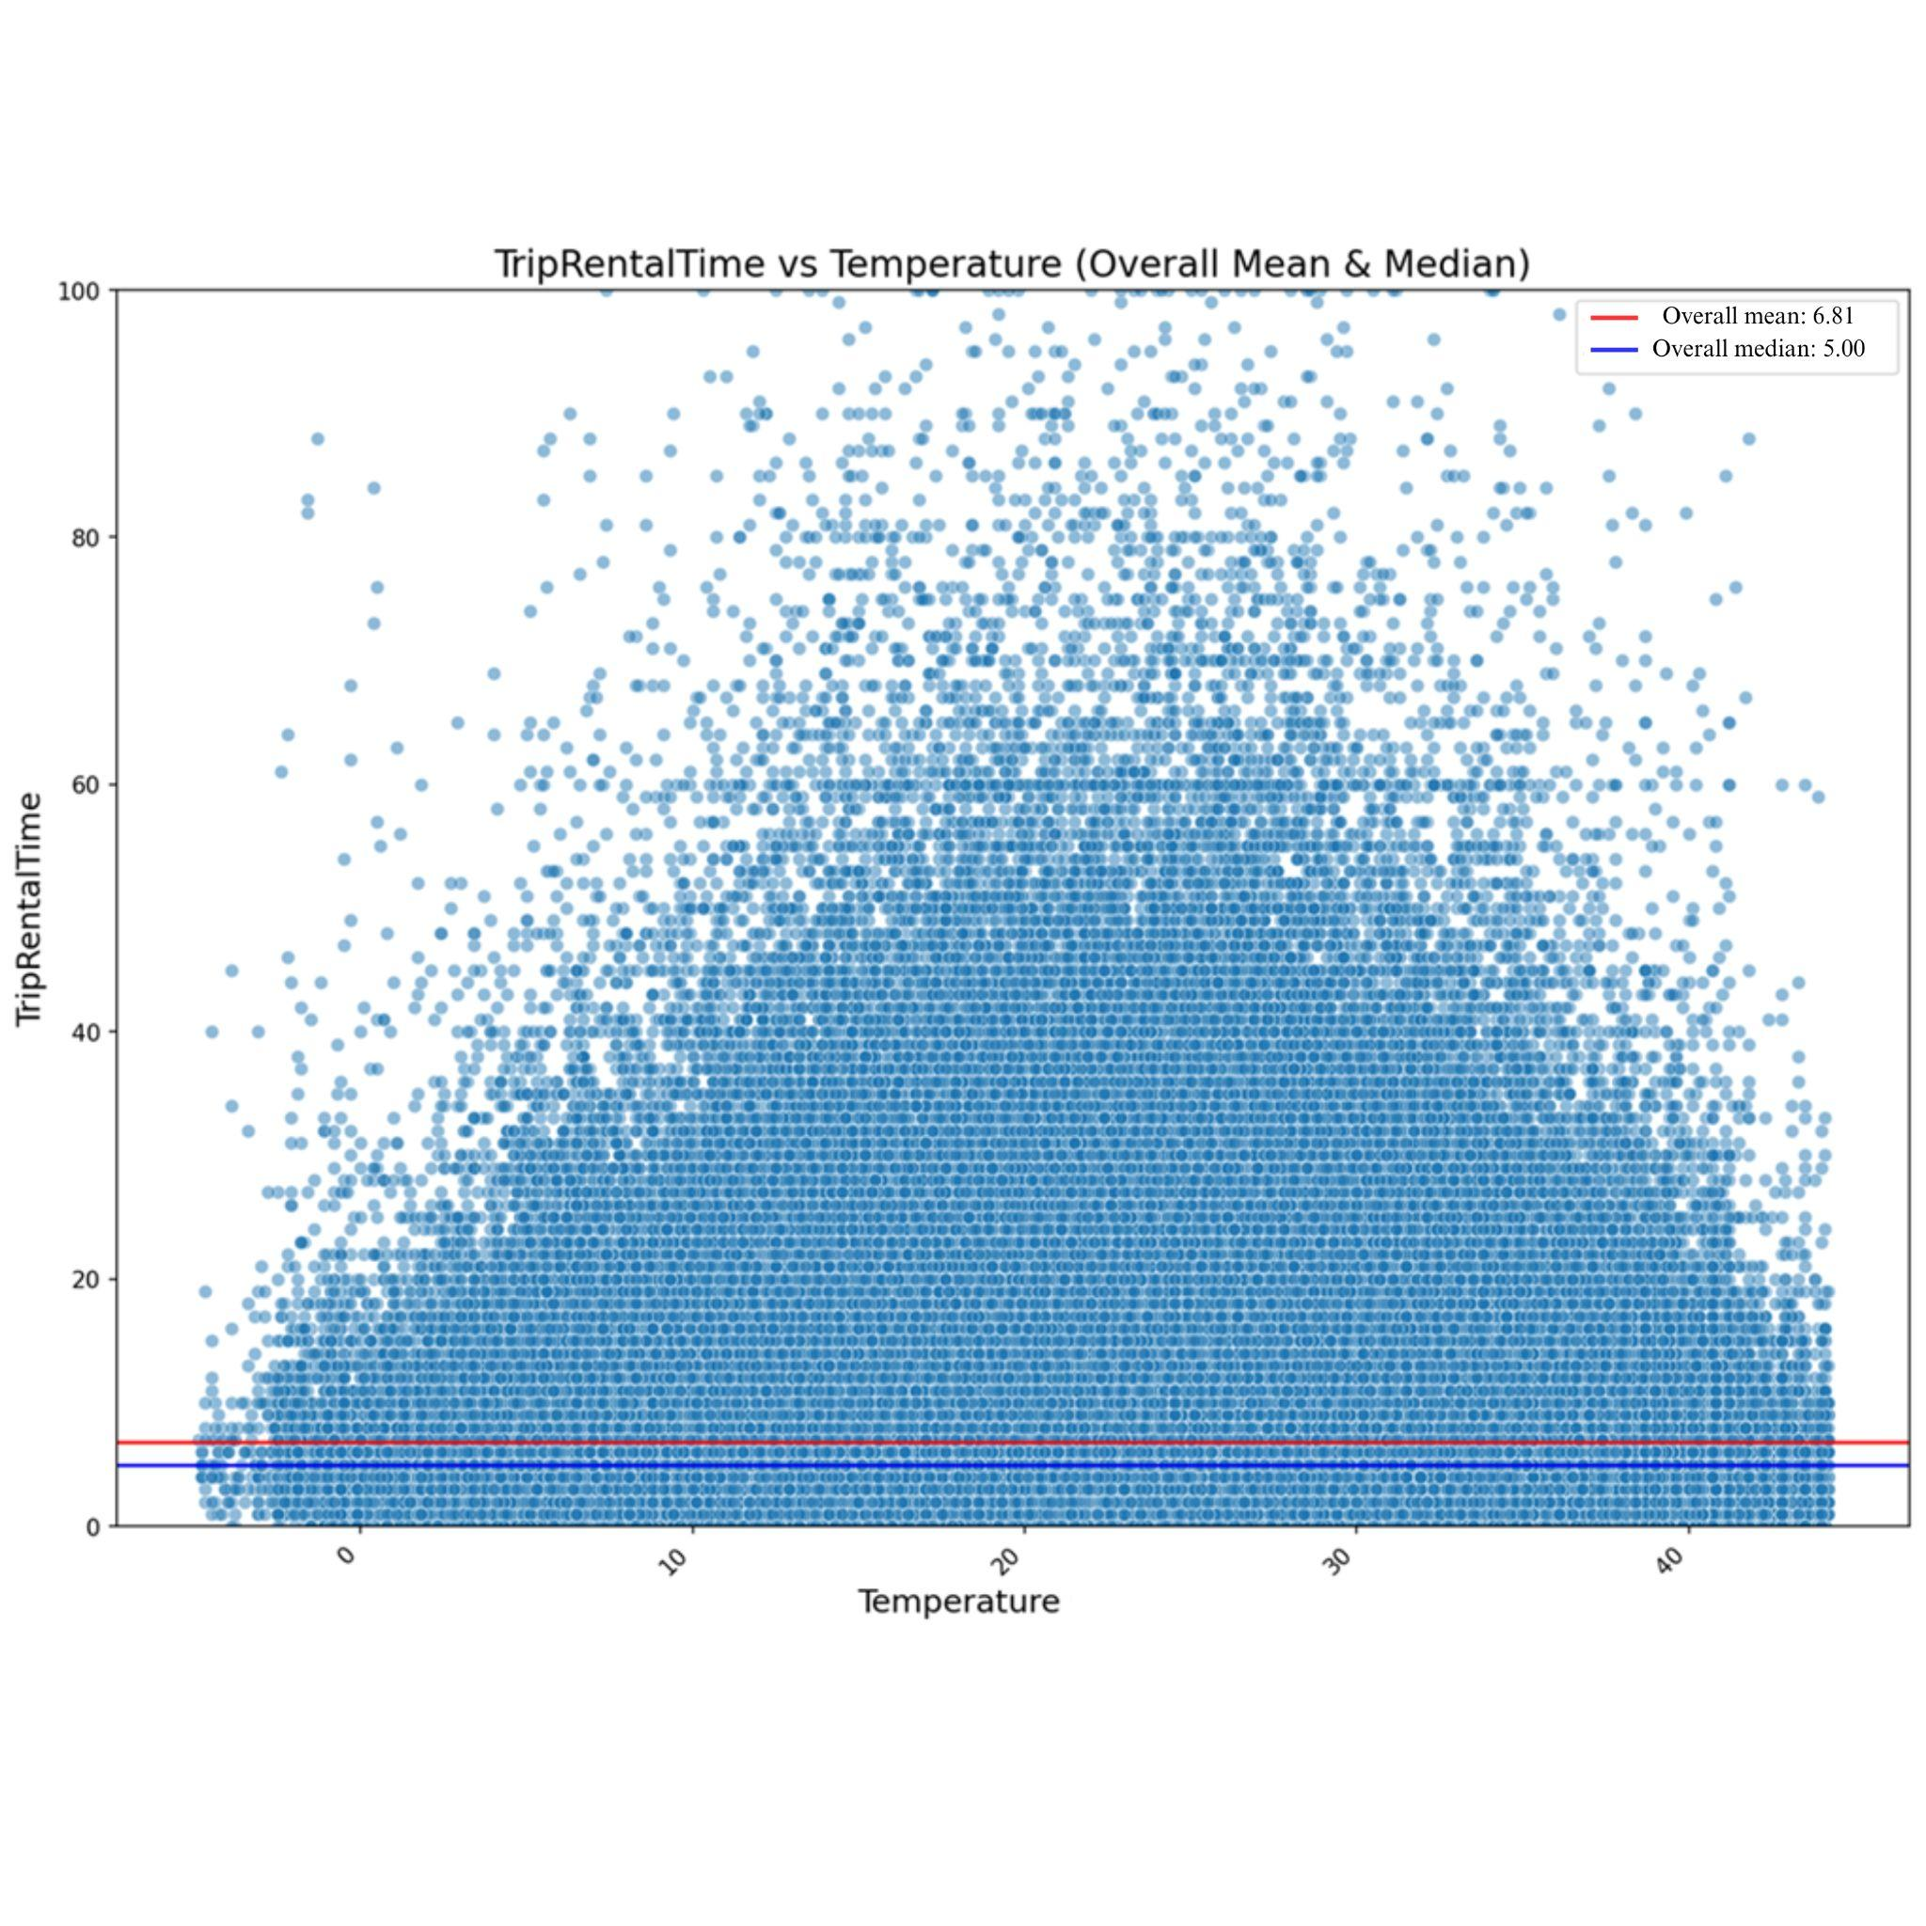

**Figure 16.** Trip rental time by temperature

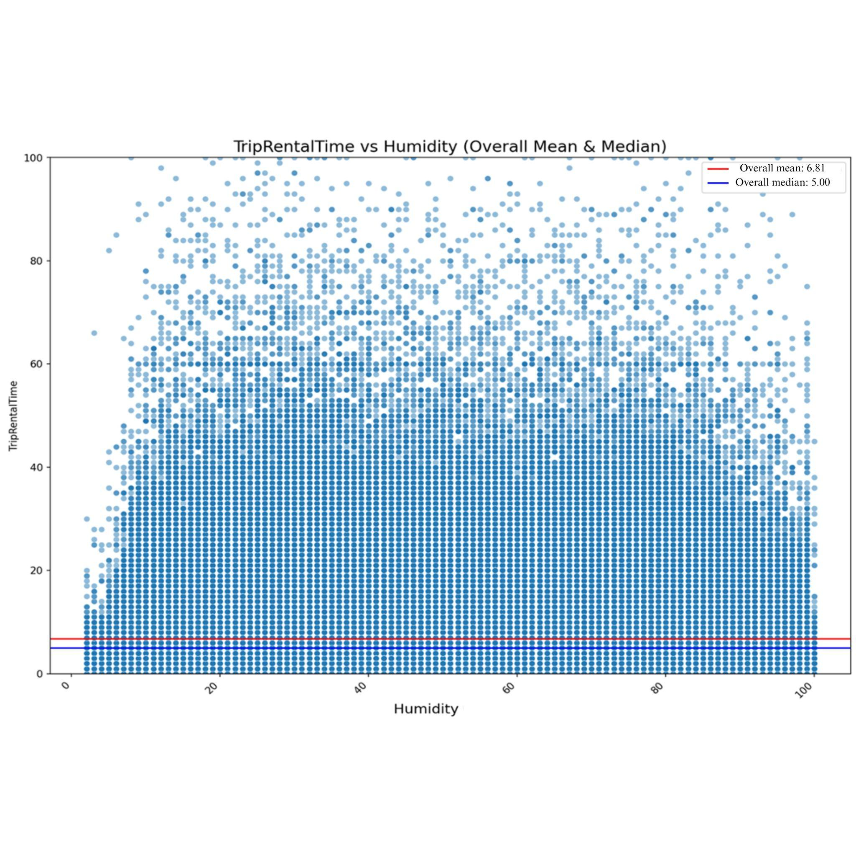

**Figure 17.** Trip rental time by humidity

1. **Conclusion and Future Work**

Shared vehicles, despite being a relatively recent addition to urban transportation, have got huge attention. They play a crucial role in connecting various modes of transportation within urban infrastructure. Additionally, these vehicles—particularly shared e-scooters are often used for tourism purposes and recreation. These diverse travel purposes have resulted in varying usage behaviors, requiring operator companies to adopt more informed and data-driven decision-making processes.

A detailed descriptive analysis of e-scooter usage data provides valuable strategic insights for companies. It highlights the need to consider external factors such as wind, precipitation, and temperature, alongside rental durations, which are influenced by hour of day, weekday, month, season, and their interactions with external conditions. Understanding users’ behavior trends is essential for enhancing service quality, improving operational efficiency, and meeting customer expectations.

Although a significant portion of users are either inactive or engage only occasionally, targeted campaigns can attract these potential users, increase retention, and promote more consistent usage. Notably, 15% of users constitute a loyal core group, which can be further engaged through rewards or incentives to maintain loyalty, boost ride frequency, and extend rental durations.

To provide solid suggestions, compared to existing studies in the literature, shared e-scooter usage in Türkiye aligns with some universal trends while exhibiting unique local dynamics. Weather conditions (e.g., precipitation and wind speed) and temporal parameters (e.g., day of the week and hour of the day) significantly influence users' riding durations. For example, increased wind speeds lead to noticeable decreases in trip rental duration. While very long rides can occur in rainy weather, riding durations are generally shorter under such conditions.

Contrary to findings in the literature, users’ behavior in Türkiye does not exhibit a linear relationship with temperature. Riding duration tends to be relatively longer at optimal temperatures between 20-25°C, whereas cold conditions result in shorter rides. No clear relationship was identified for humidity.

Analyzing hour-of-day effects reveals that the highest number of trips occurs between 5 pm and 9 pm. However, trip rental durations are relatively shorter during early morning hours (6:00-10:00 am) and increase until the peak period. Regarding the day of the month, a noticeable increase in rides is observed around common salary payment days in Türkiye, although unexpected variations, such as on the 28th, also occur.

Monthly and seasonal analyses show that average riding durations differ in March and April and during the Spring season, consistent with temperature trends. Finally, weekday and weekend riding behaviors differ, with weekends showing longer rides on average compared to weekdays.

In conclusion, the findings offer valuable insights into the usage patterns of the shared e-scooter service, helping operators optimize deployment strategies, rebalancing efforts, and enhancing user experience by analyzing trip durations and counts across different hours, days, seasons, months, and external factors of the weather such as humidity, precipitation, and wind. Also, strategies could be developed and implemented to encourage longer ride durations, particularly those exceeding 10 minutes, which currently account for only 9% of the dataset even though they provide more revenue when compared to users in other segments based on users’ behaviour. Such initiatives could expand the service's usage range and promote adoption for diverse commuting needs.

In the future, users' walking behaviors can be further analyzed by integrating riding and location telemetry datasets to identify patterns leading to riding spots. Additionally, the influence of external factors such as weather and altitude on walking patterns can be examined to better understand how these factors determine walking behaviors.

**Author Contributions:** Gürkan Çelik: coding, data analysis, funding acquisition, writing - original draft. Ümit Deniz Uluşar: data collection, coding, writing. Murat Alper Başaran: statistics, writing, data analysis, visualization.

**Financial support and sponsorship:** This work was supported by the Scientific and Technological Research Council of Türkiye (TÜBİTAK) under grant 124E543.

**Acknowledgments:** The authors would like to thank GEZ Mobility for providing the raw data used in this study and PhD candidate Taha Yiğit Alkan for his assistance in developing SQL queries.

**Conflicts of Interest:** None

**References**

[[1] ‘World Cities Report 2022: Envisaging the Future of Cities | UN-Habitat’. Accessed: Nov. 21, 2024. [Online]. Available: https://unhabitat.org/world-cities-report-2022-envisaging-the-future-of-cities](https://www.zotero.org/google-docs/?7T8BHD)

[[2] G. Celik, U. D. Ulusar, A. Sarsenbay, and A. Taleb-Ahmed, ‘Innovative Parking Solutions in Smart Cities’, in 2023 8th International Conference on Computer Science and Engineering (UBMK), Sep. 2023, pp. 51–56. doi: 10.1109/UBMK59864.2023.10286713.](https://www.zotero.org/google-docs/?7T8BHD)

[[3] U. D. Ulusar, G. Celik, and F. Al-Turjman, ‘Wireless Communication Aspects in the Internet of Things: An Overview’, in 2017 IEEE 42nd Conference on Local Computer Networks Workshops (LCN Workshops), Oct. 2017, pp. 165–169. doi: 10.1109/LCN.Workshops.2017.82.](https://www.zotero.org/google-docs/?7T8BHD)

[[4] N. Saum, S. Sugiura, and M. Piantanakulchai, ‘Short-Term Demand and Volatility Prediction of Shared Micro-Mobility: a case study of e-scooter in Thammasat University’, in 2020 Forum on Integrated and Sustainable Transportation Systems (FISTS), Nov. 2020, pp. 27–32. doi: 10.1109/FISTS46898.2020.9264852.](https://www.zotero.org/google-docs/?7T8BHD)

[[5] R. B. Noland, ‘Scootin’ in the rain: Does weather affect micromobility?’, Transp. Res. Part Policy Pract., vol. 149, pp. 114–123, Jul. 2021, doi: 10.1016/j.tra.2021.05.003.](https://www.zotero.org/google-docs/?7T8BHD)

[[6] A. A. Campbell, C. R. Cherry, M. S. Ryerson, and X. Yang, ‘Factors influencing the choice of shared bicycles and shared electric bikes in Beijing’, Transp. Res. Part C Emerg. Technol., vol. 67, pp. 399–414, Jun. 2016, doi: 10.1016/j.trc.2016.03.004.](https://www.zotero.org/google-docs/?7T8BHD)

[[7] H. Younes, Z. Zou, J. Wu, and G. Baiocchi, ‘Comparing the Temporal Determinants of Dockless Scooter-share and Station-based Bike-share in Washington, D.C.’, Transp. Res. Part Policy Pract., vol. 134, pp. 308–320, Apr. 2020, doi: 10.1016/j.tra.2020.02.021.](https://www.zotero.org/google-docs/?7T8BHD)

[[8] D. J. Reck, H. Haitao, S. Guidon, and K. W. Axhausen, ‘Explaining shared micromobility usage, competition and mode choice by modelling empirical data from Zurich, Switzerland’, Transp. Res. Part C Emerg. Technol., vol. 124, p. 102947, Mar. 2021, doi: 10.1016/j.trc.2020.102947.](https://www.zotero.org/google-docs/?7T8BHD)

[[9] M. Abouelela, E. Chaniotakis, and C. Antoniou, ‘Understanding the landscape of shared-e-scooters in North America; Spatiotemporal analysis and policy insights’, Transp. Res. Part Policy Pract., vol. 169, p. 103602, Mar. 2023, doi: 10.1016/j.tra.2023.103602.](https://www.zotero.org/google-docs/?7T8BHD)

[[10] K. Gebhart and R. B. Noland, ‘The impact of weather conditions on bikeshare trips in Washington, DC’, Transportation, vol. 41, no. 6, pp. 1205–1225, Nov. 2014, doi: 10.1007/s11116-014-9540-7.](https://www.zotero.org/google-docs/?7T8BHD)

[[11] M. Hasan and V. P. Sisiopiku, ‘Shared E-Scooter Practices in Birmingham, Alabama: Analyzing Usage, Patterns, and Determinants’, Future Transp., vol. 4, no. 1, Art. no. 1, Mar. 2024, doi: 10.3390/futuretransp4010008.](https://www.zotero.org/google-docs/?7T8BHD)

[[12] J. K. Mathew, M. Liu, and D. M. Bullock, ‘Impact of Weather on Shared Electric Scooter Utilization’, in 2019 IEEE Intelligent Transportation Systems Conference (ITSC), Oct. 2019, pp. 4512–4516. doi: 10.1109/ITSC.2019.8917121.](https://www.zotero.org/google-docs/?7T8BHD)

[[13] U. D. Ulusar, G. Celik, E. Turk, F. Al-Turjman, and H. Guvenc, ‘Accurate indoor localization for ZigBee networks’, in 2018 3rd International Conference on Computer Science and Engineering (UBMK), IEEE, 2018, pp. 514–517. Accessed: Dec. 11, 2024. [Online]. Available: https://ieeexplore.ieee.org/abstract/document/8566532/](https://www.zotero.org/google-docs/?7T8BHD)

[[14] G. Celik, M. Baimagambetova, and V. Abromavičius, ‘A Review of Fingerprinting Techniques for Smart Cities’, in 2022 IEEE Open Conference of Electrical, Electronic and Information Sciences (eStream), Apr. 2022, pp. 1–4. doi: 10.1109/eStream56157.2022.9781754.](https://www.zotero.org/google-docs/?7T8BHD)

[[15] ‘GEZ’. Accessed: Dec. 12, 2024. [Online]. Available: https://gezmobility.com/](https://www.zotero.org/google-docs/?7T8BHD)

[[16] ‘Meteoroloji Genel Müdürlüğü’. Accessed: Aug. 20, 2024. [Online]. Available: https://mevbis.mgm.gov.tr/](https://www.zotero.org/google-docs/?7T8BHD)