**INTELLIGENT UNMANNED ROBOT USING IOT FOR MILITARY APPLICATIONS**

Chandana S**,**

*Department of Electronics and Communication Engineering,*

BGSIT, BG Nagara,

Karnataka, India,

[chandana7028@gmail.com](mailto:chandana7028@gmail.com)

Nithya DB*,*

*Department of Electronics and Communication Engineering,*

BGSIT, BG Nagara,

Karnataka, India, [nithyadb15@gmail.com](mailto:nithyadb15@gmail.com)

Pavan Gowda KN,

*Department of Electronics and Communication Engineering,*

BGSIT, BG Nagara,

Karnataka, India, [pavan666gowda@gmail.com](mailto:pavan666gowda@gmail.com)

Varshini PL,

*Department of Electronics and*

*Communication Engineering,*

BGSIT, BG Nagara,

Karnataka, India,

[varshinilokesh02@gmail.com](mailto:varshinilokesh02@gmail.com)

Dr. Manoj Kumar SB,

*Department of Electronics and*

*Communication Engineering,*

BGSIT, BG Nagara,

Karnataka, India,

[manojkumarsb@bgsit.ac.in](mailto:manojkumarsb@bgsit.ac.in)

***Abstract—*  *Most military organization now takes the help of robots to carry out many risky jobs that cannot be done by the soldier. These robots used in the military are usually employed with an integrated system, including video screens, sensors, grippers, and cameras. The military robots also have different shapes according to the purposes of each robot. Here the new system is proposed with the help of low low-power IOT wireless sensor network to trace out the intruders (unknown persons) and the robot will take the necessary action automatically. Thus the proposed system, an Intelligent Unmanned Robot (IUR) using IOT saves human lives and reduces manual error on the defense side. This is a specially designed robotic system to save human life and protect the country from enemies.***

***Robots are specially designed for humans to make our lives easier. Robots are designed for various purposes like military purposes, industry, for home home-based applications. At the border, different tanks, missiles, guns, etc are used by the enemy. This causes problems and harms our forces or soldiers. For this, a robot is designed and developed for military purposes application to protect our army. robots are used to detect obstacles that are found in their path. If it finds any obstacle in its path then using a gun mechanism it will able to shoot that obstacle. To make it a multifunctional robot all the actions performed by the user same actions performed by a robot using the stretch sensor. All these mechanisms are embedded in the propeller***

***Key Word: Military robot; IOT Wireless network; Intelligent Unmanned Robot (IUR).***

1. **Introduction**

The Kargil war also known as the Kargil conflict, was an armed conflict between India and Pakistan that took place between May and July 1999 in the Kargil district of Kashmir and elsewhere along the Line of Control (LOC). The conflict is also referred to as Operation Vijay (Victory in Hindi) which was the name of the Indian operation to clear the Kargil sector.

The cause of the war was the infiltration of Pakistani soldiers and Kashmiri militants into positions on the Indian side of the LOC, which serves as the de facto border between the two states. During the initial stages of the war, Pakistan blamed the fighting entirely on independent Kashmiri insurgents, but documents left behind by casualties and later statements by Pakistan's Prime Minister and Chief of Army Staff showed the involvement of Pakistani paramilitary forces, led by General Ashraf Rashid. The Indian Army, later supported by the Indian Air Force, recaptured a majority of the positions on the Indian side of the LOC infiltrated by the Pakistani troops and militants. With international diplomatic opposition, the Pakistani forces withdrew from the remaining Indian positions along the LOC.

The war is one of the most recent examples of high-altitude warfare in mountainous terrain, which posed significant logistical problems for the combating sides. INDIAN government had to face huge losses because of the war. Human loss, machine loss, aircraft, tankers. Indian economy decreased by 38%, the cost of all commodities increased, and taxes increased together country had to face tremendous loss. The proposed system is based on IOT. The system uses an IR and camera-based security system for protected areas and borders, which senses intruders, and trespassers and transfers video to other end.

1. *Internet of Things*

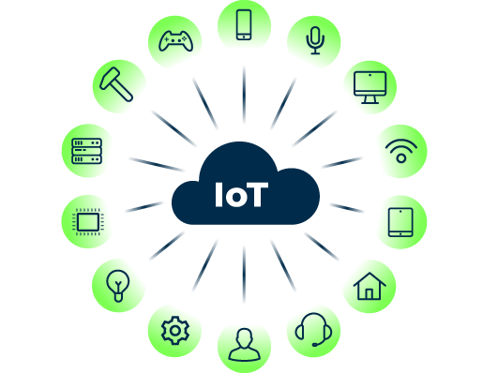

1. IoT

The Internet of Things (IoT) describes devices with sensors, processing ability, software, and other technologies that connect and exchange data with other devices and systems over the Internet or other communications networks. The Internet of Things encompasses electronics, communication, and computer science engineering. Internet of Things has been considered a misnomer because devices do not need to be connected to the public internet, they only need to be connected to a network and be individually addressable.

The Internet of Things (IoT) describes the network of physical objects "things" that are embedded with sensors, software, and other technologies to connect and exchange data with other devices and systems over the Internet. These devices range from ordinary household objects to sophisticated industrial tools. With more than 7 billion connected IoT devices today, experts are expecting this number to grow to 10 billion by 2020 and 22 billion by 2025. Over the past few years, IoT has become one of the most important technologies of the 21st century. Now that we can connect everyday objects—kitchen appliances, cars, thermostats, baby monitors—to the internet via embedded devices, seamless communication is possible between people, processes, and things.

IoT is not only limited to consumer devices and applications though. There are also game changers such as industrial and commercial IoT. We are talking about self-driving cars that communicate with each other and to the road, constantly sharing and exchanging data. To keep traffic flowing, IoT can calibrate how closely automobiles follow each other based on multiple variables surrounding them. These commercial and industrial applications of IoT are revolutionary. A multitude of possibilities arise as IoT advances.

Using low-cost computing, the cloud, big data, analytics, and mobile technologies, physical things can share and collect data with minimal human intervention. In this hyperconnected world, digital systems can record, monitor, and adjust each interaction between connected things. The physical world meets the digital world—and they cooperate. While the idea of IoT has been in existence for a long time, a collection of recent advances in several different technologies has made it practical.

1. *Connectivity*.

A host of network protocols for the internet has made it easy to connect sensors to the cloud and other "things" for efficient data transfer.

1. *Cloud computing platforms.*

The increase in the availability of cloud platforms enables both businesses and consumers to access the infrastructure they need to scale up without actually having to manage it all.

1. *WIRELESS COMMUNICATION*

The process using the Radio - Frequency spectrum for Transmitting and Receiving Voice, Data, and Video signals by which information(s) are shared is known as Wireless Communication.

1. **Problem Statement**

The loss of human lives is a tragic consequence, emphasizing the need for robust protective measures. Inadequate protection against surgical strikes, lack of comprehensive 360-degree, 24\7 surveillance system, and absence of merciless shooting facilities pose significant vulnerabilities. The persistent issue of drug penetration, and lack of effective solutions for soldiers coping with limb loss. Our reported model Unmanned Wireless multifunctional robot with its functionality, advancement in technology surveillance advent to use in remote and defense areas of military applications using IOT where the proposed system replaces soldiers to save lives and decreases the amount of trespassing on the border.

1. **Objectives**

* To identify the person, a Camera is attached to show the real-time data wireless through RF.
* To detect toxic gases and particular gases in the air; a gas sensor can be used and all these values are updated on the website for every predefined time.
* To detect metal arms and weapons metal sensor is used.
* To detect human intruders or soldiers beneath the earth PIR sensor is used.

1. **Methodology**
2. *Proposed System*

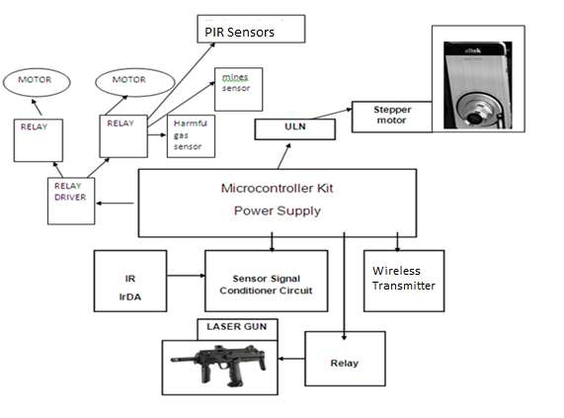

1. **Proposed System**

Implementing a comprehensive security and surveillance system can be achieved using a variety of advanced technologies. MQ series sensors (135, 37, 55) can provide effective protection from potential threats like surgical strikes by detecting specific gases or chemicals. A 360-degree motion sensor system ensures continuous, 24/7 surveillance, covering all angles and leaving no blind spots. To enhance defense capabilities, a merciless shooting facility utilizing LASER guns can be integrated, providing a precise and immediate response to intrusions. Additionally, metal detector sensors are crucial for identifying and neutralizing mines and bombs, offering protection against explosive threats. For live human detection, PIR sensors are employed to accurately sense movement and presence. An artificial intelligence photography system can be established using ESP32 cameras, which provide real-time image processing and analytics. Furthermore, an IoT-based notification system can be implemented using the IFTTT server, Jio Cloud, and BLYNK servers, ensuring timely alerts and updates. A 360-degree surveillance solution also plays a vital role in combating drug trafficking, helping to prevent the penetration of narcotics like cocaine and opium into the country. These integrated technologies work together to create a robust and multi-faceted security framework.

1. *System Requirements*

To be used efficiently, all computer software needs certain hardware components or other software resources to be present on a computer. These prerequisites are known as system requirements and are often.

1. *Hardware Requirements*
2. Micro controller ESP32

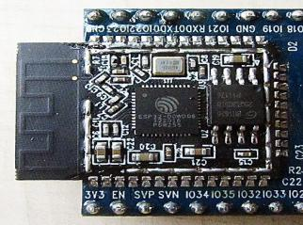

1. ESP32

The ESP32 series employs either a Ten silica Xtensa LX6 microprocessor in both dual-core and single-core variations, Xtensa LX7 dual-core microprocessor, or a single-core RISC-V microprocessor and includes built-in antenna switches, RF balun, power amplifier, low-noise receive amplifier, filters, and power-management modules. ESP32 was created and developed by Es Press if Systems, a Chinese company based in Shanghai, and is manufactured by TSMC using its 40 nm process. It is a successor to the ESP8266 microcontroller.

1. *laser Gun*

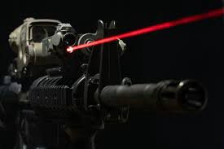

1. Laser Gun

Laser guns enhance precision targeting and rapid response capabilities on the battlefield. The laser gun's advanced technology promises improved efficiency and reduced logistical burden in combat scenarios. This research aims to explore its potential impact on future military operations

1. *IR Sensor*

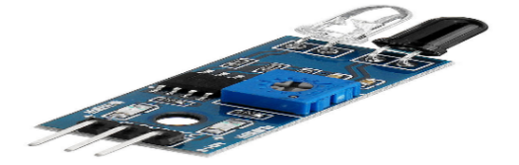

1. IR Sensor

Infrared technology addresses a wide variety of wireless applications. The main areas are sensing and remote controls. In the electromagnetic spectrum, the infrared portion is divided into three regions: near-infrared region, mid-infrared region, and far infrared region.

1. *Gas sensor*

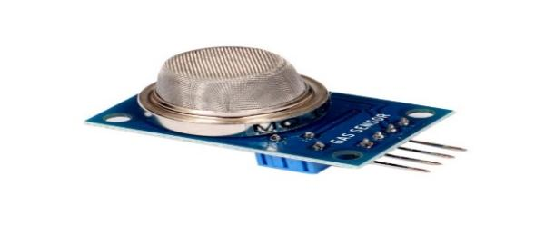

1. Gas Sensor

The Gas Sensor Module is a low-cost semiconductor sensor that can detect the presence of Ammonia (NH3), Mono-nitrogen oxides (NOx), Alcohol, Benzene, Smoke, carbon dioxide (CO2), etc.

1. *Metal Sensor*

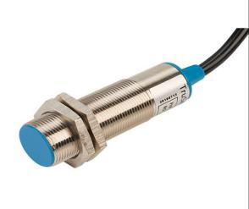

1. Metal sensor

A metal sensor detects metallic objects by generating electromagnetic fields or using pulse induction technology, crucial for security screenings, archaeological digs, and industrial applications. Its ability to locate buried metals aids in various fields including security, construction, and resource exploration.

1. *PIR sensor*

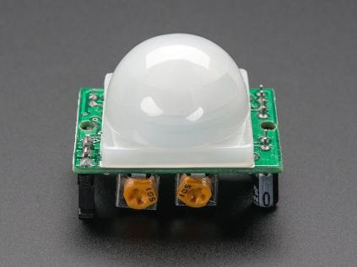

1. PIR Sensor

A PIR (Passive Infrared) sensor detects infrared radiation emitted by living beings and objects with heat. It's commonly used in security systems to detect motion, trigger alarms, or activate lights, making it invaluable for both residential and commercial applications.

1. 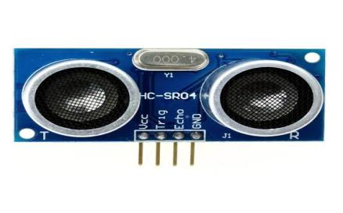*Ultrasonic Sensor*
2. Ultrasonic Sensor

The HC-SR04 ultrasonic sensor uses sonar to determine the distance to an object as bats do.

1. *Software Requirements*
2. *BLYNK IoT App*



1. Blynk

When a user opens a mobile app, the app communicates with the device's operating system and other built-in software components to access the device's hardware which can control the various operations.

1. *Arduino IDE*

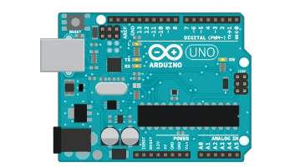

1. Arduino IDE software

Arduino is an open-source electronics platform based on easy-to-use hardware and software. Arduino boards can read inputs - a light on a sensor, a finger on a button, or a Twitter message - and turn them into an output - activating a motor, turning on an LED, publishing something online. can tell the board what to do by sending a set of instructions to the microcontroller on the board. To do so use the Arduino programming language (based on Wiring), and the Arduino Software (IDE), based on Processing.

1. *System Design*

Initialize Microcontroller

Initialize sensor

Detect the VALUE

Activate Buzzer / SEND NOTIFICATION

Alert message

1. System Design

The word system is possibly the most overused and abused term in the technical lexicon. A system can be defined as "a set of facts, principles, rules, etc., classified and arranged in an orderly form to show a logical plan linking the various parts" Here the system design defines the computer-based information system. The primary objective is to identify user requirements and to build a system that satisfies these requirements.

Design is a much more creative process than analysis. Design is the first step in the development of any system or product. Design can be defined as "the process of applying various techniques and principles to define a device, a process or a system in sufficient detail to permit its physical realization".

It involves four major steps they are

1. Understanding how the system is working now;

2. Finding out what the system does now;

3. Understanding what the new system will do; and

4. Understanding how the new system will work.

To avoid these difficulties, a new system was designed to keep these requirements in mind. Therefore the manual process operation has been changed into GUI GUI-based environment, such that the user can retrieve the records in a user-friendly manner and it is very easy to navigate to the corresponding information.

1. *Data Flow Diagram*

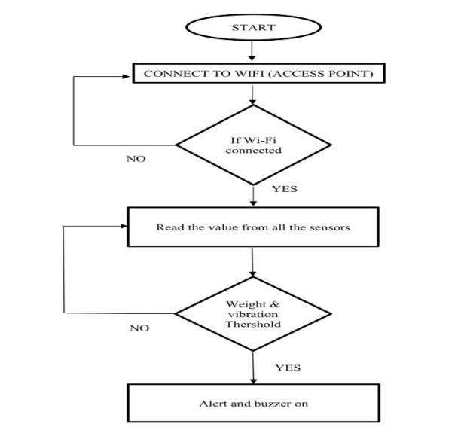

1. Data Flow Diagram

Figure 13. shows the data flow diagram for the proposed system. A DFD is a logical model of the system. The model does not depend on the hardware, software, and data structures of file organization. It tends to be easy for even non-technical users to understand and thus serves as an excellent communication tool.

DFD can be used to suggest automatic boundaries for the proposed system at a very high level; the entire system is shown as a single logical process identifying the sources and destination of data. This is often referred to as zero-level DFD.

Then the processing is exploded into major processes and the same is depicted as level one DFD.

1. Results and Discussions

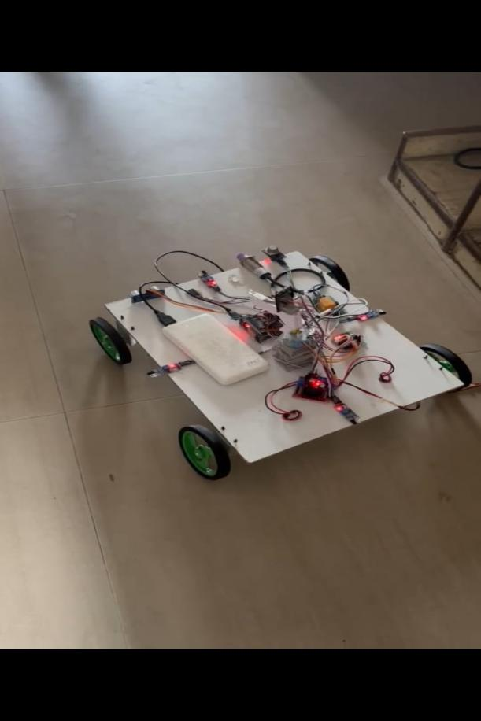

1. Unmammed Robot Hardware Model

The working of a robot with sensors, where all three sensors of live human detection, Metal, and Gas sense the object in front of it within 10cm and gives us a sensed notification on the App called BLYNK. The movement of a robot can be controlled and operated by a mobile phone by a user like the front, back, left, and right. Along with the sensing, the gun turns in the direction of detection and also shoots the object on the spot with a laser gun.

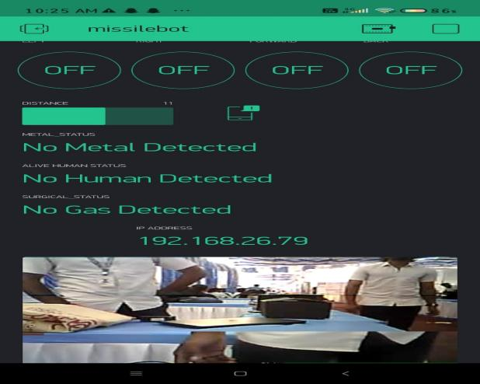

Fig 15. Dashboard of BLYNK app

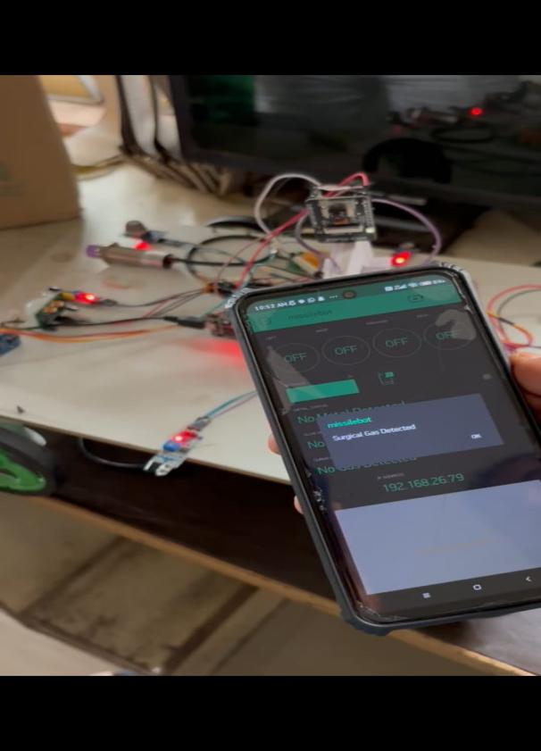

Fig16. Surgical Gas Detected

Above fig 16. shows the surgical gas detection like hydrogen sulfide, carbon dioxide, ethylene oxide, etc.,

The emergence of intelligent unmanned robots leveraging IoT for military applications signifies a transformative leap in modern warfare capabilities. These robots, equipped with advanced sensors, communication systems, and autonomous decision-making capabilities, offer a multitude of strategic advantages and operational opportunities on the battlefield. One of the key strengths of intelligent unmanned robots in military applications is their ability to operate autonomously or semi-autonomously, reducing the need for human intervention in hazardous or high-risk environments. This autonomy enables these robots to perform a wide range of tasks, including reconnaissance, surveillance, target acquisition, and logistics support, with precision and efficiency. Moreover, the integration of IoT technologies allows these robots to collect, process, and transmit vast amounts of data in real time, providing commanders with timely and actionable intelligence to make informed decisions on the battlefield. By leveraging sensors such as cameras, LiDAR, GPS, and environmental sensors, these robots can gather valuable information about enemy positions, terrain conditions, and potential threats, enhancing situational awareness and operational effectiveness. Furthermore, intelligent unmanned robots offer significant advantages in terms of flexibility and adaptability. Their modular design allows for easy customization and integration of additional capabilities or payloads, depending on the mission requirements. This versatility enables these robots to perform a wide range of tasks across different operational environments, from urban warfare to remote reconnaissance missions. However, the deployment of intelligent unmanned robots in military applications also raises ethical, legal, and strategic considerations. Questions surrounding the ethical use of autonomous weapons, accountability for actions taken by these robots, and adherence to international humanitarian law are paramount. Additionally, concerns about cybersecurity, data privacy, and the potential for unintended consequences or escalation of conflicts must be carefully addressed.

1. **Conclusion**

Merciless bsf is the current area of research where lots of scope exists. Currently this particular security technique is required by several countries .one such enhancement we are trying to do. The type of communication technique enhance operation, where the user can control the m from any part of world by getting live video feedback, compared to earlier robots work like wifi with constraints have limited, iot and s video camera makes it cost effectives combat robot. This robotic vehicle with different widely be used as surveillance robot for se c emergency rescue operations where human and user will be able to alert prior to intruderThe proposed system gives an exposure to design a multifunctional defence robot. This robot has a widespread industrial, defense applications. The laser gun attached to the robot is an excellent substitute for the weapons carried by the soldiers. The laser gun can be triggered with the help of wireless camera. It can be used in a hostage situation to pinpoint the exact location of terrorists with the help of wireless camera, saving many lives during rescue mission. Another application is border security system to sense movement of intruder through pir sensor. The current range of operations is up to 10m and can be made more sophisticated. Laser gun found to be very accurate in pointing to the target.

1. **ACKNOWLEDGEMENT**

The authors would like to sincerely thank Dr. B N SHOBHA, principal, BGSIT, BG NAGAR for providing the necessary facilities and support, Dr. P S PUTTASWAMY, professor and head of the department, electronics, and communication Engineering BGSIT, BG NAGAR, for their support and valuable suggestion to complete this paper and we would like to thank KSCST SPP for funding this project.to complete this paper and we would like to thank KSCST SPP for funded this project.

**References**

[1]. Bhawana D. Parate and Jagruti J. Shah, "Design and Development of Multifunctional Robot for Military Purpose Application", International Journal of Engineering Research and Applications IJERA ISSN: 2248-9622 International Conference on Industrial Automation and Computing ICIAC- 12-13th April 2014.

[2]. Sharath Sethu Raghavan, Jasim M,[2], "Hazardous Gas & Mine Detecting Robot", International Journal of Computer Trends and Technology (IJCTT) – Volume 28 Number 1 – JUNE 2020.

[3]. Sweeta Deshmukh, Priyadarshini, Mamta Madhura Deshmukh, Dr.Md.Bakhar, "IOT Based Surveillance Robot",2nd National Conference on Recent Advances in Engineering and Technology, 2019

[4]. Vishal L. Mate, Mayuri B.Borse, KomalPatalpure, BhagyashreePawar," IOT Based Wireless Multifunctional Robot for Military Applications" IJARIIE-ISSN(O)-2395-4396-4295", Vol-3 Issue-2 2017

[5]. Ramesh Nayak and Mithuna Shetty, "Touch Screen Controlled Defence Robot", The IIOAB General, 4th April 2016.

[6]. A Sharma and Balamurgan MS. "Mobile robotic system for search mission", International Conference on Innovations in Information, Embedded and Communication Systems (ICIIECS), Coimbatore, 2020, 1–4.

[7]. Premkumar .M, "Unmanned multi-functional robot using Zigbee adopter network for defense application" International Journal of Advanced Research in Computer Engineering & Technology (IJARCET) Volume 2, Issue 1, January 2020.

[8]. Tarunpreet Kaur, Dilip Kumar, "Wireless Multifunctional Robot for Military Applications" Proceedings of 2015 RAECS UIET Panjab University Chandigarh 21-22nd, December 2020

[9]. R. Karthikeyan, S. Karthik, Prasanna Vishal, S. Vignesh snitch design and development of a "Mobile robot for surveillance and reconnaissance" IEEE Sponsored 2nd International Conference on Innovations in Information Embedded and Communication Systems ICIIECS'2021

[10]. Muhammed Jabir NK, Neetha John, Muhammed Fayas, Midhun Mohan, Mithun Sajeev, and Safwan CN, "Wireless Control of Pick and Place Robotic Arm Using an Android Application," International Journal Of Advanced Research In Electrical, Electronics And Instrumentation Engineering 2021.