**Instant Sign Language Translation to Text and Speech via CNN**

**V.Karpagam1, Hariharan Balachandran2, K.R Aakash3, R.G. Kabilesh Kannan4**

*1Assistant Professor Department of Computer Science and Engineering, K.L.N. College of Engineering, Sivagangai, Tamilnadu, India.*

*2,3,4,5 Final Year Students, Department of Computer Science and Engineering, K.L.N. College of Engineering, Sivagangai, Tamilnadu, India.*

**Abstract:** To create a real-time strategy for recognizing and vocalizing American Sign Dialect (ASL) finger spelling, using Convolutional Neural Systems (CNN's). Sign dialect, one of the most seasoned and most characteristic shapes of communication, can be viably recognized through programmed motion acknowledgment from camera pictures. In this strategy captures hand signals through a camera, forms these pictures to distinguish and channel the hand, and after that analyzes the hand's position and introduction. The handled information is utilized to prepare a CNN, which precisely classifies the ASL signals. In expansion to motion acknowledgment, the framework changes over the recognized motions into content, which is at that point talked out loud. This highlight empowers a consistent interpretation from sign dialect to discourse, making communication more available for both sign dialect clients and those who may not get it.

**Keywords:** Convolutional Neural Network , Image Processing, Gesture recognition ASL.

# **I. INTRODUCTION**

This venture executes a real-time sign dialect acknowledgment framework that employments a CNN demonstrate to translate hand signals captured through webcam. Leveraging Media-pipe for hand following and Open-CV for video input, it recognizes and classifies signals into content, interpreting American Sign Language Dialect (ASL). The recognized content is at that point changed over to discourse employing a text-to-speech motor. The framework gives a consistent way to bridge communication between sign dialect clients and non-signers, upgrading openness and incorporation.

## **II. OBJECTIVE**

The most objective of this venture is to create a real-time sign dialect acknowledgment framework that precisely identifies and interprets hand signals employing a prepared CNN demonstrate. The framework points to encourage communication by interpreting American Sign Dialect (ASL) signals into text and changing over the content into discourse employing a text-to-speech motor. It looks for to improve openness for the hearing and speech-impaired community, permitting them to connected more effectively with non-signers. Also, the framework aims to be proficient and user-friendly, leveraging computer vision procedures like Media-pipe for exact hand following and Open-CV for video capture. This extend will advance more prominent inclusivity by bridging the communication crevice between underwriters and non-signers.

## **III. LITERAURE SURVEY**

1. **Gesture Recognition Using CNN Models and Media-pipe for Real-Time Tracking:**

Later ponders have appeared the viability of utilizing Convolutional Neural Systems (CNN's) for signal acknowledgment, especially for American Sign Dialect (ASL). Investigate by Z hang et al. (2020) highlights CNN's capacity to precisely classify hand signals by extricating spatial highlights from video inputs. This strategy has belated conventional acknowledgment methods in both precision and effectiveness.

1. **Text-to-Speech (TTS) Integration for Accessibility:**

Text-to-speech (TTS) motors are a significant component in moving forward openness in sign dialect acknowledgment frameworks. The viability of motors like pyttsx3 in changing over recognized motions into discourse yield, permitting for smoother communication between underwriters and non-signers. By interpreting sign dialect into both content and discourse, these frameworks bridge communication crevices in both individual and proficient settings, cultivating more prominent consideration for the hearing and speech-impaired community.

## **IV. EXISTING SYSTEM**

The Sign Dialect Acknowledgment frameworks basically depend on picture handling procedures and machine learning models like CNN to classify hand signals. A few frameworks utilize Media-pipe for real-time hand following, whereas others change over signals into content or discourse utilizing text-to-speech (TTS) motors. These frameworks point to encourage communication between endorsers and non-signers but frequently need exactness or speed.

**V. PROPOSED SYSTEM**

## The proposed framework points to make a real-time sign dialect acknowledgment arrangement employing a CNN show for accurate gesture classification and Media-pipe for exact hand following. It'll change over recognized motions into content and discourse employing a text-to-speech motor, upgrading communication and availability for the hearing and speech-impaired community.

## **VI. ARCHITECTURE DIAGRAM**

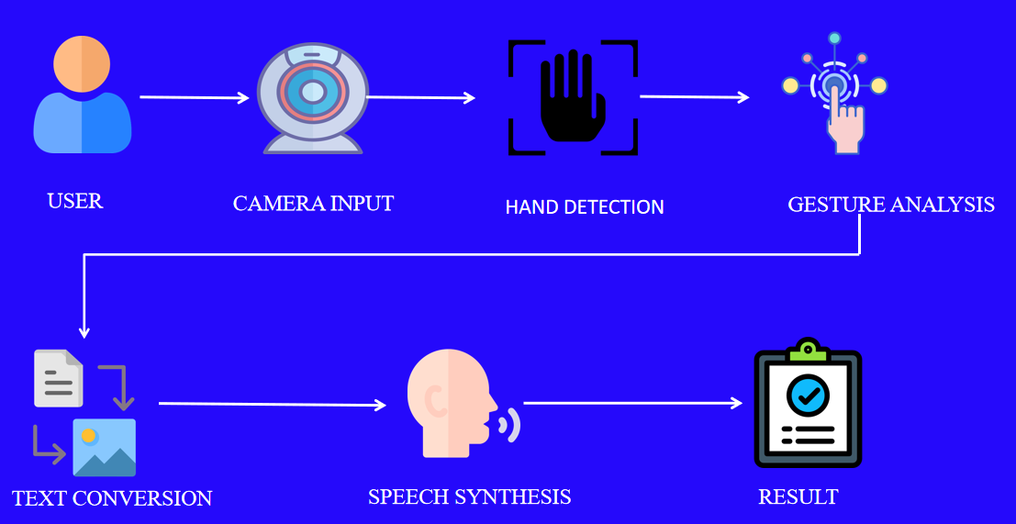

## **VII. SYSTEM OVERVIEW**

### **1. Data Collection**

### Data Information collection for the sign dialect acknowledgment framework ought to center on capturing hand motions from different people to extend show precision. This could be done by means of a webcam, capturing different foundations, lighting conditions, and points. Guarantee a adequate dataset of motions like 'hello' and 'hi' for steady expectations**.**

### **2. Hand Detection and Segmentation**

In this phase, the camera captures input from the user, and the system processes the video stream to detect the user's hands. Techniques like **MediaPipe** (as you are already using) or other computer vision methods are utilized to recognize the hand(s) within the camera frame and segment them from the background.

### **3. Text Conversion**

The recognized sign gestures are transformed into written text. This conversion allows the system to output the corresponding words, providing an accurate representation of the signs performed by the user.

### **4. Speech Synthesis**

After text conversion, speech synthesis takes the generated text and converts it into spoken words. This can be done using text-to-speech (TTS) technologies, where a machine learning model or predefined engine reads the text out loud. This phase improves accessibility by giving the user auditory feedback or helping them communicate with others in real-time.

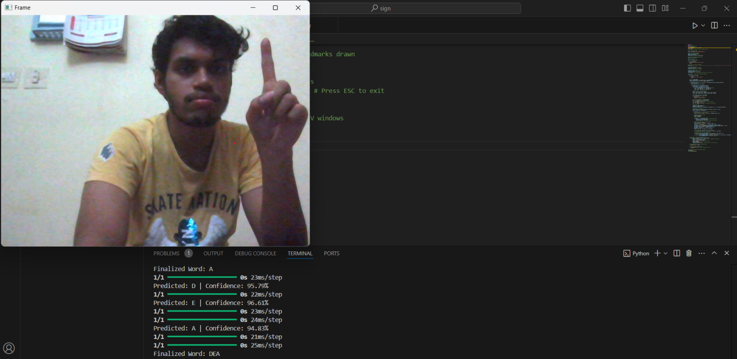

***Figure 7.1 Detection of sign***

**IX. CONCLUSION**

The proposed arrangement upgrades communication for the hearing and speech-impaired community by executing a real-time sign dialect acknowledgment framework. By coordination hand following, motion acknowledgment, and text-to-speech innovation, it cultivates inclusivity and availability, successfully bridging the crevice between sign dialect clients and non-signers.

# **REFERENCES**

[1]. Joao Carreira andA. Zisserman “ An efficient two stream network for isolated sign language Recognition” IEEE Xplore Vol.no:10,Published 2022

[2].A. A. Barbhuiya, R. K. Karsh, and R. Jain, ‘‘CNN based feature extraction 918 and classification for sign language,’’ Multimedia Tools Appl., vol. 80, 919 no. 2, pp. 3051–3069, 2021.

[3]. A. A. I. Sidig, H. Luqman, S. Mahmoud, and M. Mohandes, ‘‘KArSL: 968 Arabic sign language database,’’ ACM Trans. Asian Low-Resource Lang. 969 Inf. Process., vol. 20, no. 1, pp. 1–19, Jan. 2021.

[4]. K. B. S. Rao, Hermann Ney, Anil K. Jain, M. L. G. Joy computer science and education on IEEE Access, Vol.no:8, ppl67341, 2023

[5].H. Luqman and E.-S.-M. El-Alfy, ‘‘Towards hybrid multimodal manual and non-manual Arabic sign language recognition: MArSL database and pilot study,’’ Electronics, vol. 10, no. 14, p. 1739, Jul. 2021.

[6].A. A. I. Sidig, H. Luqman, S. Mahmoud, and M. Mohandes, ‘‘KArSL: Arabic sign language database,’’ ACM Trans. Asian Low-Resource Lang. Inf. Process., vol. 20, no. 1, pp. 1–19, Jan. 2021.

[7].J. Imran and B. Raman, ‘‘Deep motion templates and extreme learning machine for sign language recognition,’’ Vis. Comput., vol. 36, no. 6, pp. 1233–1246, Jun. 2020.

[8]Chen, L., & Wang, Y. (2023). "Enhancing Accessibility: A Sign Language Recognition System with Real-Time TTS Output." Journal of Accessibility and Design for All, 13(2), 102-118.

[9].Zhang, H., & Zhang, W. (2022). "Real-time Sign Language Recognition Using CNNs and MediaPipe." Journal of Machine Learning Research, 23(45), 1-20.

[10].B.; Zdravevski, E.; Lameski, P.; Pires, I.M.; Melero, F.J.; Martinez, T.P.; Garcia, N.M.; Mihajlov, M.; Chorbev, I.; Trajkovik, V. Technological Solutions for Sign Language Recognition: A Scoping Review of Research Trends, Challenges, and Opportunities. IEEE Access 2022, 10, 40979–40998.