**IOT ENABLED SMART WASHROOM**

Abhishek Y P**,**

*Department of Electronics and Communication Engineering,*

BGSIT, BG Nagara,

Karnataka, India,

[abhishekyp20@gmail.com](mailto:abhishekyp20@gmail.com)

Bharath K R*,*

*Department of Electronics and Communication Engineering,*

BGSIT, BG Nagara,

Karnataka, India,

[bharathkr395@gmail.com](mailto:bharathkr395@gmail.com)

Jayanth Kumar A R,

*Department of Electronics and Communication Engineering,*

BGSIT, BG Nagara,

Karnataka, India,

[jayanthcrpar@gmail.com](mailto:jayanthcrpar@gmail.com)

Nanditha J,

*Department of Electronics and*

*Communication Engineering,*

BGSIT, BG Nagara,

Karnataka, India,

[gnanditha29@gmail.com](mailto:gnanditha29@gmail.com)

Dr. Manoj Kumar S B,

*Department of Electronics and*

*Communication Engineering,*

BGSIT, BG Nagara,

Karnataka, India,

[manojkumarsb@bgsit.ac.in](mailto:manojkumarsb@bgsit.ac.in)

***Abstract—While progress is undoubtedly being made in the cutting-edge globe, our country's cleanliness is in jeopardy. The purpose of this paper is to supply hygienic and clean restrooms. Every public restroom ought to be hygienic and spotless. The government of our nation launched the "Swachh Bharat" (Clean India) program. One of the goals of the Clean India initiative is to maintain uncontaminated toilets. This study has the potential to support the clean India initiative. It may eventually demonstrate the major role in the Clean India Plan. The smart bathroom system integrates features like an automatic water tap for hands-free operation, water leakage detection to prevent waste, and an exhaust fan with odour sensing for improved air quality. It dispenses auto air freshener based on bad smell detection linked to overall air quality monitoring. Users can control and monitor these functions through a mobile app. Additionally, an auto-cleaning mechanism activates after every 10 entries to ensure a hygienic space. This system aims to enhance efficiency and convenience in the bathroom environment.***

1. **Introduction**

Digital technology is the closest thing to undefined, constantly evolving vocabulary. Jargon abounds in the world of technology, from dongles to routers, smart hubs to podcasts. But there's one term that might be useful to know: IoT. Although it's a strange way to put it, items that are configured for WLAN (wireless local area network) or WPAN (wireless personal area network) could find their way into every home in the globe by tracking behaviours and monitoring things in different contexts. Studies on improving the restroom experience are, nevertheless, scarce. This article, which builds upon our earlier publication in the conference proceedings, details the creation and application of a smart health-monitoring bidet in full, including new and additional information that we did not previously report. Traditionally, bidets have been used to clean and maintain the perianal area of a toilet seat.

A high-pressure water jet is used in basic bidets to clean the genital and anus regions. On the other hand, the jets can also operate on their own in more current models. The project was created during a summer internship in AI with the goal of increasing productivity and working convenience. There was a clear issue with the restroom at the beginning of the internship: there was only one toilet on the level where more than twenty people worked. This turned out to be a hassle because folks would frequently stroll to the bathroom only to discover it was occupied. However, people's working productivity would increase if there was a mechanism to determine whether the restroom was occupied. This would eliminate the need for individuals to constantly check.

1. *Internet of Things*

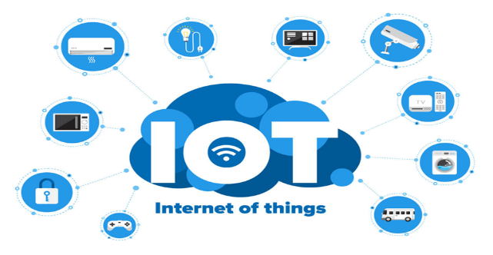

1. IoT

Devices containing sensors, processing power, software, and other technologies that connect to other devices and systems over the Internet or other communications networks to exchange data are referred to as Internet of things, or IoT devices. Electronics, communication, and computer science and engineering are all included in the Internet of things. The term "internet of things" has been deemed misleading since gadgets merely need to be individually addressable and connected to a network, not the whole internet.

The network of physical items, or "things," that are implanted with sensors, software, and other technologies in order to communicate and exchange data with other devices and systems over the internet, is known as the Internet of Things (IoT). These gadgets might be anything from simple domestic items to highly advanced industrial instruments. Experts predict that the current number of linked IoT devices—more than 7 billion—will increase to 10 billion by 2020 and 22 billion by 2025. IoT has emerged as one of the 21st century's most significant technologies in the last few years. Now that commonplace items like vehicles, baby monitors, thermostats, and kitchen appliances can be connected to the internet through embedded devices, communication between people, processes, and things may happen seamlessly.

IoT isn't just for consumer electronics and apps, though. Then there are the game-changers, like commercial and industrial IoT. We are discussing self-driving automobiles that exchange and share data continuously, both with the road and with each other. IoT can adjust how closely cars follow one another based on several factors around them to maintain traffic flow. These IoT applications for business and industry are ground breaking. As IoT develops, numerous opportunities present themselves.

Physical objects can communicate and collect data with minimal human intervention thanks to low-cost computers, the cloud, big data, analytics, and mobile technologies. Digital technologies in today's hyperconnected environment are able to record, monitor, and modify every interaction between connected objects. When the real and digital worlds collide, they work together.

1. *Connectivity*

The internet's many network protocols have made it simple to link sensors to other "things" and the cloud for effective data transfer.

1. *Cloud computing platform*

Cloud platforms are becoming more widely available, giving consumers and organizations access to the infrastructure they need to grow up without actually having to manage it all.

1. *Industrial IoT*

The use of IoT technology in industrial settings, particularly in relation to the instrumentation and management of sensors and devices that use cloud technologies, is referred to as industrial IoT (IIoT). Machine-to-machine (M2M) communication has been employed recently by industry to accomplish wireless automation and control. However, companies can achieve a new automation layer and with it develop new revenue streams and business models thanks to the rise of cloud computing and related technologies. IIoT is frequently referred to as Industry 4.0, or the fourth wave of the industrial revolution.

Typical applications for IIoT include the following

* Connected assets
* Predictive and Preventative maintenance Smart power grids
* Smart cities
* Connected logistics, and smart digital supply chains

1. **Problem Statement**

The current restroom environment lacks efficiency and hygiene, prompting the need for a smart bathroom system. Users face challenges with manual water taps, potential water wastage due to undetected leaks, and unpleasant odours affecting air quality. The absence of a systematic approach to address these issues leads to discomfort and inconvenience. To tackle this, there is a need for an integrated solution that includes automatic water taps for hygiene and conservation, water leakage detection to prevent waste, and an exhaust fan with odor sensing for improved air quality. The implementation of a mobile app for monitoring and control adds convenience, while an auto-cleaning mechanism ensures ongoing hygiene. The problem lies in the inefficiency and discomfort caused by the current restroom setup, emphasizing the necessity for a comprehensive smart bathroom system to enhance user experience and promote cleanliness.

1. **Objectives**

* To develop a smart washrooms prototype model for society.
* To develop an automated model to enhance user hygiene and convenience, reducing the reliance on manual operation and minimizing the risk of germ transmission.
* To integrate water leakage detection mechanisms and alert users about potential leaks, preventing prolonged water flow and reducing water wastage.
* To oversee and manage the diverse features of the smart bathroom system, offering up-to-date data and augmenting user autonomy.

1. **Methodology**
2. *Proposed System*

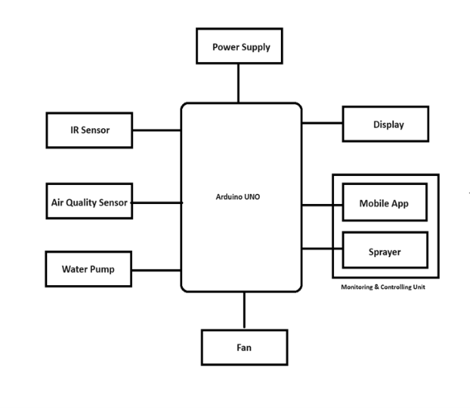

1. **Proposed System**

The proposed smart bathroom system uses Arduino which integrates several features to enhance user experience and promote efficiency. Firstly, an automatic water tap is incorporated using the pump to facilitate hands-free operation, promoting hygiene and water conservation. Secondly, IR sensor is utilized by the system for water leakage detection. This feature not only helps in preventing water wastage but also aids in early detection of potential plumbing issues. The bad smell detection is linked to the overall air quality monitoring within the bathroom. Users can monitor and control these functionalities through a mobile application, providing convenience and real-time management. Furthermore, to maintain cleanliness, an auto-cleaning mechanism is activated entry of every 10 members, ensuring a hygienic space for each user. This comprehensive system aims to blend automation, convenience, and cleanliness in the bathroom environment.

1. *System Requirements*

All computer software requires specific hardware parts or additional software resources to function properly on a computer. These prerequisites are frequently referred to as system requirements.

1. *Hardware Requirements*
2. Node MCU

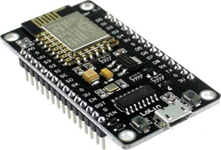

1. Node MCU

The ESP-12E module is equipped by the development board with an ESP8266 chip that houses a 32-bit Tensilica Xtensa LX106 RISC CPU. This microprocessor supports RTOS and works at an adjustable clock frequency of 80 to 160 MHz Additionally, there is 4MB of Flash memory for software and data storage and 128 KB of RAM, which is more than enough to handle the enormous strings that make up JSON/XML data, web pages, and other modern IoT device demands.

1. *Submersible Water pump*

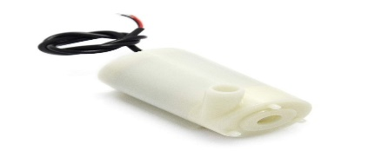

1. Submersible Pump

This submersible water pump operates between three and six volts DC. It's very straightforward to use and quite basic. To begin pumping water, just submerge the pump in water, attach an appropriate pipe to the output, and supply 3-6V of electricity to the motor. Excellent for creating scientific projects, plant watering systems, fire extinguishers, firefighting robots, fountains, and waterfalls, among other things.

1. *IR Sensor*

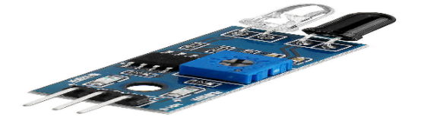

1. IR Sensor

Numerous wireless applications are addressed by infrared technology. The two primary domains are remote controls and sensors. The near infrared area, mid infrared region, and far infrared region comprise the infrared section of the electromagnetic spectrum.

1. *Air quality sensor*

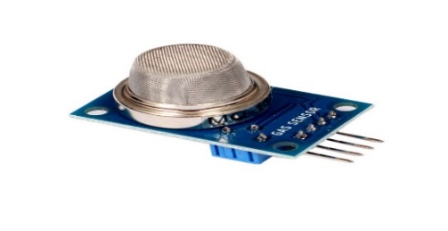

1. Air Quality Sensor

The MQ Air Quality Sensor Module is an inexpensive semiconductor sensor that can identify many substances, such as smoke, alcohol,

1. *Exhaust Fan*

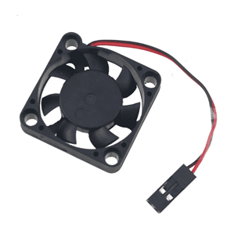

1. Fan

The purpose of exhaust fans is to help remove smoke, fumes, and odours from a space. To do this, they extract all of the air from the room and release it outdoors.

1. *Buzzer*

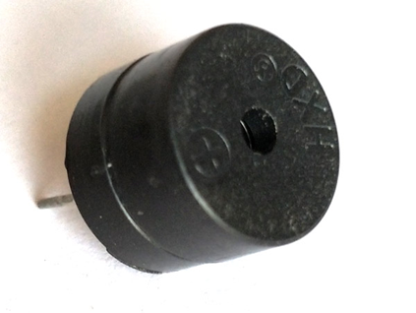

1. Buzzer

A buzzer is a little yet effective part that gives our project or system sound capabilities.

1. 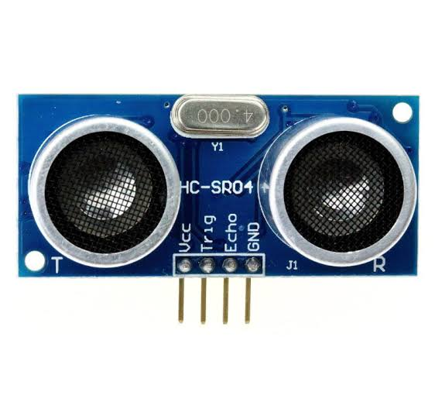*Ultrasonic Sensor*
2. Ultrasonic Sensor

Like bats, the HC-SR04 ultrasonic sensor uses sonar to measure its distance from an item.

1. *Li-Ion Battery*

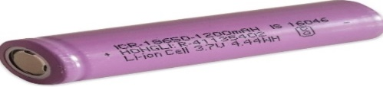

1. Li-ion Battery

High-performance 3.7V 2600mAh Li-Ion battery is what's being used here. Its 2600mAh capacity and cylindrical shape make it compatible with a wide range of devices.

1. *Software Requirements*
2. *BLYNK IoT App*



1. Blynk

When a user launches a mobile application, the app connects to the operating system and other pre-installed software on the device to gain access to the hardware, which is responsible for controlling different functions.

1. *Arduino IDE*

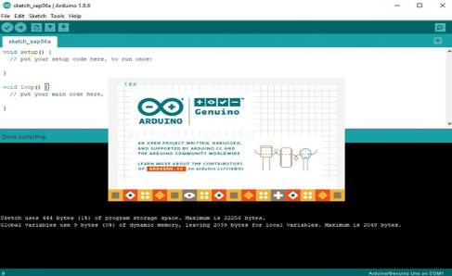

1. Arduino IDE software

The open-source electronics platform Arduino is built on user-friendly hardware and software. An Arduino board can read an input (a light on a sensor, a finger on a button, or a tweet) and convert it to an output (a motor going on, an LED turning on, or something being published online). can provide instructions to the board's microcontroller, telling it what to do. Use the Arduino Software (IDE), based on Processing, and the Arduino programming language, based on Wiring, to accomplish this.

1. *System Design*

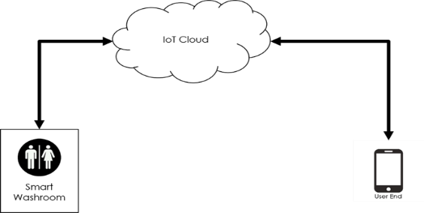

1. System Design

The suggested system's IoT system design is depicted in the above picture. The restroom at one end of the system is equipped with a variety of sensors, making it intelligent. These numerous sensors are employed for a variety of tasks. The sensors are integrated or synced with the IoT cloud, or Think Talk. Subsequently, the entire system will communicate with the user, enabling them to operate and do necessary actions for the restrooms.

1. *Data Flow Diagram*

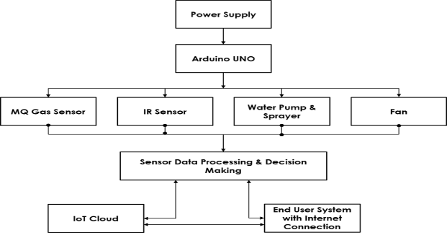

1. Data Flow Diagram

The data flow diagram for the suggested system is displayed in figure 14. First, the Arduino initializes all of the interfaced sensors when the system receives electricity. As and when needed, each sensor will begin with their actions. Every piece of data is gathered and uploaded to the IoT cloud. The last user who has an internet connection has these values enabled. The data flow is carried out in this manner continually until the system is turned on.

1. *UML Diagram*

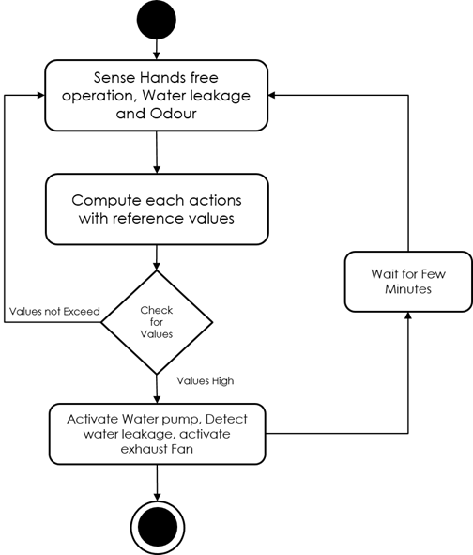

1. *UML Diagram*

The UML diagram is as shown in figure 15 smart bathroom system uses Arduino which integrates several features to enhance user experience and promote efficiency. Firstly, an automatic water tap is incorporated using the pump to facilitate hands-free operation, promoting hygiene and water conservation. Secondly, IR sensor is utilized by the system for water leakage detection. This feature not only helps in preventing water wastage but also aids in early detection of potential plumbing issues. Additionally, the system incorporates an exhaust fan equipped with an odour sensor, automatically activating when bad smells are detected.

1. Results and Discussions

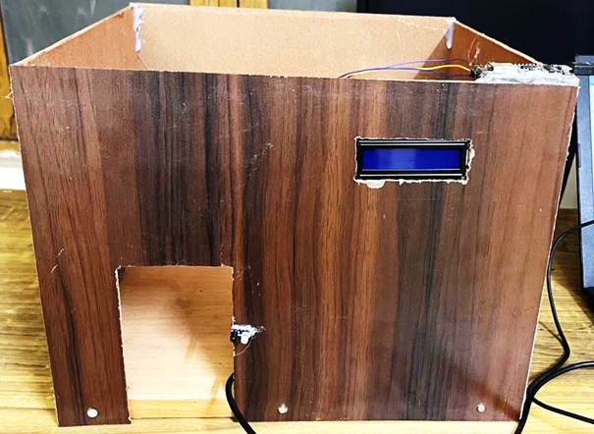

1. Smart Washroom Hardware Model

The above Fig 16 shows the Hardware Model of proposed system.

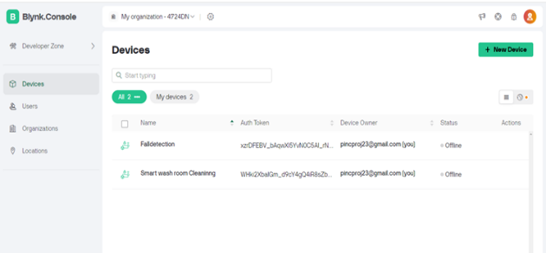

1. Blynk IoT Application dashboard

Fig 17. shows the dashboard of the project where the NodeMCU devices connected are seen and are synchronised with the sensors of the model.

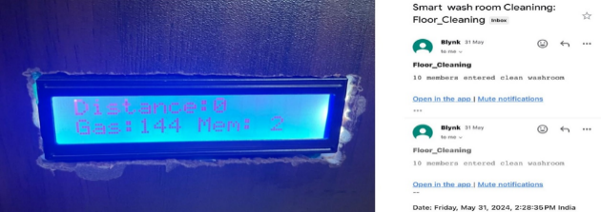

1. Floor Cleaning

Since our project is automated, first feature included is floor cleaning. The hardware is connected with IR sensors at the entry and exit levels where the LCD displays number of members as in fig 18.

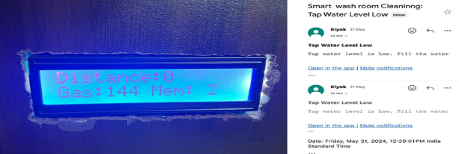

1. Tap water level

Next feature which we have concentrated on is tap water level. Here ultrasonic sensor has been utilised to detect the water level in a tank. If water is sensed it has gone below certain level then an email notification will be sent to the admin. The distance part which is seen on the LCD of Fig 19, shows the water level.

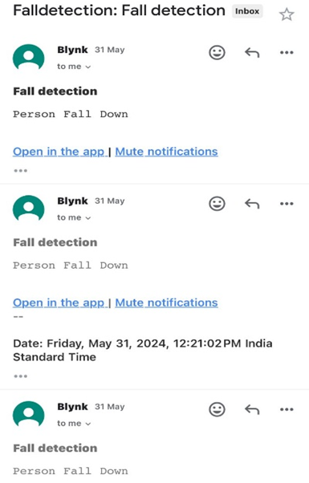

1. Fall Detection

The sensor senses if the person is lying on the floor more number of seconds, through which an email will be sent to the admin immediately as in fig 20, further help can be given as soon as possible.

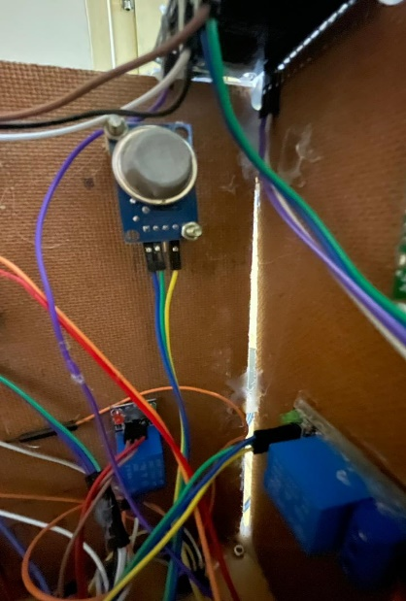

1. Gas Level

In the model, gas sensor has been integrated for odor detection feature. The sensor has been programmed to sense three levels of odor. Further it is connected to Fan and a pump which sprays room freshener. According to the level of odor, the fan and sprinkler runs for longer time like in the Table 1.

|  |  |
| --- | --- |
| **Odour level** | **Fan & Sprinkler ON (seconds)** |
| Mild Odour (Level 1) | 5 secs |
| Moderate Odour (Level 2) | 10 secs |
| High Odour (Level 3) | 15 secs |

1. Odor Levels

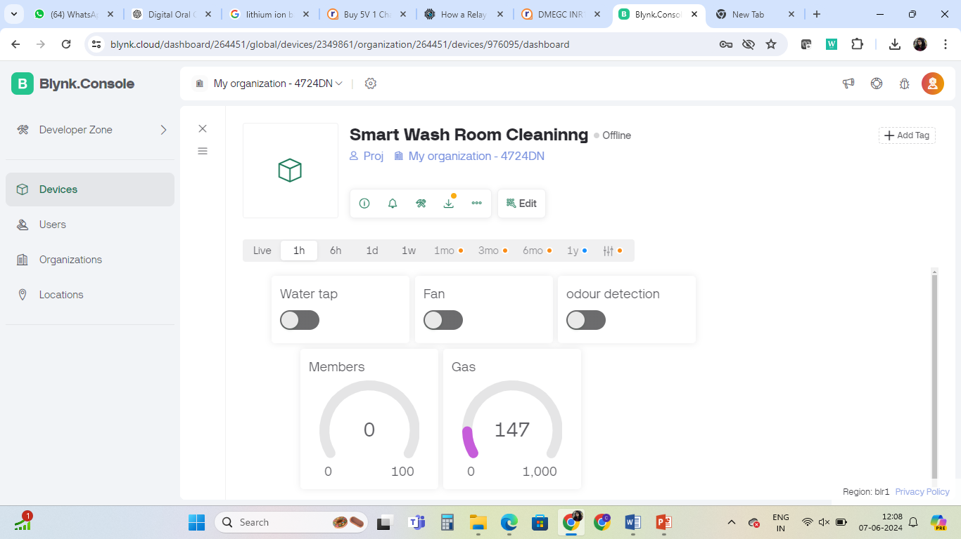

1. Manual controlling dashboard in BLYNK app

The first row has three buttons where we can control water tap, fan and freshener sprinkler manually. The second row shows the number of members’ entry and exit in real time. Gas block shows the gas sensor level in real-time.

1. **Conclusion**

In conclusion, the development of a smart bathroom system offers significant advantages in enhancing the cleanliness and hygiene of public restrooms. By integrating advanced features such as automatic water taps, odour-sensing exhaust fans, water leakage detection, and auto-cleaning mechanisms, this system aligns with the objectives of the "Swachh Bharat" (Clean India) initiative. It ensures efficient water use, reduces maintenance efforts, and provides a convenient and user-friendly experience. Despite potential challenges such as high initial costs and technical maintenance, the benefits in promoting public health and supporting sanitation initiatives are substantial. This project represents a vital step towards improving sanitation standards and fostering a healthier community.

1. **References**
2. N. Brown, P. L. Purdon, and C. J. Van Dort, “General anesthesia and altered states of arousal: A systems neuroscience analysis,” Annu. Rev. Neurosci., vol. 34, no. 1, pp. 601–628, Jul. 2011
3. A. Fritz et al., “Intraoperative electroencephalogram suppression predicts postoperative delirium,” Anesthesia Analgesia, vol. 122, no. 1, p. 234, 2016.
4. P. L. Purdon et al., “Electroencephalogram signatures of loss and recovery of consciousness from propofol,” Proc. Nat. Acad. Sci. USA, vol. 110, no. 12, pp. E1142–E1151, 2013.
5. S. Chakravarty et al., “Closed-loop control of anesthetic state in non-human primates,” bioRxiv, 2021, doi: 10.1101/2021.09.12.459958.
6. N. Sessler et al., “The Richmond agitation–sedation scale: Validity and reliability in adult intensive care unit patients,” Amer. J. Respiratory Crit. Care Med., vol. 166, no. 10, pp. 1338–1344, 2002.
7. T. A. Bowdle, “Depth of anesthesia monitoring,” Anesthesiol. Clinics North Amer., vol. 24, no. 4, pp. 793–822, 2006.
8. X.-S. Zhang, R. J. Roy, and E. W. Jensen, “EEG complexity as a measure of depth of anesthesia for patients,” IEEE Trans. Biomed. Eng., vol. 48, no. 12, pp. 1424–1433, Dec. 2001.
9. L. da Silva, “EEG and MEG: Relevance to neuroscience,” Neuron, vol. 80, no. 5, pp. 1112–1128, 2013.
10. O. Akeju et al., “Electroencephalogram signatures of ketamine anesthesia-induced unconsciousness,” Clin. Neurophysiol., vol. 127, no. 6, pp. 2414–2422, Jun. 2016.
11. W. Shin et al., “Monitoring of anesthetic depth and EEG band power using phase lag entropy during propofol anesthesia,” BMC Anesthesiol., vol. 20, no. 1, pp. 1–10, Dec. 2020.