A STUDY ON PERCEPTION OF JOB SEEKER ON RECRUITMENT THROUGH JOB PORTALS

1Deepika RM and 2PRAVEEN SV

1MBA student Jerusalem College of Engineering, Chennai

2Professor and Head MBA, Jerusalem College of Engineering, Chennai

## Abstract:

## This study investigates the perceptions of job seekers regarding the effectiveness and reliability of job portals as a recruitment platform. With the proliferation of online job search platforms, understanding job seekers' perspectives is crucial for both employers and job portal operators. Through a mixed-method approach involving surveys and interviews, this research delves into the preferences, concerns, and experiences of job seekers utilizing job portals. Initial findings suggest a mixed perception among job seekers, highlighting factors such as platform usability, trustworthiness of job listings, and the relevance of job matches. The study aims to provide insights for improving job portal functionalities and enhancing the overall recruitment experience for both job seekers and employers.

**INTRODUCTION**

The emergence of job portals has brought about a substantial shift in the recruitment environment by providing new channels of communication for job seekers and companies alike. The purpose of this study is to investigate how job seekers view hiring via employment portals. It is critical for scholars and human resources professionals to comprehend how job seekers view and use these portals in an era where digital platforms rule many facets of life.

We hope to learn more about job seekers' attitudes toward job portals, their experiences utilizing these platforms, and their general satisfaction with the recruitment process that these portals facilitate by conducting this survey. We hope to gain knowledge from exploring these facets in order to guide the creation of additional. Overall, this study contributes to the existing literature by shedding light on the evolving dynamics of recruitment in the digital age and providing valuable insights into the perceptions of job seekers regarding job portals. By understanding these perceptions, stakeholders in the recruitment process can better tailor their strategies to meet the evolving needs and preferences of job seekers, ultimately fostering more efficient and satisfactory outcomes for both parties involved.

**REVIEW OF LITERATURE**

**Erin M. K., Christopher K. and Jeremy M (2021)** has mentioned that young job seekers have become a policy priority for many governments - global youth unemployment is currently at 13% and rising. Job seekers prefer to wait for good jobs rather than accept something that is irrelevant. Overall, their findings suggest that job placement platforms raise job seekers' expectations in ways that may not be rational; and these expectation effects can only be overcome if job seekers have sufficient information about the types of jobs the portal offers. **Wadhawan and Sinha (2018)** published an article about various factors which influence the job seekers perception towards the job portals. The study is descriptive in nature. Primary and secondary both type of data was used. The primary data was collected through convenient sampling method with the help of questionnaire distributed among 150 students of University of Delhi. It showed that providing the information to job seeker about the opening is not only factor which influence the job seeker. There are other factors also such as extended services, prospective career opportunity, system quality, perceived trustworthiness, perceived ease of use and perceived usefulness which influence the job seekers’ perception. **Hafeez et. al. (2018)** investigated the effectiveness of E-recruitment system and the impacts among job seekers. Primary data was collected through sampling method and data was collected from 302 respondents in Lahore with the help of questionnaire. Regression analysis was performed to analyze the data. It was found that quality of e-recruitment websites that can increase or decrease the effectiveness of e-recruitment. **Rathee and Bhuntel (2018)** investigated the perception and attitude of employees regarding e-recruitment. The study also analyzed the impact of e-recruitment on organizations and also explored the benefits of E-Recruitment. The research design was mainly exploratory cum descriptive in nature. Primary and secondary data was used. Primary data collected through structured questionnaire based on Five point- likert scale. Secondary data collected through various online articles, research papers, journals etc.

**RESEARCH METHODOLOGY**

**ANALYSIS**

**Percentage analysis**

Table 1

**Percentage analysis for** **which online job portal do you consider your primary source for job opportunities**

**Which online job portal do you consider your primary source for job opportunities?**

|  |  |  |  |  |  |
| --- | --- | --- | --- | --- | --- |
|  | | Frequency | Percent | Valid Percent | Cumulative Percent |
| Valid | LinkedIn | 32 | 30.2 | 30.2 | 30.2 |
| Indeed | 24 | 22.6 | 22.6 | 52.8 |
| Naukri | 38 | 35.8 | 35.8 | 88.7 |
| Monster | 7 | 6.6 | 6.6 | 95.3 |
| Glassdoor | 5 | 4.7 | 4.7 | 100.0 |
| Total | 106 | 100.0 | 100.0 |  |

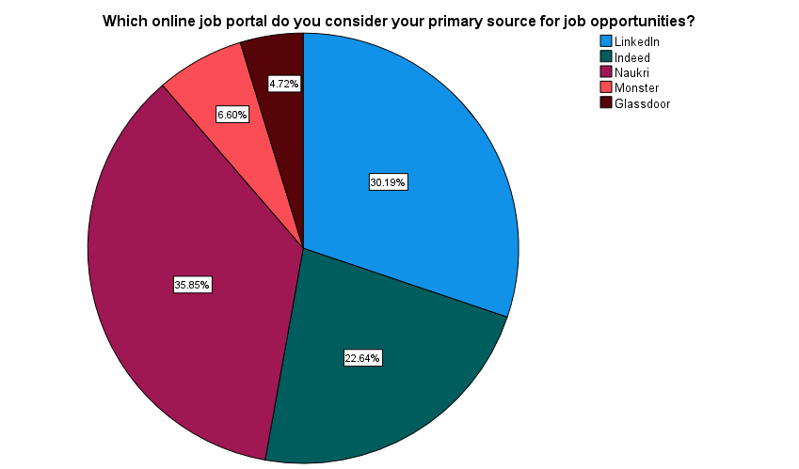

**INFERENCE:**

From the above table, it can inferred that 30.19% responded as almost LinkedIn, 22.64% responded as Indeed, 35.85% responded as Naukri, 6.60% responded as Monster, 4.72 responded as Glassdoor.

**Percentage analysis for the privacy concerns a barrier for you when using job portals**

Table 2

|  |  |  |  |  |  |
| --- | --- | --- | --- | --- | --- |
|  | | Frequency | Percent | Valid Percent | Cumulative Percent |
| Valid | Yes | 65 | 61.3 | 61.3 | 61.3 |
| No | 41 | 38.7 | 38.7 | 100.0 |
| Total | 106 | 100.0 | 100.0 |  |

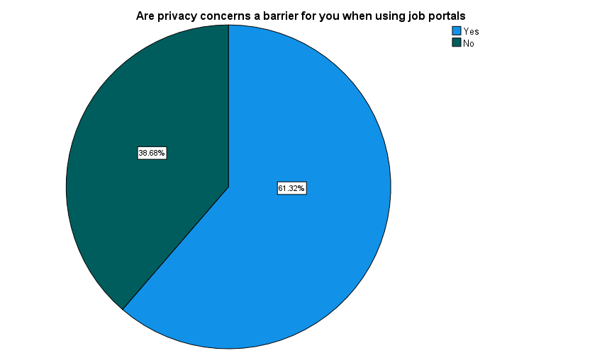

**INFERENCE:**

From the above table, it can inferred that 61.32% of the respondent are Yes and 38.68% of the responded are No. Most of the respondents are Yes

**Percentage analysis for how effective do you find job potals in matching your skills and qualications with suitable job opportunities?**

Table 3

|  |  |  |  |  |  |
| --- | --- | --- | --- | --- | --- |
| How effective do you find job portals in matching your skills and qualifications with suitable job opportunities? | | | | | |
|  | | Frequency | Percent | Valid Percent | Cumulative Percent |
| Valid | Very effective | 31 | 29.2 | 29.2 | 29.2 |
| Somewhat effective | 46 | 43.4 | 43.4 | 72.6 |
| Neutral | 24 | 22.6 | 22.6 | 95.3 |
| Not very effective | 5 | 4.7 | 4.7 | 100.0 |
| Total | 106 | 100.0 | 100.0 |  |

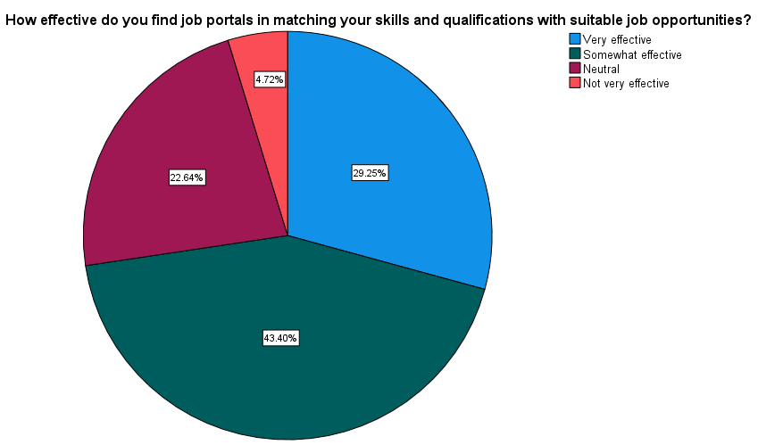

**INFERENCE:**

From the above table, it can inferred that 29.25% responded as almost very effective, 43.40% responded as somewhat effective, 22.64% responded as neutral, 4.72% responded as not very effective.

**Percentage analysis for how would you rate your overall experience with online experience with online platforms for job searching?**

Table 4

|  |  |  |  |  |  |
| --- | --- | --- | --- | --- | --- |
| How would you rate your overall experience with online platforms for job searching? | | | | | |
|  | | Frequency | Percent | Valid Percent | Cumulative Percent |
| Valid | Excellent | 24 | 22.6 | 22.6 | 22.6 |
| Good | 57 | 53.8 | 53.8 | 76.4 |
| Average | 23 | 21.7 | 21.7 | 98.1 |
| Poor | 1 | .9 | .9 | 99.1 |
| Very Poor | 1 | .9 | .9 | 100.0 |
| Total | 106 | 100.0 | 100.0 |  |

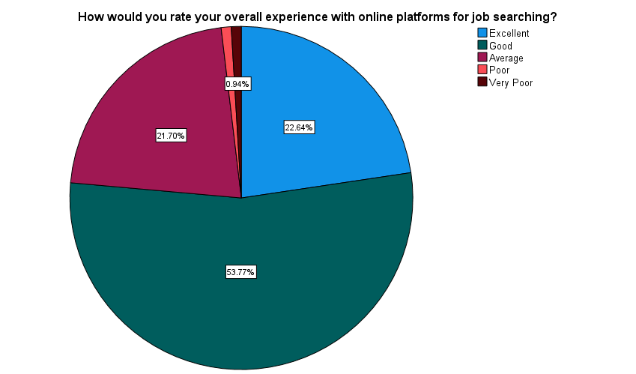

**INFERENCE:**

From the above table, it can inferred that 22.64% responded as excellent, 53.77% responded as good, 21.70% responded as average, 0.94% responded as poor, 0.95% responded as very poor.

**Percentage analysis for what types of jobs do you typically search for on job portals?**

Table 6

|  |  |  |  |  |  |
| --- | --- | --- | --- | --- | --- |
| What types of jobs do you typically search for on job portals? | | | | | |
|  | | Frequency | Percent | Valid Percent | Cumulative Percent |
| Valid | Full-time positions | 76 | 71.7 | 71.7 | 71.7 |
| Part-time positions | 14 | 13.2 | 13.2 | 84.9 |
| Freelance opportunities | 13 | 12.3 | 12.3 | 97.2 |
| Internships | 3 | 2.8 | 2.8 | 100.0 |
| Total | 106 | 100.0 | 100.0 |  |

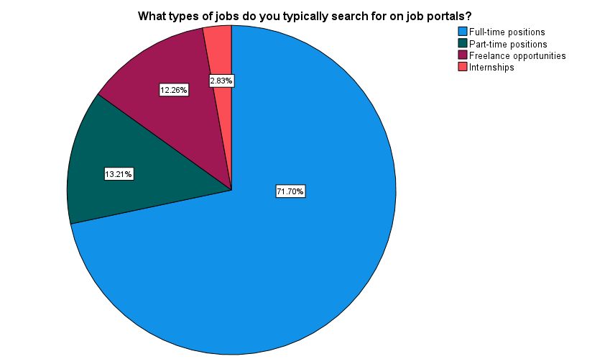

**INFERENCE:**

From the above table, it can inferred that 71.70% responded as full-time position, 13.21% responded as part-time positions, 12.26% responded as freelancer opportunities, 2.83% responded as internsips.

ONE WAY ANNOVA

* **H0:** There is no significance difference between type of job and thee privacy concern
* **H1:** There is significance difference between type of job and thee privacy concern

Table 7

|  |  |  |  |  |  |
| --- | --- | --- | --- | --- | --- |
| ANOVA | | | | | |
| What types of jobs do you typically search for on job portals? | | | | | |
|  | Sum of Squares | df | Mean Square | F | Sig. |
| Between Groups | 7.848 | 1 | 7.848 | 13.060 | .000 |
| Within Groups | 62.501 | 104 | .601 |  |  |
| Total | 70.349 | 105 |  |  |  |

**INFERENCE**

From the above result it is found that the significance value (0.00) is less than the table value (0.05). Therefore, the null hypothesis was rejected. That is, there is an association between type of job and thee privacy concern

**REGRESSION:**

**H0:** There is no significance difference between type of job and matching with their skills and qualifications

**H1:** There is significance difference between type of job and matching with their skills and qualifications

|  |  |  |  |  |  |  |
| --- | --- | --- | --- | --- | --- | --- |
| ANOVAa | | | | | | |
| Model | | Sum of Squares | df | Mean Square | F | Sig. |
| 1 | Regression | .035 | 1 | .035 | .051 | .821b |
| Residual | 70.314 | 104 | .676 |  |  |
| Total | 70.349 | 105 |  |  |  |
| a. Dependent Variable: What types of jobs do you typically search for on job portals? | | | | | | |
| b. Predictors: (Constant), How effective do you find job portals in matching your skills and qualifications with suitable job opportunities? | | | | | | |

Table 8

**INFERENCE**

From the above result it is found that the significance value (0.821) which is greater than the table value (0.05). Therefore, the null hypothesis was accepted. That is, there is no association between type of job and matching with their skills and qualifications.

CORRELATION:

* **H0:** There is no significance difference measuring the success of job search and their overall experience with online platform for job searching
* **H1:** There is significance difference between measuring the success of job search and their overall experience with online platform for job searching

Table 9

|  |  |  |  |
| --- | --- | --- | --- |
| Correlations | | | |
|  | | How would you rate your overall experience with online platforms for job searching? | Which online job portal do you consider your primary source for job opportunities? |
| How would you rate your overall experience with online platforms for job searching? | Pearson Correlation | 1 | .244* |
| Sig. (2-tailed) |  | .012 |
| N | 106 | 106 |
| Which online job portal do you consider your primary source for job opportunities? | Pearson Correlation | .244* | 1 |
| Sig. (2-tailed) | .012 |  |
| N | 106 | 106 |
| *. Correlation is significant at the 0.05 level (2-tailed). | | | |

**INFERENCE**

From the above result it is found that the significance value (0.012) which is lesser than the table value (0.05). Therefore, the null hypothesis was rejected. That is, there is an association between measuring the success of job search and their overall experience with online platform for job searching

**Findings**

Nearly 53.77% of the respondents are rate their overall experience with online platforms for job searching. As the table shows that 35.85% of the respondents using Naukri as online job portals by considering as primary source for job opportunities. As the table shows that 61.32% of respondents are thinking that job portals gives their privacy concern. As the table shows that nearly 71.70% of respondents are searching the full time type of job in the job portals. As the table shows that 43.40% of the respondents are feel that the job portals are matching with their skills and qualification with suitable job opportunities

**Suggestions**

It is crucial to use a mixed-method approach that combines qualitative and quantitative methodologies in order to accurately determine job seekers' preferences about job portals and comprehend the obstacles and difficulties they encounter. Quantitative data can be obtained through surveys, which offer statistical insights into the most desired features, usability problems, and job searchers' general satisfaction levels with job portals. Furthermore, holding focus groups or in-depth interviews can provide qualitative insights into the subtleties of job seekers' experiences, clarifying the particular difficulties they face and the underlying causes of their choices.Moreover, researchers can use comparative analyses or longitudinal studies to fully examine the effect of job portals on the success of job searches. By monitoring the advancement of job searchers over time and contrasting the results of those who use job portals

**Reference**

* http://www.essay.utwente.nl/61154. (Abel S, 2011; The role of social networking sites in recruitment: Results of a quantitative Study among German companies, 12 April 2013). http://www.quepublishing.com/articles/article.aspx?p=1829424 (Carter B, 2012; Facebook versus LinkedIn for professional networking, 25 September 2013)
* Clark LA, & Roberts SJ, 2010; Employers` use of social networking sites: A socially irresponsible practice, Journal of Business Ethics, Vol. 95, pp. 507-525.
* Dickie C & Dwyer J, 2011; A 2009 perspective of HR practices, Journal of Management Development, Vol. 30, No. 4, pp. 329-343.