**COMPUTATIONAL VIDEO ANALYSIS ON THE**

**PERFORMANCE OF INDIAN FOOTBALL TEAM IN WORLD**

**CUP QUALIFIERS 2026**

Ajay S1, Nallavan G2

*1(Department of sports Technology, Tamil Nadu Physical Education and Sports University, India)*

*2(Department of sports Technology, Tamil Nadu Physical Education and Sports University, India)*

*Corresponding Author: ajaydanielp.27@gmail.com*

|  |
| --- |
| ***Abstract:****The rise of Indian football has been gradual yet consistent. The journey for the Blue Tigers in World Cup Qualifying matches has been challenging thus far. The Indian Men's Football Team experienced their first taste of World Cup Qualifying matches in 1985 for the 1986 FIFA World Cup. Their debut match in the qualifying round resulted in a 2-1 loss against Indonesia.They skipped the 1990 World Cup Qualifiers but returned for the 1994 edition. So far, India has played 48 World Cup qualifiers and won 10 games. Their most successful campaign was the 2002 World Cup Qualifiers, where the Blue Tigers earned 11 points in six games, as per an Indian Super League (ISL) press release. India has been doing well so far in the 2026 world cup qualifiers.While football remains as the most popular sport in the world, there is a lack of understanding of the many components, or parameters, in a match that can lead to an overall successful season. Knowing how to adjust a team’s tactics based on several key parameters may provide coaches with the tools necessary to create a successful outcome. This project aims to study the performance of Team India in World Cup Qualifiers 2026 through dartfish video analysis which provides information through statistical data resulting in a better outcome.*  ***Key Word:****Football Match Analysis, Dartfish Tagging, Team Performance Analysis, World Cup Qualifiers.* |

1. **Introduction**

Football is the world’s most popular ball game in numbers of participants and spectators. Simple in its principal rules and essential equipment, the sport can be played almost anywhere, from official football playing fields (pitches) to gymnasiums, streets, school playgrounds, parks, or beaches. Football’s governing body, the [Fédération International de Football Association](https://www.britannica.com/topic/Federation-Internationale-de-Football-Association) (FIFA), estimated that at the turn of the 21st century there were approximately 250 million football players and over 1.3 billion people “interested” in football;The FIFA organizes the World Cup every four years. The finals tournament is held every four years. In the other years there are only qualifiers (qualifying tournaments) in the six FIFA world regions. These games help to decide which teams will move on. Over 160 national teams play in the qualifying games. The best teams from the qualifying games win a place in the finals. The finals now include 32 teams. Before 1998, only 24 teams were in the finals; starting in 2026, there will be 48 teams in the finals. Many years before each World Cup, FIFA picks the host nation, the country where the finals will be held [8]. Being the host nation means that their team has qualified for the finals tournament automatically and does not need to play any qualifying games [6]. The 32 teams in the finals then play for four weeks, usually between June and July, to decide who the champion (tournament winner) will be.

1. **Material And Methods**

Video analysis in sports is used for assessing and enhancing the performance of a team or an athlete and it provides visual feedback for the coaches and athletes [4] [5]. It can be used for two purposes; for technical analysis to analyze individual skills and for tactical analysis to analyze the team performance and tactics. Dartfish is one such video analysis program that integrates software and online tools for delivering a flexible, efficient and comprehensive match analysis system [9]. It can be used for many purposes, such as for game strategy, skill development, player development, etc. Dartfish gives an opportunity to “tag” the game either during the game or after the game with the help of a tagging panel [1]. The tags make it easy to find, review and statistically analyze the moments in a game or analyze specific tags in more detail and also sustainable practices in performance can be carried out [11]. Examples of tags are goals, transitions from attack to defense, free kicks, penalties and good or bad outcomesand also motion analysis is possible with dartfish [10] [12].The recorded videos from the recent matches of the Indian football team in World Cup Qualifiers 2026 are downloaded from various platforms and with the help of tagging using the tagging panel, analysis is carried out. This research work focuses on the statistical analysis of the performance based on ball possession and attacking.The analysis of this research procedures survey method references and sources of specialized scientific and exploratory studies [2].

* Laptop device
* Dartfish program version 8

By using this tagging software, we will identify the variables of the study.

* Shot, Foul, Turnover lost and Kickout

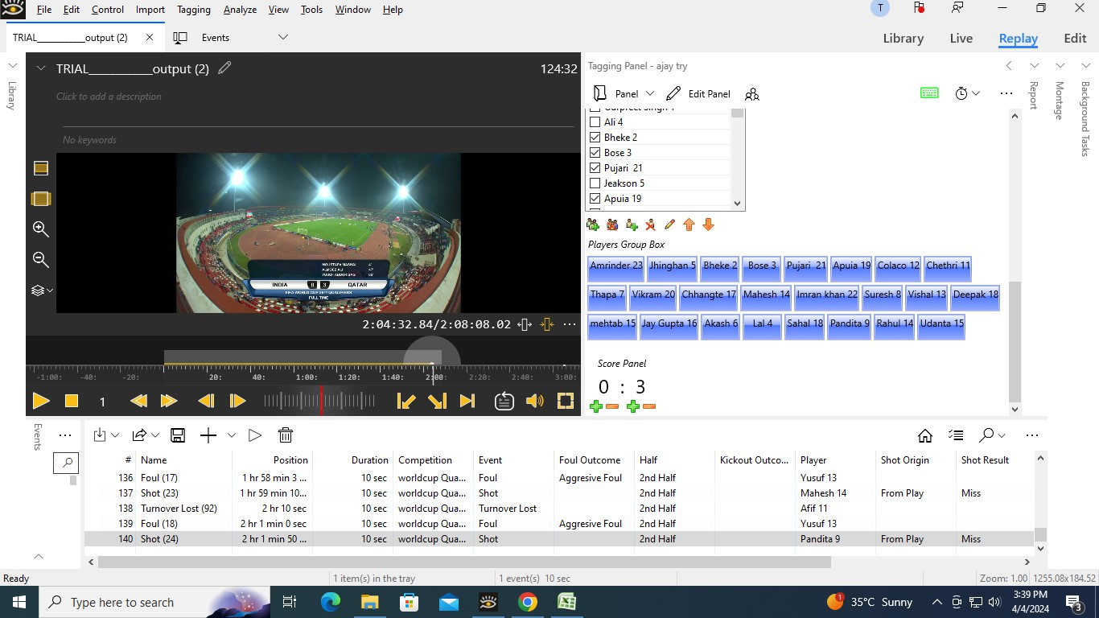

Fig. 1. Tagging Panel

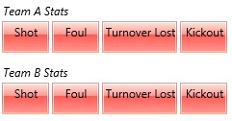

Fig. 2. Event Tagging Panel

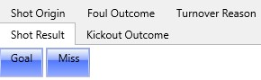

Fig. 3. Tagging Event Outcome Panel

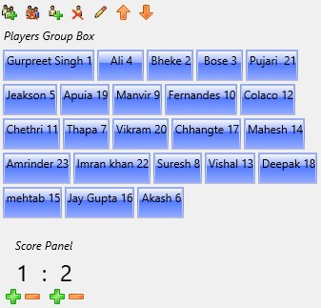

Fig. 4. Player group box and score panel

**Statistical analysis**

Here is the detailed game statistics of the two games with that occurred in every half of the matches. The tables that we are listing below will define about the foul outcome, turnover outcome, kickout outcome, short origin and short results [3] [7]. Table no 1 Shows that Team A(India) in the first half of the match they have been analyzed with two aggressive foul and one technical foul, likewise in the second half of the match they have been analyzedwith 5 aggressive fouls and 4 technical fouls. Team B(Afghanistan) in the first half of the match they have been analyzed with two aggressive foul and two technical foul, likewise in the second half of the match they have been analyzedwith 2 aggressive fouls and 2 technical fouls. As a whole, Team A got 12 foul outcomes and Team B got 8 foul outcomes in total.

**Table no 1:**Shows the foul outcome results in both first and second half of the match between India Vs Afghanistan

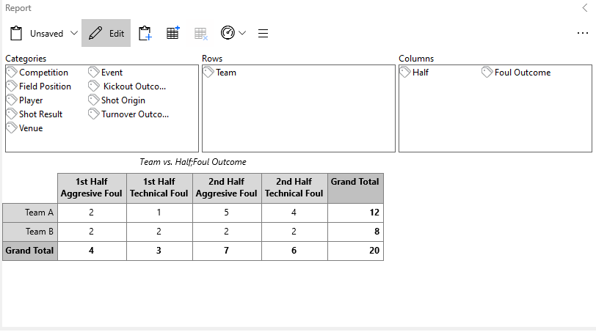

Table no: 2 Shows that Team A(India) in the first half of the match they have been analyzed with total of seventeen turnover lost which two were lost in tackle and seven were lost in opposition pressure and eight were lost in poor pass, likewise in the second half of the match they have been analyzed with total oftwelve turnover lost whichthe one was last in opposition pressure and eleven were missed by poor pass. Team B (Afghanistan) in the first half of the match they have been analyzed with total of eleven turnover lost where three in tackle and two in opposition pressure and six in poor pass, likewise in second half of the match they have been analyzed with total of sixteen lost over where one was lost in tackle one was lost in opposition pressure and fourteen were lost in poor pass. As a whole, team A got twenty-nine turnover lost and Team B got fifteen turnovers lost in total.

**Table no 2:**Shows the turnover outcome results in both first and second half of the match between India Vs Afghanistan

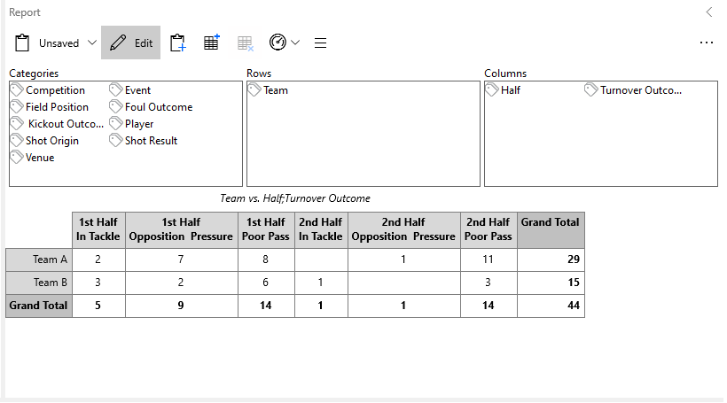

Table no: 3Shows that Team A(India) in the first half of the match they have been analyzed with one kickout, likewise in the second half of the match they have been analyzed with one kickout. Team B (Afghanistan) in the first half of the match they have been analyzed with one outcome, likewise in second half of the match also they have been analyzed with one kickout. As a whole, team A got two kickout and Team B got two kickout outcome in total.

**Table no 3:**Shows the kickout outcome results in both first and second half of the match between India Vs Afghanistan

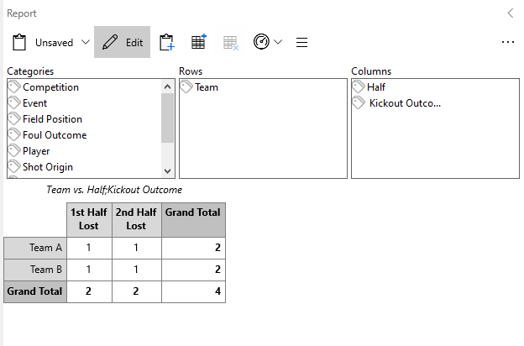

Table no 4: Shows that Team A(India) in the first half of the match they have been analyzed with three shot origin from play and two shot origin from set piece, likewise in the second half of the match they have been analyzed with three shot origin from play. Team B(Afghanistan) in the first half of the match they have been analyzed with four shot origins from play and two shot origin from set piece, likewise in the second half of the match they have been analyzed with six shot origin from play and two shot origin from set piece. As a whole Team A got eight shot origin and Team B got fourteen shot origin in total.

**Table no 4:**Shows the shot origin outcome results in both first and second half of the match between India Vs Afghanistan

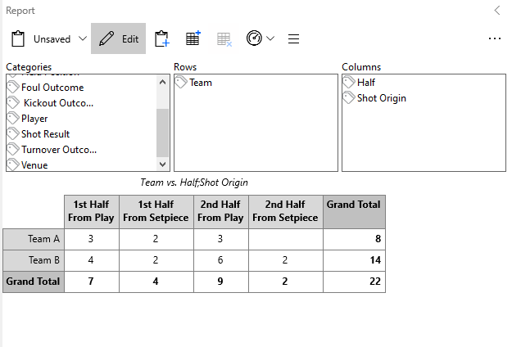Table no 5:Shows that Team A(India) in the first half of the match they have been analyzed with they have got four shots on goal where one shot was succeeded and three shots where missed, likewise in the second half of match they have got three shots on goal and the three were missed. Team B(Afghanistan) in the first half of the match they have been analyzed with they have got six shots on goal where six shots where missed, likewise in the second half of match they have got eightshots on goalwhere thetwo shot was succeeded and six shots were missed. As a whole Team A got seven shots and Team B got fourteen shots in total.

**Table no 5:**Shows the shot outcome results in both first and second half of the match between India Vs Afghanistan

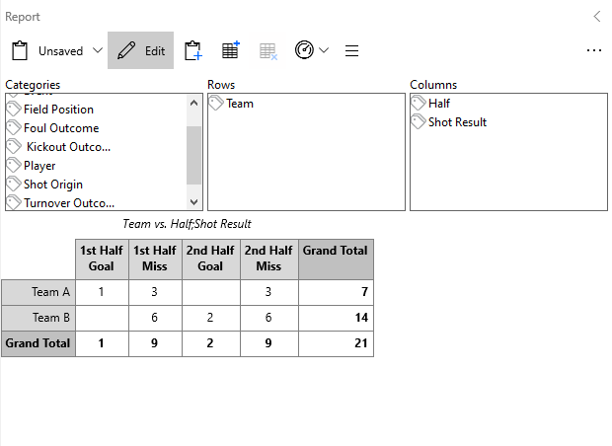

Table no 6:Shows that Team A(India) in the first half of the match they have been analyzed with eight aggressive foul and four technical foul, likewise in the second half of the match they have been analyzedwith eight aggressive fouls and two technical fouls. Team B(Qatar) in the first half of the match they have been analyzed with four aggressive foul and six technical foul, likewise in the second half of the match they have been analyzedwith four aggressive fouls and zero technical fouls. As a whole, Team A got twenty-two foul outcomes and Team B got fourteen foul outcomes in total.

**Table no 6:**Shows the foul outcome results in both first and second half of the match between India Vs Qatar

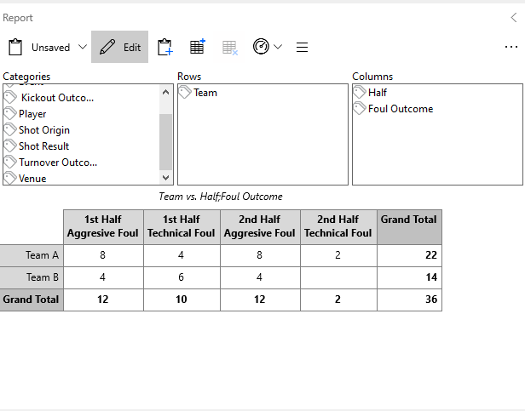

Table no 7: Shows that Team A(India) in the first half of the match they have been analyzed with total of forty-six turnover lost which two were lost in tackle and sixteen were lost in opposition pressure and thirty were lost in poor pass, likewise in the second half of the match they have been analyzed with total offifty-six turnover lost which the eight was last in opposition pressure and forty-six were missed by poor pass. Team B (Qatar) in the first half of the match they have been analyzed with total of thirty-six turnover lost where zero in tackle and ten in opposition pressure and thirty-six in poor pass, likewise in second half of the match they have been analyzed with total of sixteen lost over where one was lost in tackle one was lost in opposition pressure and fourteen were lost in poor pass. As a whole, team A got one hundred and two turnover lost and Team B got eighty-twoturnovers lost in total.

**Table no 7:**Shows turnover outcome results in both first and second half of the match between India Vs Qatar

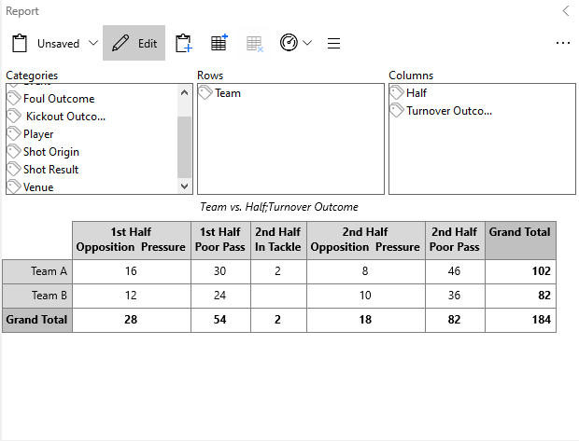  
Table no 8: Shows that Team A(India) in the first half of the match they have been analyzed with six kickout, likewise in the second half of the match they have been analyzed with zero kickout. Team B (Qatar) in the first half of the match they have been analyzed with fouroutcomes, likewise in second half of the match also they have been analyzed with two kickout. As a whole, team A got six kickout and Team B got six kickout outcome in total.

**Table no 8:**Shows the kickout outcome results in both first and second half of the match between India Vs Qatar

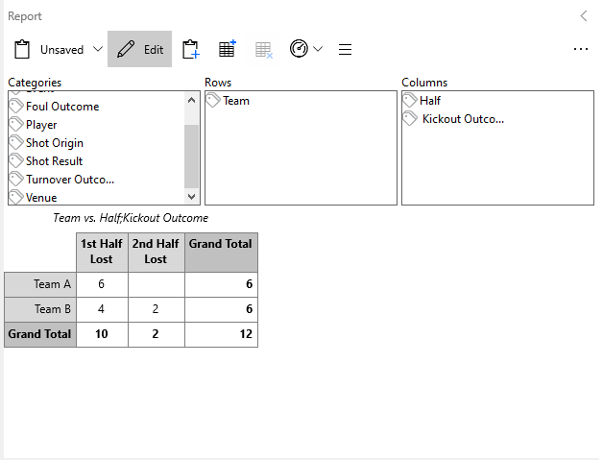

Table no 9: Shows that Team A(India) in the first half of the match they have been analyzed with six shot origin from play and zero shot origin from set piece, likewise in the second half of the match they have been analyzed with ten shot origin from play. Team B(Qatar) in the first half of the match they have been analyzed with nine shot origin from play and twelve shot origin from set piece, likewise in the second half of the match they have been analyzed with six shot origin from play and two shot origin from set piece. As a whole Team A got sixteen shot origin and Team B got twenty-nine shot origin in total

**Table no 9:**Shows the shot origin outcome results in both first and second half of the match between India Vs Qatar

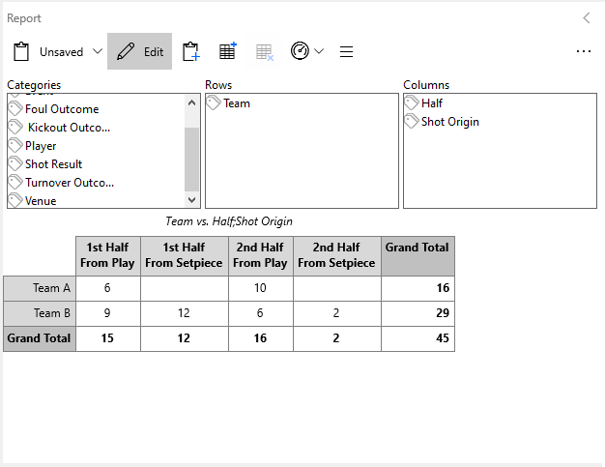

Table no 10: Shows that Team A(India) in the first half of the match they have been analyzed with they have got six shots on goal where zero shot was succeeded and six shots where missed, likewise in the second half of match they have got tenshots on goal and the ten were missed. Team B(Qatar) in the first half of the match they have been analyzed with they have got twenty-one shots on goal where one shot was succeeded and twenty shots where missed, likewise in the second half of match they have got eightshots on goal where the two shot was succeeded and six shots were missed. As a whole Team A got sixteen shots and Team B got twenty-nineshots in total.

**Table no 10:**Shows the shot outcome results in both first and second half of the match between India Vs Qatar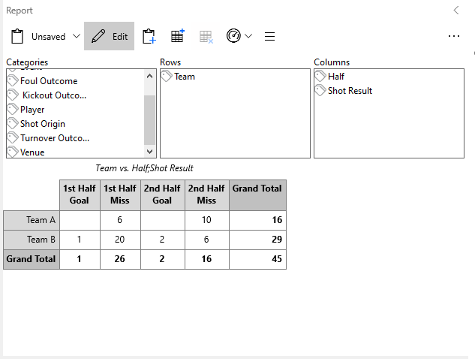

On the whole comparing with both the teams Indian team performance over the selected parameters is not satisfied and it is not at all entering into any minimum criteria in entering the qualifiers it is mandatory to have more insight generation strategical planning and decision making with advanced training will lead to increase the performance with the help of advanced and emerging technologies [8].

1. **Result**

As a result, the analysis done by using Dartfish software which was used to find the details of the match that let the players improve through setbacks, it has been found that in the entire matches played by our Indian team against Qatar and Afghanistan in World cup Qualifiers there are a lot of areas the team has to work on. Improving the overall performance of the team involves ball control, more coordination between the players, arranging more international matches and tournaments to give players exposure to different styles of play & higher level of competition and conducting camps a month before the matches. Also, the coaches can utilize this analysis to work in the weaker areas of the players to enhance their performance.

1. **Discussion**

**Discussion on the performance of players:**

(Goal keeper) Gurpreet Singh:

He is one of the best goalkeepers and India's first choice goalkeeper. He also plays for Bengaluru FC in the ISL. His height is an added advantage to him. He is the pillar of the Indian team. But in Afghanistan match he made a foul because of which the opposite team was awarded with penalty kick.  He has to calmer in our defensive box area.

(Defender) Sandesh Jhingan:

He is playing for Indian team for the last 8 years; he is a strong player he also got offer from foreign club but he could not perform well there so he returned to India here he played well but he could not perform well while facing foreign teams so his performance also below average

Anwar Ali:

He is playing in fullback position for Indian team, he has also played under 17 World cup. He has to improve in heading, surprise long kicks to forward players, endurance and body power.

[Subashish Bose](https://www.espn.in/football/player/_/id/268007/subashish-bose):

He is playing in left back position, he needs to run for many overlaps, he should provide more crosses and improve in defending.

[Rahul Bheke](https://www.espn.in/football/player/_/id/227975/rahul-bheke):

He is playing in right back position; he needs to improve in defending and attend more set pieces as he is a good header.

(Midfielder) [Brandon Fernandes](https://www.espn.in/football/player/_/id/227947/brandon-fernandes):

He is playing in attacking midfielder position, he is good in short passes and must improve in long passes, must provide more passes in opponent area.

[Anirudh Thapa](https://www.espn.in/football/player/_/id/246791/anirudh-thapa):

He is playing in defending midfielder position; he is good in long passes but his contribution in the match was less. He has to improve in box to box playing.

[Lallianzuala Chhangte](https://www.espn.in/football/player/_/id/243306/lallianzuala-chhangte):

He is playing in right winger position, his performance was average, he must improve in dribbling, play more in opponent area and supply more crosses.

[Liston Colaco](https://www.espn.in/football/player/_/id/268041/liston-colaco):

He is playing in left wing position; his performance was below average and must improve a lot in ball control and take powerful shots.

(Forward) [Sunil Chhetri](https://www.espn.in/football/player/_/id/111682/sunil-chhetri):

He is the main striker playing in Indian team, he is a legend of Indian football team and a top scorer. But in the Qualifiers, his performance was average. He did not get any ball passes from midfielders. He has to score more goals to get India Qualified.

Indian team performance

In the World cup Qualifier matches, the overall performance of the team was average. We have lost in both the matches. We have conceded 5 goals and we scored only one goal in the two matches. So, we have to improve and work in every position, we should not receive any goals and the defending lineup should be strong. The midfielders must work a lot in passing and defending in the entire match. The endurance must be improved. The coach should be tactically superior to the other team in order to identify the player's strengths and weakness and create a more cohesive squad. If India wins against Kuwait in their next match, they can qualify for the next round of world cup qualifiers.

1. **Conclusion**

Video analysis of the entire matches played by our Indian team with Qatar and Afghanistan was analyzed by tagging events with the help of Dartfish and the statistical report for improving the players' performance has been generated. This statistical analysis of the performance is based on ball possession and attacking. Coaches can further utilize these data from each match to result in a better outcome in the upcoming matches. Focusing on the weaker areas of players, ball control and endurance, increasing the number of team camps, playing more international matches and resulting in a better outcome.

**References**

[1] Prasanth, V. V., & Nallavan, G. (2022). ANALYSIS OF FOOTBALL PLAYERS’PERFORMANCE USING PYTHON AND DARTFISH.

[2] Martin, Denise & Donoghue, Peter & Bradley, Jonathan & Mcgrath, Denise. (2021). Developing a framework for professional practice in applied performance analysis. International Journal of Performance Analysis in Sport. 21. 1-44. 10.1080/24748668.2021.1951490.

[3] Stojmenovic, Dragutin & Stojmenovic, Tamara. (2023). Physiological parameters of professional football players in teams of various levels. Pedagogy of Physical Culture and Sports. 27. 361-367. 10.15561/26649837.2023.0502.

[4] Tupamäki, A. (2012). Use of external resources to expand boundaries of professional competencies-Case video analysis for football coaching.

[5] Thomas, Brendan Nigel. “Video analysis as a form of feedback to improve sport performance.” (2004).

[6]https://indianexpress.com/article/sports/football/arsene-wenger-on-how-to-improve-indian-football-equip-players-from-5-to-15-with-the-best-possible-technical-skills.

[7] Kiliç, Tahir & Tosur, Mehmet. (2018). A Comparison of Some Parameters of Football Players According to the Leagues They Play In. Journal of Education and Training Studies. 6. 135. 10.11114/jets.v6i11.3591.

[8] Yüksel, M., & Koç, (2023). A STUDY ON AMATEUR FOOTBALL PLAYERS' PERFORMANCE PARAMETERS IN RELATION TO THEIR POSITIONS. Journal Of Athletic Performance And Nutrition, 9(2), 9-21. doi:10.31131/japn.v9i2.129.

[9] https://www.sportperformanceanalysis.com/article/overview-dartfish-videoanalysis

[10] Eltoukhy, M., Asfour, S., Thompson, C., & Latta, L. (2012). Evaluation of the performance of digital video analysis of human motion: Dartfish tracking system. Int J Sci Eng Res, 3(3), 1-6.

[11] Prasanth, V. V., & Nallavan, G. (2024, February). Greening the Game with Sustainable Practices in Sports Performance Analysis. In 3rd International Conference on Reinventing Business Practices, Start-ups and Sustainability (ICRBSS 2023) (pp. 897-905). Atlantis Press.

[12] Khadilkar, L., MacDermid, J. C., Sinden, K. E., Jenkyn, T. R., Birmingham, T. B., & Athwal, G. S. (2014). An analysis of functional shoulder movements during task performance using Dartfish movement analysis software. International journal of shoulder surgery, 8(1), 1.