**DONATION CAMPAIGN**

**AUTHOR:**

R.Lakshmanan (lakshmanan251277@gmail.com)

Department of MCA

Adhiyamaan College of Engineering (Autonomous), Hosur.

**GUIDED BY:**

Prof.N.Sakthivel , MCA.,M.Phil.,([sakthivel.mca@adhiyamaan.in](mailto:sakthivel.mca@adhiyamaan.in))

Department of MCA

Adhiyamaan College of Engineering (Autonomous), Hosur.

**ABSTRACT:**

In today's dynamic world, community development stands as a cornerstone for societal progress. However, numerous communities around the globe face various challenges hindering their growth and well-being. In response, our project aims to launch a donation campaign focused on addressing these challenges and fostering sustainable development within underserved communities. Through strategic planning and community engagement, we aspire to make a meaningful impact and create positive change on a grassroots level.

The donation campaign seeks to address pressing issues such as poverty, education gaps, healthcare deficiencies, and environmental degradation within marginalized communities. By providing targeted assistance and resources, we aim to uplift these communities and empower individuals to break the cycle of poverty.

The primary objective of the campaign is to mobilize resources and support from individuals, businesses, and organizations to fund initiatives that promote community development. These initiatives include but are not limited to providing access to education, healthcare services, clean water, sustainable livelihood opportunities, and environmental conservation efforts. Our campaign targets individuals and entities passionate about social impact and community development. This includes philanthropists, corporate entities with corporate social responsibility (CSR) initiatives, foundations, and individuals looking to make a difference in the lives of others.

The campaign will employ a multi-faceted approach, utilizing various communication channels such as social media, traditional media, community events, and partnerships with local organizations to raise awareness and solicit donations. We will also leverage technology to facilitate easy and secure donation processes, ensuring transparency and accountability. The campaign will be executed in phases, starting with a comprehensive needs assessment to identify priority areas within target communities. Following this, fundraising activities will be initiated, alongside community engagement efforts to ensure buy-in and participation from local stakeholders. Funds raised will be allocated towards implementing sustainable solutions tailored to the specific needs of each community.

Our donation campaign for community development represents a concerted effort to address systemic challenges faced by marginalized communities. By harnessing the collective power of donors and stakeholders, we aim to foster inclusive growth and create a brighter, more sustainable future for all. Join us in making a meaningful difference and building stronger, more resilient communities.

**OBJECTIVE**

The objective of our donation campaign is to create a comprehensive platform that facilitates and encourages charitable contributions across various sectors. Upon logging in, users will be directed to a dynamic home page where they can navigate seamlessly through different donation categories. Our focus areas include healthcare, food, clothing, and education donations, each with its dedicated section. Through this platform, we aim to streamline the donation process, making it easier for users to contribute to causes they care about.

In the healthcare donation section, users can explore various initiatives aimed at improving healthcare access, supporting medical research, or aiding individuals in need of medical assistance. Whether it's funding treatments for rare diseases, supporting local clinics, or providing medical supplies to underserved communities, users can make a difference in the lives of those facing health challenges.

In the food donation segment, users can discover opportunities to combat hunger and food insecurity. They can contribute to food banks, support meal programs for vulnerable populations, or sponsor agricultural projects aimed at sustainable food production. By donating to this cause, users play a vital role in ensuring that nutritious meals reach those who need them the most.

The clothing donation section provides users with the chance to give back by supporting initiatives that provide clothing to those in need. Whether it's donating winter coats to homeless shelters, contributing to clothing drives for low-income families, or supporting vocational training programs that empower individuals through attire, users can make a meaningful impact on someone's life through their generosity.

In the education donation category, users can contribute towards improving access to education for children and adults alike. From funding scholarships for underprivileged students to supporting schools in disadvantaged communities, users can help break the cycle of poverty through the gift of education. Additionally, they can support initiatives focused on literacy programs, teacher training, or providing educational resources to underserved areas.

To facilitate seamless transactions, our platform integrates a secure payment gateway, allowing users to make donations conveniently and securely. Additionally, users can create personalized profiles to track their donation history, set donation goals, and receive updates on the impact of their contributions. By incorporating these features, we aim to foster transparency, accountability, and engagement within our community of donors.

Our donation campaign project strives to harness the power of collective generosity to address pressing social issues and make a positive difference in the world. Through targeted initiatives in healthcare, food, clothing, and education, coupled with user-friendly features such as a payment gateway and user profiles, we aim to inspire individuals to become active participants in philanthropy and create lasting change in the lives of those in need.

**SOFTWARE REQUIREMENT**

**MINIMUM REQUIREMENTS**

* Web Technology : React Js
* Frontend : React Js, bootstrap, CSS, JavaScript
* Hardware : 512 GB
* Operating System : Windows 10 and Above

**OBJECTIVES OF REACT JS**

React.js is a powerful JavaScript library designed to facilitate the development of dynamic and interactive user interfaces. At its core, the primary objective of React.js is to simplify and streamline the process of building complex UIs by breaking them down into modular, reusable components. These components encapsulate both the structure and behavior of specific parts of the user interface, promoting a modular and maintainable codebase.

One of the key features of React.js is its use of a virtual DOM (Document Object Model), which is a lightweight representation of the actual DOM in memory. By employing a virtual DOM, react can efficiently update the user interface in response to changes in data or state without directly manipulating the DOM, resulting in significant performance improvements.

Another crucial objective of React.js is to enable developers to build UIs using a declarative programming paradigm. Instead of imperatively defining the steps needed to update the UI in response to changes, developers can simply declare how the UI should look based on the current state of the application. This declarative approach not only makes the code more intuitive and easier to understand but also helps minimize bugs and improve code maintainability.

React.js also promotes the idea of unidirectional data flow, where data flows from parent components down to their children via props (properties). This ensures that the data flow within the application remains predictable and makes it easier to understand how changes in one part of the UI can affect other parts.

React.js emphasizes the concept of composability, allowing developers to compose complex UIs by combining smaller, reusable components. This approach encourages code reuse and modularity, making it easier to manage and maintain large-scale applications.React.js promotes a philosophy of "learn once, write anywhere" through its use of a component-based architecture and its compatibility with both web and mobile platforms. Developers can leverage their knowledge of React.js to build not only web applications but also mobile apps using frameworks like React Native.

The primary objective of React.js is to provide developers with a powerful and efficient tool for building dynamic and interactive user interfaces by promoting modularity, reusability, performance, and a declarative programming paradigm. By achieving these objectives, React.js has become one of the most popular choices for front-end development, empowering developers to create robust and engaging UIs across a variety of platforms.

**JAVASCRIPT**

JavaScript  (often shortened to JS) is a lightweight, interpreted, object-oriented language with [first-class functions](https://en.wikipedia.org/wiki/First-class_function), and is best known as the scripting language for Web pages, but it's [used in many non-browser environments](https://en.wikipedia.org/wiki/JavaScript#Uses_outside_Web_pages) as well. It is a [prototype-based](https://en.wikipedia.org/wiki/Prototype-based_programming), multi-paradigm scripting language that is dynamic, and supports object-oriented, imperative, and functional programming styles.

JavaScript runs on the client side of the web, which can be used to design programs on how the web pages behave on the occurrence of an event. JavaScript is an easy to learn and also powerful scripting language, widely used for controlling web page behavior. JavaScript can function as both a [procedural](https://en.wikipedia.org/wiki/Procedural_programming) and an [object oriented language](https://developer.mozilla.org/en-US/docs/Web/JavaScript/Introduction_to_Object-Oriented_JavaScript).

JavaScript supports much of the [structured programming](https://en.wikipedia.org/wiki/Structured_programming) syntax from [C](https://en.wikipedia.org/wiki/C_(computer_language)) (e.g., if statements, while loops, switch statements, do while loops, etc.). One partial exception is [scoping](https://en.wikipedia.org/wiki/Scope_(computer_science)): JavaScript originally had only [function scoping](https://en.wikipedia.org/wiki/Function_scoping) with var. ECMAScript 2015 added keywords let and [const](https://en.wikipedia.org/wiki/Const_(computer_programming)) for block scoping, meaning JavaScript now has both function and block scoping. Like C, JavaScript makes a distinction between [expressions](https://en.wikipedia.org/wiki/Expression_(computer_science)) and [statements](https://en.wikipedia.org/wiki/Statement_(computer_science)). One syntactic difference from C is [automatic semicolon insertion](https://en.wikipedia.org/wiki/Defensive_semicolon), which allows the semicolons that would normally terminate statements to be omitted.

Values are cast to numbers by casting to strings and then casting the strings to numbers. These processes can be modified by defining to String and value Of functions on the [prototype](https://en.wikipedia.org/wiki/JavaScript#Object-orientation_(prototype-based)) for string and number casting respectively.

**EXISTING SYSTEM**

Our initiative seeks to address the pressing issue of educational inequality by mobilizing resources to support schools in marginalized communities. Through the generous contributions of individuals and organizations alike, we aim to bridge the gap and ensure that every child has the opportunity to learn, grow, and thrive.

With your support, we can make a tangible difference in the lives of countless children who are currently denied access to education. Your donation will directly impact their futures, opening doors to a world of possibilities and breaking the cycle of poverty for generations to come. Education is not merely about acquiring knowledge; it is about unlocking potential, fostering creativity, and instilling a sense of dignity and purpose. By investing in education, we invest in the future — a future where every child has the chance to reach their full potential and contribute meaningfully to society.

Join us in our mission to make education accessible to all. Your contribution, no matter how small, will make a profound difference in the lives of those who need it most. Together, let's build a brighter and more equitable future through the power of education. To donate or learn more about our campaign, please visit our website or contact us directly. Together, we can create lasting change and empower the next generation through education. Thank you for your support and generosity.

**PROPOSED SYSTEM**:

The proposed system advocates for the integration of technology at every stage of the donation campaign process. This includes leveraging social media platforms, mobile applications, and crowdfunding websites to expand outreach and encourage engagement. By tapping into the vast digital landscape, campaigns can connect with a wider audience, facilitate seamless donations, and foster a sense of community participation. Additionally, employing data analytics tools can provide valuable insights into donor behavior, preferences, and trends, enabling campaigns to tailor their strategies for maximum effectiveness.

Successful donation campaigns often hinge on the strength of collaborative partnerships forged with various stakeholders. The proposed system advocates for establishing partnerships not only with corporate entities and philanthropic organizations but also with government agencies, academic institutions, and civil society groups. By pooling resources, expertise, and networks, campaigns can amplify their impact, access additional funding sources, and leverage collective influence to effect systemic change.

The proposed system offers a holistic approach to optimizing donation campaign projects, harnessing the power of technology, community engagement, and data-driven strategies to enhance their impact and foster sustainable change. By adopting these principles and practices, campaigns can unlock new opportunities for collaboration, innovation, and collective action, ultimately driving meaningful progress towards addressing pressing societal challenges.

**MODULES**

* Healthcare
* Education
* Food
* Clothing
* Payment Gateway
* Donation List

**MODULE DESCRIPTION**

**HEALTHCARE**

The first component of our healthcare module focuses on enhancing infrastructure in underprivileged regions. This involves building and renovating healthcare facilities, equipping them with essential medical equipment, and ensuring a steady supply of medications and consumables. By bolstering infrastructure, we aim to provide communities with the necessary resources to deliver comprehensive healthcare services efficiently.

**EDUCATION**

The Education Donation is designed to be user-friendly and accessible to anyone willing to support the cause of education. Through this module, donors can easily navigate and choose from a variety of options to contribute, whether it be monetary donations, supplies, or volunteering their time and expertise. The platform offers transparency by showcasing how each donation directly impacts the lives of beneficiaries, fostering trust and accountability among donors.

**FOOD**

The essence of "Donation Campaign" lies in its inclusivity. We believe that everyone deserves access to nutritious food, regardless of their circumstances. Whether it's a single can of beans or a basket full of fresh produce, every contribution counts. Through the collective generosity of individuals, businesses, and organizations, we can make a tangible impact on the lives of our neighbors facing food insecurity.

**CLOTHING**

Contribution to our clothing donation campaign goes beyond mere fabric and stitching. It represents hope, dignity, and the promise of a brighter future for someone less fortunate. With each donation, you're helping individuals and families dress themselves with warmth and confidence, enabling them to pursue opportunities and face the world with renewed courage. Your generosity can uplift spirits and restore self-esteem, fostering a sense of belonging within communities.

**PAYMENT GATEWAY**

By participating in this campaign, you are not just making a financial contribution; you are becoming a part of a larger movement towards positive change. Your generosity will directly translate into tangible benefits for [mention who will benefit from the campaign, whether it's individuals, communities, animals, etc.], providing them with the resources and support they need to thrive.

**DONATION LIST**

The donation list serves as a comprehensive record of contributions made to a donation campaign project, providing transparency and insight into the types of items or funds donated. This list is instrumental in showcasing the generosity of donors and ensuring accountability in the management of the campaign.

**SCREENSHOTS:**

LOGIN PAGE:

HEALTH PAGE:

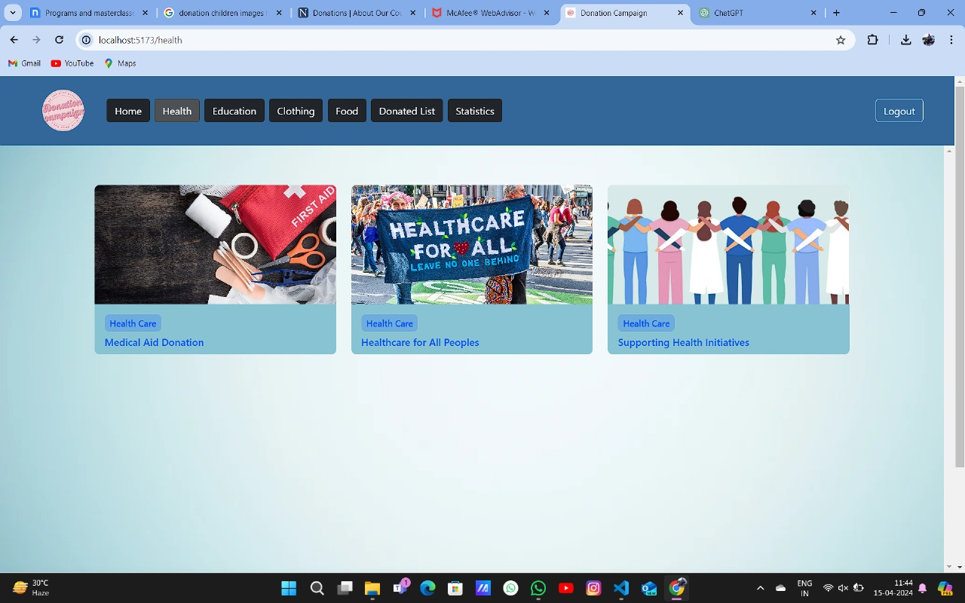

EDUCATION PAGE:

CLOTHING PAGE:

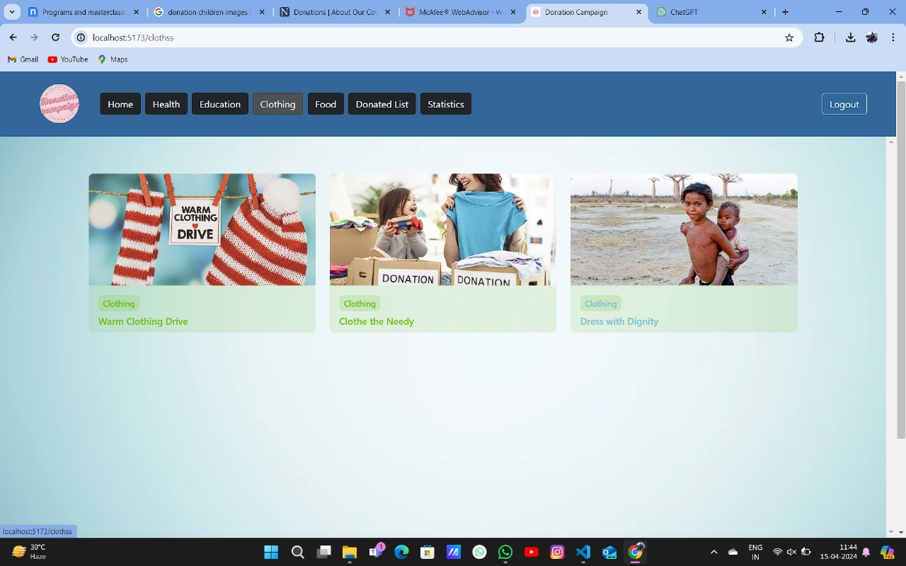

FOOD PAGE:

DONATED LIST:

DONATION PAGE:

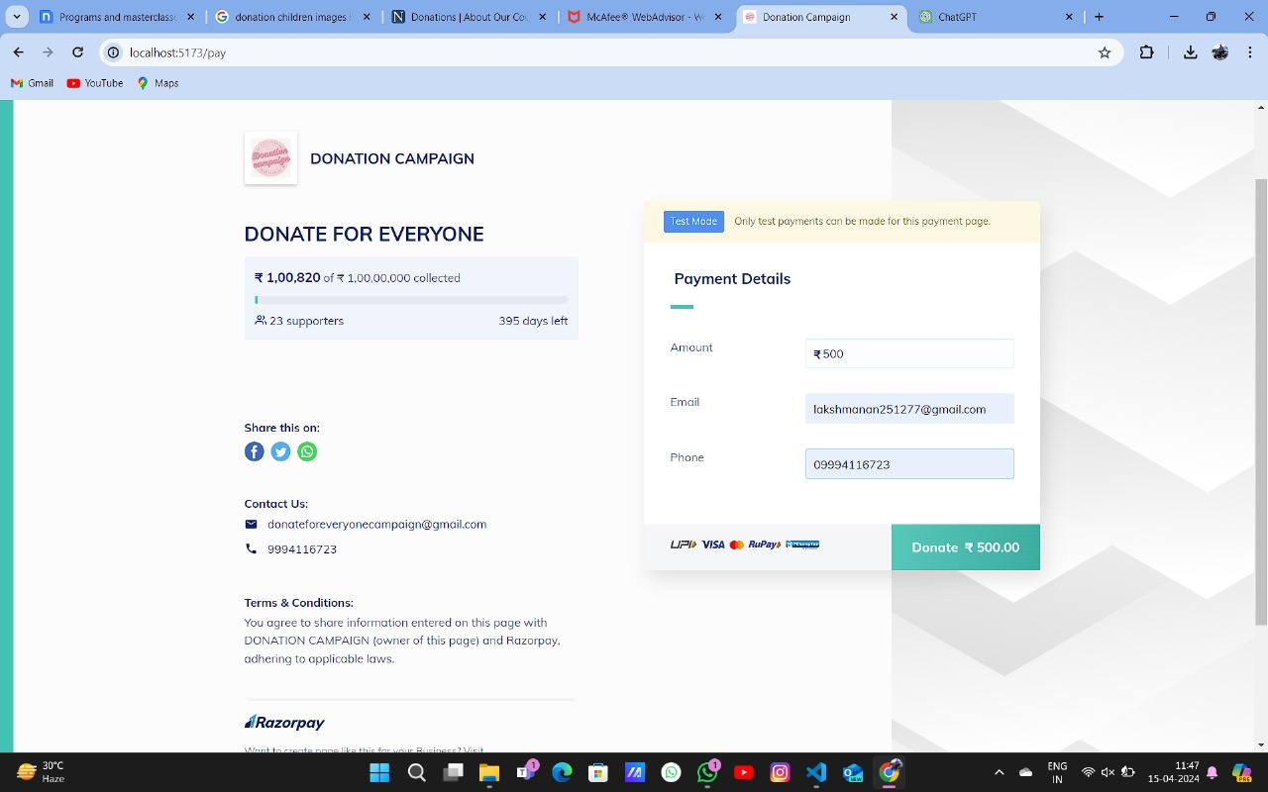

**CONCLUSION**

The "Donation campaign" project stands as a beacon of hope and solidarity, representing the collective generosity and compassion of individuals who believe in the power of giving to make a difference in the lives of others.

**REFERNCES:**

* [**https://react.dev/**](https://react.dev/)
* [**https://www.w3schools.com/REACT/DEFAULT.ASP**](https://www.w3schools.com/REACT/DEFAULT.ASP)
* [**https://legacy.reactjs.org/**](https://legacy.reactjs.org/)
* [**https://react-bootstrap.netlify.app/docs/components/cards/**](https://react-bootstrap.netlify.app/docs/components/cards/)
* [**https://legacy.reactjs.org/docs/forms.html**](https://legacy.reactjs.org/docs/forms.html)
* [**https://razorpay.com/**](https://razorpay.com/)
* [**https://react-bootstrap.netlify.app/**](https://react-bootstrap.netlify.app/)
* [**https://react-bootstrap.netlify.app/docs/components/navbar/**](https://react-bootstrap.netlify.app/docs/components/navbar/)