**Review Paper on Comparison of Asymmetric and Symmetric RCC Building with Soil Structure Interaction by Dynamic Loading.**

**Maheshwari Pimpalshende1, Prof. Priti Chauhan2**

*1M. Tech Student, Structural and Construction Engineering Department, Ballarpur Institute of Technology, Maharashtra, India*

*Maheshwaripimpalshende01@gmail.com*

*2Assistant Professor, Structural and Construction Engineering Department, Ballarpur Institute of Technology, Maharashtra, India*

|  |
| --- |
| ***Abstract: Multi story building are very much common in the urban area nowadays due to scarcity of land and increase in the cost of land. Most of the structure are not in regular either in shape and mass distribution. But the performance of structure will not be good as regular symmetric type structure. A plan asymmetric having L shaped normally exhibits a complex response under dynamic loads. In this research work, effect of change of height and change of number of bays are studied separately with soil structure interaction. In recent years, due to demand in aesthetical view and architectural design, people want unique in building so the building are designed with irregularities. Using software is used for modelling and studying the various parameter such as story drift, displacement, time period and story shear***  ***Key Word****: Asymmetrical building, Symmetrical building , story drift, software.* |

1. **Introduction**

The prior research is mainly focused on the analysis of symmetric and asymmetric buildings regarding the percentage of opening, life safety factors, and re-entrained corners of the building having L shaped under static seismic forces. However, analysis of L shape plans asymmetric and symmetric building with a varying number of bays with different soil condition. . response parameters such as story drift, base shear, story shear, and natural period of Symmetrical and Asymmetrical building. From the analysis results and comparative study made among the Symmetric and Asymmetric structures using equivalent static and dynamic earthquake analysis the following set of conclusions are drawn. An attempt is made in this study to understand and perceive the behaviors of building frame system. The core idea in comparison between Symmetric and Asymmetric tall building is to restrict the story drift of the building into something more rigid and stable to limit deformation and enhance stability. Performance of Symmetrical building is better than Asymmetrical building. The story drift is observed to be more in Asymmetric structure when compared to the Symmetric structure.

**1.1 Symmetrical Building:** Building is said to be symmetrical if it is regular or symmetric in plan and also symmetrical vertically. It means the building in which the horizontal plan remains same in every direction and remains same vertically on the subsequent above stories

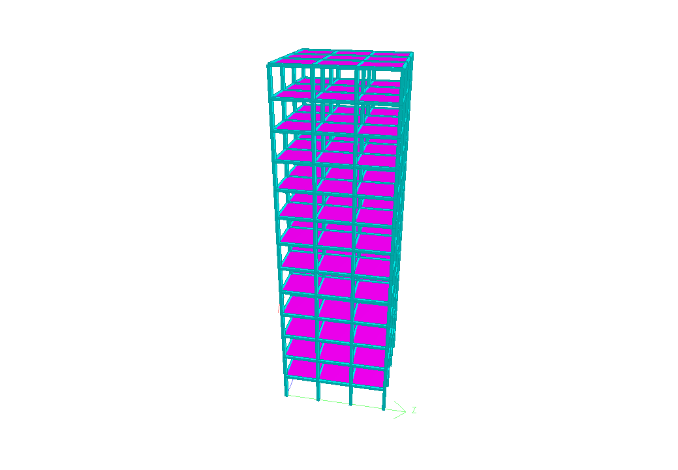

**1.2 Asymmetrical Building:** The building is said to be asymmetrical when it is irregular in plan or irregular vertically. It means the building in which there is change or discontinuity in the horizontal plan or any changes or discontinuity vertically with respect to the subsequent stories above.

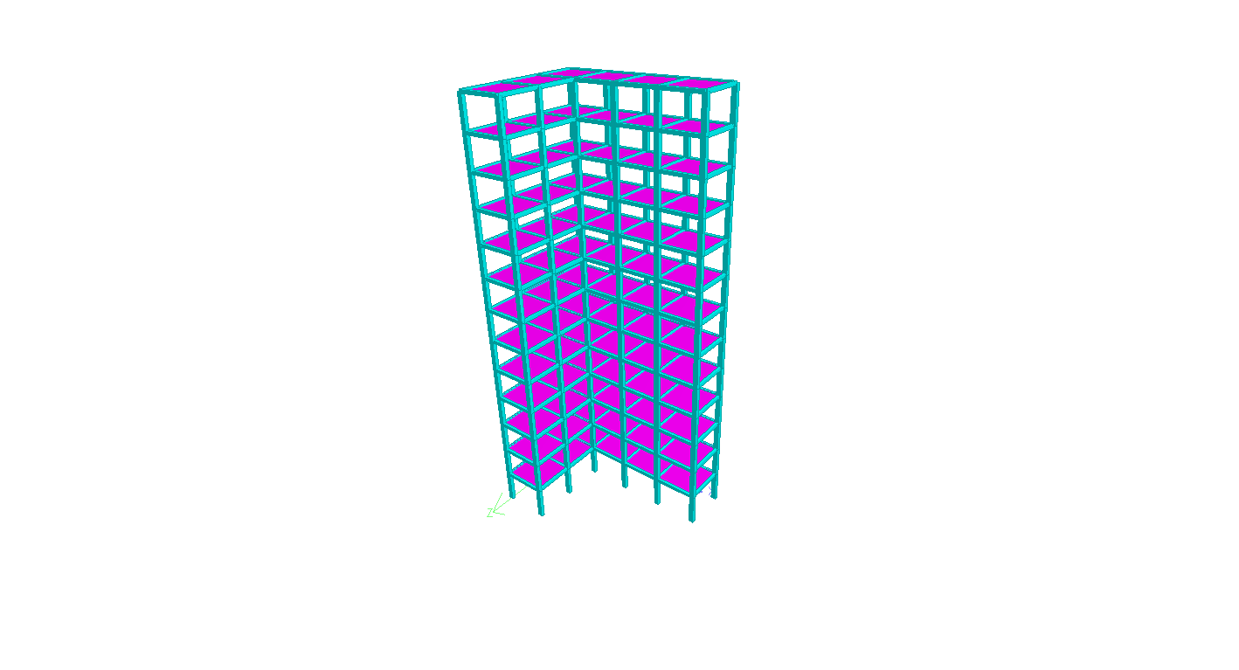

**2. Problem Statement:**

A Comparative analysis of two type of structure Asymmetric and Symmetric. 12 and 16 Story building, which is Asymmetric and Symmetric type of structure that lies in earthquake zone IV which is the most active region in the India. and the consideration of asymmetric plan 16 X 12 X 4 and symmetric plan 12*12. Calculation of deflection, moments, frequency, base shear, time period will be calculated.

**2.1. Objective of the Study:**

1. The main Aim of this project is increasing the stability of asymmetric structure.

2. Comparative study between symmetric and asymmetric RCC Building with hard soil, medium soil and soft soil.

3. The base shear reduction with increase of stiffness of soil.

4. Fundamental frequency decreases with increases of story height of building.

5. Performing all the activities for 2 different heights of stories of model.

**3. LITERATURE REVIEW:**

[1] dynamic performance of l shaped asymmetric building with soil Structure interaction. Debi Prasad Das, Diptesh Das, Pijush Topdar and Bibhuti Bhusan Ghosh West Bengal, India The prior research is mainly focused on the analysis of symmetric and asymmetric buildings regarding the percentage of opening, life safety factors, and re-entrained corners of the building having L shaped under static seismic forces. However, analysis of L shape plans asymmetric building with a varying number of bays of one wing where bays of other are unchanged with different soil support conditions was not considered. Also, the literature survey reveals that the effect of change of height of building having L shaped on different support such as fixed base, hard soil, medium soil, and soft soil is very limited. In this paper, twelve, nine, six, and single-storied buildings with different supporting mediums under ground motion have been addressed.

[2] A Comparative Study on Analysis of Symmetric and Asymmetric Building Structure. S.M. Hashmi, Mohammed Azeem Uddin Kalaburagi, India In present study a comparison is done between symmetric and asymmetric RC structure. Four models are made, 2 models are six storied in which 1 model is symmetric and other is asymmetric and another 2 models are nine storied in which 1 model is symmetric and other is asymmetric and various parameters are studied. ETABS software is used for modelling and studying the various parameters such as Story drift, displacement, time period and story shear. R.S Method is used for analyzing of models. Story drift increases in starting, reaches maximum at the Story 3 than it starts decreasing. Torey drift is greater at starting stories in case of symmetrical building, but it becomes less and the drift in asymmetrical building overtakes. Story displacement increases exponentially as height of the building model increases. Torey displacement remains almost same in starting stories of both the models, then displacement of asymmetrical building increases more than symmetrical building.

[3] Seismic Response Analysis of Symmetrical and Asymmetrical High-Rise Structures in Seismic ZoneII. G.V.S. Siva Prasad, Dr.P.Jyotsna devi,Manikanta Patnaik Visakhapatnam To study the effect of story drift for symmetric and asymmetric multi-storied G+25 high rise R.C building in seismic zone II.To study the response spectrum method for analysis of symmetric andasymmetric building structures. To compare theresponse parameters such as story drift, base shear, story shear, and natural period of Symmetrical and Asymmetrical building. From the analysis results and comparative study made among the Symmetric and Asymmetric structures using equivalent static and dynamic earthquake analysis the following set of conclusions are drawn. An attempt is made in this study to understand and perceive the behaviors of building frame system. The core idea in comparison between Symmetric and Asymmetric tall building is to restrict the story drift of the building into something more rigid and stable to limit deformation and enhance stability. Performance of Symmetrical building is better than Asymmetrical building. The story drift is observed to be more in Asymmetric structure when compared to the Symmetric structure.

[4] Seismic behaviors of Symmetric and Asymmetrical Multi Storied Building: A Review Dipak Pawar1 ,Asst.Prof.C.M.Deshmukh2 , Dr.S.S.Kadam Pandharpur severe earthquakes concluded that most vulnerable building structures are those, which are symmetrical and a symmetric in nature. Asymmetric-plan buildings, namely buildings with in-plan asymmetric mass and strength distributions, are systems characterized by a coupled torsional- translational seismic response. To study the effect torsional analysis of symmetrical and asymmetrical building, study on the influence of the torsional moment effects on the behaviors of structure is done by using Response spectrum method. Then simplified nonlinear pushover analysis has been used find structural descriptors required in seismic vulnerability assessment. And how we can avoid torsion by doing structural changes has been carried out.

[5] analysis and design of symmetric and asymmetric Building frame subjected to gravity load. Divya Vishnoi Jaipur, (Rajasthan) India-302022 The behaviors of axial force in column were found similar in magnitude in both Asymmetric and symmetrical frame. The Symmetric frame was found more Cost Effective with respect to Asymmetric frame as the volume of material being used was more in Asymmetric model. The Symmetric model provides more Gross Leasable Area (GLA) as compared to Asymmetric model. Hence, Area Utilization will be more. The Load Distribution in Symmetric model is more uniform as compared to asymmetric model. The requirement of reinforcement is more in asymmetric frame than the symmetric frame. The Symmetric model is more Cost Effective with respect to Asymmetric model as the volume of material being used is more in Asymmetric model.

## [6] Seismic Performance of Symmetric and Asymmetric Multi-Storeyed Buildings. Sammelan Pokharel, S. Lakshmi Ganesh, G. Sabarish The objectives of this study are as follows: To model a symmetric structure and its equivalent asymmetric structures in Etabs and perform seismic analysis by static and dynamic methods of analysis. To compare the seismic response of symmetric and asymmetric structures. To compare the structural response from the static and dynamic methods of seismic analysis. To determine a suitable method to reduce the structural response parameters in the asymmetric building. Asymmetric buildings are more susceptible to damage during earthquakes. The extent of damage will increase with the height of the structure. The seismic coefficient method is found to be more conservative than the response spectrum method for all the shapes of the building although the IS code recommends the use of response spectrum method in asymmetric buildings with a height greater than 12 sm. Shear walls can be used in order to decrease lateral loads in columns, but the selection of the position of the shear wall has to be done carefully. Shear walls do not reduce axial load carried by columns.

**3.1. Methodology**

* Give the brief idea about the project and the methodology adopted for execution of the research work.
* Depict the literature review carried out for the project.
* Considering a 12 and 16 story L Shaped Asymmetric and Symmetric structure plan.
* Considering 3 x 3 and 3 x 4 bays of equal width of 4m.
* Plan Asymmetric and Symmetric building is modeled by using software STAAD Pro v8i
* Time History Analysis Method.
* Then performing analysis on symmetric building plan 12*12 and asymmetric building plan 16 x 14 x 4 with height 36 and 48 m .
* Comparison of the fundamental frequency, displacement, rotation, base shear, and time period.
* To calculate the results from using staad- pro software and Thus comparison of result from both the Asymmetric and Symmetric RCC Building with Soil Structure Interaction by Dynamic Loadingwill takes place and the conclusion will be drawn.
* Gives an idea about the future scope for research in this area.

**REFERENCES**

[1] Dynamic performance of L shaped asymmetric building with soil Structure interaction by Debi Prasad Das1*, Diptesh Das2, Pijush Topdar3 and Bibhuti Bhusan Ghosh.

[2]A Comparative Study on Analysis of Symmetric and Asymmetric Building Structure by S.M. Hashmi, Mohammed Azeem Uddin

[3] Seismic Response Analysis of Symmetrical and Asymmetrical High-Rise Structures in Seismic ZoneII by G.V.S. Siva Prasad1Dr.P. Jyotsna devi, Manikanta Patnaik,

[4] Seismic behaviors of Symmetric and Asymmetrical Multi Storied Building: A Review by Dipak Pawar1, Asst.Prof.C.M. Deshmukh2 , Dr.S.S.Kadam

[5] analysis and design of symmetric and asymmetric Building frame subjected to gravity load by Divya Vishnoi

[6] Seismic Performance of Symmetric and Asymmetric Multi-Storied Buildings by Sammelan Pokharel, S. Lakshmi Ganesh, G. Sabarish