**HIGH GAIN STEP-UP CONVERTER FED VOLTAGE SOURCE INVERTER FOR RENEWABLE ENERGY APPLICATION**

AKSHAYA MEERA.G1, Dr.V.GEETHA2

*1(Pg Scholar, Department of EEE, / GCE Salem, Tamil Nadi, India)*

*2(Associate Professor, Department of EEE ,/GCE, Salem, Tamil Nadu, India)*

*Corresponding Author: akshayaganesan281@gmail.com*

|  |
| --- |
| ***Abstract:  A high gain step-up Converter is typically used to boost lower DC Voltage (from a source like batteries or Solar panels to a higher DC voltage suitable for feeding into a single-phase half-bridge voltage source inverter. The level of achievement in the type of converter DC Voltage is high enough to achieve the desired AC output Voltage from the Voltage Source Inverter. The controlling switches MOSFET to regulate the output voltage. In single phase inverter used in a transformer step down and step up into controlled AC Output Voltage.***  ***Key Word****:* *Multimeter, CRO, MOSFET Switches, Optocoupler* |

**I. INTRODUCTION**

The rapid advancements in renewable energy technologies and the increasing need for efficient power conversion systems have underscored the importance of high-gain step-up converters in various applications. These converters play a crucial role in boosting low DC voltage levels, typically generated by renewable energy sources such as solar panels and fuel cells, to higher DC voltage levels required for further conversion or utilization. A significant application of such converters is in feeding voltage source inverters (VSIs), which are essential voltages suitable for various loads or grid connections. The combination of a high-gain step-up converter and a VSI forms a versatile and efficient power conversion solution that can cater to a wide range of power levels and application requirements converting DC power to AC power for grid integration or standalone applications.

A high-gain step-up converter-fed VSI system is particularly valuable in scenarios where renewable energy sources generate relatively low voltage outputs that need to be stepped up efficiently before inversion to AC power. The VSI then converts this high DC voltage to a high-quality AC.

**II. EXISTING SYSTEM**

The generalized circuit diagram of the proposed inverter is depicted in Figure 2.1. This boost converter has one inductor, one capacitor, and one diode.

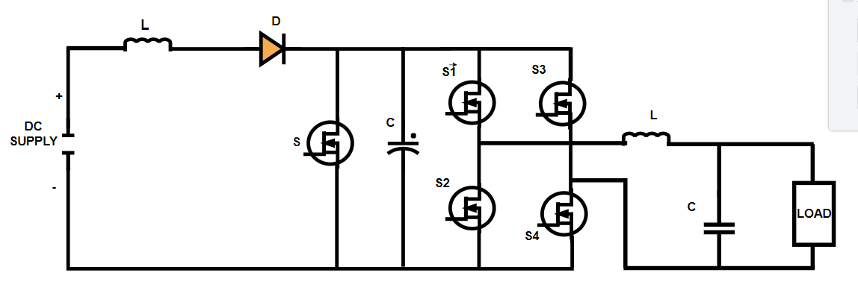

**Figure 2.1 High Gain Step-Up Converter Fed Voltage Source Inverter**

**III. HARDWARE IMPLEMENTATION**

**High-Gain DC-DC Converter:** This is used to step up the low DC input voltage to a higher level, suitable for the VSI. Common topologies include boost converters, coupled inductor converters, and switched-capacitor converters. **Voltage Source Inverter (VSI):** Converts the high DC voltage into AC voltage. It typically uses IGBTs or MOSFETs as switching device.

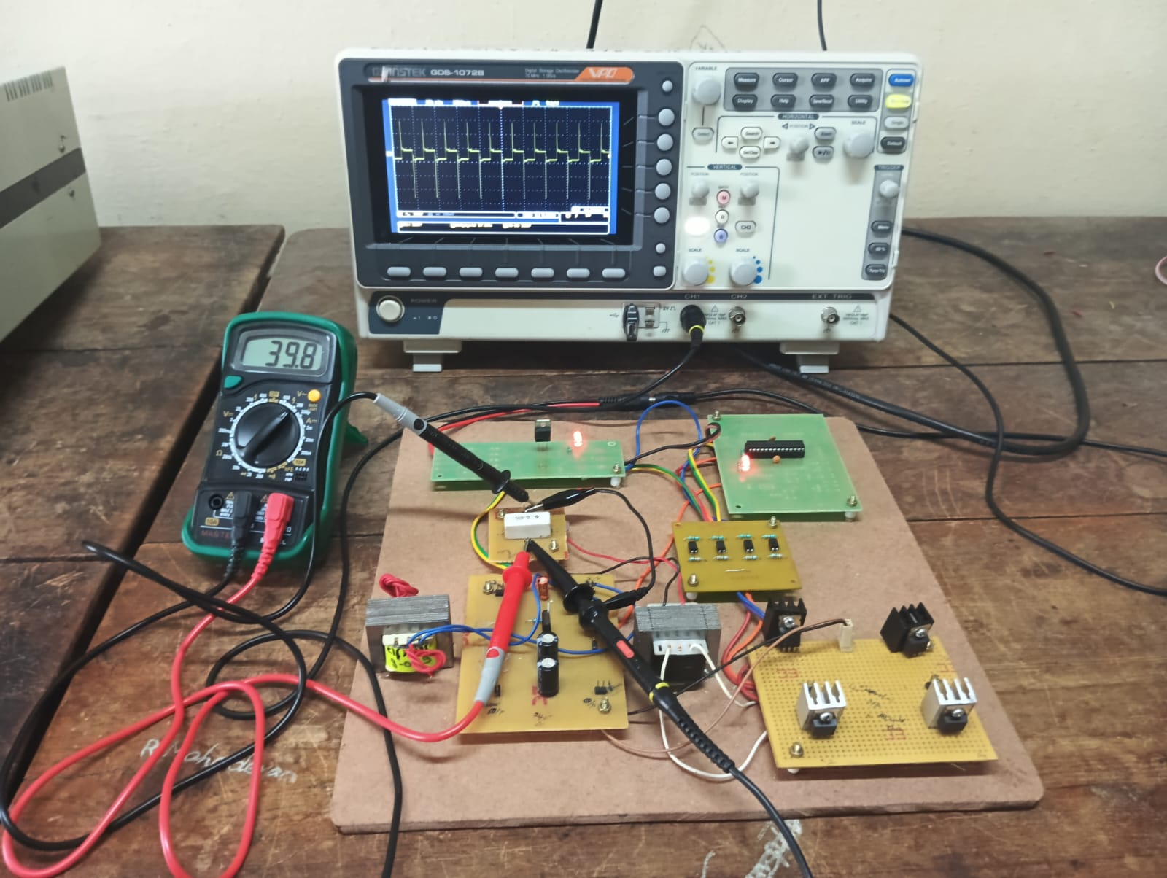

**Fig 3.1 Analysis And Implementation Of High Gain Step-Up Converter Fed Voltage Source Inverter**

**IV. SOFTWARE SIMULATION**

**4.1 SIMULATION OF HIGH GAIN DC-DC CONVERTER FED VOLTAGE SOURCE INVERTER**

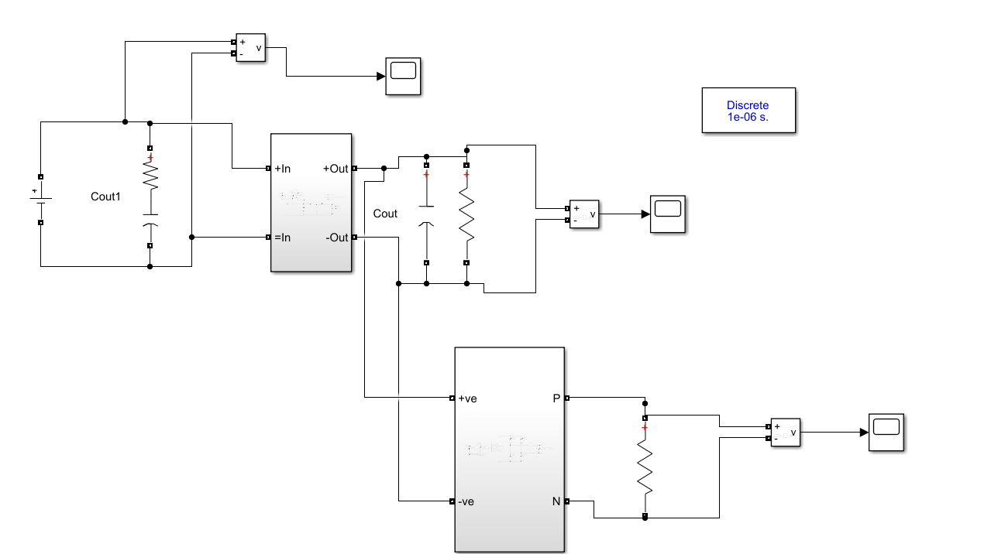

**Figure 4.1 Simulation Of High Gain Dc-Dc Converter Fed Voltage Source Inverter**

**4.2 SIMULATION OF HIGH GAIN STEP-UP CONVERTER**

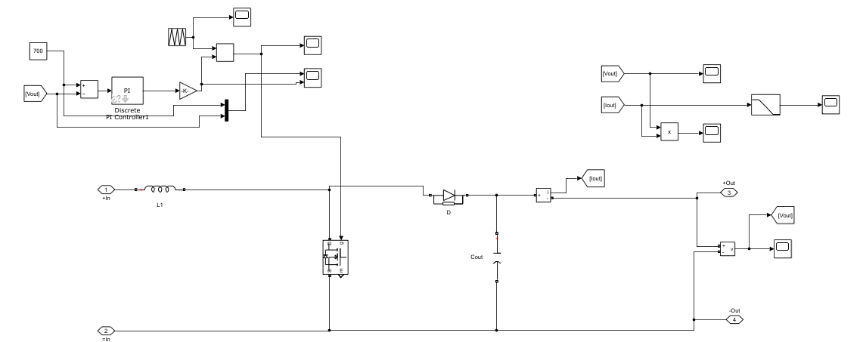

**Figure 4.2 Simulation Of High Gain Step-Up Converter**

**4.3 SIMULATION OF VOLTAGE SOURCE INVERTER**

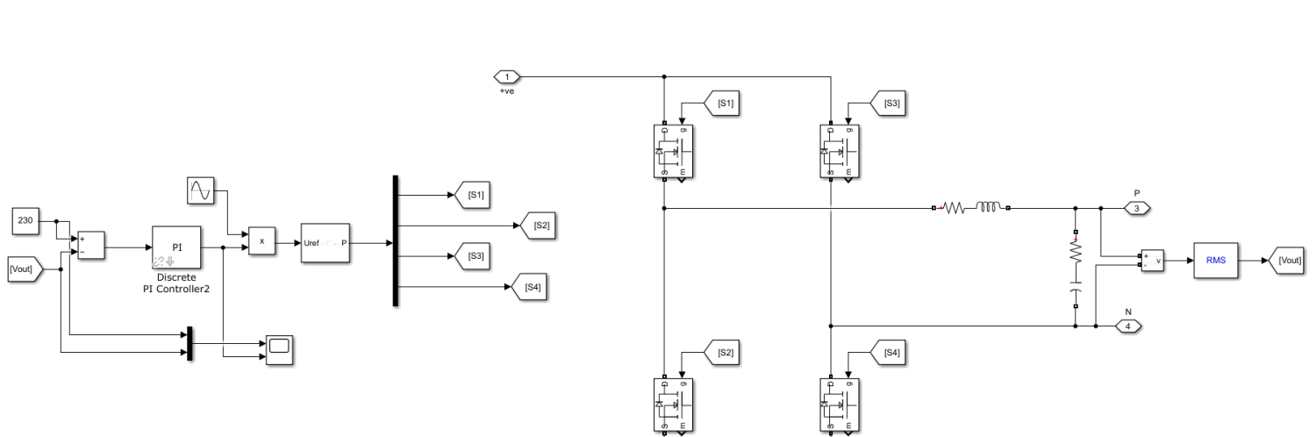

**Figure 4.3 Simulation Of Voltage Source Inverter**

**4.5 SIMULATION WAVEFORM OF DC SUPPLY VOLTAGE**

This type increases the input voltage to a higher output voltage. It's used in applications like battery-powered devices that need a higher operating voltage.

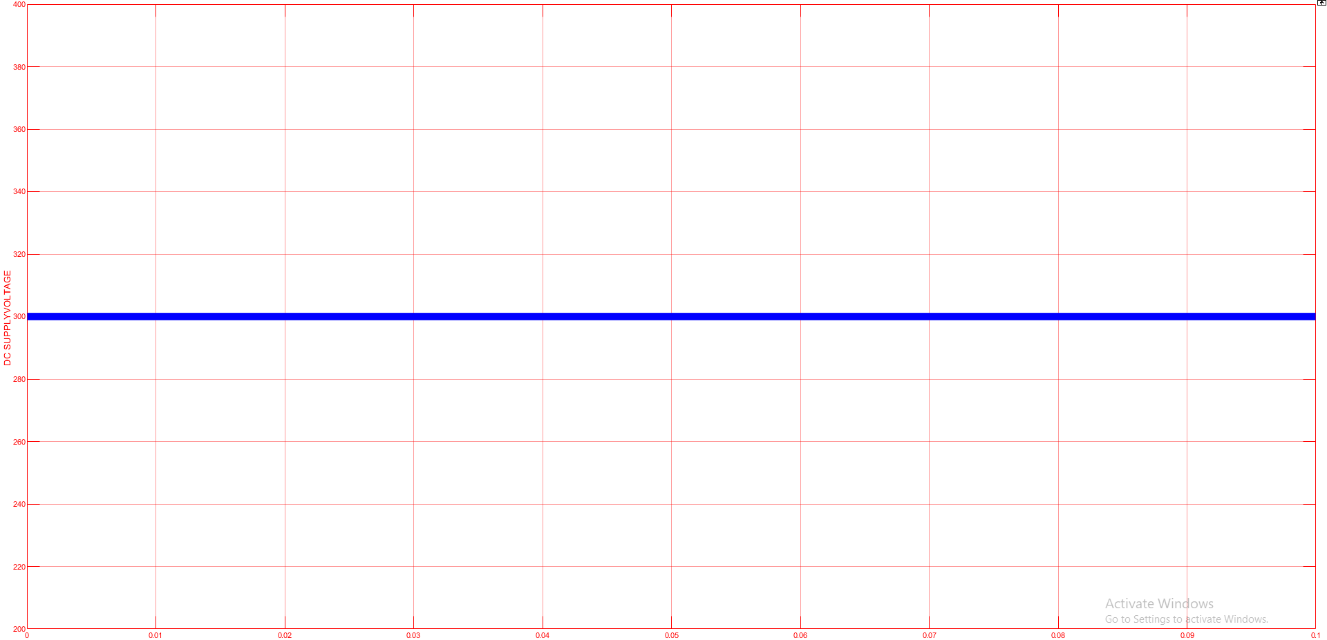

**Figure 4.5 Simulation Waveform Of DC Supply Voltage**

**4.6 SIMULATION WAVEFORM OF BOOST CONVERTER**

Boost converter is a type of DC-DC converter that steps up voltage from its input to its output.

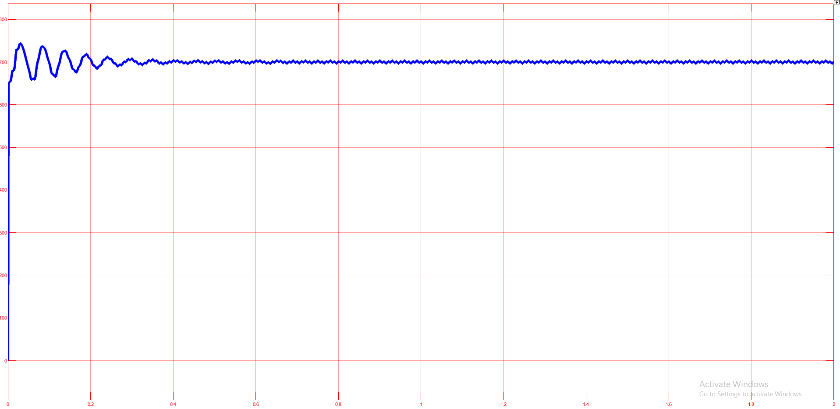

**Figure 4.6 Simulation Waveform Of Boost Converter**

**4.7 SIMULATION WAVEFORM OF SINGLE-PHASE INVERTER**

A Voltage Source Inverter (VSI) converts DC voltage into AC voltage. It typically consists of switching devices such as IGBTs or MOSFETs and can produce various types of output waveforms, including square waves, modified sine waves, and pure sine waves.

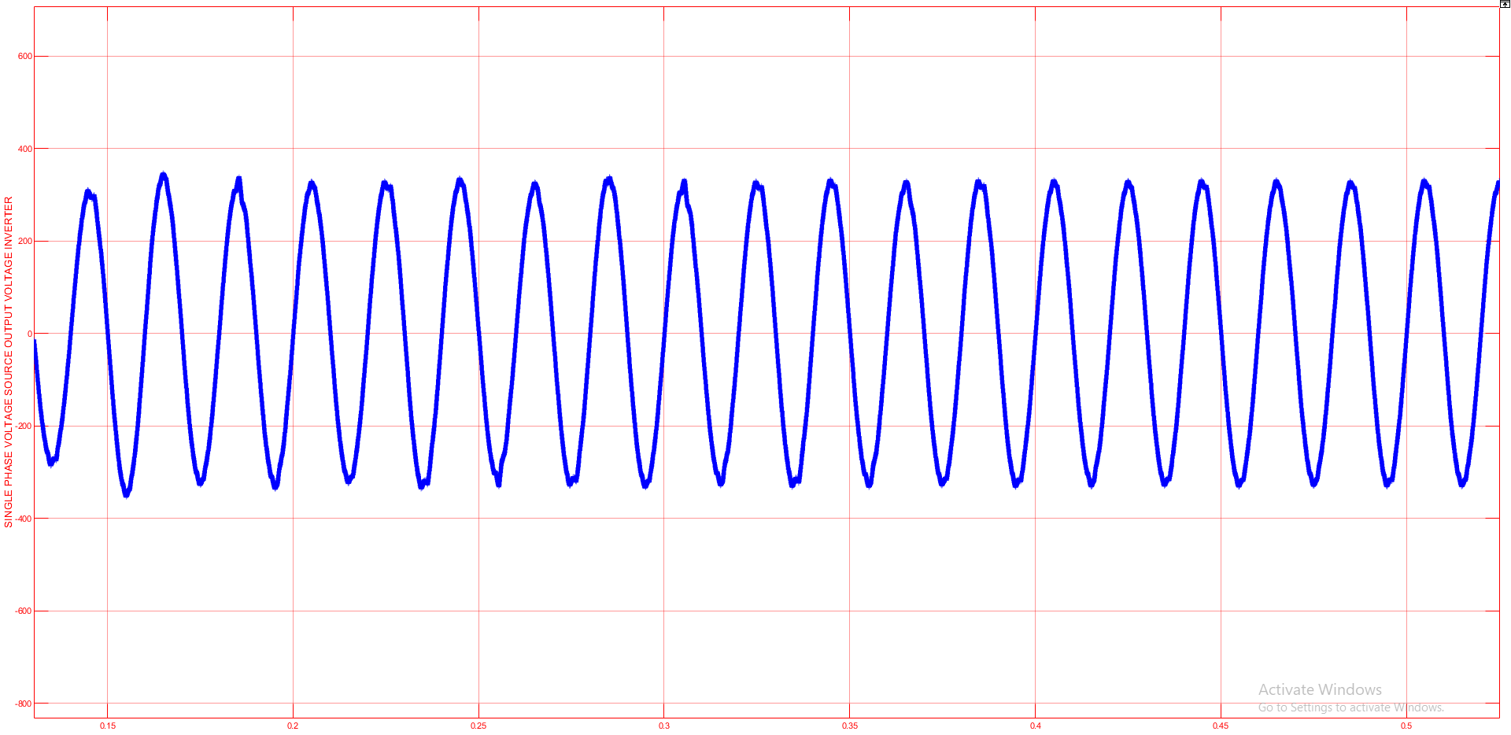

**Figure 4.7 Simulation Waveform Of Single Phase Inverter**

**4.8 SIMULATION WAVEFORM OF PI CONTROLLER VOLTAGE SOURCE INVERTER OUTPUT VOLTAGE**

The raw PWM waveform typically contains high-frequency components. To obtain a smooth sinusoidal AC output, the waveform is often filtered using an LC filter (inductor-capacitor filter).

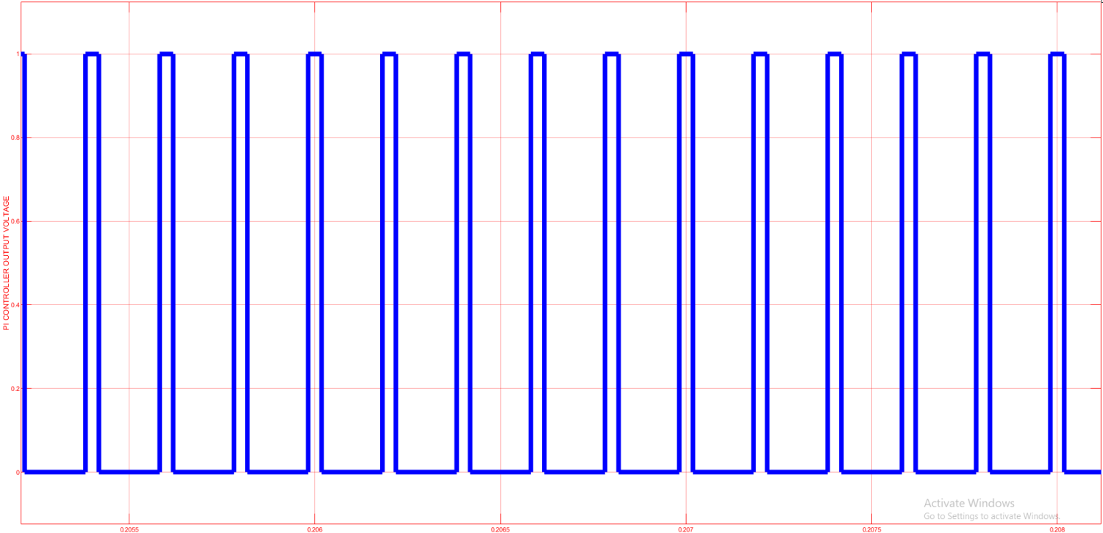

**Figure 4.8 Simulation Waveform Of Single Phase Voltage Source Inverter Output Voltage**

**4.9 PARAMETER OF HIGH GAIN STEP-UP CONVERTER**

**Table 4.9 Parameter Of High Gain Step-Up Converter**

|  |  |
| --- | --- |
| **PARAMETER** | **SPECIFICATION** |
| Input dc voltage | 230V |
| Load resistance | 100 Ω |
| Load inductance | 1e-3 mH |
| Load capacitance | 1e-6µF |
| Proportional integral | 0.1 |
| Proportional gain | 0.5 |

**V. RESULT AND DISCUSSION**

**5.1 INPUT VOLTAGE WAVEFORM OF CONVERTER**

A boost converter, also known as a step-up converter, is a type of DC-DC converter that increases (boosts) the input voltage to a higher output voltage. It typically consists of an inductor, switch (usually a transistor), diode, and a capacitor

For a DC-DC converter with an input voltage of 12V, the choice of converter type depends on the required output voltage.Powering devices requiring higher voltage, like certain types of LEDs or charging higher voltage batteriesboost converter operates by storing energy in an inductor while a switch (typically a transistor) is on, and then releasing that energy to the output when the switch is off. The output voltage is regulated by controlling the duty cycle of the switch. A higher duty cycle results in a higher output voltage. Output Waveforms: Look for the generated AC waveforms in the output, which should show the characteristics of the desired wave (e.g., sine wave).Events: Observe the switching events in the simulation to ensure correct operation of the PWM control.Harmonics: Analyze the harmonic content of the output waveforms, especially if generating non-sine waveforms.

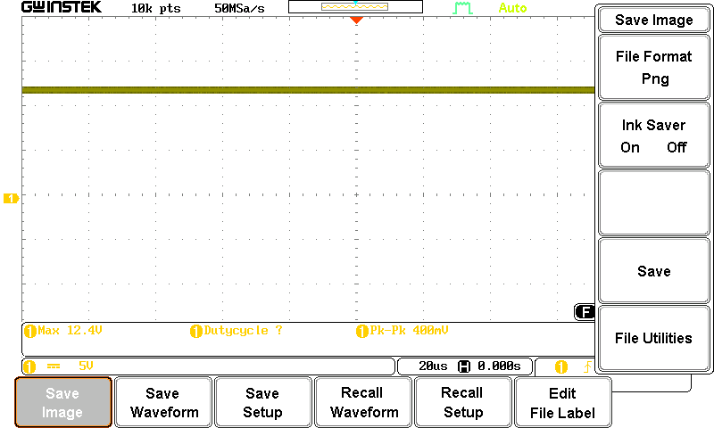

**Figure 5.1 Input Voltage Waveform For Dc-Dc Boost Converter**

**5.2 OUTPUT VOLTAGE WAVEFORM FOR CONVERTER**

A DC-DC converter is an electronic circuit that converts a source of direct current (DC) from one voltage level to another. It is commonly used in power supplies for various electronic devices. For a 24V DC-DC converter, the output voltage waveform can vary depending on the type of converter being used.

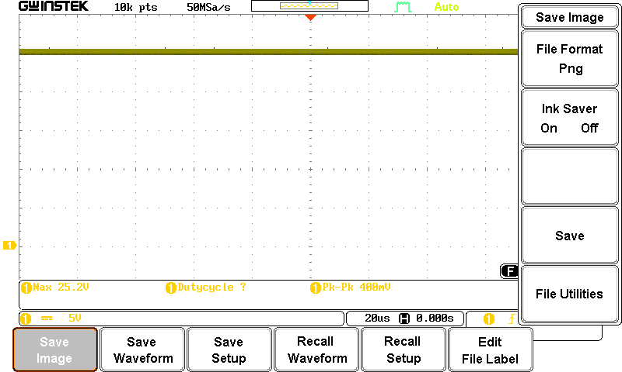

**Figure 5.2 Output Voltage Waveform For Converter**

**5.3** **AC OUTPUT WAVEFORM INVERTER PULSE STEP-DOWN TRANSFORMER**

A step-down transformer is an electrical device that reduces the voltage from the primary side to a lower voltage on the secondary side. It operates on the principle of electromagnetic induction, where a varying current in the primary coil generates a varying magnetic field, inducing a voltage in the secondary coil.

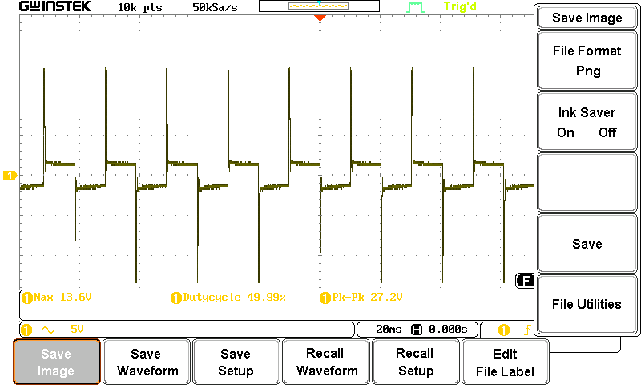

**Figure 5.3 Output Voltage Waveform Step-Down Transformer**

An inverter generates AC pulses by switching the DC input on and off rapidly. The switching devices, typically transistors or MOSFETs, are controlled by a pulse-width modulation (PWM) technique to create the desired AC waveform. The high-frequency AC pulse is fed into the primary winding of the transformer.The transformer steps down the voltage to the desired lower AC level.

**5.4**  **AC OUTPUT VOLTAGE WAVEFORM STEP-UP TRANSFORMER**

A step-up transformer inverter with AC pulse modulation is a device used to convert low-voltage DC (direct current) to a higher-voltage AC (alternating current) using a step-up transformer and pulse modulation .techniques**.**

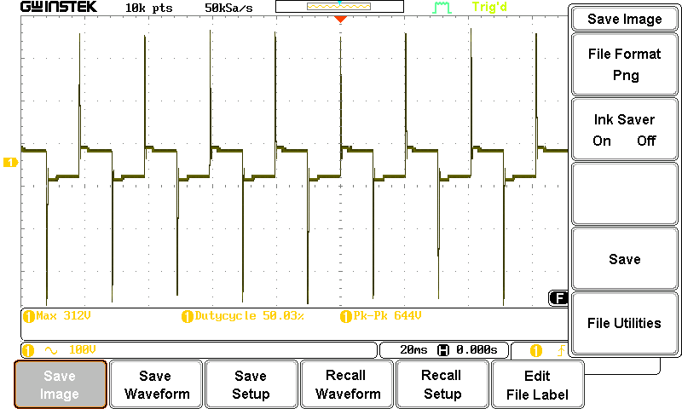

**Figure 5.4 Output Voltage Waveform Step-Up Transformer**

**VI . CONCLUSION**

A voltage source inverter is a critical component in solar power systems, responsible for converting the direct current (DC) generated by solar panels into alternating current (AC) suitable for use in homes or the grid. Using solar power, we harness a clean and renewable energy source, reducing dependence on conventional fossil fuels and minimizing environmental impact. The Boost Converter is a type of DC-DC converter used in photovoltaic systems to efficiently regulate the voltage and maximize power output **.**

**REFERENCES**

* 1. Pawlak M, Radomski G, Kaplon A. Experimental verification of DC/DC Boost Converter calculation model considering conduction losses. Selected Problems of Electrical Engineering and Electronics(WZEE); 2015 Sep. p. 1–6. 11.
  2. Hwang JH, Soh JH, Kim YR.Design procedure for minimizing conduction loss for ZCT PWM boost converter**.** Future Energy Electronics Conference (IFEEC); 2015 Nov. p. 1–6. 12.
  3. Ghamrawi A, Gaubert JP, Mehdi D. New control strategy for a Quadratic Boost Converter used in the solar energy system. Energy Conference (ENERGYCON); 2016 Apr. p. 1–6. Crossref.
  4. Milad Rezaie1, Vahid Abbasi1, Tamas Kerekes2 High step-up DC-DC converter composed of quadratic boost converter and switched capacitor Power Electron., 2020, Vol. 13 Iss. 17, pp. 4008-4018 © The Institution of Engineering and Technology 2020
  5. .Sherif M. Dabour1, Majed Alotaibi2, Amr A. Abd-Elaziz1 Modeling and Control of Single-Stage Quadratic-Boost Split Source Inverters Author Name: Preparation of Papers for IEEE Access (December 2021)
  6. Beena KH, Benny A. Analysis and implementation of Quadratic Boost Converter for Nanogrid applications. IJAREEIE. 2017 Jul; 4(7):1–6. 5.
  7. Tattiwong K, Bunlaksananusorn C. Analysis design and experimental verification of a Quadratic Boost Converter. TENCON, IEEE; 2022 Oct. p. 1–6. 6.
  8. Navamani DJ, Veena ML, Lavanya A, Vijayakumar K. Efficiency comparison of Quadratic Boost DC-DC Converter in CCM and DCM. International Conference on Electronics and Communication Systems; 2015 Jun. p. 1156–61. Crossref.
  9. M. Forouzesh, Y. P. Siwakoti, S. A. Gorji, F. Blaabjerg and B. Lehman, "Step-Up DC-DC Converters: A Comprehensive Review of Voltage Boosting Techniques, Topologies, and Applications," in IEEE Transactions on Power Electronics, vol. 32, no. 12, pp. 9143-9178, 06 March 2017