**A Study On Unified Modelling Approach For Memristor : Next Generation Semiconductor Devices**

Dr.K.Paramasivam1, Ameer M2, Bala Krishna R M2 , Kishore K2

*1Professor, EEE Department, Kumaraguru College of Technology, India.*

*2UG scholar, EEE Department, Kumaraguru College of Technology, India.*

*Corresponding Author: paramasivam.k.ece@kct.ac.in*

|  |
| --- |
| ***Abstract:****This research investigates the voltage-current (V-I) characteristics of three distinct memristor models, each representing a unique composition and behaviour. The model, denoted as TiN-TiOx-HfOx-Pt-Bilayered Memristor model, is a compact representation designed for Metal–Oxide Resistive Random Access Memory (RRAM). Matlab tool is used for the simulation to analyse V-I characteristics of Memristor. Through comprehensive analysis and simulations, we aim to provide a detailed insight into the intrinsic behaviours of the memristor models. Understanding the V-I characteristics of these models is crucial for their potential applications in emerging memory technologies. This Study elaborate the mathematical modelling of memristor with the outcome untuned V-I Characteristics - DC Switching characteristics. The findings contribute to the broader field of memristor research, fostering advancements in electronic memory devices and computational systems.*  ***Key Word****:Memristor, RRAM, material, fabrication, Modelling MATLAB, VI Characteristics* |

1. **Introduction**

An electrical circuit that expresses the connection between magnetic flux and electric charge is called a memristor. Resistance is a feature of the memristor, although, unlike resistance, the memristor's resistance depends on the charge passing through it. As a result, you can determine the amount of charge passing through the memristor and, consequently, the memory charge function by measuring its resistance.

Cai Shaotang, an American professor at the University of California, Berkeley at the time, was the one who initially put out the idea of the memristor. Professor Cai concluded that, in addition to resistor, capacitor, and inductor, there should be another component that represents the relationship between charge and magnetic flux. In 1971 after researching the relationship between charge, current, voltage, and magnetic flux, he came up with the missing circuit element, memristor. This component has the effect of changing resistance in response to the amount of current passed. It will also maintain its prior resistance even in the event of a current halt, and it won't be pushed back until it receives the reverse current.

To put it simply, a memristor is a memory-functioning non-linear resistor. By managing the change in current, the resistance value can be adjusted. This type of resistance can achieve the purpose of storing data if the high resistance value is designated as "1" and the low resistance value is defined as "0". It has a memory function and is a non-linear resistor.

Chua discovered a theoretical symmetry between the non-linear inductor (magnetic flux linkage vs. current), non-linear resistor (voltage vs. current), and non-linear capacitor (voltage vs. charge) in his 1971 work. He deduced the properties of a fourth basic non-linear circuit element—the memristor—that connected magnetic flux and charge based on this symmetry. The memristor has a dynamic relationship between current and voltage, including a memory of previous voltages or currents, in contrast to a linear (or non-linear) resistor. Chua provided a mathematical generality to the dynamic memory resistors that other scientists had developed, such as Bernard Widrow's memristor.

Leon Chua first presented the idea of memristive networks in his 1965 paper "Memristive Devices and Systems." Chua suggested creating artificial neural networks that mimic the functioning of the human brain by utilising memristive devices. Kirchhoff's rules result in complicated interactions between memristive devices in circuits. Based on memristive devices, which are electronic components with the memristance property, memristive networks are a kind of artificial neural network. Memristive devices are employed in a memristive network to mimic the actions of synapses and neurons in the human brain. The memristive devices in the network are arranged in layers, with a set of weights connecting one layer to the next.

Throughout the training phase, these weights are changed to help the network pick up new skills and adapt to fresh input data. Memristive networks are a good choice for creating low-cost artificial intelligence systems since they can be built with relatively basic and inexpensive technology. Because they can store and process information with less power than typical artificial neural networks, they may also be more energy-efficient than the latter. Memristive networks are still in their infancy as a field, and more study is required to properly grasp both their advantages and disadvantages.

In the literature5, An animation For the purpose of exploring circuits and systems, a compact model of a resistive random access memory (RRAM) with cycle-to-cycle variation is developed in Verilog. The model incorporates intrinsic random fluctuations and variations in addition to capturing the behavior of dc and ac. The approach to methodically calibrate the model parameters through experiments is showcased and supported by an extensive collection of experimental data, encompassing multilayer RRAM.

This paper2 fills the void by putting forth an algorithm for fine-tuning a model's parameters to correspond with particular RRAMs. Because Resistive RAMs (RRAMs) are non-linear, modelling them is an arduous task. Although the urgent need for a model has prompted research teams to develop realistic models, the differences in characteristics between RRAMs have caused a divide between model creators and users. To achieve this, a flexible physics-based compact model was selected, and the suggested algorithm was applied to precisely fit the model to various RRAMs, which varied substantially in terms of their switching behaviour and material composition.

1. **Material And Methods**

# **Algorithm For The Model:**

Mathematical modelling is a process used in various scientific and engineering disciplines to describe and understand real-world phenomena using mathematical equations. In this process, some parameters are obtained directly from experimental data or literature, while others may need to be assumed or estimated. Here's an expanded explanation of this process:

* **Problem Definition:**
  + Defining the model that needs to be studied.
  + Identify the key variables and parameters that influence the system.
* **Formulation of Mathematical Equations:**
  + Identify mathematical equations that represent the relationships between the identified variables and parameters.
  + These equations may involve differential equations, algebraic equations, or other mathematical expressions, depending on the nature of the system and these equations are found in base paper.
* **Parameter Identification:**
  + Some parameters can be directly measured or obtained from experimental data, literature, or existing knowledge. These are considered known parameters.
  + However, certain parameters might be difficult or impossible to measure directly. In such cases, assumptions or estimates may be necessary.
* **Assumption of Parameters:**
  + Parameters that cannot be directly measured may need to be assumed based on simplifications, theoretical considerations, or expert judgement.
  + Assumptions help simplify the model and make it more tractable. However, it's important to be aware of the limitations introduced by these assumptions.
* **Estimation of Parameters:**
  + In some cases, parameters can be estimated through calibration or fitting the model to experimental data.
  + Statistical methods, optimization techniques, or data-driven approaches can be used to refine parameter values based on observed system behaviour

**Model Validation:**

* + Validate the mathematical model by comparing its predictions to experimental data or observations from the real system.
  + Adjust the model if there are discrepancies between predictions and observations.
* **Sensitivity Analysis:**
  + Perform sensitivity analysis to understand how changes in parameters impact the model predictions.
  + Identify critical parameters that significantly affect the system behavior.
* **Graphical Representation:**
  + Use the mathematical model to generate graphs or plots that visually represent the system's behaviour over time or under different conditions.
  + Visualization helps in interpreting the results and communicating findings to others.
* **Iterative Process:**
  + Mathematical modelling is often an iterative process. Models may need refinement or modification based on new data, insights, or changes in the system under study.
  + This refers to tuning the model based on various considerations.
* **Application and Prediction:**
  + Once validated and refined, the mathematical model can be used for predictions, simulations, or analysis under various scenarios.

**MODEL 1 : TiOx/HfOx Bilayered Model for Characterizing RRAM Devices**

* The TiOx/HfOx bilayered memristor model is taken for study and while understanding the electrical characteristics of metal-oxide resistive random access memory devices. This model allows for the investigation of various parameters and enables the prediction of device behaviour under different operating conditions.
* One of the advantages of using the TiOx/HfOx bilayered model is its ability to enhance resistance uniformity and suppress current overshot effects. This is particularly important in achieving reliable and consistent device performance. By carefully selecting the thickness and composition of the TiOx and HfOx layers, it is possible to optimize the device performance and improve its scalability.
* During the SET process, oxygen ions drift to the anode interface, creating a conductive path through the oxide and programming the cell to the low-resistance state (LRS).
* In terms of the RESET operation, the TiOx/HfOx bilayered model offers insights into the gradual decrease in resistance towards the high-resistance state. This phenomenon is crucial for the stable operation of the RRAM device and plays a key role in achieving multilevel switching characteristics. The bilayer structure, with TiOx serving as an oxygen reservoir, allows for controlled charge transport, power dissipation, and temperature increase.
* Recent advancements in these models have shown promising results in terms of reducing device operating current and improving resistive switching reliability. Further research is needed to elucidate the underlying mechanisms and optimize the bilayer structure for even better device performance.

**Physical model:**

* "The Physical Model of Bipolar Switching Processes in RRAM” delves into the comprehensive analysis and application of bipolar switching processes in Resistive Random Access Memory.
* The researchers have utilized the ASU RRAM model, calibrated with experimental data from IMEC, to acquire the I-V characteristics of a bipolar HfOx-based RRAM device. Resistance-switching RRAM offers advantages such as high endurance, long retention, fast switching speed, and compatibility with CMOS technology.
* The ability to achieve multiple levels of states with low energy consumption makes it an excellent choice for energy-efficient computation and reconfiguration of neural networks in 3D integrations.
* The bipolar switching mode in RRAM is characterized by the formation and annihilation of conductive filaments through the migration of ions driven by an electric field. This mode enables precise control over the resistance states of the memory cell, making it ideal for storing and retrieving information in RRAM devices.

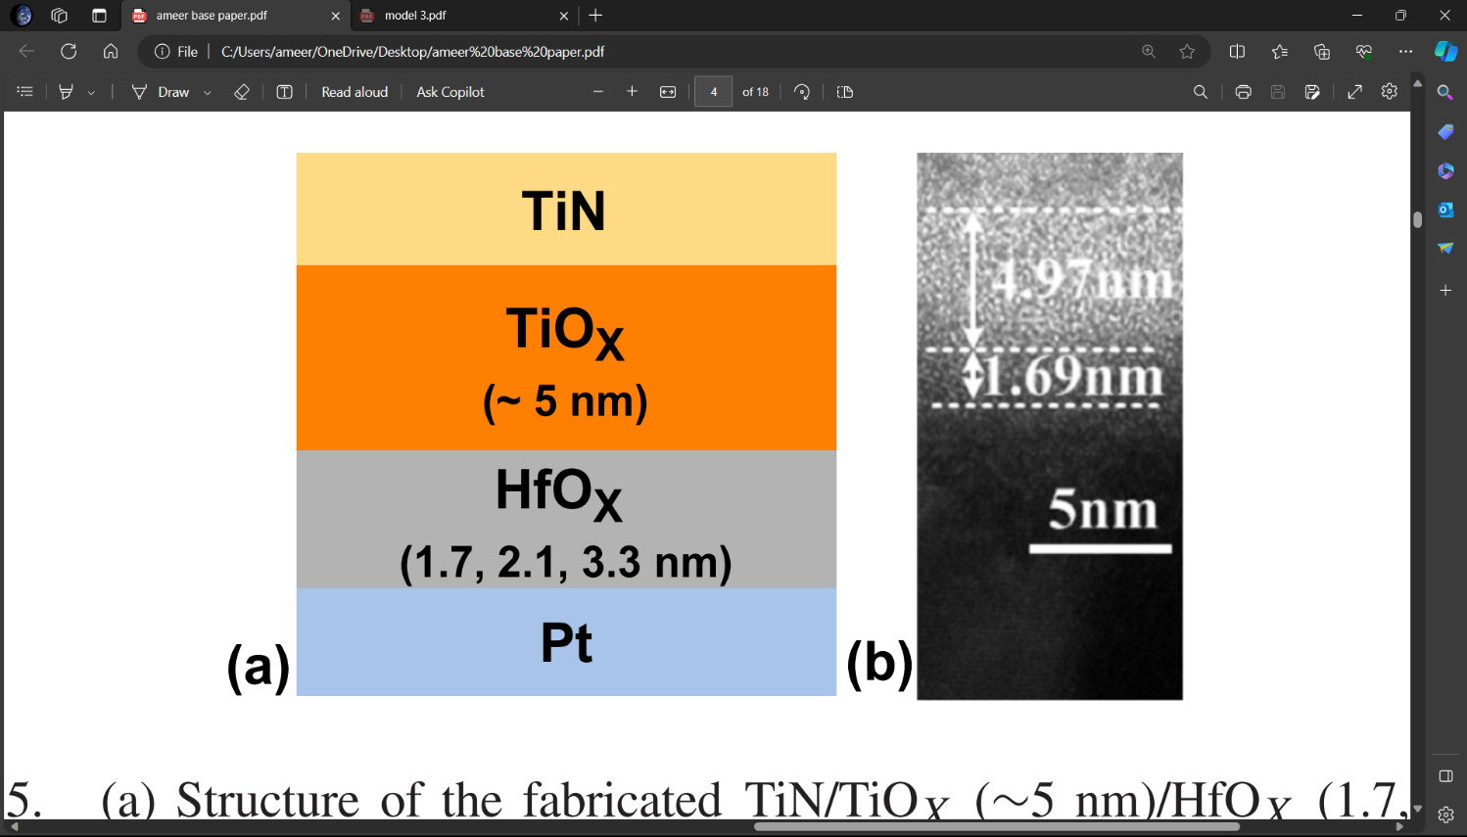

Fig 1. M-I-M structure of the Bilayered memristor model

The diagram shows the four layers of the device: TiN, TiOx, HfOx, and Pt. The TiOx layer is the undoped region, while the HfOx layer is the doped region. The memristance of the device depends on the length of the doped region, which changes according to the applied voltage. The specifications of this memristor are:

* The total device length is 50 nm
* The thickness of the TiN and Pt electrodes is 10 nm each
* The thickness of the TiOx layer is 5 nm
* The thickness of the HfOx layer can vary from 1.7 nm to 3.3 nm
* The resistance of the device can range from 100 Ω to 16 kΩ
* The switching time of the device is less than 10 ns
* The power consumption of the device is less than 10 pW

# 

# **Fundamentals of memristor :**

The terms **"set"** and **"reset"** are pivotal actions that dictate the resistance states of these unique two-terminal non-volatile memory components. Memristors exhibit alterations in resistance based on the historical application of voltage and current, and the set and reset operations are integral to establishing specific resistance states within the device.

**1. Set Operation:**

The set operation involves applying a voltage pulse across the memristor terminals. This pulse induces a resistance change, typically transitioning the memristor from a high-resistance state (HRS) to a low-resistance state (LRS). Essentially, the set operation serves as a programming mechanism, configuring the memristor to a desired conductive state.

**2. Reset Operation:**

In contrast, the reset operation requires the application of a distinct voltage pulse across the memristor terminals. This reset pulse induces a resistance change that returns the memristor from a low-resistance state (LRS) back to a high-resistance state (HRS). The reset operation is essential for reprogramming the memristor or reverting it to a specific resistance state.

# **3. Compliance Current :**

# Compliance current is a parameter that controls the quantum of current that flows through a memristor during the switching process. It's used to cover the device from endless damage by limiting the current swell that can do when the voltage exceeds a certain threshold[4]. Compliance current also affects the resistance state and the retention time of the memristor, which are important for its memory and computing operations. By conforming the compliance current, one can achieve multilevel switching in a memristor, which means that the device can store further than one bit of information per cell.

# **Equations for mathematical modelling :**

The following equations are concerned with mathematical modelling in matlab.The RRAM model described in the document includes several parameters that are used to characterize the behaviour of the device[5]. These parameters are essential for understanding the relationship between the gap distance and the resistance of the cell.

**1. Equation to find the change in average gap distance :**

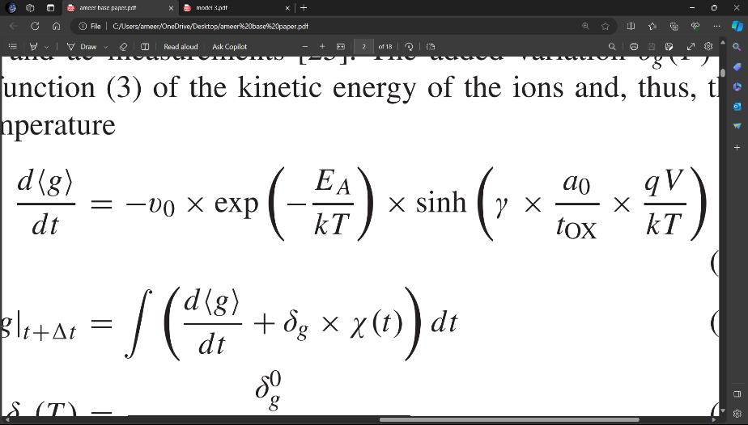 **--------(1)**

1. g: The gap distance between the tip of the filament and the opposite electrode.
2. 〈g〉: The average gap distance.
3. γ: The field local enhancement factor that accounts for the polarizability of the material.
4. ν0 : The velocity dependent on the attempt-to-escape frequency.
5. E: The effective activation energy (migration barrier) for vacancy generation (oxygen migration).
6. t: The thickness of the switching material.
7. a: The hopping site distance.
8. k: Boltzmann constant k or kB = 1.3806452 × 10-23 J/K.
9. T: change in local temperature
10. V: The applied voltage across the cell.
11. q: The charge of an electron = 1.6×10−19 C

**2. Equation to find the gap distance :**

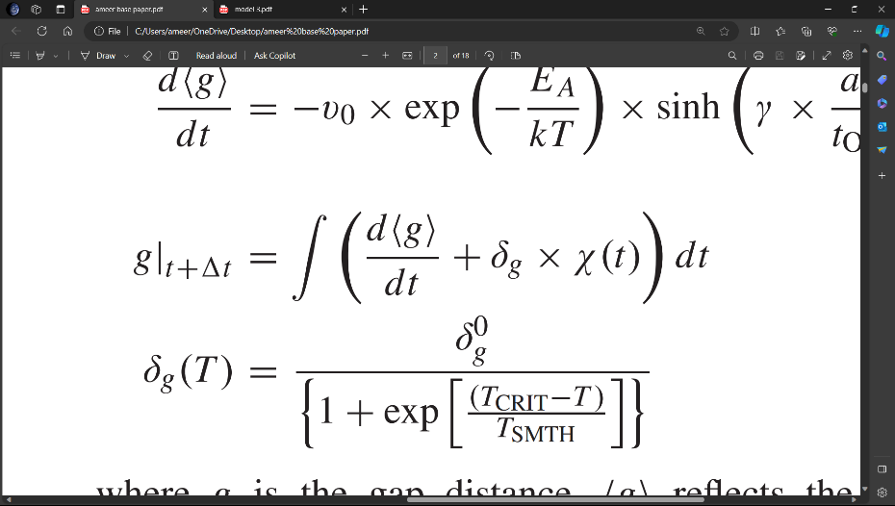**--------(2)**

**1**.〈g〉: The average gap distance.

**2**. g : dynamic random variations in the gap distance, which depend on the temperature.

**3**. χ(t): A zero-mean Gaussian noise sequence randomly generated at each time step.

**4.** g: The gap distance between the tip of the filament and the opposite electrode.

**3. Equation to find dynamic random variations in the gap distance with respect to time :**

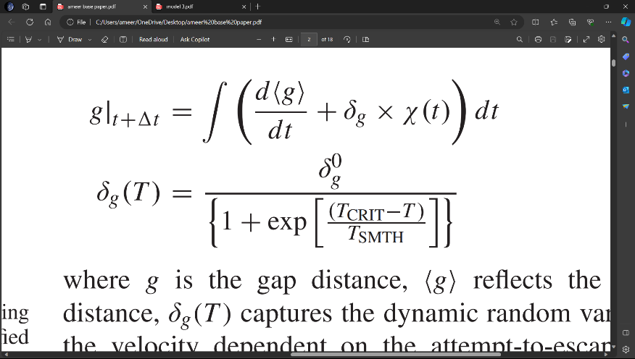**--------(3)**

1. (T): Captures the dynamic random variations in the gap distance, which depend on the temperature.
2. : A fitting parameter for variations in the gap distance.
3. T: A threshold temperature above which a significant random variation of the gap size occurs.
4. T: A smoothing parameter.

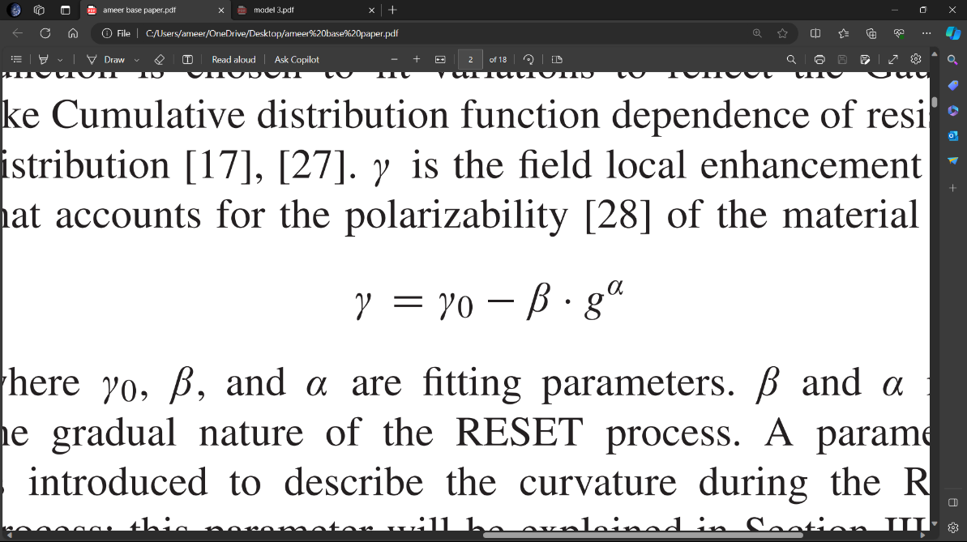**4. Equation to find local enhancement factor :**

**--------(4)**

1. γ: The field local enhancement factor that accounts for the polarizability of the material.
2. γ, β, α: Fitting parameters that describe the gradual nature of the RESET process.

**5. Equation for the change in local temperature :**

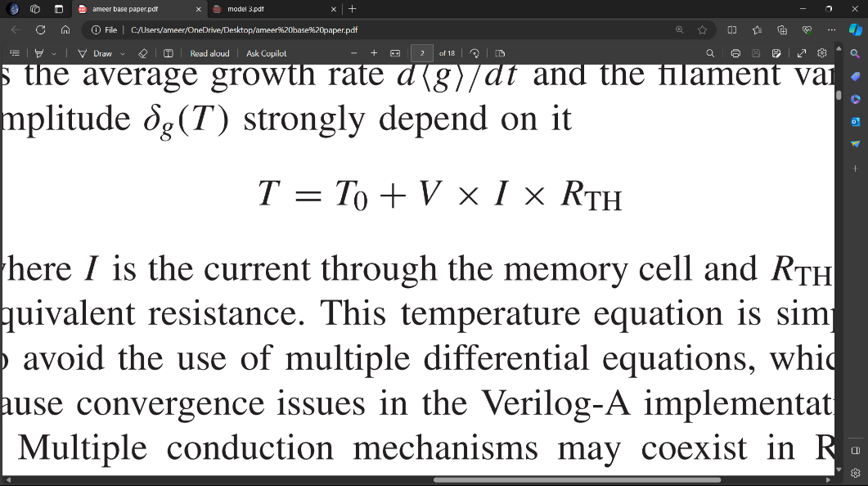**--------(5)**

1. T: Environment Temperature (~300k)
2. R: Equivalent thermal resistance (~500k)
3. V: The applied voltage across the cell.
4. I: The current flowing through the memory cell.

**6. Equation for the current flowing through the RRAM cell :**

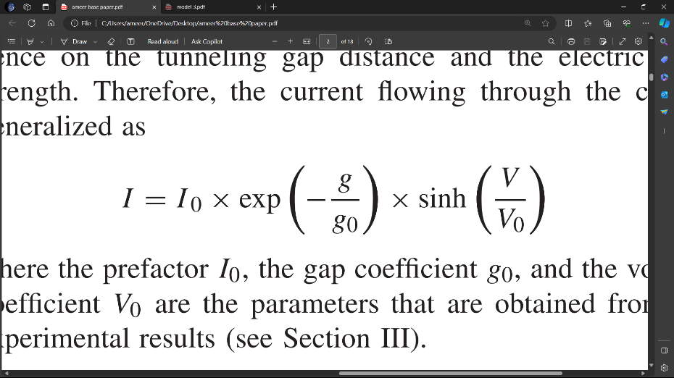**--------(6)**

1. V: The applied voltage across the cell.
2. I: The current flowing through the memory cell.
3. I 0, g 0, V 0: Parameters that describe the median of switching behaviours.
4. g: The gap distance between the tip of the filament and the opposite electrode.

These Equations are essential in deriving the mathematical model for the memristor. The Final Equation(6) shows the relation between the Voltage and Current.

# **Table of parameters :**

The above parameters values are known values and taken from the range of values in the base paper5,6.

Table 1. Table of parameters

|  |  |  |  |
| --- | --- | --- | --- |
| **Device parameters** | **Value** | **Device parameters** | **Value** |
| v | 10 m/s | Rth | 500 K |
| Ea | 0.6 eV |  | 0.04368 |
| a0 | 0.33 nm | Io | 0.4 mA |
| Tox | 3 nm | g | 0.28 nm |
| k | 1.380649e-23 J/K | Vo | 0.4 V |
| χ | 1 | γ | 16.8 |
|  | 0.1 | α | 1 |
| Tcrit | 420 K | β | 1.1 |
| Tsmth | 500 K | q | 1.602e-19 C |
| T | 300 K |  |  |

# **Matlab code and results**

The proposed memristor device is modelled in MATLAB using equations discussed in above sections. Delta_g is manually computed and its value is 0.008810 with delta_g0 as 0.02 T~300K and T_crit and T_smth are 420 and 500 respectively. The graph obtained is as expected from the fabricated model in the base paper. This Graph depicts the DC characteristics for compliance current of the 1.7-nm HfOx device. A larger compliance current results in a smaller gap distance at LRS (gLRS) after the SET process. The compliance current is illustrated by the minimum gap distance (gLRS) in the model5. Figure 2 shows the Dc characteristics for compliance current of the 1.7-nm HfOx device.

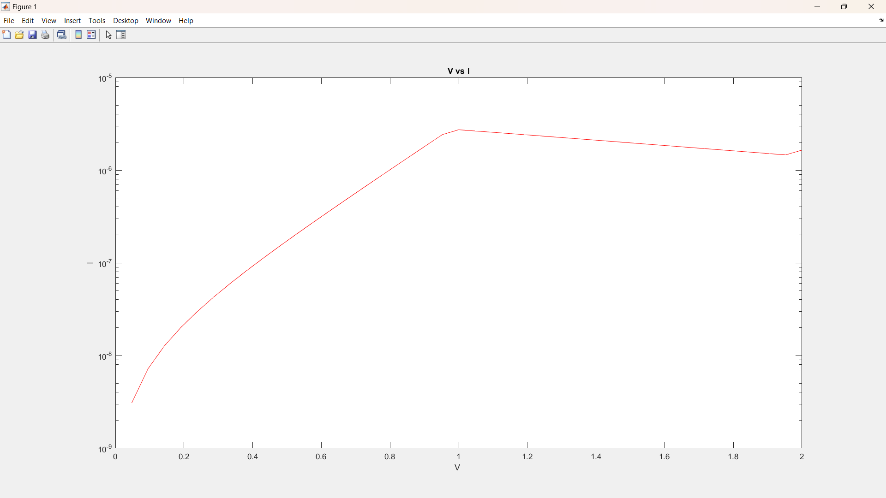

Fig. 2. DC Characteristics for compliance current of the 1.7-nm HfOx device.

Figure 3 shows DC Switching Characteristics(Untuned) for Bilayered device. The graph is a Untuned graph from the mathematical modelling for the proposed memristor. Hence Changing the fitting parameters like g0,Tsmth,γo, β, α, will lead to the results as expected.

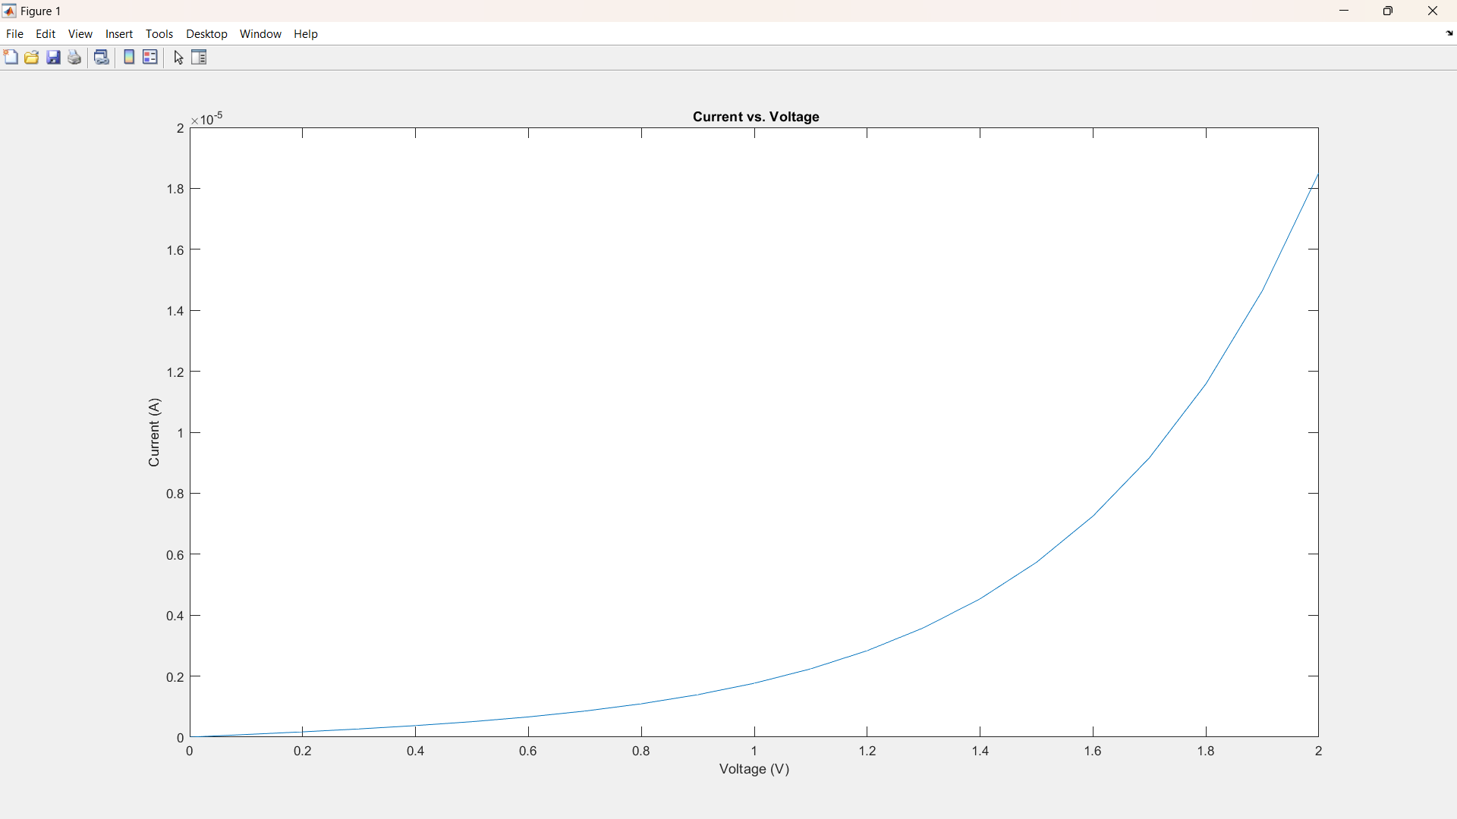

Fig. 3. DC Switching Characteristics(Untuned) for Bilayered device.

Hence the results from the proposed mathematical model for Bilayered memristor with M-I-M composition (TiN-TiOx-HfOx-Pt) is partially correct and it is inferred that if the parameters are tuned and fitted as expected,the hysteresis curve would have show that the memristor has two stable states of low and high resistance, and can switch between them when the applied voltage crosses a certain threshold and the memory effect would have been observed.

**IV.Conclusion**

In our exploration of the voltage-current (V-I) characteristics of three memristor models—TiN-TiOx-HfOx-Pt representing Metal–Oxide Resistive Random Access Memory (RRAM). The TiN-TiOx-HfOx-Pt model demonstrated promising compactness and efficiency, suggesting its potential for high-density memory applications. However, the observed approximate results underscore the importance of fine-tuning parameters to unveil the complete behavior of the model. As a comparison, these partial outcomes highlight the challenges in accurately capturing memristor behavior through modeling and simulation. The journey from partial to complete results underscores the iterative nature of scientific inquiry and encourages researchers to meticulously tune parameters for enhanced model accuracy.

**REFERENCE**

1. Wikipedia - [https://en.m.wikipedia.org/wiki/Memristor#](https://en.m.wikipedia.org/wiki/Memristor)
2. J. Reuben, D. Fey and C. Wenger, "A Modeling Methodology for Resistive RAM Based on Stanford-PKU Model With Extended Multilevel Capability," in IEEE Transactions on Nanotechnology, vol. 18, pp. 647-656, 2019, doi: 10.1109/TNANO.2019.2922838.
3. <https://knowm.org/memristor-models-in-ltspice/>
4. Humood, K., Saylan, S., Mohammad, B. et al. Effect of the Compliance Current on the Retention Time of Cu/HfO2-Based Memristive Devices. Journal of Elec Materi 50, 4397–4406 (2021). <https://doi.org/10.1007/s11664-021-08995-5>
5. A Compact Model for Metal–Oxide Resistive Random Access Memory With Experiment Verification Zizhen Jiang, Student Member, IEEE, Yi Wu, Shimeng Yu, Member, IEEE, Lin Yang, Kay Song, Zia Karim, Member, IEEE, and H.-S. Philip Wong, Fellow, IEEE
6. Guan, Ximeng & Yu, Shimeng & Wong, H.-S. Philip. (2012). On the Switching Parameter Variation of Metal-Oxide RRAM—Part I: Physical Modeling and Simulation Methodology. IEEE Transactions on Electron Devices - IEEE TRANS ELECTRON DEVICES. 59. 1172-1182. 10.1109/TED.2012.2184545.
7. B. Hajri, H. Aziza, M. M. Mansour and A. Chehab, "RRAM Device Models: A Comparative Analysis With Experimental Validation," in IEEE Access, vol. 7, pp. 168963-168980, 2019, doi: 10.1109/ACCESS.2019.2954753.
8. Compact Modeling of Complementary Switchingin Oxide-Based ReRAM Devices
9. Camilla La Torre , Alexander F. Zurhelle , Thomas Breuer, Rainer Waser, Member, IEEE,and Stephan Menzel , Member, IEEE