**GREEN BONDS: A PATHWAY TO SUSTAINABLE INVESTMENT AND ENVIRONMENTAL RESILIENCE**

**Centre for Management Studies, Jain (Deemed-to-be University)**

**Prof. Krishna Reddy** (Faculty Advisor)

**Mr. Aryan Agarwal**

**Miss. Saanvi J Naik**

**Mr. Aaditya Singh**

**Mr. Anirudh Ramji**

**Mr. Rishi Jain**

**ABSTRACT**

Green bonds (or climate bonds) are one of the most used sustainable investment instruments, and under the Paris Climate Agreement of 2015, the climate bond market is expected to thrive soon. Green bonds are gaining increasing popularity among environmentally responsible investors, as well as investors who “simply” attempt to benefit from portfolio diversification, including green issuances, that are close to other fixed bonds. This paper aims to take advantage of previous literature contributions on the green bond market to indicate the way forward for future research. Herein, through a systematic literature review on the green bond market, our goal is to provide investors, main markets actors, and policymakers with some helpful insight on the role of environmental investments in reshaping the financial markets and fostering the sustainability of the economy.

**KEYWORDS**

Green bonds; systematic literature review; climate bond introduction, sustainable investment

**INTRODUCTION**

Green bonds, a unique fixed income security, are designed to fund environmentally conscious projects. They are asset-linked and carry the same credit rating as the issuer’s other debts. The main goal of green bonds is to support sustainable projects that contribute to environmental conservation and national growth. The government can use green bonds to encourage individuals and organizations to start eco-friendly projects, which would benefit both society and the environment.

The increase in ecological development projects in the country due to green bonds would also lead to an increase in the country’s development and attract Foreign Direct Investment (FDI). This would result in an increase in the Gross Domestic Product (GDP) and the overall development of the country, thereby increasing the trust of the people in the government due to the increase in the government’s goodwill.

Green bonds come in four different types: Green Use of Proceeds Bond, Green Revenue Bond, Green Project Bond, and Green Scrutinized Bond. Each type of bond has its unique characteristics and is used for specific purposes, ranging from financing eligible ecological projects to pooling a group of eco-friendly projects or assets.

One of the most appealing aspects of green bonds is the potential tax benefits, which could include tax exemptions and credits, incentivizing firms to undertake projects addressing various environmental issues. This initiates a shift towards renewable energy sources and a sustainable future. The tax advantages of green bonds are a significant factor in their rising popularity.

The relevance of green bonds in today’s world cannot be overstated. As the global community becomes increasingly aware of the environmental challenges we face, such as climate change and resource depletion, the demand for sustainable and environmentally friendly projects is growing. Green bonds serve as a crucial financial instrument to meet this demand. They provide the necessary funding for these projects, enabling the transition to a more sustainable and eco-friendly economy. Moreover, they offer a viable solution for governments and businesses to meet their environmental objectives while also providing attractive returns for investors.

Green bonds are instrumental in achieving the United Nations Sustainable Development Goals (SDGs), especially those related to climate action, clean energy, and sustainable cities and communities. They finance projects in these areas, contributing to global sustainability efforts.

The green bond market has seen significant growth recently, with global green bond issuance reaching a record high in 2021 according to the Climate Bonds Initiative. This growth reflects the increasing recognition of green bonds as a crucial tool for climate finance.

The issuer base for green bonds has diversified. Initially dominated by multilateral institutions and governments, corporate issuers, including utility companies, financial institutions, and real estate firms, have been steadily increasing. This trend signifies the growing corporate commitment to sustainability and the recognition of green bonds as an effective financing tool for green initiatives.

The development of green bond guidelines and standards is another emerging trend, ensuring the transparency and integrity of the green bond market. These guidelines provide clear criteria for green project eligibility, proceeds management, and environmental impact reporting, thereby enhancing investor confidence in green bonds.

Several successful green bond projects demonstrate their effectiveness in financing environmentally friendly projects and contributing to a sustainable future. These include India’s Sovereign Green Bonds, the Indian Renewable Energy Development Agency’s (IREDA) Green Masala Bonds, ReNew Power’s green bond project, and Energy Efficiency Services Limited’s green bond issuance, all of which unlocked new financing for clean energy projects in India. Additionally, the Gatehouse Bank Green Saver and Oxbury Bank Forest Saver funded tree planting initiatives. However, the success of these projects also depends on clear reporting procedures and uniform standards to ensure the legitimacy of these financial instruments.

In summary, green bonds are a sustainable investment instrument that provides financial returns while contributing to environmental conservation and societal improvement. They offer a promising path for governments, businesses, and individuals to invest in a sustainable future. As the market continues to evolve and mature, green bonds are expected to play an increasingly significant role in financing the global transition to a sustainable economy.

**RESEARCH METHODOLOGY**

**STATEMENT OF PROBLEM**

The problem statement, which also serves as the title of our research, is designed to clearly articulate the research issue. It provides an overview of the research objectives and expected outcomes to the readers.

Our research problem statement is:

“An exploration of public perception regarding green bonds, their applications, and the advantages they offer.”

**OBJECTIVES OF STUDY**

The objective of this particular research are as follows:

1. To assess public awareness and understanding of green bonds as an investment vehicle and their applications.
2. To evaluate the effect of disseminating information about the advantages and importance of investing in green bonds.
3. To analyse the potential growth trajectory of investments in green bonds once their benefits are understood, and the subsequent impact on both individuals and the national economy.

**SCOPE OF STUDY**

This research primarily focuses on understanding the awareness and perception of green bonds as an investment vehicle among a diverse group of individuals, including working professionals, budding investors, investing enthusiasts, and students. A questionnaire was distributed to approximately 40 individuals, primarily aimed at gauging the current awareness about green bonds, their importance in promoting sustainable projects, their indirect influence on investors to fund eco-friendly projects, and potential barriers preventing individuals from choosing green bonds. The geographical scope of this study was confined to Bangalore. The research delved into the subject matter in depth, drawing upon insights from previously published research papers and news articles. This approach allowed for a comprehensive understanding of green bonds, their applications, and their benefits, despite the geographical limitation.

**METHODOLOGY**

The research methodology predominantly involved survey distribution and extensive literature review. The survey provided firsthand data about the perception and understanding of green bonds among the target population. The literature review supplemented this data by providing broader context and insights into the subject matter. The collected data was then segregated into quantitative and qualitative data. The quantitative data was tabulated for ease of analysis and interpretation. Various software and statistical tools such as bar graphs, pie charts, and figurative representations were used to analyze this data and determine the current mindset and level of knowledge people possess with respect to green bonds. The qualitative data provided by the respondents was analyzed separately to draw conclusions about their opinions and ideations. This analysis provided insights into the importance of understanding the functioning of people’s minds, including aspects such as cultures, growth, development, prospects, logical thinking, and strategic analysis. After analyzing all the data, conclusions were drawn about the current standing of the people and what can be done to improve the understanding of the topic of green bonds. These conclusions can guide various drives and initiatives for the betterment of the people and the nation.

**LIMITATIONS**

The sample size of the survey was relatively small, which may not fully represent the diverse perspectives on green bonds. Additionally, conducting such research requires significant time and resources, particularly when collecting data from a larger geographical area. Factors such as income, level of education, language constraints, and other barriers may not have been taken into consideration while preparing the questionnaire. This could lead to the collected data being scattered and tangled, posing challenges during the segregation and analysis of the data for drawing conclusions. Despite these limitations, this study provides valuable insights into the awareness and perception of green bonds, contributing to the broader discourse on sustainable finance.

**REVIEW OF LITERATURE**

**Paper 1 - Do green bonds play a role in achieving sustainability**

* + **Muhammad Alamgir and Ming-Chang Cheng**

The paper "Do Green Bonds Play a Role in Achieving Sustainability" by Muhammad Alamgir and Ming-Chang Cheng delves into the evolution and impact of green bonds. The authors note a substantial rise in green bonds from less than $1 billion in 2008 to $143 billion in 2018, with expectations of further growth due to the critical role of sustainable investments in addressing climate change. They discuss the advantages of green bonds, including access to a wider investor base and enhanced corporate reputation, while also expressing concerns about the effective use of funds for intended environmental benefits. The authors explore the role of green bonds in renewable energy, arguing that it is vital in reducing greenhouse gas emissions and promoting sustainable development. They discuss various policies and factors influencing renewable energy investment and deployment, such as renewable portfolio standards, feed-in tariffs, foreign direct investment, green bonds, environmental taxes, and regulations. However, they also point out that the green bond market is still niche compared to the overall bond market, with challenges in scalability and liquidity. In conclusion, the paper emphasizes the crucial role of green bonds in fostering sustainable development and combating climate change. It offers valuable insights into the benefits and challenges of green bonds, marking a significant contribution to the literature on sustainable finance. The authors stress the need for transparency and robust reporting standards to prevent "greenwashing" and ensure the bonds achieve their environmental objectives.

**Paper 2 – The viability of green bonds as a financing mechanism for green buildings in ASEAN**

* + **Anant Kapoor**

The paper “The Viability of Green Bonds as a Financing Mechanism for Green Buildings in ASEAN” by Anant Kapoor analyses the potential of green bonds for financing green buildings in the ASEAN region. The authors highlight the growing energy demand in Southeast Asia and the need for energy efficiency improvements. They discuss the benefits of green buildings and green bonds, noting that despite the low penetration rate of green buildings in ASEAN, a significant proportion of green bond proceeds have been used to finance them. The authors foresee an increasing role for green bonds as a funding source for green buildings in ASEAN. The authors also explore the role of ASEAN governments in promoting green bonds to address the underinvestment in green buildings. They suggest that governments can provide information on green bonds, endorse green building investments through green building standards, and promote local currency bond financing. The paper concludes by acknowledging the challenges associated with green bonds, emphasizing the need for clear reporting procedures, uniform standards, reliable information for assessing environmental impact, and strengthened regulatory frameworks to ensure the legitimacy of green bonds and instil confidence in the green bond market.

**Paper 3 – Green bond: A systematic literature review for future research agendas**

* + **Giuseppe Cortellini And Ida Claudia Panetta**

The paper "Green Bonds: A Systematic Literature Review for Future Research Agendas" by Giuseppe Cortellini and Ida Claudia Panetta offers a thorough review of the green bond market, emphasizing their growing importance as sustainable investment tools. The authors discuss the Green Bond Principles (GBP) introduced in 2014, which have boosted green bond issuances and served as a basis for numerous green labels. They also acknowledge the emergence of regional green bond regulations, leading to a fragmented regulatory landscape. The concept of the Greenium, suggesting that green bonds can be priced lower than traditional bonds, is explored, with factors such as green bond certification, CSR scores, ownership structure, and investor preferences influencing it. The review also investigates the impact of Environmental, Social, and Governance (ESG) ratings on green bond pricing, revealing that bonds issued by companies with higher ESG ratings tend to have a more significant negative premium. The authors identify the issuer’s governance characteristics within the ESG rating as a primary driver of the green bond premium. In conclusion, the review underscores the growing importance of green bonds in financing environmentally beneficial projects and fostering global sustainability. It serves as a valuable resource for academics, investors, market participants, and policymakers, contributing significantly to the existing body of knowledge on green bonds and setting the stage for future research.

**Paper 4 – Green bond and financial markets: Co-movement, diversification and price spillover effects**

* + **Juan Roboredo**

This is one of the first and increasingly cited contributions in this field of research. The author explored the co-movement between four international green bond market indexes with other non-green financial market global indexes. Utilizing a copula model, Reboredo found a heavy price co-movement between the green bond and other fixed-income markets (both treasury bond market and corporate bond market) on average and in extreme values. The green bond market is a net receiver of price spillover from the corporate and government bond markets. In contrast, the green bonds poorly co-move with the stock market and energy commodity market. The same author that refined his model in cooperation with Reboredo and Ugolini 2020, using a structural VAR model, added that the green bond market correlates closely with the USD currency market. The results reveal that high-yield bonds co-move weakly with the green bonds, even if the green bond and corporate non-green bond markets are strongly connected. Finally, Reboredo et al. (2020), in order to study the network connectedness between the green bonds and other asset classes in the EU and US, performed a wavelet-based model that focuses on different time horizons effects. Green bonds have a strong price connectedness with treasury and corporate bonds in the short and long run in the EU and US. Moreover, green bonds are weakly price correlated with the high-yield corporate bond, stock, and energy stock markets in different time horizons. Previous findings reveal that green bonds have some strategy portfolio implications, such as the hedging and diversification effect with some financial markets.

**PAPER 5** – **SUSTAINABLE FINANCING PRACTICES THROUGH GREEN BONDS: WHAT AFFECTS THE FUNDING SIZE?**

* + **CHIESA AND BARUA (2019)**

The research paper "Sustainable financing practices through green bonds: What affects the funding size?" by Suborna Barua and Micol Chiesa examines the determinants of green bond issuance size. They analyze a sample of 771 corporate green bonds issued globally from 2010 to 2017, investigating various factors influencing the volume of green bond issuance. Their findings indicate that the coupon rate, bond credit rating, availability of collateral, and currency of issuance significantly impact the issuance size. They also reveal that company characteristics and industry type influence the volume of green bonds issued.

In a subsequent study, the authors examine the evolution of the green bond market over time. They conclude that the market's significant growth is primarily due to increased participation rather than an increase in issuance size. The paper provides valuable insights into the green bond market, offering practical guidance for investors, issuers, and policymakers. It highlights the potential of green bonds in financing environmentally beneficial projects and promoting global sustainability.

**DATA ANALYSIS**

**PRIMARY DATA ANALYSIS**

The primary data analysis offers a comprehensive view of the perceptions and awareness of individuals aged 18-40 regarding investment practices, green bonds, and their attitudes towards societal and environmental engagement.

Exploring investment practices, the majority of respondents **(63.2%)** indicated a tendency to rarely invest, contrasting with **13.2%** who actively invest and **23.7%** who invest sometimes. This suggests a prevailing cautious approach to investments within the surveyed demographic.

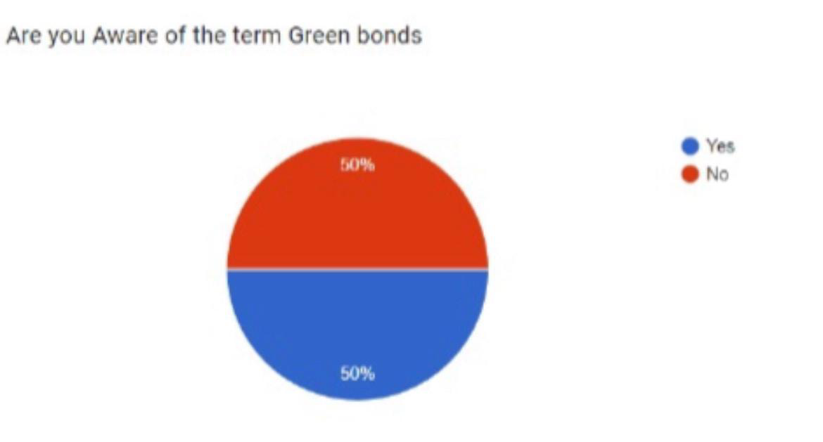

The awareness of "Green bonds" revealed an even split, with 50% being aware and 50% not aware. This balanced distribution underscores the need for educational initiatives to enhance awareness about green bonds among this age group.

For those aware of green bonds, opinions on their societal benefits varied. Approximately **40.6%** believed green bonds would be beneficial to society, **50%** were uncertain, and **9.4%** expressed a negative view. These findings indicate a positive inclination towards the societal benefits of green bonds among the aware group, although a significant portion remains uncertain.



Among those unaware of green bonds, a majority **(61.1%)** expressed a positive willingness to learn, **36.1%** were open to the possibility, and a minority declined the opportunity **(2.8%)**. This suggests potential receptiveness to educational campaigns to enhance awareness and understanding among the uninformed segment.

On whether respondents knew that green bonds serve as a medium for investing in green projects, **52.6%** were aware, **26.3%** were uncertain, and the remaining percentage was not aware. This distribution suggests that while there is awareness, there is still a need for further education and clarification.

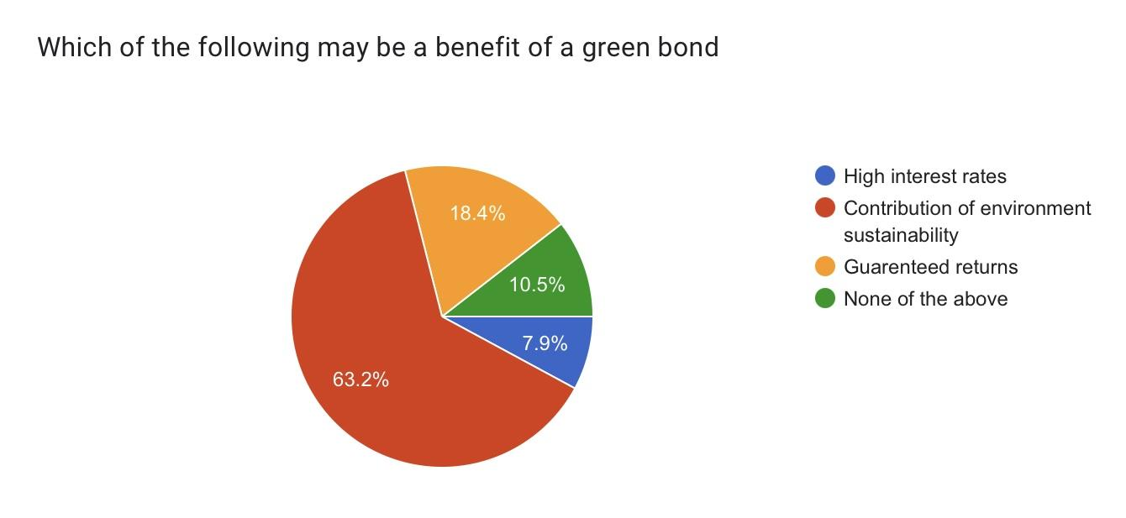

Regarding the perceived benefits of green bonds, **63.2%** recognized the contribution to environmental sustainability as a key benefit, **18.4%** believed in guaranteed returns, **10.5%** chose none of the above, and **7.9%** thought high-interest rates were a potential benefit.

This breakdown underscores a clear understanding of the environmentally conscious nature of green bonds among the respondents.

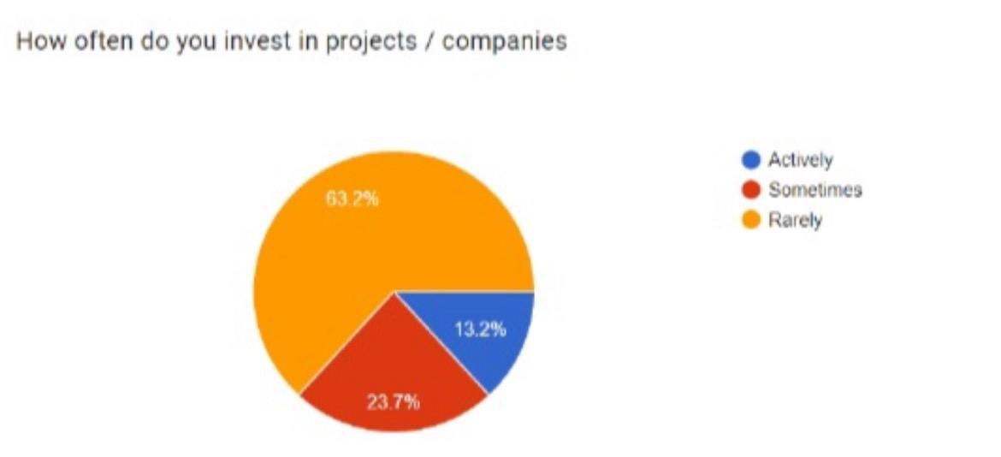Concerning actual investment behavior in renewable projects, a majority **(63.2%)** indicated they had not invested, while **36.8%** had. This suggests that despite positive perceptions of green bonds and benefits, a significant portion has yet to actively engage in renewable investments.

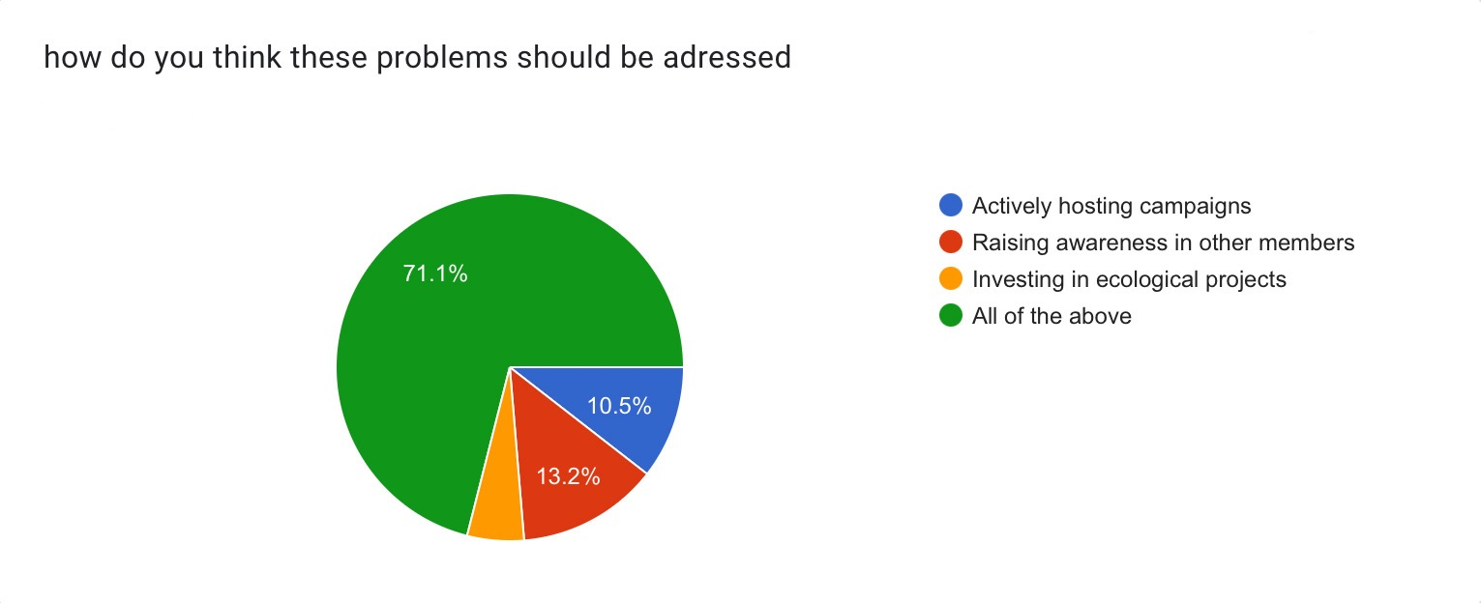

When queried on potential solutions to bridge this gap, respondents’ opinions varied: **10.5%** advocated for actively hosting campaigns, **13.2%** suggested raising awareness among other members, and **5.2%** proposed investing in ecological projects. However, the majority, at **71.1%** believed that a combination of all these strategies would be the most effective approach. This data suggests a strong consensus for a multifaceted approach to encourage more active engagement in renewable investments.

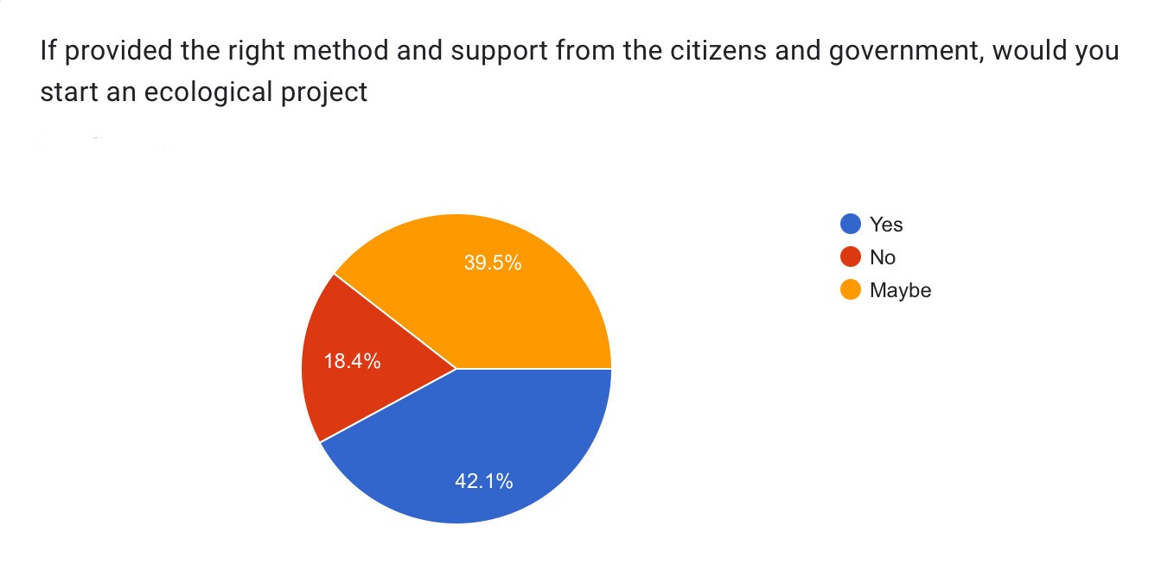

Regarding the inclination to start an ecological project with the right support, **42.1%** expressed a willingness, **39.5%** were open to the idea, and **18.4%** declined. This split suggests a favorable disposition towards ecological projects but also highlights a segment that may require additional incentives or support.

Responses to the open-ended question about thoughts on government initiatives revealed a spectrum of opinions. While some praised the initiatives, others expressed concerns about execution, awareness, and the need for more tangible actions, such as subsidizing and rewarding companies engaged in renewable projects.

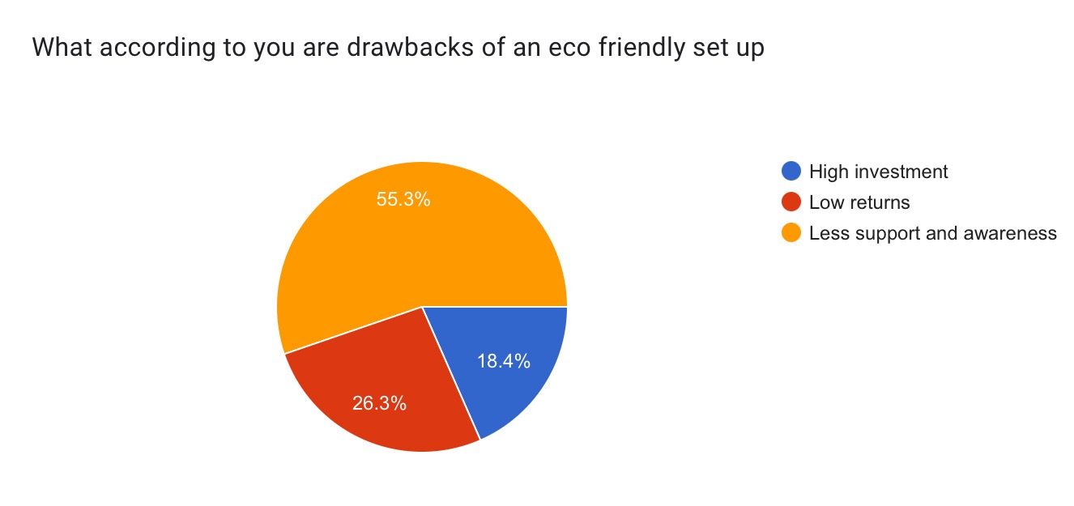

When survey participants were asked to identify the drawbacks of an eco-friendly setup, the responses highlighted several perceived challenges. A significant majority, **55.3%**, cited a lack of support and awareness as a major obstacle. Additionally**, 26.3%** of respondents pointed to low returns as a deterrent, while **18.4%** expressed concerns about the high initial investments required. These findings underscore the need for increased education and supportive policies to overcome these barriers and promote wider adoption of eco-friendly practices.

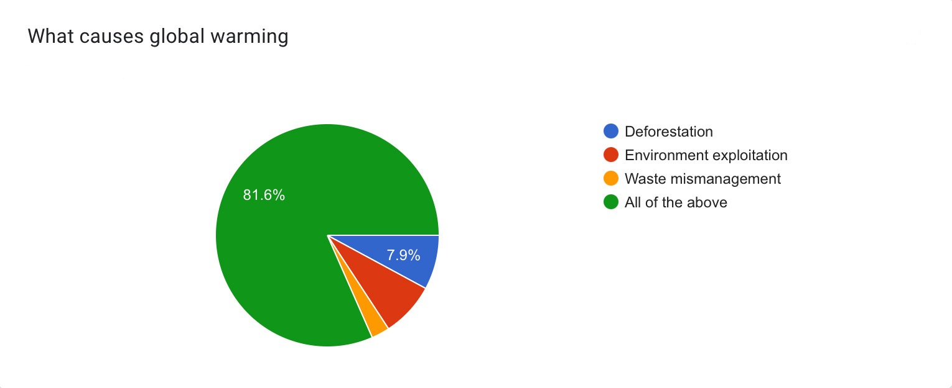

In the survey, respondents identified several key factors. A minority of respondents singled out specific issues: **7.9%** attributed global warming to deforestation, **6.5%** to environmental exploitation, and **4%** to waste mismanagement. However, the majority view, held by **81.6%** of respondents, was that all these factors collectively contribute to global warming. This suggests a broad consensus on the multifaceted nature of the causes of global warming, underscoring the need for comprehensive solutions to address this global challenge.

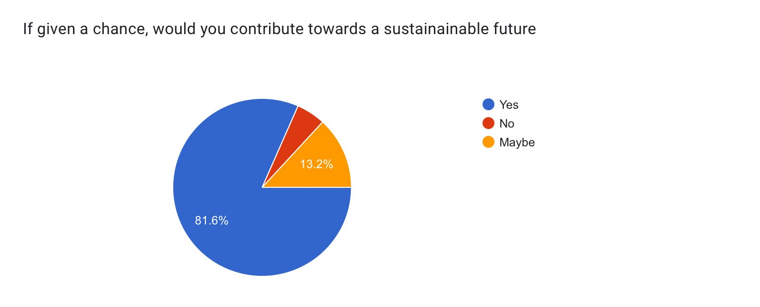

In terms of contributing towards a sustainable future, a significant majority **(81.6%)** expressed a positive willingness, indicating a strong sense of responsibility towards sustainability. A small percentage **(5.3%)** declined, while **13.2%** remained unsure. This result suggests a prevailing ethos of responsibility and a readiness to actively contribute to sustainable initiatives.

The overwhelming response **(94.7%)** in favor of spreading awareness about the environment demonstrates a collective interest in raising consciousness about environmental issues. This high level of agreement indicates a shared belief in the importance of environmental awareness and education.

The question about developing knowledge about green bonds elicited positive responses, with **71.1%** expressing interest in enhancing their understanding. A small percentage **(7.9%)** declined, while **21.1%** were unsure.

This result underscores the potential for increased education and awareness initiatives related to green bonds, aligning with the earlier findings about the need for more information.

In conclusion, the primary data analysis paints a nuanced picture of the surveyed demographic's awareness, perceptions, and inclinations towards green bonds, renewable investments, and government initiatives. The findings highlight areas for targeted educational efforts, potential avenues for enhancing support and participation in ecological projects, and the need for nuanced interpretations considering demographic factors such as gender distribution.

**SUMMARY OF FINDINGS AND CONCLUSION**

* The comprehensive analysis of green bonds and their impact on investors, governments, and the general public reveals significant findings that underscore the importance of these financial instruments in promoting environmentally conscious decision-making. The study indicates that green bonds not only attract investors with their potential for high financial returns but also serve as a crucial tool for supporting sustainable development.
* Investors are drawn to green bonds due to their dual benefits of financial returns and support for sustainable initiatives. The research highlights that investor frequently experience improved long-term returns, reflecting a growing market interest in investments aligned with environmental responsibility. In the face of climate change challenges, green bonds emerge as a valuable avenue for investors to align financial goals with ecological considerations.
* Governments, too, stand to gain economically and environmentally by issuing green bonds. The study demonstrates that governments can use these bonds to fund essential projects, such as eco-friendly infrastructure, renewable energy transitions, and climate change mitigation. Beyond addressing environmental concerns, this approach fosters innovation in sustainable technology and job creation, contributing to overall economic growth.
* The positive ripple effects of green bonds extend to communities, resulting in increased resilience to climate-related disasters, improved air and water quality, and enhanced living conditions. The allocation of funds to environmentally beneficial projects enhance the overall well-being of the general public, creating a more sustainable and healthier environment through the impact of green bonds.
* However, the study acknowledges the challenges and considerations associated with green bonds. Clear reporting procedures and uniform standards are deemed essential to ensure the legitimacy of these financial instruments. Reliable information is crucial for assessing the environmental impact of green investments, and strengthening regulatory frameworks is imperative to instill confidence in the green bond market.

**CONCLUSION**

In conclusion, the research emphasizes the pivotal role played by green bonds in establishing a mutually beneficial relationship between financial objectives and environmental sustainability. The broader public benefits from a cleaner and greener future, governments secure funding for crucial projects, and investors find a profitable avenue for responsible investing. Green bonds emerge as a beacon of hope in the complex landscape of climate change and sustainable development, providing a tangible pathway toward a more resilient and ecologically conscious global economy. The study concludes by highlighting the profound impact of green bonds in shaping a sustainable and prosperous future for both the financial and environmental realms.

**REFERENCES**

[**https://www.bbc.co.uk/news/business-57670057//**](https://www.bbc.co.uk/news/business-57670057//)

[**https://www.lse.ac.uk/granthaminstitute/news/indias-sovereign-green-bonds-steps-for-building-on-a-successful-debut//**](https://www.lse.ac.uk/granthaminstitute/news/indias-sovereign-green-bonds-steps-for-building-on-a-successful-debut//)

[**https://www.climatelinks.org/sites/default/files/asset/document/2023-01/GreenBondsIndia.pdf//**](https://www.climatelinks.org/sites/default/files/asset/document/2023-01/GreenBondsIndia.pdf//)

[**https://link.springer.com/chapter/10.1007/978-981-16-3599-1_12//**](https://link.springer.com/chapter/10.1007/978-981-16-3599-1_12//)

[**https://www.eco-business.com/news/what-makes-marina-bay-financial-centre-tick//**](https://www.eco-business.com/news/what-makes-marina-bay-financial-centre-tick//)