**WIRELESS CHARGING OF MOVING ELECTRIC VEHICLE WITH HYBRID CHARGER AND ADVANCED ROAD SIGNAL INDICATOR**

Mrs. Jasmine J , M.E , (Ph.D).,

Mr. Alex Pandian S

Mr. M.Velmurugan

Mr. Bijo Johnson

Mr. Jacob Thampi Vaidyan

Department of Electrical and Electronics Engineering,

Stella Mary’s College of Engineering - Nagercoil, India

**Abstract**

The integration of wireless charging technology with renewable energy sources like solar and wind power has sparked a revolution in the realm of electric vehicle( EV) structure. This paper delves into the generality of wireless charging for moving EVs through a crossbred coliseum system that harnesses solar and windmill energy, reshaping the terrain of sustainable transportation. Traditional EV charging styles constantly bear vehicles to be stationary at charging stations, limiting their usability and convenience, especially for long expeditions or marketable lines.

The crossbred coliseum system breaks this barricade by enabling continuous charging while EVs are in stir, thanks to renewable energy sources. At the heart of this system are solar panels and windmill generators strategically placed along roadways or integrated into charging stations. These factors internee sun and harness wind energy, singly, converting them into electrical power.

The crossbred coliseum also utilizes wireless charging technology, analogous as inductive power transfer( IPT) or glamorous resonance coupling, to transfer this energy to EVs equipped with entering coils. Road signal information directly into vehicles through radio signal transmitters, enhancing the automobilist's situational awareness and promoting safer driving practices. Unlike traditional road signal pointers that calculate on visual cues, this approach leverages technology to transmit real- time road signal data directly to in- bus displays, revolutionizing the driving experience

**Introduction**

In a world where environmental enterprises and technological advancements are consummate, the automotive assiduity is witnessing a significant metamorphosis. Electric vehicles( EVs) and wireless charging technology are at the van, offering a sustainable result to transportation challenges. Imagine a cityscape where EVs glide quietly, emblematizing progress towards a cleaner terrain. What sets them piecemeal isn't just their mode of propulsion but also their system of charging — wireless charging. This technology liberates EVs from the constraints of charging stations and conventional refueling styles, operating on a clever yet straightforward principle. It's a paradigm shift that aligns with the global drive for greener, smarter transportation systems.

**Literature Review**

1. This review provides a comprehensive overview of wireless charging systems for moving electric vehicles (EVs), covering system architectures, power transfer technologies, efficiency, safety considerations, and real-world applications.

2. This review focuses on the impact of dynamic wireless charging on EV battery performance, including charging efficiency, energy losses, and battery degradation rates.

3. Published in 2019, this review explores deployment strategies for dynamic wireless charging infrastructure in urban environments, discussing infrastructure planning, cost considerations, and user acceptance.

4. This review, published in 2022, focuses on wireless charging standards and interoperability issues related to moving EVs, evaluating current standards and initiatives by organizations like SAE International and ISO.

**Working Principle**

The working principle of wireless charging for moving EVs with a mongrel bowl involves energy harvesting from solar panels and windmills, energy storehouse in batteries, wireless power transfer to EVs via electromagnetic fields, and dynamic charging during stir for nonstop operation. Displaying road signals inside a auto using a radio signal transmitter and receiver includes factors like radio transmitters in business structure, radio receivers in buses , radio frequence communication, data decoding, real- time updates, motorist commerce, and integration with vehicle systems. The advantages of wireless charging and road signal displays inside buses include convenience, sustainability, safety, enhanced motorist mindfulness, and flawless integration with being structure. still, challenges similar as hindrance, limited range, structure conservation, effectiveness, original costs, and parking constraints are also important considerations in enforcing these technologies.

**Components Required**

* Arduino board
* Radio Transmitter
* Radio Receiver
* Coil
* Solar Panel
* Wind Mill
* Booter Transformer
* Connecting Wires
* Resistance
* DC Chopper

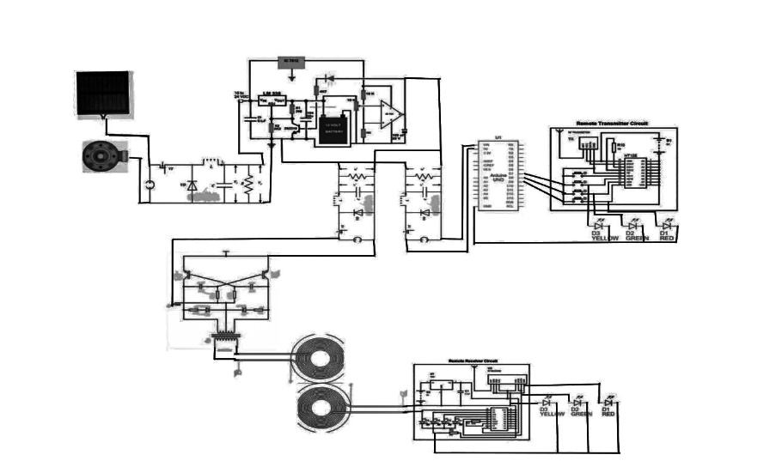**Circuit Diagram**

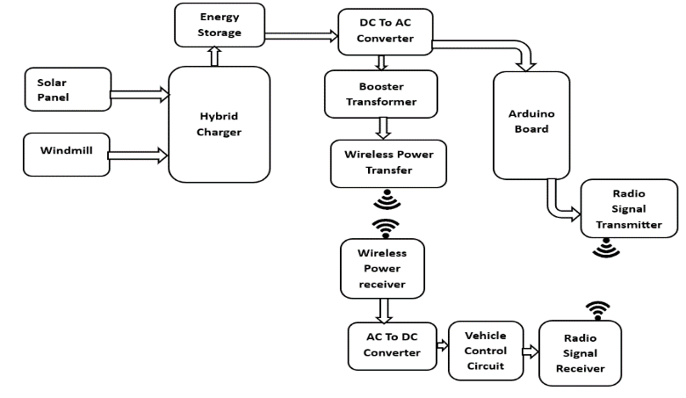**Block Diagram**

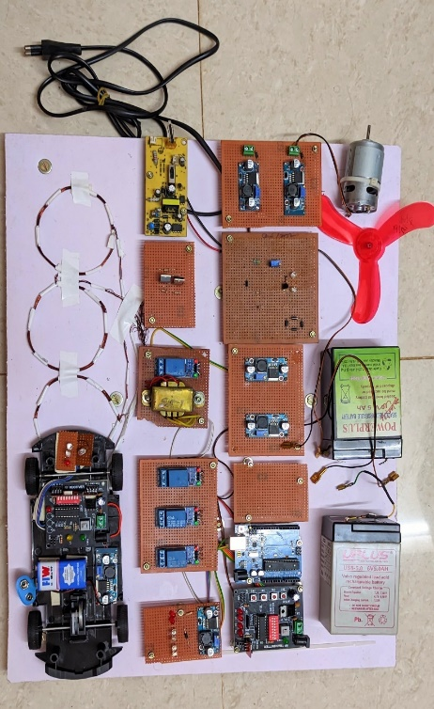**Hardware View**

**433mhz Wireless Rf Transmitter Receiver Board**

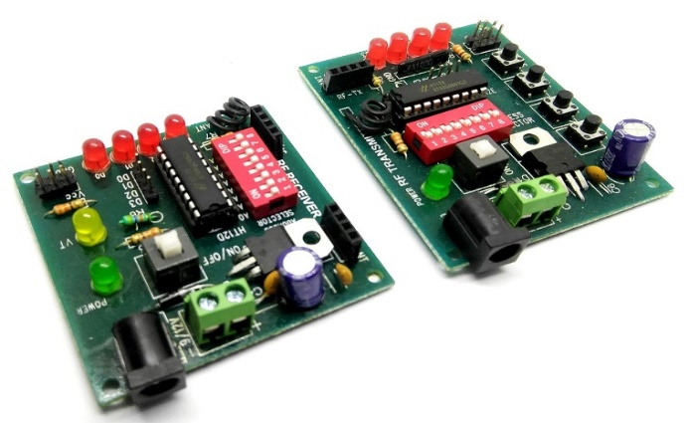The 433 MHz Wireless RF Transmitter Receiver Board is a brace of modules designed for wireless communication at the 433 MHz frequence

**RF Transmitter Board**

* **Frequence:** Operates at 433 MHz, making it suitable for short- range wireless communication.
* **Antenna:** generally includes a spiral or spring antenna for transmitting RF signals efficiently.
* **Interface:** Connects to a microcontroller or Arduino board via digital legs for transferring data wirelessly.
* **Encoding**: frequently supports colorful garbling schemes like ASK( breadth Shift Keying) or OOK( On- Off Keying) for data modulation
* 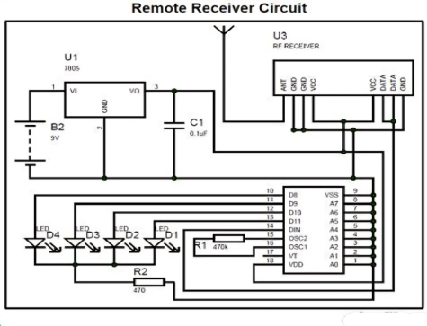**Range**: Offers a limited range depending on environmental factors, antenna quality, and power force.

**RF Receiver Board**

* **Frequence**: Matches the 433 MHz frequence of the transmitter for dependable communication.
* **Antenna**: analogous to the transmitter, it includes an antenna for entering RF signals.
* **Interface**: Connects to a microcontroller or Arduino board through digital legs for entering and recycling data.
* **Decoding**: Supports decoding of the transmitted data using the same garbling scheme as the transmitter.
* **Range**: Receives signals within the effective range of the transmitter, generally suitable for short- range operations 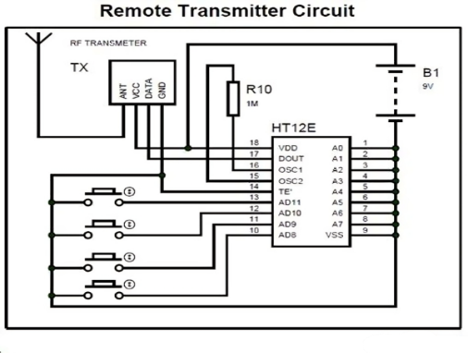

**Applications And Uses**

1. Smart metropolises Integration enforcing this technology in smart metropolises can lead to effective and sustainable transportation systems. Electric vehicles can charge wirelessly while on the move, reducing the need for frequent stops at charging stations.
2. Public Transportation Wireless charging can be integrated into public transportation systems, similar as motorcars and wagonettes. This allows for nonstop operation without the need for extended breaks for charging, perfecting overall service trustability.
3. Fleet Management Companies with large lines of electric vehicles, similar as delivery services or hack companies, can profit from wireless charging. Vehicles can charge during time-out or while staying at business signals, optimizing their operation.
4. Civic structure Installing advanced road signal pointers inside vehicles can enhance safety by waking motorists to forthcoming business signals, speed limits, and road conditions. This can reduce accidents and ameliorate business inflow.

**Conclusion**

The combination of wireless charging for moving electric vehicles with a mongrel bowl solar, windmill) and displaying road signals inside the auto using radio signal transmitters and receivers represents a significant advancement in sustainable transportation and intelligent business operation. This conclusion summarizes the crucial benefits and counteraccusations of integrating these technologies. One of the primary benefits of this integrated system is its eventuality to revise the way we approach electric vehicle charging and road signal communication. By enabling nonstop charging while EVs are in stir, wireless charging with a cold-blooded bowl addresses range limitations and enhances the practicality of electric vehicles for everyday use, long- distance trip, and marketable operations. This nonstop charging capability reduces time-out and reliance on traditional charging structure, promoting a flawless and effective electric mobility ecosystem. also, the integration of road signal displays inside buses using radio signal transmitters and receivers enhances motorist mindfulness, safety, and decision- making on the road. Real- time information about business lights, speed limits, road conditions, and other critical signals.

**Reference**

1. Zhang, L., & Cao, J. (2017). Wireless Charging Technologies for Electric Vehicles: A Review of State-of-the-Art Technologies and Challenges. IEEE Access, 5, 23765-23784.
2. Lim, C., Kim, J., & Cho, S. (2018). Integration of Solar and Wind Energy into Wireless Power Transfer for Electric Vehicles. Sensors, 18(12), 4398.
3. Huang, Y., & Zhang, H. (2019). Design and Optimization of a Hybrid Energy Harvesting System for Wireless Charging of Electric Vehicles. IEEE Transactions on Industrial Electronic, 66(12), 9522-9532.