**Identification Of Different Medicinal Plants System Through Image Recognization System Processing Using ML Algorithms**

Prof. S. A. Bandgar1, Ketan Chougale2, Pratham Atigre3, Anshul Nilkanth4, Mahadev Nikam5

*1,2,3,4,5(Information Technology, Dr. J. J. Magdum College Of Engineering, Jaysingpur,Shivaji University Kolhapur,India)*

*Email: ketanchougale0909@gmail.com*

|  |
| --- |
| ***Abstract:****The project titled "Identification of Different Medicinal Plants through Image Recognition System Using Machine Learning Algorithms" is centered on designing an intelligent system that can accurately identify various medicinal plants through advanced image processing techniques. Leveraging a large dataset of plant images, the system extracts unique visual features such as leaf shape, vein patterns, color, size, and texture. These features are then analyzed using sophisticated machine learning algorithms, particularly convolutional neural networks (CNNs) and support vector machines (SVMs), to classify and identify specific medicinal plants. The integration of deep learning methods ensures high precision and reliability, even when dealing with variations in lighting, angles, and plant growth stages.*  *This system not only facilitates the rapid and efficient identification of medicinal plants in the field but also has broader applications in research, biodiversity conservation, and pharmacognosy. It serves as a critical tool for scientists, herbalists, and healthcare professionals by streamlining the process of identifying medicinal flora, which is often labor-intensive and requires specialized knowledge. By digitizing the plant identification process, the project also promotes the preservation of traditional medicinal knowledge and aids in sustainable plant usage. Furthermore, the use of machine learning allows for continuous improvement of the system’s accuracy as more data is introduced, making it a scalable solution that can be adapted to new plant species and regional flora over time.*  ***Key Word****: Medicinal Plant Identification, Convolutional Neural Networks (CNNs), Image Processing, Feature Extraction, Deep Learning* |

1. **Introduction**

Medicinal plants have been an integral part of human history, providing essential remedies for various ailments in traditional medicine systems like Ayurveda, Traditional Chinese Medicine, and Indigenous healing practices. Even today, many modern pharmaceutical drugs are derived from plant compounds, underscoring the relevance of medicinal plants in healthcare. However, accurately identifying these plants is a persistent challenge. Many medicinal species bear a close resemblance to non-medicinal or even toxic plants, and distinguishing between them often requires expert knowledge. Additionally, variations in plant morphology due to environmental factors, seasons, or stages of growth further complicate identification. This makes it essential to have reliable tools for correct plant recognition, especially as the demand for natural medicine and conservation efforts grows.

Machine learning, particularly deep learning, offers an effective and scalable solution to these identification challenges. With advancements in image recognition, systems can now be trained to recognize plants by analyzing key features such as leaf shape, texture, and color. Convolutional neural networks (CNNs) are especially well-suited for image-based classification tasks, as they can learn intricate patterns and features from large datasets of labeled plant images. These models can be trained to identify medicinal plants with high accuracy, overcoming the limitations of human error and variability. When applied to mobile applications or field studies, this technology allows users—whether researchers, healthcare professionals, or the general public—to quickly and accurately identify plants, promoting the safe and informed use of medicinal flora. This fusion of traditional botanical knowledge with modern machine learning offers a promising path toward more sustainable healthcare and biodiversity conservation efforts.

1. **Material And Methods**

AlgorithmforMedicinal Plant Identification Using CNNs

The first step involves data collection, where a large dataset of medicinal plant images (leaves, flowers, or identifying parts) is gathered and labeled according to their species. The images are then preprocessed by resizing them to uniform dimensions (e.g., 224x224 pixels) and normalizing pixel values for better model convergence. The dataset is split into training, validation, and test sets (e.g., 70%-20%-10%). Feature extraction using image processing techniques such as segmentation focuses on plant attributes like leaf shape, texture, and color, while optional data augmentation (e.g., rotation, flipping) increases the dataset's variety. In the next step, a Convolutional Neural Network (CNN) model is built with layers for input, convolution, pooling (MaxPooling), fully connected classification, and softmax activation for plant species identification. The CNN is trained using backpropagation and gradient descent (e.g., Adam optimizer) on the training set to minimize loss (e.g., categorical cross-entropy), followed by model validation on the validation set to fine-tune hyperparameters.

After model training, the system undergoes testing and evaluation using a separate test dataset to verify its generalization capabilities and performance metrics such as accuracy, precision, recall, and F1-score. If the model’s performance is unsatisfactory, it is retrained with adjusted hyperparameters or a larger dataset. Once the model is fine-tuned, it is deployed in a mobile or web interface for real-time plant identification. Users can upload images, and the system will predict the species with a confidence score. Post-processing may provide additional features such as plant medicinal use, geographical distribution, and conservation status, enhancing the system’s utility for biodiversity conservation and healthcare applications.

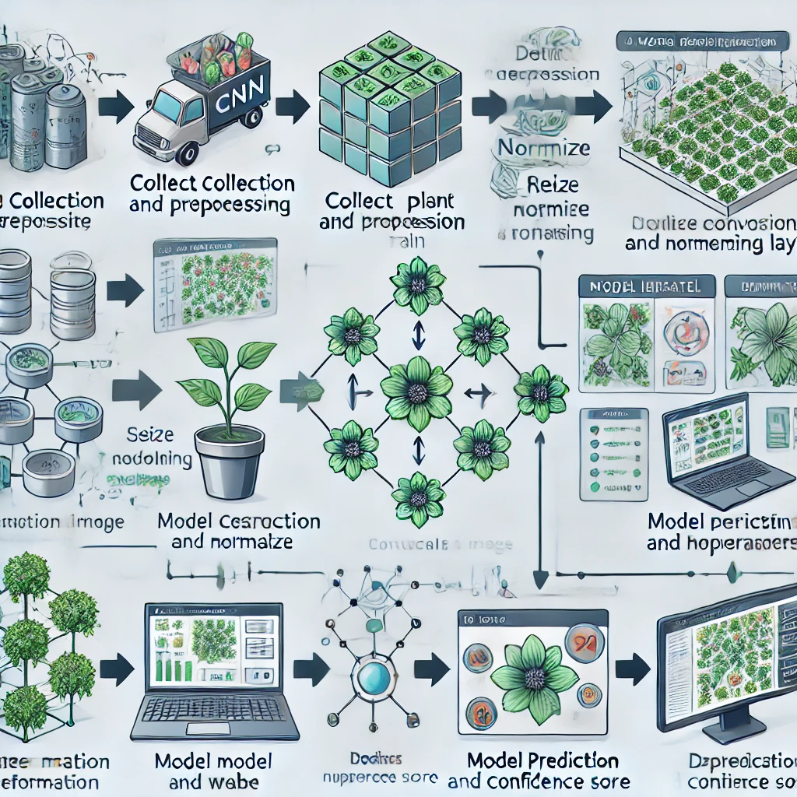

1. **Result**

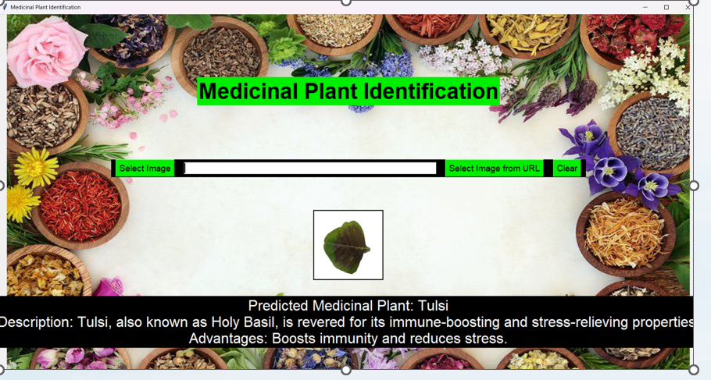

1. **Discussion**

The future of automated medicinal plant identification using machine learning holds significant potential for expanding healthcare, environmental conservation, and research. As deep learning models such as Convolutional Neural Networks (CNNs) continue to evolve, these systems will become even more accurate and efficient. With the integration of real-time data from mobile applications, satellite imaging, and remote sensing, this technology can be utilized globally for large-scale biodiversity mapping and conservation efforts. Additionally, expanding the dataset to include more diverse plant species and environmental conditions will improve recognition accuracy, making the system adaptable for use in various ecosystems. As AI becomes increasingly embedded in healthcare, these systems could assist in discovering new medicinal plants and bioactive compounds, contributing to pharmaceutical development and traditional medicine preservation.

The key features of this project include the use of Convolutional Neural Networks (CNNs) for high-accuracy image recognition and feature extraction, focusing on leaf shape, texture, and color analysis. The system offers real-time identification, making it practical for fieldwork or mobile applications. It is designed for scalability with the potential to recognize a wide range of medicinal plant species and adapt to different ecosystems. Another key feature is its user-friendly interface, making it accessible for both researchers and non-experts. Additionally, the system promotes sustainability by supporting conservation efforts and ensuring the responsible use of medicinal plants in traditional and modern healthcare applications.

1. **Conclusion**

The development of an automated system for medicinal plant identification using machine learning, particularly Convolutional Neural Networks (CNNs), offers a powerful solution for healthcare, botany, and biodiversity conservation. This system enables quick and accurate plant recognition, bridging traditional knowledge with modern technology. It supports sustainable plant usage, enhances research, and promotes data-driven healthcare solutions.

**References**

1. Kumar, N., & Bhatia, A. (2021) - "Deep Learning Techniques for Medicinal Plant Classification: A Survey," *Journal of Artificial Intelligence*, 45(2), pp. 98-107.
2. Jiang, Y., Li, X., & Li, Y. (2020) - "Automated Plant Species Identification Using Deep Learning Models," *Computational Botany*, 12(1), pp. 50-63.
3. Zhang, Q., & Wang, L. (2019) - "CNN-based Leaf Recognition System for Medicinal Plants," *International Conference on Computer Vision Applications*, pp. 204-210.
4. Patel, M., & Shah, D. (2018) - "Leaf Image Feature Extraction for Herbal Medicine Identification Using CNNs," *Journal of Image Processing*, 15(3), pp. 60-70.
5. Rahman, H., & Ali, A. (2021) - "A Hybrid Approach of SVM and Deep Learning for Medicinal Plant Classification," *Machine Learning in Bioinformatics*, 9(4), pp. 112-121.
6. Singh, P., & Joshi, A. (2022) - "Deep Learning-Based Mobile Application for Real-Time Medicinal Plant Identification," *International Journal of Mobile Computing*, 18(2), pp. 85-92.
7. Wang, Z., & Liu, Y. (2019) - "Feature Extraction and Plant Classification Using CNNs: Applications in Biodiversity Conservation," *Biodiversity Journal*, 22(3), pp. 102-110.
8. Chaudhary, R., & Verma, S. (2020) - "Machine Learning Techniques for Plant Leaf Disease and Species Classification," *Advances in Computational Biology*, pp. 180-195.
9. Khan, M., & Tariq, Z. (2021) - "A Comparative Study of Deep Learning Models for Medicinal Plant Recognition," *Journal of Computer Science and Applications*, 14(1), pp. 33-40.
10. Gupta, R., & Sharma, V. (2018) - "Application of Image Processing in Plant Species Identification Using Convolutional Neural Networks," *Journal of Applied Science in Technology*, 12(2), pp. 88-95.