**Pothole Sensing System for Vehicles**

Prajeesh T. K1*, Gopika P. L2, Mebin G Babu3, Saran S Nair4, Dr. Manoj Kumar T5

*1,2,3,4(Electrical and Electronics Engineering, St. Thomas College of Engineering & Technology, India)*

*5(Associate Professor, Department of Electrical and Electronics Engineering, St. Thomas College of Engineering & Technology, India)*

*Corresponding Author: prajeeshtk2752002@gmail.com*

|  |
| --- |
| ***Abstract:*** *Potholes are a serious hazard to motorcyclists and often lead to accidents and injuries. To solve this problem, the proposed system is designed to proactively identify potholes on the road surface and provide the driver with an early warning, allowing them to safely navigate and avoid potential hazards. This system aims to develop a robust pothole detection system for vehicles using advanced sensing technology, including ultrasonic sensors, gyroscope sensors and Global Positioning System. The system uses state-of-the-art sensor technology mounted on the vehicle, strategically placed to sense the road ahead. Whether using ultrasonic sensors, radar systems or microwaves, each technology offers unique advantages in terms of range, accuracy and environmental resistance. By continuously monitoring the road surface, the sensors can detect deviations indicating potholes regardless of lighting conditions. Upon detecting a pothole, the system activates the alarms integrated into the motorcycle interface and alerts the rider via visual or audio signals. These warnings prompt the rider to adjust their speed or maneuver, minimizing the risk of accidents or bike damage. In addition, the system can be extended with a data logging capability to record the location and characteristics of potholes, facilitating proactive road maintenance and infrastructure improvements. In conclusion, the proposed pothole detection system provides a proactive solution to reduce the risks associated with the occurrence of potholes in driving. Utilizing advanced sensor technology and intuitive warning mechanisms, the system allows riders to navigate confidently and safely, contributing to a safer and more enjoyable riding experience.*  ***Key Word****: Pothole; Ultrasonic; Safety; Road; Vehicle* |

1. **Introduction**

Potholes pose significant risks to drivers and vehicles, leading to accidents, vehicle damage and road damage1. Traditional pothole detection methods often rely on visual inspection, which can be unreliable and inefficient2. Therefore, there is a growing need for automated systems capable of real-time pothole detection to increase road safety and maintenance efficiency3. The paper presents the design and prototype of an innovative pothole detection system based on an ultrasonic sensor, which aims to increase vehicle safety and road infrastructure maintenance4. In the vast landscape of modern transportation, safety is a paramount concern5. With millions of vehicles traversing road networks worldwide, the need for innovative solutions to mitigate potential hazards is ever pressing6. Among the myriad hazards faced by motorists, potholes emerge as a constant menace, capable of wreaking havoc on vehicles and endangering lives7. Taking up this challenge, our project seeks to use advanced technology to efficiently detect and navigate potholes8. Potholes are depressions in the road surface caused by wear and tear caused by weather and vehicle traffic, and are an all-around hazard on the roads9. Although these holes appear harmless, they can cause significant damage to vehicles and pose a serious risk to drivers10. The effects of encountering a pothole go beyond mere discomfort11. This can lead to expensive repairs, vehicle breakdowns, and in the worst-case scenario, a tragic accident12. Our project aims to use the capabilities of ultrasonic sensors integrated into vehicles to devise an active solution to the pothole problem13. Using the power of these sensors, our system enables real-time pothole detection and analysis, thereby enabling drivers to navigate the roads with greater awareness and safety14. Additionally, our solutions have features designed to address the specific challenges posed by adverse conditions such as flooding and low visibility scenarios, providing comprehensive protection for drivers in all conditions15.

1. **Material And Methods**

**System Architecture:**

The proposed pothole detection system includes an ultrasonic sensor that acts as both a transmitter and a receiver. The sensor emits ultrasonic waves at a predetermined angle to the road and the receiver records the time it takes for the ultrasonic waves to hit the road and return. Measuring this time is important for determining the distance to the target (in this case, an obstacle such as a road surface or pothole). The architecture can also provide driver assistance for avoiding collisions with obstacles and other vehicles during scenarios of road accidents.

**Sensor Operation:**

The operation of an ultrasonic sensor involves the emission of ultrasonic pulses to the road surface by a transmitter. These pulses travel through the air until they hit an object or road surface. When it hits an obstacle such as a road surface or pothole, the pulse is reflected back to the receiver. The receiver records the return time of the pulse and can calculate the distance to the target based on the speed of sound and the ultrasonic time of flight. The difference of receiving time on a normal road condition and a road with deep hole helps in the detection of potholes. Hence slight variations in the receiving time is crucial for the system.

**Pothole Detection Algorithm:**

Pothole detection algorithms use time measurements obtained from ultrasonic sensors to detect the presence of potholes. By comparing the recorded time with predefined thresholds, the system can determine if there is a hole in front of the car. This algorithm considers factors such as vehicle speed and ultrasound impact angle to accurately detect potholes and provide timely warnings to drivers. The algorithm may switch between various predefined climatic conditions to improve the accuracy of the sensing technology under varying refractive index of the surrounding conditions. The combination of gyroscopic sensing systems helps in performance improvement as well as evaluation under sloppy road conditions.

**Prototype implementation:**

The design and implementation of a pothole detection system involves the integration of an ultrasonic sensor with a microcontroller unit (MCU) for data processing and decision making. The transmitter and receiver which is mounted on the vehicle on a predetermined angle and can vary with vehicle to vehicle. The MCU receives time measurements from the sensors, implements pothole detection algorithms and generates warnings or alerts to the driver if required. Additionally, the prototype includes a user interface to display real-time pothole detection information to the driver. The implementation of GPS systems as an add-on can collect and provide pothole reports for efficient road maintenance. This modification allows the driver to get alert based on real time evaluation as well as historical data.

**Figure no 1:** Shows difference between transmitting & receiving time on a normal road condition versus road with pothole.

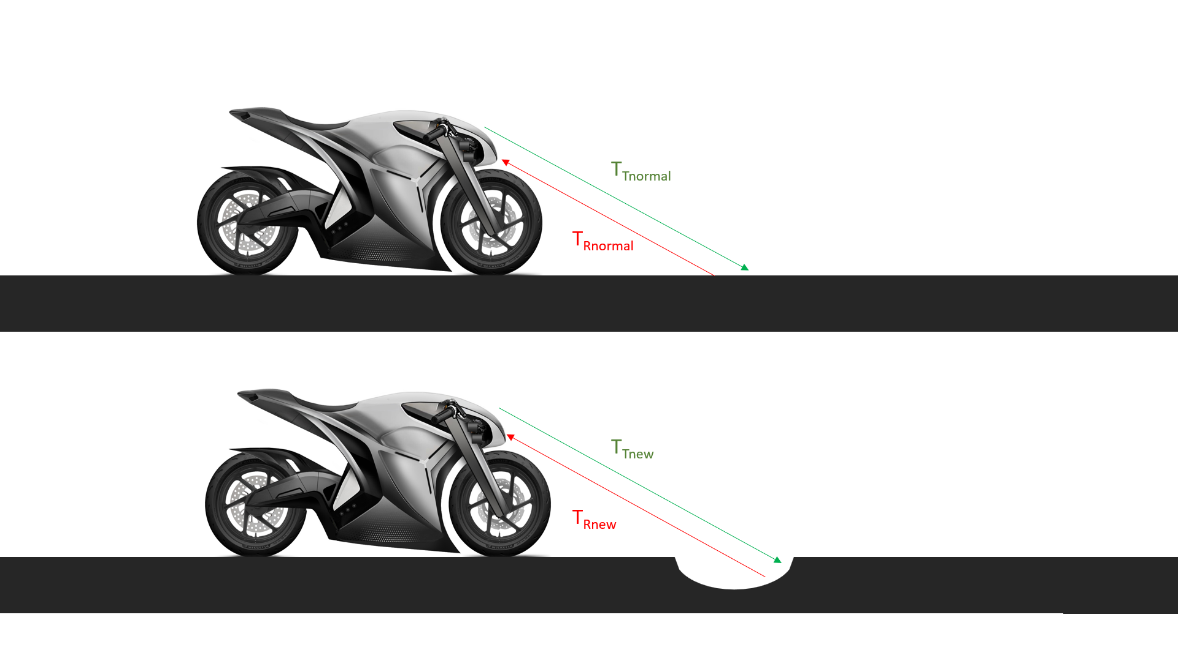

Where, TTnormal and TRnormal denotes the transmitting and receiving time on normal road respectively; TTnew and TRnew denotes the transmitting and receiving time while approaching a pothole respectively.

**Figure no 2:** Block diagram of the proposed system.

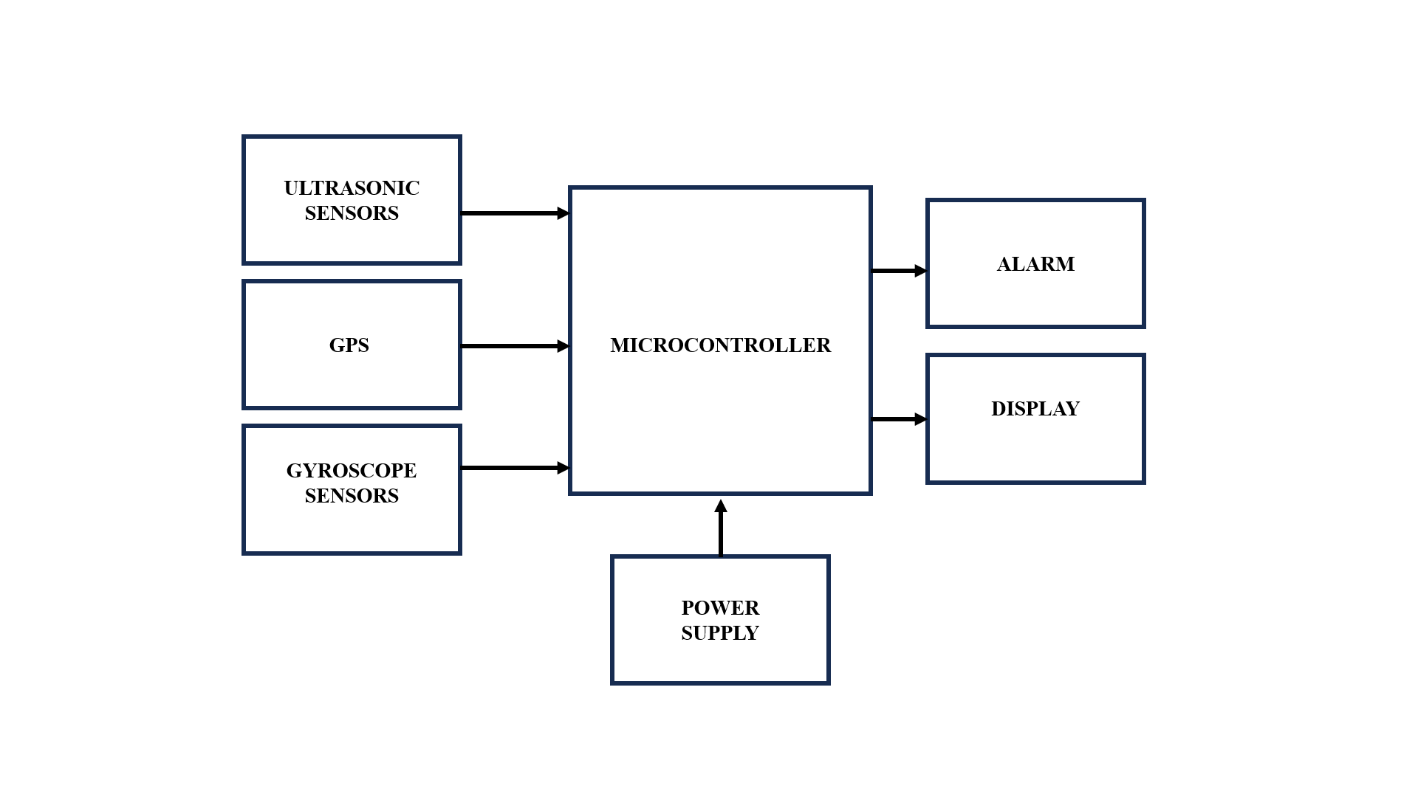

**Microcontroller:**

Microcontroller plays a crucial role in the entire sensing technology. The microcontroller interfaces with ultrasonic sensors placed on the vehicle. The data collected using ultrasonic sensors are processed and decision making in interpreted in the microcontroller. When a pothole is encountered, the distance between the sensor and the road increases, which is detected by the sensor. The microcontroller processes this change in distance and time detect the presence of pothole.

**Ultrasonic sensors:**

Ultrasonic sensors are electronic devices that can calculate the distance to a target by emitting ultrasonic sound waves by converting the reflected waves into electrical signals. The speed of these emitted ultrasonic waves is faster than that of audible sound. An ultrasonic sensor has two essential elements: a transmitter and a receiver. The transmitter generates sound using piezoelectric crystals, which travels to the target and is reflected back to the receiver. The sensor calculates the time required for sound to travel from the transmitter to the receiver to determine the distance to target. Ultrasonic sensors are used in a variety of applications, including proximity sensing, obstacle detection systems in robotics or autonomous vehicles, and level sensing to detect, monitor, and control liquid levels in closed vessels. It is also used in the medical industry for imaging internal organs, identifying tumors and ensuring the health of babies in the womb. The effectiveness of these sensors largely depends on their specifications, such as sensing range, response time, beam angle, operating voltage, precision, frequency, resolution, and output voltage. These specifications help to realize a reliable estimate of the distance measure. Ultrasonic sensors are versatile tools that provide accurate and reliable distance measurements for various applications.

**Global Positioning System:**

In the vehicle pothole detection system, the Global Positioning System (GPS) plays a key role in the geolocation of detected potholes. Pothole detection: When it hits a pothole, the ultrasonic sensor detects it and sends a signal to the microcontroller.

* GPS activation: At the same time, the GPS module is activated.
* Location Capture: The GPS receiver will get the location coordinates of the detected pothole.
* Data transfer: These coordinates are then transferred to the microcontroller.
* Data display: The pothole location can be displayed on the LCD display.
* Data storage: The location of all detected potholes is stored in a database.
* Sending data: In some systems, this data can be sent to a server database or mobile application via a communication module.

This system helps ensure road safety by providing drivers with early warning of potholes and their location.

**Gyroscope sensors:**

* Motion Capture: A gyroscopic sensor, also known as a gyroscope, measures the angular velocity of the vehicle 1. They capture the vertical and horizontal acceleration of the vehicle2.
* Pothole detection: When a vehicle encounters a pothole, it experiences a sudden change in its dynamics. This change is picked up by gyroscopic sensor1.
* Data Processing: The microcontroller processes the data from the gyroscopic sensor to identify the presence of potholes.
* Alert Generation: Once a pothole is detected, the microcontroller triggers an alert system to alert the driver.

**Alarm & Display:**

The warning system and the display drive play an important role in alerting the driver of the detected pothole.

* Alarm system: When a pothole is detected by the ultrasonic sensor, the microcontroller activates the alarm system. This warning can be in the form of visual signals, audible signals or activation of the braking system. A warning system alerts the driver to the presence of a pothole and allows him to take the necessary actions to avoid it.
* Display system: Along with the alarm, the system displays the pothole distance detected on the display, usually LCD. This gives the driver a clear picture of the distance of the pothole. In some systems, the display can also show the location of holes equipped with a GPS module.

This system works together to keep drivers safe by providing timely warnings of potholes.

**Inclusion criteria:**

1. Sloppy road conditions.
2. Can be used for both motorcycles and cars.
3. Under any lighting conditions.
4. Slightly flooded roads.
5. Varying climate conditions.

**Exclusion criteria:**

1. Heavily raining conditions.
2. High vehicle speeds.
3. Heavily flooded roads.

**Procedure methodology:**

Pothole detection in vehicles using ultrasonic sensors includes steps like:

**Sensor placement:** Ultrasonic sensors are placed on the exterior of the vehicle at a predetermined angle. The calculations and other parameters will vary vehicle to vehicle due to this reason.

**Signal Transmission:** Ultrasonic sensors turn an electrical signal into a pulse of ultrasonic sound. It sensor has two transducers, transmitter and receiver.

**Signal Receiving:** The pulse from the transmitter gets reflects after having contact with the obstacle. This signal is received by the receiver. Thetime taken for sending and receiving the pulse by the transducers are recorded. This is the crucial step in the system.

**Pulse analysis:** When the pulses are reflected back to the receiver, the echo pin goes low, creating a pulse whose width varies between 150 microseconds to 25 seconds. If the pulses are not reflected back, the echo signals will timeout after 38 microseconds.

**Pothole detection:** The system classifies the road surfaces with potholes and non-potholes. It measures the depth and height of the potholes based on the received signals.

**Driver alert:** When the pothole is detected, the system alerts the driver by raising an alarm and by means of led indications thus helping the driver avoid any major damages or accidents.

**Data Broadcasting:** As an additional functionality, we can use GPS to capture the geographical location coordinates of potholes. Thus, improving the system performance by providing analysis upon historical data.

**Statistical analysis**

The performance of the prototype pothole detection system is evaluated through extensive laboratory and field experiments. The experiments assess the accuracy, reliability, and responsiveness of the system in detecting potholes under various road and weather conditions. Quantitative metrics such as detection accuracy, false positive rate, and response time are measured and analyzed to validate the effectiveness of the system. Pothole detection and depth estimation is obtained by the complex calculations comparing the difference between transmitting time (TTnormal) and receiving time (TRnormal) on a normal road and transmitting time (TTnew) and receiving time (TRnew) on a road with pothole.

1. **Result**

Considering the current road scenario, there is a need to design a system to warn the driver about upcoming potholes while the vehicle is in operation. The purpose of our proposed system is to provide appropriate services to give information about potholes to the driver. Moreover, the system enables the detection even on slightly flooded roads if slight modifications are done. It is a low-cost solution aimed at road safety. Enhanced GPS facilities could collect pothole reports providing ease of maintenance as well as historical data-based alerts.

1. **Discussion**

The pothole sensing system using ultrasonic sensors provides real time as well as historical data-based driver alerts which can effectively acknowledge significant risks to drivers and vehicles, leading to accidents, vehicle damage and road damage. The combined modification with GPS technology can provide information on pothole data which improves the efficiency in road maintenance as well as alerts. The accuracy limitation that can be occurred due to the variation of climatic conditions in turn affects the refractive index of the medium which can affect the sensing capabilities of the system can be overcome by automated adjustments based on the pre tested climate data and switchable modes. Additional modifications can provide driver assistance for avoiding collisions. Even though the system can provide alerts based on historical data effectively, the technology might lack accuracy on providing alerts based on real time analysis on certain conditions like heavy rainfall, highly flooded roads and during high vehicle speeds.

1. **Conclusion**

The design and prototype of the ultrasonic sensor-based pothole detection system demonstrate its potential to significantly improve road safety and maintenance. By leveraging ultrasonic technology and intelligent algorithms, the system offers a reliable and cost-effective solution for detecting potholes in real-time, thereby reducing accidents, vehicle damage, and road infrastructure deterioration. Future research directions may focus on enhancing the system's robustness, scalability, and integration with existing vehicle safety systems.

**References**

1. "A Cost-Effective Ultrasonic Sensor-Based Driver-Assistance System for Congested Traffic Conditions" Vivek Agarwal, Senior Member, IEEE, N. Venkata Murali, and C. Chandramouli.
2. P. Barber and N. Clarke, “Advanced collision warning systems,” in Proc. IEEE Colloq. Ind. Autom. Control, 1998, pp. 2/1– 2/9.
3. K.-T. Song, C.-H. Chen, and C.-H. C. Huang, “Design and experimental study of an ultrasonic sensor system for lateral collision avoidance at low speeds,” in Proc. IEEE Intell. Vehicles Symp., Parma, Italy, 2004, pp. 647–652.
4. A. Carullo andM. Parvis, “An ultrasonic sensor for distance measurement in automotive applications,” IEEE Trans. Instrum. Meas., vol. 1, no. 2, pp. 143–147, Aug. 2001.
5. Pothole Detection System Based on Android Device and Ultrasonic Sensor (IJIRCCE).
6. Rajeshwari Madli, Santosh Hebbar, Praveenraj Pattar, and Varaprasad Golla, Automatic Detection and Notification of Potholes and Humps on Roads to Aid Drivers IEEE Sensors J., Vol. 15, No. 8, August 2015.
7. Guangtao Xue, Hongzi Zhu, Zhenxian Hu, Wen Zhuo, Chao Yang, Yanmin Zhu, Jiadi Yu, Yuan Luo," Pothole in the Dark: Perceiving Pothole Pro_les with Participatory Urban Vehicles ", 1536-1233 (c) 2016 IEEE.
8. Murthy, S.B.S. and G. Varaprasad, Detection of potholes in autonomous vehicle. IET Intel. Transp. Syst. 8(6): 543–54 (2013)
9. Chan Yet, W., Qidwai, U., Intelligent sensor network for obstacle avoidance strategy. Sensors IEEE Pp.4 Oct. 30 (2005).
10. Rode, S.S., Vijay, S., Goyal, P., Kulkarni, P., Arya, K.: Pothole detection and warning system: Infrastructure support and system design. In: Proceedings of International Conference Electronic and Computer Technology, February 2009, pp. 286–290 (2009).
11. LaxmaRedy, D., Arulananth, T.S., Kandasamy, N., Telagam, N., Ramesh Reddy, G.: Intelligent vehicular system with speed limit. Int. J. Eng. Technol. **7**, 20–23 (2018
12. Di Boa, G., Silvestri, A., Forcina, A., Petrillo, A., DeFelice, F.: An analytical model to measure the effectiveness safety management systems global safety improve risk assessment (G-SIRA) method. J. Failure Anal. Prevent. **16**(6), 1024–1037 (2016)
13. Milonislam, M., Sheikh Sadi, M.: Pothole detection to assist the visually impaired people in navigation conference. In: 4th International Conference on Electrical Engineering and Information & Communication Technology (ICEEICT), At Dhaka, Bangladesh, September (2018)
14. Danti, A., Kulkarni, J.Y., Hiremath, P.S.: An image processing approach to detect lanes, pot holes and recognize road signs in Indian roads. Int. J. Model. Optim. **2**, 658–662 (2012).
15. Vijay, S.: Pothole detection System using WiFi, M.tech Project Report, July 2007.