**REAL – TIME LICENSE PLATE RECOGNITION AND VALIDATION SYSTEM THROUGH IMAGE PROCESSING AND KNN**

**M. Arul Selvan1, A.V. Gowtham2 , T.S. Haarish3 , K.R. Ram Kishore4, S.U. Vignesh Ram5**

*1Associate Professor Department of Computer Science and Engineering, K.L.N. College of Engineering, Sivagangai, Tamilnadu, India.*

*2,3,4,5Final Year Students, Department of Computer Science and Engineering, K.L.N. College of Engineering, Sivagangai, Tamilnadu, India.*

***Abstract:*** This license plate recognition and confirmation framework captures and preprocesses pictures by changing over them to grayscale for clarity, at that point utilizes Optical Character Recognition (OCR) to precisely extricate content. Utilizing the

K-Nearest Neighbours (KNN) calculation, the extricated content is coordinated against a database of enlisted plates. In the event that a coordinate is found, the plate's realness is affirmed, and vehicle points of interest are shown; something else, the plate is hailed as possibly fake. This strategy guarantees tall precision in content extraction and gives a solid device for distinguishing unregistered or adulterated plates.

***Keywords:*** License Plate Recognition, Image Processing, Optical Character Recognition, Vehicle Identification, Regulatory Compliance.

**I. INTRODUCTION**

This system classifies various vehicle types for identification and tracking by capturing and decoding license plates from pictures or videos. Real-time plate processing is made possible by installed surveillance cameras, which is helpful in restricted and busy areas. By keeping an eye on parking lots, identifying unauthorized movements, setting off alarms, and gathering information for inquiries, the system helps prevent bike theft. However, if only visual characteristics are taken into account, it might have trouble distinguishing similar bike models, underscoring the necessity of differentiation based on license plates. All things considered, this LPR system improves traffic and parking area management, bolsters security, and aids law enforcement.

**II. OBJECTIVE**

The License Plate Recognition (LPR) system's purpose is to reliably and efficiently record and analyze license plate information, employing advanced imaging and OCR technologies to ensure precise vehicle identification in a variety of settings. By keeping an eye out for illegal conduct in places like bicycle parking, the system's live processing through surveillance cameras greatly helps prevent theft and improves security in crowded or restricted areas. The approach reduces misidentification by focusing on license plate data rather than vehicle appearance, hence improving overall accuracy and efficacy.

## **III. LITERATURE SURVEY**

1. **Optical Character Recognition (OCR) in License Plate Detection:**

Optical character recognition (OCR) is an important technology in license plate recognition (LPR). It changes visual text into data that can be read by machines after processing the image, such as converting it to grayscale. It is important to accurately capture characters from different fonts and styles, even in challenging conditions like dim lighting or damaged plates. Contemporary OCR techniques, like Tesseract, depend on artificial intelligence and neural networks to enhance accuracy in identification. Paired with methods such as Convolutional Neural Networks (CNN), OCR allows for instant use in monitoring traffic and identifying vehicles.

.

**2. K-Nearest Neighbors (KNN) Algorithm for Vehicle Identification:**

The KNN method is utilized to compare captured license plate information with entries in a database by analyzing it with the closest data points. The non-parametric nature of KNN makes it easy to use in vehicle identification systems that rely on regular database updates, and it can be easily adapted. Despite its advantages, KNN may encounter difficulties with noisy data, so preprocessing is necessary. Combining KNN with machine learning methods enhances its effectiveness, particularly in large-scale, live recognition systems.

**3. Challenges and Solutions in License Plate Recognition (LPR) Systems:**

License plate recognition (LPR) systems encounter difficulties such as harsh weather, blurry movement, and a variety of plate styles, all of which can impact the accuracy of recognition. Preparation methods, such as decreasing noise and improving contrast, are important for addressing these problems. Recent developments like advanced deep learning models and Convolutional Neural Networks (CNN) provide more accurate pattern recognition. Incorporating live monitoring using cloud systems also improves flexibility, making LPR systems more effective for identifying vehicles in different settings.

## **IV. EXISTING SYSTEM**

This system enhances car identification by using a formula that relies on ALPR information. This is meant to decrease mistakes in recognizing vehicles in different weather and lighting situations. The software consists of features such as calculating the likelihood of travel time, determining confidence intervals, and using restricted fuzzy matching to improve data matching accuracy. Although the system is more accurate, it has limitations in terms of scalability, dependence on ALPR data quality, and limited testing scenarios. In general, it provides a hopeful method for enhancing car identification but needs more work to process bigger sets of data and more complicated surroundings.

**V. PROPOSED SYSTEM**

## The technology takes pictures of license plates and preprocesses them, converting them to grayscale to improve clarity. Alphanumeric characters are extracted using Optical Character Recognition (OCR), and the K-Nearest Neighbors (KNN) method compares them with entries in a validated database. Relevant ownership and registration information is shown if a match is discovered; if not, the plate is marked as possibly fraudulent, notifying authorities for additional examination. Vehicle verification is made easier by this OCR and KNN interface, which aids security and legal compliance initiatives in regions under observation.

## **VI. ARCHITECTURE DIAGRAM**

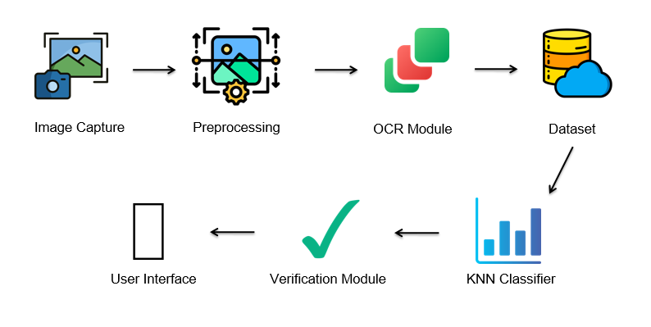

## **VII. SYSTEM OVERVIEW**

### **1. Image Capture and Preprocessing**

This module takes pictures of license plates as cars drive up to the surveillance zone. In order to simplify the photos and improve their clarity for word recognition, they are transformed to grayscale. Preprocessing ensures high-quality input for later OCR processing by adjusting contrast and reducing noise. These procedures produce a consistent and lucid image, which is necessary for precise character extraction under various lighting scenarios.

### **2. Optical Character Recognition (OCR):**

The OCR module converts each character on the license plate for additional analysis by turning the image into digital text. This module guarantees the highest level of accuracy in the extracted characters by handling ambiguous text and identifying a variety of fonts. Reliable vehicle identification is made possible by processing the text and passing it to the next module for database matching.

### **3. Database and KNN Classification:**

The extracted characters can be quickly looked up thanks to a central database that holds confirmed license plate numbers. The OCR results are compared to the items in this database using the K-Nearest Neighbours (KNN) technique. The system shows ownership information if a match is detected; if not, the plate is marked as possibly fraudulent. The KNN's flexibility in handling fresh input facilitates a precise and dynamic matching procedure.

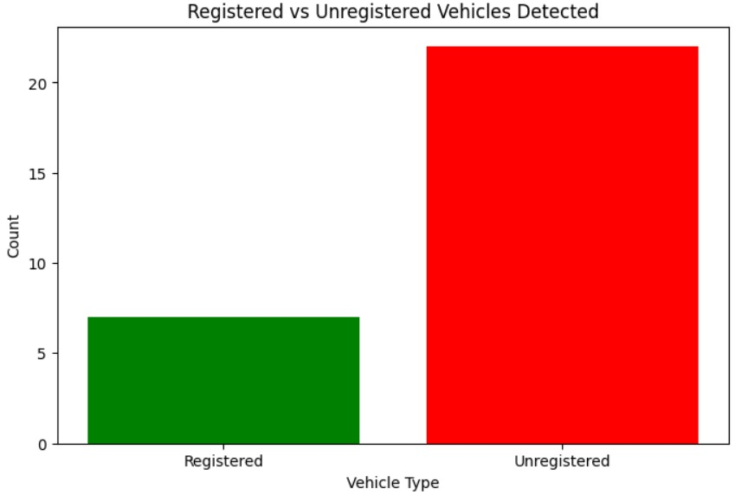

***Fig 7.1 Database for detected vehicles***

### **4. Verification and Alert System:**

This module creates alerts for unregistered plates and verifies that each license plate matches. The system shows pertinent vehicle information if it finds a match. It helps authorities identify illegal vehicles in real time by flagging plates with unmatched entries for additional review.

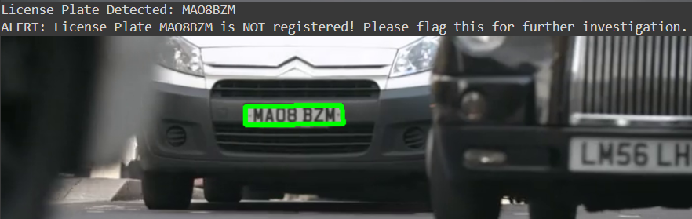

***Fig 7.2 Verification and Alert System Page***

**IX. CONCLUSION**

The Real-Time License Plate Recognition and Validation System captures and analyzes license plates using OCR and machine learning, improving security by flagging unregistered plates in real time. OCR characters are extracted from preprocessed images and compared to a KNN-based database. The system is flexible and can accommodate a range of requirements with future additions like cloud storage and non-Latin script compatibility. It has a modular design for scalability and an alert system for prompt action.

# **REFERENCES**

[1]. AlaMutka KM (2005), ‘A survey of automated assessment approaches for programming Assignments’ in Computer Science Education on Taylor francisVol.No 12 pp83–102.

[2]. Blikstein P, Worsley M, Piech C, Sahami M, Cooper S, Koller D (2014), ‘Programming pluralism: Using learning analytics to detect patterns in the learning of computer programming’ in Journal ofLearningScience on Taylor Francis ;Vol.No23pp561– 99,

[3]. CharlotteVanPetegem, RienMaertens, NikoStrijbol, JorgVanRenterghem, FelixVanderJeugt, RademeyerDawyndt, BartMesuere (2023),’ Dodona: Learn to code with a virtual coteacher that supports active learning’ insoftwareX on Science DirectVol no24, pp101578.

[4]. Chow S, Yacef K, Koprinska I, Curran J (2017),‘Automated datadriven hints for computer programming students.’, In: Adjunct publication of the 25th conference on user modeling, adaptation and personalization. New York, NY, USA: Association for Computing Machinery, pp. 5–10.

[5]. Costa EB, Fonseca B, Santana MA, de Araújo FF, Rego J (2017), ‘Evaluating the effectiveness of educational data mining techniques for early prediction of students’ academic failure in introductory programming courses’inComputers in Human Behavior on science direct,Vol.No73, pp247– 256.

[6]. Edwards SH, PerezQuinones MA (2008), ‘WebCAT: Automatically grading programming assignments’. In: Proceedings of the 13th annual conference on innovation and technology in computer science education. New York, NY, USA: Association for Computing Machinery; p. 328.

[7]. Ferguson R (2012), ‘Learning analytics: Drivers, developments and challenges.’ in Int Journal of Technology Enhanced Learning, pp304–17.

[8]. Fonseca I, Martins NC, Lopes F (2023). ‘A webbased platform and a methodology to teach programming languages in electrical engineering education – evolution and student feedback’. In: 32nd annual conference of the European association or education in electrical and information engineering., pp. 1–3.