**Water Quality Assessment of Godavari River**

Jeet K. Ganeshkar, Nikhil K. Marathe, Pratiksha G. Shinde.

Guided by: Mrs. Y. S. Kumawat

*(Diploma in Chemical Engineering, K. K. Wagh Polytechnic, Nashik, Maharashtra, India)*

*Corresponding Author: jeetganeshkar@gmail.com*

|  |
| --- |
| ***Abstract:*** *Godavari is the second largest river in India. It originates from Triambakeswar, Nashik, Maharashtra and finally discharges into the Bay of Bengal near Narasapuram in West Godavari district of Andhra Pradesh. The study covers about 39 km of river starting from Gangadwar to Dasak village. Five locations were selected for collection of water samples from the river and water samples were analysed for water quality parameters. It was observed that untreated or partially treated sewage along with industrial wastewater is entering into the river at five prominent locations in the study stretch. Based upon the results, the existing conservation measures have been reviewed and additional measures are suggested. The study concludes that infiltration of sewage is the main precursor of Godavari river pollution and available sewage treatment facilities in the region are inadequate.*  ***Key Word****: Water quality index; River Pollution and BOD; Godavari River, Sewage and industrial wastewater’ Physicochemical, Chemical, Physical and chemical parameters.* |

1. **Introduction**

The Godavari River holds immense cultural, religious, and economic importance for Nashik, a city in Maharashtra, India. Situated on the banks of the Godavari, Nashik is deeply intertwined with the river, which serves as a vital source of water for agriculture and other purposes. The river also holds religious significance, particularly evident during the Kumbh-Mela pilgrimage that occurs every 12 years, attracting millions of devotees who come to take a holy dip in its sacred waters.

Furthermore, the Godavari River and its surroundings in Nashik have witnessed historical events and ancient civilizations, contributing to the rich heritage of the region. The river's serene flow through Nashik provides a picturesque setting, attracting tourists and nature enthusiasts.

However, despite its cultural and historical importance, the Godavari River faces challenges, particularly concerning pollution. Numerous studies have been conducted to assess water quality, highlighting the impact of human activities such as industrial discharges, agricultural runoff, and urban waste on pollution levels. This pollution has ecological consequences, affecting aquatic life and biodiversity.

Despite these challenges, interdisciplinary research on the Godavari River continues to explore its environmental, cultural, and historical dimensions. Scholars seek sustainable solutions to address pollution concerns while preserving the cultural and historical heritage associated with this iconic river in India.

1. **Material And Methods**

Water quality assessments of the Godavari River in India use a variety of materials and methods, including:

• Sampling stations: Five sampling stations were selected to collect water samples from the Godavari River.

• Grab sampling: Samples were collected from January 21 to February 7.

• Portable water quality analyzer: Temperature, pH, and total dissolved solids are measured in the field after sample

collection.

• Titrimetric: Chloride, total hardness, calcium, and total alkalinity are analyzed

• Modified Winkler's method: Dissolved oxygen (DO) is estimated

• Dichromate reflux method: Chemical oxygen demand (COD) is carried out.

• Fuzzy logic approach: Five main parameters are used: DO, BOD, turbidity, total solids and pH.

**Table No. 2.1:** Sampling Locations in the Study Stretch of the Godavari River

|  |  |  |  |  |
| --- | --- | --- | --- | --- |
| **Sr. No.** | **Category** | **Sampling** | **Location** | **Remarks** |
| 1 | Surface Water | S1 | Gangadwar | Godavari River makes its first appearance on the Brahmagiri hill. |
| 2 | Surface Water | S2 | Kushawart | Origin of River with no anthropogenic impacts |
| 3 | Surface Water | S3 | Ramkund | Mass bathing activities |
| 4 | Surface Water | S4 | Takali | Solid waste treatment plant and biomedical wasted water meet the river |
| 5 | Surface Water | S5 | Dasak | Remain/ashes of human dead bodies, sewage/waste water from settlements/ oil and grease from vehicle washings added. |

* 1. **Different Sampling stations where we collected water samples:**
     1. **Gangadwar:**

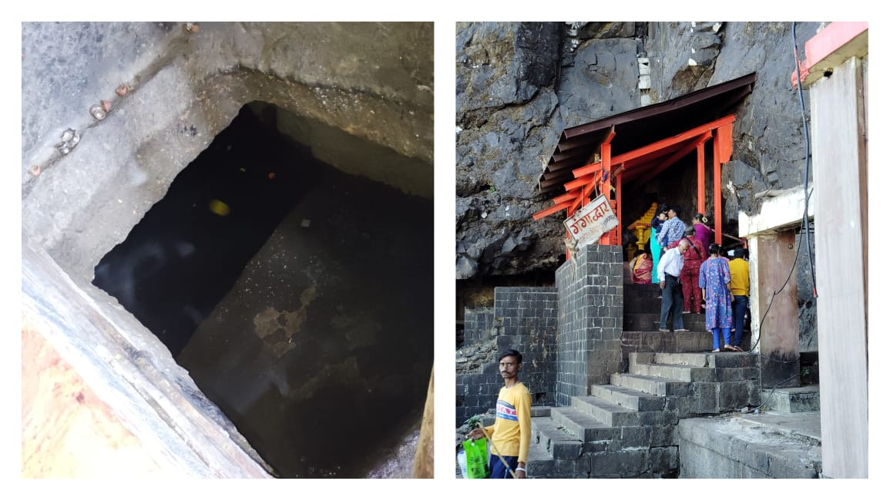

**Figure no. 4.1:** Origin of Godavari River at Gangadwar

This beautiful hillock is considered important from many religious and pilgrimage perspectives, particularly for Hindu visitors. The point named as Gangadwar is where the Gangadwar River originates. Water is often referred to as 'Ganga'. Therefore, Gangadwar may also be interpreted as the place where water originates. It is regarded as a sacred place.

* + 1. **Kushawart:**

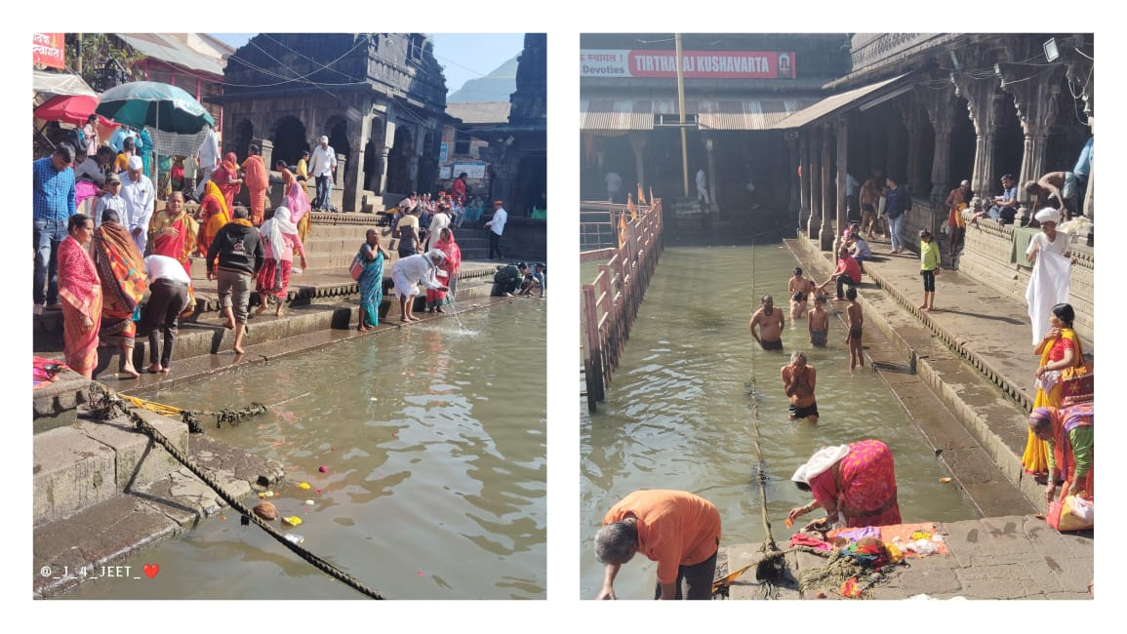

**Figure no. 4.2:** Kushawart Tirtha at Trimbakeshwar

There is very famous place at Trimbakeshwar. This is place of God Shiva knows as “Trimbak Raja”. Kushawart Tirtha is a unique place of religious importance at all the times, especially in the “Mahashivratri”. Many of Hindu Bhavik comes here to holy dip in water.

* + 1. **Ramkund:**

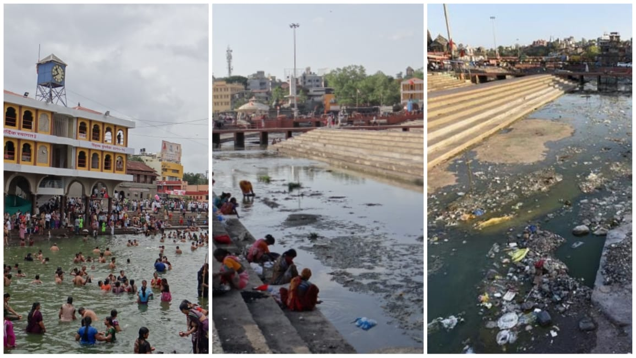

**Figure no. 4.3:** Polluted area at Ramkund, Panchavati

Ramkund is Most Populated area in Nashik. Ramkund is a unique place of religious importance at all the times, especially in the “Kumbhamela”. It is a place for holy dip. Daily thousands of people take a dip in Ramkund. During kumbha parva Lakhs of people take holy dip in Ramkund. The belief is that God Rama use to take a bath in Ramkund and the river takes a turn in ninety degree at this place.

* + 1. **Takali:**

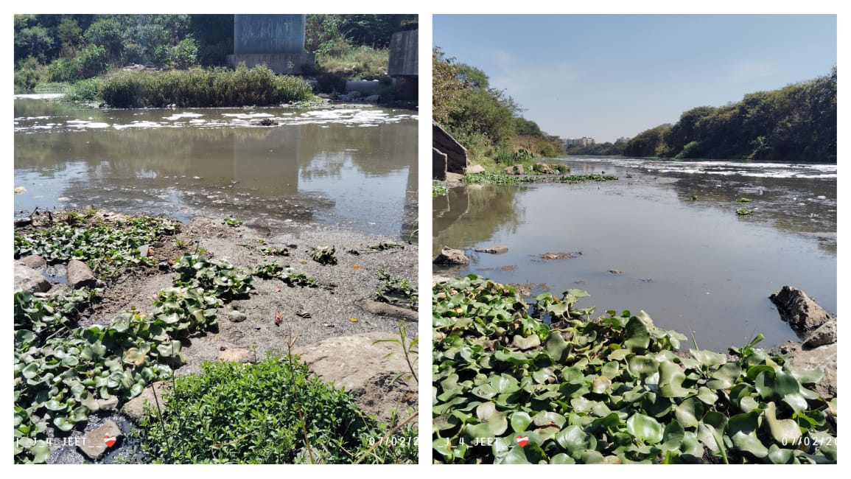

**Figure no. 4.4:** Polluted area at Takali Bridge

Takali road is the most polluted area in Nashik. Hence it pollutes Godavari River. Here the Nasardisagam 40 MLD SPS and 210 MLD SPS Agar Takali are two Sewage Pumping Stations are situated near the Godavari River at Takali road.

* + 1. **Dasak:**

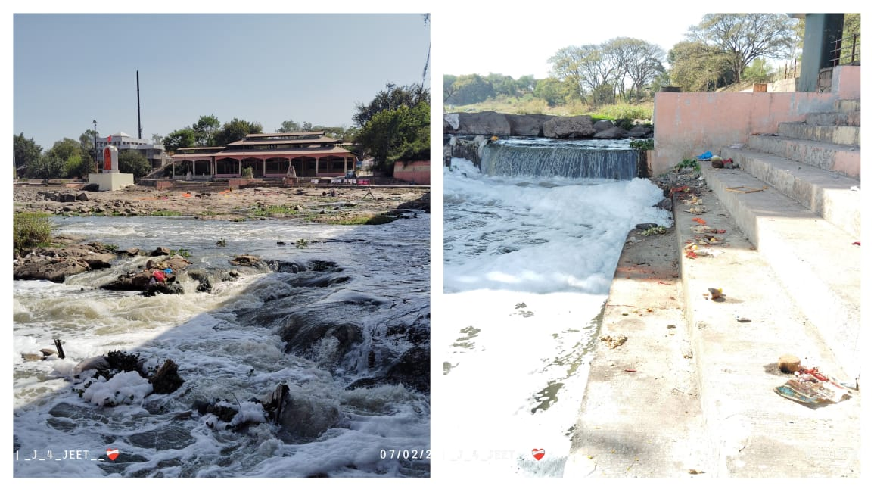

**Figure no. 4.5:** Polluted area at Dasak nala

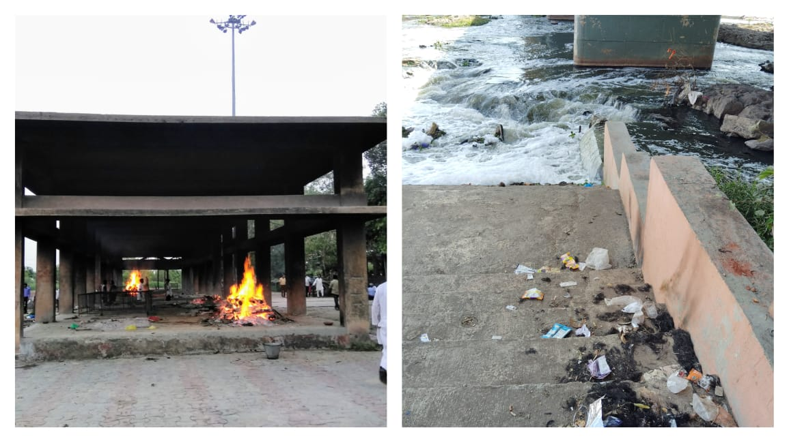

**Figure no. 4.6:** Cremation area at Dasak nala

Dasak village that is comes under at Niphad Taluka. It is situated at near the Godavari River. Here we observed pollution in rivers like the Godavari can be attributed to Hindu rituals, hair cutting, industrial waste, agricultural runoff, untreated sewage, and littering.

* 1. **Parameters to assess:**

Assessing water quality involves evaluating various physical, chemical, and biological parameters to determine the suitability of water for specific purposes. Here is some key water quality parameters commonly assessed:

1. **pH (Potential of Hydrogen):** Measures the acidity or alkalinity of water. It is essential for the survival of aquatic organisms and affects the solubility of minerals.
2. **Temperature:** Influences the rate of chemical reactions and the solubility of gases. Fluctuations can impact aquatic ecosystems and the health of organisms.
3. **Dissolved Oxygen (DO):** The amount of oxygen dissolved in water, crucial for the survival of aquatic organisms. Low DO levels can indicate pollution or excessive organic matter.
4. **Turbidity:** A measure of water clarity or cloudiness caused by suspended particles. High turbidity can affect light penetration and aquatic plant growth.
5. **Total Dissolved Solids (TDS):** The total concentration of inorganic and organic substances dissolved in water, including salts, minerals, and ions.
6. **Conductivity:** Indicates the ability of water to conduct an electric current, which is related to the concentration of ions in the water. It is often used as a proxy for TDS.
7. **Nutrients (Nitrogen and Phosphorus):** Excessive nutrient levels, often from agricultural runoff or wastewater, can lead to eutrophication, causing algal blooms and oxygen depletion.
8. **Heavy Metals:** Such as lead, mercury, cadmium, and arsenic, can be toxic to aquatic life and humans. Industrial discharges and urban runoff are common sources.
9. **Biological Oxygen Demand (BOD):** Measures the amount of oxygen consumed by microorganisms while decomposing organic matter in water. High BOD indicates organic pollution.
10. **Fluoride Concentration:** The primary parameter to monitor is the concentration of fluoride in the water. This is usually measured in milligrams per liter (mg/L) or parts per million (ppm).
11. **Chemical Oxygen Demand (COD):** Measures the amount of oxygen required to chemically oxidize organic and inorganic matter in water. It is an indicator of water pollution.
12. **Alkalinity:** Alkalinity is a measure of the water's capacity to neutralize acids. It can impact the solubility of fluoride compounds. Low alkalinity may result in more acidic conditions, affecting fluoride levels.

These parameters are often measured together to provide a comprehensive understanding of water quality. The specific parameters considered may vary depending on the intended use of the water, such as drinking water, recreational use, or support of aquatic ecosystems.

1. **Result**

In our Project we measured total 17 Parameters to Assessed water quality of Godavari River. As Shown in Table no. 3. To all water samples collected.

**Table no 3.1:** Results of Water sampling stations with different parameters.

|  |  |  |  |  |  |  |  |  |
| --- | --- | --- | --- | --- | --- | --- | --- | --- |
| Sr. No. | Parameters | Gangadwar (S1) | Kushawart (S2) | Ramkund (S3) | Takali (S4) | | Dasak (S5) | Unit |
| 1. | pH | 7.92 | 7.30 | 7.22 | | 7.36 | 7.17 | - |
| 2. | Electrical Conductivity | 652 | 245 | 421 | | 443 | 211 | mS/cm |
| 3. | Total Dissolved Solids | 423 | 159 | 273 | | 278 | 137 | mg/L |
| 4.. | Total Hardness | 192 | 80 | 124 | | 136 | 72 | mg/L |
| 5. | Fluorine | 0.24 | 0.13 | 0.12 | | 0.12 | 0.11 | mg/L |
| 6. | Nitrate | 5 | 1 | 1 | | 2 | 1 | mg/L |
| 7. | Iron | 0.01 | 1.24 | 1.12 | | 1.09 | 0.95 | mg/L |
| 8. | Chloride | 56 | 12 | 22 | | 20 | 10 | mg/L |
| 9. | Total Alkalinity | 156 | 48 | 80 | | 88 | 40 | mg/L |
| 10. | Sulphate | 32 | 12 | 21 | | 22 | 10 | mg/L |
| 11. | Color | 1 | 1 | 1 | | 1 | 1 | Hazen Unit |
| 12. | Odor | Disagreeable | Disagreeable | Disagreeable | | Disagreeable | Disagreeable | - |
| 13. | Taste | Disagreeable | Disagreeable | Disagreeable | | Disagreeable | Disagreeable | - |
| 14. | Turbidity | 0 | 0 | 0 | | 0 | 0 | NTU |
| 15. | Residual Chlorine | 0 | 0 | 0 | | 0 | 0 | mg/L |
| 16. | COD | 21 | 152 | 40 | | 40 | 36 | mg/L |
| 17. | BOD | 5.1 | 85 | 10.3 | | 15 | 21 | mg/L |

From the table of all parameters reading we took 4 Parameters for final Result and conclusion that’s TDS, COD, BOD and Total Alkalinity. Therefore we can say that:

* **TDS** – It is trends due to contamination of Sewage water in the Godavari River. Is it mainly caused by disposal of large amount of sewage waste, also domestic waste water Low TDS water is not harmful. In the range of 50 – 150 ppm is excellent for drinking. But form our table no any sample reading is less than 150, so we can say all samples water are not drinkable.

* **COD** – It is amount of the Oxygen consumed in a degradation of organic and inorganic matter. Kushawart has more COD value (152 mg/L), similarly Ramkund (40 mg/L) and Takali (40 mg/L) has more COD values so its most serious the pollution of organic matter by water.
* **BOD** – It is amount of the Oxygen consumed in a biodegradation of organic matter. Low BOD indicates a safe or good quality of water. So Kushawart has more BOD value (85 mg/L), so it’s more polluted water.
* **Alkalinity** – Here low alkalinity values are harmful for river water. From the sample’s values we can say Dasak (40 mg/L) and Kushawart’s water sample (48 mg/L) has less Alkalinity also Ramkund (80 mg/L) and Takali (88 mg/L) has low Alkalinity. So they are not drinkable water.

1. **Discussion**

This passage highlights the religious significance and environmental concerns surrounding various sites along the Godavari River in Nashik, India.

**1. Gangadwar:**

A sacred place where the Gangadwar River originates. It holds religious importance for Hindu visitors, especially during Mahashivratri. However, despite efforts to maintain cleanliness, open defecation and pollution from flower and coconut offerings affect the water quality.

**2. Kushawart Tirtha:**

Also known as Kushawart, this site is densely populated and holds religious importance, particularly during Mahashivratri. It's believed to be where the sacred river Godavari remerges. Despite being a place of religious significance, pollution and cloudy water due to heavy foot traffic mar its beauty.

**3. Ramkund:**

A site of religious importance throughout the year, especially during the Kumbh-Mela. It's believed that Lord Rama bathed here and the river takes a turn here. However, pollution from sewage and industrial waste, along with improper waste disposal practices, degrade the water quality. Rituals like Ganesh Visarjan contribute to pollution with chemical dyes and waste from idols and offerings.

**4. Takali Road:**

Considered the most polluted area in Nashik, it contributes to the pollution of the Godavari River due to sewage pumping stations and industrial waste.

**5. Dasak:**

It’s a site for cremations. The remains and ashes of the deceased are often immersed in the river along with garlands and other materials, contributing to river pollution.

Addressing river pollution requires a multifaceted approach involving regulatory measures, public awareness campaigns, proper waste disposal facilities, and community involvement. It's essential to distinguish between harmless religious practices and those that harm the environment to effectively tackle pollution while respecting religious sentiments.

1. **Conclusion**

The investigation downstream of the Godavari River in Nashik city concluded that the river's quality is contaminated primarily due to domestic wastewater. Key parameters such as Dissolved Oxygen (DO), Biochemical Oxygen Demand (BOD), Chemical Oxygen Demand (COD) and Total Alkalinity indicate high pollution levels at sampling stations 2, 3, 4 and 5. This Gangadwar’s River water (S1) is clean water. This pollution is attributed to the mixing of Nashik city effluents at Ramkund (S3) and Takali (S4) effluents with high organic load. Kushawart (S2), Ramkund (S3) and Takali (S4) shows particularly high BOD values, indicating a significant presence of organic matter in sewage at those sites.

The study also reveals elevated chloride and hardness levels, leading to increased chemical consumption and treatment costs. Downstream of the Godavari River, water is utilized for agricultural purposes, resulting in reduced crop yields due to contamination and mainly harmful for Aquatic life of Godavari River. The main focus of the study is on the pollution of the Godavari River downstream of Nashik city, caused by domestic and industrial effluents. This contamination severely impacts users of the river who rely on its water.

**References**

1. Chavhan, Mr., & Bhargava, Water Quality assessment of the Godavari River. Researchgate.net. Retrieved January 26, 2010.
2. Comprehensive Study of Polluted River Stretches and Preparation of action plan of river Godavari from Nashik D/S to Paithan (By M. E. Sawant). (2015, March 10). Retrieved Jan. 2, 2018.
3. CEO Company in Bangalore, Save the Rivers (River pollution in India) CEO by Bharat Go Digital. (August 5, 2022)
4. Godavari River in India, Britannica by Adam Zaidan. at (March 27, 2024)
5. Godavari River – Everything you need to know, textbook.com by IAS Preparation on (Jan. 7, 2024)
6. E. Venkatesh Presented- All about Godavari River on slideshare.com on Feb 21, 2018
7. APHA, AWWA, WPCF (1989): Standard Methods for the examination of water and Waste Water, 17th Ed (Clescerina, L.S. Eds., Trussell, R.R., Greenberg, A.E.), APHA, Washington D.C. U.S.A.
8. Assadian,N.W., DiGiovanni, Enciso G.D.Iglesias, J.Lindemann,W., (2005): The transport of water borne solutes and bacteriophage in soil subirrigated with a wastewater blend Agric. Ecosys Environ 111: 279-291.
9. BIS (1991): Bureau of Indian Standards, Indian Standard Specification for Drinking water IS 10500: 2-4.
10. Chattopadhyay Srikumar and Rani, L.S. (2005): Water quality variation as linked to land-use pattern: A case study in Chhalakudy river basin, Kerala, Current science, volume 89, no12 Chemical factors in Sathiyar reservoir, Hydrobiologia, 70: 103-117.
11. Dhirendra, M.J., Alok Kumar, and Namita Agrawal, (2009): Studies on Physicochemical parameters to assess the Water Quality of river Ganga for drinking purpose in Haridwar district, Rasayan J. Chem. 2: 195-203.
12. Doyle, M.P. (1990): Food borne illness: Pathogenic E.coli, Y.enterocolitica and Y parahaemolyticus. Lancet 336: 1111-1115.
13. Ford, T.E. (1990): Microbiological Safety of Drinking water, United States and Global Perspectives, Environ Health Perspect 107:191.
14. Gaikwad, V.B. (2000): Water quality monitoring of Godavari river in and around Nashik, Ph.D. Thesis Submitted to University of Pune, India.
15. Hutchinson,G.E.(1957): A treatise on limnology, volume I, John Wiley and Sons, Inc., New York.
16. Khadse, G.K. Patani, P.M. Kelkar, P.S. and Devotta, S. (2008): Qualitative evaluation of Kannhan river and its tributaries flowing over central Indian plateau, Environmental Monitoring and assessment, 147: 83-92.
17. MERI Report, (2001): the study water quality of Godawari river in Nashik City, Maharashtra Engineering Research Nashik-422004.
18. Okafo C.N, Umoh, V.J., Galadima M., (2003): Occurence of pathogens on vegetables harvested from soils irrigated with contaminated streams Sci of total Environ 311: 49-56.