**REVIEW ON SILVER NANO PARTICLES**

***INDRAPATI MAMATHA1, CHERLAGUDEM DHARANI2, DASARI NANDINI3, GAJULA MALATHI4, KUTHURU SHIVA PRASAD5.***

***ABSTRACT***

*The aspect of human life, making nanotechnology an exciting field for biomedical applications. Over the years, metal nanoparticles, such as silver, have attracted a lot of attention because of their extraordinary optical, electrical, and antibacterial qualities. Unfortunately, those nanoparticles' aggregation and toxicity have restricted their employment in more advantageous applications. Choosing therapeutically active bimolecular judiciously to functionalize the surface of these particles would undoubtedly improve their biological applicability and biocompatibility. In addition to providing an overview of the current approaches being used to biofunctionalize silver nanoparticles for certain purposes, the current review the distinct size-dependent properties of nanoscale materials have had a significant impact on every aims to highlight the application areas of these particles. Nanotechnology is a promising subject for biomedical applications because of the distinctive size-dependent features of materials at the nanoscale that have greatly touched all aspects of human life. Because of their exceptional optical, electrical, and antibacterial qualities, metal nanoparticles—like silver—have attracted a lot of attention over time. However, their employment in highly optimized applications has been limited due to their poisonous nature and tendency to aggregate. The biocompatibility and biological applicability of these particles are certain to be improved by the logical selection of therapeutically active bimolecular to functionalize their surface. The present review endeavors to emphasize the various application areas of silver nanoparticles while providing an overview of the current approaches entailed in biofunctionalizing these particles for particular uses.*

**Keywords:**silver nanoparticles, synthesis, characterization, applications, mechanisms,

1. **INTRODUCTION**

Due to of the unique size-dependent characteristics of materials at the nanoscale, which have had an important effect on all facets of human life, nanotechnology is a promising field for biomedical applications. Metal nanoparticles, such as silver, have garnered a great deal of interest over time due to their remarkable optical, electrical, and antibacterial properties. Unfortunately, because of their toxicity and aggregating tendency, their use in highly optimized applications has been restricted. The logical selection of therapeutically active bimolecular to functionalize the surface of these particles would undoubtedly improve their biocompatibility and biological applicability. The current review aims to highlight the diverse applications of silver nanoparticles and gives a summary of the existing methods used to biofunctionalize these particles for specific purposes. There are two ways to prepare metal nanoparticles. The first is a physical method that involves a number of techniques like laser ablation and evaporation/condensation. The other is a chemical method wherein the concentration of metal ions in the solution reduces under circumstances that encourage the eventual development of small metal aggregated or clusters (Khomutov and Gubin, 2002, Oliveira et al., 2005, Egorova and Ravine, 2000).[1]

AgNPs' biological activity is dependent upon various factors, such as their surface chemistry, size, distribution, shape, morphology, composition, coating/capping, agglomeration, and dissolution rate; additionally, the type of reducing agents employed during AgNPs' synthesis plays a critical role in determining their cytotoxicity . The physical and chemical properties of nanoparticles can influence cellular uptake, biological distribution, penetration through biological barriers, and subsequent therapeutic effects. On the other hand, they can improve the bioavailability of therapeutic agents following both systemic and local administration. Thus, for a variety of biological uses, the production of AgNPs with regulated structures that are homogeneous in size, morphology, and functionality is crucial [2]

The impact of different analytical procedures on the findings acquired during the research process of Ag NPs is another topic that has not received enough attention in the literature. However, some information may be inferred from the scientists' comments, leading one to the conclusion that the characteristics of Ag NPs under study can vary greatly according on the instrumental technique. Additionally, artifacts from the technique, equipment, or sample preparation steps may have an impact on the results While advances in technology have made it feasible to erase a large number of artifacts that may have been introduced by the equipment, it is nearly difficult to take into account or Silver nanoparticles[3]

1. **Properties of silver nano particles:**

The AgNPs' physical and chemical characteristics, such as their surface chemistry, size, distribution, shape, morphology, composition, coating/capping, agglomeration, rate of dissolution, reactivity of the particles in solution, efficiency of ion release, cell type, and lastly the kind of reducing agent used during synthesis, are essential for determining their cytotoxicity. For instance, spherical, rod, octagonal, hexagonal, triangle, flower-like, and other shapes can be created from AgNPs employing biological reducing agents like culture supernatants of different Bacillus species (Figure 2). Previous studies confirmed the idea that because smaller particles have a bigger surface area than larger ones, they may be more dangerous. When determining toxicity, shape is just as significant. Various types of the nanostructures, such as nano cubes, nano plates, nanorods, spherical nanoparticles, flower-like, and so on, have been used, for instance, in the field of health care. The presence of chemical or biological coatings on the surface of the nanoparticles is the primary determinant of AgNP toxicity. The toxicity effect in cells may be determined by AgNP surface charges. For example, these NPs are more appropriate because of their positive surface charge, which makes them able to remain in the bloodstream longer the negatively-charged NPs, which is a significant way that anticancer drugs are administered [24].

An external file that holds a picture, illustration, etc.
Object name is ijms-17-01534-g002.jpg

Figure :1

1. **Synthesis of Silver nanoparticles**

**Physical techniques** The two most significant physical methods are laser ablation[4] and evaporation-condensation. The benefits of physical synthesis methods over chemical methods consist of the homogeneity of NPs distribution and the lack of solvent contaminants in the generated thin films. The physical synthesis of silver nanoparticles at atmospheric pressure has certain drawbacks. For instance, the tube furnace takes up a lot of room, uses a lot of energy to raise the temperature surrounding the source material, and takes a long time to reach thermal equilibrium. In addition, a standard tube furnace has to consume more energy than a few kilowatts and take many tens of minutes to attain a temperature that is stable for operation studied.[5]

LASER ABLATION METHOD:

The method used for creating different types of nanoparticles is laser ablation. These include core shell nanoparticles, semiconductor quantum dots, carbon nano tubes, and nano wires. This process creates nanoparticles through permitting species that have been laser-vaporized to nucleate and grow in a background gas. The production of high purity nanoparticles in the quantum size range (< 10 nm) benefits from the vapor's extremely rapid quench [21].

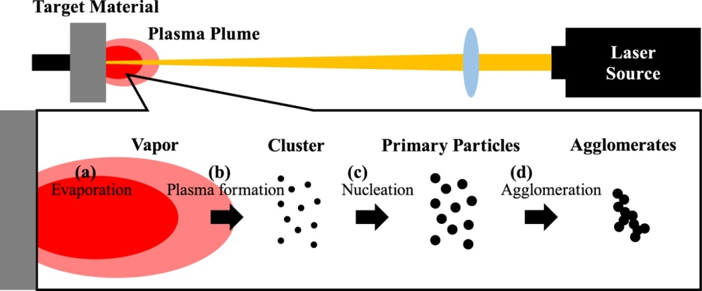

Figure: 2

The primary factor influencing the material removal (ablation) caused by an intense laser beams contact with it is the laser pulse's temporal breadth in proportion to the material's electron-phonon coupling time constant. The material carriers get the laser energy first; in the case of a metal, this is the free electrons; in the case of semiconductors, it is the electrons in the valence band, which are subsequently excited to the conduction band. Following a brief period of carrier thermallization (often on the order of 100 fs), the carriers begin to transmit energy to the lattice through electron-phonon coupling (often within a time scale of 1 ps). In this phase, even after the carriers have completed transferring their energy into the lattice, the laser beam continues to pass energy into the material if the pulse width is greater than the electron-phonon coupling time constant (as in the case of a nanosecond [ns] pulse) (Figure (1a)). Because of this, heat is released from the area of the material's surface where the laser beam is impacted. This leads to a number of issues around the area where the laser beam is incident on the material's surface, including melting of the material, the formation of a noticeable heat affected zone, recast layers, surface debris, mechanical cracks, and other issues (Figure 1(c)). In this case, even for low fluencies, the material is ablated by melting and vaporization, or a transition from solid to liquid to vapor. Conversely, in situations where the laser pulse's temporal width incident on the material's surface is less than the electron-phonon coupling time constant (such as in a femtosecond [fs] pulse) (Figure 1(b)), the laser energy is primarily contained within the initial volume where the irradiation was absorbed. Since the ultra short pulse width prevents laser energy from dissipating into heat from the irradiated area, the material's surface enthalpy is several orders of magnitude larger than its sublimation enthalpy in this instance According to Figure 1(e) this leads to a direct solid-to-vapor transition or the ablation of the material at low fluencies by sublimation. Not only does ablation depend on the optical absorption length of the laser radiation into the material, but even in the case of a fs pulse, for fluencies greater than a certain value, the heat penetration depth controls the energy penetration depth into the material, and thermal diffusion from the volume defined by the focused beam diameter and the skin depth leads to thermal diffusion. Like in the case of a ns pulse, ablation of the substance takes place in this instance by melting and vaporization.. similar to a ns pulse. The situation of a laser pulse with a picoseconds (ps) time period is an intermediate case in between the ns and the fs pulse (Figure 1(d)).[22]



FIG. 1 Schematics of ns (a) and fs (b) laser ablation, and holes drilled in a 100 μ m thick steel foil with: (c) 3.3 ns, 1 mJ, F = 4.2 J/cm2, (d) 80 ps, 900 μ J, F = 3.7 J/cm2, and (e) 200 fs, 120 μ J, F = 0.5 J/cm2 laser pulses at 780 nm. (Reprinted with kind permission from Springer Science + Business Media, Chichkov et al.Citation
1
 Copyright 1996.)


Figure:3

EVAPORATION & CONDENSATION

The structure and composition of nano crystals, as well as the synergy between the two metallic elements, influence the qualities of nanoparticles made from these elements. For their synthesis to be successful, the molar fractions of the component elements and the crystal structure must be precisely adjusted. The production of aerosol nanoparticles through evaporation-condensation is based on the re agglomeration of metallic components in the gas phase. In order to create spherical particles smaller than 10 nm in size, we employed a dual evaporation–condensation approach in this study, which involved two furnaces to alter the molar fractions of Ag–Au nanoparticles with an alloy-type nano crystalline structure. Depending on the heating temperature, the molar fraction of Ag atoms in the produced particles ranged from 0 to 80%. Ag and Au elements were found in all particles and formed an alloy structure, according to energy-dispersive X-ray spectroscopy data. This suggests that alloyed composite particles with varying stoichiometries can be readily manufactured using the dual evaporation–condensation process. Furthermore, the gas phase-produced nanoparticles were effectively recovered through immobilization on a substrate and functioned as bimetallic catalysts for the oxidation of CO. It is interesting to notice that the suggested approach only required one step to prepare the nanoparticles and fix them to a substrate.[23]

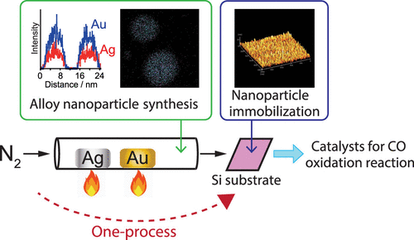

Figure:4

**Chemical reduction**

Chemical reduction using both organic and inorganic reducing chemicals is the most widely used method for creating silver nanoparticles. Silver ions (Ag+) in aqueous or non-aqueous solutions are generally reduced using a number of reducing agents, including sodium citrate, ascorbate, sodium borohydride (NaBH4), elemental hydrogen, polyol process, Tollens reagent, N, N-dimethylformamide (DMF), and poly ethylene glycol -block copolymers. These reducing chemicals reduce Ag+, resulting in the agglomeration of silver into oligomeric clusters and the generation of metallic silver (Ag0). Eventually metallic colloidal silver particles get generated by these clusters. The aerosol nanoparticles production technique known as evaporation-condensation (EC) is predicated on the re agglomeration of metallic components in the gas phase.[6,7]

**There are few methods of Chemical reduction**

**Chemicals required**:

Silver nitrate, tri-sodium citrate Merck (Germany), malt extract was procured from Himedia (India). Sterile distilled water was used throughout the experiments.

### 1 Bacterial cultures used

*Staphylococcus aurous, Bacillus subtilis, Escherichia coli* and *Pseudomonas aeruginosa* were procured from Microbial Type Collection (MTCC) centre, IMTECH, Chandigarh, India.

**2. Silver nanoparticles produced chemically**

Double distilled water was used to prepare all of the reactive material's constituents. A standard experiment involves heating 50 milliliters (1 × 10−3 M AgNO3) to boiling point. Drop by drop, 5 milliliters of 1% trisodium citrate were added to this solution. During this process, the solution was vigorously stirred and heated until a significant color change (to a pale brown). Finally, the heating element had to be removed and it was swirled until it cooled to the ambient temperature.[18]

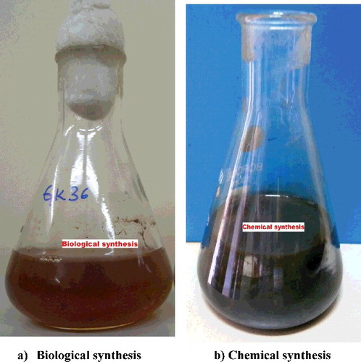

**Figure:5**

3**. Silver nanoparticles produced biologically**

The white rot fungus Pycnoporus sp. (HE792771) has been grown in malt extract broth with 5 g/l of malt extract and 10 g/l of glucose. After bringing the final pH down to 6.0, the flasks were incubated at 32 °C and 200 rpm in an orbital shaker. After incubating for five days, the mycelium had been separated by filtering, and the supernatant was challenged with an equivalent volume of a 1 mm silver nitrate solution (made in deionizer water). The shaker was then incubated at 200 rpm in the dark at 32 °C (Figure 1). A negative control that contained only silver nitrate solution and a positive control that contained both silver nitrate solution and deionizer water were simultaneously maintained under the identical circumstances

**4. Study of UV-Vis spectroscopy**

In the 350–470 nm regions, the ELICO SL-159 Spectrophotometer was used to perform ultraviolet–visible (UV–Vis) spectrum analysis. Using a UV–Vis spectrum measurement of the reaction mixture, the decrease of pure silver ions produced chemically and biologically was tracked [19]

**5. Possessing antimicrobial properties**

Gram-positive and Gram-negative bacteria were used in the agar well diffusion method to investigate the antibacterial activity of silver nanoparticles produced by chemical and biological processes, Spooned into sterile Petri plates was twenty milliliters of nutritional agar material. Bacterial lawns were prepared using a one-day-old bacterial culture (1 × 105 CFU/ml). Agar wells measuring 8 mm in diameter were created with the use of a sterile borer. Sixty μl of solutions containing biologically andchemically synthesized silver nanoparticles, one milliliter of 1 milligram of AgNO3 as a negative control, and thirty microliters of 30 μg/ml of streptomycin as a positive control were introduced into the wells using injection methods After another 24 hours of incubation at 37 °C, the plates were checked to see if any areas of inhibition were present. The measurement and expression of the inhibiting area were done in millimeters[20]

1. **Characterization of silver nano particles:**

Understanding and managing the synthesis and usage of nanoparticles requires careful characterization. Numerous techniques are used for characterization, including atomic force microscopy (AFM), transmission and scanning electron microscopy (TEM, SEM), dynamic light scattering (DLS), powder X-ray diffractometry (XRD), X-ray photoelectron spectroscopy (XPS), Fourier transform infrared spectroscopy (FTIR), and UV–Vis spectroscopy. (8)

1. **Applications of green silver nano particles**:

AgNPs are widely employed as anti-bacterial agents in textile coatings, food storage, the health sector, and several other environmental applications. 9

AgNPs are widely employed as anti-bacterial agent, silver nanoparticles of drug delivery system, sliver nanoparticles for catheter modification, silver nanoparticles of dental application, sliver nanoparticles for wound healing, sliver nanoparticles for bone healing, sliver nanoparticles for other medical applications, toxicity of sliver nanoparticles. [10]

Excellent metal nanoparticles are a novel type of optical and spectroscopic tags for biological sensing because of their outstanding absorption and scattering capabilities. [11]

Metal nanoparticles possess a wide range of uses, including bio-detection of pathogens, tumor destruction via heating (hyperthermia), magnetic resonance imaging, textile engineering, electronics, optics, paints, lubricants, fuel additives, food packaging, biodegradation of pathogens, and Nano medicine.[12]

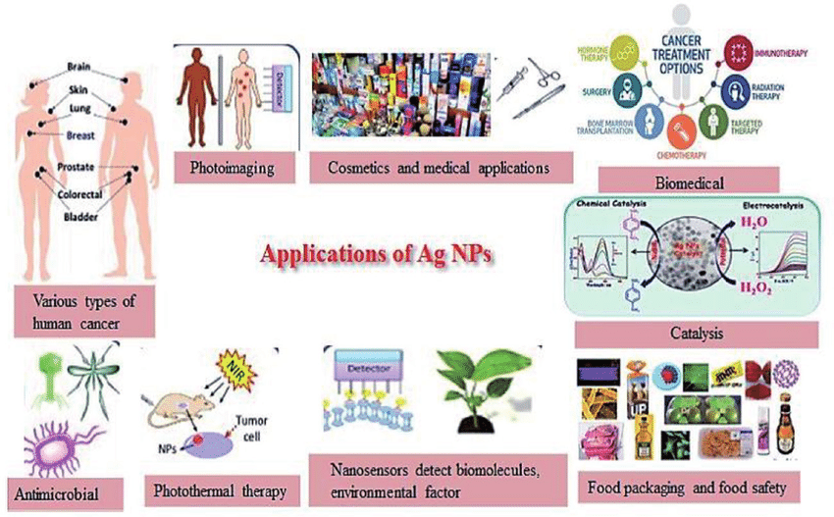

Figure:6

1. **Advantages of silver nanoparticles**

Excellent antimicrobial and [catalytic properties](https://www.sciencedirect.com/topics/engineering/catalytic-property) employing microorganisms such as fungi, bacteria, and yeast to biosynthesize these nanoparticles has begun to receive increased attention as a simpler and more eco-friendly approach to their preparation. Biosynthetically produced AgNPs demonstrate higher antibacterial activities [26]

The use of antibiotics has long been advised to treat Aeromonas infections; use of these drugs has been proven to hasten the evolution of antibiotic resistance. Likewise it has been shown that the environment and humans are severely impacted by the buildup of leftover antibiotics [13]

The World Health Organization (WHO) states that resistance to antibiotics is a serious global danger to public health [14]

1. **Disadvantages**

harmful substances and the high-energy consumption required for the preparation of silver [nanoparticles](https://www.sciencedirect.com/topics/materials-science/nanoparticle) represent disadvantages[27]

Silver nanoparticles have the ability to enter circulation through the skin, lungs, and intestines. As a result, they can end up in organs like the liver, kidney, spleen, brain, heart, and testes. This may be slight skin and eye irritation from nano silver. It has the potential to be a mild skin allergy[15]

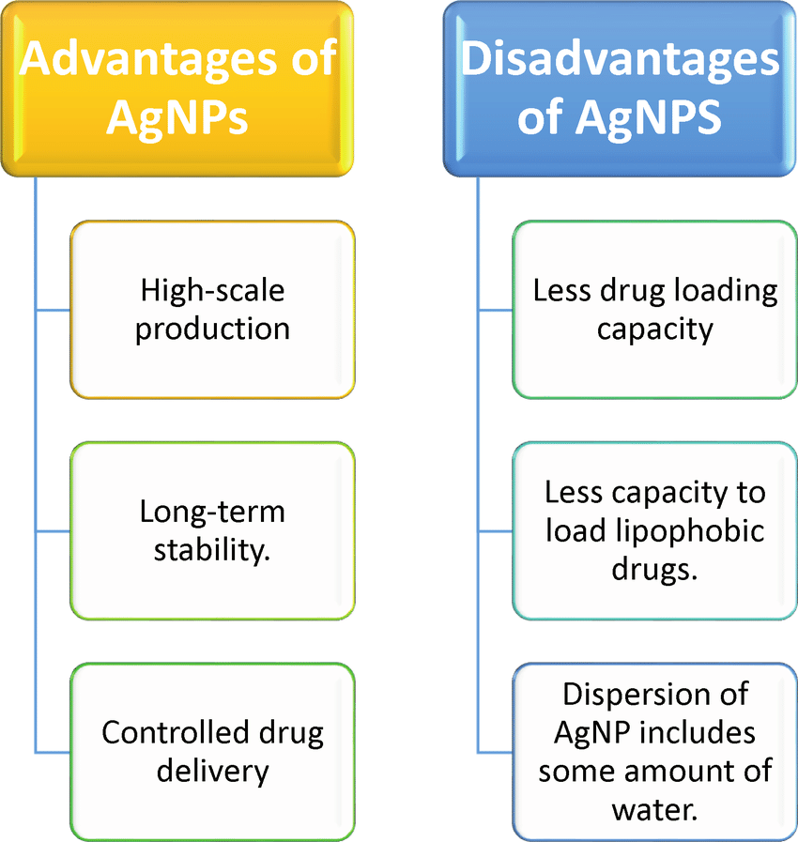

1. **Future aspects or scope of nano particles or nano chemistry**:

Further research is necessary on the development of Phyto-synthesized NP synthesis, which is an important topic. Scientists should focus on creating more efficient, stable, and ecologically appropriate agricultural variants of these nanoparticles, even if there is now a way for generating them. In order to do this, we need to look into novel concepts and approaches for improving the synthesis process in order to generate higher yields and higher-quality nanoparticles. Research into the effects of many factors, including plant species, extract amounts, and reaction conditions, on the production of nanoparticles would also be highly advantageous. By understanding these components, we can simplify the process and make sure we consistently and reliably produce these nanoparticles for use in agriculture[16]

To assess the impact of these nanoparticles on ecosystem organisms other than the core targets, such as soil health and water purity, more research is needed. By comprehending the wider ecological implications, scientists may make sure that using Phyto-synthesized NPs is compliant with sustainable agriculture practices and avoids inadvertent ecological disruptions. Addressing the issue of increasing the manufacturing of nanoparticles is also important [17]..

1. **Conclusion:**

Silver and other noble metal nanoparticles have shown strikingly different physical, chemical, and biological characteristics from their equivalents in bulk over the last few decades. Silver nanoparticle synthesis, characterization, and bio applications are the focus of this chapter, which also discusses the mechanisms underlying their antibacterial and anticancer effects. Developing silver nanoparticles is one use of green chemistry. Plant extracts are used in a variety of ways to produce silver nanoparticles as decreasing or capping agents. The synthesis of silver nanoparticles and their use in many domains are illustrated in the current chapter.

1. **REFERENCE**
2. Kholoud M M ABOU-El-Nour,ALA Eftaiha,Abdulrahman Al-Warthan,Reda A A Amar synthesis and applications of silver nanoparticles
3. Xi-Feng Zhang,Zhi-Guo Liu, Wei shen and Sangiliyandi Gurunathan .silver nano particles; synthesis ,characterization ,properties ,Application and therapeutic approaches .Int.J.Mol.science 17,volume(9),2016,1534
4. Oleksandra Pryshchepa,Pawl Pamastowksia,Bogustaw Buszewski. Advances in colloid and Interface science ,volume(284),October 2020,102246
5. M. Ganglia,*, M. Ganjalib , P. Vahdatkhahc , S. M. B. Maras hid, Synthesis of Ni Nanoparticles by Pulsed Laser Ablation Method in Liquid Phase, Science Direct, Precede Materials Science 11 ( 2015 ) 359 – 363 (7)
6. S.Iravan ,H Korbekandi, Mirmohammadi and B.Zolfaghari. Synthesis of silver nano particles, chemical, physical and biological method. Res Pharma Sci , volume 9,6, November-December 2024
7. Willey B, Sun Y, Mayer’s B ,Xi Y. Shape controlled synthesis of metal nanoparticles the case of silver. Chemistry Eur J 2005;11:454-463
8. Evanoff, Chumanov , G. Size-controlled synthesis of nanoparticles. 2 Measurement of extinction scattering and absorption cross section. J Physchem B. 2004;108:13957-13962
9. (Choy, Yusuf, Hatter, [Sun et al., 2000](https://www.sciencedirect.com/science/article/pii/S1878535210000377#bib111), Vetches, [Yeo et al., 2003](https://www.sciencedirect.com/science/article/pii/S1878535210000377#bib128), [Zhang et al., 2004](https://www.sciencedirect.com/science/article/pii/S1878535210000377#bib130), [Zhang et al., 2006](https://www.sciencedirect.com/science/article/pii/S1878535210000377#bib131), [Chimentao et al., 2004](https://www.sciencedirect.com/science/article/pii/S1878535210000377#bib18), [He et al., 2004](https://www.sciencedirect.com/science/article/pii/S1878535210000377#bib40), [Khomutov and Gubin, 2002](https://www.sciencedirect.com/science/article/pii/S1878535210000377#bib61)). (8)

## Kholoud M.M. Abou El-Nour , Ala’a Eftaiha , Abdulrhman Al-Warthan b, Reda A.A. Ammar , Synthesis and applications of silver nanoparticles, [Arabian Journal of Chemistry](https://www.sciencedirect.com/journal/arabian-journal-of-chemistry), [Volume 3, Issue 3](https://www.sciencedirect.com/journal/arabian-journal-of-chemistry/vol/3/issue/3), July 2010, Pages 135-140 (9)

1. Alexandra-Cristiana Burdusel, Oana Gherasim, Alexandra mi hay Grumezescu, Laurentiu, Mongo anta fascia, and on and Eucaterina Andronicus. Biomedical Application of silver nanoparticles : An up-to-date overview. Nanomaterial, volume (8) ,9, 2018, 681
2. Aswathy Ravindran, Preethy chandran, S. Sudheer Khan. Bioinformatics silver nanoparticles: Advance and Prospects. Collaidal and surface B: Biointerface. Volume 105, 1, may 2013, 342-352
3. Khwaja, Salahuddin Siddiqi and Azamal Husen, Fabrication of metal nanoparticles from fungi and metal salts: scope and applications. Nano scale research  letter, volume (11), 24 february 2016, 98
4. Soumya Das, R. Aswani, Sebastin Jose Midhun, E.K. Radhakrishnan, Jyothis Mathew. Advantages of zinc oxide nanoparticles over silver nanoparticles for the management of Aeromonas Veronii infection in Xi phosphorous hellerii. Microbial Pathogenesis, volume (147), October 2020,104348
5. Porous Polymers as carrier for siver nanoparticles and nanoclusters : Advantages of compartmentalization for antimicrobial usage. Biomacromolecules 2023,24,12,5905-5914
6. AnnaMaria Swidwinska-Gajewska, Slawomir CZerczak. Nanosilver-harmfull effects of biological activity. National Center For BiotechnologyIinformation,2024;65 (6):831-45.
7. Samari, F. Baluchi, L. Salehipoor, H. Yousefinejad, S.Controlled photosynthesis of cupric oxide nanoparticles by aqueous extract of capparis spinosa (capper) leaves and application in iron sensing. Micro chem. J. 2019,150,104158.
8. Javed, B.Nadhman, A.Optimization, characterization and antimicrobial activity of silver nanoparticles against plant bacterial pathogens phyto-synthesized by Mentha longifolia mater Res. Express 2020,7,085406
9. Fang, J. Zhang C MUR. The study of deposited silver particulate films. Simple method for efficient SERS. Chem Phys Letter, 2005;401;271-275
10. Srinivasulu B, Prakasham RS. Jetty A, et al, Neomycin production with free and immobilized cells of streptomycin marinensis in an airlift reactor process. Biochemistry 2002;38;593-598
11. Song KC, Lee SM. Park TS, et al, Preparation of colloidal silver nanoparticles. Chemistry reduction method. Korean J Chemistry Eng. 2009;26;153-155
12. Myungjoon Kim, Saho Osone, Taesung Kim, Hidenori Higashi, Takafumi Seto. KONA Powder and particle Journal ,volume(34) 2017,80-90
13. N.G.Semaltianos, Nanoparticles. Laser Ablation, Critical Review In Solid State And Material Science. Volume 35,2010,105-124
14. Chichkov, B.N., Momma, C.Nolte, S.Von Alvensleben, F. and Tunnermann. Femtosecond Picosecond and Nanosecond Laser Ablation of Solid. Volume(63),1996,109-115
15. Naomi Sakono, Yuto Ishida,Kazuki Ogo, Nobuko Tsumori, Haruno Murayama and Masafumi Sakono. Mola-Fraction-Tunable Synthesis of Ag-Au Alloy Nanoparticles via a Dual Evaporation-Condensation Method as Supported Catalyst for Co Oxidation. Nano Mater.2023,6,4,3065-3074
16. [Xi-Feng Zhang](https://pubmed.ncbi.nlm.nih.gov/?term=Zhang%20XF%5BAuthor%5D), [Zhi-Guo Liu](https://pubmed.ncbi.nlm.nih.gov/?term=Liu%20ZG%5BAuthor%5D), [Wei Shen](https://pubmed.ncbi.nlm.nih.gov/?term=Shen%20W%5BAuthor%5D), and [Sangiliyandi Gurunathan](https://pubmed.ncbi.nlm.nih.gov/?term=Gurunathan%20S%5BAuthor%5D) Silver Nanoparticles: Synthesis, Characterization, Properties, Applications, and Therapeutic Approaches [Int J Mol Sci.](https://www.ncbi.nlm.nih.gov/pmc/articles/PMC5037809/) 2016 Sep; 17(9): 1534.
17. Xixi Zhao, Xiaoguang Xu, Chongyang Ai, Lu Yan, Chunmei Jiang, Junling Shi, Chapter 22 - Advantages of silver nanoparticles synthesized by microorganisms in antibacterial activity, [Green Synthesis of Silver Nanomaterials](https://www.sciencedirect.com/science/book/9780128245088) Nanobiotechnology for Plant Protection, 2022, Pages 571-586
18. Xixi Zhao, Xiaoguang Xu, Chongyang Ai, Lu Yan, Chunmei Jiang, Junling Shi, Chapter 22 - Advantages of silver nanoparticles synthesized by microorganisms in antibacterial activity, [Green Synthesis of Silver Nanomaterials](https://www.sciencedirect.com/science/book/9780128245088) Nanobiotechnology for Plant Protection, 2022, Pages 571-586