**SOLAR POWERED DYNAMIC WIRELESS ELECTRIC VEHICLE CHARGING SYSTEM USING INDUCTIVE POWER TRANSFER TECHNOLOGY**

**Mr. Kunal Shirke1, Mr. Aditya Chavan2, Mr. Samarth Dyandyan3, Mr. Sagar D. Dhawale4**

*1.2.3Student, Department of Electronics and Telecommunications, Ajeenkya DY Patil School of Engineering, Lohegaon, Pune*

*4 Assistant Professor, Department of Electronics and Telecommunication, Ajeenkya DY Patil School of Engineering, Lohegaon, Pune*

**Abstract:** With growing environmental concerns and the need for sustainable solutions in urban transport, electric vehicles (EVs) are becoming a more popular and eco-friendly alternative to traditional fuel-powered cars. However, the adoption of EVs is still limited by challenges like range anxiety—drivers’ concerns about running out of battery power on longer trips—and a lack of accessible charging stations, especially in cities. Addressing these issues requires innovative approaches that make EVs more convenient for everyday use while also supporting clean energy sources. This project proposes a solar-powered dynamic wireless charging (DWC)system for electric vehicles, using inductive power transfer (IPT) technology embedded in road infrastructure. The system enables EVs to charge continuously while driving, reducing range anxiety and improving charging accessibility by eliminating the need for frequent stops. By utilizing solar energy, this solution lessens the dependence on conventional power sources, promoting EV adoption as part of a greener transportation network. Working in collaboration with urban planners and engineers, the project aims to integrate this charging system directly into city roads, turning them into dynamic charging networks and contributing to reduced greenhouse gas emissions. This initiative envisions a future where electric vehicles can recharge seamlessly during travel, supporting a more sustainable and efficient urban mobility system.

**Key word:** Electric Vehicles (EVs), Dynamic Wireless Charging (DWC), Inductive Power Transfer (IPT), Wireless Power transfer (WPT).

**I. INTRODUCTION**

Large scale deployment of Internal Combustion Engine (ICE) based vehicles in transport system lead to the release of harmful fumes into an atmosphere lead to global warming and climate change, which is main concern of global community Therefore, to lessen dependence on fossil fuel based energy sources and to reduce its harmful impacts on the atmosphere, there is a need for alternative solutions such as EVs charged on renewable energy sources [1]. Renewable energy generation and Electric Vehicles (EVs) have been widely used in recent decades due to the pressing concerns about climate change, air pollution, and energy security [7]. Wireless charging is a technology that allows devices to be charged without a physical connection using electromagnetic induction. Wireless Charging System (WCS) is working on the theory of Mutual induction is a phenomenon introduced by Sir Nikola Tesla in 1887 where an induced emf is caused in the second coil known as receiver coil can create electrical energy with a given current in the first coil known as transmitter coil [8].

This technology is also expanding beyond consumer electronics. In the automotive industry, wireless charging is being developed for electric vehicles (EVs), enabling drivers to charge their cars by parking over special charging pads embedded in the ground. This eliminates the need for plugging in cables, making the process more convenient and user-friendly. Other sectors, like healthcare, benefit from wireless charging as well, with medical implants and devices using it to avoid the need for wires, which could introduce risks or be impractical in certain environments.

The DWC system is an in-motion charging system for EVs. The transmitter track contains multiple transmitter pads that are positioned along the roadside. The receiver pad is positioned under the vehicle with an allowable ground clearance level. The main components of the DWC system are Charging pads (Ground-side transmitter pad and vehicle-side receiver pad), a Compensation network, and Power Modulators to control the input and output power [5].

**II.AIM**

* To design and develop the wireless charging system which uses inductive charging technology. To reduce the time taken for charging the electric vehicles.
* The aim of the project is to design and develop a solar-powered wireless electric vehicle charging system using inductive charging technology. This system will be integrated into road infrastructure to enable continuous, on-the-move charging of electric vehicles, harnessing solar energy to enhance sustainability, reduce reliance on conventional power sources, and promote the widespread adoption of electric vehicles.

**III. PROPOSED SYSTEM**

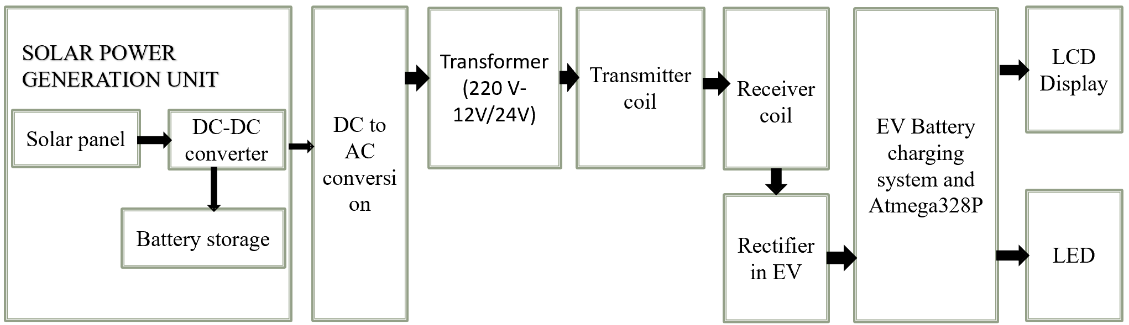

**Fig.1** Block Diagram of Solar Powered Dynamic Wireless Electric Vehicle Charging System Using Inductive Power Transfer Technology

**Power Generation and Conversion**: Solar panels generate DC power, which is regulated through a DC-DC converter and stored in batteries. This DC power is then converted to AC, stepped down by a transformer (e.g., from 220V to 12V/24V) for transmission.

**Wireless Power Transfer**: The AC power is transferred from a transmitter coil (on the road infrastructure) to a receiver coil (in the EV) using inductive coupling. The received AC power is then rectified back to DC for charging the EV's battery.

**Charging Management**: The Atmega328P microcontroller in the EV manages the charging status and displays information on an LCD. LEDs indicate charging status: a red LED lights up when charging, and a green LED when fully charged [11].

**IV. WORKING PRINCIPLE**

Is battery full ?

Glow red LED

Charge battery using solat panel

Convert DC to AC

AC power fed to transforemer

Detect receiver coil ?

Initialize wireless charging

Rectifier convert AC to DC power

Glow red LED

Display voltage in LCD

NO

YES

YES

NO

Glow green LED

**Fig.2** Operational Flowchart Of The System [11].

The flowchart explains the operational principle of a solar-powered dynamic wireless electric vehicle (EV) charging system. Firstly, the system initiates by charging a battery using solar power collected through a solar panel. The DC power generated is converted to AC, which is then stepped down by a transformer to the required voltage level for transmission. Next, the system checks for the presence of a receiver coil in the EV. If the receiver coil is detected, wireless charging begins. The AC power received by the coil is converted back to DC through a rectifier for charging the EV’s battery. The system then continuously monitors the battery’s charge level. If the battery is not fully charged, a red LED glows to indicate the charging process is active. Once the battery reaches full capacity, the red LED turns off, and a green LED lights up, signaling that the battery is fully charged. Additionally, the voltage level is displayed on an LCD, providing real-time feedback to the user on the battery status. This operational cycle ensures efficient, wireless charging of the EV battery using renewable solar energy [11].

**V. METHODOLOGY**

The methodology for a solar-powered dynamic wireless EV charging system begins with solar panels generating DC power, which is regulated through a DC-DC converter and stored in a battery. This DC power is converted to AC using an inverter, then stepped down by a transformer to a suitable voltage for transmission through a transmitter coil. When an EV’s receiver coil is detected, wireless charging is initiated. The receiver coil in the EV captures the AC magnetic field, which is then rectified back to DC for battery charging. A microcontroller (e.g., Atmega328P) manages the charging process, activating a red LED during charging and switching to a green LED once the battery is full. The voltage and charging status are displayed on an LCD screen for real-time monitoring. System testing and optimization are conducted to enhance efficiency, and routine maintenance ensures reliable operation and safety. This methodology supports sustainable EV charging by using renewable solar energy and wireless inductive power transfer technology [11].

1.The method we are using has different sensors and different technology such as various sensors:

Solar panel battery

Voltage sensor transformer

Atmega328 P 16x2 LCD Display

**Components Information:**

1. **Hardware Requirements**

**SOLAR PANEL:**

A solar panel is a device that converts sunlight into electrical energy through the photovoltaic effect, utilizing semiconductor materials, typically silicon, to absorb photons and generate direct current (DC) electricity. Solar panels are composed of multiple solar cells interconnected in a module, which can vary in size and capacity. They are commonly used in residential, commercial, and utility-scale applications to provide clean, renewable energy for electricity generation, heating, and powering various devices. Solar panels are environmentally friendly, reducing reliance on fossil fuels and contributing to a decrease in greenhouse gas emissions, making them a vital component of sustainable energy solutions.

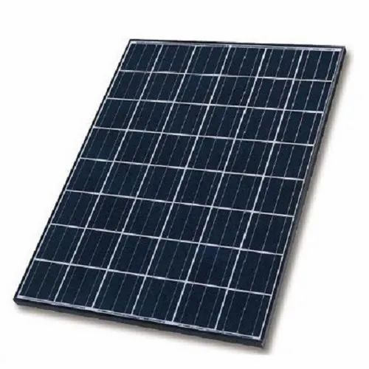

**Fig 3.1** Solar panel

**VOLTAGE SENSOR:**

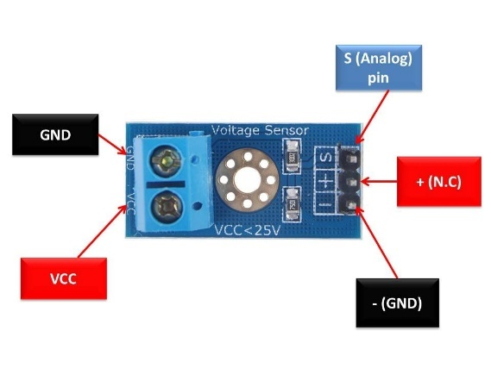A voltage sensor is a device that measures the electrical potential difference between two points in a circuit and outputs either an analog or digital signal for real-time monitoring. It is used in various applications such as battery management systems, power supply monitoring, and renewable energy setups to ensure devices operate within safe voltage levels, protecting them from overvoltage or undervoltage conditions. By continuously tracking voltage, it enhances system safety, performance, and efficiency.

**Fig 3.2** Voltage sensor

## 16x2 LCD Display:

A 16x2 LCD display is a popular text-based module that can show up to 16 characters per line across two lines, allowing a total of 32 characters. It uses liquid crystals to control light and display characters through a 5x8 or 5x10 pixel matrix for each character. The display often interfaces with microcontrollers via parallel (multiple data lines) or I2C (two lines: SDA and SCL) communication. It typically has an LED backlight for visibility in low-light conditions and operates at 5V DC. Standard control pins include RS (register select), RW (read/write), E (enable), data pins (D0-D7), and a contrast control (V0).

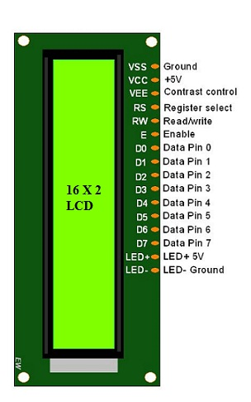

**Fig 3.3** 16x2 LCD Display

**STEP DOWN TRANSFORMER:**

A Transformer is a static apparatus, with no moving parts, which transforms electrical power from one circuit to another with changes in voltage and current and no change in frequency. There are two types of transformers classified by their function: Step up Transformer and Step-down Transformer.

A Step-up Transformer is a device which converts the low primary voltage to a high secondary voltage i.e., it steps up the input voltage. A Step-down Transformer on the other hand, steps down the input voltage i.e., the secondary voltage is less than the primary voltage. Schematic diagram of transformer is shown in figure 4.3 below.

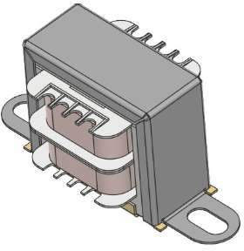

**Fig 3.4** Step Down Transformer

**ATMEGA328P:**

ATMEGA328Pis high performance, low power controller from Microchip. ATMEGA328P is an 8-bit microcontroller based on AVR RISC architecture. It is the most popular of all AVR controllers as it is used in ARDUINO boards. Figure 4.1 shows the package of ATmega328P

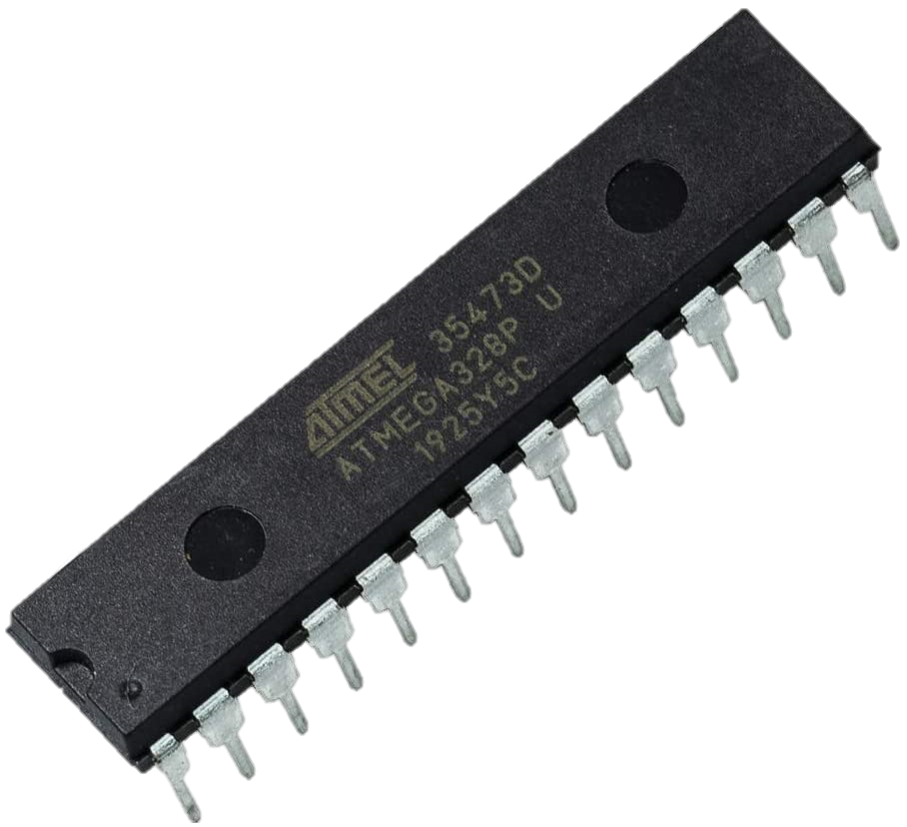

**Fig 3.5** ATMEGA328P

**BATTERY:**

A **lithium-ion battery** is a rechargeable energy storage device with high energy density, long life cycle, and efficient charging capabilities, making it ideal for solar energy systems. It operates by transferring lithium ions between electrodes during charging and discharging, providing lightweight energy storage with minimal self-discharge. These batteries are widely used for renewable energy applications due to their compact size and ability to store large amounts of energy. Lithium-ion batteries also offer faster charging and higher energy efficiency compared to other types like lead-acid. To ensure safety and optimize performance, they are often equipped with advanced battery management systems (BMS) that regulate voltage, temperature, and state of charge.

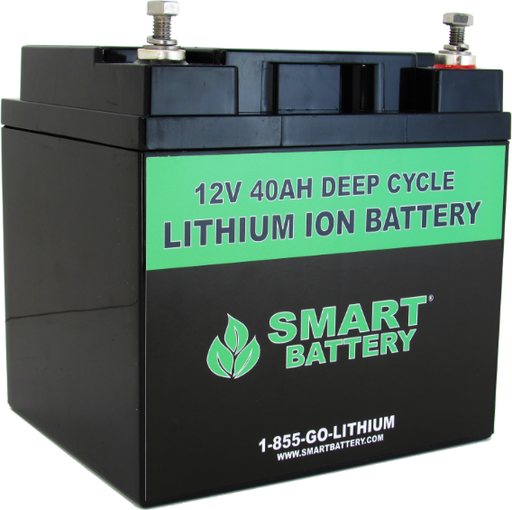

**Fig 3.6** Battery

**Transmitter and Receiver coil:**

In a wireless charging system, the transmission coil generates an alternating magnetic field when powered by AC current, and this magnetic field is used to transfer energy wirelessly. The receiver coil, mounted on the electric vehicle, captures this magnetic field and induces a current to charge the vehicle’s battery. Both coils are tuned to the same resonant frequency to ensure efficient power transfer through inductive coupling, enabling seamless wireless energy transmission, especially in dynamic charging setups for electric vehicles.



**Fig 3.7** Transmitter and Receiver coil

## LEDs :

A **Light Emitting Diode (LED)** is a semiconductor device that emits light when an electric current passes through it. Unlike traditional incandescent bulbs, LEDs are highly efficient, converting most of the electrical energy into light with minimal heat generation. LEDs come in various colors, depending on the material and design, and are widely used in a range of applications, including display screens, indicator lights, and general lighting. They are known for their long lifespan, energy efficiency, and durability, making them a popular choice for both commercial and residential use. LEDs are also available in different forms, including single LEDs, LED strips, and high-power LEDs, making them versatile for various lighting solutions.

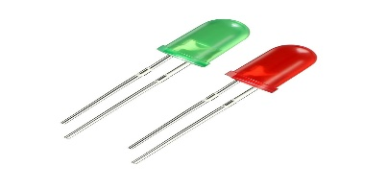

**Fig 3.8** LEDs

**2.Software Requirements:**

**Raspbian OS:**

**Fig 3.9** Raspbian OS

Raspbian is a Debian-based PC working gadget for Raspberry Pi. There are quite a few variations of Raspbian which includes Raspbian Stretch and Raspbian Jessie. It has been formally provided by way of the Raspberry Pi Foundation as the foremost operating machine for the family of Raspberry Pi single-board computers. Raspbian was once created by using Mike Thompson and Peter Green as an impartial project. Raspbian is exceedingly optimized for the Raspberry Pi line's low performance ARM CPUs. Raspbian makes use of PIXEL, Pi Improved X home windows Environment, Lightweight as its essential computing device surroundings as of the state-of-the-art update. The scripts and documents created are run on the Raspbian OS.

**VI. ACKNOWLEDGEMENT**

First of all, we would like to thank the Head of Electronics & Telecommunication Engineering Department, to give us the opportunity to work on the proposed system. We wish to express our sincere gratitude to our guide for his kind guidance and valuable suggestions without which this proposed work would not have been taken up. We sincerely acknowledge the encouragement, timely help and guidance given to us by our beloved Guide to carry out this proposed work within the stipulated time successfully.

**REFERENCES**

1. A. Mahesh, B. Chokkalingam and L. Mihet-Popa, "Inductive Wireless Power Transfer Charging for Electric Vehicles–A Review," in IEEE Access, vol. 9, pp. 137667-137713, 2021, doi: 10.1109/ACCESS.2021.3116678.
2. N. Mohamed et al., "A Comprehensive Analysis of Wireless Charging Systems for Electric Vehicles," in IEEE Access, vol. 10, pp. 43865-43881, 2022, doi: 10.1109/ACCESS.2022.3168727.
3. V. Ramakrishnan et al., "A Comprehensive Review on Efficiency Enhancement of Wireless Charging System for the Electric Vehicles Applications," in IEEE Access, vol. 12, pp. 46967-46994, 2024, doi: 10.1109/ACCESS.2024.3378303.
4. I. Casaucao Tenllado, A. Triviño Cabrera and Z. Lin, "Simultaneous Wireless Power and Data Transfer for Electric Vehicle Charging: A Review," in IEEE Transactions on Transportation Electrification, vol. 10, no. 2, pp. 4542-4570, June 2024, doi: 10.1109/TTE.2023.3309505.
5. Y. Shanmugam et al., "A Systematic Review of Dynamic Wireless Charging System for Electric Transportation," in IEEE Access, vol. 10, pp. 133617-133642, 2022, doi: 10.1109/ACCESS.2022.3227217.
6. J. Rahulkumar. et al., "An Empirical Survey on Wireless Inductive Power Pad and Resonant Magnetic Field Coupling for In-Motion EV Charging System," in IEEE Access, vol. 11, pp. 4660-4693, 2023, doi: 10.1109/ACCESS.2022.3232852.
7. X. Mou, Y. Zhang, J. Jiang and H. Sun, "Achieving Low Carbon Emission for Dynamically Charging Electric Vehicles Through Renewable Energy Integration," in IEEE Access, vol. 7, pp. 118876-118888, 2019, doi: 10.1109/ACCESS.2019.2936935.
8. M. R. R. Razu et al., "Wireless Charging of Electric Vehicle While Driving," in IEEE Access, vol. 9, pp. 157973-157983, 2021, doi: 10.1109/ACCESS.2021.3130099.
9. A. Triviño, J. Sánchez and A. Delgado, "Efficient Methodology of the Coil Design for a Dynamic Wireless Charger," in IEEE Access, vol. 10, pp. 83368-83378, 2022, doi: 10.1109/ACCESS.2022.3196023.
10. A. Sagar et al., "A Comprehensive Review of the Recent Development of Wireless Power Transfer Technologies for Electric Vehicle Charging Systems," in IEEE Access, vol. 11, pp. 83703-83751, 2023, doi: 10.1109/ACCESS.2023.3300475.
11. K. Kumar, Z. S. L. Albulushi, and A. . Shil, “Solar Wireless EV Charging System”, *J Stud Res*, May 2023.