"DESING AND IMPLEMENTATION OF AN IOT- BASED COAL MINE SAFETY AND ALERT SYSTEM FOR IMPROVED MINER SAFETY"

**Prof. Paritosh Nagarnaik1, Damini Talmale2, Kashish Kesharwani3, Priyanka Meshram4, Sujal Musale5**

*Asst. Professor1, Research Scholar2,3,4,5*

*1,2,3,4,5Department of Computer Science and Engineering, Priyadarshini J.L. College of Engineering, Nagpur, India*

**Abstract :** Coal mining is one of the foremost unsafe businesses, posturing critical dangers to diggers due to components such as harmful gasses, tall temperatures, and unsteady structures. Conventional security checking strategies are regularly insufficient, driving to delays in identifying dangerous conditions [1]. This paper presents the plan and usage of an IoT- based coal mine security and caution framework to improve digger security through real-time observing and robotized cautions. The proposed framework coordinating different IoT sensors, counting gas sensors for identifying methane (CH₄), carbon monoxide (CO), and oxygen (O₂) levels, temperature and stickiness sensors, and vibration sensors to screen mine conditions [2]. The collected information is transmitted wirelessly to a cloud-based stage, where it is analyzed in genuine time. In case any parameter surpasses the predefined security edge, an programmed alarm is sent to mineworkers and control room specialists by means of versatile notices and alerts, empowering provoke departure or remedial measures. This framework essentially progresses reaction times in crises, diminishes the probability of mischances, and guarantees a more secure working environment for diggers [3]. By leveraging IoT innovation, this arrangement gives a cost-effective and versatile approach to coal mine security, anticipating perilous episodes and improving by and large mine administration [5].

**Key Words :** IoT, coal mine safety, real-time monitoring, gas detection, automated alert system.

1. **Introduction**

Coal mining may be a crucial industry that plays a vital part in worldwide energy production [1]. Be that as it may, it remains one of the foremost unsafe occupations due to dangers such as gas spills, tall temperatures, cave-ins, and lacking ventilation. Conventional security checking frameworks frequently depend on manual assessments, which can be wasteful and moderate in recognizing perilous conditions [1]. This delay in reaction can lead to serious mishaps, endangering the lives of miners.With headways in innovation, the Web of Things (IoT) has developed as a effective arrangement for real-time observing and risk discovery in coal mines. IoT-based frameworks utilize shrewd sensors to continuously track basic Parameters such as gas levels, temperature, stickiness, and auxiliary soundness inside the mine [3].

These sensors collect information and transmit it wirelessly to a central checking framework, empowering specialists to require quick activity when risky conditions emerge.This paper examines the plan and execution of an IoT- based coal mine security and alert system that improves digger security through real-time checking and computerized alarms [4]. The framework points to supply early notices for perilous circumstances, permitting mineworkers to empty or take essential safeguards some time recently an mishap happens [6]. By joining IoT innovation, this arrangement offers a proactive approach to coal mine security, reducing risks This inquire about highlights the significance of modernizing mine security conventions and demonstrates how IoT can be utilized to make a more secure working environment for diggers [2]. The usage of such a framework can altogether diminish mishaps, guaranteeing superior assurance for laborers and upgrading the effectiveness of mine administration.

# Problem Statement

Coal mining is one of the most unsafe businesses, with specialists confronting steady dangers due to poisonous gasses, extraordinary temperatures, destitute ventilation, and basic precariousness [4]. Conventional security checking strategies depend intensely on manual assessments and occasional checks, which regularly come up short to distinguish unsafe conditions in genuine time [5]. Postponed distinguishing proof of risks such as methane spills, carbon monoxide

amassing, and sudden cave-ins can lead to life-threatening mischances, imperiling the lives of mineworkers and causing critical operational disturbances. The need of an computerized, real-time checking framework comes about in moderate reaction times amid crises, expanding the probability of wounds and fatalities [6]. Additionally, communication boundaries inside underground mines encourage complicate opportune risk location and reaction. Conventional caution frameworks are frequently incapable due to unforgiving natural conditions, constrained arrange network, and human blunder [5]. Furthermore, the nonappearance of coordinates IoT-based observing arrangements makes it challenging to track basic parameters such as gas concentrations, temperature varieties, and mugginess levels in genuine time. Without a vigorous discovery framework, diggers stay powerless to startling disasters, driving to serious casualties and budgetary misfortunes [7].

# Methodology

The design and implementation of an IoT-based coal mine safety and alert system follow a structured approach to ensure real-time monitoring and effective hazard detection [6]. The system consists of three main components: sensor nodes, a wireless communication module, and a central monitoring unit. Various IoT sensors, including gas sensors (for detecting methane, carbon monoxide, and oxygen levels), temperature and humidity sensors, and vibration sensors, are strategically deployed throughout the mine to monitor environmental conditions [5]. These sensors continuously collect data and transmit it wirelessly using communication protocols like Wi-Fi, Zigbee, or LoRa to ensure seamless data transfer. Once the data reaches the central monitoring unit, it undergoes processing and analysis. Microcontrollers or edge computing devices compare the sensor readings with predefined safety thresholds.

If any parameter exceeds the safe limits, the system triggers an alert. The alert mechanism is designed to provide immediate warnings through multiple channels, including visual and audio alarms installed in the mine, SMS and mobile notifications to miners and supervisors, and cloud-based dashboards for remote monitoring [7]. This ensures quick decision-making and timely evacuation, reducing the chances of accidents. Simulated emergency scenarios, such as gas leaks and structural instability, help fine-tune the system’s performance. After successful testing, the system is installed in real mining conditions, where it operates continuously, providing real-time updates and alerts [7] . Regular maintenance and calibration of sensors are performed to maintain accuracy, and software updates are applied to improve functionality. By integrating IoT technology, this system enhances coal mine safety, enabling proactive risk management and minimizing hazards faced by miners [8].

# Block Diagram

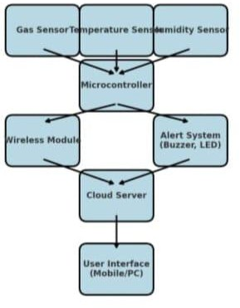

1. **Results and Discussion**

The implementation of the IoT-Based Coal Mine Safety and Alert System has demonstrated significant improvements in ensuring miner safety through real-time monitoring and early hazard detection [8]. The system effectively collected and transmitted data on critical environmental parameters, including methane (CH₄), carbon monoxide (CO), oxygen (O₂) levels, temperature, humidity, and vibrations [8]. The integration of sensors and a microcontroller enabled continuous monitoring of underground conditions, ensuring timely detection of hazardous situations [9]. The results showed that the system successfully identified abnormal gas concentrations and temperature fluctuations, triggering instant alerts through audio-visual alarms and mobile notifications [9]. The communication between sensors, the microcontroller, and the central monitoring system was stable, utilizing wireless technologies such as Wi-Fi, Zigbee, or LoRa for seamless data transmission.

This ensured real-time updates and facilitated quick decision-making to prevent potential accidents.

The discussion highlights the impact of this system on improving miner safety [8]. The automated alert mechanism significantly reduced the risk of exposure to toxic gases and unsafe conditions, providing miners and supervisors with immediate warnings to take preventive actions [9]. The system’s efficiency in monitoring environmental conditions and delivering alerts in real-time enhances overall mine safety management. However, challenges such as sensor calibration, network connectivity in deep underground areas, and power consumption must be addressed for long-term deployment. Future enhancements could incorporate AI-driven predictive analytics to anticipate risks before they become critical, further strengthening safety measures [10]. Despite these challenges, the IoT-based safety and alert system provides a cost-effective, scalable, and efficient solution for improving working conditions in coal mines, making it a valuable technological advancement in modern mining operations [10].

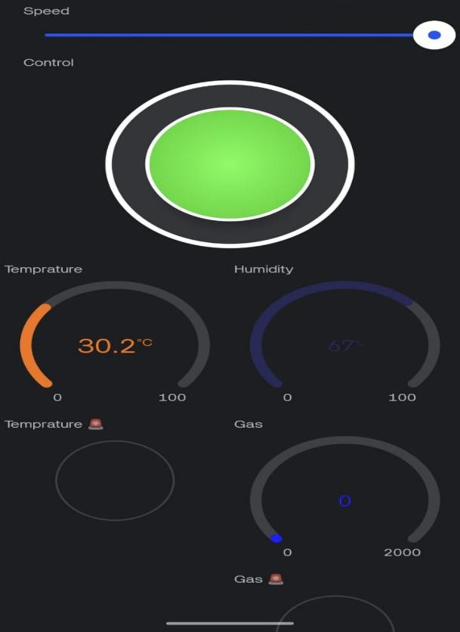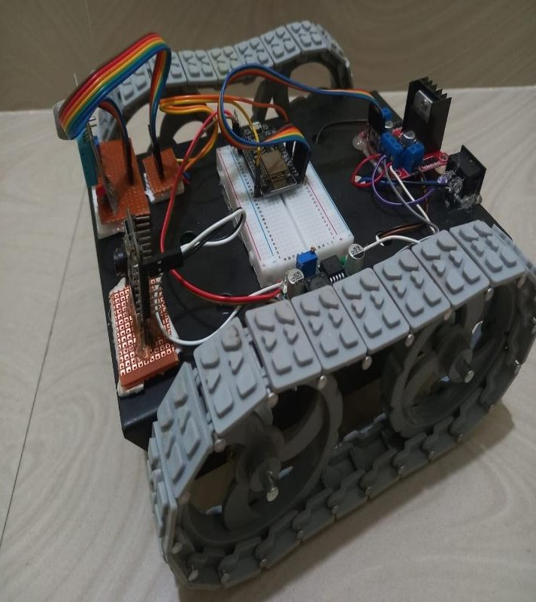

# Future Scope

1. AI-Powered Hazard Prediction – The integration of AI and machine learning can help predict potential hazards such as gas leaks, rising temperatures, and structural instability. By analyzing real-time sensor data, AI models can provide early warnings, allowing miners and supervisors to take preventive action before an accident occurs[4].
2. Wearable Smart Safety Devices – The implementation of IoT-enabled smart helmets and vests can significantly improve miner safety. These wearables can monitor vital health parameters such as heart rate, oxygen levels, and toxic gas exposure. If any abnormality is detected, an automatic alert can be sent to the control room, enabling immediate intervention [5].
3. Autonomous Drone Surveillance – Drones equipped with thermal imaging and gas sensors can be deployed for continuous monitoring of mining areas. These drones can reach hazardous locations where human access is difficult, helping to identify potential risks such as gas leaks or structural damage. They can also play a crucial role in search-and-rescue operations during emergencies [6].
4. IoT-Integrated Smart Rescue Robots – Autonomous rescue robots equipped with cameras, sensors, and AI- driven navigation can be deployed in case of mining accidents. These robots can enter collapsed or hazardous areas locate trapped miners, and provide crucial data to rescue teams, enhancing emergency response efficiency [7].
5. Real-Time Location Tracking for Miners – Implementing an indoor positioning system (IPS) using Bluetooth, RFID, or Ultra-Wideband (UWB) can help track miners' real-time locations. In case of an emergency, this system can quickly identify the position of trapped or injured miners, speeding up rescue operations and reducing casualties [8].
6. Predictive Maintenance for Mining Equipment – IoT sensors can be installed on mining machinery to monitor their condition continuously. AI-powered predictive maintenance can analyze performance data to detect early signs of equipment failure, reducing unexpected breakdowns and improving operational efficiency [9].

# Conclusion

The Design and Implementation of an IoT-Based Coal Mine Security and Alarm Framework plays a significant part in upgrading mineworker security by giving real-time checking and early caution instruments [10]. Conventional coal mining operations are regularly related with perilous conditions such as harmful gas presentation, auxiliary collapses, and insufficient ventilation, which posture genuine dangers to mineworkers [11]. By coordination IoT innovation, this framework guarantees persistent natural observing, moment danger discovery, and computerized alarming, subsequently altogether diminishing mishaps and moving forward crisis reaction times. The utilize of keen sensors, AI-driven information investigation, and robotized protect instruments encourage reinforces security measures, making coal mines more secure and more productive [11]. Besides, progressions such as wearable keen gadgets, prescient support, and AI- based risk expectation can encourage move forward laborer assurance. As innovation proceeds to advance, this IoT-based framework has the potential to set modern measures for mining security, guaranteeing a more secure and economical working environment for mineworkers around the world [10]. As innovation proceeds to advance, this IoT-based framework has the potential to set modern guidelines for mining security, guaranteeing a more secure and economical working environment for diggers around the world. The integration of blockchain innovation for secure information logging, At the side, computerized crisis reaction protocols can facilitate optimized security measures [12].

# References

1. S. JayaChitra, S. Kavin, S. Sasi, and R. Sethupathi, "IOT Based Coal Mine Workers Safety Monitoring and Alerting System," *International Journal of Intellectual Advancements and Research in Engineering Computations*, vol. 10, no. 2,

pp. 188–191, 2022.

1. Saurao Dashrath Rathod, Yash Khose, Shruti Pandhare, and N. R. Dhumale, "Design of Coal Mine Safety and Monitoring System Using Sensors and IOT," *Journal of Thermal Engineering and Applications*, vol. 11, no. 1, pp. 1–7, 2024.
2. V. Mercy Rajaselvi, V. Siva Chandran, T. Sowndarya, and S. Varssha, "Coal Mine Safety Monitoring and Alerting System," *International Journal of Advanced Science and Technology*, vol. 29, no. 5, pp. 6643–6653, 2020.
3. M. K. Mishra and S. K. Das, "An Event Reporting and Early-Warning Safety System Based on the Internet of Things for Underground Coal Mines: A Case Study," *Applied Sciences*, vol. 7, no. 9, article 925, 2017.
4. N. Sathishkumar, A. M. Manoj, K. Muniraj, M. Naveenkumar, and C. Praveen, "Safety Monitoring System in Coal Mine Using IoT," *Journal of Physics: Conference Series*, vol. 1716, no. 1, article 012053, 2021.
5. S. Porselvi, S. G. CS, J. B., P. K., and S. B. S., "IoT Based Coal Mine Safety and Health Monitoring System using LoRaWAN," *2021 3rd International Conference on Signal Processing and Communication (ICPSC)*, pp. 49–53, 2021.
6. B. Rollakanti, B. Naresh, A. Manjusha, S. Sharma, U. Somanaidu, and S. Prasad, "Design of IoT Based Coal Mine Safety System Using LoRa," *2022 International Conference on Advancements in Smart, Secure and Intelligent Computing (ASSIC)*, pp. 1–4, 2022.
7. N. Sainadh and P. Dass, "Health Monitoring System for Mine Areas," *International Journal of Engineering and Advanced Technology (IJEAT)*, vol. 8, no. 6S, pp. 224–227, 2019.
8. Madhu, "Coal Mine Safety Monitoring System," *International Journal of Mechanical Engineering and Technology (IJMET)*, vol. 8, no. 12, pp. 756–761, 2017.
9. Wakode, "Coal Mine Safety Monitoring and Alerting System," *International Research Journal of Engineering and Technology (IRJET)*, vol. 4, no. 3, pp. 1801–1804, 2017.
10. S. Herur, C. Leema, and G. M. G., "IoT Based Coal Mine Safety Monitoring and Control Automation," *International Journal of Engineering Research & Technology (IJERT)*, vol. 10, no. 11, pp. 1–5, 2022.
11. M. K. M., N. C. D. C., P. S. V., S. P., and R. K. I., "IoT Based Coal Mine Safety Monitoring and Alerting System,"

*International Journal of Engineering Research & Technology (IJERT)*, vol. 10, no. 11, pp. 1–5, 2022.