**IOT-BASED POWER THEFT DETECTOR**

1. **Edigi Madhuri,** *B. tech, Department of Information Technology,*

***CMR Engineering College,*** *Hyderabad*

1. **Derangula Sushanth,** *B. tech, Department of Information Technology****,***

***CMR Engineering College,*** *Hyderabad*

1. **Duddela Narsimha Reddy*,*** *B. tech, Department of Information Technology,*

***CMR Engineering College,*** *Hyderabad*

1. **Kasnagari Vinay Kumar*,*** *B. tech, Department of Information Technology,*

***CMR Engineering College,*** *Hyderabad*

1. **Mrs. G.Swetha***, Assistant Professor , Department of Information Technology,*

***CMR Engineering College,*** *Hyderabad*

**Abstract—** Today energy theft or energy meter tampering is the worldwide problem that contributes heavily to revenue losses. Consumers have been finding new methods to manipulate their electric meters. In any way their intention is to stop working energy meters and at the same time they are enjoying free power. The most common method is by passing the meter by shorting input & output terminals and using power without paying for it. Power theft through energy meter tampering is one of the major causes of revenue losses. In this method of tampering to bypass the meter, one must remove the terminal block top cover where input and output terminals are connected. After removing the top cover, a person uses to short input and output terminal through a piece of wire. We are not shorting terminals, but using an IR sensor network arranged inside the top cover, automatically supply to the house will be automatically disconnected and the alarm will be energized. Once the supply is disconnected, automatically power theft information will be transmitted to the concerned mobile phone through the WiFi module. Whenever the top cover is removed, power will be disconnected through relay and power will not resume until the reset key is activated, in practical this reset key must be arranged inside the meter somewhere in a secret place such that it will not be accessible to the energy user. For demo purposes, it is arranged outside for easy accessible. In this project work an electronic energy meter is used which generates pulses according to the load applied to it, therefore energy consumption information also will be displayed through an LCD interfaced with main processing unit designed with an 89C52 microcontroller chip.

**Keywords—** **internet of Things (IoT), Smart energy meter, IR sensor network, Power theft alarm, WiFi module communication, 89C52 microcontroller, LCD interface**

**INTRODUCTION**

Energy theft and tampering with energy meters pose a significant challenge globally, resulting in substantial financial losses for power distribution companies and utilities. This issue has persisted for decades, as consumers discover innovative ways to manipulate energy meters to evade payment. The bypassing of energy meters, particularly through tampering with input and output terminals, is one of the most prevalent methods employed to steal electricity. Such practices not only disrupt revenue collection but also compromise the integrity of power distribution systems. To address this pressing issue, innovative solutions that combine sensor technology and automated response mechanisms are critical. This project introduces a novel approach to combating energy theft by integrating an **Infrared (IR) sensor network** with an energy meter's terminal block cover. The system detects unauthorized access or tampering attempts by monitoring the removal of the terminal block cover. Upon detection, it takes immediate action to prevent theft by disconnecting the power supply using a relay mechanism and triggering an alarm. Additionally, the system is equipped with a **Wi-Fi communication module** to notify relevant authorities via mobile alerts about the tampering attempt. The supply remains disconnected until a secure reset mechanism is activated, ensuring no unauthorized reconnection. For enhanced user interaction, an **LCD display** is interfaced with the 89C52 microcontroller to provide real-time energy consumption data, making the system both theft-resistant and user-informative. This automated, intelligent design not only detects energy theft but also ensures accountability and efficiency in energy distribution, offering a practical and scalable solution to a widespread problem.

**OBJECTIVE**

The objective of this project is to design address energy theft and meter tampering, which significantly impact utility revenues. Using an IR sensor network, the system detects tampering attempts, such as bypassing or removing the meter’s terminal block top cover, and triggers automatic power disconnection through a relay, while simultaneously activating an alarm. Real-time notifications are sent to authorities via a WiFi communication module, ensuring prompt action. The system features an electronic energy meter integrated with an 89C52 microcontroller to record and display energy consumption on an LCD interface. A secure reset mechanism is implemented for authorized personnel to restore power supply, preventing unauthorized access. The solution is efficient, reliable, and user-friendly, offering a cost-effective approach to mitigating revenue losses caused by energy theft while promoting sustainable energy management.

**METHODOLOGY**

This section outlines the methodology for developing an **IoT-Based Power Theft Detector.** The process includes system design, component selection, implementation, and testing.

**1. System Design**

Requirement Analysis: Identify system requirements, including: Detection of unauthorized energy usage, Real-time monitoring of energy consumption patterns, Alerts in case of anomalies indicative of power theft.

**2.Architecture Design:** Develop a block diagram representing the system architecture showing how, Smart meters interface with sensors for voltage, current, and tampering detection, Data is transmitted to an IoT platform for real-time monitoring and anomaly detection.

Sensors: Select sensors for the specific application. For example, Top cover position detector designed with IR sensors & IC 567.

**WiFi-Module:** Select a Wi-Fi module (e.g., ESP8266 WiFi module) to transmit power theft information to the mobile.

Power Supply: Ensures an uninterrupted power source with a backup battery to maintain system continuity.

**3. Circuit Design**

Wiring Diagram: Create a clear wiring diagram showing connections between the smart meter, sensors, microcontroller, and communication module. The connections should be clear, and communication between each component should be ensured.

Component Connections: Connect the IR sensor, relay, alarm, Wi-Fi module (ESP8266), and LCD display to the 89C52 microcontroller by wiring their respective power (VCC, GND) and data pins to designated input/output ports, ensuring seamless communication and tamper detection of the energy.

**4. Software Development**

Programming Environment: Use embedded C or assembly language to program the 89C52 microcontroller.

Code Development:

Write code to configure the IR sensor, relay module, and digital pulse generator.

Read signals from the IR sensor to detect tampering attempts.

Monitor digital pulses from the energy meter to calculate energy consumption.

**5. Testing and Validation**

Unit Testing: Test individual sensors(IR,relay, LCD) and the Wi-Fi module to ensure they are functioning properly.

Integration Testing: Test the complete system to ensure smooth communication and accurate energy theft detection.

User Acceptance Testing: Test the system in a real-world scenario to ensure it meets requirements. Make any necessary adjustments based on feedback.

**6. Deployment**

Installation: Ensure the IR sensor network is securely arranged inside the meter cover. Ensure that the Wi-Fi connection is stable and consistent.

Training: Provide training sessions for users Train on how to interpret alerts and reset the system.

**HARDWARE COMPONENTS**



89C51 Microcontroller chip



IR Sensor

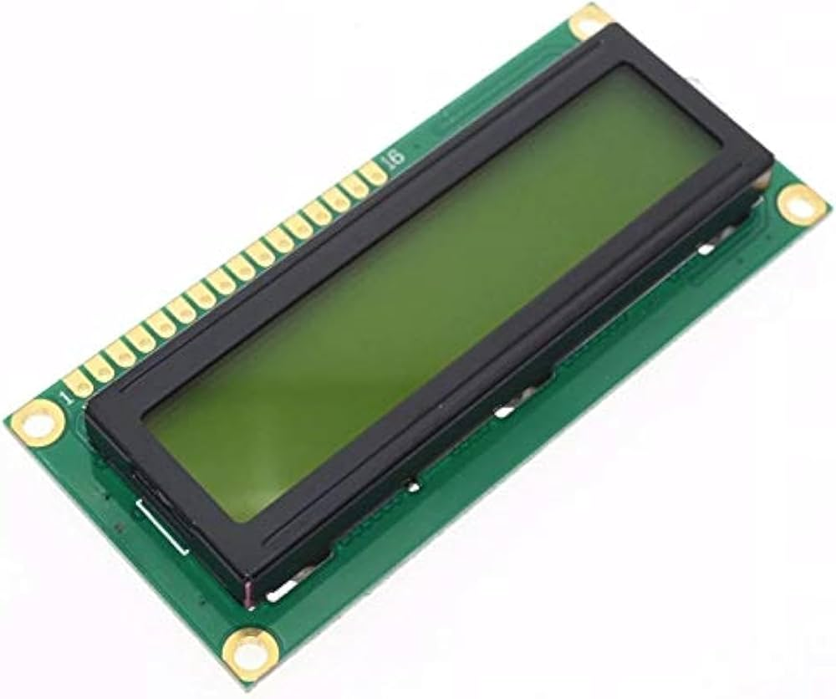 LCD Display

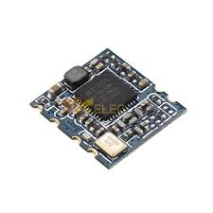

Wifi Module

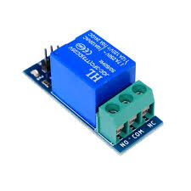

Relay

**EXISTING SYSTEM**

Current power theft detector rely on Node MCU, sensors, and Arduino IoT cloud. The transformer and consumer's home will have a voltage sensor and a current sensor. The sensors in the transformer acquire the amount of data transmitting the power to the consumer’s home. The voltage sensor and current sensor in the consumer’s home receive the amount of power and sense the power consumed by the consumer. Electricity theft can be stolen by unauthorized tapping between the distribution and receiver centers. The power is calculated as Power = Voltage X Current (P = V*C). The power of the transformer that transmits to the home is 250 watts (W). When the voltage sensor and current sensor in the consumer’s home give the consumed power of the same 250W, the power is not theft. If the power difference between the transformer and the house is more than 1, then there is a power theft.

**PROPOSED SYSTEM**

The proposed system introduces an advanced power theft detector that addresses the limitations of traditional setups. The system integrates multiple sensors with a versatile microcontroller and Wifi module. The system features three key sensors: a IR sensor network arranged inside the top cover, automatically supply to the house will be disconnected and alarm will be energized. Once the supply is disconnected, automatically power theft information will be transmitted to the concern mobile phone through WiFi module. Whenever the top cover is removed, power will be disconnected through relay and power will not resume until the reset key is activated, in practical this reset key must be arranged inside the meter somewhere in secret place such that it will not accessible to the energy user. In this project work an electronic energy meter is used which generates pulses according the load applied to it, therefore energy consumption information also will be displayed through an LCD inter faced with main processing unit designed with 89C52 microcontroller chip.

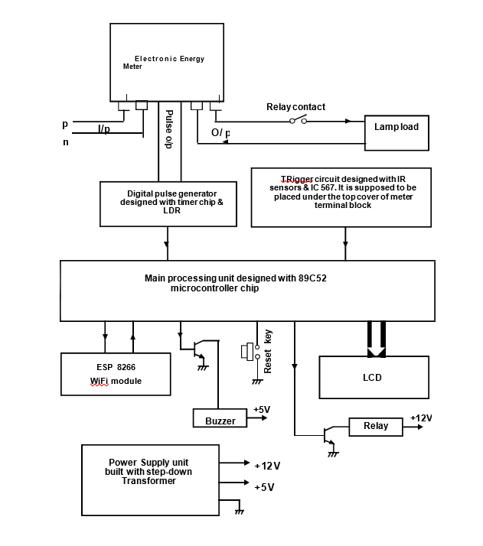

**System architecture**

**RESULT**

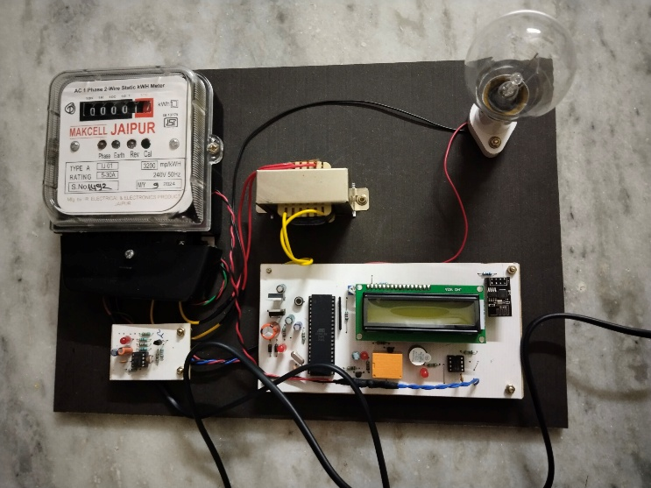

Fig1: IOT-Based Power theft detector

##### 

Fig2:LCD Display

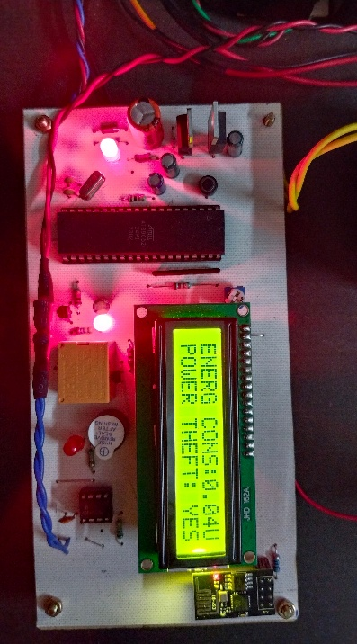

Fig3: LCD Display when power theft

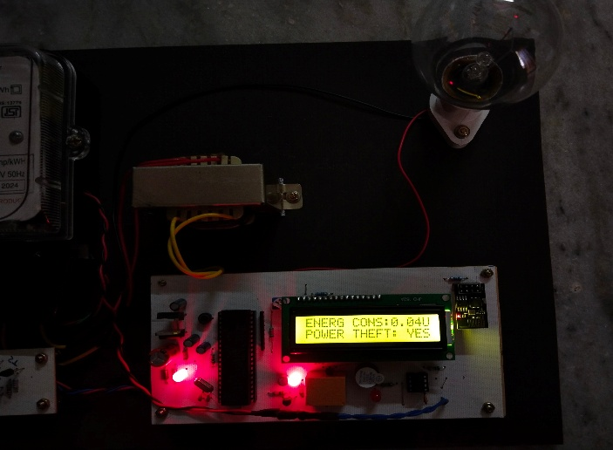

##### **ACKNOWLEDGEMENT**

**1.** We are extremely grateful to **Dr. A. Srinivasula Reddy**, Principal and **Dr. Madhavi Pingili,** HOD & Professor, **Department of Information Technology, CMR Engineering College** for their constant support.

**2.** We are extremely thankful **to Mrs. G.Swetha,** Assistant Professor, Internal Guide, Department of Information Technology, for her constant guidance, encouragement and moral support throughout the project.

**3.** We express our thanks to all staff members and friends for all the help and co-ordination extended in bringing out this project successfully in time.

**CONCLUSION**

The project work **“IOT based power theft detector”** is completed successfully, for the demonstration purpose a prototype module is constructed, which is very near to the real working system, and results are found to be satisfactory. The concept of smart energy meter is the new trend in technology, wide variety of smart systems with various features are developed, but here the system designed with IOT technology offers unique features such that energy theft information along with energy consumption data can be transmitted to the concern mobile phone through WiFi module. As described in advantages chapter, the technology implemented here is quite innovative, the benefits of this system are plenty when compared with normal energy meters.

Since the system utilizes IOT technology, many more features like monitoring the line voltage, load current, etc. can be monitored remotely through the same network. If required the customer can disconnect the supply to the house through same phone, like wise many features can be added to the system. By implementing this type of smart energy meters everywhere at domestic and industrial side for the utility of energy users, power theft can be totally avoided by which lot of revenue can be saved by the electricity department.

##### **REFERENCES**

1. A. Althobaiti, C. Rotsos and A. K. Marnerides, "Adaptive Energy Theft Detection in Smart Grids Using Self-Learning With Dual Neural Network," in IEEE Transactions on Industrial Informatics, vol. 20, no. 2, pp. 2776-2786, Feb. 2024, doi: 10.1109/TII.2023.3297588.
2. M. Muhammad et al., "IoT-Based Smart Meter with Energy Theft Detection," 2023 2nd International Conference on Smart Cities 4.0, Cairo, Egypt, 2023, pp. 111-114,doi: 10.1109/SmartCities4.056956.2023.10525848.
3. P. Sawat, A. Tandale, H. Upadhye, O. Takale, R. Mirajkar and P. Shelke, "Power Theft and Energy Fraud Detection," 2023 7th International Conference On Computing, Communication, Control And Automation (ICCUBEA), Pune, India, 2023, pp. 1-7, doi: 10.1109/ICCUBEA58933.2023.10392260.
4. X. Xia et al., "ETD-ConvLSTM: A Deep Learning Approach for Electricity Theft Detection in Smart Grids," in IEEE Transactions on Information Forensics and Security, vol. 18, pp. 2553-2568, 2023, doi: 10.1109/TIFS.2023.3265884.
5. A. T. El-Toukhy, M. M. Badr, M. M. E. A. Mahmoud, G. Srivastava, M. M. Fouda and M. Alsabaan, "Electricity Theft Detection Using Deep Reinforcement Learning in Smart Power Grids," in IEEE Access, vol. 11,pp.59558-59574,2023,doi: 10.1109/ACCESS.2023.3284681.
6. X. Xia, Y. Xiao, W. Liang and J. Cui, "Detection Methods in Smart Meters for Electricity Thefts: A Survey," in Proceedings of the IEEE, vol. 110, no. 2, pp. 273-319,Feb,2022,doi: 10.1109/JPROC.2021.3139754.
7. L. J. Lepolesa, S. Achari and L. Cheng, "Electricity Theft Detection in Smart Grids Based on Deep Neural Network," in IEEE Access, vol. 10, pp. 39638-39655, 2022, doi: 10.1109/ACCESS.2022.3166146.
8. R. and K. V., "IoT Based Smart Energy Theft Detection and Monitoring System for Smart Home," 2020 International Conference on System, Computation, Automation and Networking (ICSCAN), Pondicherry, India,2020,pp.1-6,doi: 10.1109/ICSCAN49426.2020.9262411.
9. M. J. Jeffin, G. M. Madhu, A. Rao, G. Singh and C. Vyjayanthi, "Internet of Things Enabled Power Theft Detection and Smart Meter Monitoring System," 2020 International Conference on Communication and Signal Processing (ICCSP), Chennai, India, 2020, pp. 0262-0267, doi: 10.1109/ICCSP48568.2020.9182144.
10. W. Li, T. Logenthiran, V. -T. Phan and W. L. Woo, "A Novel Smart Energy Theft System (SETS) for IoT-Based Smart Home," in IEEE Internet of Things Journal, vol. 6, no. 3, pp. 5531-5539, June 2019, doi: 10.1109/JIOT.2019.2903281.