Image Processing in MATLAB

Enhancement, Encryption and Decryption

| Arpit Goyal, Gayatri Chauhan and Divya Meena | Guide: Dr. Deepak Jhanwar |
| --- | --- |
| *College Roll No - 18EC11,20,19* | *Assistant Professor* |
| *Department of Electronics & Communication* | *Department of Electronics & Communication* |
| *Engineering College, Ajmer, Rajasthan, India* | *Engineering College, Ajmer, Rajasthan, India* |
| {mrarpitgoyal1999 & chauhangayatri665}@gmail.com | dj@ecajmer.ac.in |

***Abstract* - Photography was invented in 1826 by French inventor Joseph Nicéphore Niépce. Since then, it has revolutionized the modern world. From medical evidence in court & drawing images of industrial machines to personal photos for memory, not a single field is left untouched by photography. Nowadays when there are so many photo editing software, not many ensure true privacy and provide open-source code to ensure that no data is being collected. In six months of project making, we have developed an Image processing app that not only provides enhancement tools but also displays the power of steganography, a user-friendly environment to encrypt your enhanced images before sending them forward, and a magnificent display of Fourier series epicycles which creates an image using Fourier series, an intuitive way to learn and understand the beauty of mathematics. Mathematics could be called the language of science. Our tool proves why it is said so. And what could be a better platform to make all this other than MATLAB which not only provides numerous libraries but also is a powerful debugging tool that can display all the things happening inside the code. This app is built using the Guide function in MATLAB and has the potential to influence this generation toward data security as well as mathematics.**

***Index Terms – Enhancement, Cryptography, Epicycles, and Steganography.***

I. Introduction

Enhancing images play a crucial role in a variety of areas, from research to day-to-day uses. Images whether taken from a microscopic level or of the mighty space could never be analyzed and studied until filtered and enhanced. Enhancing images also applies when detecting defects in products that cannot be identified by the human eyes, such as PCBs. Any circuit faults can be easily identified by computers using image processing and enhancement. All sorts of entertainment and marketing media use image processing. Keeping in mind all the applications, we have built a MATLAB-based GUI platform that supports every basic image processing and filtering function, with additional features of data hiding using steganography, image encryption, and a beautiful demonstration of how any image can be drawn using Fourier series and epicycles. Apart from all the features, we have built a GUI platform making the interfacing easy and fun for the user.

II. Objective

The objective of this project is to build a platform that promises every basic function used in image filtering and processing using MATLAB. Not only enhancing the image but hiding crucial and selected information or hiding the whole image is another feature that this platform provides. One of the highlights of this platform is a demonstration of images using the Fourier series. Our goal is to show a new and magnificent way of showing the power of mathematics and the Fourier series.

III. Design Theory

1. *Enhancement*

An RGB image can be viewed as three different images(a red scale image, a green scale image, and a blue scale image) stacked on top of each other. In MATLAB, an RGB image is an M*N*3 array of color pixels, where each color pixel is associated with three values that correspond to the red, blue, and green color component of the RGB image at a specified spatial location. For filters like showing the red component, other color component values can be made to 0. For other filters and noise, MATLAB provides a library to be directly used.

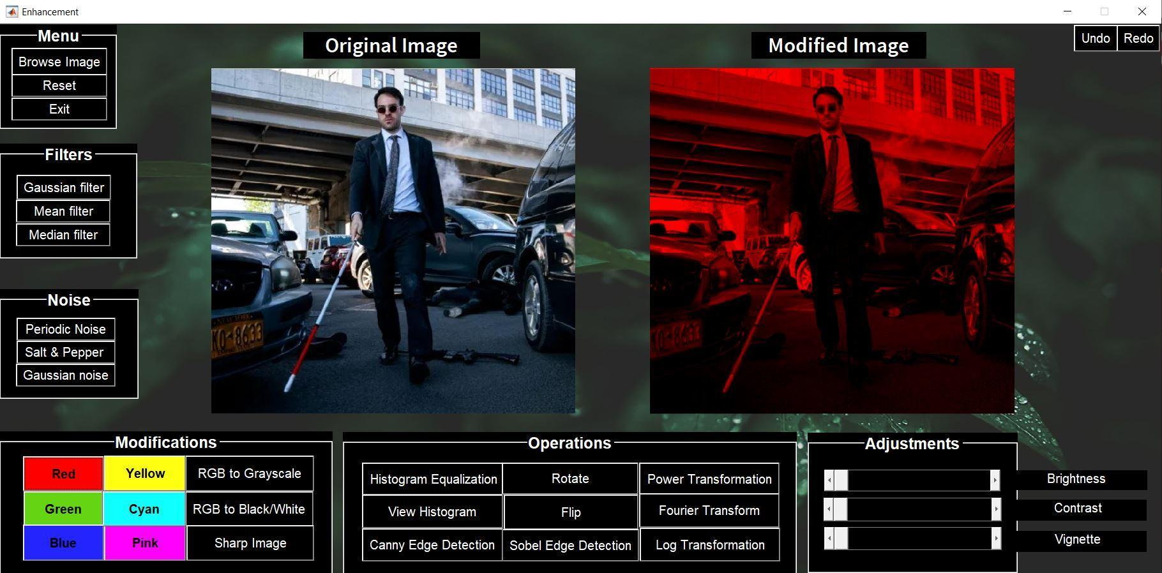

fig 1. Enhancement platform demonstrating noise features.

Adjustments such as brightness, contrast, and vignette need different user values as per requirement.Brightness can be adjusted by adding user-defined values to the image data. In contrast, we can multiply that value instead to increase vivid colors. Vignette requires the first centroid of the image. With that centroid as the center, using the euclidian distance of pixels, each pixel value is reduced to increase darkness as the distance increases.   
Formula: vignette(row, col) = sqrt ((row - Center(1)) ^ 2 +(col - Center(2)) ^ 2).

For history control, Undo and Redo options are available. For each modification, image data is stored by the name of that filter, and a unique variable is appended into a list to be extracted when undo and redo are called. As the operations increase, a counter also increases which works as an index for the list, and with the value at the index, we recall that particular image data to be edited again.

*B. Cryptography*Cryptography is a way of communication that is secure. The prefix "crypt" means "hidden" and the suffix "graphy" means "writing". In cryptography, plain text is converted to encrypted text before it is sent, and it is converted to plain text after communication on the other side.

*C. Encryption*

This feature enables us to browse any image from our system and encrypt it using a password. This password is set by the user and the image can only be decrypted when the password has been fed correctly. If the password is wrong,the image will not be decrypted. As it takes the used defined 6-digit password, it calls the key generation function. This function takes the image as well as password as input. Then by using the dimensions of the images, it makes a key using that password. Key will be having same dimensions as the image. After that this binary key is converted to decimal form using simple conversion formula.Once key is generated, image process function (encryptImg) is called with key passed to it. This function uses bitwise XOR to process image. When key and image are passed through XOR gate, we get the encrypted image. XOR gate have one beautiful characteristic i.e. when same key is XOR with the encrypted image, we get the decrypted imge.Decryption doesn’t require another or different piece of code. With the help of XOR gate, we can encrypt and decrypt using same key which can only by generated by that particular 6 digit password.

*D. Steganography*

Steganography is the technique of hiding secret data within an ordinary, non-secret, file or message to avoid detection; the secret data is then extracted at its destination. In this project, we are changing the last bit or least significant bit of the image as per our message to send the hidden data. We need to be displayed, we are using a logical function. Steganography is different from cryptography as here we only hide information by changing the least significant bit but in encryption, we are processing the whole image.

*E. Epicycles*

Fourier series can be explained as expressing a repetitive curve as the sum of sine curves. Since the “summation of sine waves” interpretation shows how many waves are there at each frequency, it is widely used in engineering, physics, and mathematics. The main idea in this interpretation is that sine and cosine functions are mutually orthogonal, like vectors that are perpendicular to each other. One can think of a sine wave as the distance covered by the shadow of a ball that turns around a circle. These circles that represent different sine waves of different frequencies are called epicycles. Using these epicycles we can demonstrate how any wave of any shape is made up of tiny sine waves. Now since every image is also composed of tiny sine waves, we can also draw any image using epicycles.

When we dive into exponential fourier series, eit forms a rotating vector which has an amplitude of Cn.

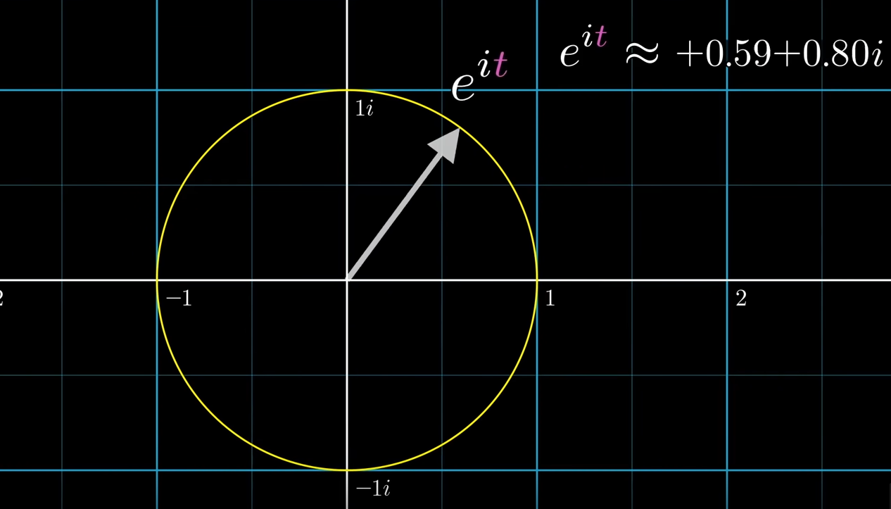

fig 2.. Demonstration of rotating vectors using exponential.

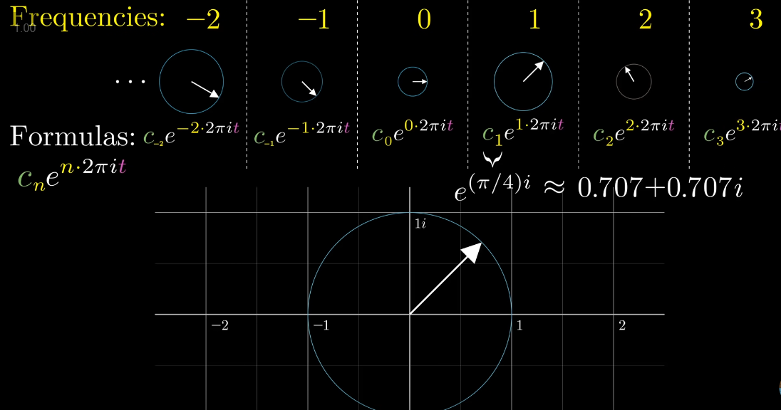

fig 3.. Rotation of circles at different frequencies.

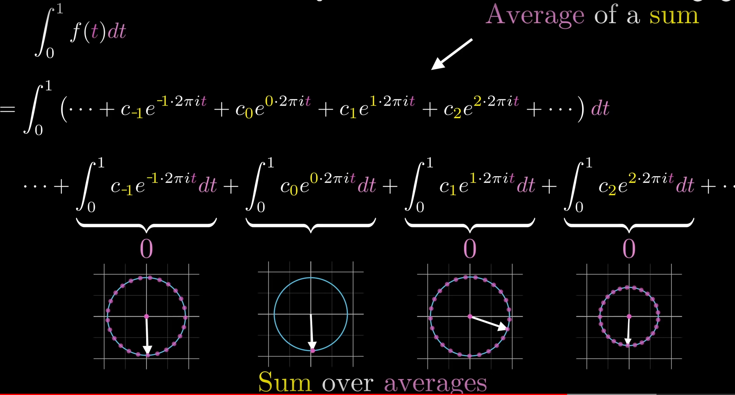

fig 4. function as a sum of multiple waves.

Combination of all rotating vectors with variable amplitude forms the signal consisting of sine and cosine waves. To calculate amplitude of any vector, we need to stop that rotating vector while making others rotate as then they will nullify to be zero and we could get the coefficient. Hence we multiply them with e-nit to get the average.

When the figure is drawn by the user, we capture the x and y coordinates of that figure and converts it into complex number. Then we decide the no. of circles which is equal to the no. of samples taken. After that we calculate the fourier transform as well the frequency of rotation, amplitude or radius and its phase. Additional sorting feature is also provided that sorts the epicycles as per its radius. After that using these values we plot the circles for that particular instance. With increase in time we move to forward coordinate. This way we can trace the head of vectors to form the desired image.

The computation and study of the Fourier series are known as harmonic analysis and are extremely useful as a way to break up an arbitrary periodic function into a set of simple terms that can be plugged in, solved individually, and then recombined to obtain the solution to the original problem or an approximation to it to whatever accuracy is desired or practical.

+ cos(nx) + sin(nx)

Fourier coefficients are obtained by :

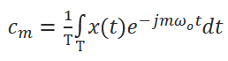

Similarly, when people depend on standard formulas to understand mathematics, this intuition of epicycles becomes a groundbreaking method to prove all other fourier transform properties intuitively.

IV. APP DESIGN

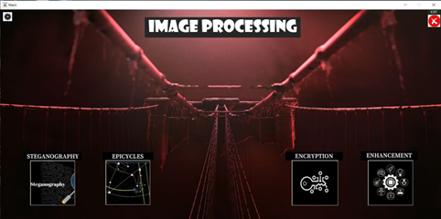

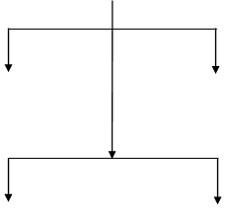

mmina

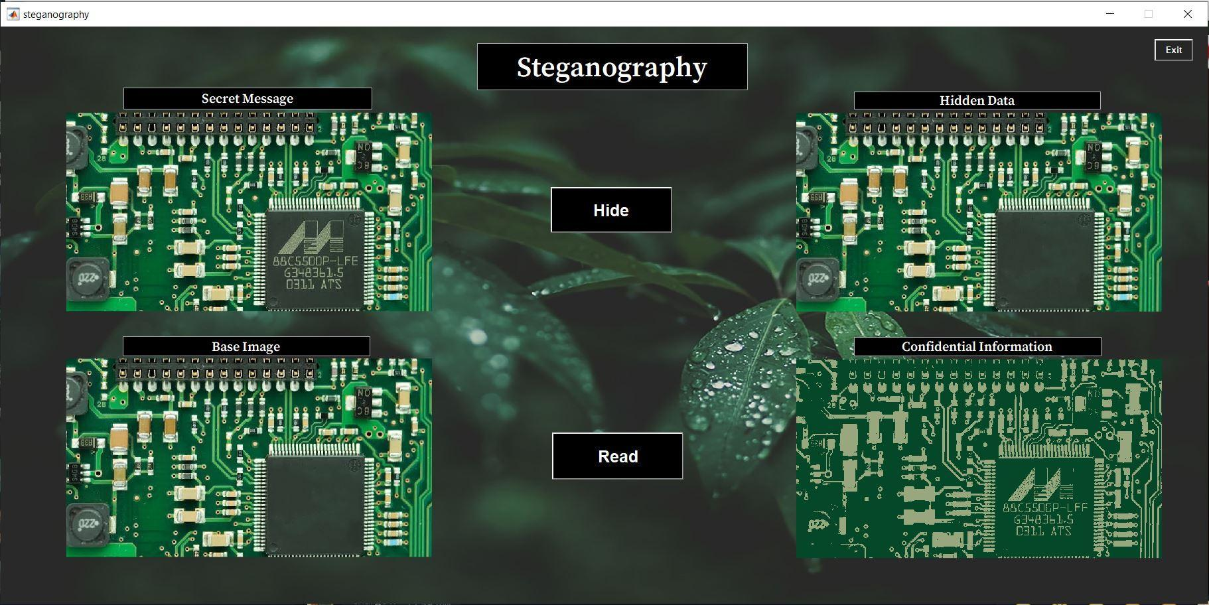

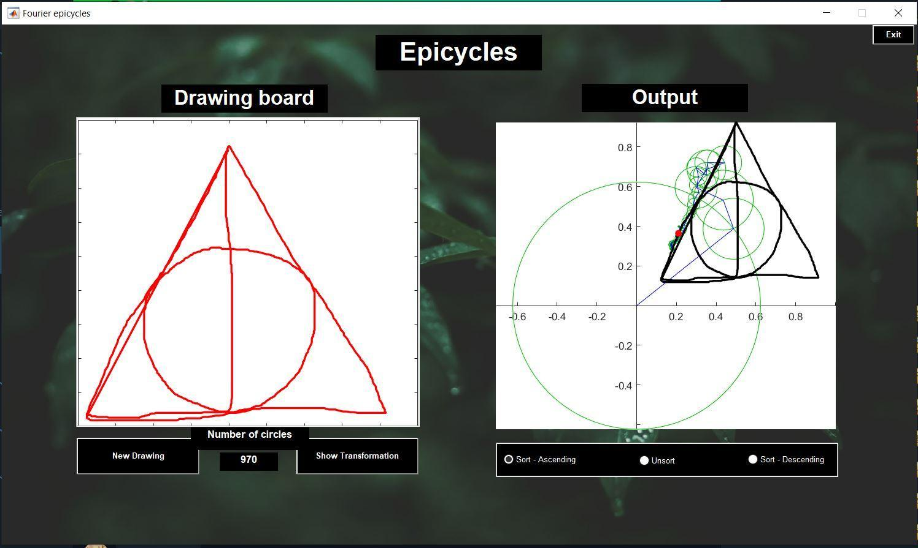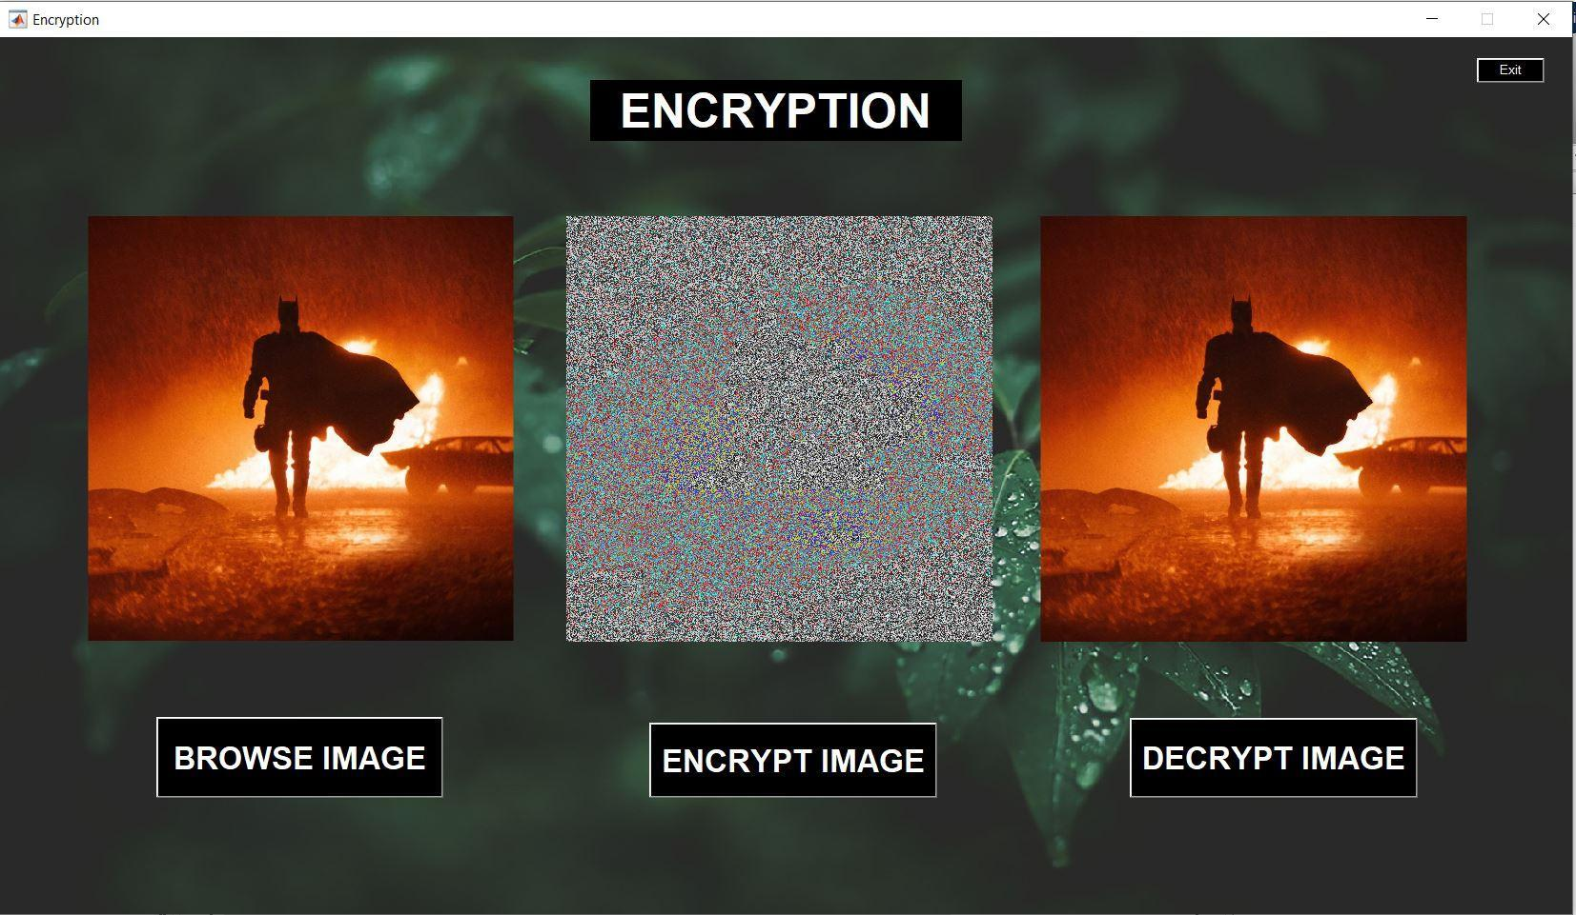

Fig 5. Flowchart of MATLAB app  
 [Main - (Steganography, Enhancement, Epicycles, Encryption)]

Acknowledgment

This research on “**Image processing in MATLAB**” results from the guidance, moral support, and devotion bestowed on us throughout our work. For this, we acknowledge and express our profound sense of gratitude and thanks to everybody who has been a source of inspiration during the project preparation.

References

1. Bilgecan Dede, “Purrier Series (Meow) and Making Images Speak”.
2. Grant Sanderson, Vivek Verma, “But what is a Fourier series? From heat flow to circle drawings ”, 13 June 2019.
3. Victor Martinez-Cagigal, “GUI that computes the required epicycles to match a custom drawing by using DFTs”.
4. <https://www.youtube.com/watch?v=mEN7DTdHbAU>
5. <https://www.youtube.com/watch?v=2hfoX51f6sg>
6. <https://www.youtube.com/watch?v=ds0cmAV-Yek>
7. <https://in.mathworks.com/help/images/image-enhancement-and-restoration.html?s_tid=srchtitle_image%20enhancement_5>
8. OpenSource code - <https://github.com/MrStrange09/Son-of-Anton/tree/main>