**Review Paper on Road Safety Analysis**

Tushar Kumar Sahu1, Ritul Kaur Ghai2, Nihal Raj Chhaliwal3, Arosha Zalke4, Ajay Kumar Garg5,

Bhumika Chandrakar6

1,2,3,4*Department of Civil Engineering, Government Engineering College, Raipur(C.G.)*

5 *Head of Department, Department of Civil Engineering, Government Engineering College, Raipur(C.G.)*

*6 Assistant Professor, Department of Civil Engineering, Government Engineering College, Raipur(C.G.)*

|  |
| --- |
| ***Abstract:****Road safety analysis refers to thoroughly examining roads and general transportation infrastructure using various analytical methods. It usually involves a multidisciplinary team with the local governing body and other stakeholders to check for potential safety issues and bring improvements within the same. The purpose of this review paper is to study the causes of road accidents and identify the active blackspots present in Raipur city. The goal is to prevent accidents by making sure road infrastructure is designed and optimised for safety and efficiency. According to the Ministry of Road Transport & Highways (MoRTH), Government of India, road accident blackspot on National Highways is a road stretch of about 500m in length in which either 5 road accidents (involving fatalities/grievous injuries) took place during the last three calendar years or 10 fatalities took place during the last three calendar years. Through detailed study and analysis, one can surmise that Road Safety Analysis can be easily broken down to factors such as types of road users, presence of traffic calming devices, weather conditions, whether users possess a driver’s licence and much more. Furthermore, it is important to address the deficiency and failure of one or more elements in road infrastructures to curb the issue of road accidents by understanding the data obtained accordingly*  ***Keywords:*** *Road accidents, Blackspots, Road Safety Analysis* |

1. **Introduction**

Despite India's impressive growth and the expansion of its road network to second place globally, road accidents persist as a grave concern. Accidents due to roads are more prone and common compared to other ways of transportation depicted by analysis, highlighting the urgent need for comprehensive measures. According to official statistics, 141,526 persons were killed and 477,731 injured in road traffic crashes in India in 2014 (NCRB, 2015). The actual number of injuries requiring hospital visits maybe 2,000,000-3,000,000 persons. This may be partly due to the increase in the number of vehicles overtime on the road but mainly due to the absence of coordinated, evidence-based policies to control the problem. The primary aim of the current research is to minimise the occurrence of road accidents, consequently reducing the rates of human fatalities and serious injuries. Technology-driven advancements in road infrastructure have shown promise in decreasing accident rates and enhancing transportation efficiency, leading to overall societal development and reduced crash incidents. Through the utilisation of the research data, continuous efforts towards advancements and improvements in road infrastructure can be made to create a safer experience on the road.

1. **Causes of Road Accidents**

Road accidents have a complex web of causes, including human errors, road conditions, and issues with vehicles. Over-speeding, in particular, played a significant role in 71.7% of road accidents, leading to 69.6% of total fatalities and 72.9% of injuries in 2021. The increase in over-speeding incidents by 11.4%, along with rises in fatalities and injuries,

paints a worrying picture. Road environment factors, human behaviours, and vehicle problems are the key contributors to these accidents.

**Environmental Causes:**

* Road Features: Poor infrastructure, improper markings, and insufficient traffic control mechanisms play a significant role.
* Ongoing Construction: Construction work often disrupts traffic flow and compromises road conditions, leading to accidents.
* Weather Conditions: Bad weather affects visibility and road grip, increasing accident risks.
* Sidewalks and Neighbourhood Layouts: Inadequate pedestrian pathways and poorly designed neighbourhoods contribute to accidents.

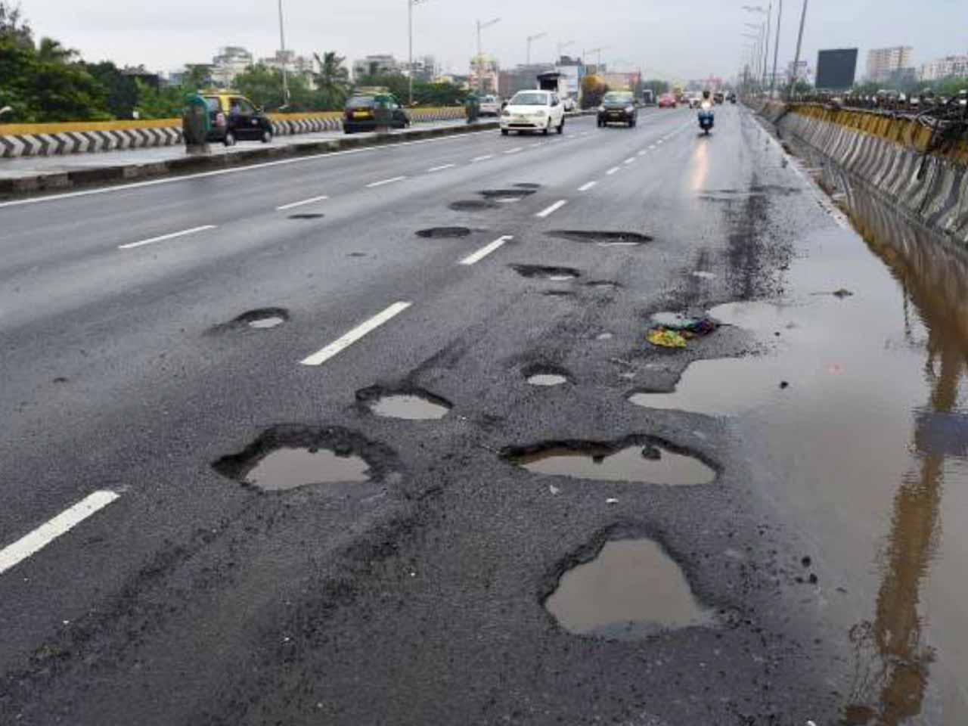

**Human Behaviour:**

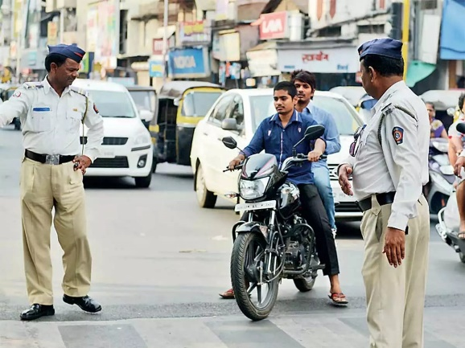

* Traffic Rule Violation: Disregarding traffic norms contributes significantly.
* Non-Use of Safety Gear: Not using helmets or seat belts increases the risk of injury.
* Distracted Driving and Negligent Parking: Engaging in distracting activities while driving or parking carelessly leads to risks.
* Overloading: Overloading vehicles compromises stability and control, leading to accidents.

**Vehicle-Related Issues:**

* Accidents in Older or Overloaded Vehicles: Ageing vehicles and overloading affect vehicle performance and safety standards, leading to accidents.

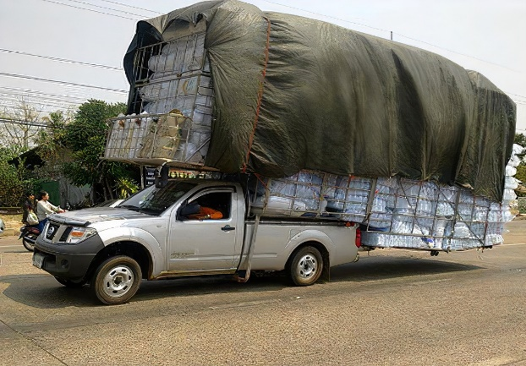

Comprehensive data is required for effective road safety management. It is essential for an evidence-based approach, particularly in producing results-focused strategies, action programmes and projects, identifying key blackspot locations, diagnosing the causes of serious and fatal injury in road accidents, selecting treatments, and monitoring and evaluating progress.

According to “Road Accident Analysis of Rajkot city”, there are two types of data collected to study the paper.

**1. Primary data                                                                                                                          2. Secondary data**

1. Primary Data Collection:

 Primary data refers to information collected directly from sources through first-hand investigation or observation.

**METHODS:**

1.Surveys

2. Interviews

3. Observations

2. Secondary Data Collection:

Secondary data refers to information that has already been collected and published by other sources for purposes other than the current research study.

**SOURCES:**

1. Government publications

2. Academic Journals

3. Online databases

4. Organisational records

1. **Conclusion**

The surge of road accidents has become a huge issue for India as it significantly impacts human life and burdens societal development. The analysis of causes, which includes environmental factors, human behaviour and vehicle-related issues, highlights the need for a strategy to comprehensively tackle road safety. Furthermore, it is important to understand the current road safety policies and infrastructure, or lack thereof. Hence, accidents blackspot identification and rectification ensures a safer road user experience and secure travel for all.

**References**

1. Dr.Bhalchandra V.Khode, Dipali R. Khamanka, Dr.Prashant Y. Pawade. “Accident Analysis and Blackspot Identification at Chandrapur City”. In: *International Journal of Scientific Research in Science and Technology* 8.2 (2021), pp. 428–440.
2. Mir, Imtiyaz & Ali Khan, Amir & Singh, Gyanendra & Dass, Sachin & Jaglan, Saurabh. “Accident Analysis: A case study of J&K”. In: *NeuroQuantology* 20.9 (2022), pp. 480-486.
3. Mr. Piyush Das Richa Dinkar. “Road Accident Analysis:Case Study of Raipur City”. In: *International Journal for Scientific Research in Modern Engineering and Science* 2.1 (2021), pp. 1–4.
4. Nupoor Dewangan Ruchi Chandrakar. “Road Safety Analysis in Raipur City”. In: *International Journal for Innovative Research In Multidisciplinary Field* 3.7 (2017), pp. 347-349
5. Tushar Chauhan, Mayursinh Jadeja & Ashraf Mathakiya. “Road Accident Analysis: A Case Study Rajkot City”.*International Journal of Creative Research Thoughts (IJCRT)* 10.5 (2022), pp. f290 - f301
6. Nikhil Katre, NH Pitale, and Shrikant Bobade. “Analysis of Black Spots on NH-3 and its Rectification”. In: *Journal of Transportation Systems* 4.2 (2019).
7. Arpit Bhayasare, Dr. S.M. Narulkar. “Accident Black Spot Identification, Analysis And Rectification With Special Reference To IRC-131:2022: A Review”. In: *International Research Journal of Modernization in Engineering Technology and Science* 5.12 (2023), pp. 2923-2931