**Aerodynamics Behaviour in high speed sports jersey fabrics with different roughness**

**S.Rohit Sadagopan1, Nallavan G2**

*1M.Tech Scholar, Department of Sports Technology, TNPESU, Tamilnadu, India*

*2Associate Professor, Department of Sports Technology, TNPESU, Tamilnadu, India*

|  |
| --- |
| ***Abstract:*** *Enhancing aerodynamic performance holds paramount importance in high-speed sports, leading to a growing interest in garments that can positively impact aerodynamic efficiency. Wind tunnel experimentation has played a pivotal role in assessing aerodynamic properties, employing both cylinder and leg models within a closed return circuit tunnel setup. Utilizing a plastic cylinder model, researchers evaluated the aerodynamic properties of various knitted samples, with dummy cylinders introduced to minimize 3D flow effects and ensure adherence to the infinite length hypothesis. By employing the foot and knee as additional dummy components, efforts were made to further mitigate 3D flow effects.* *These wind tunnel tests encompassed nine knitted single jersey fabrics, predominantly composed of 100% polyester, subjected to speeds ranging from 20 to 80 km/h to simulate real-world sporting conditions. The findings revealed a significant correlation between fabric manufacturing, indicated by the cover factor, and fabric roughness, with discernible impacts on aerodynamic parameters. Notably, consistent aerodynamic behaviors were observed across fabric tests conducted on both the cylinder and leg models, underscoring the reliability of the experimental setup.*  ***Key Word****:**Aerodynamics, Textiles, Roughness and Cover factor* |

1. **Introduction**

Enhancing aerodynamic performance holds paramount importance in high-speed sports like athletics. Consequently, there has been a surge in interest regarding garments that can positively impact aerodynamic performance in sports. Current research has pinpointed several factors crucial for improving athletes' aerodynamic capabilities:

* The aerodynamic properties of the sports equipment utilized
* The positioning of the athlete's body during activity
* The design and style of the garments
* The fit of the garments worn
* The aerodynamic attributes of the garment surface

Improving the aerodynamics of athletes in motion can be significantly enhanced through meticulous garment design, styling, and fit. This has been evidenced across various sports disciplines such as running, cycling, downhill and cross-country skiing, bobsled, and speed skating. Studies, including one by Laing, have demonstrated that drag reduction of up to 10% can be achieved through strategic clothing choices. Multiple methodologies have been employed to assess the impact of garment design and styling on aerodynamic performance. For instance, Kyle and Caiozzo conducted wind tunnel experiments using materials and wigged-head models, predicting a potential decrease in wind resistance ranging from 0.5% to over 6% by covering the hair and employing elastomeric clothing materials with a snug fit. Similarly, Brownlie et al. compared various garment styles and materials for running, concluding that certain prototypes led to a significant reduction in running time. The importance of garment styling and design, particularly focusing on minimizing aerodynamic drag, was highlighted by Spring et al. in their study on cross-country skiers. Further advancements were made by Brownlie et al. who designed stretch fabric suits specifically tailored to athletes, resulting in notable reductions in aerodynamic drag.

**II.LITERATURE REVIEW**

The papers included in this literature review offer valuable insights of aerodynamics forces calculated using different factors

1. **JulianJ. C.Chua ( 2011) :** This study investigated the aerodynamic behaviour of flapping garments of different looseness ratios (garment length to cylinder circumference) mounted on a horizontal cylinder. The tight fitting garments showed the typical flow transition and a critical flow regime, with Recrit correlating with the roughness of the garments.
2. **Viviana Valsecchi ( 2022 ) :** This study is to investigate and quantify the aerodynamics advantage, the physiological and performance advantage produced by pacemaker drafting in the case of long endurance running. In endurance races, as in many sports, a part of the power produced by athletes is used to overcome air resistance.
3. **FirozAlam (2019) :** This study is to investigateaero/hydrodynamics understanding of athlete’s body orientation and sports textile is paramount for achieving high performance in speed sports. The surface morphology and physical shape determine aero/hydrodynamic behavior and flight trajectory of all speed sports balls.
4. **K.SaiAdithya (2020) :** Project focuses on aerodynamics design of a Wind Tunnel to simulate subsonic flows. Our specific aims were to design and construct a user-friendly Wind Tunnel facility, to adapt Wind Tunnel experiments such as flow visualization and measuring lift, drag to DBT (Design, Build and Test) projects, to assess and disseminate results. The review on the use of low speed Wind Tunnel applications shows that Wind Tunnels are very efficient for experimental simulations and flow visualization.
5. **Harun Chowdhury (2012) :** The results demonstrated that the cycling suit should be selected depending on the cycling position and speed range in order to take the aerodynamic advantage. As the position in the world class competitions are decided with a fraction of time difference, apart from the athletic performance, an efficient sport garment can enhance the overall performance of the athlete. Depending on the nature of the sport, this methodology can be used as a basic design tool to optimise or select proper parameters for the betterment of the outcome.

**III.METHODOLOGY**

Aerodynamic Test

1.Wind tunnel

The Wind Tunnel was used to experimentally measure the aerodynamic properties on cylinder and leg models. The tunnel is a closed return circuit wind tunnel. The maximum speed of the tunnel is approx- imately 145 km/h. The rectangular test section dimension is 3 m (wide) 9 2 m (high) 9 9 m (long) with a turntable to yaw suitably sized objects. More details about the tunnel can be found in Alam et al. . A zero measurement was taken before each series of measurements in order to eliminate possible errors due to the offset. The aerodynamic resistance was acquired at different incremental speeds from 20 km/h to 80 km/h in order to cover the range of speeds relevant to sports, such as cycling or speed skating. The tunnel was calibrated before conducting the experi- ments and the tunnel’s air speeds were measured via a modified NPL ellipsoidal head pitot-static tube (located at the entry of the test section) connected to a MKS Baratron pressure sensor through flexible tubing. Purpose made computer software was used to compute all 3 forces and 3 moments (drag, side, lift forces and yaw, pitch and roll moments) and its non-dimensional coefficients. Thedata stream with 3 forces and 3 moments data at 8 kHz. The sensor was mounted under the wind tunnel floor and was connected to the model with a support. Frequency filtering has been used in order to remove the background noise frequencies and a sampling frequency of 200 Hz was used during the experiments. Samples taken were 20 s long, 3 samples have been taken and averaged. Data varied by a maximum of 5% between two different tests. Based on these initial results, force values were taken as the average of a 1 min run for a single sample.

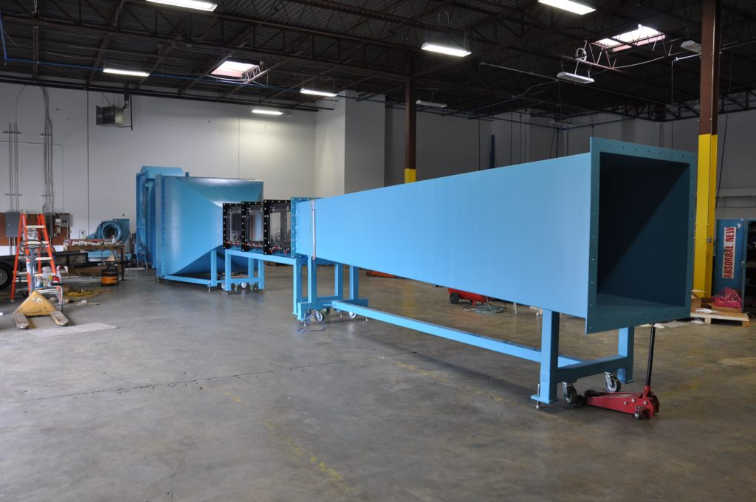

FIGURE1. Wind Tunnel

**Apparel scale down model:**

Height (H)= 0.2m (1:3.5)

Width (W)=0.102m

For a standing subject in running position at constant speed, to neglect body weight effect on acceleration and deceleration, defines projected area as a function of the athlete's height alone. The projected frontal area 'A' is given by:

A = (0.146×H^2)m^2 (3.11)

Area of actual model =0.7*0.36m = 0.252m^2

Area of scale-down model = 0.2*0.10^2

=0.02m^2

**Reynold's number of actual models:**

Re(actual) = p. v. Lu

= 1.225*5*0.1.81*10^-5 = 2.41*10^5

**Reynold's number of scale down model:**

Re(scale down) = p. v. Lu = 1.225*17.5*0.21.81*10^-5

= 2.36*10^5

**Blockage Ratio:2.7**

The frontal area of the object Cross section area of wind tunnel =0.02/0.72×100

= 2.7% (i 5%)

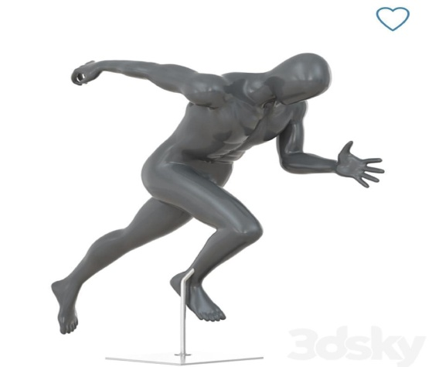 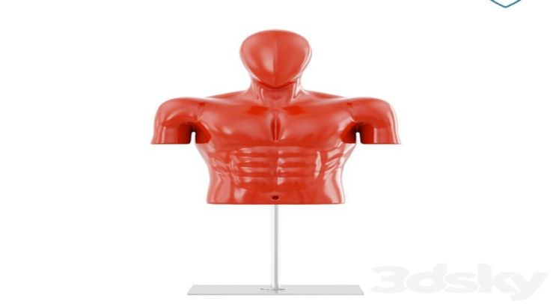

FIGURE2. HUMAN Apparel Model

**DRAG ESTIMATION**

The Apparel model of height 200mm and width 100mm was tested in a wind tunnel with a test section of 600x600x2000mm at a velocity of 17.5 m/s. Wind tunnel testing is a common method used to study the aerodynamic characteristics of objects in a controlled environment. The test section of the wind tunnel is a confined space where the model is placed, and the airflow is generated using a powerful fan. The velocity of the airflow can be adjusted to simulate various real-world conditions. By measuring the drag force on the model and other relevant data, the aerodynamic properties of the model can be analysed , including the co-efficient of drag (Cd).

At V= 17.5 m/sec

Strain = 30 ×10^-6

Stress = 30×10^-6x 42x109 N/M^2

=1260×103

M=0.026

Force= M/I = 0.026/0.003

= 0.1113 N

Cd= 2D/0.5*v^2*p*s

=2*0.1113/0.5*1.225*306.25*0.02

=0.023

**IV. RESULTS AND DISCUSSION**

|  |  |  |  |  |  |
| --- | --- | --- | --- | --- | --- |
| Velocity | Strain | F1 | F2 | Cd1 | Cd2 |
| 5.07 | 1 | 0.00371 | 0.007 | 0.011 | 0.022 |
| 7.2 | 4 | 0.0148 | 0.0113 | 0.023 | 0.017 |
| 8.9 | 7 | 0.025 | 0.01855 | 0.025 | 0.018 |
| 10.5 | 10 | 0.0371 | 0.025 | 0.027 | 0.019 |
| 12.5 | 15 | 0.055 | 0.0371 | 0.028 | 0.0198 |
| 14.3 | 20 | 0.0742 | 0.051 | 0.029 | 0.02 |
| 15.7 | 26 | 0.0965 | 0.07 | 0.031 | 0.021 |
| 17.5 | 30 | 0.113 | 0.089 | 0.033 | 0.023 |
| 18.3 | 40 | 0.148 | 0.113 | 0.036 | 0.027 |

Table1. Drag estimation

When an object is streamlined with a low drag coefficient (cd) value, applying additional force can result in smoother fluid or gas flow around the object, thus reducing drag. Conversely, if an object has a complex shape and a high cd value, increasing the force may induce turbulent flow, leading to an increase in the drag coefficient.

**V. CONCLUSION**

The wind tunnel test conducted on the Apparel model, measuring 200mm in height and 100mm in width, yielded crucial insights into its aerodynamic behaviour. Within the wind tunnel's test section, precise measurements of drag force acting on the model were obtained, along with other key data such as the coefficient of drag (Cd). By leveraging the model's dimensions and airflow velocity, the Cd value was calculated, offering opportunities to optimize the design of the apparel model or enhance athlete performance.

Notably, the drag force experienced by the model increased proportionally with airflow velocity, aligning with fundamental principles of fluid dynamics. Overall, wind tunnel testing emerges as a potent tool for unraveling the aerodynamic attributes of objects, with potential applications spanning sports and engineering, among other domains.

**References**

1. Gay, T., Harper Collins**“**Aerodynamics Of Football” , 2005.*The Physics of Football.* Available at :<https://www.sciencebuddies.org/science-fair-projects/project-ideas/Sports_p028/sports-science/aerodynamics-of-a-football>DOI : 10.2202/1559-0410.1234.

2. Mehta, R. D.**“**Aerodynamics of sports balls”. Available at : <https://www.annualreviews.org/doi/10.1146>. DOI :17.010185.001055

3. K.Sai adhitya, M.Mani Kanta, CH.Raghu Ram , Y.Yogendhra, B.Usha Rani**“**Experimantal design and testing of wind tunnel**”**. Available at : <https://www.irjet.net/archives/V7/i6/IRJET-V7I682>. DOI :p-ISSN: 2395-0072

4. Harun Chowdhury, School of Aerospace, Mechanical and Manufacturing Engineering, RMIT University Australia.**“**Aerodynamic Design of Sports Garments**”**. Available at : <https://cdn.intechopen.com/pdfs/36821/intech-aerodynamic_design_of_sports_garments>DOI :376-381

5. Julian J. C. Chuaa, Franz Konstantin Fussa , Olga Troynikovb a School of Aerospace, Mechanical and Manufacturing Engineering, RMIT University, Melbourne VIC 3083, Australia b School of of Fashion and Textiles, RMIT University, Melbourne VIC 3056, Australia. **“**Aerodynamics of loose sports garments**”**. Available at : <https://pdf.sciencedirectassets.com/278653/1-s2.0-S1877705811X00085>DOI :s2.0-S1877705811010149

6. Viviana Valsecchi, Giuseppe Gibrtini, Andrea Morelli : Wind Tunnel Test of Drafting at Endurance Run velocity.

7. Quantifying the effect of wind on running performance in elite endurance athletes, Jonathan M.Peake, Ross Tucker

8. Drag estimation of a marathon runner using computational fluid dynamics, Kazuki Tsuji, Yuki Nishimoto, Takashi Takeuchi, Yoshinobu Kubota, Masataka Yamaguchi

9. A review on aerodynamics and hydrodynamics in sports, FirozAlam, Harun Chowdhury, HazimMoria. Available at www.elsevier.com/locatae/procedia

10.Pavithran, Dr.R.Ramakrishnan: CFD simulation on the drag of the marathon runner by the following car