**SLEEP ALARM DETECT FOR DRIVER’S USING EYE BLINK SENSOR**

**S.DHINESH KUMAR, G.RAMKUAMR**

**Department Of Computer Science,**

**Sri Kaliswari College (Autonomous), Sivakasi, India.**

**Abstract** *:* There has been a very large increase in road accidents due to the drowsiness of drivers while driving which leads to enormous fatal accidents. The driver loses control when he falls asleep which leads to an accident. This is because when the driver is not able to control his vehicle at a very high speed on the road. This project can generate a model which can prevent such accidents. Therefore, I have with an idea and successfully develop a sleepy detection and alarming system, which could effectively meet this demand.

**Keywords — Infrared Obstacle Avoidance IR Sensor, Buzzer**

**I. INTRODUCTION**

In modern-times, owing to hectic schedules it becomes very difficult to remain active all the time. Imagine a situation where a person is driving home from work, dead tired after facing all the challenges of the day. His hands are on the wheel and foot on the pedal but suddenly he starts feeling drowsy, his eyes start shutting and his vision blurs and before he knows it, he’s asleep. Falling asleep on the wheel can lead to serious consequences, there may be accidents and people may even lose their lives. This situation is much more common then we notice and hence, it is very important to counter this problem. So to address this issue, I have come up with a sleep alarm detect. This system alerts the user if he/she falls asleep at the wheel thereby, avoiding accidents and saving lives. This system is useful especially for people who travel long distances and people who are driving late at night. The circuit is built using Infrared Obstacle Avoidance IR Sensor. Whenever the driver feels sleepy and bends his neck down the tilt sensor detects and the buzzer sounds an intermediate beep... When driver comes back to his normal position tilt sensor senses that and buzzer gets switched off.

Hardware required for this project as follows

* Eye Blink Sensors
* Arduino Nano

* 9V Battery Connector

* Buzzer

* Jumper Wires
* DC Motor
* 5v Single Channel Relay Module

**Functions of the Components:**

**IR SENSOR:** It is a electronic device used to detect some objects near-by surroundings. It detects the movement of an object. In this project we used IR Sensor as an input to detect the moment of eye-blink.

**ARDUINO NANO:** It is a Microcontroller board. It is used for technical support, where we dump a code into it and it works as a Controller or a Function. The operating Voltage of 5v, however the input Voltage can vary from 7 to 12v.

**BUZZER:** A Buzzer is used to get output of the executed program and any errors occurs in process an immediate buzzer is generated.

**II.HARDWARE COMPONENTS**

**2.1 INTRODUCTION TO ARDUINO NANO:**

**2.1.1 Arduino Nano**

The Arduino Nano is a small, complete, and breadboard-friendly board based on the ATmega328P released in 2008. It offers the same connectivity and specs of the Arduino Uno board in a smaller form factor. The Arduino Nano is equipped with 30 male I/O headers, in a DIP-30-like configuration, which can be programmed using the Arduino Software integrated development environment (IDE), which is common to all Arduino boards and running both online and offline. The board can be powered through a type-B mini-USB cable or from a 9 V battery. Despite the size, Arduino Nano packs in more or less the same features as UNO. If you compare UNO and Nano, then Nano lacks the DC Power Jack and contains a mini B type USB connector. Other than that Nano is very similar to UNO in terms of functionality.

The Nano board is designed in such a way that the pins are breadboard friendly so that you can easily mount it on one for your DIY projects. Overall, the Arduino Nano is a very good alternative to the mighty Arduino UNO and is available at a lower price. Personally speaking, I suggest Arduino Nano over UNO as it is cheaper, breadboard friendly, small in size and has couple of more pins (digital and analog IO) than UNO.

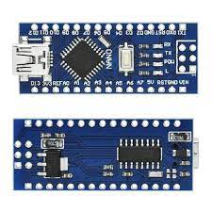

**Figure 2.1: Arduino Nano**

**IR Sensor:** IR sensor is an electronic device that emits the light in order to sense some object of the surroundings. An IR Sensor can measure the heat of an object as well as detects the motion. Usually, in the Infrared spectrum all the objects radiate some form of thermal radiation. These types of radiations are invisible to our eyes, but infrared sensor can detect these radiations. The emitter is simply an IR LED and the detector is simply an IR photodiode. Photodiode is sensitive to IR light of the same wavelength which is emitted by the IR LED. When IR light falls on the photodiode, the resistances and the output voltages will change in proportion to the magnitude of the IR light received. There are five basic elements used in a typical infrared detection system: an infrared source, a transmission medium, optical component, infrared detectors or receivers and signal processing. Infrared lasers and Infrared LED's of specific wavelength used as infrared sources.

The three main types of media used for infrared transmission are vacuum, atmosphere and optical fiber. Optical components are used to focus the infrared radiation or to limit the spectral response.

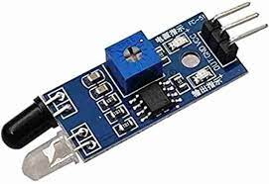

**Figure 3.1: IR SENSOR**

**BUZZER:** The buzzer produces sound based on reverse of the piezoelectric effect. The generation of pressure variation or strain by the application of electric potential across a piezoelectric material is the underlying principle. These buzzers can be used alert a user of an event corresponding to a switching action, counter signal or sensor input. They are also used in alarm circuits. The buzzer produces a same noisy sound irrespective of the voltage variation applied to it. It consists of crystals between two conductors. When a potential is applied across these crystals, they push on one conductor and pull on the other. This, push and pull action, results in a sound wave. Most buzzers produce sound in the range of 2 to 4 kHz. The Red lead is connected to the Input and the Black lead is connected to Ground.

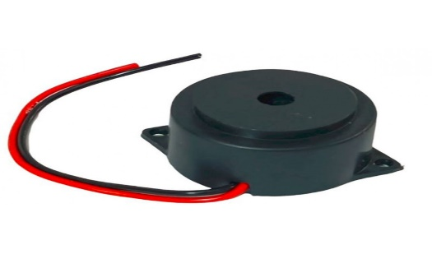

**Figure 3.2: Buzzer**

**Eye Glasses / Spectacles:**

The eye blink system comes with an IR sensor mounted on glasses which the user can wear like regular glasses, shown in the picture below. Eye blink Sensor is a relatively simple sensor used to detect eye blinks. It uses a simple infrared sensor to detect if the person's eye is closed and the corresponding data received can further be processed by any logic as required for the application.

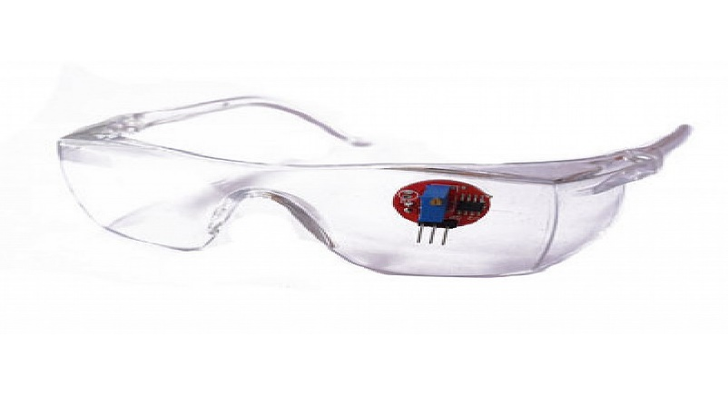

**Figure 3.3: Eye glass with Sensor**

**POWER SUPPLY:**

**A 9V Battery:**

The nine-volt battery, 9V Battery, is an electric battery that supplies a nominal voltage of 9 volts. Actual voltage measures 7.2 to 9.6 volts. Here we 9V battery for power supply to execute the working process.

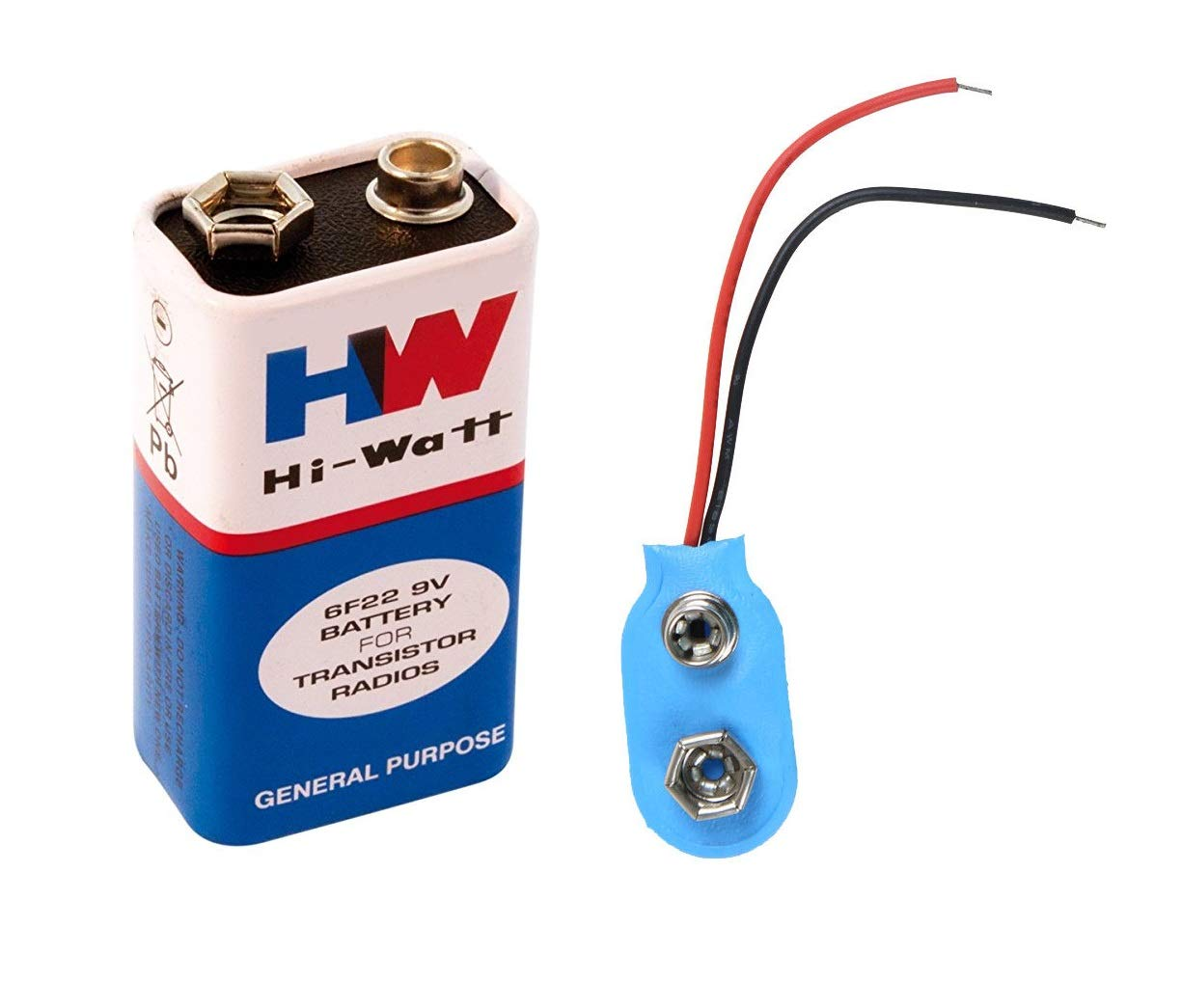

**Figure 3.4: A 9V Battery**

**SWITCH:**

SPST Single pole single throw switch is nothing but a simple two-terminal switch which help us to disconnect the one terminal to another terminal (vice versa– ON or OFF operation).

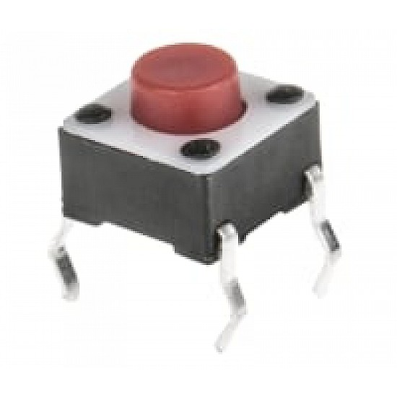

**Figure 3.4: Switch**

**III.PROJECT WORKING & RESULT**

**3.1 CIRCUIT DIAGRAM:**

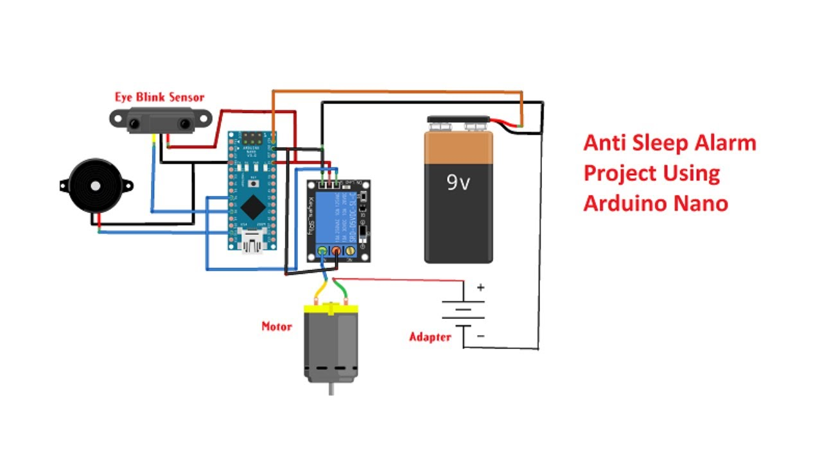

**PROCEDURE:**

• Connected all the Components as Shown in above Circuit Diagram.

• Required Code is dumped into Arduino NANO using Arduino IDE by Connecting USB Cable to Laptop/ Computer.

• Now Power supply is given to the Circuit with a help of a 9V Battery.

• IR Sensor is used to detect the Eye-blink or closing the eyes of a person, if eyes closed for a while an immediate buzzer automatically turns ON.

• The buzzer automatically turns OFF, when the person come back to his normal State.

**IV. RESULT**

**Output of the Project WORKING:**

• The Arduino Nano interfaces with the Eye Blink Sensors and Processes signals indicating eye activity. When the sensor detects prolonged eye closure, it triggers the 5V Relay to half the DC Motor representing the engine, simultaneously activating the Buzzer to generate a sound alert, simulating an immediate response to prevent potential risks.

• Given below Figure shows the working of the project.

**CONCLUSION**

This type of sensors are so important that use to identify the motion of an object in very easy method. The design is simple and the cost is very low so everyone can use it. Also we can carry it, so we can use it whenever it is needed and at any time. It is not just a device it is a trusty device which can save someone’s life. It is apparent that the overall project success is not derived from one team member’s mind but the keen coloration within our group. Each part is indispensable and every team member made the great dedication on the completion of this design project. By using our Driver Sleep Detection and Alarming System, customers would be warned when his/her physical condition is not good enough for driving and thus prevents dangerous behaviors from happening. It is consistent with the safety and welfare of the public. To avoid injuring others, their property, reputation, or employment by false or malicious action;

**REFERENCES**

[1] https://nevonprojects.com/driver-anti-sleep-device/

[2] https://youtu.be/OJRTLPR-dcE

[3] https://images.app.goo.gl/T6zcRbWQ4igyz6kd6

[4]https://www.researchgate.net/publication/305722865_A_STUDY_ON_DRIVER_FATIGUE_NOTIFICATION_SYSTEMS