Development of Android-based Real-time Observing and Control system for Renewable Energy Sources

Miss.Samiksha Gedam  
Electronics and communication Engineering  
TulsiramjiGaikwad-Patil College of Engineering & TechnologyNagpur, India

samikshagedam155@gmail.com

Prof. Rohini Pochhi  
Electronics and communication Engineering  
TulsiramjiGaikwad-Patil College of Engineering & TechnologyNagpur, India

hod.ece@tgpcet.com

Prof. Pallavi Rokde  
Electronics and communication Engineering  
TulsiramjiGaikwad-Patil College of Engineering & TechnologyNagpur, India  
pallavi.ece@tgpcet.com

*Abstract*— This project presents the development of Android-based online monitoring and control system tailored for Renewable Energy Sources, fondly known as RES. The system aims to enhance the effectiveness and operation of renewable energy installations by feeding real- time data monitoring and remote- control capabilities through a client friendly mobile software. The system, like, integrates various sensors deployed in renewable energy systems, such as solar panels and wind turbines, to collect essential data. This data is transmitted to a cloud-based platform for real-time processing and storage. The Android application serves as the user interface, offering comprehensive insights into energy production, consumption, and system status.

We all know energy is like super important, so having this system is like totally crucial for monitoring and controlling renewable energy sources. It's like the ultimate tech solution for improving the efficiency of energy installations. Plus, with the amazing sensors and the cloud processing, you can monitor everything like a boss. Go green with RES and be energy-smart with this android-based system.

Let's embrace the power of renewable energy and make a difference with this high-tech monitoring and control system.

***Keywords— Renewable Energy Sources (RES), Real time data monitoring, Sensors, Solar Panels, Wind Turbines, Data Transmission, Cloud-based Platform, Android application***

# **Introduction**

Android based Real-time Observing and Control System for Renewable Energy Sources

The raising request for cleaner and maintainable vitality arrangements has driven a surge within the appropriation of Renewable Vitality Sources (RES) such as sun powered, wind, and hydroelectric control. Be that as it may, the effective utilization of these assets requires advanced checking and control frameworks that can adjust to the energetic nature of renewable vitality era. In reaction to this request, our extend centers on the improvement of an Android-based online observing and control framework outlined to address the challenges confronted by RES partners. The framework leverages the ubiquity and user-friendliness of Android gadgets to form a seamless and open interface for both specialists and non-experts within the renewable vitality space. The essential objectives of this venture incorporate:

Real-Time Observing- The framework joins state-of-the-art sensors to assemble real-time information from renewable vitality establishments. This information is at that point prepared and displayed to clients through an Android application, permitting for immediate experiences into vitality generation and framework execution.

Farther Control Usefulness: With an accentuation on client strengthening, the Android application empowers inaccessible control of renewable vitality frameworks. Clients can make alterations, fine-tune parameters, and react to energetic natural conditions, optimizing the in general effectiveness of their establishments.

User-Friendly Interface: Recognizing the different client base within the renewable vitality segment, the Android application gloats a natural and outwardly engaging interface. This plan guarantees that clients, notwithstanding of their specialized mastery, can effortlessly comprehend and associated with the observing and control highlights.

Cloud Integration: The framework utilizes cloud-based advances to encourage consistent communication between the Android application and the renewable vitality foundation. This integration empowers real-time information synchronization, guaranteeing that clients get exact and opportune data.

Security Measures: In light of the touchy nature of energy-related information, robust security conventions are actualized to protect against unauthorized get to and information breaches. The keenness and privacy of the framework are fundamental in building up client believe.

This extend stands at the crossing point of innovation and supportability, advertising a comprehensive arrangement to upgrade the execution and administration of renewable vitality sources. Through the advancement of this Android-based observing and control framework, we point to contribute to a more economical and flexible vitality future!

# **Literature Review**

[1] In Development of a Self-adaptive based Renewable Energy Management in Smart Micro Grid- in this paper Identification and evaluation of self-adaptation algorithms that dynamically adjust energy management parameters based on real-time conditions. [2] Investigation on Sizing of Voltage Source for a Battery Energy Storage System in Microgrid- in this paper the load profile analysis helps identify the energy consumption patterns, peak demand periods, and load variability within the microgrid. [3] IoT Application for On-line Monitoring of 1 kWp Photovoltaic System Based on Node MCU ESP8266 and Android Application- In this paper the Nodemcu ESP8266 is employed as a central node for data acquisition from PV system sensors. The collected data is then transmitted to the cloud for storage and processing. An Android application serves as the user interface, allowing users to access real-time data and control system parameters remotely. [4] Digital Control System for Solar Power plant using IoT- This project presents a solution that combines PLCs and SCADA for comprehensive solar power monitoring. [5] Development of Android based on-line monitoring and control system for Renewable Energy- in this paper system aims to enhance the efficiency and management of renewable energy installations by providing real-time data monitoring and remote-control capabilities through a user-friendly mobile application. [6] Development of a data acquisition system for remote monitoring of renewable energy systems- In this paper a Data Acquisition System (DAS) designed for remote monitoring plays a pivotal role in gathering, processing, and transmitting essential data from renewable energy installations to a central monitoring station.

# **METHODOLOGY**

* **Algorithm:**

1. In Data Acquisition data is collected from the sensors measuring renewable energy parameters like solar irradiance, wind speed, battery voltage. Ensure proper calibration and conversion of raw sensor data.
2. Then we have to Establish communication channels between the Android app and the renewable energy system. Utilizing appropriate communication protocols like MQTT, RESTful APIs for real-time data exchange.
3. In Data Processing raw data is collected from the sensors. Appling that raw data filtering algorithms to remove noise from sensor data and smoothing the data to provide a more stable representation.
4. Data Analysis - Analyze Actual data to identify patterns and trends. Use algorithms to read unborn energy generation and consumption.
5. Control Logic Decision Making Implement control algorithms based on the anatomized data. Determine optimal control conduct considering renewable energy source conditions and user- defined preferences.
6. Safety Checks Include safety mechanisms to help conduct that may harm the system or violate functional limits. apply unfailing to handle sudden scenarios.
7. Human (Client) Interface – Real time Visualization Display real- time data on the Android app, furnishing client with perceptivity into the current state of the renewable energy system.
8. Control Interface produce client-friendly interface for Actual to configure settings and control conduct. apply features for setting thresholds and cautions.
9. Security Data Encryption Implement secure communication styles to cover data during transmission. Use encryption algorithms to guard sensitive information.
10. Human (Client) Authentication Incorporate human (client) authentication mechanisms to control access to monitoring and control functionalities.
11. Feedback Medium client announcements give announcements to clients for significant events or changes in the renewable energy system. Include cautions for system warnings.
12. Nonstop Monitoring - Deviating Medium produce a nonstop circle for monitoring and control conduct. Regularly modernize the Android app with the rearmost data.
13. Error Handling - Exception Handling Implement robust error- handling mechanisms to manage unanticipated events or communication failures.
14. Testing Unit - Testing Perform unit testing for individual components of the algorithm. Conduct integration testing to ensure flawless interaction between different modules.
15. Optimization - Optimize the algorithm for performance and resource effectiveness. Consider the limitations of mobile devices and ensure the algorithm runs easily on Android.

# **Flowchart**

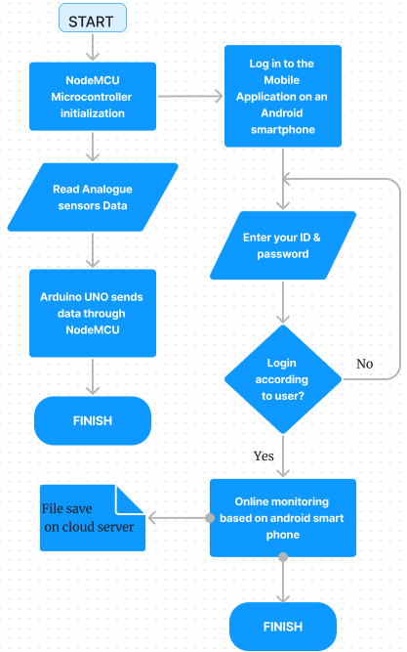

Fig.1 Monitoring system Flowchart

# **HARDWARE DESIGN AND IMPLIMENTATION**

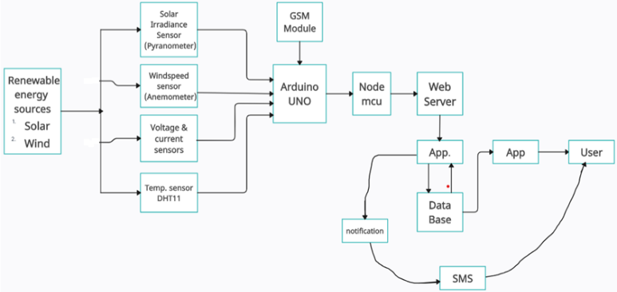

Fig.2 Block diagram of Android based Real-time Observing and Control System for Renewable Energy Sources.

1. Sensor Selection and Integration:

* Solar Panels: Solar irradiance sensor, Temperature sensor, Voltage/current sensor
* Wind Turbines: Anemometer (wind speed sensor),
* Temperature sensor, Rotational speed sensor
* Battery System: Voltage and current sensors

2. Microcontroller: Select a microcontroller (e.g., Arduino or Raspberry Pi) capable of handling sensor inputs and supporting communication modules.

Ensure compatibility with the selected sensors and communication protocols.

3. Communication module: Select a communication module to transfer data to your Android application. Options include Wi-Fi, Bluetooth, or GSM modules depending on application requirements and deployment environment.

4. Power supply: Design reliable power systems. Use solar panels or other renewable resources to power the monitoring system to ensure sustainability. Integrate rechargeable batteries or energy storage systems for continuous operation with low energy production.

5. Microcontroller Sensor Interface: Establishes the connection between the microcontroller and the sensor. Use the appropriate interface (analogue, digital) depending on the sensor specifications. Implement analogue to digital conversion.

# **SMARTPHONE USER INTERFACE AND IOT CLOUD SERVER**

1. **Smartphone User Interface:**

* Dashboard Design Intuitive dashboard with clear plates representing real data. Add several contraptions, maps, and graphs to display important information similar as energy product, consumption, and system status.
* User Authentication: apply a secure client authentication system to control access to IoT systems. cover client credentials with strong encryption.
* Real- time monitoring Enables real- time monitoring of renewable energy system parameters. It provides client to live updates on solar panel performance, wind turbine speed, battery status, and other affiliated data.
* Literal Data Analysis Adds functionality that allows client to dissect trends in literal data. apply an interactive map that allows clients to explore data at specific time intervals.
* Control medium Contains client friendly controls for remote operation of renewable energy systems. apply switches, sliders, or buttons to allow clients to control connected bias or acclimate system settings.
* Cautions and announcements Integrate alert systems to notify clients of important events and system anomalies. Allows clients to customize announcement settings, including exemplifications dispatch, push announcements.
* Energy effectiveness perceptivity Provides energy effectiveness perceptivity and suggests optimizations grounded on literal data. Provides clients with recommendations to ameliorate overall system performance.
* Weather Integration: Integrate rainfall information to help clients understand how environmental conditions affect energy product. View rainfall vaticinations and real- time rainfall vaticinations more easily.
* Client Profile Management Allows client to produce and manage biographies with substantiated settings. apply a client-friendly interface for streamlining settings and contact information.

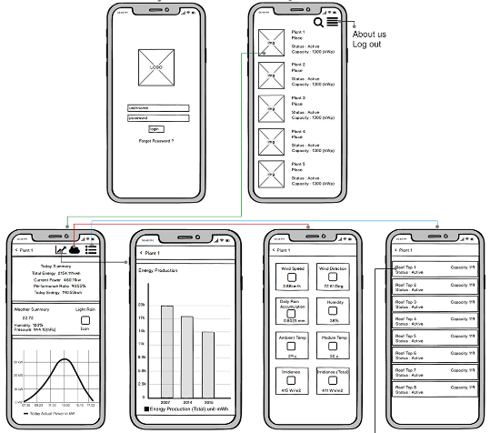

Fig.3 Smartphone User Interface

1. **IoT Cloud Server:**

* Data Reception and Storage - Establish a robust data event medium to admit data from connected IoT devices. apply a cloud- based storage solution for efficiently storing large volumes of data.
* Data Processing and Analysis - Develop algorithms for processing and assaying incoming data. Use machine learning or statistical models to decide perceptivity and trends from the collected data.
* Security Measures - Apply strict security measures to guard data during transmission and storage. Use encryption protocols, secure APIs, and access controls to cover sensitive information.
* Communication Protocols - Support standard IoT communication protocols (e.g., MQTT, CoAP) for flawless integration with connected devices. Ensure compatibility with a variety of IoT devices and platforms.
* APIs for Integration - Give well- proved APIs to allow third- party integrations or custom operations. Support integration with other IoT platforms or smart home systems.
* Scalability - Design the cloud server to be scalable, allowing it to accommodate more devices and data as the IoT system expands. use scalable cloud services. Data Visualization Offer data visualization tools for client to cover the performance of their IoT devices. give customizable dashboards and reports.
* Trust ability and Redundancy - Ensure high trust ability by enforcing redundancy measures. apply backup and recovery strategies to help data loss.
* Client Access Controls - Implement client access controls and authorizations to regulate who can penetrate specific data or perform certain conduct. give an inspection trail for covering stoner conditioning.
* for Remote Device Operation Implement features for remotely managing connected devices. Allow firmware updates, configuration changes, and troubleshooting actions. Remote Device Operation Implement features for remotely managing connected devices. Allow firmware updates, configuration changes, and troubleshooting actions.

By fastening on these aspects for both the smartphone user interface and the IoT cloud server, you can produce a comprehensive and client-friendly IoT system for monitoring and controlling renewable energy devices.

**Conclusion:**

In summary, the development of an Android based Real-time observing and control system for renewable energy sources holds great significance in promoting sustainability and client commission. Despite challenges in specialized complexity and data security, the system's capability to enhance functional effectiveness, give remote availability, and enable smart grid integration makes it a precious asset. Upcoming directions may involve incorporating machine learning, optimizing energy storage, and expanding community and grid interactions. With scalability in mind, these systems have the possibility to shape a more sustainable and technologically advanced energy geography.

##### **References**

[1] C. P. Kandasamy, P. Prabu, and K. Niruba, “Solar Potential Assessment Using PVSYST Software”, in International Conference on Green Computing, Communication and Conservation of Energy’ (ICGCE-2013)

[2] Blynk, “How blynk works,” *About Blynk*, pp. 1–81 (2013).

[3] Sangwongwanich, “A New Power Control Strategy for Grid- Friendly Single-Phase Photovoltaic Systems”, (2014).

[4] C. Rus-Casas, L. Hontoria, J. I. Fern, G. Jim, and F. Muñoz-rodr, “Development of a Utility Model for the Measurement of Global Radiation in Photovoltaic Applications in the Internet of Things (IoT” *Electronics J.*, vol. 8, no. 304, pp. 1–17, 2018

[5] S. Priyadarshi, S. Bhaduri, and N. Shiradkar, “IoT Based, Inexpensive System for Large Scale, Wireless, Remote Temperature Monitoring of Photovoltaic Modules,” in IEEE 7th World Conference on Photovoltaic Energy Conversion (WCPEC) (A Joint Conference of 45th IEEE PVSC, 28th PVSEC & 34th EU PVSEC), 2018, pp. 749– 752.

[6] M. Anthony, V. Prasad, K. Raju, M. H. Alsharif, Z.W. Geem, and J. Hong, “Design of rotor blades for vertical axis wind turbine with wind _ow moodier for low wind pro_le areas,'' *Sustainability*, vol. 12, no. 19, p. 8050, Sep. 2020, Doi: 10.3390/su12198050.

[7] Development of a data acquisition system for remote monitoring of renewable energy systems Kostas Kalaitzakis, Eftichios Koutroulis, Vassilios Vlachos Department of Electronics and Computer Engineering, Technical University of Crete, GR- 73100, Chania, Greece.

[8] Controllogger: A remote monitoring system for decentralized renewable energy sources: Fábio T. Brito, Sandro C.S. Jucá and Paulo C.M. Carvalho.