**Social Media App for Connecting Similar Interests People**

**Using flutter**

Aditya Prakash Sharma1, Ritesh Gupta2, Tanmay Kushwaha3

*1,2,3(Final Year B.TECH(IT) Students, Department of COMPUTER SCIENCE & ENGINEERING, INSTITUTE OF TECHNOLOGY & MANAGEMENT, GIDA GORAKHPUR, INDIA)*

*Corresponding Author: riteshshahofficial1@gmail.com*

|  |
| --- |
| ***Abstract:*** *Understanding interest similarity in Online Social Networks (OSNs) is crucial for various applications. This study addresses the challenge of determining interest similarity on platforms like Facebook, where users may not explicitly disclose their interests. Utilizing a substantial dataset of 479,048 users and 5,263,351 user-generated interests, the research focuses on movies, music, and TV shows. Findings reveal homophily in interest similarity, demonstrating that individuals tend to share more similar tastes when they have comparable demographic information or are connected as friends.*  *A practical prediction model is proposed, facilitating the selection of users with high-interest similarities and enhancing decision-making for OSN applications. Additionally, the paper introduces a novel method using a tag network to connect users with similar interests, outperforming traditional methods by providing a more efficient means of connecting like-minded individuals in social networks.*  ***Key Word****:**Face image synthesis, Generative adversarial network, Face Recognition* |

1. **Introduction**

In the ever-evolving landscape of online social networks, the pursuit of meaningful connections has become paramount. Traditional friend recommendation systems prove insufficient in efficiently reaching the vast long tail of users, highlighting the importance of connecting like-minded individuals. While current social media platforms offer diverse services, their limitations become apparent in scenarios requiring nuanced connections based on users' interests.

The increasing significance of social networking underscores the need to foster connections beyond the superficial. Existing friend recommendation systems, often reliant on connectivity alone, encounter challenges regarding inefficiency and incompleteness. The exponential space complexity of exhaustive searches and the risk of not reaching certain long-tail users illustrate these limitations. Connecting individuals based on shared interests, however, holds practical significance, providing not only efficient information sharing and problem-solving but also addressing psychological needs such as a sense of belonging and fulfillment.

The proposed work aims to bridge the gap by concentrating on connecting like-minded people beyond the constraints of traditional link-based methods. This endeavor is not only personally rewarding for users but also holds implications for service providers. From expediting information sharing to assisting in collaborative endeavors, connecting individuals with similar interests transcends the conventional paradigm of social networking.

**Challenges:**The challenges in connecting like-minded users are multifaceted. Users typically have an egocentric view of their social network, limiting their visibility to immediate contacts. The sheer scale of platforms like Facebook, Twitter, or LinkedIn makes manual searches impractical. Moreover, recommendation systems based solely on links face limitations due to the long-tail distribution of users. These challenges necessitate more effective and efficient tools for forging connections based on shared interests.

**Diverse Perspectives:** Recognizing the diverse perspectives and interests within social networks, the proposed research aims to overcome these challenges. The traditional representation of social networks as isolated islands impedes the exchange of information and communication between platforms. Additionally, differences in user profile domains and objectives across sites contribute to the complexity of profile matching. Addressing these issues, the study introduces a matching framework capable of considering all profile attributes. Through experiments and tests, the framework demonstrates its superiority in comparison to existing methods, offering a more holistic approach to user profile matching.

**Evolution of Online Social Networks:** The emergence and rapid growth of Online Social Networks (OSNs) over the last decade have transformed the way people interact, share information, and form communities. Unlike legacy web systems, OSNs center around both individuals and content, providing unprecedented opportunities to understand human relationships, behaviors, and preferences. Within this dynamic environment, understanding interest similarity among users has become essential for maintaining vibrant and engaging OSNs.

**Interest Similarity and Social Features:** Estimating interest similarity between users in OSNs is a nuanced challenge, given that users often do not explicitly detail their interests. The study explores how interest similarity relates to various social features, including profile overlap, geographic distance, and friend similarity. While previous research has shown that friends share more interests than strangers, this study takes a step further by addressing the issue of inferring users' interest similarity in the absence of complete information about their interests.

In conclusion, this research aims to enhance the landscape of social media connections by prioritizing the meaningful over the superficial. By addressing the limitations of existing recommendation systems and exploring novel approaches to profile matching, the study aims to contribute to the evolution of online social networks into more dynamic and personalized spaces for users.

1. **Problems**

**Algorithmic Bias and Echo Chambers:** Presently, social media platforms frequently utilize algorithms that unintentionally reinforce users' existing beliefs, resulting in the creation of echo chambers. This phenomenon restricts exposure to diverse perspectives, fostering polarization and the dissemination of misinformation.

**Privacy Concerns:** Persistent privacy issues arise as social media platforms gather and employ extensive user data for targeted advertising and content personalization. Users may express discomfort regarding the extent to which their personal information is used without explicit consent.

**Content Moderation Challenges:** Social media platforms continually grapple with the effective moderation of content, tackling issues such as the proliferation of fake news, hate speech, and other harmful content. Achieving a delicate balance between freedom of expression and preventing abuse remains a multifaceted task.

**Addictive Design Patterns:** Numerous social media platforms employ addictive design patterns, such as infinite scrolling and notifications, to prolong user engagement. This practice may contribute to social media addiction, negatively impacting mental health and overall well-being.

**Lack of Nuanced Connection Options:** Friend recommendation systems solely based on connectivity may lead to inefficient and incomplete connections. Users often find themselves restricted to recommendations from their immediate circle, limiting the potential for meaningful connections beyond their immediate network.

**Data Silos and Interoperability:** Social networks function as data silos, presenting challenges for users seeking seamless connectivity and information sharing across platforms. This lack of interoperability curtails user autonomy and complicates efforts to maintain a consistent online presence.

**Impersonation and Fake Accounts:** The prevalence of impersonation and fake accounts on social media platforms raises concerns about the authenticity of online identities. Users may encounter difficulties in distinguishing genuine accounts from fraudulent ones, resulting in trust issues within the online community.

**Limited Control Over Content Visibility:** Users frequently experience limited control over the visibility of their content. Algorithms determine content appearance on users' feeds, and alterations in these algorithms can significantly impact the reach of individual posts, influencing the organic growth of user-generated content.

**Monetization Pressures:** Many social media platforms heavily depend on advertising revenue for their business models. This reliance may lead to design decisions that prioritize user engagement solely for the sake of ad views, potentially compromising user experience and content quality.

**Inadequate Tools for Long-Tail Connections:** Social media platforms confront challenges in efficiently connecting users with niche or specific interests. Recommendation systems based solely on links may struggle to reach the diverse long tail of users, impeding the potential for meaningful connections rooted in shared interests.

1. **Literature Review**

**Recommendation through Tag Network Inference**

Our proposal aims to connect users with similar interests via tag network inference. The concept is depicted in Figure 1, where nodes of different colors represent users within a social network. Some users are part of the largest network component, while others are disconnected, either isolated or in small groups. Highlighted in blue (dark) are four users who are enthusiasts of Apple products like the iPhone and iTouch, hence considered "like-minded" (Formal definition in Section 3). On the right side of the figure is a tag network, where each node represents a tag, and the weight between two tags signifies users employing both tags simultaneously.

By harnessing the "wisdom of the crowd," the tag network elucidates semantic relationships among tags. Tag usage similarity serves as a metric to gauge users' likeness. For instance, if we aim to connect other Apple fans to the upper left user in blue (dark), we utilize the tag network and identify the three other Apple fans in the lower left.

This approach is advantageous as it necessitates no parameter tuning, making it practical to employ. Additionally, its efficiency is notable, with recommendation time complexity being linear concerning the number of users and tags in a social network.

**Synopsis**

Connecting individuals with akin interests diverge from link prediction, as it focuses on dissimilar objectives. While link prediction endeavors to suggest individuals one may already know, connecting like-minded people aims to discover "familiar strangers" who share analogous experiences, opinions, or interests. Notably, similarity does not guarantee friendship, as individuals with shared interests may not necessarily be friends, and vice versa.

**Key points of our proposal include:**

* Utilizing a tag network to denote semantic relevance among tags, showcasing its superiority over latent semantic indexing (LSI).
* Connecting like-minded users through tag network inference, leveraging collective crowd wisdom. This approach proves effective compared to baseline methodologies.

**Tag Network Construction**

Tagging serves as a method to organize various objects such as bookmarks and blogs using informal vocabulary for future browsing and sharing. Tags, which can be words or phrases, may not be conventional dictionary terms. Figure 2 provides an example of blog description tagging on the Blog Catalog.

Tagging represents collective wisdom, amalgamating diverse tagging knowledge to naturally cluster semantically relevant tags. The connectivity of tags is represented in a network format termed Tag Network.

**Construction steps for a tag network on the Blog Catalog dataset include:**

* Connect tags within each object (e.g., blog) as a clique.
* Combining all cliques corresponding to objects owned by each person to form unweighted tag networks. Aggregating these tag networks yields a weighted tag network, where tags represent the union of all users' vocabularies, and link weight denotes the number of users employing both tags simultaneously.

The weighted tag network snapshot illustrates this process, with link weight representing the number of users. This method avoids bias from spam users while enabling future considerations for user influence in link weight assignment. Tags are prevalent across various social networking platforms, facilitating easy adaptation of the construction process.

**RELATED WORK**

Recommendation systems are increasingly prevalent in social media, aiming to predict user preferences for various items like products, movies, services, or information. Collaborative Filtering (CF) stands out as a widely utilized technique across numerous applications. Its fundamental principle lies in the observation that individuals who have concurred in the past are likely to concur in the future. Consequently, CF algorithms seek out individuals with similar tastes to provide item recommendations.

Another category of recommendation systems focuses on suggesting people rather than items. For instance, Facebook's "People You May Know" system employs mutual connections or the triadic closure principle. According to this principle, if two individuals share strong connections with a third person, there's a higher likelihood of a connection, whether strong or weak, between the two individuals.

Link prediction, on the other hand, revolves around predicting future interactions between users in a social network based on current knowledge. The essence of this approach lies in recommending potential friends based on their proximity to a given

user. Recent advancements in this domain include extensions that leverage user profiles, activities, interactions, user-generated content, network structures, and other factors.

**IMPLEMENTATION AND EXPERIMENTATION**

In this section, we introduce the prototype we developed to validate our approach, along with the outcomes of a series of experiments conducted to assess and substantiate the efficacy of our proposal.

**Implementation**

Our prototype, built using C#, comprises four main components, as depicted in Figure 1:

**Profile Generator:** Responsible for generating random social network profiles with varying or similar attribute values utilizing the FOAF vocabulary. To streamline this process, we employ a "word generator" to produce random words with a similarity measure exceeding a designated threshold. Users can define the percentage of profiles with:

* Identical IFP values.
* Similar profiles referencing the same user but possessing different IFPs.
* Common attributes between two similar profiles.

**Profile Retriever:** Extracts profiles with identical IFP values from the initial set, either through a smasher or by accessing a locally provided dataset. Crawling profiles from social networks presents challenges due to platform policies.

**Weight Assignment:** Manually or automatically assigns a weight to each attribute in the user profile, as discussed in Section III-C.

**Profile Matcher:** Determines whether two compared profiles are identical, employing a decision-making algorithm computed using weighted similarity scores.

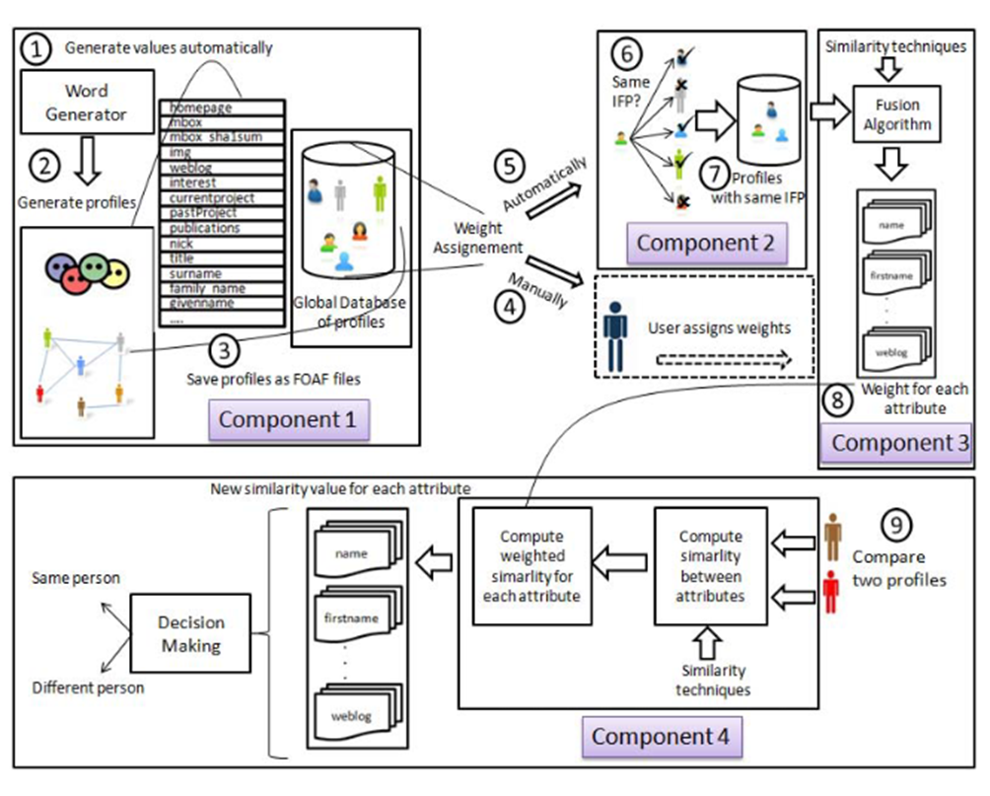

**Figure 1:** Prototype Architecture

**Experiments**

**Context:** We generated three datasets of user profiles with FOAF attributes for experimentation purposes. Attribute values were automatically generated using a word generator, with a similarity threshold set at 0.8 to generate similar words. Each dataset contained profiles representing different individuals, with a predefined set of words unique to each dataset. These profiles were divided into three sets: Set 1 (25 profiles), Set 2 (15 profiles), and Set 3 (10 profiles). Additionally, 20% of the generated profiles (Set R) represented the same individual but with different IFP values. Experiments were conducted on a machine with specifications of 2.8 GHz Intel Centrino and 4GB RAM.

**Relevance of the Proposed Approach:** This experiment aimed to demonstrate the capability of our method to identify profiles referring to the same individual more effectively than existing methods. We compared the results between the IFP-based method and our approach, varying the percentage of attributes with similar values between the two profiles.

**Impact of Assigning Weights to Attributes:** We conducted experiments to evaluate the benefits of assigning weights to attributes.

**Different Decision-Making Algorithms:** A series of experiments were conducted to assess the performance of various decision-making algorithms. Precision and recall measures were computed for methods including DS, BN, Avg, Min, and Max. DS method emerged as the preferred choice due to its reliability and completeness.

Overall, the experiments conducted provided insights into the effectiveness and efficiency of our proposed approach, validating its relevance in profile-matching tasks.

**Different Decision-Making Algorithms:** To further evaluate the efficacy of various decision-making algorithms, a comprehensive series of experiments was undertaken. These experiments aimed to measure the potential benefits and reliability of each algorithm while varying the number of attributes with differing values. Precision and recall measures were computed using the following formulas:

Five methods, as outlined in Section III, were tested: DS, BN, Avg, Min, and Max. The focus of this test was to evaluate each algorithm's performance solely on the decision-making level, without considering any fusion-level performance.

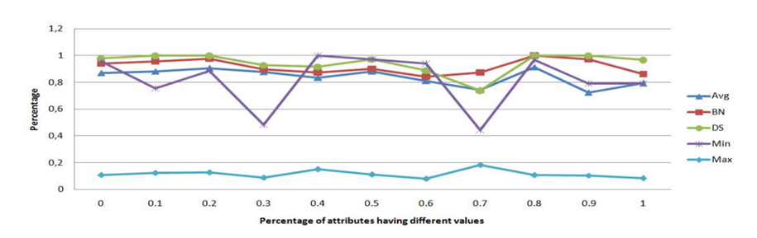

**Figure 2:** Precision percentage while varying the number of attributes having different values

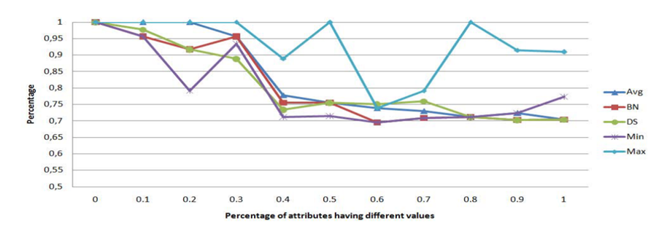

**Figure 3:** Recall percentage while varying the number of attributes having different values

As depicted in Figure 2, the precision of the DS method emerged as the highest, closely followed by BN. The precision of Avg. was deemed acceptable, while Min exhibited consistent variation. Notably, the Max method displayed the lowest precision but the highest recall, as illustrated in Figure 3.

The DS method notably boasted a good recall percentage, surpassing the remaining methods (BN, Min, and Avg.). Furthermore, it was chosen due to two primary reasons:

**Reliability:** A significant majority of the detected profiles were deemed relevant.

**Completeness:** A substantial proportion of previously generated relevant profiles were successfully detected.

These experiments provided valuable insights into the performance and suitability of different decision-making algorithms, ultimately confirming the DS method as the preferred choice for its reliability and completeness in profile-matching tasks.[1]

**The Influence of Social Media on Interpersonal Relationships**

**Overview of Interpersonal Relationships**

Interpersonal relationships encompass various connections between individuals, including familial ties, friendships, romantic partnerships, and professional affiliations. These relationships significantly impact individuals' physical and mental well-being, as well as their overall quality of life. The depth and intimacy of interpersonal relationships often hinge on the extent of self-disclosure between the involved parties, as posited by Altman and Taylor's social penetration theory. The advent of social media has revolutionized social interaction, presenting both opportunities and challenges for interpersonal relations. Understanding the effects of social media on these relationships is crucial for fostering healthy social dynamics and promoting positive engagement in online platforms.

**Ways Social Media Influences Interpersonal Relationships**

The influence of social media on interpersonal relationships can be categorized into several key aspects.

**Providing Diverse Social Channels**

Social media platforms offer accessible and varied avenues for communication, enabling individuals to interact with friends, family, and colleagues across geographical boundaries. Online communities, chat applications, and social networks facilitate seamless communication, contributing to the expansion of interpersonal networks.

**Enhancing Social Reach and Depth of Communication**

Social media transcends temporal and spatial constraints, allowing for flexible and profound exchanges between individuals. Online interactions enable people to broaden their social circles and engage with individuals from diverse backgrounds, fostering mutual understanding and mitigating prejudice.

**Increasing Dependency on Social Media**

The ease and immediacy of social media usage may lead to heightened reliance, potentially diminishing face-to-face communication opportunities. Excessive dependence on social media can exacerbate feelings of isolation and estrangement, negatively impacting interpersonal relationships.

**Reducing Physical Interaction**

The prevalence of social media may diminish the frequency of in-person interactions, as individuals gravitate towards online communication platforms. This substitution of physical interaction with virtual engagement may impede genuine interpersonal connection and emotional expression.

**The Impact of Social Media on Interpersonal Relationships**

Social media encompasses digital platforms and technologies that facilitate communication and interaction among users. While social media serves as a conduit for sharing experiences and perspectives, its influence on interpersonal relationships is multifaceted.

**Positive Effects of Social Media**

Social media fosters connectivity by bridging geographical distances and nurturing social support networks. Through online platforms, individuals can maintain relationships, share experiences, and strengthen interpersonal bonds, particularly in long-distance scenarios.

Proceedings of the 4th International Conference on Educational Innovation and Philosophical Inquiries. Furthermore, social media platforms facilitate frequent communication and information sharing, thereby enhancing mutual understanding and closeness among individuals.

**Negative Effects of Social Media**

Despite its benefits, social media usage may engender feelings of loneliness and anxiety due to reduced face-to-face interaction. Additionally, the proliferation of false information and cyberbullying on social media platforms can undermine trust and exacerbate interpersonal conflicts.

Moreover, excessive engagement with social media may detract from meaningful offline relationships, leading to neglect and deterioration of interpersonal bonds.

**Impact of Social Media Dependency**

The widespread adoption of social media has led to increased dependency among users, particularly evident in platforms like WeChat. Social media dependency can detrimentally affect mental health, time management, and physical well-being, ultimately hindering individuals' ability to cultivate and sustain meaningful interpersonal relationships.

In conclusion, while social media offers unprecedented opportunities for connectivity and communication, its overreliance can have adverse effects on interpersonal relationships. Balancing online engagement with real-life interactions is essential for fostering healthy social dynamics and maintaining meaningful connections in the digital age. Efforts to regulate social media usage and promote responsible online behavior are crucial for nurturing a positive and supportive online community.[2]

**Social Media Platforms and Social Behavior**

Social media (SM) is not always a mere distraction or procrastination platform. While some users perceive social media networks as the ultimate means to stay informed, the majority of newsgroups, businesses, and individuals utilize SM to communicate with the general public, keeping their intended audience promptly updated through posts. Despite concerns from some parents regarding the potential harm of SM for their children, there are instances where it ensures positive outcomes from maintaining social media accounts (Atwan, Lushing, & Andrews, 2008). Teenagers should possess the same level of concern and awareness as adults (Barker, 2009). They can adhere to their cherished rules and principles while utilizing SM, which, despite feelings of social alienation, provides them with a sense of connection and belonging (Panagiotes Anastasiades, Zaranis, & SpringerLink (Online Service, 2017).

An increase has been noted in the usage of SM among youngsters, with findings indicating that 40% of respondents are teenagers using SM sites. These findings suggest that young individuals utilize social media on an almost daily basis, with the primary objectives being to maintain contact and influence these networks through frequent visits. According to quantitative data, most young people prefer using social media applications and dedicate significant hours to surfing various websites. The study's statistics reveal Facebook's popularity among youth.

The research indicates that young users are the most impacted group by social media, as these platforms offer opportunities to make friends within large communities, express ideas, and alleviate daily life stress. Undoubtedly, social media has an impact on young people's lives, including their social activities, to some extent.

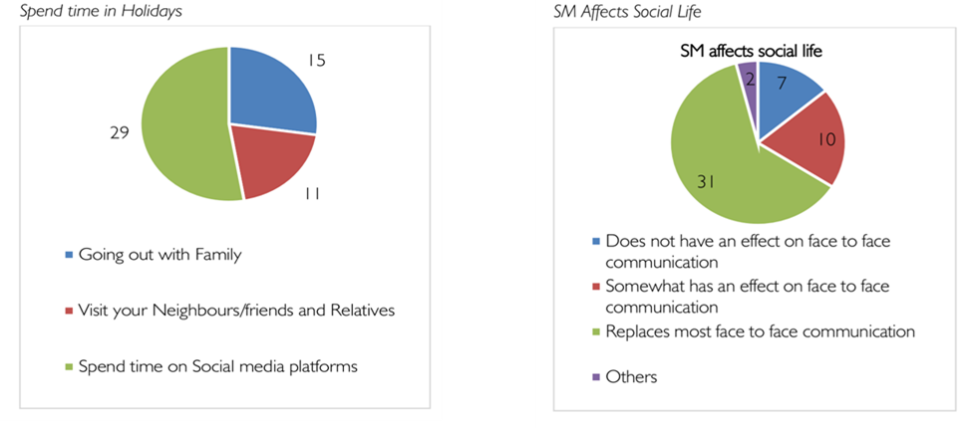

**Figure 4 :** Social Media Platform and its effects on human behaviour.

Findings reveal that 62% of respondents acknowledged that social media largely replaced in-person interactions. A significant proportion prefers staying at home to play online games (56%) compared to going outside or to playgrounds with friends (44%). This attitude contributes to a lack of social interaction within the community, with results showing that 52.7% of males and females are more inclined to spend time on social media platforms during holidays than engaging in activities with family (27.3%) or visiting neighbors/friends and relatives (20%). Similarly, the majority of respondents believe that an increase in online friends correlates with a decrease in real friends (66%), yet the same proportion strongly agrees that social media facilitates connections with distant relatives (66%). The study also suggests that youth intend to continue using social media, emphasizing the need for a positive approach to maintain a balance between SM usage and social behavior.[3]

**Methodology**

The main aim of this method is to forecast the most probable profile of a user 'X' on Facebook, given their Twitter profile, assuming they have accounts on both platforms. This method relies on counting the Common High-Frequency Words (CHFWs) found in the content attributes of profiles. The profile of user 'X' on either Twitter (T) or Facebook (F) is represented as POSN, X, where the OSN belongs to {Twitter, Facebook}. So, the profile of user 'X' on an OSN can be expressed as:

*i* *n*

*POSN* , *X*  *Cix*

*i* 1

Here, Ci represents the ith post or tweet out of the total n posts or tweets shared by or with user 'X'. The most probable profile of user 'X' among all Facebook profiles is determined based on HFWs as follows:

 *MP*, if (*HFWs*)*S*  (*HFWs*)*T*  *threshold* (*η*)

*PFacebook*, *X*  

*Null*, if (*HFWs*)*S*  (*HFWs*)*T*  *threshold* (*η*)

Where (HFWs)S and (HFWs)T represent the number of high-frequency words in the source and target profiles respectively, and 'η' denotes the threshold value for the number of CHFWs required for the profile to be designated as MP. After preprocessing the content attributes (such as removing whitespaces, stop words, etc.), word clouds were created to identify high-frequency words in the user's profile. String matching techniques were then used to identify the CHFWs shared between the source and target profiles. For this purpose, the Jaro-Winkler algorithm was employed (Winkler, 2005). This algorithm measures the similarity between two strings, where a score of 1 indicates no similarity and 0 represents an exact match.

**Threshold Value for the Number of HFWs and CHFWs**

While developing the word cloud to extract HFWs from users' posts/tweets, we filtered out whitespaces, numbers, punctuations, and stop words to ensure the extraction of meaningful HFWs that could significantly impact the matching process. A threshold value was determined to select the number of HFWs and corresponding CHFWs. We considered only significant words with the following:

Frequency of words≥

Total number of useful words in the content of a profile

Total number of posts

Frequency of words≥

Total number of posts

Total number of useful words in the content of a profile

A threshold value for selecting the MP target profile among all target profiles based on the number of CHFWs was determined using equation (2). The target profile(s) with the highest value of CHFWs would be designated as the MP target profile.

*frequency of words* *total number of useful words in the content of a profile total number of posts*

Similarly, a threshold value was determined for selecting the MP target profile among all target profiles based on the number of CHFWs. The target profile(s) with the highest value of CHFWs would be designated as the MP target profile.[4]

 *CHFW* [*T1*] , *CHFW* [*T2*] , ………………. , ⎫

*CHFWs*   

 *CHFW* [*TN-1*] , *CHFW* [*TN*] ⎭

**Leveraging Online Relationships for New Opportunities**

The initial excitement surrounding social media platforms in recent years has largely focused on their potential to facilitate connections that might otherwise be difficult or impossible. These platforms enable individuals to build relationships, collaborate, and find support across geographical and social boundaries, leading to the formation of new groups and the strengthening of existing communities (Ellison et al., 2010). This article explores the diverse types of relationships fostered by social media and their significance in various aspects of life.

**Types of Relationships Facilitated by Social Media:**

* **Friendships:** Social media platforms provide tools for creating and maintaining friendships, allowing individuals to interact with peers and engage in reciprocal relationships. While some argue that online-only friendships may lack the depth of face-to-face interactions, online connections offer unique opportunities for emotional support and social engagement, complementing offline interactions.
* **Kinship Relationships:** Social media extends the reach of family connections, enabling relatives to stay connected and share information despite geographical distances. Activities such as monitoring children's activities and fostering connections among distant relatives are made easier through these platforms.
* **Professional Relationships:** Social media platforms like LinkedIn facilitate professional networking, allowing individuals to connect with colleagues and industry peers for collaboration and knowledge sharing. The integration of social media into the workplace blurs the lines between personal and professional relationships, requiring new strategies for managing interactions.
* **Consumer Relationships:** Social media platforms play a crucial role in shaping consumer relationships by facilitating communication between consumers and businesses. Features like the "Like" button enable consumers to affiliate with brands and share feedback, influencing purchasing decisions and enhancing marketing strategies. The rise of social media has transformed consumer relationships into co-production endeavors, where individuals actively contribute to innovation and value creation. Crowdsourcing platforms invite consumers to participate in problem-solving and idea generation, tapping into diverse perspectives and expertise.

**Conclusion:**

Social media platforms intersect with various types of relationships, reshaping the dynamics and expectations associated with them. As users navigate this evolving landscape, understanding the interplay between relationship dynamics and social media systems is crucial for harnessing their full potential while addressing challenges that may arise.[5]

Social media encompasses a range of Internet-based applications founded on the principles and technology of the Web, facilitating the creation and exchange of user-generated content. With its accessibility and support from scalable communication methods, social media platforms are increasingly prevalent, transforming consumer behavior. Nowadays, consumers can effortlessly engage with content, such as watching ads on YouTube, expressing opinions on Twitter, and sharing content with friends on Facebook. Unlike traditional paper-based or electronic media like magazines, newspapers, radio, and TV, social media offers distinctive features including frequency, interactivity, usability, and performance.

There are four primary types of social media platforms:

**Social Networking Sites:** These online platforms enable users to build social networks or relationships based on shared personal or professional interests, activities, backgrounds, or real-life connections. Users typically input a list of people they know, who are then allowed to confirm the connection. Examples include LinkedIn for professional networking and Facebook for personal and professional connections.

**Social News Websites:** These communities encourage users to submit news stories, articles, and media, which are then shared and ranked based on popularity through user voting. Users can also comment on and share these stories further.

**Media Sharing Sites:** These platforms allow users to store and share multimedia files such as photos, videos, and music with others. The media can be accessed and viewed through any web browser and may be made available either with a password or to the public.

**Blogs:** A blog is a web-based discussion featuring informal diary-style entries known as posts. It provides individuals with a platform to express their views on various topics. As of February 16, 2011, there were over 156 million public blogs in existence.[6]

1. **Conclusion**

In conclusion, this paper introduced a robust framework for user profile matching in social networks, addressing challenges in discovering profiles linked to the same physical user. The proposed methodology, employing manual and automatic attribute weighting, string and semantic similarity metrics, and aggregation functions, demonstrated superior performance in comparison to existing methods. Additionally, a prototype validated the effectiveness of the approach. Future work involves exploring further intersocial operations and functionalities. Another study presented a tag network inference approach connecting like-minded users, outperforming baseline methods in recommending users with similar interests. The tag network method, with linear time complexity for online recommendation, offers potential for diverse applications and warrants exploration in tag selection for network construction.

1. **References**
2. Srivastava, D. K., & Roychoudhury, B. (2022). *Profile matching of online users across multiple social networks: a text mining approach.* International Journal of Enterprise Network Management*,* 13(1), Retrieved from Inderscience Enterprises Ltd
3. Chopra, C., & Gupta, S. (2020). *Impact of social media on consumer behavior*. International Journal of Current Research and Technology, 8(6), 265. Retrieved from http://www.ijcrt.org ISSN: 2320-2882
4. Rustam, H., Anwar, M. N., & Iqbal, Q. (2023). *Social media impact on human Behaviour*. Global Sociological Review, VIII(II), 15-29. https://doi.org/10.31703/gsr.2023(VIII-II).03.
5. Butler, B. S., & Matook, S. (2014). *Social media and relationships*. In Encyclopedia of Information Science and Technology (pp. xx-xx). DOI: 10.1002/9781118767771.wbiedcs097.
6. Raad, E., Chbeir, R., & Dipanda, A. (2010). *User profile matching in social networks*. In Proceedings of the International Conference on Network-Based Information Systems (NBiS), Takayama, Japan. DOI: 10.1109/NBiS.2010.35
7. Wang, X., Liu, H., & Fan, W. (2011). *Connecting users with similar interests via tag network inference*. DOI: 10.1145/2063576.2063723.