**CFD AND WIND TUNNEL STUDY ON CRICKET BALL AT DIFFERENT SEAM ANGLE AND VELOCITY**

Magesh Sooraj P U1, Nallavan G2

*1Department of sports technology Tamil Nadu Physical Education and Sports University, India)*

*2(Department of sports technology /Tamil Nadu Physical Education Sports University, India)*

*Corresponding Author: mageshsooraj04@gmail.com*

|  |
| --- |
| ***Abstract:***  *This study delves into the intriguing investigation of flow patterns over a cricket ball, employing both computational and experimental methods for a comparative analysis. The work explores about variation of velocities in different angles, here we have used as 4 cricket balls they are dukes cricket balls, SG cricket balls, dukes 3d printed cricket ball and SG printed cricket ball. While comparing all the cricket balls it shows values in the wind tunnel experiment in seam angles of 0°,30°,45°,60°& 90° in a subsonic wind tunnel. Both computational simulations and experimental observations were conducted to analyze the impact of seam angles and velocities on the cricket balls. The results obtained from computational models were successfully validated through experimental data, affirming the reliability of the computational approach in predicting aerodynamic characteristics. Flow visualization techniques further confirm these findings, highlighting the significance of keywords such as drag, seam angles, reverse swing, flow visualization, and computational fluid dynamics (CFD) in understanding the aerodynamics of cricket balls. Overall, this research provides valuable insights into optimizing bowling strategies by considering the interaction between seam angles, velocities, and aerodynamic behavior of cricket balls.*  ***Key Word****: Ball drag analysis, Reverse swing analysis, CFD analysis, Cricket ball analysis* |

1. **Introduction**

This study uses 4 cricket balls: dukes cricket balls, SG cricket balls, dukes 3d printed, cricket SG printed cricket balls are compared with each other. The exploration of aerodynamics in sports, particularly cricket, offers fascinating insights into the physics governing ball movement. The attributable to spinning, causes a cricket ball to deviate from its original trajectory, adding an element of unpredictability to the game. This phenomenon is pivotal in understanding swing, a crucial tactic employed by bowlers to outmaneuver batsmen [3]. A cricket ball's characteristics, including weight, diameter, and construction, significantly influence its behavior on the pitch. Swing, categorized as conventional or reverse, depends on factors like seam position and ball velocity. Scientific studies, pioneered by researchers like Cooke, Alam, Bartlett, Barton, Metha, Sayers, and Hill, have delved into unraveling the complexities of cricket ball swing. The presence of a seam complicates aerodynamic analysis, making it essential to conduct meticulous studies to comprehend swing mechanics fully [8]. Previous research has shed light on the role of pressure differentials and boundary layer separation induced by the seam in facilitating swing, particularly in the initial overs of a match when the ball's surface remains laminar due to shine orientation [10]. This study builds upon existing research by investigating the influence of ball age and release angle on swing [5]. Utilizing wind tunnel experiments on both used and fresh cricket balls, the research explores the effects of ball wear and seam orientation under various velocities and seam angles. By employing both experimental and computational fluid dynamics (CFD) analyses, the study aims to deepen our understanding of swing dynamics, contributing valuable insights to cricket tactics and strategy [6].

1. **Material and methods**

Aerodynamics of cricket ball involved in the suction cup with wind tunnel support there are certain dimensions for testing sections the seam has 5 different types of angles. The wind tunnel's peak velocity capability was 40m/s, while the focused-on velocities it has a ranging from 10m/s to 30m/s it can enhance maximum no. of velocity. Four types of models were utilized for experimentation: two original cricket ball and two 3D printed ball equipped with 18 pressure ports [1],[2]. Diagrams illustrating the attached of these models are provided in Figure 1, while outlines the details of the experiments conducted, including seam angles have studied and measurements performed. Pressure measurements

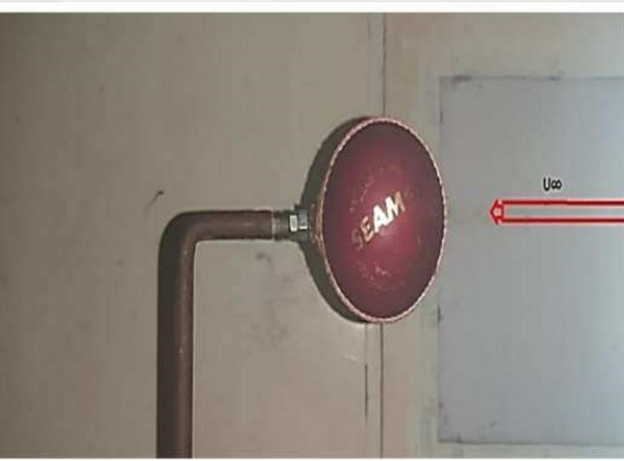

Fig.1.3D cricket ball mounted in wind tunnel

3d ball model Pressure tubes were attached to the ball and connected to manometer tubes. The measurements were taken without any support out at velocities ranging from 11.5m/s to 30m/s, with the setup adjusted manually to align with different seam angles (0°, 30°, 45°, 60°, and 90°). Manometer readings were noted for each seam angle and velocity, which were subsequently used to calculate pressure coefficients (Cp). Force measurements were performed on the dukes’ cricket ball using a six-component system. The setup involved a vertical stringer the horizontal connecting upright post in the frames us connected to the component system, which was easily directly attached to the cricket ball via a nut and bolt. Measurements were guidance under various velocities for each seam angle and were reiteration for three different ball conditions rough smooth: both sides smooth, one side rough, and both sides rough. Additionally, separate experiments were conducted for laser smoke flow visualization, force measurements, and pressure measurements, owing to the limitations of available instrumentation and setup. Overall, this experimental setup facilitated a comprehensive analysis of the aerodynamic characteristics of cricket balls, considering various seam angles, velocities, and ball conditions, providing valuable insights into the factors influencing ball behavior during flight.

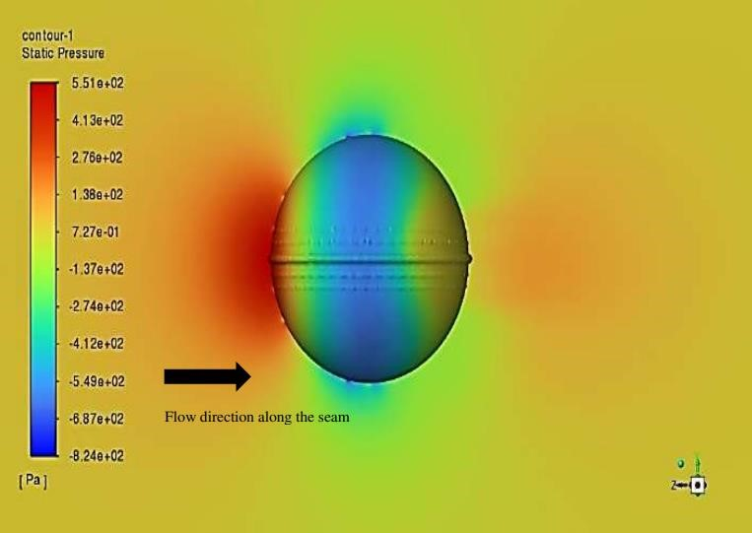

Fig. 2. Cricket ball analysis using Ansys

A combined Computational Fluid Dynamics (CFD) and wind tunnel study on cricket balls at varying seam angles and velocities offers invaluable insights into the intricate aerodynamics governing ball behavior. This discussion highlights the significance of such research and its implications for cricket performance and strategy.

**1. Comprehensive Analysis**

Integrating CFD simulations with wind tunnel experiments allows for a holistic examination of cricket ball aerodynamics. CFD enables detailed numerical analysis of flow patterns, while wind tunnel experiments provide empirical validation under controlled conditions, ensuring the reliability of the findings.

**2. Seam Angle Effects**

Seam angles play a pivotal role in determining the aerodynamic forces acting on the ball. Different seam orientations induce distinct pressure differentials and boundary layer separations, influencing the ball's trajectory and potential for swing [4]. Exploring a range of seam angles, from 0° to 90°, the study elucidates the optimal configurations for maximizing swing potential and overall performance.

**3. Velocity Influence**

The study investigates how variations in velocity impact cricket ball aerodynamics. Changes in velocity affect the magnitude of aerodynamic forces, including drag and lift, thereby influencing the ball's flight characteristics and responsiveness to bowler input [7],[9]. By examining a spectrum of velocities, from low to high, the research provides valuable insights into the dynamic interplay between bowling speed and ball behavior.

**4. Validation and Confidence**

The agreement between CFD predictions and wind tunnel measurements enhances confidence in the predictive capabilities of computational models. Validation through experimental data ensures the accuracy and reliability of the simulations, reinforcing the credibility of the study's findings. This validation strengthens the foundation for future research endeavors and practical applications in cricket training and equipment design. Insights gleaned from this study have practical implications for players, coaches, and equipment manufacturers. Understanding how seam angles and velocities influence ball flight allows for the refinement of bowling techniques, the development of strategic approaches, and the optimization of equipment design to enhance performance on the field. Moreover, this research contributes to the advancement of cricket coaching methodologies and the formulation of data-driven strategies tailored to exploit the nuances of ball aerodynamics. In summary, the CFD and wind tunnel study on cricket ball aerodynamics across various seam angles and velocities represents a significant advancement in our understanding of the sport. By integrating computational modeling with experimental validation, this research offers valuable insights that can inform player training, strategic decision-making, and the continual evolution of cricket equipment technology.

**Statistical analysis**

Here, we have analyzed 4 types of balls in different angle which ranges from zero degree to 90 degree to compare and get to know about the benefits of the balls in different angle in aerodynamics perspective. Out of the four balls, we have dukes cricket ball, SG cricket ball and also 3D printed models for both of them.

**Table no 1:** Shows the ball type and dukes cricket ball comparing with 3d cricket ball absorbing seam angle velocity

|  |  |  |  |  |
| --- | --- | --- | --- | --- |
| Ball type | radius | Height (seam) diameter ratio | Seam angle velocity | Measurement carried out |
| Dukes cricket ball | 36mm | 0.32 | 0°,30°,45°,60°and  90° | Force and smoke flow vis |
| Dukes cricket ball | 36mm | 0.20 | 0° | Force and smoke flow vis |
| Dukes cricket ball | 36mm | 0.25 | 30° | Force and smoke flow vis |
| Dukes cricket ball | 36mm | 0.14 | 45° | Force and smoke flow vis |
| Dukes cricket ball | 36mm | 0.12 | 60° | Force and smoke flow vis |
| Dukes cricket ball | 36mm | 0.01 | 90° | Force and smoke flow vis |
| Dukes 3d printed ball | 36mm | 0.31 | 0°,30°,45°,60°and  90° | Pressure measurement |
| Dukes 3d printed ball | 36mm | 0.22 | 0° | Pressure measurement |
| Dukes 3d printed ball | 36mm | 0.19 | 30° | Pressure measurement |
| Dukes 3d printed ball | 36mm | 0.23 | 45° | Pressure measurement |
| Dukes 3d printed ball | 36mm | 0.14 | 60° | Pressure measurement |
| Dukes 3d printed ball | 36mm | 0.01 | 90° | Pressure measurement |
| SG cricket ball | 36mm | 0.31 | 0°,30°,45°,60°and  90° | Force and smoke flow vis |
| SG cricket ball | 36mm | 0.31 | 0° | Force and smoke flow vis |
| SG cricket ball | 36mm | 0.19 | 30° | Force and smoke flow vis |
| SG cricket ball | 36mm | 0.22 | 45° | Force and smoke flow vis |
| SG cricket ball | 36mm | 0.14 | 60° | Force and smoke flow vis |
| SG cricket ball | 36mm | 0.01 | 90° | Force and smoke flow vis |
| SG 3d printed ball | 36mm | 0.31 | 0°,30°,45°,60°and  90° | Pressure measurement |
| SG 3d printed ball | 36mm | 0.18 | 0° | Pressure measurement |
| SG 3d printed ball | 36mm | 0.23 | 30° | Pressure measurement |
| SG 3d printed ball | 36mm | 0.14 | 45° | Pressure measurement |
| SG 3d printed ball | 36mm | 0.01 | 60° | Pressure measurement |
| SG 3d printed ball | 36mm | 0.02 | 90° | Pressure measurement |

Fig. 2. Cricket ball analysis using Ansys

Fig. 2. Cricket ball analysis using Ansys

Fig. 2. Cricket ball analysis using Ansys

Fig. 2. Cricket ball analysis using Ansys

1. **Result**

Experiment of 4 balls: dukes cricket ball, SG cricket ball, dukes 3D printed ball, and Sg cricket ball are compared to find the force and smoke flow visualization and pressure measurement. We have used 36 mm of all the cricket balls of dukes’ balls and sg cricket balls and 3d printed ball to calculate the difference for the studyTop of Form. In these results provide valuable insights into the aerodynamic principles governing cricket ball flight and swing, which can inform strategies for players, coaches, and equipment designers seeking to optimize performance[11],[12]. The study would investigate how seam angle and velocity impact the spin rate and axis stability of the cricket ball. This information is essential for bowlers aiming to control the movement of the ball through the air cfd results with wind tunnel measurements can optimize the balls designs of enhancing this could lead to the developments of balls that exhibit more predictable flights greater swing increased spin capabilities [3].

1. **Discussion**

Let’s compare the aerodynamics of the dukes cricket balls ,the sg cricket balls and a 3d printed dukes cricket balls across various seam angles 0 degree high seam stability generates swing due to polished surface and pronounced seam in sg cricket ball moderate seam stability ,less swing compared to dukes ball similar to dukes balls depends on materials properties 15 degrees continues to maintain the stability and swing seam acts as an airfoil generating lift 15 degrees sg cricket balls stability decreases slightly swing may vary stability and swing depends on material properties and seam design 30 degrees seam acts a significant aerodynamics elements generating pronounced swing sg cricket balls swing mat reduce compared to lower seam angles swing mat vary depending on the design and material properties 45degrees significant swing seam becomes more prominent in aerodynamics effects sg cricket balls swing decreases the further seam may not have as much impact swing could be influenced by seam design and material properties 60 degrees dukes balls swing continues but decreases compared to lower angles sg cricket balls swing diminishes seams effect may be minimal 3d printed ball swing could vary based on the materials and design 75 degrees minimal swing seams aerodynamics effects decreases sharply sg cricket very little swing seam may not affect the trajectory significantly swing might be negligible on depending on materials properties 90 degrees dukes cricket balls seam has negligible effects on swing trajectory mostly determined by balls spin minimal to no swing seams aerodynamics influence is minimal swing unlikely spin becomes primary factors

.

1. **Conclusion**

In this study, we conducted experiments comparing the aerodynamic properties of four different cricket balls: Dukes cricket ball, SG cricket ball, and two 3D printed replicas. Through force analysis, smoke flow visualization, and pressure measurements, we found remarkable similarities in the aerodynamic behavior of all balls, regardless of their make or construction. Our results offer valuable insights into the principles governing cricket ball flight and swing, essential for players, coaches, and equipment designers aiming to optimize performance. We investigated how seam angle and velocity influence spin rate and axis stability, crucial factors for bowlers seeking control over ball movement. The correlation between CFD results and wind tunnel measurements suggests potential for optimizing ball design to enhance flight predictability, swing, and spin capabilities. Notably, variations in seam angle, ranging from 0 to 90 degrees, yielded predictable changes in stability and swing characteristics across all ball types. These findings underscore the significance of material properties and seam design in determining ball behavior. While certain seam angles favored pronounced swing, others led to diminished aerodynamic effects. Our study provides a comprehensive understanding of cricket ball aerodynamics, laying the groundwork for future advancements in ball design and player performance optimization.

1. Top of Form

**References**

1. Achenbach, E. (1972). Experiments on the flow past spheres at very high Reynolds numbers. In J. Fluid Mech (Vol. 54).
2. Achenbach, E. (1974). The effects of surface roughness and tunnel blockage on the flow past spheres. In J. Fluid Mech (Vol. 65, Issue 1).
3. Alam, F., Tio, W., Watkins, S., Subic, A., & Naser, J. (2007). Effects of Spin on Tennis Ball Aerodynamics: An Experimental and Computational Study.
4. Baker, C. J. (2010). A calculation of cricket ball trajectories. Proceedings of the Institution of Mechanical Engineers, Part C: Journal of Mechanical Engineering Science, 224(9), 1947–1958.
5. Bartlett, R. M., Stockill, N. P., Elliott, B. C., & Burnett, A. F. (1996). The biomechanics of fast bowling in men’s cricket: A review. Journal of Sports Sciences, 14(5), 403–424.
6. Barton, N. G., & Bartont, N. G. (1982). On the Swing of a Cricket Ball in Flight. In Proceedings of the Royal Society of London. Series A, Mathematical and Physical Sciences (Vol. 379, Issue 1776).
7. Cadot, O., Desai, A., Mittal, S., Saxena, S., & Chandra, B. (2015). Statistics and dynamics of the boundary layer reattachments during the drag crisis transitions of a circular cylinder. Physics of Fluids, 27(1).
8. Haake, S. J., Goodwill, S. R., & Carre, M. J. (2007). A new measure of roughness for defining the aerodynamic performance of sports balls. Proceedings of the Institution of Mechanical Engineers, Part C: Journal of Mechanical Engineering Science, 221(7), 789–806.
9. Hart, F. X., & Little, C. A. (1976). Student investigation of models for the drag force. American Journal of Physics, 44(9), 872–878.
10. Mehta, R. D. (1985). Aerodynamics of Sports Balls.
11. Mehta, R. D. (2005). An overview of cricket ball swing.
12. Mehta, R. D. (n.d.). Fluid Mechanics of Cricket Ball Swing