**Streamlined Workforce Management System Using AI**

Yogita Fatangare1, Makrand Dhanokar2 , Devyani Deore3 , Pratik Bora4 , Darshan Rajput5

*1Assistant Professor, Dept. of I.T., P.E.S Modern College of Engineering, Savitribai Phule Pune University, Maharashtra,*

*India*

*2,3,4,5 Dept. of I.T., P.E.S Modern College of Engineering, Savitribai Phule Pune University, Maharashtra, India*.

|  |
| --- |
| *Abstract:  In today's digital landscape, face recognition technology has emerged as a versatile and non-invasive tool used across sectors, despite its lower accuracy compared to iris or fingerprint recognition. Its applications range from security and authentication to optimizing attendance systems in educational institutions and workplaces. This paper introduces an innovative class attendance system employing face recognition technology, replacing manual processes prone to inaccuracies like proxy attendance. The system involves database creation from student images, utilizing Haar-Cascade classifiers for face detection, and Local Binary Pattern Histogram algorithms for live recognition from classroom video streams. It automates attendance data distribution to faculty members, enhancing efficiency and precision. Simultaneously, the security industry necessitates alert and vigilant security personnel to prevent breaches. A sophisticated hybrid system, leveraging machine learning techniques like OpenCV and EAR/MAR algorithms alongside UHD cameras, detects guard drowsiness and alerts them promptly using sound cues and preventive measures, ensuring continual vigilance. This innovative hybrid system fortifies security guard surveillance, mitigating potential vulnerabilities due to lapses in attentiveness.**Key Word:  Face Recognition Technology, Biometrics, Attendance Management, Security, Authentication, Surveillance, Machine Learning, OpenCV, Security Guard Monitoring, Vigilance, Drowsiness Detection.* |

1. **Introduction**

In today's evolving landscape, modern technological advancements have spurred the need for innovative solutions in various domains, particularly in attendance management, employee promotions, and the Internet of Things (IoT). Traditional methods of attendance marking in educational institutions pose challenges, being laborious and prone to inaccuracies like proxy attendance. The advent of face recognition technology offers a promising alternative, providing a non-intrusive and efficient solution to replace queue-based systems like RFID, iris, or fingerprint recognition. Face recognition, categorized into verification and identification processes, presents a viable approach for attendance systems, leveraging its non-invasive nature and robustness. Simultaneously, the workplace landscape delves into the intricate realm of employee promotions, emphasizing the importance of fair promotion policies based on qualifications and seniority. Face recognition has set an important biometric feature, which can be easily acquirable and is non-intrusive. Face recognition-based systems are relatively oblivious to various facial expression. Face recognition system consists of two categories: verification and face identification. Face verification is a 1:1 matching process, it compares face image against the template face images and whereas is a 1: N problems that compares a query face images [2].

Recognizing the profound impact of promotions on employee motivation, job performance, and organizational success, this facet necessitates a structured approach to ensure equitable opportunities for career advancement. One of the most delicate topics in any employee's life is promotion. Promotion is the assignment of an employee to a higher-level position in terms of responsibility, authority and pay. When the promotion procedure is applied correctly, the company's success grows as well as the employees' motivation and devotion to the organization [1]. Furthermore, the burgeoning field of the Internet of Things (IoT) holds immense potential in revolutionizing industries by enhancing efficiency, accuracy, and convenience through connected devices and data-driven insights. IoT's transformative capabilities span industries such as manufacturing, infrastructure monitoring, and energy optimization, promising not just operational enhancements but also novel business models driven by data analytics from interconnected devices. While IoT presents substantial opportunities, concerns regarding privacy, security, and socio-economic impact underscore the need for responsible and ethical adoption. This paper aims to explore and address the multifaceted dimensions of these cutting-edge technologies, emphasizing their impact, challenges, and potential implications across various domains.

In the security industry, it is critical to ensure that security guards remain alert and attentive throughout their shifts. Drowsiness and inattention can lead to security breaches and endanger the safety of the premises and the people within them. To address this issue, a hybrid system is being developed to detect security guards' drowsiness and alert them using sound buzzers and water sprinklers to prevent security breaches [3]. The system uses advanced machine learning and deep learning techniques like OpenCV along with a UHD camera, to detect signs of drowsiness using algorithms like Eye Aspect Ratio [3]. The "Streamlined Workforce Management System Using AI" is an innovative and comprehensive solution designed to optimize workforce management in organizations. This system incorporates cutting-edge technologies and advanced artificial intelligence and Machine Learning tech to address various aspects of workforce management, including attendance monitoring, employee performance tracking, and guard monitoring. The system also integrates with Power BI for report generation and analysis, ensuring data-driven decision-making.

1. **Motivation**

The motivation lies in replacing outdated attendance methods prone to errors like proxy attendance with an efficient and non-intrusive face recognition system. The aim is to streamline attendance processes in educational institutions and workplaces, reducing time consumption and ensuring accuracy. Leveraging face recognition technology offers a promising solution, enhancing efficiency and eliminating manual marking methods.

It emphasizes the significance of fair promotion policies based on seniority and qualifications. Motivation stems from recognizing the profound impact of promotions on employee motivation, commitment, and organizational success. The goal is to establish transparent promotion criteria and policies, fostering employee engagement and contributing to organizational growth. Security breaches due to lapses in attentiveness pose serious risks to the safety and security of premises and occupants. The primary motivation is to prevent security threats by ensuring guards remain vigilant throughout their shifts. Leveraging advanced machine learning and deep learning techniques such as OpenCV, Eye Aspect Ratio algorithms, and UHD cameras offers a proactive approach to detect signs of guard drowsiness. The motivation lies in adopting these technologies to enhance security guard monitoring and response.

The ultimate motivation is to proactively detect and address drowsiness among security guards before it leads to security breaches. Alerting guards promptly using sound cues and preventive measures such as water sprinklers ensures continual alertness and prevents potential threats. By utilizing technology-driven systems, the goal is to fortify security measures and minimize vulnerabilities arising from lapses in attentiveness or drowsiness. Ensuring continual vigilance among security personnel contributes significantly to effective surveillance and risk mitigation.

1. **Literature Survey**

Author in [1]explores employee promotion prediction model using machine learning algorithms, addressing the challenge of imbalanced datasets. It emphasizes Random Forest's superior performance, with 98% F1-Score, and its potential applications in HR.

In [2] Author proposed system has several advantages over traditional methods of attendance marking, including: It is faster and more efficient. It is more accurate and reduces the risk of proxy attendance. It is non-contact and non-intrusive. However, the system also has some limitations.

In [3] author proposed system that can detect the drowsiness level of the security guard in real-time and alert them to take appropriate action. The system achieved an accuracy rate of 90%, which is considered good enough to prevent any drowsiness-related incidents.

1. **Project Modules**

**1. Facial recognition system:** The Facial Recognition System module within the workforce management system aims to accurately identify individuals within an organization using facial biometrics. It leverages machine learning algorithms and facial recognition techniques to provide secure access control, attendance tracking, and personalized user experiences.

**Attendance Tracking:** Enables employees to clock in/out by facial recognition, automating attendance management processes and ensuring accuracy.

**Identity Verification:** Verifies and authenticates individuals' identities for various purposes, such as user authentication in applications or access to sensitive information.

**2. Performance evaluation system:** The Performance Evaluation System module evaluates and monitors employee performance, enabling data-driven decision-making and fostering productivity improvement within the organization.

**Functionalities:**

**Data Analytics:** Provide a means to analyze productivity metrics and work patterns to identify areas for improvement.

**Goal Setting and Feedback:** Facilitates setting performance goals, providing feedback, and evaluating achievements against set targets.

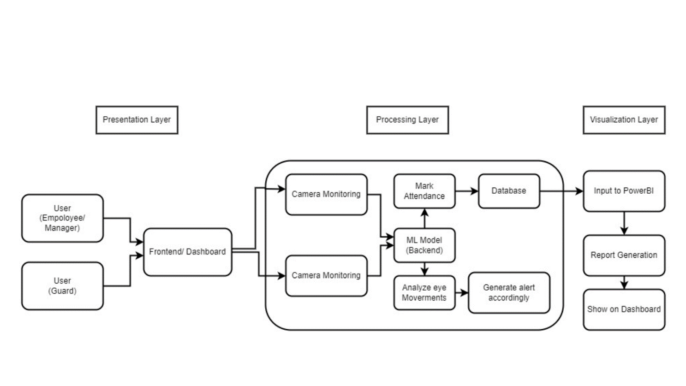

**3. Guard monitoring system:** The Guard Monitoring System module focuses on monitoring and ensuring the vigilance of security personnel through AI-based surveillance, particularly in high-security areas.

**AI-Based Surveillance:** Utilizes AI algorithms to monitor guard activity, especially their alertness and attentiveness during duty.

**Eye Status Detection:** Tracks the eyes of security guards to detect periods of drowsiness or inattentiveness.

**Real-Time Alerts:** Generates alerts or notifications to higher authorities in case of prolonged instances of closed eyes or signs of decreased vigilance.

1. **Future Scope**

Several opportunities for future enhancements and expansions exist. One area of focus involves continuous refinement and optimization of ML models used for attendance and guard monitoring to improve accuracy and response time. Exploring advanced data visualization techniques beyond Power BI, such as incorporating more interactive charting libraries or exploring custom visualization frameworks, could provide deeper insights for stakeholders. Integrating more sophisticated AI functionalities, such as predictive analytics for workforce trends or NLP for user interactions, could further elevate the system's capabilities. Continuous updates and adaptations will be necessary to ensure the system remains adaptable and compliant with emerging industry standards and regulations.

1. **Conclusion**

The "Streamlined Workforce Management System Using AI" stands as a comprehensive solution addressing crucial aspects of workforce management. The project successfully achieved objectives related to attendance monitoring, employee productivity analysis, guard surveillance, and robust reporting. Leveraging a combination of frontend, backend, data visualization technologies, and AI models has resulted in a system that streamlines processes, enhances security, and provides valuable insights for organizational decision-makers. The system not only modernizes traditional workforce management but also ensures compliance with data privacy regulations while maintaining user-friendly interfaces for seamless user experiences.

**References**

1. K. Şahinbaş, "Employee Promotion Prediction by using Machine Learning Algorithms for Imbalanced Dataset," in Proceedings of the International Conference on Machine Intelligence (ICMI), April 2022, DOI: 10.1109/ICMI55296.2022.9873744.

https://www.researchgate.net/publication/363312443_Employee_Promotion_Prediction_by_using_Machine_Learning_Algorithms_for_Imbalanced_Dataset

1. Smitha, Pavithra S Hegde, and Afshin, "Face Recognition based Attendance Management System," International Journal of Engineering Research & Technology (IJERT), vol. 9, no. 05, May 2020, ISSN: 2278-0181, IJERTV9IS050861.

https://www.researchgate.net/publication/341876647_Face_Recognition_based_Attendance_Management_System

1. E. Poornima, Ram Kumar, Srujan Katukam, Vikas Varma Pericherla, and Sukain Kumar Birelli, "A Real-Time IoT-based Model to Detect and Alert Security Guards’ Drowsiness," E3S Web of Conferences, vol. 391, June 2023, DOI: 10.1051/e3sconf/202339101151.

<https://doi.org/10.1051/e3sconf/202339101151>