**Student Activity Tracker Using Blockchain Technology**

**Fathima Ansar1, Akshara Satheesh2, Aiswarya S3, Bilsa Elizabeth Shaijan4, Dr. Shyjith M B5**

*1(Computer Science and Engineering, St. Thomas College of Engineering and Technology)*

*2(Computer Science and Engineering, St. Thomas College of Engineering and Technology)*

*3(Computer Science and Engineering, St. Thomas College of Engineering and Technology)*

*4(Computer Science and Engineering, St. Thomas College of Engineering and Technology)*

*5(Computer Science and Engineering, St. Thomas College of Engineering and Technology)*

**Abstract:** In academic programs such as B. Tech, students are supposed to achieve some activity points at the end of every academic year. Programs like B. Tech last about four years. Each year, students are supposed to submit their certificates and other information related to the activities they completed. These activities are then subjected to score calculation. Every student should score a minimum of one hundred activity points per year for the successful completion of that academic year. These extra academic activities are supposed to improve the quality of learning. These improvements may reflect in their future career achievements. Achieving valid activity points is not an easy task. There exist certain rules and regulations for calculating these rules. The activities performed on such software based systems are susceptible to manipulations. It is easy to make a student victim by modifying the content of the database. Therefore, the entire system processes are recorded using blockchain technology. Blockchain with Sha256 encoding uses hash code from previous block and current activity to register a new hash. Manipulations will produce entirely different hash codes. The change in such codes can help identify any sort of malpractice in the system. Additionally, a notification system is also created for the students to identify the mentor who verified their entries. The blockchain technology incorporated into the system even tracks password changes. Therefore, any sort of activity can be recognized.

**Key Words:** Blockchain, Certificate, Student, Faculty, Admin

1. **Introduction**

In academic programs like B. Tech, students are mandated to accumulate activity points each year, reflecting their engagement in extracurricular pursuits. These activities, crucial for holistic development, are integral to the learning experience and can significantly impact future career achievements. However, navigating the rules and regulations governing the calculation of these points presents a challenge. This introduction sets the stage for the "Student Activity Tracker with Blockchain Technology," a project designed to simplify and secure the process, ensuring accurate tracking, calculation, and verification of student activities. However, acquiring valid activity points adheres to strict regulations, governing their calculation. These guidelines ensure the integrity and efficacy of the system, encouraging students to actively participate in activities beyond their academic curriculum.

These rules include:

**1)Activities come under different categories.**

Implementing a framework with room for additional categories is crucial for future-proofing the application. While currently six categories exist for scoring points in academic programs like B. Tech, a flexible framework allows seamless integration of new categories as needed. This adaptable structure ensures scalability and accommodates evolving requirements, enhancing the application's effectiveness in managing and accessing student activity points across diverse academic pursuits. Such an application needs a more flexible framework.

**2)Each activity differs in the score they hold.**

Inside each category, there exist various activities. These activities may vary in scores. But the same activity can have multiple scores based on the position secured by the student. For example, if a student scores first place in a running race, a score of 18 points can be alloted. But a second place in a running race can have a score of 16 points.

**3)Each category has a year limit.**

Under a given category, there may exist a yearly limit for activities that can be considered for scoring. These yearly limits can cause confusions. For any given category, a student can participate in many activities. Selecting optimum activity based on limits is a tedious problem if such activities are not well organized and verified.

1. **Existing System**

In the current system, the distribution of certificates poses significant challenges, primarily through email or hardcopy. The reliance on Gmail or physical copies introduces vulnerabilities that may lead to the loss or misplacement of certificates. This process not only raises concerns about the security of sensitive information but also creates a sense of confusion and uncertainty.

**Risk of Loss:**

Certificates sent via email are susceptible to accidental deletion, misplacement in spam folders, or even loss due to technical issues. Additionally, hardcopy certificates are prone to physical misplacement or damage, causing potential disruptions in the verification process.

**Security Concerns:**

Transmitting certificates through email lacks the robust security measures required for safeguarding sensitive academic data. Unauthorized access or interception during the transfer process poses a considerable threat to the confidentiality and integrity of the certificates.

**Operational Confusion:**

The reliance on multiple channels for certificate distribution can lead to operational confusion. Tracking the status of certificate delivery and ensuring that each faculty member receives the relevant documents becomes a challenging task, contributing to potential delays and errors.

**Lack of Accountability:**

The existing system may lack a transparent and traceable mechanism to confirm the receipt of certificates by faculty members. This absence of accountability increases the likelihood of overlooking or neglecting important documents.

1. **Proposed System**

In the proposed system there are 3 modules

**Modular Description**

#### The project consists of 3 modules which are;

▪ Admin

▪ Faculty

▪ Student

The proposed system represents a paradigm shift in the landscape of academic administration, harnessing the transformative power of blockchain technology to redefine traditional processes within the Admin, Faculty, and Student modules. This visionary integration aims to cultivate a secure, transparent, and highly efficient ecosystem that not only addresses prevailing challenges but also propels academic management into a new era characterized by enhanced data integrity and security.

**The Admin Module**

The Admin are equipped with a suite of tools to manage profiles, verify faculty and student accounts, assign students to faculty members, and facilitate the uploading of new certificate types. However, the true innovation lies in the infusion of blockchain features, which serves as a digital fortress against unauthorized access and data tampering. This ensures the immutability of academic records, fortifying the entire system with an unprecedented level of data integrity. Administrators, in their pivotal role overseeing the academic landscape, can now navigate a more streamlined and secure environment, confident in the resilience of the system.

**The Faculty Module**

It is elevated with blockchain features that enhance the faculty's engagement with student data. Beyond profile management, faculty members are presented with a dynamic dashboard displaying assigned students, certificate verification capabilities, and a nuanced point tracking system. The introduction of blockchain technology in this module not only fortifies the security of the certificate verification process but also amplifies transparency. Faculty members can navigate a digital landscape where the authenticity of academic achievements is guaranteed, and the risk of unauthorized alterations is effectively mitigated.

**The Student Module**

The student’s interface with a user-friendly platform that facilitates profile management, offers a comprehensive dashboard with reports on uploaded certificates, and provides a secure channel for uploading new certificates via blockchain. This integration not only streamlines the student experience but also underscores the commitment to confidentiality and authenticity in recording academic achievements. The blockchain becomes the bedrock of trust, ensuring that each student's academic journey is accurately and securely documented.

The overarching innovation of integrating blockchain features across all modules propels the proposed system beyond conventional academic management frameworks. It establishes a cohesive, interlinked ecosystem where each participant—be it administrators, faculty, or students—engages with heightened efficiency, transparency, and security.

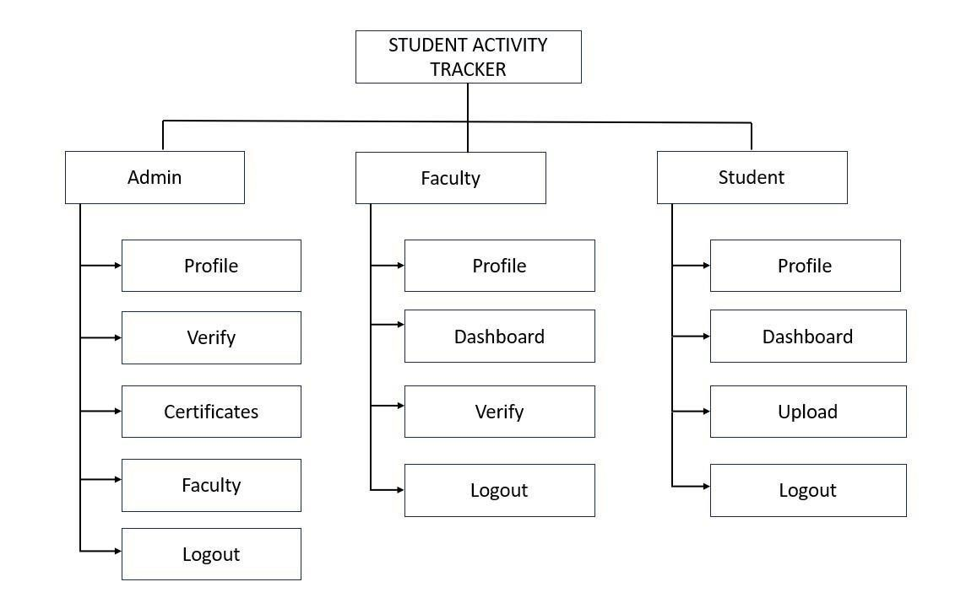

**Fig: System Architecture**

* **Member and Workflow**

There exist three types of members- Administrator, Faculty and Student member. Administrators control Mentors and Mentors manage students. Faculty/Mentor members in the institution are responsible for calculation and verification of uploaded/submitted documents. Currently students can submit their activities to the faculties by two means. If a hardcopy of the certificate is available for the activities then students can submit it directly. If softcopies exist, they can opt for submitting them as email attachments. When the number of students are more, faculties may face difficulties in selecting certificates based on best scores per category since any given student can participate in as many events as possible. Sending activity reports or certificates via email can lead to other problems. Sometimes these emails can end up in spam folders or cant be delivered. In such situations, these activities are lost until someone finds the mistake and rectifies it. Faculty members may also face difficulty in handling data for a very large number of students. Going through all the mails and sorting them is a time consuming process. Such a process, if automated , will be very useful. Creating a certificate and score management software for students will be a great idea. Such a score management software can raise some ethical issues. But a centralised model providing equal opportunity to every student will be more suitable. Such a centralised web server based concept requires more planning and resources. For every quick web based project, django framework and python come in handy. Which helps us focus more on ideas than spending time and resources on setting up a complex server environment. Rather than a score management software, additional features can be incorporated into the project to make it an activity tracker app for students. An activity tracker level idea could allow us the opportunity to set up mentors and administrator users for the management and verification of certificates and registered users.

* **Blockchain**

The activities performed on such software based systems are susceptible to manipulations. It is easy to make a student victim by modifying the content of the database. Therefore, the entire system processes are recorded using blockchain technology. Blockchain with Sha256 encoding uses hash code from previous block and current activity to register a new hash. Manipulations will produce entirely different hash codes. The change in such codes can help identify any sort of malpractice in the system. Additionally, a notification system is also created for the students to identify the mentor who verified their entries. The blockchain technology incorporated into the system even tracks password changes. Therefore, any sort of activity can be recognized.

In the blockchain architecture, the 'hashcode' field serves as a repository for the hexadecimal digest of the SHA256 hash, encapsulating the current block's data. This cryptographic hashcode uniquely identifies the contents of the block, ensuring its integrity and security within the chain.

|  |  |  |  |
| --- | --- | --- | --- |
| **Table Name** | **Column Name** | **Data Type** | **Default Value** |
| blockchain | hashcode | CharField[256] | 0 |
| previoushash | CharField[256] | 0 |
| data | CharField[500] | 0 |
| date | DateTimeField | Present Time |

**Table: Blockchain**

Meanwhile, the 'previous hash' field preserves the hexadecimal digest of the SHA256 hash representing the preceding block in the chain. This linkage establishes the chronological order and immutability of the blocks, as any alteration in a previous block would necessitate recalculating the hash of subsequent blocks, thereby preserving the integrity of the entire chain. The 'data' field contains the substantive log entry, capturing the essential information or transaction that generated the current block. This text-based record provides transparency and context to the blockchain, enabling stakeholders to understand the history and evolution of the data within each block.

Finally, the 'date' field is configured to automatically append a date and timestamp when the current block is created. This temporal metadata adds a chronological dimension to the blockchain, facilitating auditability, traceability, and analysis of the data over time. Together, these fields and their functionalities constitute the foundational elements of a robust blockchain system, ensuring data integrity, transparency, and accountability throughout the chain's lifecycle.

1. **Result**

* **Admin Interface**

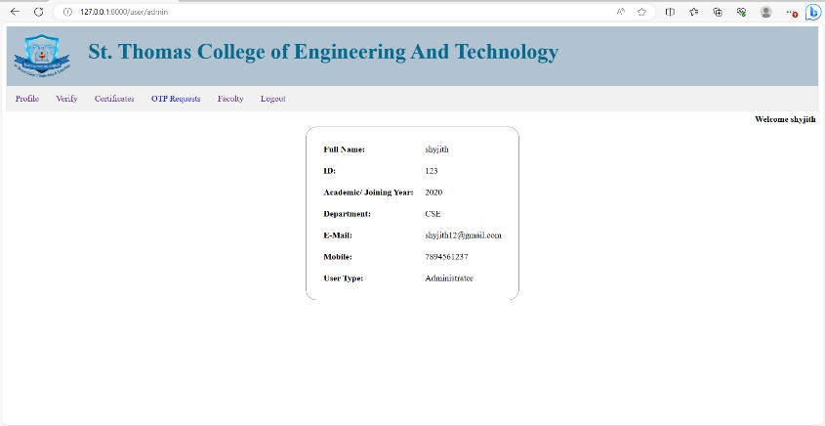

The admin control in the Student Activity Tracker using blockchain technology is comprehensive, encompassing verification of students and faculty, assignment of students to faculty members, and management of certificates. It empowers administrators with efficient tools to oversee and streamline academic processes while maintaining data integrity and accountability.

* **Faculty Dashboard**

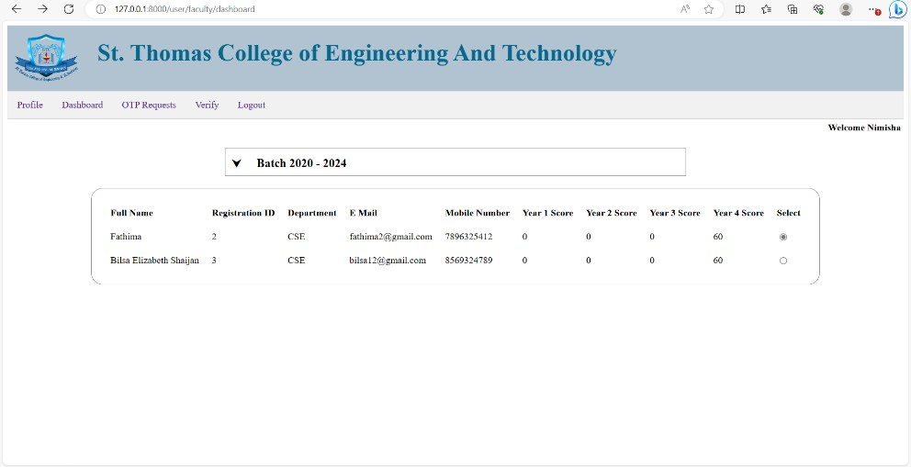

The faculty dashboard features a comprehensive list of assigned students, providing faculty members with a clear overview of their responsibilities and allowing for efficient management of student interactions and progress tracking. This feature enhances communication and collaboration between faculty and students within the Student Activity Tracker system, fostering a productive and organized learning environment.

* **Student dashboard**

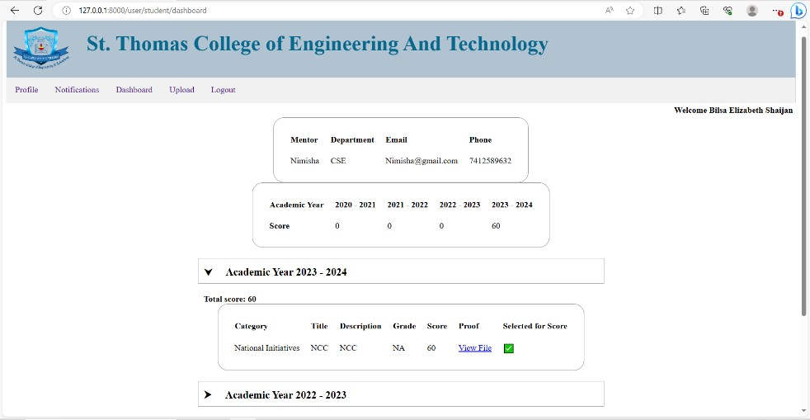

The student dashboard within the Student Activity Tracker incorporates essential features such as displaying the assigned faculty for each student, providing details of uploaded certificates including certification information, and presenting the scores achieved on those certificates. This comprehensive view empowers students to track their academic progress, stay informed about their faculty interactions.

1. **Conclusion**

The creation of a centralized certificate and score management system, along with an activity tracking app for students, offers a comprehensive solution to academic program management challenges. By adopting a transparent and fair model, ethical concerns are effectively addressed. Integration of blockchain technology ensures enhanced security and transparency in record-keeping. This software not only automates tasks but also allows educators more time for meaningful mentoring, thereby enhancing the quality of learning experiences. Continuous refinement of the system will enable it to adapt to evolving academic and technological landscapes, potentially revolutionizing program management practices. Through these innovations, the software aims to streamline administrative processes, promote fairness and integrity in evaluations, and ultimately empower both students and educators to excel in their respective roles within the academic ecosystem.

1. **Acknowledgement**

We express our special gratitude to **Dr. SHYJITH M B**, Head of the Department of Computer Science and Engineering for providing us constant guidance and encouragement throughout the Project preliminary work.

We express our sincere gratitude to the Project Supervisor **Mr. JAISON MATHEW JOHN**, Assistant Professor, Department of Computer Science and Engineering for the inspiration and timely suggestions.

We also express sincere gratitude to our guide **Dr. SHYJITH M B**, Professor, Department of Computer Science and Engineering for his guidance and support. We have to appreciate the guidance given by the panel members during the Project Preliminary presentations, thanks to their comments and advice. Last but not the least we place a deep sense of gratitude to our family members and friends who have been constant sources of inspiration during the preparation of the Project Preliminary works.

**References**

[1]. Tarek Kanan, Ahamd Turki Obaidat, Majduleen Al-Lahham, "SmartCert BlockChain

Imperative for Educational Certificates", Electrical Engineering and Information Technology (JEEIT) 2019

[2].Karuppanan Komathy. (2018). Verifiable and Authentic Distributed Blockchain Shipping Framework for Smart Connected Ships. Journal of Computational and Theoretical Nanoscience.

[3].Karuppanan Komathy. (2018). Verifiable and Authentic Distributed Blockchain Shipping

Framework for Smart Connected Ships. Journal of Computational and Theoretical

Nanoscience [4]. Xiuping Lin, “Semi-centralized Blockchain Smart Contracts: Centralized Verification and

Smart Computing under Chains in the Ethereum Blockchain,”Department of Information Engineering, National Taiwan University, Taiwan, R.O.C., 2017.

[5]. E. Whitford and J. Novack (Forbes Staff). (Feb. 2023). How Thousands Of Nurses Got Licensed With Fake Degrees. Accessed: Mar. 1, 2023. [Online]. Available:

https://www.forbes.com/sites/emmawhitford/2023/02/21/how thousands-of-nursesgotlicensed-with-fake-degrees/?sh=2edbdf8f5c6d

[6]. A. S. Rajasekaran, M. Azees, and F. Al-Turjman, ‘‘A comprehensive survey on blockchain technology,’’ Sustain. Energy Technol. Assessments, vol. 52, Aug. 2022, Art. no.

102039, doi: 10.1016/j.seta.2022.102039.

[7]. T. Savelyeva and J. Park, ‘‘Blockchain technology for sustainable education,’’ Brit. J. Educ. Technol., vol. 53, no. 6, pp. 1591–1604, Nov. 2022, doi: 10.1111/bjet.13273.

[8]. A. O. J. Kwok and H. Treiblmaier, ‘‘No one left behind in education: blockchain-based transformation and its potential for social inclusion,’’ Asia Pacific Educ. Rev., vol. 23, no. 3, pp. 445–455, Sep. 2022, doi: 10.1007/s12564-021-09735-4.

[9]. F. P. Oganda, N. Lutfiani, Q. Aini, U. Rahardja, and A. Faturahman, ‘‘Blockchain education smart courses of massive online open course using business model canvas,’’ in Proc.

2nd Int. Conf. Cybern. Intell. Syst. (ICORIS), Oct. 2020, pp. 1–6, doi: 10.1109/ICORIS50180.2020.9320789.

[10]. E. Kahraman. (Oct. 28, 2021). Wharton Accepts Crypto Payments for Blockchain Program Tuition Fees. Accessed: Feb. 14, 2023. [Online]. Available: https://cointelegraph.com/news/wharton-accepts-cryptopayments-for-blockchainprogramtuition-fees