**Mathematical Modeling of Gait for Lower Limb Exoskeleton**

Takeshwar kaushik1, Khemanshu kumar Sahu2 , Deepak Sharma3

*1(Assistant Professor, Mechanical Engineering Department, ISBM University, Chhura, Gariyaband, Chhattishgarh, India)*

*2(Assistant Professor, Mechanical Engineering Department, ISBM University, Chhura, Gariyaband, Chhattishgarh, India)*

*3(Research Scholar, Mechanical Engineering Department, IIT GOA, India)*

*Corresponding Author:* [*kaushiktekeswer0@gmail.com*](mailto:kaushiktekeswer0@gmail.com)

|  |
| --- |
| ***Abstract:*** *This study presents the mathematical Modeling of gait. This model is for the lower limb exoskeleton. The exoskeleton has wide scope in hospitals, physical training, and army. The comfortable gait with exoskeleton requires a good mathematical model of gait. This Modeling of this study starts with a C3D file which is taken from a hospital. This Modeling uses MLSviewer, MOKKA, AnyBody, and Matlab software. The basic information of the C3D file read with the MLSviewer software. This software tells the type of force plate, name of maker points, the number of force plate and marker points use in the gait analysis. The motion of marker points visualizes in MOKKA software. These visuals in MOKKA software give the position of all marker points. The MOKKA software also gives information about the starting frame number and last frame number for the gait on the force plates. The information collected from the MLSviewer and MOKKA software uses for modification of AnyScript of the inbuilt model of AnyBody software. The kinematic and inverse dynamic analysis of C3D file data performs in AnyBody software after proper changes in AnyScript of the model. The linear position and velocity data obtained from kinematic analysis use in Matlab Modeling. Matlab Modeling has two-step: curve fitting and curve plotting. The sum of sine equation fits on this linear position and velocity data using the curve fitting app of Matlab. Another velocity equation is evaluated by the differentiation of the position equation. These equations of linear position and velocity simulate using Matlab software. The plot of kinematic analysis data and plot of modeled equations compare in the Matlab software. The goodness of the results of all these equations is decided based on root mean square error (RMSE).*  ***Key Word****: Gait Analysis; Biomechanics; C3D files; Anybody Software; Root mean square error (RMSE); Electromyography(EMG); OpenSim; Mokka Analysis; AnyBody Analysis; MLSviewer; MatLab Modeling.* |

1. **Introduction**

The exoskeleton is an external suit that is used for assistance or increase in the working capacity of a human. In other words, the exoskeleton is a robot system that is a brand new type of human-robot cooperation system. It fully combines human intelligence and robot power to enhance robot intelligence and human operator's power. The invention of the wheel was a great millstone for transportation and other assistance for human. The wheeled vehicle can do almost all transportation work. However, many environments, such as rocky slopes and staircases, pose significant challenges to wheeled vehicles20. Exoskeleton robots can classify according to muscle strength supporting parts: upper limb systems, lower limb systems, upper and lower limbs integrated systems, and specific joint muscle strength support system Such robots develop for old and disabled persons for assistance and rehabilitation of injured persons. Power augmentation systems are to amplify the power of wearers, enabling them to perform the tasks that they otherwise cannot easily perform by themselves. These systems are developed for the army8. Elementary technologies for the development of exoskeleton robots include mechanism design technology, human intent measurement technology, and human-robot cooperation control technology. Along with these, we have to knowledge of the biomechanics of the human body. Consideration of the application field, the purpose of power support and the body part to which the robot would give support are also need for the successful development of exoskeleton robot systems8. This work is focusing only on the lower limb exoskeleton. This section starts with the discussion of gait related terms, basic knowledge and elementary technology required for the lower limb exoskeleton. This section also has a brief introduction of marker protocols that use in the motion capture method. The data of the motion capture method stores in the C3D file. This data of gait analysis simulate in software like OpenSim, AnyBody software.

1. **Material And Methods**

The primary thing for the modeling of the lower limb exoskeleton is the study and analysis of the human gait. There are two methods of gait analysis: (1) camera-based motion capture method and (2) sensor method. In this model, we are using the first method. The direct experiment is not done for this, but we take a C3D file of human gait. The C3D file data are studied and analyzed using MLSviewer software, Mokka software, and AnyBody software. This analysis gives a large number of data of linear velocity and position for each marker. It is very difficult to handle this large data for further analysis. It is very easy to remember and handle an equation than large data. So, the main aim of this modeling is to fit an equation for this large data. This curve fitting is performed with the help of MATLAB.

**MLSviewer Analysis:** The C3D file opens in MlsViewer software to see its property. The MlsViewer software show all information of C3D file like the number of markers, number of force platform, type of force platform, etc. as shown in figure.3.2.1. The naming of marker points can view in the video data option. But this software is not able to visualize the C3D file. So the C3D file opens in Mokka to visualize the marker position on the body.

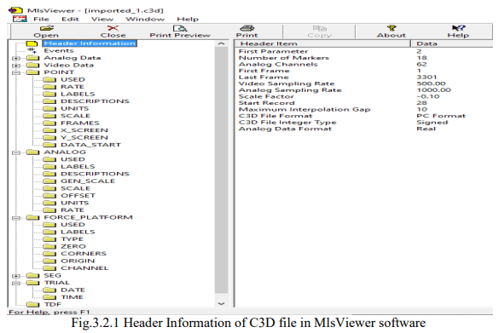

**Mokka Analysis:** The Mokka software shows the actual movement of all marker points when the file plays in this software. The white points in figure 3.3.1 show the marker position on the body. The white curved line in the figure shows the path for the full path of the sacrum maker point movement. The vertical yellow line represents the reaction force from the ground. It also not gives data of joint torque and force. This Mokka software provides the value of the starting frame (when the first step put on the force plate) and the last frame (when the last step put off from the force plate).

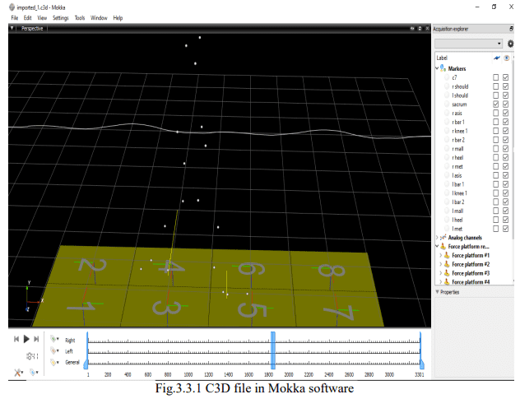

**AnyBody Analysis:** The AnyBody software already has inbuilt models for the various analysis of the human body movement. But these models are needed some modification in AnyScript code according to project requirement. The lower extremity model was chosen from inbuilt models for the analysis. The C3D file was given as an input for the gait analysis in AnyBody. Some information of the C3D file (like the type of force plate, markers name, starting frame number when the ankle put on the force plate, etc) should be known before giving the C3D file as input in AnyBody. The information of the C3D file from MLSviewer and Mokka is used in AnyBody to modify AnyScript of the lower limb model. The Helen Hayes marker set’s name and its locations regarding the anatomical reference frame were defined in the software. The number and type of force plates were also changed. An Extra Driver named Pelvis Thorax Rotation was switched ON as there were not enough markers on the upper body to get the sufficient information of the movements. The Optimization of the Trunk Height was switched OFF for the same reason. The data of position, linear velocity and acceleration are collected after full kinematic analysis in AnyBody software. This data is further used for modeling in MatLab software.

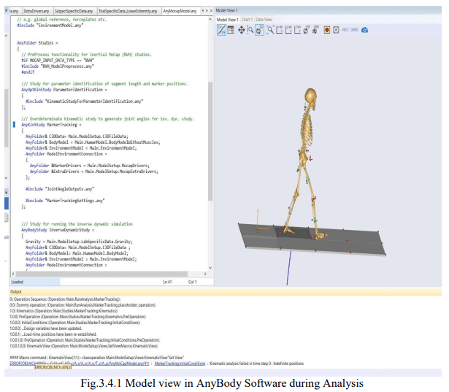

**MatLab Modeling:** The recorded data of linear position and velocity from AnyBody is import in MatLab using ‘importdata’ command. These data points are again plotted in MatLab. After plotting these points, we try to fit an equation with the help of the Curve Fitting Tool. This Curve Fitting Tool is inside the apps option of MatLab.

This Curve Fitting Tool can fit a curve using the input of X data, Y data, Z data and weights as input. There should at least two axis input and weight is optional. The modeling data has a 2D plot without weightage to any axis data. So X data and y data give as input from the imported data in the MatLab program. There are 4 suitable options in the curvefitting tool for these data (1) Fourier (2) Interpolant (3) Smoothing Spline (4) Sum of sine. The number of equations is very large in the case of interpolant and smoothing spline to express the data. So these two options obsolete for modeling. The Fourier has less value of 31 SSE (sum of square error) and RMSE (root mean square error) than the sum of sine but the difference of these errors of the sum of sine and Fourier are not very high. The sum of sine has a simple form of the equation. So we decide to go with the sum of sine to curve fit for all data of linear velocity and position.

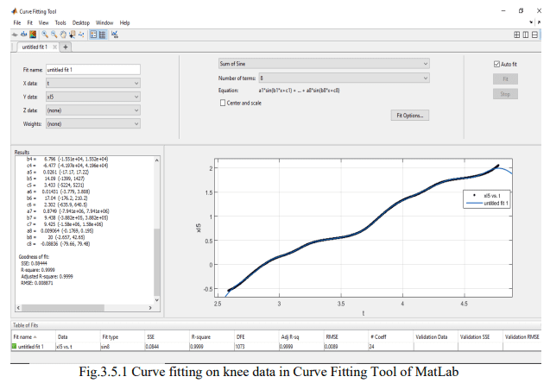

The mathematical model is formed for human gait. The Mlsviewer, Mokka, AnyBody and Matlab software are used in this modeling. The The Mlsviewer and Mokka software is used for checking the property of C3D file. The AnyBody software is used for getting the data of gait. The sum of sine equation for all marker points is modeled in matlab software.

The modeling of equations for gait uses MLSviewer, Mokka, AnyBody, and MatLab software. The method of modeling has explained in the previous chapter. The kinematic operation on the lower exoskeleton model using the C3D file was performed in AnyBody software. This simulation in AnyBody software provides large data for curve fitting. The equations obtain after curve-fitting on this data are simulated in MatLab.

**AnyBody Simulation**: The C3D file was having a total of 3301 frames, 18 standard markers according to the Helen Hayes Protocol, 8 Force Plates each of Type 2. The first and last frame value of the C3D file is filled in the AnyScript so that the initial position of the markers and ground reaction is consistent with its original position in AnyBody model. The first frame chosen was 1280 and the last frame was 2400. We use 16 marker points in AnyBody excluding two shoulders marker because this analysis is only concentrated on the lower limb. The weight of the subject was 53.2 kg and the height was 1.66 m. The kinematic and inverse kinematic simulation performs on the modified model of lower limb exoskeleton with C3D in AnyBody. The results of the linear position, velocity and acceleration are saved in csv format file.

The kinematic and inverse kinematic simulation performs on the modified model of lower limb exoskeleton with C3D in AnyBody. The results of the linear position, velocity and acceleration are saved in csv format file. The csv file has data of two gait cycle. Each data file has 1097 rows and 4 columns. The four columns represent data of time, X-direction, Ydirection and Z-direction respectively. The gap between two consecutive rows of time column is 0.002s. The X-direction, Y-direction, and Z-direction data is in between 2.584 sec and 4.776 sec. Tables 4.2.2 and 4.2.3 presents 20 data points of linear position and velocity of the left knee marker as a sample. Figures 4.2.2 and 4.2.3 present plot of left knee linear position (m) vs. time (s) and left knee linear velocity (m/s) vs. time (s) respectively. All graphs are plotted for two complete Gait- Cycle. The first Cycle is from Time t1 = 2.584s to t2 = 3.642s and the second is from time t3 = 3.642s to t4= 4.700s.

The blue, green and red line represents X, Y, and Z position data respectively. The Xaxis position is continuously increasing. The variation in Y-axis and Z-axis position is small but cyclic. The plot has this nature because gait is in a straight direction.

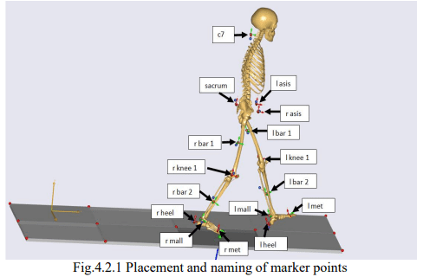

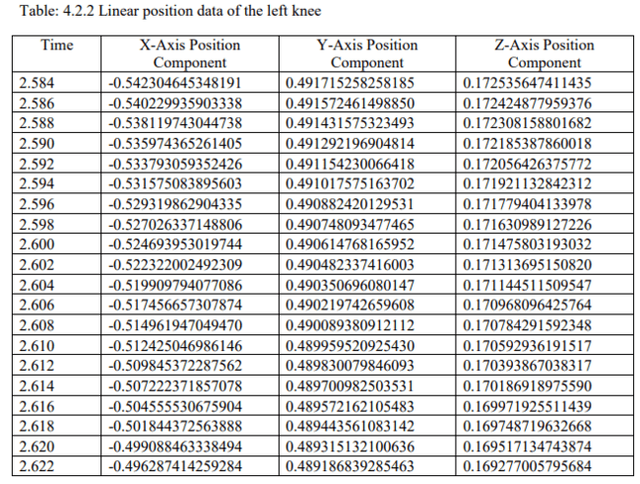

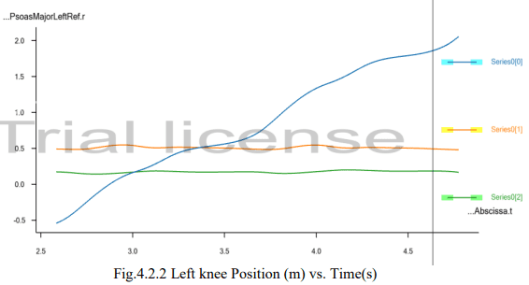

**MatLab Simulation:** The result of kinematic analysis in AnyBody is further plotted in MatLab software. Figure 4.3.1 presents the linear position vs time plot in MatLab by using AnyBody data. The sum of sine curve fits on this plotted data using the inbuilt app of MatLab. Each sum of sine equation has 8 sine term and 24 constant.

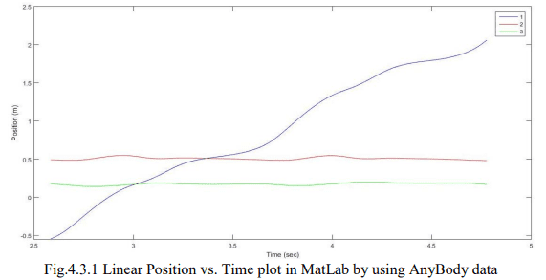

The figure 4.3.2 is showing the method of finding sum of sine equation in curve fitting app and figure 4.3.3 presents the plot of sum of sine equation for left knee position in MatLab. The following sum of sine equation can be evaluated for x coordinate of position of left knee in curve fitting app. The figure 4.3.4 is showing the plot for comparison of sum of sine graph and original data graph.

f(t) = a1*sin(b1*t + c1) + a2*sin(b2*t + c2) + a3*sin(b3*t + c3) + a4*sin(b4*t + c4) + a5*sin(b5*t + c5) + a6*sin(b6*t + c6) + a7*sin(b7*t + c7) + a8*sin(b8*t + c8)

Where, t = time

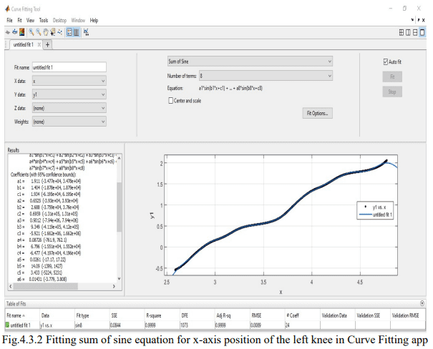

In figure 4.3.4 Blue, red and green lines are representing X, Y and Z coordinate of the position vector.

The colored lines are the original curve. The overlapped black lines are showing the sum of sine curve.

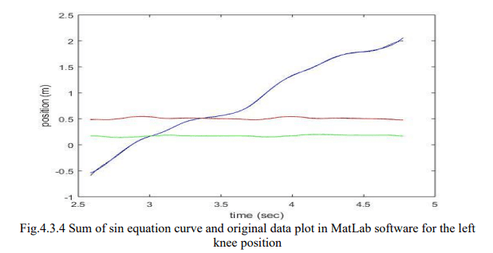

1. **Result**

First, we compare position data of AnyBody software and position data getting from the sum of sine equation. We also compare velocity results from three approaches: 1) Original data of velocity getting from AnyBody software 2) Velocity data getting from the sum of sine equation that is fitted on original AnyBody software velocity data 3) Velocity data getting from the differentiation of position vector.

**Position Result**: There are two sets of data of position. The first set of data for the position is obtained from AnyBody software and the second set of data for the position is obtained from the sum of sin equation. These both set of data is plotted in 3D in Matlab to compare as shown in figure 5.2.1.

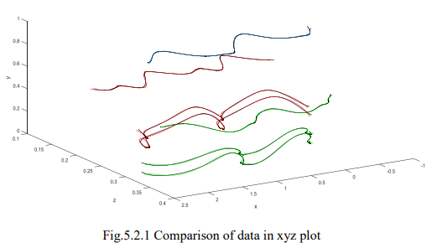

The root mean square error (RMSE) of curve fitting is also calculated. Table 5.2.1 presents the RMSE between AnyBody data and the sum of sine data in X, Y and Z directions. We can see in the table that RMSE is in between 10-2 and 10-5

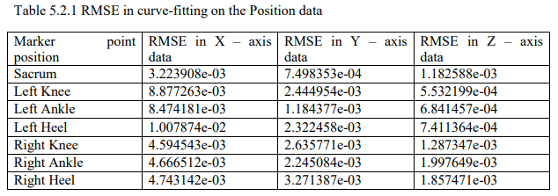

**Velocity Result**: The sum of sine equations also fits on velocity data. The goodness of fit of the sum of sine equations is compared on the basis of RMSE. The RMSE of fit for seven main marker points is shown in table 5.3.1. The RMSE is in between 10-1 and 10-4 . The overlapped plot of the sum of sin equation and original data is the plot for comparison. The plot for the sacrum, left knee, left ankle and left heel is presented below in fig.5.3.1, fig.5.3.2, fig.5.3.3 and fig.5.3.4 respectively. The blue, red and green lines in these figures are original data lines and overlapped black lines are representing the sum of sine equations.

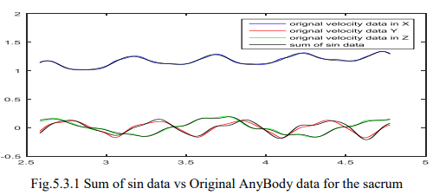

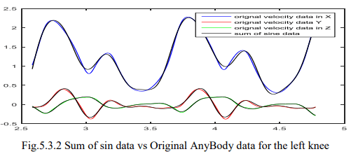

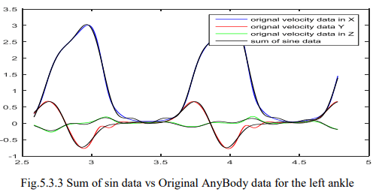

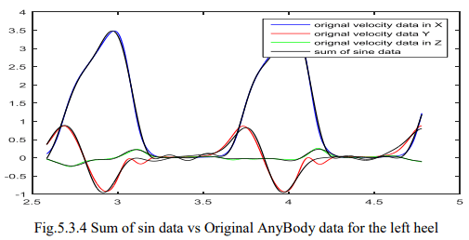

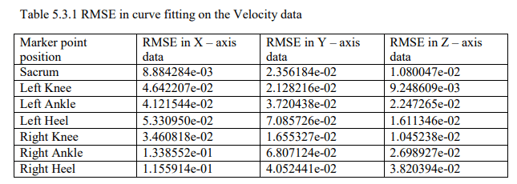

The velocity equation can also get by differentiation of position equation. So we differentiate the fitted of the sum of sin equation on position data. Then the result of velocity from this is compared with original data on the basis of RMSE. The plot for the sacrum, left knee, left ankle and left heel in fig.5.3.5, fig.5.3.6, fig.5.3.7 and fig.5.3.8 respectively. Table 5.3.2 presents the RMSE for seven marker points’ data. The RMSE is between 10-1 and 10-3.

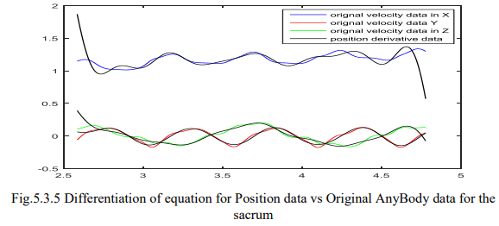

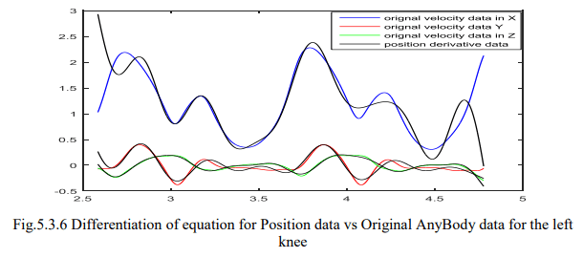

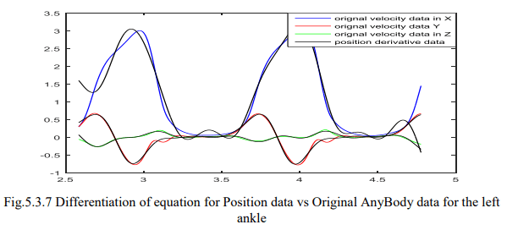

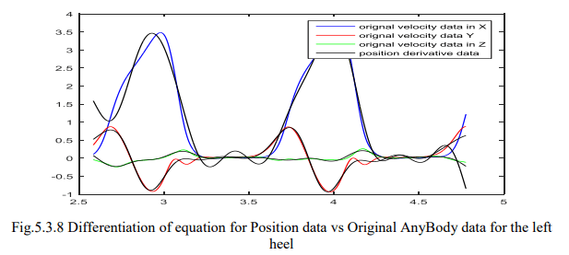

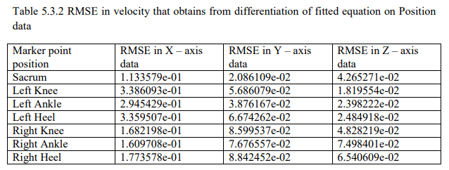

The velocity equation can be obtained in two ways. The RMSE of both equation data is different as we can see from tables 5.3.1 and 5.3.2. Some RMSE values in table 5.3.1 and table 5.3.1 for the corresponding marker position has similar value. But some values of RMSE in table 5.3.2 are ten times the corresponding value in table 5.3.1. From this, it can be said that equations for velocity obtained by curve fitting are more suitable than equations for velocity obtained by differentiation of position equation.

1. **Discussion**

The RMSE in the fitted curve on position data is in between 10-1 and 10-5. So these equations can be used in those designs where the error in between 10-1 and 10-5 is allowed for position. If error around 10-1 is allowed in velocity then differentiation of fitted equation on position data can be used. The accuracy will increase if we use a fitted equation on velocity data rather than equation obtains from the differentiation of fitted equation on position data.

1. **Conclusion**

The kinematic and inverse dynamic analysis of C3D file data performs in AnyBody software after proper changes in AnyScript of the model. The linear position and velocity data obtained from kinematic analysis use in Matlab Modeling. Matlab Modeling has two-step: curve fitting and curve plotting. The sum of sine equation fits on this linear position and velocity data using the curve fitting app of Matlab. Another velocity equation is evaluated by the differentiation of the position equation. These equations of linear position and velocity simulate using Matlab software. The plot of kinematic analysis data and plot of modelled equations compare in the Matlab software.

**References**

1. Cenciarini, M. & Dollar, A. M. (2011). Biomechanical considerations in the design of lower limb exoskeletons. 2011 IEEE International Conference on Rehabilitation Robotics.
2. Chen, G., Qi, P., Guo, Z. & Yu, H. (2016). Mechanical design and evaluation of a compact portable knee–ankle–foot robot for gait rehabilitation. Mechanism and Machine Theory, 103, 51–64.
3. Chen, J., Mu, X. & Du, M. (2017). Biomechanics analysis of human lower limb during walking for exoskeleton design, Journal of Vibroengineering, 19(7), 5527-5539.
4. Damsgaard, M., Rasmussen, J., Christensen, S. T., Surma, E. & de Zee, M. (2006). Analysis of musculoskeletal systems in the AnyBody Modeling System. Simulation Modeling Practice and Theory, 14(8), 1100–1111.
5. Han, Y. & Wang, X. (2011). The biomechanical study of lower limb during human walking. Science China Technological Sciences, 54(4), 983–991.
6. Huo, W., Mohammed, S., Moreno, J. C. & Amirat, Y. (2016). Lower Limb Wearable Robots for Assistance and Rehabilitation: A State of the Art. IEEE Systems Journal, 10(3), 1068–1081.
7. Kadaba, M. P., Ramakrishnan, H. K. & Wootten, M. E. (1990). Measurement of lower extremity kinematics during level walking. Journal of Orthopaedic Research, 8(3), 383–392.
8. Lee, H., Kim, W., Han, J. & Han, C. (2012). The technical trend of the exoskeleton robot system for human power assistance. International Journal of Precision Engineering and Manufacturing, 13(8), 1491–1497.
9. Li, M., Deng, J., Zha, F., Qiu, S., Wang, X. & Chen, F. (2018). Towards Online Estimation of Human Joint Muscular Torque with a Lower Limb Exoskeleton Robot. Applied Sciences, 8(9), 1610.
10. Lovrenovic, Z. & Doumit, M. (2016). Review and analysis of recent development of lower extremity exoskeletons for walking assist. 2016 IEEE EMBS International Student Conference (ISC).
11. Maria, S.L.J. & Pablo, C.C. (2017) Human Gait Kinematic Measurement. Open Journal of Orthope dics, 7, 79-89.
12. Moreira, P., Lugrís U., Cuadrado J. & Flores P. (2013). Biomechanical models for human gait analyses using inverse dynamics formulation. Paper presented at: The 5th Portuguese Biomechanics Congress, Espinho, Portugal, February.
13. Tao, W., Liu, T., Zheng, R. & Feng, H. (2012). Gait Analysis Using Wearable Sensors. Sensors, 12(2), 2255–2283.
14. Vimieiro, C., Andrada, E., Witte, H. & Pinotti, M. (2013). A computational model for dynamic analysis of the human gait. Computer Methods in Biomechanics and Biomedical Engineering, 18(7), 799–804.
15. Wahab, Y. & Bakar, N. A. (2011). Gait analysis measurement for sport application based on ultrasonic system. 2011 IEEE 15th International Symposium on Consumer Electronics (ISCE).
16. Wu, X., Liu, D.-X., Liu, M., Chen, C. & Guo, H. (2018). Individualized Gait Pattern Generation for Sharing Lower Limb Exoskeleton Robot. IEEE Transactions on Automation Science and Engineering, 15(4), 1459 – 1470.
17. Zhang, G., Liu, G., Ma, S., Wang, T., Zhao, J. & Zhu, Y. (2017). Biomechanical design of escalading lower limb exoskeleton with novel linkage joints. Technology and Health Care, 25, 267–273.
18. Zhiyong, T., Xiaodong, X., & Zhongcai, P. (2015). Trajectory planning and mechanic’s analysis of lower limb rehabilitation robot. Bio-Medical Materials and Engineering, 26(s1), S347–S355.
19. BTS GAITLAB – Analysis Protocols Helen Hayes Protocol.