**To Study the Role of Forest -Based**

**Industries in Promoting Trade**

**1 – Ramanand Mishra - Asst. professor, Commerce & Management, St. Mary’s P.G.**

**College Vidisha**

**Email id – ramanandmishra705@ gmail.com, Mob.no. - 9926376254**

**2 – Dr. Basanti Mathew Merlin – Head, Department of Commerce, Ravindranath Tagore**

**University Bhopal**

**Email id –** [**drbmathew11@gmail.com**](mailto:drbmathew11@gmail.com) **, Mob.no. – 9174982059**

**Abstract –**

Since the prevailing business model is based on capturing comparative advantages at the right cost, the forest products industry has made strong efforts to open up to global trade. In many emerging countries, forests are valued, processing industries seek more employment, and raw materials seek additional value (Lash, J., & Wellington, F. (2007)). In the forest products industry, international investors are willing allies; however, they wish to ensure the macroeconomic climate is predictable, transparent fiscal incentives are in place, and there is an abundance of labor - and preferably a sustainable wood supply from the beginning. The domestic market should be dynamic in order to attract foreign investments since many emerging economies have bustling urban markets that lack high-quality forest products.

A number of emerging countries have experienced economic growth and poverty eradication due to increases in forest product trade. It has proven difficult for some countries to trade their way out of poverty, leading to further marginalization and misconduct. In order to ensure that trade is legal, sustainable and based on fair labor conditions and a fair distribution of benefits, adequate safeguards must be put in place (Pearce, J. M. et. al. (2014)). The establishment of sustainable policies and regulations requires effective governance.

Increasingly, environmental issues are influencing trade, both directly and indirectly. As a result, environmental policies and international agendas on trade have been recognized as a common international concern partially because the regulations impact the competitiveness of the environment. Consequently, imports and exports are influenced. Environmental concerns are underlying concerns. Trade can also affect quality and deplete resources. However, natural resource management cycles occur. Trade policies, environmental concerns, and political reforms of macroeconomic policies will likely continue to dominate public debate (International Resource Panel, United Nations Environment Programme. Sustainable Consumption, & Production Branch. (2011)). Developed countries have increased exports, which have led to environmental groups focusing on commodities. Multilateral agreements on the impacts of such policies on natural resources do not constitute a trade policy under environmental standards.

There is evidence that these impacts are negative, but they have not been thoroughly assessed. Consequently, the World Trade Organization (WTO) has established a working program on trade and policy, probably the most complex sector from the perspective of land use, since the General Agreement on Tariffs and Trade (GATT) has become more important in recent years. The environment contains a significant amount of forest resources. A large part of NAFTA's land area is the environment, and their survival is vital if the agreement is to succeed. (Segura, O. et. al. (1994)).

A number of factors contribute to improper harvesting practices. Forests are increasing in importance regionally and are essential in maintaining biological systems. Multilaterally, this can be attributed to recent reductions in forest cover, but this role is only fully appreciated once traditional barriers to imports have been removed. Once these forest exports are gone, this effect is no longer apparent. In part because the deforestation problems that arise outside the sector itself are the origins of the exposure of national economies to competition, attention has shifted more sharply to inter-sectoral coordination in policies. The forest provides habitat for the majority of world's environmental standards that influence biodiversity, including cost-raising domestic policies. The forest contributes significantly to international competition among businesses.

As a result, they are one of the largest sources of foreign exchange. This is especially true when a new player enters the scene with lower exchange earnings than many developing countries (Anderson 1995). Environmental trade debates focus on revenues generated by the environmental trade sector for the purpose of financing investment in resource management and utilization. However, mixed effects of policy instruments have resulted in policy failures on a national and international scale. For instance, developing countries have a low rent capture rate. A classical problem further complicates this. Economic development should take precedence over the conservation of the world's forests, leading to environmental conservation, and this is largely a matter of time preference, which is a topic of debate in many planning horizons (Agarwal, B. (2010)). As part of the standard-setting process, environmental issues were raised, and they are relevant to the management of forests as well. 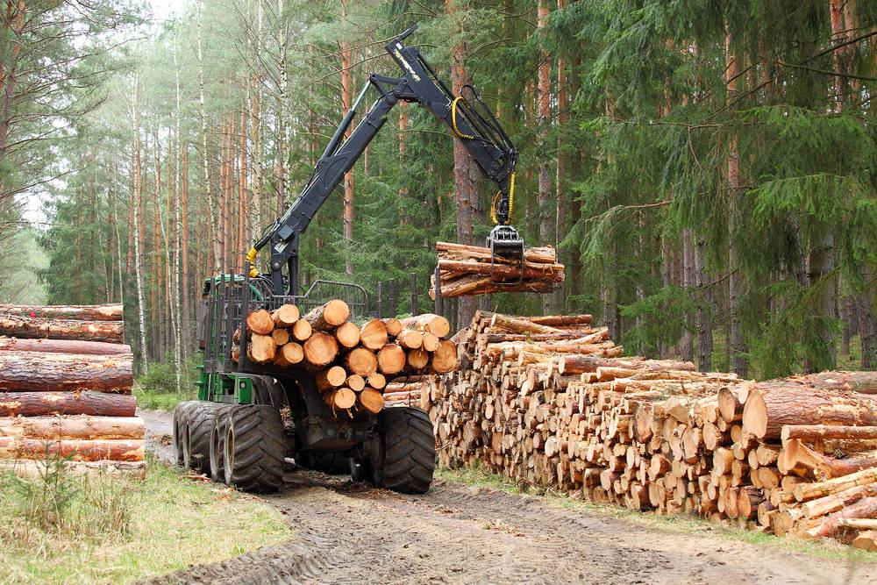

To study the role of forest-based industries in promoting trade.

To achieve objective 1 of the study, the following two alternate hypotheses are formulated:

**Ha:** Respondents’ perceptions on the role of forest-based industries in promoting trade significantly differ across different experience groups.

**Hb:** Respondents’ perceptions on the role of forest-based industries in promoting trade significantly differ across designations.

The present study incorporated a set of five questions/items, utilising a five-point Likert scale, in order to ascertain the perceptions of respondents on the role of forest-based sectors in facilitating trade. Therefore, the gathered responses reflect the beliefs of survey participants regarding the ability of forest-based companies to promote trade in Madhya Pradesh.

Table - presents the average scores for each of the five items, which were utilized to examine the participants' perspectives regarding the contribution of forest-based sectors in facilitating trade. It is evident that respondents with greater levels of experience, specifically those with 8-11 years and more than 11 years, exhibited a higher degree of agreement compared to respondents with experience ranging from 0 - 3 years and 4 -7 years. This is supported by the observation that the average score for these two experience groups hovers around 4, indicating their agreement regarding the ability of forest-based industries to facilitate trade. **Average scores of the responses*Experience**

|  |  |  |  |  |  |  |
| --- | --- | --- | --- | --- | --- | --- |
| Experience | | The product of a forest-based industrial institute given a boost to business. | Are there more forest-based industries (business) in Madhya Pradesh than other states? | Do you agree that due to the high forest area in Madhya Pradesh, the trend of people in wood business has increased? | Due to the high price of teak wood, more profit can be made, hence the trade of teak has increased. | Due to various types of materials obtained from forests, people benefit from forest-based industries. |
| 0-3 years | Mean | 2.39 | 2.28 | 2.52 | 2.67 | 3.26 |
| N | 54 | 54 | 54 | 54 | 54 |
| Std. Deviation | 1.265 | 1.393 | 1.270 | 1.374 | 1.417 |
| 4- 7years | Mean | 3.36 | 3.83 | 2.37 | 3.38 | 3.62 |
| N | 115 | 115 | 115 | 115 | 115 |
| Std. Deviation | 1.346 | 1.415 | 1.518 | 1.478 | 1.399 |
| 8- 11 years | Mean | 3.36 | 3.40 | 3.33 | 3.26 | 3.30 |
| N | 144 | 144 | 144 | 144 | 144 |
| Std. Deviation | 1.221 | 1.454 | 1.409 | 1.499 | 1.374 |
| more than 11 years | Mean | 4.20 | 3.94 | 3.88 | 3.99 | 3.82 |
| N | 85 | 85 | 85 | 85 | 85 |
| Std. Deviation | 1.307 | 1.373 | 1.460 | 1.471 | 1.384 |

Table - below shows results of one-way ANOVA for the average scores of the five questions on the role of forest-based in promoting trade across four experience groups. Results are found to be statistically significant (Sig < 0.05) for all the five questions. Hence, H11a: Respondents’ perceptions on the role of forest-based industries in promoting trade significantly differ across different experience groups is NOT rejected. It can be concluded that a significant difference exists across four experience groups regarding their perception on the role of forest-based industries in promoting trade and the respondents with greater levels of experience, specifically those with 8-11 years and more than 11 years, exhibited a higher degree of agreement that forest-based industries facilitate trade.

**Table - One-way ANOVA: the Role of Forest-Based Industries in Promoting Trade*Experience**

|  |  |  |  |  |  |  |
| --- | --- | --- | --- | --- | --- | --- |
|  | | | | | | |
|  | | Sum of Squares | df | Mean Square | F | Sig. |
| The product of a forest-based industrial institute given a boost to business. | Between Groups | 10.844 | 3 | 3.615 | 2.19** | .039 |
| Within Groups | 648.038 | 394 | 1.645 |  |  |
| Total | 658.882 | 397 |  |  |  |
| Are there more forest-based industries (business) in Madhya Pradesh than other states? | Between Groups | 12.857 | 3 | 4.286 | 2.13** | .041 |
| Within Groups | 791.698 | 394 | 2.009 |  |  |
| Total | 804.555 | 397 |  |  |  |
| Do you agree that due to the high forest area in Madhya Pradesh, the trend of people in wood business has increased? | Between Groups | 14.289 | 3 | 4.763 | 2.31** | .034 |
| Within Groups | 811.131 | 394 | 2.059 |  |  |
| Total | 825.42 | 397 |  |  |  |
| Due to the high price of teak wood, more profit can be made, hence the trade of teak has increased. | Between Groups | 15.031 | 3 | 5.010 | 2.31** | .035 |
| Within Groups | 852.305 | 394 | 2.163 |  |  |
| Total | 867.336 | 397 |  |  |  |
| Due to various types of materials obtained from forests, people benefit from forest-based industries. | Between Groups | 15.375 | 3 | 5.125 | 2.65** | .026 |
| Within Groups | 760.449 | 394 | 1.930 |  |  |
| Total | 775.824 | 397 |  |  |  |

Note: Signif. Codes: 1% ‘***’ 5% ‘**’ 10% ‘*’

Given that the data did not exhibit a normal distribution, Hypothesis 1 was additionally assessed using the Kruskal Wallis test. The findings indicate that there is no significant disparity observed between the outcomes obtained from conducting a one-way ANOVA and a Kruskal Wallis test.

**Table - Robustness check: Kruskal Wallis Test *Experience**

|  |  |  |
| --- | --- | --- |
| The product of a forest-based industrial institute given a boost to business. | Chi-Square | 7.08** |
| Df | 3 |
| Asymp. Sig. | .028 |
| Are there more forest-based industries (business) in Madhya Pradesh than other states? | Chi-Square | 8.59** |
| Df | 3 |
| Asymp. Sig. | .040 |
| Do you agree that due to the high forest area in Madhya Pradesh, the trend of people in wood business has increased? | Chi-Square | 9.95** |
| Df | 3 |
| Asymp. Sig. | .045 |
| Due to the high price of teak wood, more profit can be made, hence the trade of teak has increased. | Chi-Square | 9.97** |
| Df | 3 |
| Asymp. Sig. | .039 |
| Due to various types of materials obtained from forests, people benefit from forest-based industries. | Chi-Square | 8.33** |
| Df | 3 |
| Asymp. Sig. | .041 |

Note: Signif. Codes: 1% ‘***’ 5% ‘**’ 10% ‘*’

The five questions regarding the contribution of forest-based sectors to trade promotion were further examined using designation as a grouping variable. The average scores for these questions are presented in Table 9. It is evident that supervisors and managers had a greater frequency of positive responses compared to laborers, as indicated by their higher average scores of 3 or above. Therefore, it may be inferred that both of these classification levels concur that forest-based companies have the capacity to facilitate trade. However, it is possible to determine the statistical significance of this observed difference by conducting a test utilizing the results of a one-way analysis of variance (ANOVA), as presented in Table 10.

**Table - Average scores of the responses * Designation**

|  |  |  |  |  |  |  |
| --- | --- | --- | --- | --- | --- | --- |
| Designation | | The product of a forest-based industrial institute given a boost to business. | Are there more forest-based industries (business) in Madhya Pradesh than other states? | Do you agree that due to the high forest area in Madhya Pradesh, the trend of people in wood business has increased? | Due to the high price of teak wood, more profit can be made, hence the trade of teak has increased. | Due to various types of materials obtained from forests, people benefit from forest-based industries. |
| Labour | Mean | 2.47 | 2.39 | 2.24 | 2.41 | 2.28 |
| N | 164 | 164 | 164 | 164 | 164 |
| Std. Deviation | 1.275 | 1.434 | 1.449 | 1.477 | 1.408 |
| Supervisor | Mean | 3.31 | 3.36 | 3.49 | 3.37 | 3.23 |
| N | 111 | 111 | 111 | 111 | 111 |
| Std. Deviation | 1.256 | 1.426 | 1.413 | 1.519 | 1.353 |
| Manager | Mean | 4.16 | 4.24 | 4.20 | 4.27 | 4.27 |
| N | 123 | 123 | 123 | 123 | 123 |
| Std. Deviation | 1.295 | 1.391 | 1.443 | 1.426 | 1.397 |

Results of one-way ANOVA reveal that there exists a statistically significant difference in the responses of the three designation levels because Sig. or p-value <0.05 in each of the five questions. Hence H1b**:** Respondents’ perceptions on the role of forest-based industries in promoting trade significantly differ across designations is NOT rejected and it can be concluded that the respondents believe that forest-based industries can facilitate trade.

**Table - One-way ANOVA: the Role of Forest-Based Industries in Promoting Trade* Designation**

|  |  |  |  |  |  |  |
| --- | --- | --- | --- | --- | --- | --- |
|  | | Sum of Squares | df | Mean Square | F | Sig. |
| The product of a forest-based industrial institute given a boost to business. | Between Groups | 16.701 | 2 | 8.351 | 5.12*** | 0.00 |
| Within Groups | 643.181 | 395 | 1.628 |  |  |
| Total | 659.882 | 397 |  |  |  |
| Are there more forest-based industries (business) in Madhya Pradesh than other states? | Between Groups | 11.783 | 2 | 5.892 | 2.92** | .02 |
| Within Groups | 794.773 | 395 | 2.012 |  |  |
| Total | 806.555 | 397 |  |  |  |
| Do you agree that due to the high forest area in Madhya Pradesh, the trend of people in wood business has increased? | Between Groups | 15.527 | 2 | 7.764 | 3.75*** | .002 |
| Within Groups | 815.892 | 395 | 2.066 |  |  |
| Total | 831.42 | 397 |  |  |  |
| Due to the high price of teak wood, more profit can be made, hence the trade of teak has increased. | Between Groups | 11.53 | 2 | 5.765 | 2.65** | .031 |
| Within Groups | 857.807 | 395 | 2.172 |  |  |
| Total | 869.337 | 397 |  |  |  |
| Due to various types of materials obtained from forests, people benefit from forest-based industries. | Between Groups | 10.211 | 2 | 5.106 | 2.64** | .032 |
| Within Groups | 762.613 | 395 | 1.931 |  |  |
| Total | 772.824 | 397 |  |  |  |

Note: Signif. Codes: 1% ‘***’ 5% ‘**’ 10% ‘*’

Given that the data did not exhibit a normal distribution, Hypothesis 1b was additionally assessed using the Kruskal Wallis test. The findings indicate that there is no significant disparity observed between the outcomes obtained from conducting a one-way ANOVA and a Kruskal Wallis test.

**Table - Robustness check: Kruskal Wallis Test * Designation**

|  |  |  |
| --- | --- | --- |
| The product of a forest-based industrial institute given a boost to business. | Chi-Square | 12.15*** |
| Df | 2 |
| Asymp. Sig. | .005 |
| Are there more forest-based industries (business) in Madhya Pradesh than other states? | Chi-Square | 10.15** |
| Df | 2 |
| Asymp. Sig. | .034 |
| Do you agree that due to the high forest area in Madhya Pradesh, the trend of people in wood business has increased? | Chi-Square | 12.57*** |
| Df | 2 |
| Asymp. Sig. | .006 |
| Due to the high price of teak wood, more profit can be made, hence the trade of teak has increased. | Chi-Square | 9.82** |
| Df | 2 |
| Asymp. Sig. | .061 |
| Due to various types of materials obtained from forests, people benefit from forest-based industries. | Chi-Square | 9.06* |
| Df | 2 |
| Asymp. Sig. | .052 |

Note: Signif. Codes: 1% ‘***’ 5% ‘**’ 10% ‘*’

**Findings Related to Objective**

The objective of the study was **“to study the role of forest-based industries in promoting trade”.** In order to attain the first objective, the following two alternate hypotheses were formulated. Therefore, the outcomes derived from testing each of the two sub-hypotheses are sequentially examined and discussed below.

**H11a: Respondents’ perceptions on the role of forest-based industries in promoting trade significantly differ across different experience groups.**

This study included five questions in the questionnaire, utilizing a Likert scale with five response options, to assess the perspectives of participants regarding the extent to which forest-based sectors contribute to the facilitation of commerce. The findings of the study indicate that respondents with extensive experience, particularly those with 8-11 years and more than 11 years, demonstrated a stronger level of agreement compared to respondents with less experience ranging from 0-3 years and 4-7 years. This suggests that experienced individuals hold a similar viewpoint regarding the capacity of forest-based industries to facilitate trade. The statistical analysis of the average scores of the five questions about the role of forest-based in fostering commerce across four experience groups yielded significant results (p < 0.05) in a one-way ANOVA. Therefore, the alternate hypothesis H11a, which states that there are significant differences in respondents' perspectives on the importance of forest-based sectors in fostering trade across different experience groups, was not rejected.

**H11b: Respondents’ perceptions on the role of forest-based industries in promoting trade significantly differ across designations.**

This study also formulated another alternate hypothesis to assess the perspectives of participants regarding the extent to which forest-based sectors contribute to the facilitation of commerce across designations. Results reveal that supervisors and managers had a greater frequency of positive responses compared to laborers, as indicated by their higher average

scores of 3 or above. Therefore, it may be inferred that both of these classification levels concur that forest-based companies have the capacity to facilitate trade. Results of one-way ANOVA reveal that there exists a statistically significant difference in the responses of the three designation levels because Sig. or p-value <0.05 in each of the five questions. Hence H1b**:** Respondents’ perceptions on the role of forest-based industries in promoting trade significantly differ across designations was not rejected. **-**

**Conclusions: -**

The objective investigated the role of forest-based enterprises in boosting trade. It can be concluded that there is a significant difference in perceptions of the role of forest-based industries in promoting trade across four experience groups, with respondents with greater levels of experience, specifically those with 8-11 years and more than 11 years, exhibiting a higher degree of agreement that forest-based industries facilitate trade. Supervisors and managers also had a larger frequency of positive replies than laborers, as evidenced by their higher average ratings. Because this study discovered a significant difference between the three levels of designation, it is possible to conclude that both of these designation levels recognize that forest-based firms have the capacity to support trade.