**Cloud-Based MIS Framework for Streamlining Outcome-Based Education Evaluation in Higher Education**

**Anil Barbole1 and Suraj B. Ronge2**

**1Chhatrapati Shivaji Night College of Arts & Commerce, Solapur, India-413001**

**2SVERI’s College of Engineering, Pandharpur, India-413304.**

**Corresponding Author:** [**sbronge@coe.sveri.ac.in**](mailto:sbronge@coe.sveri.ac.in)

**Abstract**

Assessing the effectiveness of Outcome-Based Education (OBE) systems in higher education is a complex and time-consuming task requiring significant effort and resources. However, with the integration of Management Information System (MIS) technology, this process can be made much more efficient and streamlined. RWork, developed by Rsense Technology Solutions Pvt. Ltd., is one such example of an MIS-integrated software solution. RWork is a software tool that synchronizes data between handheld or portable and host computers. By leveraging RWork, evaluating OBE systems becomes more accessible, faster, and evidence-based, saving significant time and effort. RWork can be used to track and analyze a wide range of data related to student performance, including grades, attendance, and course outcomes. This software also allows for integrating various data sources, enabling staff members and administrators to gain a comprehensive understanding of the overall effectiveness of the OBE system. Implementing RWork in higher education institutions can also help end users identify areas where improvements are needed and track the effectiveness of any changes made to the OBE system. Overall, RWork is an essential tool for any institution looking to improve the efficiency and effectiveness of its OBE evaluation processes. This paper focuses on elucidating the software framework and its operational methodology, emphasizing the utilization of a Management Information System (MIS).

*Keywords: Assessment, Outcome-Based Education, Management Information System, RWork.*

1. **Introduction and motivation**

The application of management software tools to evaluate outcome-based education systems in higher education holds significant importance in India. Implementing efficient assessment processes guarantees academic quality and fosters continuous improvement in student learning experiences [1]. Utilizing outcome-based assessment methods can encourage staff engagement and streamline assessment and reporting processes using effective visualization techniques [2]. Moreover, educational management information systems (EMIS) hold the capability to gather, analyze, and process data and information, providing valuable insights for both educational institutions and students [3]. Nevertheless, it is crucial to highlight that the current literature lacks an in-depth characterization of how EMIS explicitly influences students' success [4]. The adoption of management software tools not only aids in staff professional development and offers accessible systems for progress documentation and accreditation [5], but it also enhances the evaluation of outcome-based education systems in higher education in India, promoting teaching and learning process quality and effectiveness. Furthermore, the current learning management systems (LMS) lack adequate support for capturing outcome-based education knowledge during the delivery and assessment stages, revealing a research gap in developing an ideal OBE-based LMS to meet system requirements. Existing LMS designed for outcome-based education has also shown below-standard usability [5].

Adopting Outcome-Based Education (OBE) poses numerous challenges for educators, including creating curricula and assessments aligning with learning outcomes, nurturing student engagement, and offering adequate professional development. Implementing OBE demands essential infrastructure and resources, including technology and materials, which might not be universally accessible. Additionally, navigating change management becomes a substantial challenge, as OBE necessitates a significant shift in educators' teaching and learning approaches. Educators must commit to professional development, resources, and effective change management to address these challenges. Outcome-Based Education (OBE) system is a student-centric approach that focuses on learning outcomes rather than the process of learning. It aims to create a relevant and customized curriculum that is based on skill-based and job-oriented education. OBE emphasizes practical learning for hands-on experience, and it ensures that students receive quality education by promoting continuous improvement and accountability for both teachers and students. Outcome based education is implemented into India for enhancing the quality of educational ecosystem this OBE model focuses on mapping, measuring and achieving pre predetermined educational goals. The educational goals are not limited to academics but also includes attributes like ethics, communication, lifelong learning, individual and team work etc.

The evaluation process, a crucial component of the Outcome-Based Education (OBE) system, is vital in measuring student achievement and learning outcomes. It ensures the delivery of quality education by fostering continuous improvement and accountability for teachers and students. By assessing student achievement and learning outcomes, educators can pinpoint areas for enhancement and adapt their teaching strategies accordingly. This, in turn, enables educators to offer a more tailored and pertinent curriculum grounded in skill-based and job-oriented education. The OBE system requires educators to evaluate student performance against learning outcomes, which involves collecting, analyzing, and interpreting data from various assessments. This process can be complex and time-consuming, mainly if there are a large number of students or if multiple assessments are used. Additionally, using Excel sheets or hand calculations can increase the likelihood of errors in the evaluation process, which can significantly impact the accuracy of the results. Further, this may negatively impact the OBE system's effectiveness, as inaccurate evaluation may lead to incorrect conclusions about student learning outcomes and hinder the improvement of the system. Incorporating technology and automation into the evaluation process can offer several benefits, including streamlining the process and minimizing errors. The use of automated systems enables efficient collection and analysis of data, which can save significant evaluation time. Moreover, automation ensures consistency and accuracy in the evaluation process, which can enhance the effectiveness of the Outcome-Based Education (OBE) system.

For instance, RWork software was developed by Rsense Technology Solutions Pvt. Ltd, is an automated software that simplifies the evaluation process. This user-friendly software only requires inputting data and relevant information and automatically generates results in standard formats, as required. By adopting such automation tools, educators can ensure that evaluations are done consistently, accurately, and efficiently, which can ultimately improve the quality of education. The advent of automated evaluation tools like RWork addresses several critical challenges faced by educators in higher education. Traditional assessment methods are often time-consuming and prone to human error, leading to inconsistencies and potential biases in the evaluation process. RWork mitigates these issues by providing a standardized and objective framework for assessment, thereby enhancing the reliability of the evaluation outcomes. Moreover, RWork's capability to generate results in standard formats facilitates seamless integration with existing educational management systems, streamlining the overall workflow for educators and administrative staff. This integration is crucial for maintaining comprehensive records and tracking student progress over time, which are essential components of an effective Outcome-Based Education (OBE) system. In the context of OBE, where the focus is on achieving specific learning outcomes and competencies, the precision and consistency offered by automated tools like RWork become even more valuable. These tools enable educators to align their assessments with predefined learning outcomes, ensuring that the evaluation process directly reflects students' attainment of these goals. Furthermore, the efficiency gained through automation allows educators to dedicate more time to instructional activities and student support, rather than being bogged down by administrative tasks. This shift not only enhances the educational experience for students but also empowers educators to focus on continuous improvement of their teaching strategies and curricula.

In this paper, we will explore the development and implementation of the RWork software, its impact on the assessment process within higher education, and its potential to transform the landscape of Outcome-Based Education. We will also discuss case studies and feedback from institutions that have integrated RWork into their evaluation systems, providing a comprehensive overview of its benefits and challenges. Through this analysis, we aim to highlight the critical role of automated evaluation tools in advancing the quality and effectiveness of higher education.

1. **The Role of RWork in OBE Evaluation**

RWork is a software tool crafted explicitly for assessing Outcome-Based Education (OBE) systems. Unlike traditional curricular approaches, OBE measures student achievement based on specific learning outcomes. The evaluation of OBE systems can be intricate and time-intensive, but RWork simplifies and enhances this process. One of its primary advantages lies in streamlining and expediting the evaluation by automating tasks like data collection, analysis, and reporting. This automation not only reduces the time and effort required for the evaluation but also allows evaluators to prioritize the substantive assessment of student performance over administrative tasks.

Beyond time and effort savings, RWork ensures the precision and integrity of assessed outcomes. Utilizing advanced algorithms and data analysis techniques guarantees the reliability and consistency of collected data—an essential aspect in Outcome-Based Education (OBE) where accurate data is paramount for precise measurement and evaluation of student outcomes. Additionally, RWork simplifies long-term data preservation by centralizing it in a database, facilitating easy access and retrieval for future use. This allows evaluators to tap into historical data from past assessments, informing subsequent evaluations and enhancing the overall efficacy of the OBE system. Moreover, RWork is known for its ease of use and simple graphical user interface. This has made it popular among evaluators who may not have extensive technical skills or experience with data analysis tools. The user-friendly interface makes it easy to input data, generate reports, and visualize results, which can help improve the evaluation process's overall efficiency and effectiveness. By providing real-time access to student data, RWork enables educators to focus more closely on students struggling with a particular course or concept. This data can be used to identify areas where the system may need to be improved or adjusted to meet the needs of students better.

1. **Software architecture**

The architecture of the Rwork web application is meticulously designed to offer a robust and scalable solution, providing an exceptional experience for users. The application's diverse technology stack ensures optimal performance, security, and scalability tailored to each client. Here is a comprehensive breakdown of the critical components.

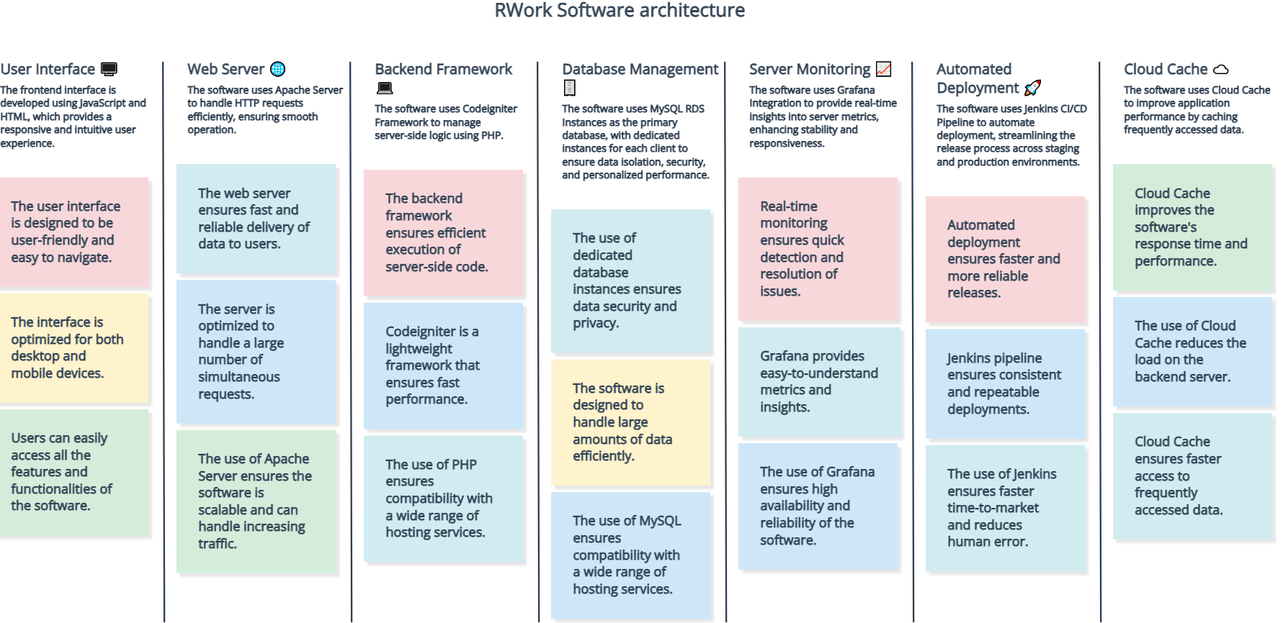

***Fig 1:*** *flowchart* *of RWork Software architecture*

1. Backend Framework and Database:

* Codeigniter Framework: The server-side logic is powered by the Codeigniter framework, leveraging PHP for efficient request processing.
* MySQL RDS Instances: Following the SaaS model, each client benefits from a dedicated MySQL RDS instance, ensuring data isolation, security, and personalized performance tailored to individual client needs.

2. Server Monitoring:

* Grafana Integration: Continuous monitoring is facilitated through Grafana, offering real-time insights into various server metrics. This proactive approach enhances stability and responsiveness across production nodes

3. Automated Deployment:

* Jenkins CI/CD Pipeline: Automated deployment is achieved through Jenkins, a powerful continuous integration and continuous deployment (CI/CD) tool. This streamlines the release process, enhancing development efficiency across staging and production environments.

4. File Storage:

* Amazon S3 Integration: File storage is seamlessly managed via Amazon S3. This scalable and reliable solution optimizes file handling, contributing to an efficient storage infrastructure

5. Database Management for SaaS:

* Individual RDS Instances: Following the SaaS paradigm, each client enjoys the benefits of a dedicated RDS instance. This architecture ensures data isolation, heightened security, and personalized performance. The database structure includes clustering with standby nodes, further enhancing data resilience.

6. Cloud Cache:

* Enabled: Implementing cloud caching mechanisms improves application performance by efficiently caching frequently accessed data, reducing response times.

7. Web Server:

* Apache Server: Efficient handling of HTTP requests is achieved through the Apache server, leveraging its robust features. Its robust features contribute to the smooth operation of the web application, providing a reliable foundation

8. Frontend:

* JavaScript and HTML Interface: The frontend is meticulously crafted using JavaScript and HTML. This dynamic combination ensures a responsive and intuitive user interface, delivering a seamless experience

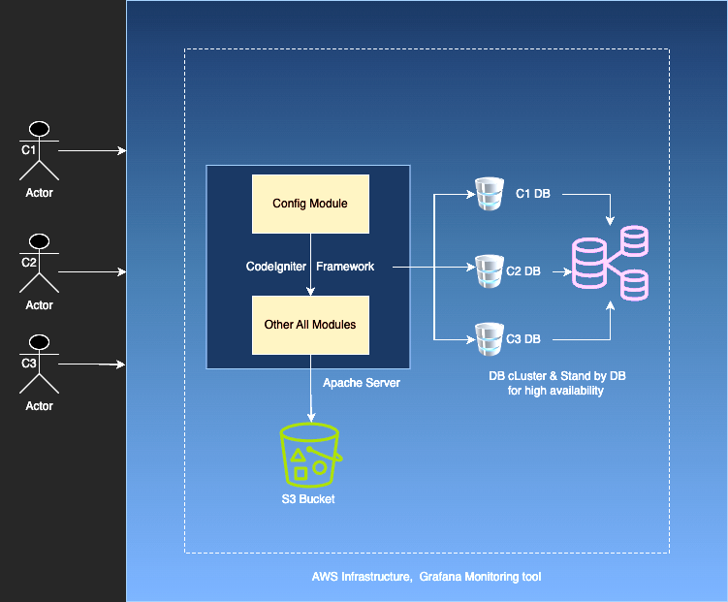

***Fig 2:*** *Software architecture of Rwork*

*where*

*C1 = Client 1*

1. **Environment-Specific Details:**

Node Configuration: The architecture includes one staging node and one production node, each serving specific purposes in the development lifecycle.

Database Redundancy: Both staging and production databases are configured as clusters with standby nodes, ensuring data availability and reliability.

The Rwork web application architecture reflects a thoughtful integration of technologies to create a secure, scalable, and high-performance environment. From backend processing and database management to deployment and user interface design, each component is crucial in delivering a top-notch SaaS experience for clients.

1. **RWork Algorithm and functionalities**

RWork software or application is an ERP software used for quick and effective evaluation of OBE systems, even in higher education institutions. This section discusses the overall backhand algorithms and mechanisms of the software.

|  |
| --- |
| ***Fig 3:*** *Flowchart of Process* |

***Step 1***

To initiate the software, start by entering institute and program details and student information. The institute's office staff handles this task. Once student names are integrated, proceed to input Vision, Mission, Program Educational Objectives (PEOs), Program Specific Outcomes (PSOs), Program Outcomes (POs), and course details.

After incorporating the course syllabus, the subsequent step involves linking faculty members with their respective courses, ensuring each faculty member can access their assigned course seamlessly through their dashboard within the academic module. RWork's evaluation OBE system is structured into eight modules, each serving a distinct purpose. These modules encompass CO creation, CO-PO mapping index, tool freezing, CO-target, tool co-linking, tool evaluation, tool CO-attainment, and course CO-attainment.

|  |
| --- |
| ***Fig 4:*** *Overall Dashboard* |

Within each module, a visual indicator in the form of a dot reflects the progress made. The dot transitions through colors, signifying the status of the task. A red dot denotes incomplete work, yellow indicates work-in-progress, and green signifies completed tasks. This intuitive color-coded system empowers faculty members to effortlessly monitor their progress and stay organized with their assigned responsibilities.

***Step 2***

RWork software provides a user-friendly platform for crafting Course Outcomes (COs) tailored to specific courses. To begin, navigate to the CO-creation module and select the red dot, triggering a new window where you can define the COs for your courses.

In this window, input at least five to six CO statements for each course, incorporating the course code and corresponding Bloom's taxonomy levels. Bloom's taxonomy, with its six levels—Remember, Understand, Apply, Analyze, Evaluate, and Create—serves as a widely embraced framework ensuring CO alignment with educational goals in accordance with AICTE examination reform policy documents. Once you've entered the CO statements and relevant details, confirm the creation of each statement by checking the corresponding checkbox. To finalize the CO creation process, click the submit button. RWork software streamlines this process, making it intuitive and straightforward, facilitating evaluation, and helping faculty members stay on track.

|  |
| --- |
| ***Fig 5:*** *CO Creation* |

***Step 3***

After creating the Course Outcomes (COs) for your designated courses using RWork software, the subsequent task is to map these outcomes with the Program Outcomes (POs). This mapping entails assigning each CO one of four correlation levels: no correlation (NA), low correlation (1), medium correlation (2), and high correlation (3). To perform this mapping, select three program-specific outcomes for each CO and designate their correlation levels. Once all COs are mapped with their corresponding POs, RWork software automatically generates the Course PO matrix, a valuable tool for evaluating the alignment between course outcomes and program outcomes.

|  |
| --- |
| ***Fig 6:*** *CO-PO and Course-PO Mapping* |

Mapping COs with POs is a crucial step in the Outcome-Based Education (OBE) evaluation process, ensuring that course goals and objectives align with broader program goals. With RWork software, this mapping process is straightforward, enabling faculty members to streamline their evaluation procedures and pinpoint areas for improvement.

***Step 4***

After mapping COs with POs in RWork software, the subsequent step is to choose assessment tools. To initiate this process, click on the red dot below the "tools freezed" option. Assessment tools are pivotal in Outcome-Based Education (OBE), and making the proper selections is essential for effective student evaluation.

RWork software offers various assessment tools, including in-semester examinations, unit tests, lab tests, assignments, lab books, practical oral examinations, and end-semester examinations. Faculty members must carefully select the appropriate assessment tools for their assigned courses, considering the course outcomes they intend to evaluate. Once the assessment tools are chosen, faculty members need to freeze them. It implies that the selected tools become immutable and cannot be altered or modified after assignment to a course. These frozen tools become instrumental in evaluating students' performance across different course outcomes.

|  |
| --- |
| ***Fig 7:*** *Selection of assessment tools* |

***Step 5***

Once the assessment tools for evaluating Course outcomes are chosen, the next step involves setting CO targets for each tool and each course outcome. It entails utilizing the same correlation levels as employed in CO-PO mapping: no correlation (NA), low correlation (1), medium correlation (2), and high correlation (3). To establish CO targets, assign weighted percentages to internal and external tools—20% for internal and 80% for external. This weighting ensures a balanced representation, accurately reflecting students' knowledge and skills concerning the COs.

|  |
| --- |
| ***Fig 8:*** *Setting tool CO target level* |

RWork software streamlines the process of setting CO targets by enabling faculty members to allocate weighted percentages to assessment tools effortlessly. It ensures fairness, accuracy, and consistency in the evaluation process. By employing the right tools and defining appropriate CO targets, faculty members can comprehensively assess their students' knowledge and skills related to the Course outcomes.

***Step 6***

The RWork program streamlines the task of connecting the questions in an assessment tool with the corresponding Bloom's taxonomy levels (BL) and course outcomes (CO) during the creation of test papers. In the tool-CO linking module, faculty members can easily link the COs and BLs with the relevant questions for each tool. This helps ensure that the question paper is appropriately aligned with the COs and BLs and that the evaluation process accurately reflects the student's knowledge and skills related to the COs.

|  |  |
| --- | --- |
| ***Fig 9:*** *Tool-CO & BL linking* | |

The software also allows for setting internal and external targets for each tool. The internal target is typically set at 60%, while the external target is set at around 40%. Another important feature of the RWork software is the ability to upload the question paper. This ensures that the question paper is securely stored for future reference and can be retrieved whenever necessary.

***Step 7***

The tool evaluation module in RWork software makes it easy for teachers to enter and keep track of students' marks in different tests. This module simplifies the whole process of evaluating and recording students' scores. Teachers can upload an Excel sheet with marks in a standard format, making it quick and easy. If they prefer, they can also manually input marks one by one. Once all the marks are in, the software automatically evaluates them, and each student's scores are saved.

|  |
| --- |
| ***Fig 10:*** *Tool evaluation* |

This module has a user-friendly interface, making it simple for teachers to view and manage the evaluation of various tests. It even calculates internal and external marks based on the goals set for each test during the linking stage. Using the tool evaluation module ensures that marks are accurately recorded and contribute to the student's final grades. This step is crucial in the Outcome-Based Education (OBE) process, allowing teachers to assess student performance and provide helpful feedback for improvement. The efficiency and accuracy of marking through this module play a vital role in the success of the OBE evaluation process.

***Step 8***

The utilization of RWork software significantly boosts the efficiency and precision of evaluating course outcomes through assessment tools by simplifying the CO attainment process. After entering marks in the tool evaluation module, the software conducts automated calculations, presenting a comprehensive report on the tool CO attainment in alignment with the predetermined targets. This particular feature proves invaluable for academic institutions, drastically reducing the time and effort invested in assessing CO attainment while enhancing the evaluation's accuracy.

|  |
| --- |
| ***Fig 11:*** *Course CO attainment* |

In traditional evaluation methods, gauging the attainment of COs through various tools can be a laborious task, demanding extensive manual calculations and assessments. In stark contrast, RWork software automates the entire process, streamlining it with just a few clicks and saving valuable time and resources. Moreover, the software ensures the evaluation's accuracy and reliability by eliminating the potential for human errors associated with manual calculations. Additionally, the software offers a detailed analysis of the tool CO attainment concerning the established targets. This functionality enables educators to pinpoint areas requiring improvement and take necessary actions to enhance the overall quality of education. This feature not only aids educators in monitoring and evaluating student progress but also ensures that the institution complies with the requisite standards for accreditation and recognition. RWork software, with its automated and detailed CO attainment analysis, not only facilitates a more efficient evaluation process but also contributes to maintaining high educational standards and meeting accreditation criteria.

***Step 9***

RWork software provides a streamlined and efficient method for calculating Course CO attainment and further PO attainment. Once the Tool CO attainment is assessed, the software seamlessly moves to the Course CO attainment module. This module generates a standardized report, presenting a detailed overview of Course CO attainment. This report showcases tool-wise CO attainment and evaluates the final course CO attainment with enhanced accuracy, minimizing time and effort.

|  |
| --- |
| ***Fig 12:*** *PO attainment* |

The report offers a comprehensive view of CO-wise tool attainments, allowing educators to quickly identify tools and COs needing attention. By clicking on a specific tool or CO, educators can delve deeper into areas where CO attainment may be lacking. This feature proves invaluable, enabling educators to pinpoint weaknesses in the course and implement corrective measures to enhance the overall learning experience for students. RWork software empowers educators to swiftly and efficiently calculate both Tool and Course CO attainment, and further PO attainment freeing up time to focus on other critical aspects of the learning process.

1. **Conclusions**

In summary, the incorporation of Rsense Technology Solutions PVT. LTD.'s RWork, a Management Information System (MIS) technology, serves as a transformative influence in higher education institutions. This innovative software effectively revolutionizes Outcome-Based Education (OBE) systems. RWork's seamless data synchronization between handheld devices and host computers significantly streamlines the intricate evaluation process of OBE systems. Its thorough tracking and analysis of diverse student performance metrics, including grades, attendance, and course outcomes, equip educators and administrators with evidence-based decision-making capabilities, providing a comprehensive understanding of the efficacy of OBE systems.

Furthermore, RWork goes beyond merely expediting evaluations; it acts as a catalyst for continuous improvement. Pinpointing areas requiring enhancement within OBE systems and monitoring the outcomes of implemented changes, ultimately, RWork signifies a crucial technological advancement that accelerates OBE system evaluations and enables educational institutions to make informed, data-driven decisions. This integration sets the stage for an environment of perpetual enhancement and refinement in higher education methodologies.

**References**

1. *Walid, Ibrahim., Wissam, Onsi, Ibrahim., Taoufik, Zoubeidi., Sayed, M., Marzouk., Amr, M.I., Sweedan., Hoda, Amer. (2022). An Online Management System for Streamlining and Enhancing the Quality of Learning Outcomes Assessment. Education and Information Technologies, doi: 10.1007/s10639-022-10918-8*
2. *Haidar, M., Harmanani. (2017). An outcome-based assessment process for accrediting computing programmes. European Journal of Engineering Education, doi: 10.1080/03043797.2016.1226781*
3. *José, Martins., Frederico, Branco., Ramiro, Gonçalves., Manuel, Au-Yong-Oliveira., Tiago, Oliveira., Mijail, Naranjo-Zolotov., Frederico, Cruz-Jesus. (2019). Assessing the success behind the use of education management information systems in higher education. Telematics and Informatics, doi: 10.1016/J.TELE.2018.10.001*
4. *Inger, Johanne, Pettersen. (2015). From Metrics to Knowledge? Quality Assessment in Higher Education. Financial Accountability and Management, doi: 10.1111/FAAM.12048*
5. *Rhona, Sharpe., Paul, J., Bailey. (1999). Evaluation and Design of Technologies To Meet Learning Outcomes. Journal of Computer Assisted Learning, doi: 10.1046/J.1365-2729.1999. 153092.X*