**“Analysis of Pedestrian Steel Bridge subjected the Seismic Load and Wind Load using Damper at different Span.”**

**Mr. Siddhesh R. Nagapure1**, **Prof. Kirti Padmawar 2**

1Student of M.TECH Department of Structural Engineering, BIT College Bamni Ballarpur

*Siddheshnagapure29@gmail.com*

2Professor of Department of structural Engineering, BIT College Bamni Ballarpur State Maharashtra, India

kirtipadmawar@gmail.com

|  |
| --- |
| *Abstract:* - A Pedestrian steel truss bridge model was created by using structural analysis by software. With the similar loading and support condition the 3D model was analyzed for different span like 20m, 25m,30m the basic emphasis has been given decreases the response of structure member by providing damper at different span I section Girder, steel plate thickness. Steel girder and M40 grade of concrete is used for column section in Etab software. The dynamic loading caused by moving pedestrian and earthquake and wind load,Excessive vibration in footbridges usually occurs when they are subjected to rhythmic dynamic loads caused by human activities like walking and running. In order to mitigate the human induced vibrations in footbridges, an increase in the damping ratio is often suggested as the most economical approach. Tuned mass dampers have been widely used for this purpose, however, their installation and maintenance costs are high. This has encouraged researchers to examine the efficiency of the other types of dampers. Viscoelastic dampers have been successfully employed for vibration mitigation of structures against wind and earthquake loads. ***Key Word****:*Pedestrian Steel Bridge, Dampers, structural Analysis, software |

1. **Introduction**

Pedestrian Bridge also called footbridge were used hundred years ago. Footbridge provides a safe movement of pedestrian over a urban roads, highways, slopes and hilly area. Asymmetrical loads cause the structure to behave in more complex ways.

Modern Footbridges are more and more sensitive to variable load created by moving pedestrians. There are several reasons for that. Very often there is no place for piers long span are only feasible solutions. The dynamic problems of footbridges have been subject of recent studies. Periodic load from pedestrian and wind can accelerate a pedestrian bridge which can be dangerous for structure itself. due to seismic load the it’s a big challenge to footbridges now a days.

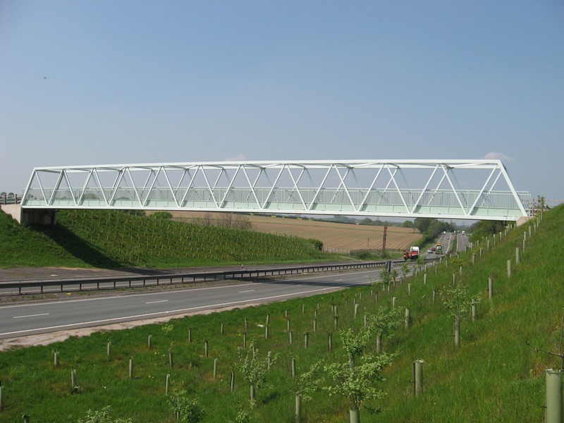

Fig.1

The dynamic problems of footbridges have been subject of recent studies. main reason of new engineering challenges related to footbridges; these bridges can fail due to low excitation energy also.

Periodic load from pedestrian and wind load can accelerate a bridge to the level which can be dangerous for structure itself. Viscoelastic damper is very essential use for pedestrian bridge, its low cost of maintenance as compare to tune mass damper and fluid viscous damper. the research efforts have been focused on the comfort ability resulting from human walking and aerodynamic properties On the other hand, the safety of the bridges subjected to earthquake excitations should also be strictly guaranteed In high-risk seismic zones, the earthquake may become the most critical factor that determines the structural configurations bridges with irregular arrangements are generally more vulnerable to seismic excitations, which has been evident by failures and damage of bridges observed in recent major earthquake.

Steel is widely accepted as primary structural material in pedestrian bridge there are established standard for design and fabrication, providing confidence in specifying steel. Most steel pedestrian bridges are built using shop fabricated truss system.

Whether it’s an urban or rural city park or busy highway overpass we design and analysis every pedestrian bridge to enhance the landscape aesthetically and environmentally and stable the pedestrian bridge due to various dynamic load as well pedestrian load acting on this structure.

1. **Literature Review**

**Umesh Rajshirake,( 2013)[1]** present this paper the Kharghar Skywalk Bridge is a two-span cable stay bridge which provides grade separated pedestrian facility between various institutes, residential areas, and railway station.

The bridge is designed considering visual interest feature of the part of Kharghar node which is planned and maintained by the state-owned agency.

It is a trend to provide a pedestrian bridge as a architecturally appealing structure along with purpose of transit the pedestrian traffic. These slender structures need to be analyzed and designed for the various dynamic loadings. In this particular project, the structural system is provided in such way that the peak acceleration due to foot vibration is within the specified limit of 5%.

**Dora Foti, Salvador Ivorra, David Bru,(2013)[2] ,** The purpose of this work is to study the dynamic behavior of a pedestrian bridge in Alicante, Spain. It is a very slender footbridge with vertical and horizontal vibration problems during the passage of pedestrians. Accelerations have been recorded by accelerometers installed at various locations of the bridge. Two scenarios, in free vibration (after the passage of a certain number of pedestrians on the bridge) and forced vibration produced by a fixed number of pedestrians walking on the bridge at a certain speed and frequency. In each test, the effect on the comfort of the pedestrians, the natural frequencies of vibration, the mode shapes and damping factors have been estimated. It has been found that the acceleration levels are much higher than the allowable by the Spanish standards and this should be considered in the restoration of the footbridge.

**Jiri Maca (2017)[3] ,** Studythe increase of vibration problems in modern footbridges shows that footbridges should no longer be designed for static loads only. Not only natural frequencies but also damping properties and pedestrian loading determine the dynamic response of footbridges and design tools should consider all of these factors. Footbridge vibrations don’t cause usually structural problems, but if the vibration behavior does not satisfy the comfort criteria, changes in the design or damping devices could be considered. The most popular external damping devices are viscous dampers and tuned mass dampers (TMD). The paper presents the basic principles of optimal TMD configuration and design procedure. The efficiency of TMD is demonstrated on the example of a footbridge prone to vibrations induced by pedestrians. It is shown that if the TMD is tuned quite precisely the reduction of accelerations can be very significant.

**Mario F. Sa, Nuno Silvestre, Joao R. Correia, Luís Guerreiro, Augusto M. Gomes (2017) [4**] study thedynamic behavior of a gfrp-steel hybrid pedestrian bridge in serviceability conditions. These studies, which focused on the recent St. Mateus footbridge (Portugal), had two main objectives: (i) to assess the ability of conventional numerical models and analytical formulae to simulate the vibration behavior of GFRP-steel hybrid footbridges; and (ii) to complement the observations and means urements made in the experimental campaign (Part 1), thus providing in-depth understanding of the vibration performance of this type of footbridges. First, a finite element (FE) model was developed and calibrated with the static and modal experimental data. Then, the FE-model was used to evaluate the vibration response of the footbridge for the same pedestrian activities induced in situ. The design formulae available in the predicting the maximum acceleration of structural systems are also reviewed and were applied to evaluate the resonant response of the footbridge for both single and crowded conditions of pedestrian traffic. The results obtained confirmed the adequate structural behaviors of the St. Mateus footbridge under real dynamic (human) pedestrian load cases and show that this innovative GFRP-steel hybrid structural solution is suitable for pedestrian bridges. The results of the different investigations reported in this paper also showed that both numerical and analytical approaches are able to predict the vibration response of GFRP-steel hybrid footbridges with reasonable accuracy.

**Monika, Pradeep, Guruprasad (2017) [5]** discussedComparative study on Time period and Frequency of Full Arch and Vierendeel Truss Steel Pedestrian Bridge, Here the bridges like full arch bridge and Vierendeel truss bridge is analyzed for the time history analysis of various spans like 40m,50m and 60m. The obtained response are time period, frequency. There are compared between full arch bridge and Vierendeel truss bridge and conclusion are drawn depending upon the obtained results. The time period for Vierendeel Truss Bridge for 40m span is 50% more than full arch bridge. Similarly, the time period for 50m and 60m span of Vierendeel truss bridge is 70% and 53% more than full arch bridges respectively. The frequency of full arch bridge for 40m span is 33% more than Vierendeel truss bridge. Similarly, the frequency for 50m and 60m span of full arch bridge is 42% and 37% more than Vierendeel truss bridge.

**Devaraju T.S, Shridhara Y (2018) [6]** discussed analyses the behavior of pedestrian steel suspension bridge structure under dynamic walking loads. This paper is thus basically a Analyzing the 10m,15m,20m span of pedestrian steel bridge structure deflection shear force and bending moment values are zero for load combination of dead load and live load

As per IS: 1893-2002 code of practice loads are applied in the combination of dead load, pedestrian load and earthquake in two directions. After analyzing the pedestrian steel bridge structure in 3D model for different span 10m, 15m and 20m results of displacement, shear force in two directions and bending moment in two directions are presented in this project.

This project looks into the analysis of pedestrian bridge under asymmetrical loads and reviews results for the dynamic loading caused by moving pedestrian and earthquake [zone 4 and soil type-2] for the vertical deflection, shear force in horizontal and vertical direction also bending moments in horizontal and vertical direction.

**Sabina piras, Kwan Chin (2018) [7],**StudyFootbridge Design for pedestrian induced vibration. This paper presents a guideline to determine the dynamic bridge characteristics under pedestrian loading. In addition, factors that influence a bridge’s response to vibration and possible vibration mitigation measures are discussed herein. This paper focuses on the recommended design procedure by presenting an analytical model of a concrete footbridge subjected to a dynamic load representing the effects of a stream of pedestrians crossing the structure. In the vertical direction, the peak acceleration from the pedestrian loading is compared with published acceptance criteria. In the lateral direction, the critical number of pedestrians at which the bridge response becomes unstable is calculated.

**Mohmmad A. Alhassan (2020) [8],** present the focus of study is directed towards the study was conducted to investigate the effect of human induced vibration on common simply supported steel footbridges in Jordan. With the help of this paper, we have understood. After attaching the TMD to footbridge the fundamental vibration of frequency was decreased to 1.146 hz which is less than the minimum value of range walking frequency 2.4 hz.

**Yi Zhang (2020) [9],** present the Effect of Ground Motion Orientation on Seismic Responses of an Asymmetric Stress Ribbon Pedestrian Bridge. stress ribbon bridge uses ribbon in high tension to transfer loads and exhibits geometric nonlinearity under dynamic earthquake excitations. A typical double-span asymmetric stress ribbon pedestrian bridge was introduced as a prototype, and nonlinear time history analysis was performed to investigate the effect of ground motion orientation on the structural responses

study investigated the variation in response quantities of a two-span asymmetric stress ribbon bridge subjected to bidirectional and tridirectionally earthquake ground motions changed with the direction.

**Haris Ali, Dr. Shobha Ram (2020) [10],** the studyas the population is increasing day by day, need of the pedestrian bridges are also increasing simultaneously. In the last few decades, due to the new technology and improvement in materials, the cross-sections of bridges are decreasing day by day. As a result of this mass and stiffness significantly decreases which leads to smaller natural frequencies, resulting in more vibration due to dynamic loads. For the analysis of pedestrian bridge dynamic excitation also plays a major role. Here, Pratt Truss and Tied Arch bridge of spans 30m, 40m, 50m, 60m are considered. Total 8 models are made and Finite element analysis is done on SAP2000 software. Time History and Modal analysis are used for the analysis purpose. Various responses like time period, frequency, peak acceleration and displacement are compared and conclusion is drawn depending upon the obtained results.

**Al Amin (2020) [11]** present the numerical design and analysis isolated single span pedestrian bridge under seismic load, In recent time earthquake has been the most dangerous threat to structures. As Bangladesh has a high risk of facing earthquake it is necessary to ensure safety of the structures. Bridges are very vulnerable to earthquake ground motion. In this study a single span composite bridge is modelled with SAP 2000 and is analyzed. The bridge is analyzed without using isolators subjected to modified El Centro data for 15, 20 seconds. Nonlinear time history analysis was performed. Then this same bridge is analyzed using a lead rubber bearing at one end of the bridge. The behaviors of the bridge are observed using isolators. From this analysis displacement vs time and acceleration vs time curves are found for different El Centro data. For base isolated and not isolated condition these results are compared. The comparison shows how seismically isolated condition can improve the response of bridge during earthquake.

**Deyuan Deng Zhijian Wang, Xiaoqing Zhang and Hongxin Lin (2022) [12]** Experimental Investigation on pedestrian walking load in steel footbridge. Accurate simulation of walking load is of great significance in conducting human-induced vibration analyses. However, accurate pedestrian walking load data obtained from long span footbridges is scarce and data reliability depends on the sensor used for measurement. In the current work, Yunluo Footbridge with 102 m span was adopted as test site and Xnode high-precision acceleration wireless sensor was applied for measurements. An experimental investigation was performed on walking loads according to bipedal walking force model. In experimental studies, single-person and multi-person walking tests were performed at Yunluo Footbridge to measure corresponding stride frequency and dynamic load factor. The acceleration time histories of walking pedestrians were accurately recorded using three-axis wireless acceleration sensor.

**Mallikarjun I Pattanashetti, Deepak Patil (2022) [13],** present thedynamic analysis of pedestrian steel bridge, Structural designing arrangements with the plan, creation and support of substantial and obviously built climate, including works like scaffolds, streets, channels, dams and homes. Development of extension has constantly been one of the most beguiling requesting circumstances to structural specialists. Materials like wood, iron, metallic and metropolitan has been utilized to develop the scaffold. In India fortified substantial scaffolds are existed. In India on account of quick urbanization and further developed site guests on streets the walker setbacks have sped up shockingly in excess two numerous years which require the accessibility of uncommon communities for walkers comprising of Pedestrian scaffold, trails and walkways. Plan and assessment of metallic Pedestrian scaffold is executed with the guide of the utilization of STAAD PRO programming program. Walker span plays out an imperative job in improving person on foot wellbeing in occupied and over the top site guest’s areas. A passerby span is a construction worked to traverse real impediments alongside streets and rail route tracks. This extension will remove site guests clog and defer at the double carriageway as well as eliminate clashes among people on foot and engine engines. In this current task work, the assessment and design of metal passerby span is executed with the guide of utilizing regular method with favored format subtleties as verified in Indian codes.

**Hassan Mazloum (2023)[14],** present Vibration Behavior of Pedestrian Bridges with Different Construction Systems. The design of pedestrian bridges is continuously being developed and the mechanical properties influence the dynamic properties in the SLS. Pedestrian induced vibrations have been a major concern regarding design criteria and construction. The opening of the Millennium bridge in London in 2000 made headlines regarding the matter and several researchers and papers have been assessing vibrations on pedestrian bridges due to pedestrian loading.

**Reina El Dahr, Xenofon Lignos, Spyridon Papavieros and Ioannis Vaya (2023) [15],** present Dynamic Assessment of the Structural Behavior of a Pedestrian Bridge Aiming to Characterize and Evaluate Its Comfort Level The assessment of infrastructure integrity is considered paramount to verify its structural health and to build its resilience. In this study, a monitoring strategy, consisting of a pre-developed microcontroller-based data acquisition system (DAQ) hardware and a software program for post processing built on LabVIEW platform, was conducted to assess the structural behavior of an arch-and-tie pedestrian bridge located in Haidari, Greece, following its construction phase. This endeavor aimed to delineate its systemic state and to verify the fulfillment of comfort criteria stated by EN1990, HIVOSS and SETRA guidelines. To this end, four trademark Bridge Diagnostic Inc. (BDI) triaxial accelerometers were meticulously deployed along the bridge expanse to scrutinize the structure’s response toward a spectrum of induced perturbations. The established framework effectively compiled the acquired acceleration time domain then employed a Butterworth bandpass filter to derive the bridge eigenfrequencies, eigenmodes, and damping ratios. The resultant findings conclusively indicate that the bridge response towards pedestrian crossing conforms to the established specifications and thus does not necessitate the installation of dampers. The bridge maintains comfortable structural integrity for pedestrian traversal up to an upper frequency limit of 3.67 Hz, substantiating its ability to absorb the dissipated energy generated by pedestrian movement.

**Zhaolan Wei, Mengting Lv, Siyin Wu, Minghui Shen, Meng Yan 2, Shaomin Jia , Yi Bao , Peng Han and Zuyin Zou (2022)[16]** , discussed the Lateral Vibration Control of Long-Span Small-Radius Curved Steel Box Girder Pedestrian Bridge with Distributed Multiple Tuned Mass Damper. Curved pedestrian bridges are important urban infrastructure with the desired adaptability to the landscape constraints and with aesthetic benefits. Pedestrian bridges feature thin cross-sections, which provide sufficient load capacities but lead to low natural frequencies that make the bridges susceptible to vibration under pedestrian excitation. This study investigates the lateral vibration of a curved bridge with a small radius down to 20 m. The results showed that the curved bridge was subjected to significant lateral vibration due to the coupling of torque and moment, and the recommended design parameters for the studied bridge were derived, i.e., the total mass ratio is 0.02, bandwidth is 0.15, center frequency ratio is 1.0, and damper number is 3. The proposed approach effectively improves the deployment of MTMD for lateral vibration control of the curved bridge. The field tests showed that the vibration was reduced by up to 82% by using the proposed approach.

**Andre Luís Gamino, Rafael Petille Hune, Ruan Richelly Santos (2023)[17],** discussed thesoil-structure interaction represents an important parameter when analyzing the dynamic behavior of bridges, taking into account the integration between soil, foundation, and structure to ensure an adequate structural representation. In this paper, a computational modeling strategy using soil-structure interaction (SSI) methodology was applied to represent the dynamic behavior of a pedestrian bridge (LOP). The computational models were validated using monitoring results from an extensive structural health monitoring campaign. The bridge monitoring program was characterized using embedded sensors and cutting-edge technology for remote monitoring: ground-based radar interferometry and video motion amplification. The instrumentation results were compared to establish the capabilities and advantages of this novel remote monitoring technique. The experimental results obtained from free and forced vibrations in the asset served as a basis for validating the developed computational model and allowed evaluating the asset behavior in service for different loading conditions. This paper emphasizes the SSI approach to represent the pedestrian bridge dynamic behavior more accurately, allowing computational models to represent the LOP structural responses over the course of its life-cycle.

**Krzysztof Zoltowski Piotr Zoltowski (2023)[18],** The paper describes a numerical study of dynamic response of a footbridge under pedestrian load and flow field created by big truck passing underneath. Standard FEM formulation is used to compute the response of the structure but the main problem discussed is how to define loads. Pedestrian load function is described in the first part of the paper. Lock in effect (interaction between pedestrians and the deck) for vertical vibrations is explained and the proposition of simple nonlinear dynamic model is presented.

1. **Summary:**

This chapter deals with the numerous numbers of papers and journals that has been found helpful for carrying out the work. From the literature survey, it was found that VED is used as deck and top story of pedestrian bridge by diagonally at mid span and both end span of pedestrian bridge. From this literature review most of the journals are used the TMD dampers and control the vibration of structure but due to high cost and more maintenance cost we are used the VED viscoelastic dampers.

1. **Objectives:**

The present study is main aim of this projects is to control or minimization the vibration of pedestrian steel bridge and provide stable the structure after subjecting the seismic and wind load providing damper at different span.

1. To analyses the pedestrian steel truss bridge considering the seismic and wind load.
2. To providing the viscoelastic damper at different span and compare the results with damper and without damper.
3. To perform nonlinear time history analysis using scaled time histories of electro earthquakes on the above structure in both the directions using their respective codes of practices.
4. To calculate the results from nonlinear analysis in form of factors like, story Acceleration time period, frequency and base shears of the Structure with each other and tabulate the observations.
5. To determine maximum values of these factors based on the observations.
6. To calculate the results from using software’s and minimization or control the vibration of foot steel bridge using viscoelastic damper.

## Methodology:

1. Modeling the footbridge on Etab software.

The pedestrian steel bridge modeling on Etab software. considering the steel deck bridge, the height of deck pedestrian bridge is 12m. the steel plate thickness considering 100mm. truss type pedestrian bridge is taken for analysis and design.

20m,25m,30m span are consider for analysis the pedestrian steel bridge, I section steel girder are use.

The M40 grade of concrete are used for pedestrian bridge piers.

1. Loading cases:

As per IS code provision various IS code use for pedestrian bridge.

Mostly IS 875-part 1 dead load, the loading value ca be taken from this IS code, live load value taken from IS code 875 part 2 and wind load value can be taken from IS code 875 part 3, as per IS code 875 part 3 the wind load is acting on any structure if the height of any structure is more than 10m, and in this project the pedestrian bridge height Is taken the 12m that is considering the wind load and analysis the footbridge at Etab software.

The location of steel pedestrian bridge is considering the zone IV. Use the earthquake IS code 1893-2002. The earthquake loading act on structure both direction, the direction X and Z direction.

1. Model the viscoelastic damper:

After the validation of the model of the footbridge, the next step is to validate the damper model. The viscoelastic damper employs two layers of rubber with are of 1200mm2 (60mm*20mm) and a thickness of 5 mm for both layers.

1. Calculation the bending moment, shear forces and torsional moment due to seismic, wind, dead and live load of pedestrian.
2. The nonlinear time history analysis carried out on the pedestrian steel bridge using Indian standards code of practice.
3. The comparison of result obtained from the analysis of pedestrian bridge and conclusion.

Gives an idea about the future scope for research.

1. **Method of Analysis**

**Nonlinear Dynamic Analysis**

As per the IS 1893, the definition of nonlinear dynamic analysis or time history analysis is the analysis in which the dynamic response of the structure is studied at each and every instance of a earthquake ground motion subjected to the base of the structure. Time histories selected shall be based on appropriate ground excitation data’s and with compatible design acceleration spectrums and shall be implemented using principles of earthquake dynamics as mentioned.

1. Modelling of structure

## Structure of 3-dimensional view

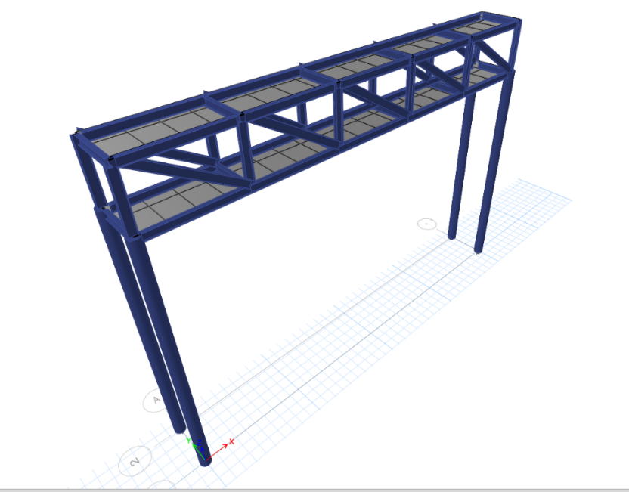

Figure: 3D view of 20 m span of pedestrian bridge

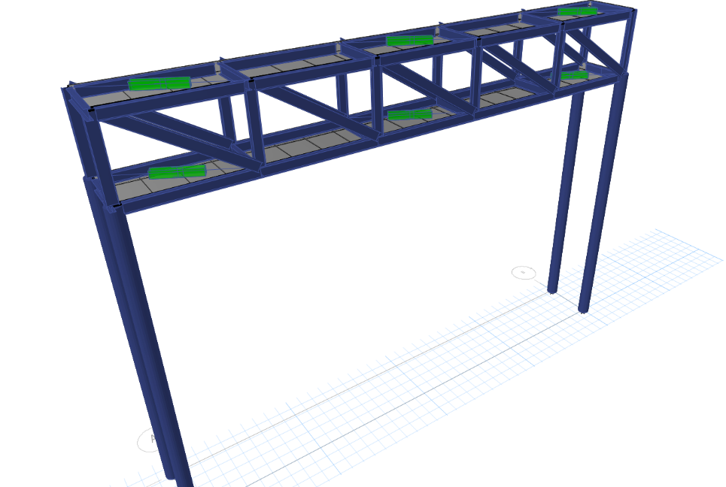

Figure: 3D view of 20 m span of pedestrian bridge Installing viscoelastic damper

1. **Results from NLTHA in X-Direction:**

|  |  |  |  |
| --- | --- | --- | --- |
| **Story** | **mode** | **Load Case/Combo** | **UX** |
| **mm/sec²** |
| top story | 1 | EQX Max | 11949.53 |
| top story | 1 | EQY Max | 12538.88 |
| top story | 1 | WX Max | 12527.78 |
| top story | 1 | WY Max | 12527.78 |

The factors like Acceleration, Time Period, frequency, and base shear determined by using El Centro ground motion data from PEERS. Refer for maximum Acceleration values.

**Maximum Acceleration from pedestrian bridge of 20 m span without damper Designed Using Indian Standards along X-Direction for El Centro data.**

|  |  |  |  |
| --- | --- | --- | --- |
| **Story** | **mode** | **Load Case/Combo** | **UX** |
| **mm/sec²** |
| top story | 1 | EQX Max | 12396.79 |
| top story | 1 | EQY Max | 12985.1 |
| top story | 1 | WX Max | 12986.31 |
| top story | 1 | WY Max | 12986.31 |

**Maximum Acceleration from pedestrian bridge of 20 m span with Visco elastic damper Designed Using Indian Standards along X-Direction for El Centro data.**

**Acceleration Reduces by installed Visco elastic damper of 20 m span of pedestrian bridge.**

|  |  |  |  |
| --- | --- | --- | --- |
| **Story** | **mode** | **Load Case/Combo** | **ACCELERATION REDUCTION IN %** |
|  |
| top story | 1 | EQX Max | 3.96 |
| top story | 1 | EQY Max | 3.44 |
| top story | 1 | WX Max | 3.53 |
| top story | 1 | WY Max | 3.53 |

From this figure I have discussed the different type of span of pedestrian bridge like considered as 20 m ,25 m & 30 m. the maximum Acceleration is obtained in earthquake x direction in 20 m span is 12396.79 mm / sec2. And 25 m span the maximum acceleration is obtained 9441.14 mm/ sec2. The Acceleration is reduced in 25 m span bridge as compare to 20 m is 2955.65 mm/sec2. i.e. 23.84 % is reduced. The Acceleration is reduced in 25 m span as compare to 30 m span bridge is 13470.72 mm / sec2 i.e.58.79 %.

The Acceleration is obtained by wind load in x & y direction of 20 m span bridge is 12986.31 mm / sec2. The acceleration is reduced in 25 m span as compared with 20 m span is 3019.07 mm / sec2. 23.24%. The acceleration is reduced in 25 m span as compared to 30 m is 13401.13 mm/ sec2. i.e. 57.34 %.

From this figure I have discussed the different type of span of pedestrian bridge like considered as 20 m ,25 m & 30 m.by installed the viscoelastic dampers diagonally at mid span and end span of the pedestrian bridge. The maximum Acceleration is obtained in earthquake x direction in 20 m span is 11949.53 mm / sec2. And 25 m span the maximum acceleration is obtained 7542.06 mm/ sec2. The Acceleration is reduced in 25 m span bridge as compare to 20 m is 4407.47 mm/sec2. i.e. 36.88 % is reduced. The Acceleration is reduced in 25 m span as compare to 30 m span bridge is 7503 mm / sec2 i.e.49.87 %.

The Acceleration is obtained by wind load in x & y direction of 20 m span bridge is 12527.78 mm / sec2. The acceleration is reduced in 25 m span as compared with 20 m span is 4457.56 mm / sec2. 35.58%. The acceleration is reduced in 25 m span as compared to 30 m is 7438.58 mm/ sec2. i.e. 47.96 %.

1. **Modal Period & Frequency:**

Model period of 20 m span of pedestrian bridge is 2.253 sec. & frequency of this span of bridge is 0.444 Cyc/sec which is less than 2 hz that is structure is stable, by installed visco elastic damper at that span the time period is 2.345 sec. it is increased by 4.08 %. And frequency is 0.426 Cyc/sec it is reduced by 4.05 %. Model period of 25 m span of pedestrian bridge is 2.424 sec. and after installed damper the time period is 2.513 which is increased by 3.67 %. And the frequency without damper is 0.413 Cyc/ sec. and with damper 0.398 Cyc/ sec. which is reduced by 3.63%. the frequency of 30 m span without damper is 0.381 sec and with damper is 0.374 sec which is reduced by 1.83 %. And model period without damper is 2.627 Cyc/sec. and with damper is 2.673 Cyc/sec. which is increased by 1.75 %.

## Conclusion

1. Maximum Acceleration is reduced by earthquake in x direction of 20 m span of pedestrian bridge is 3.96 % at top story of bridge. & y direction acceleration is reduced by 3.44 %. maximum wind load also reduces in x and y direction by 3.53 % by installed Vasco-elastic damper diagonally at top story and deck at mid span and end span of bridge.
2. Maximum Acceleration is reduced by earthquake in x direction of 25 m span of pedestrian bridge is 20.11 % at top story of bridge. & y direction acceleration is reduced by 19 %. maximum wind load also reduces in x and y direction by 19 % by installed Vasco-elastic damper diagonally at top story and deck at mid span and end span of bridge.
3. Maximum Acceleration is reduced by earthquake in x direction of 30 m span of pedestrian bridge is 34.33 % at top story of bridge. & y direction acceleration is reduced by 33.63 %. maximum wind load also reduces in x and y direction by 33.63 % by installed Vasco-elastic damper diagonally at top story and deck at mid span and end span of bridge.
4. Model period of 25 m span of pedestrian bridge is 2.424 sec. and after installed damper the time period is 2.513 which is increased by 3.67 %. And the frequency without damper is 0.413 Cyc/ sec. and with damper 0.398 Cyc/ sec. which is reduced by 3.63%.
5. We concluded that the from this different type of span of pedestrian bridge the most preferable pedestrian bridge is 25 m span.
6. If light weight of structure there will be more accelerate the structure and if the span of structure is increased then stiffness of structure is increased and acceleration is reduces unto certain limit of increasing the span and if more span increases then it will be also more accelerate the structure so in this project we consider the 25 m span for zone IV by considering the electro ground motion data.

## Future scope

The present study is carried out for a pedestrian bridge with visco elastic damper and without damper for considering different type of span.

1. For further project we can use different type of dampers and analysis.
2. The pedestrian bridge can be analysis by using composite section .
3. The pedestrian bridge can be analysis and design by using different type of section for deck.
4. **References:**
5. Devraj T.S Shridhar y “behavior of pedestrian steel bridge subjected to seismic load. Volume: 05 issue June 2018
6. Mohammad A. Alhassan Rajai Z Al-Rousan “control of vibration of common pedestrian bridge in Jordan using tuned mass dampers.
7. Umesh Rajshirake Design and construction of pedestrian bridge Navi Mumbai Kharghar.
8. Yi Zhang “Effect of Ground Motion Orientation on Seismic Responses of an Asymmetric Stress Ribbon Pedestrian Bridge”.
9. Deyuan Deng1,2 *, Zhijian Wang3, Xiaoqing Zhang4 and Hongxin Lin5

“Experimental Investigation on pedestrian walking load in steel footbridge”.

Footbridge Design for pedestrian induced vibration.

1. Sabina piras “Footbridge Design for pedestrian induced vibration”.
2. Hassan Mazloum Vibration Behavior of Pedestrian Bridges with Different Construction Systems.
3. Haris Ali, Dr. Shobha Ram (2020) , the numerical design and analysis isolated single span pedestrian bridge under seismic load,
4. Mallikarjun I Pattanashetti, Deepak Patil, the dynamic analysis of pedestrian steel bridge,
5. Hassan Mazloum (2023) Vibration Behavior of Pedestrian Bridges with Different Construction Systems.
6. Reina El Dahr, Xenofon Lignos, Spyridon Papavieros and Ioannis Vaya (2023)Dynamic Assessment of the Structural Behavior of a Pedestrian Bridge Aiming to Characterize and Evaluate Its Comfort Level The assessment of infrastructure integrity is considered paramount to verify its structural health and to build its resilience.
7. Zhaolan Wei, Mengting Lv, Siyin Wu, Minghui Shen, Meng Yan 2, Shaomin Jia , Yi Bao , Peng Han and Zuyin Zou (2022) ,the Lateral Vibration Control of Long-Span Small-Radius Curved Steel Box Girder Pedestrian Bridge with Distributed Multiple Tuned Mass Damper.