**Review Paper On Partial Replacement Of Coarse Aggregate**

**By Jhama Brick In Concrete**

Vinit Nag1, Shubham Raj Sinha2, Shreya Jaiswal3, Anju Jangade4, Ajay Kumar Garg5

*123Department of civil Engineering, Government Engineering College, Raipur(C.G)*

*4Assistant Professor, Department of Civil Engineering, Government Engineering College, Raipur (C.G)*

*5Head of Department, Department of Civil Engineering, Government Engineering College, Raipur(C.G)*

|  |
| --- |
| ***Abstract:*** *The experiment explores using demolished brick aggregate, specifically Jhama brick, as a substitute for traditional coarse aggregate in concrete production. Different proportions of Jhama brick (15%, 25%, and 35%) were tested in M25 grade concrete. Testing included fresh and hardened concrete characteristics like workability and compressive strength at 7 and 28 days. Results showed that a 25% replacement of Jhama brick was cost-effective and had suitable strength for moderate load structures, although overall strength was lower than standard concrete.*  ***Key Word****: Jhama brick, And Compressive strength test.* |

1. **Introduction**

Concrete, a key construction material, relies on cement and aggregates for quality and cost efficiency. Aggregates, comprising over 70% of concrete volume, are favored for their affordability and strength. Bricks, known for durability, are being explored as substitutes for natural coarse aggregate in concrete. Crushed and recycled bricks offer sustainable solutions, utilizing demolition and construction waste. Rejected bricks from production present further potential for coarse aggregate. This paper investigates replacing natural aggregate with Jhama brick aggregate, aiming for sustainable and cost-effective construction practices [1].

1. **Material And Methods**

**Material used**

**Cement:** Cement, a fine gray powder, is combined with water, sand, gravel, and crushed stone to create concrete. When mixed with water, this mixture forms a binding paste, solidifying as the concrete hardens. Ordinary Portland cement, with a 28-day compressive strength of 53 MPa, was uniformly utilized in preparing all concrete cubes. The study focuses on examining how altering the types of coarse aggregate in concrete influences its characteristics [2] [3].

|  |  |  |
| --- | --- | --- |
| **S.No** | **Properties** | **Test Results** |
| 1. | Specific gravity | 3.15 |
| 2. | Initial setting time | 45 min |
| 3. | Final setting Time | 482 min |
| 4. | Soundness | 1.92 min |

**Fine Aggregate:** The sand utilized in the experimental study was sourced locally and complied with the Indian Standard Specifications IS 383-1970. Initially, the sand underwent sieving through a 4.75 mm sieve to eliminate particles larger than 4.75 mm. Subsequently, it was washed to eliminate any dust particles. The sand employed in this investigation was categorized as M sand [1] [2].

|  |  |  |
| --- | --- | --- |
| **S.No** | **Properties** | **Test Results** |
| 1. | Specific gravity | 2.74 |
| 2. | Fineness modulus | 2.85 |
| 3. | Grading Zone | II |
| 4. | Density | 717 Kg/m3 |

**Coarse Aggregate:** Broken stone is typically the primary coarse aggregate in construction projects. The selection of the maximum size of the coarse aggregate is determined by the project's specific requirements. In our study, we utilized locally sourced coarse aggregate with a maximum size of 20 mm. Before use, the aggregates underwent a thorough washing process to eliminate any dust and dirt particles, followed by drying until they reached a surface dry condition. The aggregates were then tested according to the guidelines outlined in the Indian Standard Specifications IS 383-1970 [2].

|  |  |  |
| --- | --- | --- |
| **Sr. No** | **Properties** | **Test Results** |
| 1. | Specific gravity | 3.15 |
| 2. | Size | 20mm |
| 3. | Fineness Modulus | 6.9 |
| 4. | Shape | Angular |

**Jhama Class Brick**: Bricks are fired in brick kilns at temperatures ranging from 800-900°C. When kiln temperatures are uncontrolled, bricks may be excessively burnt, reaching temperatures of 1100-1200°C. These over-burnt bricks, also known as Jhama bricks, are often sold at lower prices due to their distorted shape. Despite this, they exhibit higher strength compared to standard burnt clay bricks and can even surpass first-class bricks in strength. Over-burnt bricks typically boast compressive strengths ranging from 120 to 150 Kg/cm2. However, their irregular shape requires approximately 40% more mortar for brickwork compared to conventional bricks [1].

|  |  |  |
| --- | --- | --- |
| **Sr. No** | **Properties** | **Test Results** |
| 1. | Specific gravity | 2.4 |
| 2. | Size | 20mm |
| 3. | Shape | Angular |

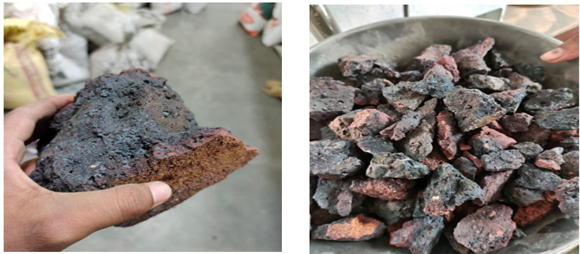

**Over Burned Jhama Bricks**

**Water:** Water used for mixing, and curing purposes should be clean, portable, fresh, and free from any bacteria. Water is a key ingredient in the manufacture of concrete.

**Methodology:**

The necessary materials were gathered, and preliminary tests were conducted on them to establish the mix design for M25-grade concrete. These tests included determining water absorption and specific gravity for sand, aggregate, and Jhama bricks, as well as conducting sieve analysis on sand and aggregate.

• Collection of materials

• Sieve Analysis of materials

• Weighing and mixing of materials

• Casting of cubes

• Curing and drying

• Compressive strength test

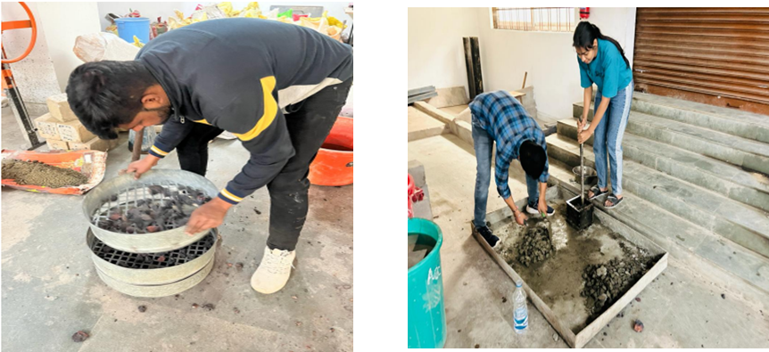

**Sieve Analysis Mixing of Materials And Casting of Cubes**

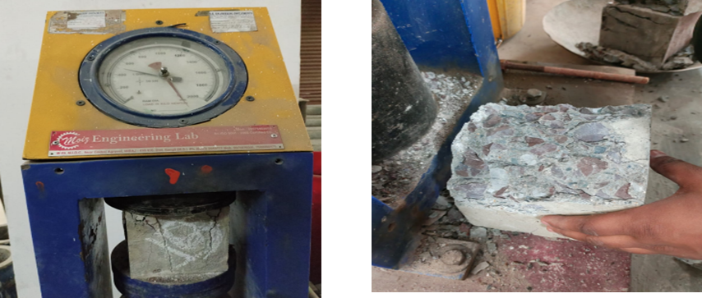

**Compressive Strength Test**

1. **Result And Conclusion**

**Compressive Strength Test:** Compressive strength of cubes 150X150X150 (mm) for M-20 and M-25 in (MPa) [1] [2].

Compressive strength test results at 7 days and 28 days are attached along with their graphical representation [3].

|  |  |  |  |
| --- | --- | --- | --- |
| **S.No** | **% Of Jhama Brick** | **Compressive Strength In N/mm2**  **(Sample1)** | **Compressive Strength In N/mm2**  **(Sample2)** |
| 1. | 0% | 22.32 | 26.15 |
| 2. | 15% | 20.57 | 25.17 |
| 3. | 25% | 23.24 | 27.17 |
| 4. | 35% | 14.53 | 23.72 |

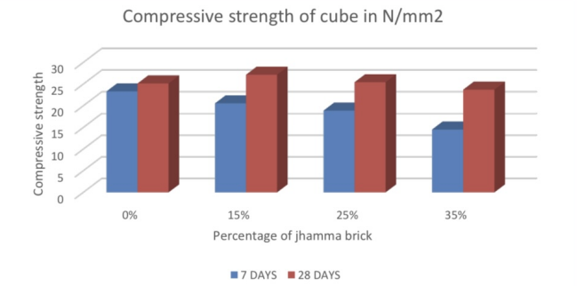

**Conclusion**

The compressive strength of conventional concrete (as estimated through three cube tests) at 7, and 28 days for M-20 and M-25 grades surpasses that of concrete made with replaced over-burnt bricks. Moreover, as the replacement of over-burnt bricks increases from 15% to 35%, the compressive strength decreases. However, when coarse aggregates are replaced by over-burnt bricks, the variation in compressive strength between conventional concrete and replacement concrete is minimal, remaining within the targeted strength range. Nonetheless, flexural strength and tensile strength decrease with the replacement of over-burnt bricks compared to conventional concrete. Additionally, the workability, indicated by the slump, decreases as the percentage of replacement of over-burnt bricks increases in M-20 and M-25 grades of concrete [2]. The 25% replacement of Jhama brick is considered a good replacement because of its strength and economy, hence we use it in moderately loaded structures [3].

**References**

1. Bidve Ganesh Shivkanth, Prof. G. N. Shete “Experimental Study on Effect of Partial Replacement of Coarse Aggregate by over Burnt Brick Bats” Vol. 7, Issue 02, 2019 | ISSN (online): 2321-0613
2. Kumar, N., Saxena, A. K., & Soni, G. (2017). Analysis of Concrete Made from Over Burned Bricks.
3. Buddhi Raj Joshi” Analysis of burned Brick in Concrete as a Coarse Aggregate” ISSN (Online): 2320-9364, ISSN (Print): 2320-9356 www.ijres.org Volume 8 Issue 1 Ser. I ǁ 2020 ǁ PP. 30-38.
4. G. S. Patil and P. B. Autade, “Effect of Partial Replacement of Coarse Aggregate by Jhama Class Brick in Concrete, International Journal of Engineering Research and General Science, Volume 3, Issue 4, Part-2, July-August, 2015 ISSN 2091-2730.
5. Tariq Ali, Nouman Iqbal, Md Zeeshan, Md Zulfiqar Ali Khan, Evaluation of the Compressive strength of Concrete for partial replacement of Over Burnt Brick Ballast Aggregate, International Journal of Science and Modern Engineering (IJISME), December 2013.
6. Apebo N. S., Agunwamba J. C., Ezeokonkwo, J. C” The suitability of crushed over burnt bricks as coarse aggregates for concrete” International Journal of Engineering Science and Innovative Technology (IJESIT), Volume 3, Issue 1, January 2014.
7. Apebo, N.S., Lorwua, M.B., Augunwamba, J.C. (2013)." Comparative analysis of the compressive strength of concrete with gravel and crushed over burnt bricks as coarse aggregates" Nigerian Journal of Technology (NIJOTECH) Vol. 32, No. 1, pp. 7–12.
8. Rashid. M. A, Hossain. T and Islam M. A, “Properties of Higher Strength Concrete made with crushed brick as aggregate,” in Journal of civil Engineering, Vol. 37(1), pp. 43 -52, 2009.
9. Kesegic, I., Netinger, I. and Bjegovic, D. “Recycled Clay Brick as an aggregate for concrete,” Technical Gazette, vol. 15, no. 3, pp. 35-40, 2008.

[10] Chong C. V. Y, “Properties of Materials,” Mac Donald and Evans Publishers, London 1981.