**SMART HYDROPONIC FARMING WITH ROBOTICS SYSTEM**

Jimy Johny E1, Manikandan N R2, Nandana Suresh3, K P Devanand4, Afna V N5

*1(Assistant Professor/Department of Electronics and Communication Engineering /Universal Engineering College Vallivattom/Thrissur, Kerala, India)*

*2345(Department of Electronics and Communication Engineering/Universal Engineering College Vallivattom/Thrissur, kerala, India)*

|  |
| --- |
| ***Abstract:*** *The traditional farming practices of ancient times were rooted in soil quality and land nutrition, contributing to successful crop yields and profitability. However, these methods were labor-intensive and time-consuming, requiring substantial manpower to maintain extensive agricultural lands. Despite the emphasis on soil quality, challenges arose in consistently maintaining optimal nutrition levels for crops. In contrast, hydroponics, a modern agricultural technique, revolutionizes this paradigm by cultivating plants in a soil-free water solution. This innovative approach offers potential solutions to the challenges of traditional farming, providing a more space-efficient and controlled environment for crop growth, ultimately enhancing productivity and nutritional management.*  ***Key word:*** *Hydroponics, Water level sensor, pH Sensor, Machine learning, Robotics.* |

1. **Introduction**

Traditional farming practices, rooted in ancient methodologies, were effective in sustaining crop quality and yields. The success of these methods was attributed to the rich- ness of the soil and the nutritional elements applied to the land. However, despite their effectiveness, traditional farming had several drawbacks. One significant challenge was the substantial time investment required to see tangible results. Farmers spent extended periods cultivating their land before reaping the benefits of their labor. Another notable limitation was the inconsistency in maintaining optimal nutrition levels in the soil. Traditional methods often struggled to sustain consistent nutrient levels, impacting crop health and yield predictability. Moreover, these conventional farming practices consumed vast amounts of space, as large expanses of land were necessary to accommodate the crops. The process also demanded significant manpower to manage the entire agricultural operation, from planting and nurturing to harvesting. In response to these challenges, hydroponics emerged as an innovative and more efficient approach to cultivation. Hydroponics involves growing plants without soil, relying instead on a nutrient-rich water solution. This method allows for precise control over the plant’s environment, ensuring optimal nutrient levels and minimizing the reliance on expansive land and manual labor. By eliminating the need for soil, hydroponics offers several advantages. First, it enables a more controlled and stable nutrient supply, promoting healthier and faster plant growth. Second, hydroponic systems are designed to optimize space usage, making them suitable for urban environments or areas with limited arable land. Additionally, the reduced reliance on traditional soil-based farming practices can lead to increased sustainability and resource efficiency.

1. **Problem Identification**

Resource scarcity, including limited water and arable land availability, poses a significant threat to sustainable food production. Additionally, agriculture contributes to environmental degradation through soil depletion, water pollution, and loss of biodiversity, often exacerbated by unregulated farming practices such as deforestation and habitat destruction. Chemical pesticides, while effective in pest control, also contribute to soil and water contamination, harm non-target species, and pose health risks. Balancing pest control with ecological sustainability is a complex challenge facing modern agriculture. Furthermore, seasonal limitations such as adverse weather conditions and temperature fluctuations can significantly impact crop yields and farming efficiency. Labour shortages, driven by demographic shifts and migration patterns, further exacerbate these challenges, affecting essential farm activities like planting and harvesting. However, the adoption of mechanization and technological solutions is underway in agriculture to address these labour shortages and improve overall efficiency.

1. **Problem Definition**

Traditional agriculture faces numerous challenges including excessive resource usage, labor-intensive practices, and imprudent management techniques. However, the emergence of smart hydroponic farming systems presents a paradigm shift in agricultural practices. Utilizing soil-less cultivation methods with water solutions enriched with nutrients, hydroponics allows precise control over nutrient delivery for optimal plant growth. This method offers several advantages, such as water recycling to minimize wastage and reduce strain on freshwater resources, particularly vital in water-scarce regions.

The integration of robotics and automation further enhances efficiency by reducing dependency on manual labor and enabling precise and consistent execution of farming operations. Continuous monitoring and adjustment of environmental variables ensure optimized growing conditions. The ultimate goal is to reduce reliance on chemical inputs, minimizing the need for synthetic fertilizers and pesticides while promoting environmentally friendly farming practices to safeguard soil and water quality.

The benefits are multifaceted, including mitigating environmental pollution, preserving biodiversity, and promoting human health. Overall, this transformation of agriculture into a more efficient, sustainable, and resilient industry harnesses technology and innovation for a prosperous and environmentally conscious future. It revolutionizes food production practices, ensuring food security for future generations.

1. **Proposed Solution**
2. **Block Diagram**

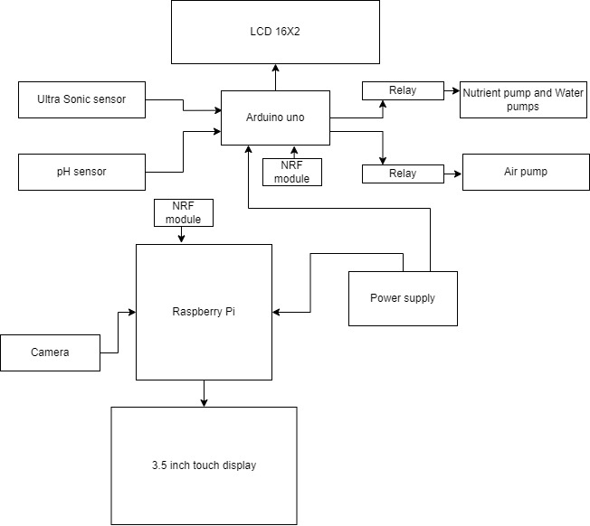

Fig.1.1 Block Diagram

* **pH Sensor** :It measures the acidity or alkalinity of the solution. This sensor helps in maintaining the ideal pH level in the nutrient solution.
* **Ultrasonic water level sensor:** Detects distance to water surface using sound waves. Threshold set at 20cm triggers actions like pump activation. Ideal for precise, non-contact water level monitoring in tanks and flood prevention systems.
* **Camera**: It captures images of the hydroponic setup for monitoring and remote control.
* **LCD Display**: It displays information about the system status, such as pH level, dissolved oxygen, water temperature, and water level.
* **NRF 24L01 MODULE**: The NRF module, based on Nordic Semiconductor chips, facilitates low-power wireless communication over short distances at the 2.4 GHz frequency. Widely used in IoT, home automation, and sensor networks, it offers reliable connectivity for various projects.
* **Arduino Uno**: It serves as the brain of the system, handling all the input/output operations, including communication with the Raspberry Pi and other sensors.
* **Raspberry Pi**: It serves as the central processing unit for the system, managing the overall operations, such as data analysis and control, along with interfacing with the Arduino Uno.
* **Power supply**: It provides power to all the electronic components of the system.
* **Nutrient solution Pump and Water pump**: They are responsible for circulating the nutrient solution and providing fresh water to the plants.
* **Air pump**: It is responsible for maintaining an ideal oxygen balance in the system by ensuring proper mixing of air with the nutrient solution.
* **Filter**: It helps in removing solid particles from the nutrient solution and maintaining its clarity. In summary, this Automated Hydroponic System utilizes various sensors and actuators to monitor and control the environment, ensuring the healthy growth of plants in the nutrient solution.
* **3.5 inch TFT touch display**: The display in this context refers to a visual output device that can be connected to a Raspberry Pi, allowing users to view graphical content such as text, images, or videos. This could include various types of screens such as LCD, TFT, OLED, or touchscreen displays. Displays for the Raspberry Pi come in different sizes and configurations, offering users options based on their project requirements and preferences.

1. **Flow chart**

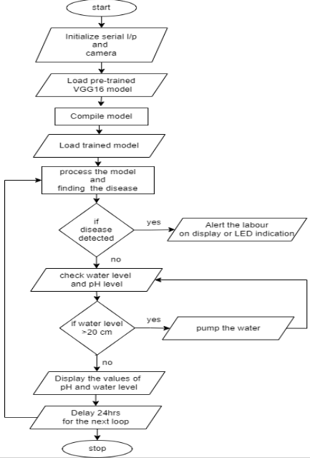  
Fig.2.1:Flow chart

1. **Circuit Diagram**

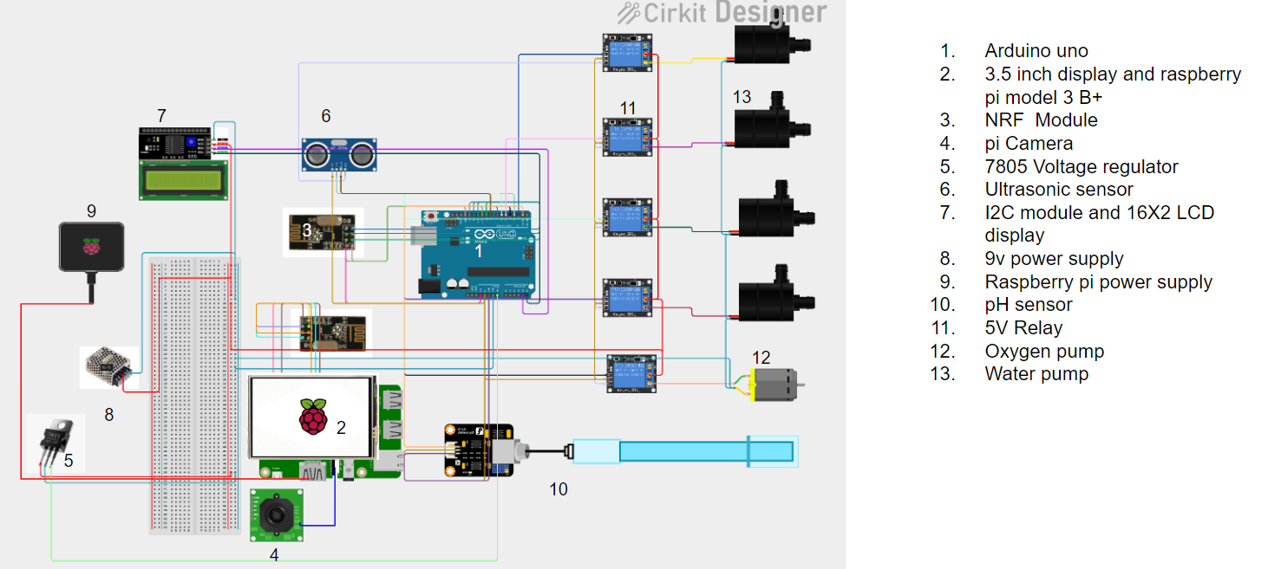

Fig.3.1:Circuit diagram

1. **Software Used**

* **Python**: Python is a high-level, interpreted programming language known for its readability and versatility. It supports multiple programming paradigms, including procedural, object-oriented, and functional programming. Python has a large standard library and a vast ecosystem of third-party packages, making it a popular choice for various applications, such as web development, data analysis, artificial intelligence, and more.
* **Arduino IDE**: The Arduino IDE is an open-source software, which is used to write and upload code to the Arduino boards. The IDE application is suitable for different operating systems such as Windows, Mac OS X, and Linux. It supports the programming languages C and C++. Here, IDE stands for Integrated Development Environment. The program or code written in the Arduino IDE is often called as sketching. We need to connect the Genuine and Arduino board with the IDE to upload the sketch written in theArduino IDE software. The sketch is saved with the extension‘ ino.’
* **Recurrent Neural Network (RNN)**: Recurrent Neural Network (RNN) is a type of Neural Network where the output from the previous step is fed as input to the current step. In traditional neural networks all the inputs and outputs are independent of each other. Still, in cases when it is required to predict the next word of a sentence, the previous words are required and hence there is a need to remember the previous words. Thus RNN came into existence, which solved this issue with the help of a Hidden Layer. The main and most important feature of RNN is its Hidden state, which remembers some information about a sequence. The state is also referred to as Memory State since it remembers the previous input to the network. It uses the same parameters for each input as it performs the same task on all the inputs or hidden layers to produce the output. This reduces the complexity of parameters, unlike other neural networks.

1. **Advantages**

* **Optimized Resource Use**: Machine learning algorithms can analyze data on environmental conditions, nutrient levels, and plant growth to optimize resource utilization, such as water and nutrients, leading to increased efficiency.
* **Labor Savings**: Automation and intelligent monitoring reduce the need for constant manual oversight, leading to labor savings and enabling farmers to focus on higher- level tasks, such as strategic planning and innovation.
* **Automated Monitoring and Control**: Machine learning enables real-time monitoring of various parameters, allowing for automated control of factors like temperature, humidity, and nutrient levels, leading to precise and consistent growing conditions.
* **Enhanced Quality Control**: Machine learning algorithms can help identify and rectify deviations from ideal growing conditions, contributing to the production of high-quality, consistent crops.
* **Early Disease Detection**: Machine learning can analyze data to detect early signs of plant diseases or stress, allowing for prompt intervention and preventing the spread of diseases throughout the crop.

1. **Applications**

* **Urban Agriculture**: Utilizing limited space in urban areas efficiently for food production.
* **Commercial Agriculture**: Increasing yields and efficiency in large-scale farming operations.
* **Remote or Harsh Environments**: Cultivating crops in regions with extreme climates or limited access to water and arable land.
* **Indoor Agriculture**: Implementing controlled environment agriculture in indoor settings such as warehouses or shipping containers.
* **Vertical Farming**: Growing crops vertically in stacked layers, maximizing space and productivity.

1. **Future Enhancement**

* **Advanced Robotics**: Development of more sophisticated robots capable of performing a wider range of tasks with higher precision, such as selective harvesting based on ripeness, delicate pruning and plant health monitoring.
* **AI-driven Decision Making**: Integration of artificial intelligence algorithms to analysis vast amounts of data collected from sensors and cameras, enabling predictive analytics for better crop management, disease detection, and optimized resource allocation.
* **Remote Monitoring and Control**: Advancements in IoT connectivity and remote sensing technologies to enable real-time monitoring and control of hydroponic farms from anywhere in the world, enhancing convenience and efficiency for farmers.
* **Vertical Farming Innovation**: Further innovation in vertical farming techniques to maximize space utilization and increase production capacity, potentially incorporating robotic systems that can navigate and work efficiently in vertical environments.
* **Modular Systems**: Designing modular hydroponic systems that can be easily customized and scaled up or down to accommodate different crops, growing conditions, and space constraints, providing flexibility to farmers.

1. **Future Enhancement**

Advanced robotics in agriculture involves the development of more sophisticated robots capable of performing a wider range of tasks with higher precision. These tasks include selective harvesting based on ripeness, delicate pruning, and plant health monitoring. Additionally, the integration of artificial intelligence algorithms enables AI-driven decision-making processes. This allows for the analysis of vast amounts of data collected from sensors and cameras, facilitating predictive analytics for better crop management, disease detection, and optimized resource allocation.

Advancements in IoT connectivity and remote sensing technologies have enabled remote monitoring and control of hydroponic farms from anywhere in the world. This enhances convenience and efficiency for farmers, allowing them to manage their farms more effectively.

Vertical farming innovation continues to progress, aiming to maximize space utilization and increase production capacity. This innovation may incorporate robotic systems capable of navigating and working efficiently in vertical environments.

Furthermore, designing modular hydroponic systems provides flexibility to farmers. These systems can be easily customized and scaled up or down to accommodate different crops, growing conditions, and space constraints, thereby enhancing efficiency and adaptability in agricultural practices.

1. **Conclusion**

The smart hydroponic farming and robotics project has successfully show- cased the transformative potential of advanced technologies, including components detection, in agriculture. This futuristic era is marked by unparalleled efficiency, reduced labor, and increased yields, with a particular emphasis on soilless cultivation to address critical issues such as food security and environmental impact. The project’s integration of components detection, a crucial aspect of precision agriculture, has played a pivotal role in optimizing resources. Through advanced sensors and data analytics, the system demonstrated an ability to monitor and control various environmental factors, ensuring precise adjustments for optimal plant growth. The automated components detection, combined with robotics, contributed significantly to 24/7 monitoring, reducing the need for manual labor and enhancing overall efficiency. The outcomes of the project, including the successful implementation of components detection, have resulted in impressive yield enhancements. Crops exhibited faster growth rates, and the consistency achieved through real-time monitoring and management underscored the importance of advanced technologies in ensuring healthier plants and reliable yields.