**Smart Robotics in Hydroponic Agriculture: Enhancing Efficiency and Sustainability**

Jimy Johny E1, Manikandan N R2, Nandana Suresh3, K P Devanand4, Afna V N5

*1(Assistant Professor/Department of Electronics and Communication Engineering /Universal Engineering College Vallivattom/Thrissur, Kerala, India)*

*2345(Department of Electronics and Communication Engineering/Universal Engineering College Vallivattom/Thrissur, kerala, India)*

|  |
| --- |
| ***Abstract:*** *The traditional farming practices of ancient times were rooted in soil quality and land nutrition, contributing to successful crop yields and profitability. However, these methods were labor-intensive and time-consuming, requiring substantial manpower to maintain extensive agricultural lands. Despite the emphasis on soil quality, challenges arose in consistently maintaining optimal nutrition levels for crops. In contrast, hydroponics, a modern agricultural technique, revolutionizes this paradigm by cultivating plants in a soil-free water solution. This innovative approach offers potential solutions to the challenges of traditional farming, providing a more space-efficient and controlled environment for crop growth, ultimately enhancing productivity and nutritional management.*  ***Key word:*** *Hydroponics, Water level sensor, pH Sensor, Machine learning, Robotics.* |

1. **Introduction**

Ancient farming techniques were essential in achieving good crop quality and yield due to their reliance on nutrient-rich soil and effective land management. Despite their benefits, these traditional methods had several significant limitations. They required a substantial amount of time before producing visible results, faced challenges in maintaining consistent soil nutrient levels, and demanded large areas of land and considerable manpower for cultivation and harvesting.In response to these issues, hydroponics has been developed as a more modern and efficient farming method. This approach involves growing plants in a nutrient-rich water solution without the use of soil, allowing for precise environmental control and reducing the need for extensive land and labor. Hydroponics offers several advantages, including a consistent nutrient supply, faster and healthier plant growth, efficient space utilization, and suitability for urban or land-scarce areas. Additionally, it enhances sustainability and resource efficiency, providing a valuable alternative to traditional farming practices.

1. **Problem Identification**

Scarce resources, including limited water and agricultural land, pose a major threat to sustainable food production. Agriculture also causes environmental damage through soil depletion, water pollution and biodiversity loss; This situation is often exacerbated by unregulated agricultural practices such as deforestation and habitat destruction. While pesticides are effective at controlling pests, they can contaminate soil and water, endanger species, and pose health hazards. Balancing pest control and ecological sustainability is a challenge in today's agriculture. Additionally, seasonal constraints such as bad weather and temperature can also have a significant impact on crop yields and agricultural productivity. These challenges are exacerbated by labor shortages caused by changing demographics and migration patterns, which also affect basic agricultural activities such as planting and harvesting. However, agriculture has adopted machinery and technology to address labor shortages and increase overall productivity.

1. **Problem Definition**

Traditional agriculture faces many challenges such as overexploitation of resources, laborious labor and disorganized management. But the emergence of smart hydroponic farming has led to a revolution in agriculture. Hydroponics uses a soil-free and water-efficient growing method that allows for proper management of nutrients for plant growth. This approach has many advantages, such as using recycled water to reduce waste and reduce pressure on freshwater; This is especially important in areas where water is scarce. Relying on automation further increases efficiency. Continuous monitoring and adaptation of environmental changes to ensure optimum growth.

The ultimate goal is to reduce dependence on chemical inputs and reduce the need for synthetic fertilizers and pesticides, while promoting sustainable agriculture to beautifully preserve soil and water. Environmental pollution, protection of biodiversity and improvement of human health. Transforming agriculture in general into a more profitable, safer and more resilient economy that uses technology and innovation to deliver future prosperity and the environment. It is revolutionizing food production and ensuring food security for future generations.

1. **Proposed Solution**
2. **Block Diagram**

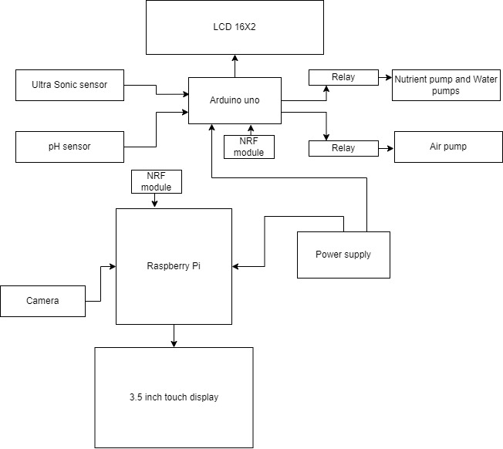

Fig.1.1 Block Diagram

* **pH Sensor** :It measures the acidity or alkalinity of the solution. This sensor helps in maintaining the ideal pH level in the nutrient solution.
* **Ultrasonic water level sensor:** Detects distance to water surface using sound waves. Threshold set at 20cm triggers actions like pump activation. Ideal for precise, non-contact water level monitoring in tanks and flood prevention systems.
* **Camera**: It captures images of the hydroponic setup for monitoring and remote control.
* **LCD Display**: It displays information about the system status, such as pH level, dissolved oxygen, water temperature, and water level.
* **NRF 24L01 MODULE**: The NRF module, based on Nordic Semiconductor chips, facilitates low-power wireless communication over short distances at the 2.4 GHz frequency. Widely used in IoT, home automation, and sensor networks, it offers reliable connectivity for various projects.
* **Arduino Uno**: It serves as the brain of the system, handling all the input/output operations, including communication with the Raspberry Pi and other sensors.
* **Raspberry Pi**: It serves as the central processing unit for the system, managing the overall operations, such as data analysis and control, along with interfacing with the Arduino Uno.
* **Power supply**: It provides power to all the electronic components of the system.
* **Nutrient solution Pump and Water pump**: They are responsible for circulating the nutrient solution and providing fresh water to the plants.
* **Air pump**: It is responsible for maintaining an ideal oxygen balance in the system by ensuring proper mixing of air with the nutrient solution.
* **Filter**: It helps in removing solid particles from the nutrient solution and maintaining its clarity. In summary, this Automated Hydroponic System utilizes various sensors and actuators to monitor and control the environment, ensuring the healthy growth of plants in the nutrient solution.
* **3.5 inch TFT touch display**: The display in this context refers to a visual output device that can be connected to a Raspberry Pi, allowing users to view graphical content such as text, images, or videos. This could include various types of screens such as LCD, TFT, OLED, or touchscreen displays. Displays for the Raspberry Pi come in different sizes and configurations, offering users options based on their project requirements and preferences.

1. **Flow chart**

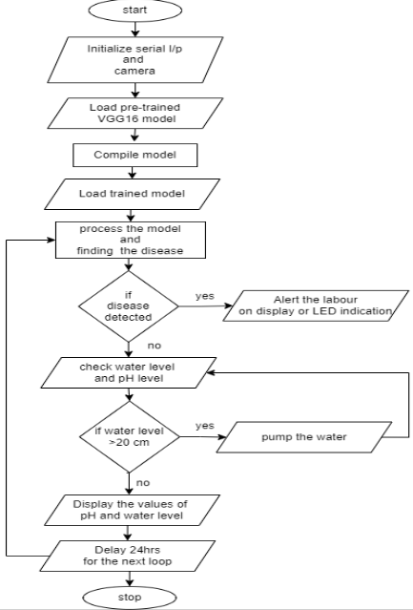  
Fig.2.1:Flow chart

1. **Circuit Diagram**

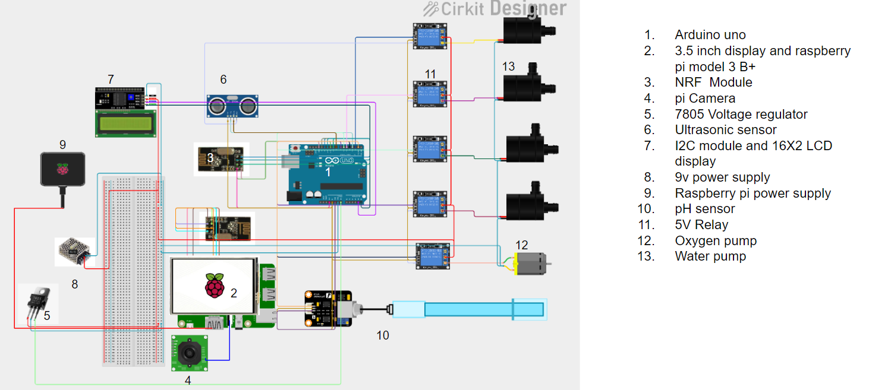

Fig.3.1:Circuit diagram

1. **Software Used**

* **Python**: Python is a high-level, interpreted programming language known for its readability and versatility. It supports multiple programming paradigms, including procedural, object-oriented, and functional programming. Python has a large standard library and a vast ecosystem of third-party packages, making it a popular choice for various applications, such as web development, data analysis, artificial intelligence, and more.
* **Arduino IDE**: The Arduino IDE is an open-source software, which is used to write and upload code to the Arduino boards. The IDE application is suitable for different operating systems such as Windows, Mac OS X, and Linux. It supports the programming languages C and C++. Here, IDE stands for Integrated Development Environment. The program or code written in the Arduino IDE is often called as sketching. We need to connect the Genuine and Arduino board with the IDE to upload the sketch written in theArduino IDE software. The sketch is saved with the extension‘ ino.’
* **Recurrent Neural Network (RNN)**: Recurrent Neural Network (RNN) is a type of Neural Network where the output from the previous step is fed as input to the current step. In traditional neural networks all the inputs and outputs are independent of each other. Still, in cases when it is required to predict the next word of a sentence, the previous words are required and hence there is a need to remember the previous words. Thus RNN came into existence, which solved this issue with the help of a Hidden Layer. The main and most important feature of RNN is its Hidden state, which remembers some information about a sequence. The state is also referred to as Memory State since it remembers the previous input to the network. It uses the same parameters for each input as it performs the same task on all the inputs or hidden layers to produce the output. This reduces the complexity of parameters, unlike other neural networks.

1. **Advantages**

* **Optimized Resource Use**: Machine learning algorithms can analyze data on environmental conditions, nutrient levels, and plant growth to optimize resource utilization, such as water and nutrients, leading to increased efficiency.
* **Labor Savings**: Automation and intelligent monitoring reduce the need for constant manual oversight, leading to labor savings and enabling farmers to focus on higher- level tasks, such as strategic planning and innovation.
* **Automated Monitoring and Control**: Machine learning enables real-time monitoring of various parameters, allowing for automated control of factors like temperature, humidity, and nutrient levels, leading to precise and consistent growing conditions.
* **Enhanced Quality Control**: Machine learning algorithms can help identify and rectify deviations from ideal growing conditions, contributing to the production of high-quality, consistent crops.
* **Early Disease Detection**: Machine learning can analyze data to detect early signs of plant diseases or stress, allowing for prompt intervention and preventing the spread of diseases throughout the crop.

1. **Applications**

* **Urban Agriculture**: Utilizing limited space in urban areas efficiently for food production.
* **Commercial Agriculture**: Increasing yields and efficiency in large-scale farming operations.
* **Remote or Harsh Environments**: Cultivating crops in regions with extreme climates or limited access to water and arable land.
* **Indoor Agriculture**: Implementing controlled environment agriculture in indoor settings such as warehouses or shipping containers.
* **Vertical Farming**: Growing crops vertically in stacked layers, maximizing space and productivity.

1. **Future Enhancement**

Advanced robotics in agriculture involves the development of complex robots that can perform various tasks with greater accuracy. These activities include growth-based crop selection, fine pruning, and monitoring plant health. Additionally, the integration of artificial intelligence algorithms enables intelligent focused decision-making. This allows analysis of large amounts of data from sensors and cameras, facilitating accurate analyzes for better crop management, disease diagnosis and resource allocation. Hydroponic farming worldwide.

This allows farmers to better manage their farms, making their work easier and more efficient. This innovation may also include robotic systems that can maneuver and operate in vertical environments. These systems can be easily adjusted and scaled up or down to suit different crops, growing conditions, and space constraints; thus making farming more efficient and flexible.

1. **Conclusion**

Smart hydroponic farming and robotics complete the high-tech revolution in agriculture, including analysis. This coming era is characterized by unequal work, shrinking workforces and rising profits, with special emphasis on hydroponic cultivation to solve major issues such as food security and environmental impact. Evaluation of the components in this study is an important part of precision agriculture and plays an important role in the development of resources. Through advanced sensors and data analytics, the system demonstrates the ability to monitor and control various aspects of the environment, making precise adjustments for efficient cultivation. Automated component inspection combined with robotics enables effective maintenance 24/7, reduces the need for manual labor and increases overall productivity. The results of the project, including the completion of the product review, resulted in a positive increase. Crops show faster and more consistent growth achieved through real-time monitoring and management, highlighting the importance of technology in ensuring healthy and reliable crop management spray.