Performance analysis of routing protocols

for an efficient data transmission in 5G

WSN communication

Prof.Rohini Pochhi,Asst.Professor  
Electronics and communication Engineering  
TulsiramjiGaikwad-Patil College of Engineering & TechnologyNagpur, India  
rohini.ece@tgpcet.com

Prof. Pravin Tajane,Asst.Professor  
Electronics and communication Engineering  
TulsiramjiGaikwad-Patil College of Engineering & TechnologyNagpur, India  
pravin.ece@tgpcet.com

Miss.sushmita V. Kamble  
Electronics and communication Engineering  
TulsiramjiGaikwad-Patil College of Engineering & TechnologyNagpur, India  
kamblesushmita1994@gmail.com

*Abstract*— --In WSN structures the routing scheme the usage of the sensor nodes are carried out in between group of specific clusters. The nodes are working for information aggregation from these supply nodes they also performs statistics dissemination and community management and activities sensing and records gathering in the neighbourhood. Many clustering topology are proposed in recent years to localize the route inside the cluster. In this paper we have reviewed and in contrast these topologies to locate out the network mechanism which are less difficult to control and scalable for getting excessive satisfactory response with recognize to dynamics of the environment.

Keywords— WSN, Routing, Clustering.

# Introduction

WSN are module made up of multiple sensor modules capable of monitoring, communicating, and processing input information to a designated location. The sensors are crafted to oversee various environmental parameters including temperature, pressure, vibrations, and geographical factors. They operate as part of a wireless network, transmitting pertinent data to the central monitoring control unit[1]. WSNs find application in various domains including healthcare monitoring, environmental observation in oil and gas facilities, forest fire recognition, qquality assessment of water, and observation of air pollution . Additionally, modern WSNs are increasingly utilized in automation, agriculture, and other fields, making them a focal point of research and development in telecommunications.

Routing protocols are essential components withinWSNs, as they are responsible for establishing optimal pathways to transmit data collected by sensor nodes to the central sink. Effective routing protocols play a pivotal role in enhancing the overall performance, efficiency, and longevity of WSNs [2]. These protocols can be classified into three main categories based on the network structure: data-centric, hierarchical, and location-based techniques., with each category employing various techniques to achieve optimal performance. However, routing in WSNs presents challenges due to application-specific requirements and resource constraints, particularly energy limitations[3].

In the application of WSNs, various constraints such as limited power, processing time, and network bandwidth need to be addressed. Modifying routing techniques can mitigate energy consumption, packet hops, error rates, and latency while improving Improving reliability, link quality, data capacity, and network lifespan is crucial in Wireless Sensor Networks (WSNs). Nevertheless, routing within WSNs faces numerous challenges such as node deployment, data delivery models, power consumption, scalability, network mobility, transmission media, and environmental conditions. Designing efficient routing protocols that address these factors remains a significant challenge and is highly application-dependent[4].

Evaluating the efficiency of protocols involves analyzing various features to collate their effectiveness. However, the lack of standardized metrics complicates accurate performance assessment and comparison of routing protocols. Therefore, the main objective of this project is to analyze the performance of cluster-based routing protocols in WSNs using performance metrics to gain insights into their impact and effectiveness[5].

# Literature Review

A Wireless Sensor Network (WSN) comprises multiple sensors designed to detect and observe surrounding condition such as temperature, pressure, motion, and other relevant factors. Each sensor node is tasked with transmitting the gathered data to a central unit via a gateway sensor node.

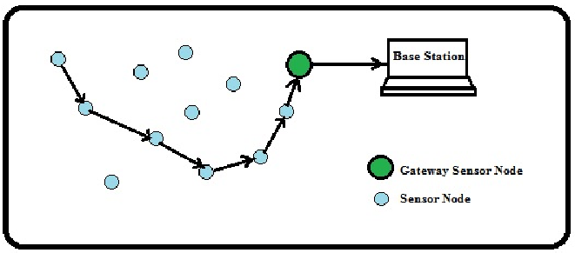

Fig.1 WSN Structure

Routing within WSNs involves selecting the optimal path to relay data or sensed information from the sensor nodes to the base station. "Sensor nodes within Wireless Sensor Networks (WSNs) come equipped with wireless communication capabilities and data processing functionalities. They convert monitored conditions into electrical signals and transmit them to the sink. Typical sensor nodes consist of supply units, operation units,detection units, and transceiver units. Power units may be sustained by energy-harvesting mechanisms like solar cells. Processing units include storage and processing components, while sensing units incorporate sensors and analog-to-digital converters (ADCs). Transceiver units facilitate node connectivity to the network. In certain applications, the system may also incorporate mobilizer units.

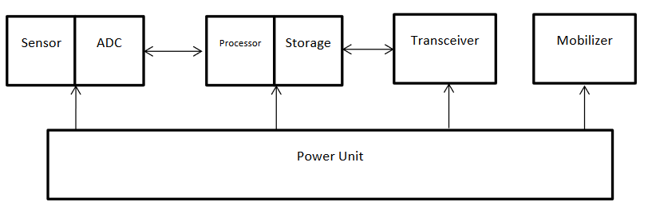

**Fig 2 : Block diagram of Sensor Node**

Several routing techniques have emerged for Wireless Sensor Networks (WSNs), classified into Data-Centric, Hierarchical, and Location-Based protocols according to their network architecture. Data-Centric protocols involve sinks issuing queries to designated regions, with sensors in those regions responding to the queries. Hierarchical routing involves the utilization of high-energy nodes for data processing and transmission, while low-energy nodes conduct sensing tasks in predefined areas. Location-Based routing leverages geographical location information of nodes to optimize routing efficiency and introduce novel services. Moreover, routing protocols can be further categorized based on route selection and operation. Below provides a condensed overview of these classifications

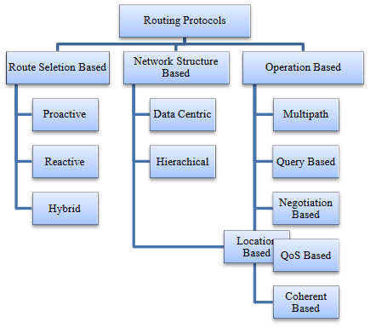

[Figure3 - Summary of Routing Protocol Classifications]

Figure 3 illustrates a summary of Routing Protocols in Wireless Sensor Networks (WSNs). Routing protocols are assessed using various metrics to gauge their effectiveness. These metrics play a vital role in comparing different routing protocols, facilitating analysis for enhancing their quality in terms of energy efficiency, availability, and other factors. These metrics are typically classified as Performance Metrics, General Metrics, Security Metrics, Quality of Service Metrics, and Link Quality Metrics [7].

Clustering in a Wireless Sensor Network (WSN) entails organizing sensor nodes into groups within a defined area. During data transmission within this region, a cluster head is designated. These cluster heads directly communicate with the base station, while regular nodes communicate with the cluster heads. This arrangement effectively mitigates energy consumption among regular nodes. Moreover, the selection of cluster heads changes dynamically across rounds to minimize energy usage. The overarching goal of clustering is to optimize energy efficiency within the network. [8].

# ENERGY EFFICIENT ROUTING

Achieving optimal routing poses significant challenges in energy-constrained networks, primarily due to the absence of future information. This necessitates a shift towards a statistically structured framework that optimizes network functionality for potential operations. An effective strategy for energy efficiency should be both statistically optimal and causal, focusing solely on past and present data without necessitating future knowledge. In practical reporting or monitoring applications, there's typically no need for a gap in functionality. Therefore, optimizing the lifespan of a node should be prioritized to occur prior to node failure rather than considering average time across all scenarios. However, due to computational limitations, it's impractical to account for all potential hypothetical scenarios beyond simulations. Consequently, directing functional schemes solely based on one scenario, as illustrated in Figure 4, can lead to distorted outcomes.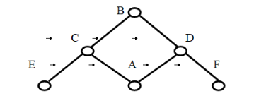

Fig. 4 Distinguishing Load from Energy Orientation

Routing Protocol operates in three distinct stages:

Setup Phase: During initial stage, localized flooding is conducted to ascertain and compute the energy expenditures from the start to end, while also establishing routing tables.

Information Communication Phase: Paths are selected based on empirical assessments of energy costs, followed by the passing of data from the start to the endpoint.

Routing Maintenance Phase:

Routing pathways are kept operational through periodic localized floods. The energy-conscious Routing Protocol demonstrates superior outcome differentiate to the traditional approach (referred to as DD). However, reliance on a single path reduces resilience to path loss. Additionally, the inclusion of position details storage and the addressing steps facilitates the establishment of more dynamic routing paths compared to DD.

**Conclusion:**

Medical imaging is an educational discipline that relies on digital image processing to provide guidance in analyzing medical disorders. Specifically, a set of rules is designed for the early detection of hemorrhage. The proposed automated system aims to identify patients with diabetic retinopathy by analyzing fundus images.

##### References

1. S. A. Chafi, H. Abbad, M. K. Benhaoua and A. El Hassan Benyamina, "Improvement of LEACH Protocol: W-LEACH Approach," 2023 International Conference on Smart Computing and Application (ICSCA), Hail, Saudi Arabia, 2023, pp. 1-6, doi: 10.1109/ICSCA57840.2023.10087572.
2. Dhabliya, D.; Soundararajan, R.; Selvarasu, P.; Balasubramaniam, M.S.; Rajawat, A.S.; Goyal, S.B.; Raboaca, M.S.; Mihaltan, T.C.; Verma, C.; Suciu, G. Energy-Efficient Network Protocols and Resilient Data Transmission Schemes for Wireless Sensor Networks—An Experimental Survey. Energies 2022, 15, 8883. https://doi.org/10.3390/en15238883
3. A. Ratnaparkhi et al., "Performance Optimization and Analysis of energy efficient multipath routing protocols for Wireless Sensor Networks," 2022 International Conference on Industry 4.0 Technology (I4Tech), Pune, India, 2022, pp. 1-5, doi: 10.1109/I4Tech55392.2022.9952358.
4. B. Liu, J. Zhang and Z. Zhu, "Research on Cluster-Based Routing Protocol for Wireless Sensor Networks," 2022 IEEE 5th International Conference on Information Systems and Computer Aided Education (ICISCAE), Dalian, China, 2022, pp. 958-963, doi: 10.1109/ICISCAE55891.2022.9927578.
5. A. F. E. Abadi, S. A. Asghari, M. B. Marvasti, G. Abaei, M. Nabavi and Y. Savaria, "RLBEEP: Reinforcement-Learning-Based Energy Efficient Control and Routing Protocol for Wireless Sensor Networks," in IEEE Access, vol. 10, pp. 44123-44135, 2022, doi: 10.1109/ACCESS.2022.3167058.
6. Wei He ,“Energy-Saving Algorithm and Simulation of Wireless Sensor Networks Based on Clustering Routing Protocol”, Journals & Magazines,IEEE Access Volume: 7, DOI:10.1109/ACCESS.2019.2956068
7. A. F. E. Abadi, S. A. Asghari, M. B. Marvasti, G. Abaei, M. Nabavi and Y. Savaria, "RLBEEP: Reinforcement-Learning-Based Energy Efficient Control and Routing Protocol for Wireless Sensor Networks," in IEEE Access, vol. 10, pp. 44123-44135, 2022, doi: 10.1109/ACCESS.2022.3167058.
8. Cao, L.; Yue, Y.; Cai, Y.; Zhang, Y. A novel coverage optimization strategy for heterogeneous wireless sensor networks based on connectivity and reliability. IEEE Access 2021, 9, 18424–18442.

Kim, W.; Umar, M.M.; Khan, S.; Khan, M.A. Novel Scoring for Energy-Efficient Routing in Multi-Sensored Networks. Sensors 2022, 22, 1673

1. Hussein, W.A.; Ali, B.M.; Rasid, M.F.; Hashim, F. Smart geographical routing protocol achieving high QoS and energy efficiency

based for wireless multimedia sensor networks. Egypt. Inform. J. 2022, 23, 225–238