**HUMAN DETECTION AND COUNTER**

Sandhiya.K1, Malini.S, MCA., M.Phil.,2

*1Department of MCA, Adhiyamaan College of Engineering (Autonomous), Hosur.*

*2Department of MCA, Adhiyamaan College of Engineering (Autonomous), Hosur.*

*Corresponding Author: sandhiyakannan142@gmail.com*

|  |
| --- |
| ***Abstract:***  Implementing human detection and counter in Python offers several advantages in various applications. Firstly, it enhances security systems by providing the capability to identify and monitor human presence in restricted or sensitive areas. This is crucial for surveillance in places such as airports, banks, and government facilities, where unauthorized access must be prevented.Secondly, human detection and counting in Python can be applied in retail analytics to analyse customer behaviour and improve store layouts. By tracking the number of people entering and exiting a store, businesses can optimize their operations, manage queues effectively, and make data-driven decisions to enhance the overall shopping experience.Moreover, in smart buildings and home automation, Python-based human detection enables the creation of intelligent systems that can adjust lighting, temperature, and other environmental factors based on the occupancy of a room. This not only contributes to energy efficiency but also enhances user comfort.Additionally, the implementation of human detection and counting in Python is valuable in the field of computer vision and robotics. It facilitates the development of applications such as social robots that can interact with humans, or autonomous vehicles that need to be aware of pedestrian presence for safe navigation. In summary, the advantages of human detection and counter in Python extend across security, retail, smart buildings, and robotics, contributing to enhanced safety, efficiency, and user experiences in diverse domains.  **Key Words**:Human Detection and Counter; Accuracy; Real-Time Monitoring; Security; Scalability; Cost Efficiency;Security. |

1. **Introduction**

Human detection and counter technologies are crucial advancements in the fields of security, surveillance, and automation. These systems utilize a combination of sensors, cameras, and sophisticated algorithms to identify and count individuals within a given area. Leveraging technologies such as computer vision, machine learning, and infrared sensing, these systems can accurately detect human presence, even in complex environments. Applications range from enhancing security in public spaces, optimizing retail operations by analyzing foot traffic, to managing occupancy in buildings for safety and efficiency. The integration of human detection and counting systems with artificial intelligence has further refined their accuracy and functionality, enabling real-time monitoring and analytics that inform decision-making processes and improve operational efficiency across various industries. Human detection and counting technologies offer several additional benefits and applications. In smart cities, these systems contribute to urban planning and public transportation management by providing data on pedestrian and vehicle flows. In healthcare settings, they assist in patient monitoring and ensuring adherence to social distancing protocols. The retail sector uses these technologies to enhance customer experience through targeted marketing and efficient store layouts based on customer movement patterns. Moreover, human detection systems play a vital role in emergency response, helping to locate individuals during disasters or in restricted areas. They also enhance workforce management in industrial settings by monitoring employee locations and ensuring safety compliance. With advancements in edge computing, these systems are becoming more efficient, capable of processing data locally to reduce latency and enhance privacy. As the technology continues to evolve, its integration with IoT (Internet of Things) devices and smart infrastructures will further expand its potential, making human detection and counting indispensable tools in the modern digital landscape.

1. **PROJECT MODULES**

The project modules encompass a comprehensive framework aimed at developing and implementing a robust human detection and counting system. The first module involves requirements gathering and analysis, where project objectives, user needs, and environmental factors are thoroughly assessed to inform system design. Following this, the system design module focuses on conceptualizing the architecture, selecting appropriate sensors, and designing algorithms for accurate detection and counting. The development module encompasses software and hardware implementation, including coding, testing, and integration of components to ensure functionality and reliability. Quality assurance and testing modules are then employed to validate system performance under various conditions, refining algorithms and addressing any issues identified. The deployment module involves installation, configuration, and training for end-users, ensuring seamless integration into operational environments. Finally, ongoing maintenance and support modules are established to provide continuous monitoring, updates, and technical assistance, ensuring the system's long-term effectiveness and sustainability. Through these interconnected modules, the project aims to deliver a comprehensive human detection and counting solution that meetsthe highest standards of performance, reliability, and user satisfaction.

# 1 Open CV

**2** Image processing

**3** Video processing

4 Person tracking

**5** Person counter

**Software Requirements**

MinimumRequirement Are:

Processor : Intel(R)Pentium(R)

Speed : 1.6GHz and Above

RAM : 6GB and Above

Hard Disk : 120GB

Monitor : 15’’ LED SVGA

Input Devices : Keyboard,Mouse

**Existing System**

Existing systems for human detection and counting utilize a variety of technologies to accurately identify and quantify human presence in a given space. These systems often employ combinations of computer vision, machine learning algorithms, and sensor technologies such as infrared sensors, thermal cameras, or depth sensors. Through these methods, they can detect human shapes, movements, and heat signatures to differentiate humans from other objects or animals. Advanced algorithms analyze the captured data to track and count individuals, providing valuable insights for various applications including crowd management, security monitoring, and retail analytics. Additionally, some systems incorporate cloud computing for real-time processing and integration with other systems, enabling efficient and scalable deployment across different environments. Despite their effectiveness, ongoing research and development continue to improve the accuracy, reliability, and versatility of these human detection and counting systems to meet evolving needs and challenges.

1. **Result**

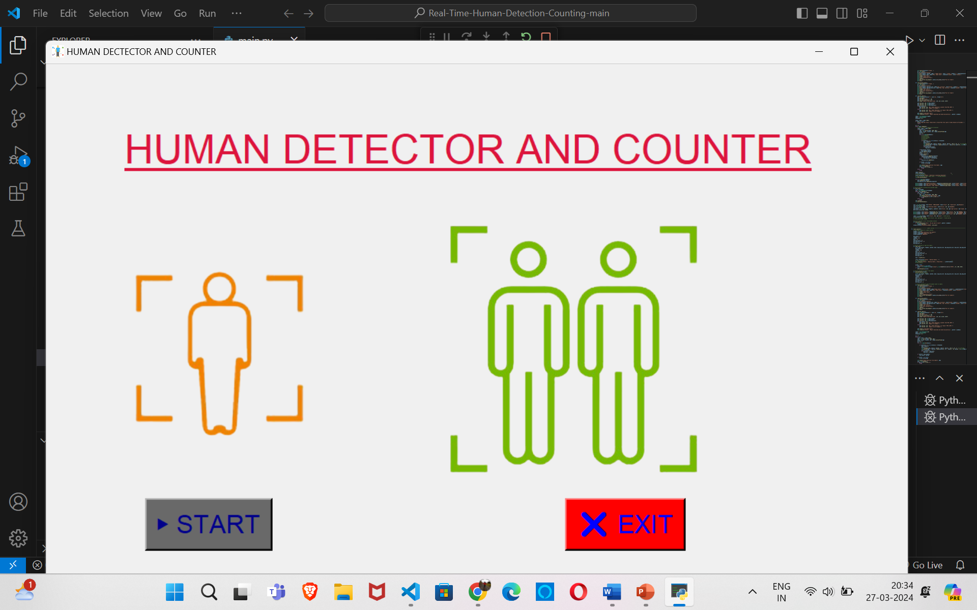

Home Page

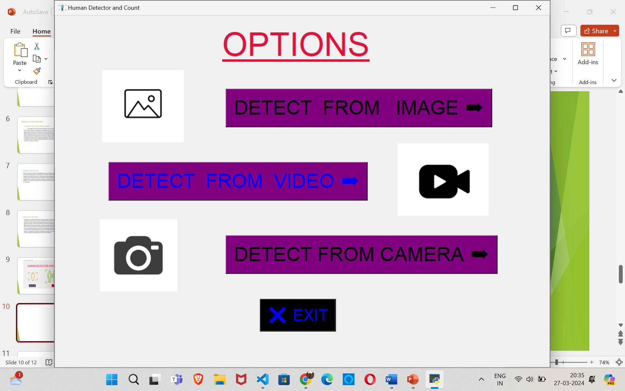

Different Methods of Detection

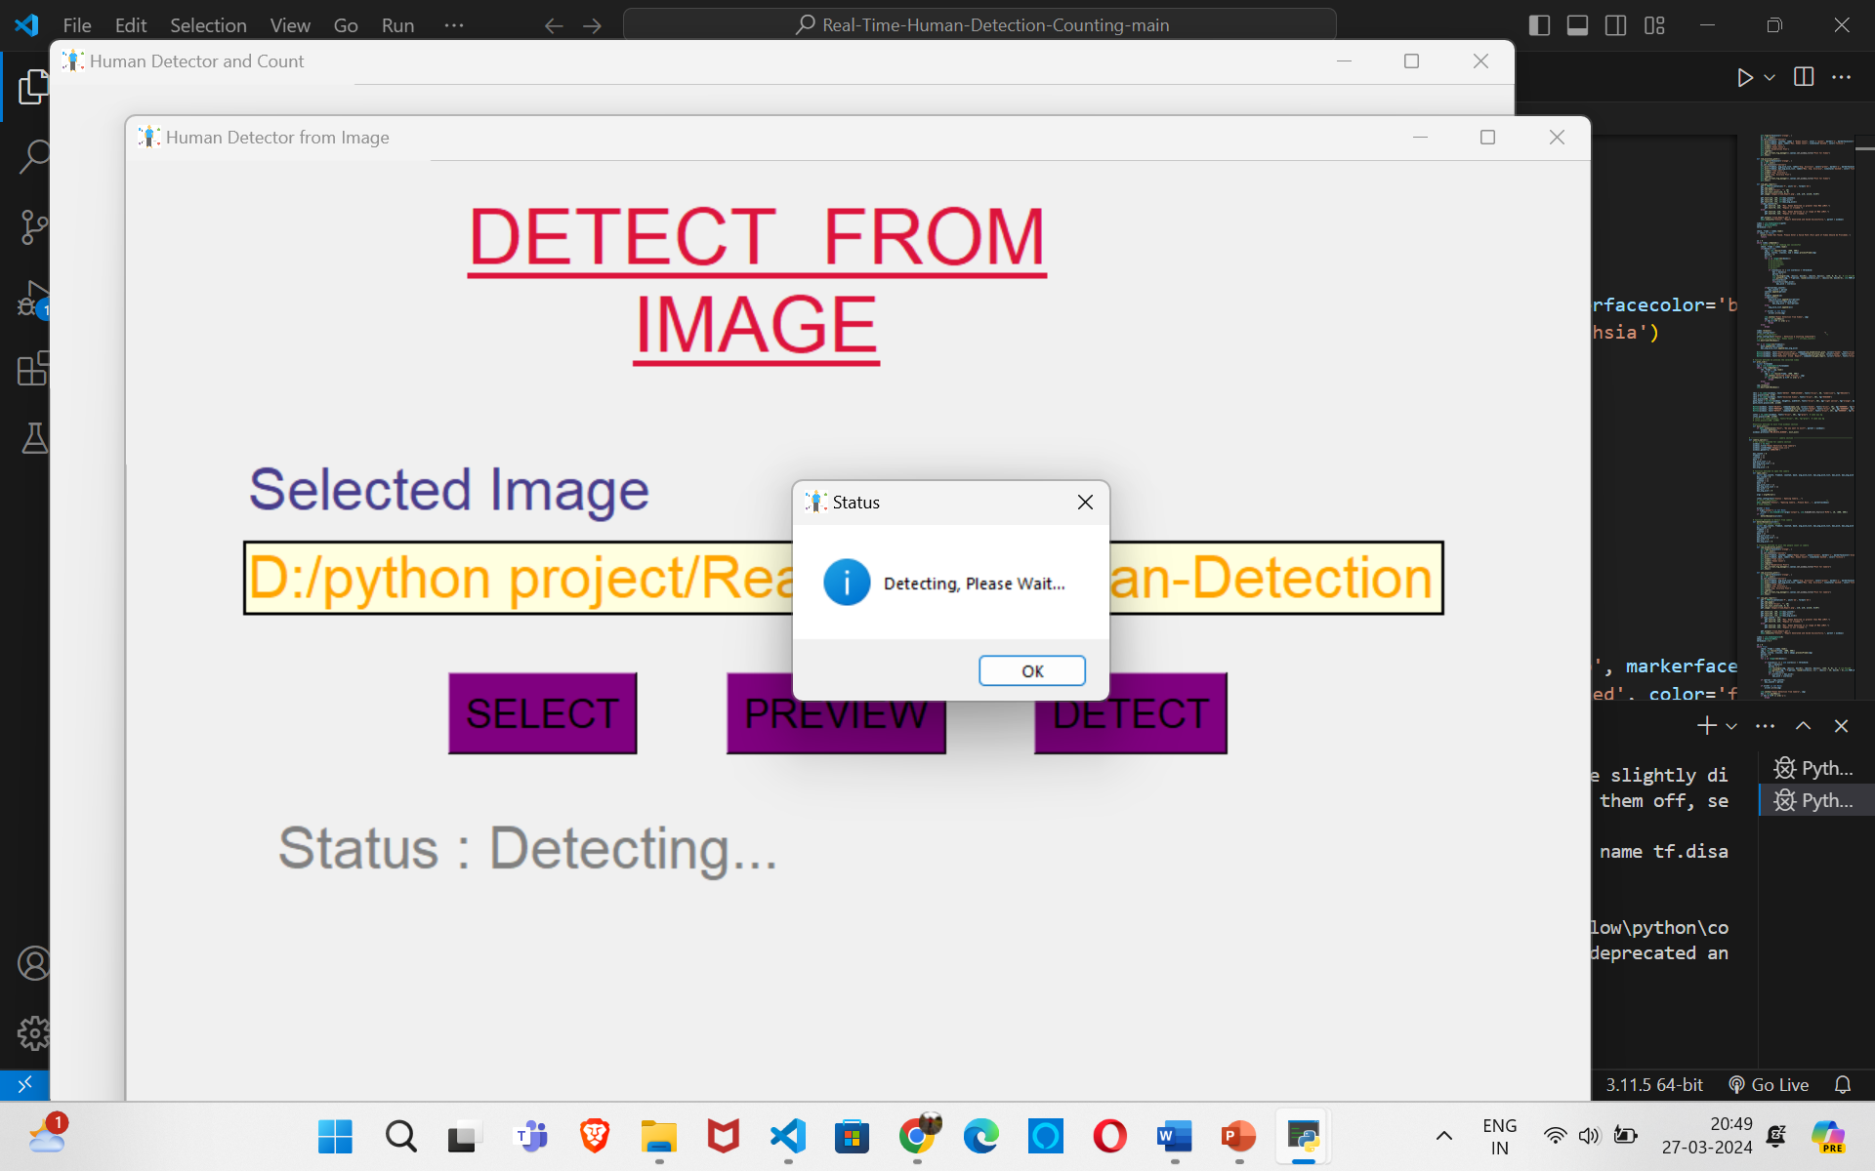

Detecting Images

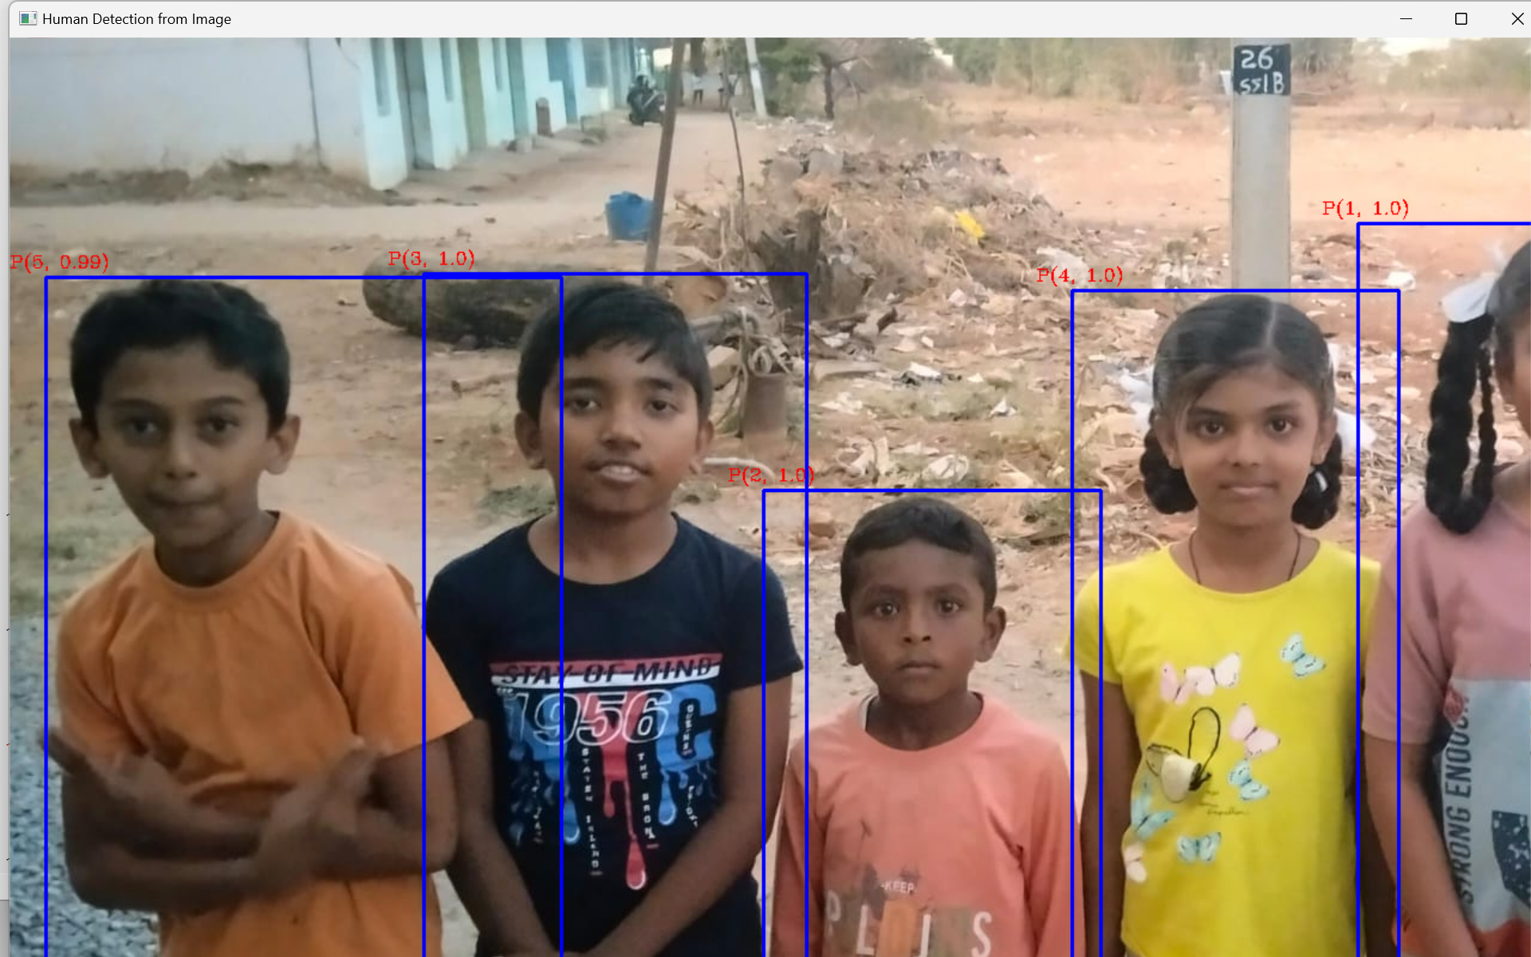

Results

1. **Advantages of proposed system**

* The proposed human detection and counter system offers numerous advantages, making it a valuable tool across various sectors. Utilizing advanced machine learning algorithms and computer vision techniques, the system ensures high accuracy and precision, even in crowded environments.
* Real-time monitoring capabilities enable instant decision-making, crucial for security surveillance and emergency responses. The system's scalability allows for deployment across different locations and integration with existing infrastructure, making it suitable for both small-scale and large-scale applications.
* By automating human detection and counting, it reduces labor costs and enhances operational efficiency. Enhanced security is achieved through continuous monitoring of unauthorized access and unusual activities, while data-driven insights help businesses optimize operations, such as store layouts and marketing strategies.
* Designed with privacy compliance in mind, the system uses anonymized data to address surveillance-related privacy concerns. Its integration with IoT devices and smart systems enhances functionality, creating a cohesive network of interconnected technologies.
* Versatile in application, the system improves safety and management in workplaces by monitoring employee locations to ensure safety compliance and efficient workforce management.
* These benefits collectively highlight the system's potential to enhance efficiency, security, and decision-making in various industries.

1. **Conclusion**

In conclusion, the development and implementation of human detection and counting systems represent crucial endeavors in enhancing security, safety, and operational efficiency across various domains. By leveraging advanced technologies such as computer vision, machine learning, and sensor fusion, these systems enable accurate and reliable identification and tracking of human presence in diverse environments. From surveillance and security applications to crowd management and industrial safety, the capabilities of these systems offer invaluable insights and proactive measures to mitigate risks and optimize resource allocation. Moreover, as technology continues to evolve, the potential for further innovation and refinement in human detection and counting systems is vast, promising even greater effectiveness and adaptability in addressing emerging challenges. Ultimately, the widespread adoption and continued advancement of these systems hold the potential to significantly enhance the resilience and responsiveness of organizations and communities, fostering safer and more secure environments for individuals and assets alike.

**References**

[1] "Practical Python and OpenCV" Author: Adrian Rosebrock Edition: Third Edition (2018).

[2] "Deep Learning for Computer Vision with Python" Author: Adrian Rosebrock Edition: First Edition (2018[3).

[3]"Python Computer Vision: Develop practical computer vision projects with the Python ecosystem" Author: Gabriel Garrido Calvo Edition: First Edition (2020).

[4] "Hands-On Computer Vision with TensorFlow 2: Leverage deep learning to create powerful image processing apps with TensorFlow 2.0 and Keras" Author: Benjamin Planche and Eliot Andres. Edition: First Edition (2020).

[5]"Programming Computer Vision with Python: Tools and algorithms for analyzing images" Author: Jan Erik Solem Edition: First Edition (2012).

[6] "Hands-On Image Processing with Python: Expert techniques for advanced image analysis and effective interpretation of image data" Author: Sandipan Dey Edition: First Edition (2018).

[7] "Python Deep Learning: Exploring deep learning techniques and neural network architectures with PyTorch, Keras, and TensorFlow" Author: Ivan Vasilev and Daniel Slater Edition: First Edition (2019).

[8] "Mastering OpenCV 4 with Python:Author: Alberto Fernandez Villan Edition: First Edition (2019).

[9] "Deep Learning for Vision Systems" Author: Mohamed Elgendy Edition: First Edition (2018).

[10]<https://www.w3schools.com/python/>

[11]<https://www.geeksforgeeks.org/python-basics/>

[12]<https://realpython.com/tutorials/projects/>

[13]https://www.geeksforgeeks.org/opencv-python-tutorial/

[14]https://data-flair.training/blogs/python-project-real-time-human-detection-counting/

[15]<https://www.geeksforgeeks.org/human-activity-recognition-with-opencv/>