**AN INGENIOUS SYSTEM TO PREDICT ROCK VS MINE BY SONAR USING LOGISTIC REGRESSION**

**G. Rajeswari1, J.V. Kowsalya2, T.S. Navalakshmi3**

*1Assistant Professor Department of Computer Science and Engineering, K.L.N. College of Engineering, Sivagangai, Tamilnadu, India.*

*2,3 Final Year Students, Department of Computer Science and Engineering, K.L.N. College of Engineering, Sivagangai, Tamilnadu, India.*

**Abstract:** Machine Learning particularly Logistic Regression is used here in this study for classifying sonar signals to distinguish between “Rock” and “Mines” in underwater detection systems. Logistic Regression is a supervised Machine Learning algorithm for binary classification is chosen for its efficiency and interpretability. The process start with a sonar system that uses sound waves to detect underwater object. Features such as amplitude and frequency are extracted from the signals and used as input variable for the model. The model’s accuracy and effectiveness are validated using evaluation metrics like accuracy, precision, recall, and AUC-ROC. This classification approach enhances the safety and efficiency of underwater navigation and exploration.

**Keywords:** Machine Learning, Logistic Regression, Sonar Signals, Underwater Detection, Binary Classification.

# **I. INTRODUCTION**

The Rock vs Mine Prediction System sets itself apart by replacing traditional methods of manual sonar data interpretation with a machine learning-based approach. By using logistic regression, the system automates the classification of rock and mine formations, making the process more efficient and accurate. This method allows users to analyze complex patterns in sonar data, offering insights that would be difficult to achieve through conventional means. By identifying key features in the signals, the system improves its ability to predict whether an object is a natural formation or a potential threat, like a mine. This technology is especially valuable in subsurface exploration, where timely and accurate decision-making is critical for operational safety. Whether in naval missions, underwater exploration, or resource extraction, the system's reliable classification of sonar data enhances situational awareness and reduces human error. The machine learning approach streamlines the detection process, ensuring safer and more effective operations. Overall, the Rock vs. Mine Prediction System is a powerful tool that improves underwater detection capabilities, aiding decision-making and minimizing risks in challenging environments.

## **II. OBJECTIVE**

The mission focuses on to develop a predictive model for classifying rock vs mine using the Logistic Regression to improve early detection and classification. It aims to analyse SONAR data, including frequencies and amplitudes, to accurately predict. This approach will automate data cleaning, fixing issues like missing values and . Additionally, exploratory data analysis will help identify important risk factors for prediction. The Logistic Regression algorithm will improve prediction accuracy and will be used for comparison. Ultimately, the aim is to provide underwater safety reliable tool to identify whether the object is either “rock” or “mine”.

## **III. LITERAURE SURVEY**

1. **Current methods of ROCK vs MINE Prediction:**

The detection of mines was done by explosive ordanance disposal divers, marine mammals, video cameras on mine neutralization vehicles, and laser systems which can be time consuming and costly. Additionally, these method had a limited range and were not highly accurate, leading to the rick of undetected mines. These traditional method had limitations and risks associated with them. Such as harm to marine life, insufficient accuracy and potential loss of human life.

1. **Technology's role in improving quality:**

Predicting Rock vs Mine is done using sonar data and machine learning techniques. It addresses the challenge of imbalanced data, as many mines are un-identified. A combination of under-sampling and oversampling techniques is applied to balance the dataset. The study utilizes Logistic Regression evaluating them based on accuracy, precision, recall, and F1-score. Data visualization tools, such as heatmaps and ROC curves, provide actionable insights for healthcare professionals to identify at-risk patients early.

## **IV. EXISTING SYSTEM**

The current underwater mine detection often involves significant human involvement which reduces the reliability and increases human risk. The un-manned vehicle is used for scanning and identifying underwater objects using Side-Scan Sonar. The manual interpretation process is time consuming and prone to human errors.

**V. PROPOSED SYSTEM**

The system utilizes the Logistic Regression algorithm for accurate predictions. It preprocesses data by handling missing values. It uses the dataset that is collected from the Autonomous under-water vehicle (AUV). This accurately distinguishes between rocks and mines based on their unique frequency characteristics. The automation of this process enhances safety, reduces human involvement and improves reliability.

## **VI. ARCHITECTURE DIAGRAM**

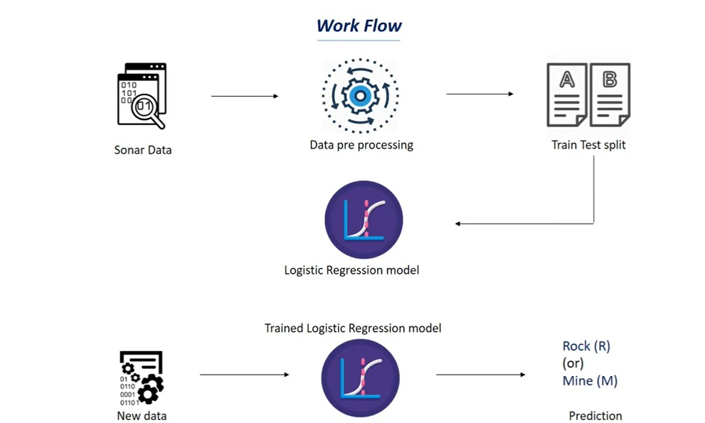

## **VII. SYSTEM OVERVIEW**

### **1. Data Collection**

The Data is gathered from a CSV file and explored to understand its structure. The dataset for predicting rock vs mine using sonar signals is typically derived from sonar readings where the goal is to classify whether the object is being detected.

### **2. Data Preprocessing**

The preprocessing steps are essential to ensure that the data is in a suitable format for training the model. Typical preprocessing steps include handling missing values or inconsistent values which are then handled through imputation or removal to maintain data integrity.

### **3. Exploratory Data Analysis**

It is a critical step in understanding the characteristics and structure of the dataset before applying any machine learning algorithms. It also involves summarizing the data using descriptive statistics, visualizing patterns distributions and identifying any anomalies are outliers.

### **4. Model Training**

The pre-processed training data is fed into the chosen model. The model used here is Logistic Regression. The data is splitted into training and testing sets, typically 80% of data used for training and 20% for testing.

### **5. Model Evaluation**

It is a crucial step in machine learning pipeline, where the performance of the trained model is assessed using a separate test dataset that it has not encountered during training. It helps in making informed decisions regarding model selection, tuning and deployment, ensuring that the chosen model meets the desired performance standards.

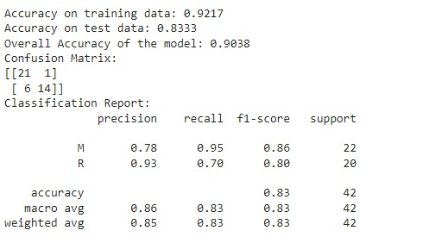 

***Fig 7.1 Performance Metrics and classification output***

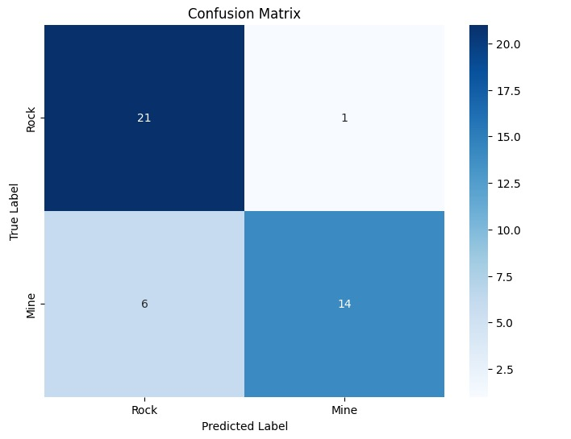 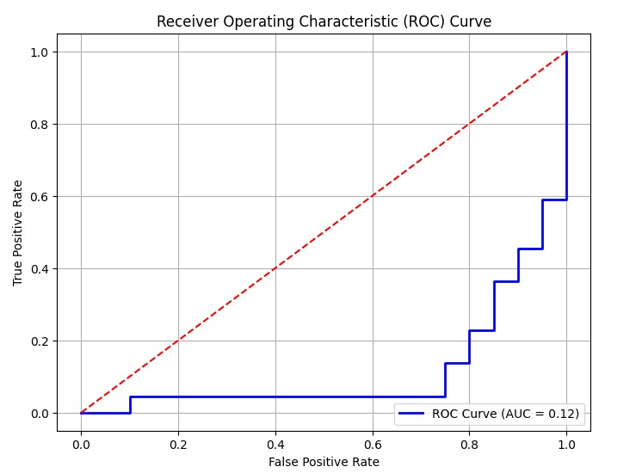

***Fig 7.2 Pictorial Representation of Performance Metrics***

.

### **6. Monitoring and optimization**

It is important to monitor model’s performance over time. Monitoring is essential to continuously observe its performance metrics such as accuracy, precision, recall. Optimization focuses on enhancing the performance of a model that has been deployed.

**IX. CONCLUSION**

* **Effective Machine Learning Application:** The sonar data classification task demonstrates the practical use of machine learning, specifically logistic regression, to distinguish between rocks and mines based on sonar signatures.
* **Structured Workflow for Success:** By following systematic steps like data collection, preprocessing, model training, and evaluation, the logistic regression model provided satisfactory performance in classifying objects.
* **High Accuracy Achieved:** The model achieved a solid accuracy rate, showing that logistic regression can be an effective approach for similar structured classification problems.
* **Crucial Preprocessing Techniques:** Key techniques such as feature scaling, label encoding, and proper data splitting significantly contributed to building a reliable and well-performing model.
* **Generalizable for Other Tasks:** The model’s performance and workflow highlight its potential for broader application in similar tasks where structured data needs classification.

# **REFERENCES**

1. The paper titled “Application of Machine Learning Algorithms for Classification of Mines and Rocks Using Sonar Data” (2024)by Abhishek Kumar and Sanjay Kumar Soni investigates the application of various machine learning algorithmsto classify sonar readings collected from underwater mines and rocks.
2. “Mine Detection and Classification using Neural Networks” by R. Todd Moon and W. Dale Blair explores the utilization of neural networks models for the identification of landmines using ground-penetrating radar (GPR) signals.
3. “Classification of Underwater Objects using Neural Networks and Spectral Analysis” by Kalyanmoy Deb and S. Sanyal.
4. “Side-scan Sonar Imaging Data of Underwater Vehicles for Mine Detection”(vol 53, 2024) by Nuno Pessanha Santos, Ricardo Moura, Goncalo Sampaio Torgal, Victor Lobo, and Miiguel de Castro NetoSide.
5. Sri Ramya Yaramasu, Uppada Sai Gayatri, Vadlamani Manjusha, Vaishna C Bhanu, Koda Indu .“UNDERWATER MINE

& ROCK PREDICTION BY EVALUATION OF,” (2016)

[6]. Stanislaw Ho˙zy´n. “A Review of Underwater Mine Detection and Classification in Sonar Imagery.”(2021).