**Optimal placement of distributed generators using improved rider optimization**

Yeruvaka Santhosh1, Dr. J. Upendar2

*1(Research Scholar, Electrical Engineering Department, University College of Engineering/Osmania University, India)*

*2(Assistant Professor, Electrical Engineering Department, University College of Engineering/Osmania University, India)*

*Corresponding Author: Santhosh.yeruvaka@gmail.com*

|  |
| --- |
| ***Abstract:*** *Power distribution networks encounter challenges such as low voltage stability, poor voltage profiles, and high-power losses. Integrating Distributed Generation (DG) units is an effective solution; however, determining their optimal placement and sizing remains complex due to operational constraints. This study introduces an Improved Rider Optimization (IRO) algorithm to optimize DG placement and sizing while minimizing power losses, installation costs, harmonic distortion, and emissions, and enhancing system reliability. The IRO algorithm, modeled on rider behaviors, is tested on IEEE 33, IEEE 69, IEEE 119, and Indian 52-bus systems using MATLAB/Simulink. Simulation results confirm that the proposed method significantly improves voltage stability, reduces losses, and optimizes costs, outperforming existing techniques. The approach ensures efficient DG integration in radial distribution systems, with future research focusing on real-time adaptability and dynamic load variations for enhanced performance.*  ***Key Word****: Distributed Generation (DG), Improved Rider Optimization (IRO), Power Loss Reduction, Voltage Stability, Metaheuristic Optimization, Radial Distribution System, Total Harmonic Distortion (THD).* |

1. **Introduction**

In recent years, distributed generation (DG) has significantly increased its presence in distribution systems worldwide, offering both advantages and challenges in power network operations. The sizing and placement of DG units play a crucial role in optimizing their impact on the network, which can be determined through various computational techniques. This study examines the necessity, location, and application of DG in distribution networks, utilizing MATLAB-based simulations on multiple bus systems to evaluate performance improvements. The results obtained are compared with existing optimization algorithms to highlight the effectiveness of the proposed approach. An electric utility system is typically categorized into three primary subsystems: generation, transmission, and distribution. Power is generated at central stations and delivered to consumers through transmission and distribution networks. The distribution system, acting as an interface between consumers and the bulk power grid, consists of three main components: the distribution substation, primary distribution, and secondary distribution. Transformers at substations reduce transmission voltage to appropriate levels for consumer use. In industrial and commercial applications, three-phase power is commonly used, while residential areas rely on a single-phase, three-wire system operating at 120/240 V. A radial distribution system, characterized by a single path for power flow from the substation to consumers, is widely adopted due to its simplicity and cost-effectiveness. However, its inherent imbalance, caused by uneven single-phase loads, presents operational challenges. Unlike traditional power flow models designed for transmission networks, radial distribution feeders require specialized power flow analysis methods. The integration of DG into these networks can yield both beneficial and adverse effects, necessitating strategic placement and control measures to maximize efficiency while mitigating potential drawbacks. Achieving optimal technical, economic, operational, and environmental benefits from distributed generation (DG) requires careful consideration of multiple factors, including unit sizing, placement within the network, type of DG technology, and operational strategies. These elements must be strategically planned to enhance system efficiency and reliability while minimizing costs and environmental impacts [1]. Moshkbar-Bakhshayesh and Faramarzi [2] implemented a conventional iterative search technique to identify the optimal sizing and placement of distributed generation (DG) units, utilizing the Newton-Raphson method for load flow analysis. Their approach was tested on modified IEEE 14-bus, IEEE 24-bus, and IEEE 30-bus systems. The study primarily aimed at optimizing a weighting factor that ensures an effective balance between cost and power loss, thereby maximizing overall system benefits and achieving the desired operational objectives. Gautam and Mithulanathan [3] developed a method for determining the optimal allocation of distributed generation (DG) units using the locational marginal price (LMP) approach. Their proposed strategy was evaluated on a modified IEEE 24-bus system to assess its effectiveness in improving network performance. Farshid Keynia et al. [4]introduced the coot bird optimization method (CBOM) method has been successfully implemented for solving the optimal placement, sizing, and PF of DG problem in Distribution Networks. Elham Mahdavi et al. [5] presents a computational technique that combines network reconfiguration with the optimal placement and sizing of DG units to minimize power losses and improve voltage profiles in distribution systems. The Whale Optimization Algorithm (WOA) is employed for this purpose, and the approach is validated using MATLAB simulations on 33-bus and 69-bus systems. Omid Feizollahzade[6] addresses the optimal placement of DG sources in unbalanced distribution systems with varying and asymmetric loads. By employing multi-objective optimization concepts, specifically the Pareto approach, the study aims to minimize voltage imbalance and real power losses while improving the voltage profile. The methodology integrates CYME-Dist and MATLAB software for analysis. Mahendra Kumar Das et al. [7] proposes a Grey Wolf Optimization (GWO) algorithm-based approach for determining the optimal placement and sizing of DG units in a distribution network. The approach aims to minimize power losses and improve voltage stability, tested on the IEEE 33-bus distribution network and a practical 33 kV 59-bus Galyang Feeder in Nepal. Adepoju et al [8] pplies the Cuckoo Search Algorithm (CSA) to determine the optimal placement and sizing of DG units in the Ayepe 34-bus distribution network in Nigeria. The objective is to reduce power losses and improve the voltage stability index and profile. Rudresh Babu Magadum et al. [9] focuses on enhancing voltage profiles and reducing power loss through the optimal sizing and placement of multiple DGs at different buses under varying loading conditions. Meisam Yahyazadeh, et al. [10] utilizes the Whale Optimization Algorithm to optimally place and size DG units, aiming to improve voltage stability, enhance voltage profiles, reduce power loss, and minimize investment costs. ​Saeed Alizadeh et al. [11] proposed a meta-heuristic approach for optimizing the placement and sizing of photovoltaic sources to minimize power losses, enhance voltage profiles, and improve the active-to-reactive power ratio in power networks. The methodology was implemented in MATLAB using the Non-dominated Sorting Genetic Algorithm (NSGA-II). Alejandro Valencia-Díaz et al. [12] presents a stochastic mixed-integer linear programming model to identify the optimal placement and sizing of DG units in DC distribution networks. The model accounts for uncertainties in electrical demand and renewable energy sources, aiming to enhance voltage profiles and reduce power losses. The methodology is tested on a 21-node DC test system, showcasing its accuracy and efficiency.

1. **Problem Formulation**

Low voltage stability, poor voltage profile values, and excessive power loss were identified as the distribution systems' problems. Therefore, in order to satisfy the customer, all of these should be reduced. The difficulty is meeting all requirements for a set number of distributed generators (DGs) and overall capacity in a given radial distribution system. This is accomplished by positioning and sizing the DGs to improve voltage stability and reduce distribution power losses. Seven objective functions that were implemented and evaluated on many distribution bus systems are considered in this optimization challenge. The following is an expression for the objective function as a whole.

**(i) Total Power Loss**

Lowering the total Active power loss is one of the main purposes of distributed generation installations in distribution networks. This objective is set as

 (1)

where is the number of lines in the system, and is the true active current of each line . and is the line resistance . When DG is installed, less power is consumed from the main grid, which lowers the distribution network's Power losses, both reactive and active. Multiplying the power loss by the operation's total energy loss yields the overall energy loss duration.

**(ii) Total cost of DG**

As the quantity and size of the DGs change, so will the DGs' total cost. Therefore, the third goal of the formula for minimizing DG costs is as follows:

 (2)

where is the total number of linked DGs, is the size of the ith DG, , is the cost of the DG per Kw, and is the total cost related to the DGs.

**(iii) Optimal Placement of DG**

Installing a large number of DGs at specific buses in order to meet load demand is initially the main objective. The buses chosen for DG placement are evaluated based on the buses with the lowest P-losses because each bus's load demand is consistent. If the DG is placed at the "jth" bus's capacity, the following statement shows the optimal location for the reactive and real components of the DG that are acquired via IRO: (3).

 (3)

The installed DG units' combined active power output cannot be greater than the system's overall load requirement because

 (4)

This limitation prevents power from flowing in both directions.

**(iv)Total Harmonic Distortion (THD)**

THD in terms of voltage and current, and use the following formula to demonstrate harmonic distortion.

 (5)

where N is the total number of buses, h is the harmonic order of the bus's voltage, and b is the basic bus voltage.

**(v) Emission factor of distributed Generation**

In order to generate the required output power, some DG systems generate CO2, SO2, and NOx in response to commands. The equation that represents this emission factor mathematically.

 (6)

 (7)

 (8)

Equations (18) through (20) represent the grid side and DG emission, with each DG unit expressed in kg/MW. are released in kilograms per million of power drawn from the substation bus.

**(vi) Line capacity index (LCI)**

It is well known that variations in the active and reactive power injected at each DG bus will result in variations in the overall actual power losses. This is represented as

 (9)

The line's state following the installation of the DG is displayed using the LCI index. The LCI value is set to zero. If the initial line flow is greater than the new current flow that occurs after installing DG.

**(vii) Reliability factor**

Distribution system reliability indexes, which are frequently divided into load point and system reliability index levels, are a crucial component and the foundation for assessing system dependability. One of the main goals of adding DG units to distribution networks is to increase the system's reliability.

**2.1 Constraints of Distribution system**

The distribution network has three main types of limits: power flow equality, power flow inequity, and DG capacity. Limitations on power, voltage, and current are considered in order to minimize system losses.

**Equality Constraints:** The outputs of the active and reactive generation are represented as,

 (10)

 (11)

Numerous references are made to the node's active and reactive loads . These are the power flow equation's equality requirements.

**Inequality Constraints:** Due to inequality constraints, the maximum allowed generated power from DGs cannot exceed the distribution system allowable limitations.

Generation operating limits

 (12)

 are the maximum permissible value and absolute power that flow between the nodes over the distribution line.

The following is the expression for the load bus voltage constraint (13)

 (13)

Where are the bus voltage amplitudes' lowest and maximum values, respectively.

**Capacity of DG constraints**: The penetration of each DG into a distribution system is limited to maintain system dependability. The maximum DG of the total active electrical load should be less than 25% due to the 25% incursion factor and the maximum amount of DG that can be injected into the distribution network. This can be computed as follows.

 (14)

**Voltage Constraint:** In a radial distribution network, every node's operating voltage must fall between the higher and lower bounds.

**Line Power Flow:** The power carrying capability cannot be exceeded by the distribution network.

**Active Power Flow**: The primary generator's power output is determined by power restrictions and is not permitted to exceed these limits.

**III. Sizing of DG Unit Using Improved Rider Optimization (IRO)**

There are two types of optimization problems: minimization and maximization. A function of variables that have a direct proportionality relationship to the objective function can serve as the fitness function in a maximization-type scenario. Any fitness function that satisfies the aforementioned criteria may be used by the programmer of Improved Rider Optimization (IRO), provided that the fitness function is chosen in such a way that the most appropriate solution is the one that is closest to the global optimum point. Overall, the evaluation step of a typical optimization issue includes calculating individual parameters, testing for equality constraints that must be met, evaluating the objective function, and determining fitness from the fitness function. Darwin's notion of evaluation serves as the inspiration for optimization. To put it simply, an evolutionary process finds the best (fittest) answer to challenges. One population's solutions are used to create a new population. The hope that the new population will outperform the old one is what drives this. Based on their fitness, solutions are then chosen to create new solutions (offspring); the more suited they are, the greater their chances of reproducing. Until a certain condition is met, this is repeated.

**Proposed Optimization Algorithm for DG System**

Once the best sites have been chosen, the next step is to determine the optimal DG size. To ascertain the optimal DG position and size, a base case study is subjected to a series of experiments. The impact of distributed generation (DG) on lowering active power losses and enhancing reliability is then examined while accounting for the system's operating constraints. Because of this, each rider group used to follow a predetermined plan for reaching the goal, which involved avoiding the leading path and not thinking about the leading rider. The follower then followed the leader rider's location to reach the target. The actual and reactive power production capability of the DGs as well as the bus number to which the generators will be connected are the variables that affect the response. The rider that places first in the race is perceived as having utilized the least amount of time in comparison to other riders. The main diagram for the Rider optimization algorithm (ROA) is displayed in Figure 1.

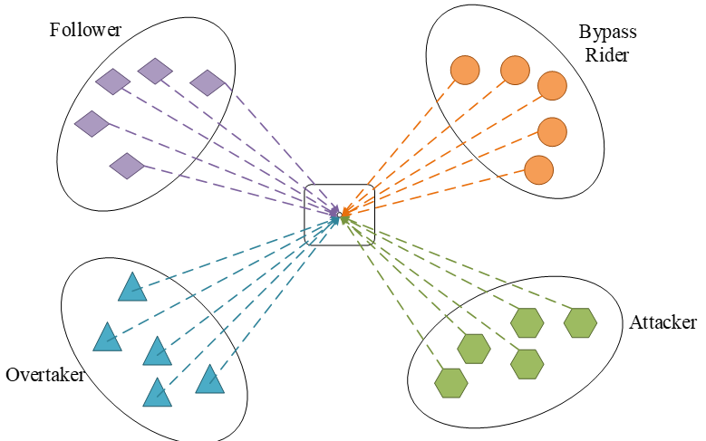

**Figure 1:** The principal diagram of ROA

The four rider groups stand in for the following: passer, overtaker, aggressor, and follower. Their identities remain consistent throughout the iteration. Different iterative procedures are needed for these four types of riders.

**Update on the location of the leader rider:** The cyclist who has a high success rate and is nearly to the goal is considered the group leader. Additionally, depending on success rate, the top rider may change over time. The leader is usually chosen in the last iteration, and the performance rate of each rider is recorded.

**Model for riders' placement:** A traditional ROA usually consists of four riders: the attacker, who takes the rider's place to reach the goal; the follower, who attempts to follow the leader rider; the overtaker, who concentrates on their particular path to reach the target; and the bypass rider, who uses the main way to reach the objective location. Each rider also adheres to preset rules to use the gear, accelerator, steering, and stop precisely in order to accomplish the objective. The riders' location is continuously updated, and the settings are changed in accordance with pre-established rules after they have reached the maximum length.

**Attacker:** The most aggressive rider in the group, the attacker assumes the rider position in order to reach the target as soon as feasible.

**Overtaker:** It advances toward the goal according to its own position while accounting for the leading rider's nearby position.

**Follower:** This is the rider group that moves in the direction of the leader in order to reach the goal.

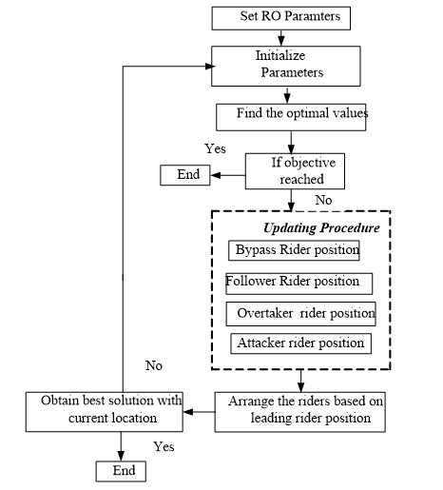

**Figure 2:** Flowchart of Rider optimization

These riders are obeying some predefined process shows in figure 2.

The improved procedure described as follows.

 (15)

 (16)

In equation (15) and (16) shows the crow realize the crows to another position of the search space. If the new position of a crow is achievable, the crow invigorates its position. Something other than what's expected, the crow stays in the present position and does not move to the delivered new position.

**Step 1:** Initializing the population with a discrete solution

Establish and configure the associated generation constraints, bus values, line limitations, and DG power restrictions. These are going to be the input for the IRO.

**Step 2:** Distributed Solution Generation

Starting the population of potential solutions is the first phase in the IRO optimization process. This type of limited optimization aids in cutting down on calculation times and the number of solution iterations. Below is a list of both continuous and discrete conditions that indicate the parameters linked to optimization. The initial candidate population is created as follows, within the suitably feasible bounds:

 (17)

First, the initial plants are used to generate the early population indiscriminately, and the original plant position is represented as . One of the variables used to make a choice is the active power that DG injects. As the optimization's input, generate and initialize the bus values, line limitations, DG power limits, and associated generation constraints.

**Step 3: Fitness function**

With f1 representing the line loss function, f2 representing the voltage deviation function, and f3 representing the cost function of DG, the multi-objective function is (16). The black window's position is used to calculate the population's fitness.

 (18)

**Step 3: Objective function**

The objective or fitness function of our suggested OP-DG system was determined by computing the loss, total cost, emission, optimal sizing, LCI, emission, and reliability factor using the mathematical equations (18) to (19). The overall objective was represented as follows:

 (19)

**Step 4: New Constraints are updated by:** The knowledge of others Group members, in addition to GL and LL in their respective stages, are used in GLP and LLP to update the monkeys' positions. Before going on to the next mini-group within that group, the previously indicated steps are finished for one mini-group using LLS, GLS, LLS, and GLLS. Instead, each monkey in the group is moved, and a better location between the old and new ones is chosen using greedy selection based on fitness. (18)

Here, determine the best position and dimensions for the DG units by using the (p) value. If a better solution is found after the values are altered, update the T (target solution) = i+1.

.

***(a) Bypass rider***

By utilizing the leading path, bypass riders effectively achieve their objective, and the initialization of the group riders can be mathematically expressed as:

1≤n≤P.(6.5) $A_{t}=\left\{A_{t}\left(m,n\right)\right\}, 1≤m≤O;1≤n≤P$ (20)

Here, $A_{t}$ denotes the position of the mth rider at time t, while O represents the total number of riders, and P signifies the dimensions of the optimization problem.

***(b)Followers***

Followers navigate their path by tracking the bypass rider, as their movement is determined by the bypass rider’s trajectory. Therefore, the position of a follower is estimated using the following mathematical formulation:

d $D_{t}=\left\{D_{t}\left(m,n\right)\right\}; 1≤m≤O;1≤n≤P$ (21)

where the steering angle at time step t is represented by Dt_The following formula can be used to update the steering angle:

$D_{m,n}^{t+1}=\left\{\begin{aligned}D_{m+1,n}^{t} if X_{u}^{t+1}\left(m\right)=1 \\ D_{m-1,n}^{t} if X_{u}^{t+1}\left(m\right)=0\end{aligned}\right.$ (22)

***(c) Over-taker***

The bypass riders' knowledge of the path is still collected even though the overtakers are following their own route. In this case, the over-taker's position is determined by three criteria: the direction indicator, relative success rate, and coordinate chooser.

***(d) Attacker***

The assailants are traveling as quickly as they can to get to the destination. The attackers follow the follower's path with the primary objective of overtaking the leader. Here, this function is used to update the position of all attackers except the selected individual. The following formula is used to estimate the attacker's location:

$A_{t+1}^{X}\left(m,n\right)=A^{S}\left(S,n\right)+\left[\cos{{\left(D_{m,n}^{t}\right)}^{*}A^{S}{\left(S, n\right)}^{*}e_{m}^{t}}\right]$ (23)

In this case, the steering angle of the mth rider in the nth coordination is represented by D_(m,n)^t, while the leader's position is shown by A^S (S,n).

**(d) Update the parameters of the rider**

Once all riders' success rates have been updated, the best option must be found by modifying the rider characteristics. The parameters used for the position update are gear, accelerator, steering angle, brake, and off-time, in addition to the parameter activity counter, which takes a value of 0 or 1 depending on the success rate. The technology offers the most economical size and positioning of the DG units in the distribution network when the procedure is finished.

**Step 5: End Process**

The value is raised by i = i + 1 if the iteration does not reach the lowest or maximum value. Following the process, the system recommends the most cost-effective placement and dimensions for the distributed generation units within the distribution network.

**IV. Simulation Results Analysis**

DG are analyzed and tested to evaluate the performance and effectiveness of the proposed approach. The technique's environmental setups are implemented using the MATLAB/Simulink platform, and the dynamic stability performance is evaluated against each benchmark system and current optimization. As the number of load flow iterations increases, the exhaustive load flow method's optimal placement and sizing of numerous DGs in a large distribution network gets more complicated. This section confirms that the model's efficiency increases on two popular distribution networks—the IEEE 33, IEEE 69, Indian 52, and IEEE 119 Bus system with a base voltage of 12.66 kV—is accurate.

• Voltage Fluctuation and Total Real Power Loss Before Deploying DG.

• One DG unit's location and size at the system's maximum capacity.

• Two DG Units at the system's maximum capacity, and three DG units at the maximum.

• Three DG unit installations and sizes at the DG system's maximum capacity

• Four DG Unit Installations and sizes at the DG system's maximum capacity.

**Table no 1:** Results of proposed-IRO for different cases

|  |  |  |  |  |  |  |  |
| --- | --- | --- | --- | --- | --- | --- | --- |
| Bus system | Cases | Active PL (KW) | Reactive PL ((kVar) | Optimal DG location | Minimum Voltage (p.u) | GC ($) | Reliability (%) |
| IEEE 33 | Without DG | 212.74 | 138.2 | nil | 0.99 | - | 95.2 |
| With DG-2 | 87.23 | 64.23 | 4 | 0.946 | 23 | 94.23 |
| With DG-3 | 75.96 | 69.56 | 2 | 0.99 | 20 | 93.14 |
| With DG-4 | 78.56 | 55.36 | 4 | 0.956 | 27 | 89.23 |
| IEEE 69 | Without DG | 234.3 | 202.14 | Nil | 0.90 | 23 | 86.14 |
| With DG-2 | 89.84 | 61.75 | 4 | 0.99 | 29 | 92.12 |
| With DG-3 | 96.45 | 86.97 | 3 | 0.965 | 30 | 84.1 |
| With DG-4 | 58.21 | 39.302 | 4 | 0.956 | 24 | 90.25 |
| IEEE 119 | Without DG | 18873.233 | 968.10 | nil | 0.95 | 30 | 83.26 |
| With DG-2 | 1249.20 | 995.2 | 3 | 0.92 | 25 | 79.2 |
| With DG-3 | 1357.56 | 894.16 | 4 | 0.93 | 24 | 81.2 |
| With DG-4 | 1450.78 | 780.2 | 4 | 0.94 | 28 | 88.2 |
| Indian 52 | Without DG | 1573.23 | 998.25 | nil | 0.85 | 27 | 92.12 |
| With DG-2 | 1549.20 | 765.2 | 4 | 0.96 | 24 | 86.1 |
| With DG-3 | 1557.58 | 774.199 | 4 | 0.97 | 31 | 78.1 |
| With DG-4 | 1550.78 | 790.23 | 4 | 0.92 | 30 | 89.1 |

Additionally, the IRO-ODG technique had the lowest power loss (PL) of 86.7461% in table 1 by reducing 202.68 kW to 41.23 kW. The results of these comparisons demonstrate the effectiveness of the suggested strategy in reducing power loss. The outcomes demonstrate the effectiveness of the suggested method in determining the best option with the lowest real power losses of 102.91 kW. The variance for the modified IEEE 69 bus system with respect to the weighting factor for various DG ratings in the 1–20 MW range. Therefore, the optimal number of DG Units in a 4DG-bus system should be 1 in order to reduce the installation and overall cost of DG. It has been discovered that the operation's minimum and maximum voltages fall between 0.84 and 0.99 p.u. In the Indian 52 bus system, bus numbers '29 10 49 42' correlate to the matching ideal places. The voltage at each bus in a system without DG units is lower than it is when DG units are included because of the reverse flow of power, which improves the voltage profile and reduces losses. The results show that inserting DG units significantly improves the voltage profile. With DG units installed, the average voltage levels are greater (0.9985 per unit) than when using the previous framework (0.9977 per unit).

**Table no 2:** Results of IEEE33 Bus system

|  |  |  |  |  |  |  |
| --- | --- | --- | --- | --- | --- | --- |
| **Techniques** | **Total Power loss** | **Optimal DG** | **Total Cost ($)** | **%THD** | **Co2 emission (Kg/MW)** | **Reliability (%)** |
| IRO | 181.5265 | '19 22' | 27 | 5.6874 | 1252 | 93.2 |
| DBWO | 183.1038 | '33 9' | 22 | 6.5244 | 4239 | 82.1 |
| Hybrid DBWALO | 187.368 | '7 11' | 26 | 8.1844 | 3287 | 84.2 |
| ALO | 210.9955 | '9 24' | 32 | 8.545 | 3656 | 83.2 |

**Table no 3:** Results of IEEE69 Bus system

|  |  |  |  |  |  |  |
| --- | --- | --- | --- | --- | --- | --- |
| **Techniques** | **Total Power loss** | **Optimal DG** | **Total Cost ($)** | **%THD** | **Co2 emission (Kg/MW)** | **Reliability (%)** |
| IRO | 226.1499 | '15 64' | 31 | 5.79 | 1920 | 94.2 |
| DBWO | 230.3262 | '59 55' | 36 | 7.3713 | 2958 | 92.2 |
| Hybrid DBWALO | 253.9807 | '63 60' | 35 | 7.0992 | 3351 | 92.02 |
| ALO | 259.1411 | '21 62' | 33 | 7.5422 | 3510 | 84.1 |

**Table no 4:** Results of IEEE119 Bus system

|  |  |  |  |  |  |  |
| --- | --- | --- | --- | --- | --- | --- |
| **Techniques** | **Total Power loss** | **Optimal DG** | **Total Cost ($)** | **%THD** | **Co2 emission (Kg/MW)** | **Reliability (%)** |
| IRO | 1942.293 | '96 74' | 29 | 7.0331 | 1668 | 96.2 |
| DBWO | 1993.962 | '78 80' | 31 | 7.2988 | 1928 | 89.2 |
| Hybrid DBWALO | 1955.799 | '78 72' | 40 | 7.0879 | 2232 | 99.2 |
| ALO | 1992.715 | '100 96' | 33 | 7.8769 | 2852 | 76.21 |

**Table no 5:** Results of Indian 52 Bus system

|  |  |  |  |  |  |  |
| --- | --- | --- | --- | --- | --- | --- |
| **Techniques** | **Total Power loss** | **Optimal DG** | **Total Cost ($)** | **%THD** | **Co2 emission (Kg/MW)** | **Reliability (%)** |
| IRO | 2.35513 | '50 17' | 31 | 6.1924 | 2037 | 91.28 |
| DBWO | 6.1595 | '44 19' | 30 | 6.4388 | 2084 | 81.24 |
| Hybrid DBWALO | 8.3866 | '40 46' | 39 | 7.5116 | 2130 | 89.29 |
| ALO | 16.9675 | '52 8' | 32 | 7.9452 | 3209 | 63.3 |

The total active power loss is significantly reduced to 71.052 kW by the proposed IRO, which is a 64.9% reduction from the initial scenario. Tables 2 to 5 display the IEEE 69 bus system's objective function results. The hybrid approach's power factor is 130.23kW, its lowest voltage is 0.93 pu, and its ideal DG falls between 30 and 18. It demonstrates how well the suggested IRO can determine the ideal location and dimensions of DGs on its own. The active and reactive power levels (PL) of the IEEE 69 and 119 bus systems, which are 113.69kW and 54.4Kw, respectively, were shown in Tables 3 and 4. For these PL levels, sites 62 and 21 are ideal. According to IEEE 119, the ideal DG locations are 57 and 61, with a minimum power output of 833kW and a minimum voltage of 0.9pu. In this case, there are three different kinds of IEEE 69-bus distribution networks with DG units. Lastly, Table 5 shows the outcomes of the Indian 52-bus system: the optimal DG is 11, 41, the smallest loss is 2.29Kw, and the minimum voltage is 0.99pu. The fitness function of the suggested approach is defined by system cost, line losses, and voltage fluctuation. Comparing the bus voltages in the base case and following the installation of the DG units is crucial. The results show that inserting DG units significantly improves the voltage profile. The fewest losses are obtained when the DGs are placed at the best buses identified by IRO. comparable to the study's findings—a 94% reduction in reactive power losses and a maximum 93% reduction in real power losses—which can be accomplished with a far smaller search field when applying the IRO technique. The ASMO then shows the lowest overall cost and emissions, totaling $31,1920,5.74. As a result, the reliability factor rises to 94.2%, 2.2% greater than the typical IRO.

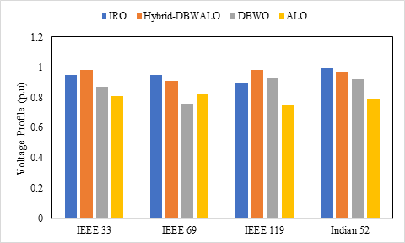

**Figure 3:** Voltage Profile analysis of Different cases

Therefore, as seen in Figure 3, 1.3 MW is the ideal distributed generator size to reduce power loss while also significantly improving the voltage profile.The best spot in the network to achieve the least amount of power loss with a notable improvement in the voltage profile is indicated by a higher value of the DG placement index. The FIS editor is used to carry out the placement of the DG unit. The primary goal of the optimization challenge is to determine the ideal DG unit size that provides a favorable voltage profile and less active power loss. The optimization difficulty is determining the size of DG units that provide a suitable voltage profile and less active power loss. the IRO-equipped system's voltage profile under load. Regarding the load situations, the voltage profile value has been adjusted in this. The voltage value is shown to be high under light load conditions and to drop under nominal load and heavy load conditions, respectively.

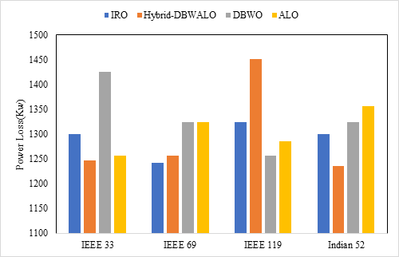

**Figure 4:** Power loss for different cases with bus system

Using the exhaustive load flow method to position and size many DGs in a large distribution network becomes more complicated as the number of load flow iterations increases (see Figure 4). Therefore, using inputs from the base case findings in terms of voltage and power loss at each bus, IROs are utilized to determine the best location for the DG in order to minimize power loss while also significantly improving the voltage profile. To optimize the DG placement index, IRO receives as inputs the bus voltages and power loss at each bus. The optimal position for DG deployment to improve the voltage profile and lower network losses is indicated by the greatest value of the DG placement index. Three test case systems—the IEEE-33, IEEE 69, IEEE119, and Indian 52 bus systems—are chosen for the study.

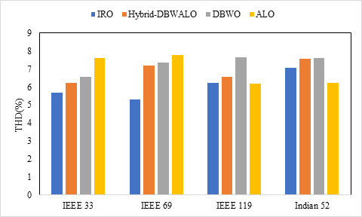

**Figure 5:** THD of different buses for different numbers of DGs

As the absorbed power rises, the PC current's THD fluctuates between 144 and 130%. The lighting fixture's current pull has a THD of 11.7%. Figure 5 shows that whereas the ninth harmonic currents are nearly out of phase, the third harmonic currents of a PC and an alighting mixture have a significant phase difference. Thus, it can be inferred that if these loads are mixed, the neutral conductor's current will be lower than if they were fed individually. Because the feeding network is located in an urban region with no productive activity on that particular day, it is clear that the harmonic voltages do not vary considerably. All of the room's computers were turned on for the duration of the hour, while the remaining loads were left off.

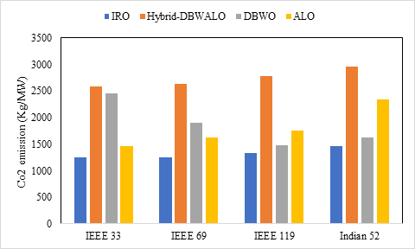

**Figure 6:** Comparative analysis of Emission parameter

Additionally, we determine the mean and standard deviation of the carbon emission rate at each node, which are displayed in Figure 6's leftmost subplot. It is evident that as the load increases, the emission rate of every node decreases. Perhaps because generators with lower emission rates begin to participate (as thearginal generators) as we approach higher demand levels, the average emission rate is continuously higher than the marginal emission rate. We observe that the standard deviation for both carbon measurements is rather high, suggesting significant variations in the nodal carbon emission patterns. Additionally, we determine the mean and standard deviation of the carbon emission rate at each node, which are displayed in Figure 6's leftmost subplot. It is evident that as the load increases, the emission rate of every node decreases. Perhaps because generators with lower emission rates begin to participate (as thearginal generators) as we approach higher demand levels, the average emission rate is continuously higher than the marginal emission rate. We observe that the standard deviation for both carbon measurements is rather high, suggesting significant variations in the nodal carbon emission patterns.

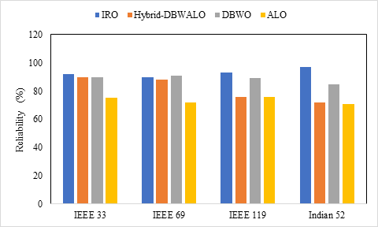

**Figure 7:** Reliability analysis of various Bus system

Figure 7 displayed the reliability analysis of each benchmark bus system, comparing these features to other optimization issues that served as inspiration. The further the DG was placed from the source, the lower the cost. This is primarily because, as opposed to depending solely on the primary source, the DG has access to a wider clientele. The hybrid model has the best reliability rate (95.23%) when compared to other DBWOs.It is clear that location significantly influenced power losses and reactive power support more than reliability did. This is mostly because the DG has access to a larger clientele than it would have if it only relied on the primary source. When compared to other models with DBWO, Figure 7 demonstrates that the ASMO model has the highest reliability rate (96.23%). Reactive power support and power losses were significantly more impacted by location than dependability.

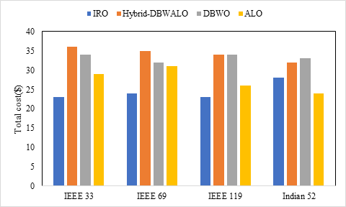

**Figure 8:** Comparison of Total cost analysis

Capacitors and capacitors involving DG units have been sized and placed optimally to reduce the system's overall cost. These include the cost per unit loss, the cost of installing both the capacitor and the DG, and the cost per kVAr and kW of injection from the DG and the capacitor, respectively. Additionally, the process entails calculating the basic dependability index of the distribution system's load points failure rate, which is significant from the perspective of the consumer.

The findings shown in Figure 8 show that the proposed IRO produced the lowest total system cost when compared to other meta-heuristic optimization techniques. These results show that, in contrast to other meta-heuristic approaches, the proposed ASMO, which is based on the optimal sizing of the Indian 52 bus system, IEEE 33, 69, and 119 bus system, and the use of two DG at ideal buses 60 and 63, may be utilized to generate the lowest possible system total cost. In comparison to other standards, the IRO minimum TC is 28, with a variation of 2.5 to 5.6%. Therefore, "one" is the optimal number of DG placements in the current IEEE-69-bus test system to maximize benefits while lowering DG installation and operating costs.

**V. Conclusion**

The study presents an Improved Rider Optimization (IRO) algorithm for the optimal placement and sizing of Distributed Generation (DG) units in radial distribution networks. The proposed approach effectively reduces active power losses, enhances voltage stability, minimizes harmonic distortion, and improves overall system reliability. By strategically positioning DG units while considering multiple constraints, the optimization framework ensures efficient power distribution with economic feasibility. Simulation results on IEEE 33, IEEE 69, IEEE 119, and Indian 52-bus test systems validate the effectiveness of the method, demonstrating superior performance compared to conventional techniques. Future research can explore adaptive real-time implementations and the inclusion of dynamic load variations to further enhance the optimization process.

**References**

1. Prakash, P. and Khatod, D.K., 2016. Optimal sizing and siting techniques for distributed generation in distribution systems: A review. *Renewable and sustainable energy reviews*, *57*, pp.111-130.
2. Yehia, M., Allam, D. and Zobaa, A.F., 2022. A novel hybrid fuzzy-metaheuristic strategy for estimation of optimal size and location of the distributed generators. *Energy Reports*, *8*, pp.12408-12425.
3. Bhattacharya, M. and Das, D., 2016, December. Multi-objective placement and sizing of DGs in distribution network using genetic algorithm. In *2016 National Power Systems Conference (NPSC)* (pp. 1-6). IEEE.
4. Memarzadeh, Gholamreza, Mohammadreza Arabzadeh, and Farshid Keynia. "A new optimal allocation of DGs in distribution networks by using coot bird optimization method." *Energy Informatics* 6.1 (2023): 30.
5. Elham Mahdavi, Seifollah Asadpour, Leonardo H. Macedo, Rubén Romero. "Reconfiguration of Distribution Networks with Simultaneous Allocation of Distributed Generation Using the Whale Optimization Algorithm" [Energies](https://ideas.repec.org/s/gam/jeners.html), MDPI, vol. 16(12), pages 1-19, June 2023.
6. Omid Feizollahzade. "Optimal Placement of Distributed Generation Sources Using Parato Multi-Objective Concepts in Power Distribution Networks" International Journal of Smart Electrical Engineering, Vol.9, No.3, Summer 2020.
7. Mahendra Kumar Das, Nava Raj Karki​ "Optimal Placement of Distributed Generation in Distribution Network Using Grey Wolf Optimization" International Conference on Role of Energy for Sustainable Social Development (RESSD-2023).
8. Gafari Abiola Adepoju, Sunday Adeleke Salimon, Hassan Adedapo Aderinko, Akeem Olawale Bisiriyu "Optimal Placement and Sizing of Distributed Generation in a Nigerian Distribution Network Using Cuckoo Search Algorithm" Current Journal of Applied Science and Technology, volume 38(6): 1-12, 2019.
9. Rudresh Babu Magadum, Deepak B. Kulkarni, "Optimal Placement and Sizing of Multiple Distributed Generators in Power Distribution Networks" International Journal of Ambient Energy​ Volume 45,  [Issue 1](https://www.tandfonline.com/toc/taen20/45/1), 2024.
10. Meisam Yahyazadeh, Hojat Rezaeeye​ "Optimal Placement and Sizing of Distributed Generation Using Whale Optimization Algorithm Considering Voltage Stability and Voltage Profile Improvement, Power Loss and Investment Cost Reducing" Iranian Journal of Science and Technology, Transactions of Electrical Engineering, Volume 44, pages 227–236, (2020)
11. [Saeed Alizadeh](https://jesit.springeropen.com/articles/10.1186/s43067-023-00073-6?utm_source=chatgpt.com#auth-Saeed-Alizadeh-Aff1), [Mehdi Mahdavian](https://jesit.springeropen.com/articles/10.1186/s43067-023-00073-6?utm_source=chatgpt.com#auth-Mehdi-Mahdavian-Aff1) & [Ehsan Ganji](https://jesit.springeropen.com/articles/10.1186/s43067-023-00073-6?utm_source=chatgpt.com#auth-Ehsan-Ganji-Aff1), "Optimal Placement and Sizing of Photovoltaic Power Plants in Power Grid Considering Multi-objective Optimization Using Evolutionary Algorithms" Journal of Electrical Systems and Information Technology, volumr **10**, Article number: 7 (2023)
12. Alejandro Valencia-Díaz, Ricardo A. Hincapié, Ramón A. Gallego​, "Optimal Placement and Sizing of Distributed Generation in Electrical DC Distribution Networks Using a Stochastic Mixed-Integer Linear Programming Model" Arabian Journal for Science and Engineering 14th October 2024​

**Author’s Profile**

**Yeruvaka Santhosh** is Research scholar at the Department of Electrical Engineering, University college of Engineering, Osmania university, Hyderabad, India. He received Master of Technology (M. Tech) in Electrical Power Systems (EPS) from Vignana Bharathi Institute of Technology and Science affiliated to JNTU Hyderabad, India in 2014 and He received Bachelor of Technology (B.Tech) in Electrical and Electronics Engineering, University college of Engineering, Kakatiya university, Kothagudem India in 2011. He can be contacted at email: [santhosh.yeruvaka@gmail.com](mailto:santhosh.yeruvaka@gmail.com)

**Dr. J. Upendar** is an Assistant Professor at the Department of Electrical Engineering, University college of Engineering, Osmania university, Hyderabad, India, where he has been a faculty member since 2013. From 2010-2013, he was also the Senior Engineer- Power Electronics Team Development, General Electric (GE Power Conversion) (CVT EDC Private Limited) Chennai-32, India (&in UK, France), and completed his Doctor of Philosophy (PhD) in Electrical Engineering from Indian Institute of Technology (IIT), Roorkee, India. His research interests are primarily in the area of Intelligent Approach for Fault Classification of Power Transmission Systems, where he is the author/co-author of over 40 research publications. He can be contacted at email: [dr.8500003210@gmail.com](mailto:dr.8500003210@gmail.com)