**Performance Analysis of Single-Stage and Boost-Assisted PV Grid Connected Systems**

Gaddam Bhagyalaxmi1, Balasubbareddy Mallala2, P. Satish Kumar3

*1,3(Electrical Engineering, University College of Engineering / Osmania University, India)*

*2(Electrical and Electronics Engineering, Chaitanya Bharathi Institute of Technology / Affiliated OU, India)*

*Corresponding Author: gblaxmi5063gaddam@gmail.com.*

|  |
| --- |
| ***Abstract:*** *The integration of photovoltaic (PV) systems into the grid necessitates efficient power conversion and control strategies to ensure stable and reliable operation. This study compares two single-phase PV grid-connected configurations: a single-stage inverter topology and a boost-assisted single-stage inverter topology. To maximize power extraction, the Incremental Conductance (IncCond) algorithm is employed for Maximum Power Point Tracking (MPPT). The control approach relies on real-time voltage and current feedback, utilizing p-q theory for effective power regulation. MATLAB/Simulink simulations evaluate system dynamics, power quality, and overall efficiency. The findings highlight the advantages and trade-offs of integrating a boost converter in a single-stage PV grid-connected system, offering valuable insights for optimizing performance.*  ***Key Words****: Photovoltaic (PV) system, Maximum Power Point Tracking (MPPT), Incremental Conductance (IncCond), Single-stage inverter, Boost converter, Grid-connected inverter, Power quality, MATLAB/Simulink, p-q theory.* |

1. **Introduction**

The increasing global demand for clean and sustainable energy sources has led to significant advancements in photovoltaic (PV) systems and their integration into power grids. Solar energy, being one of the most abundant and renewable sources, is widely utilized through PV technology, which directly converts sunlight into electrical energy. However, due to the intermittent nature of solar energy, efficient power conversion and control mechanisms are required to ensure stable and reliable operation in grid-connected systems [1].

PV systems primarily generate DC power, necessitating conversion into AC for grid compatibility. This conversion is achieved through power electronic interfaces, including inverters and DC-DC converters. Single-stage inverter topologies provide a direct DC-to-AC conversion, whereas a boost-assisted single-stage topology incorporates an additional DC-DC converter to regulate voltage before inversion, improving power extraction efficiency and system performance [2]. The integration of PV systems with grid networks involves challenges such as voltage fluctuations, power quality issues, and synchronization, which necessitate advanced control strategies for effective operation [3].

To maximize power extraction from PV arrays, Maximum Power Point Tracking (MPPT) techniques are employed, with the Incremental Conductance (IncCond) algorithm being a widely adopted approach. The IncCond MPPT method dynamically adjusts the operating point of the PV system to ensure optimal power output under varying solar irradiance and temperature conditions [4]. Furthermore, power regulation in grid-tied PV systems requires real-time voltage and current feedback mechanisms. The p-q theory, initially developed for three-phase systems, has been adapted for single-phase configurations to enhance active and reactive power control, thereby improving grid synchronization and overall efficiency [5].

In this study, a comparative analysis is conducted between two single-phase PV grid-connected configurations: a single-stage inverter topology and a boost-assisted single-stage inverter topology. The performance of these configurations is evaluated based on their efficiency, power-sharing capability, and dynamic response under different operating conditions. MATLAB/Simulink simulations are utilized to assess system behavior, voltage stability, and power quality parameters [6]. The comparative results provide valuable insights into the benefits and trade-offs associated with incorporating a boost converter in a single-stage PV grid-connected system.

The remainder of this paper is structured as follows: Section 2 details the system configuration, including the single-stage and boost-assisted topologies. Section 3 discusses the control strategy incorporating MPPT and p-q theory for power regulation. Section 4 presents simulation results and comparative analysis, highlighting the impact of each topology on system performance. Finally, Section 5 concludes the study and suggests future research directions.

***1.1 Boost-Assisted Single-Stage PV System***

Figure 1 illustrates a Boost-Assisted Single-Stage PV System, where a PV array generates DC power, which is then fed into a boost converter to step up the voltage to a desired level before inversion. The MPPT algorithm extracts the maximum power from the PV array by adjusting the duty cycle of the boost converter through a gate pulse. The boosted DC voltage is then supplied to the inverter, which converts it into AC power using PWM control for synchronization with the load/grid. An R-L-C filter smoothens the inverter output, ensuring a high-quality AC waveform before reaching the load. A control unit monitors load voltage (V Load) and load current (I Load), adjusting the inverter operation to maintain stable power delivery. This two-stage configuration enhances voltage regulation compared to a single-stage system while improving system adaptability under varying solar conditions.

In the boost-assisted single-stage inverter topology, an additional DC-DC boost converter is incorporated before the inverter stage. This configuration provides better voltage regulation, ensuring that the DC voltage level is optimally adjusted before inversion. By using a boost converter, the system can operate efficiently even under low irradiation conditions, leading to improved power quality and enhanced grid synchronization [7]. The implementation of this topology enables greater flexibility in managing PV system output and contributes to reduced power losses compared to the single-stage inverter topology [8].

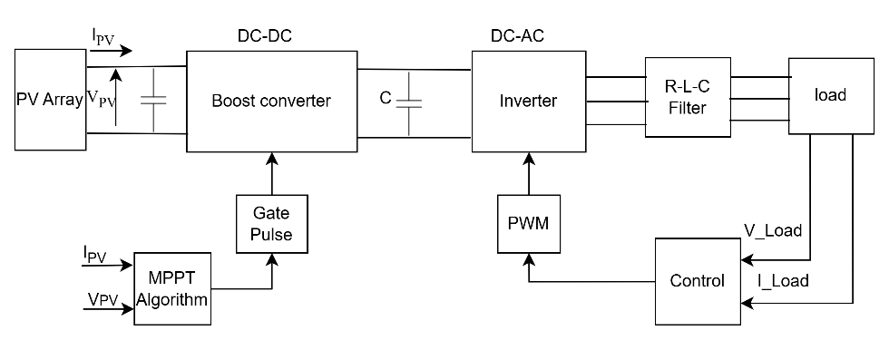

Figure 1: Block Diagram of Boost-Assisted Single-Stage PV System

1. **Proposed Method**

The integration of PV systems into the grid requires careful design and optimization of the power conversion stages. The system under consideration consists of a single-phase grid-connected PV system with two configurations: a single-stage inverter topology and a boost-assisted single-stage inverter topology. These configurations are analyzed to determine their impact on power quality, efficiency, and voltage stability [9].

***2.1 Single-Stage PV System without Boost Converter***

The single-stage inverter topology directly converts DC power from the PV panel to AC, making it a simple and cost-effective solution for grid integration. However, this approach has limitations in voltage regulation and power quality, especially under varying solar irradiation conditions. The absence of a boost converter means that the DC voltage output of the PV array must be high enough to meet the grid voltage requirements, which may not always be feasible [10]. To address this, advanced control strategies such as MPPT and real-time feedback mechanisms are essential [11].

Figure 2 illustrates a Single-Stage PV System without a Boost Converter, where a PV array directly supplies DC power to an H-bridge inverter (S1, S2, S3, S4) which converts it into AC power for grid connection. A DC-link capacitor (CdC) stabilizes the voltage, while an L-C filter (Lf1, Lf2, Cf) reduces harmonics before injecting power into the grid via inductors (Lg1, Lg2). The inverter control ensures proper switching for synchronization with the grid voltage (Vgrid) and supports MPPT for efficiency. This single-stage approach simplifies the system by eliminating the boost converter but limits voltage control flexibility, making it less adaptable to varying PV output. Despite its efficiency, this system may exhibit higher harmonic content if not properly filtered.

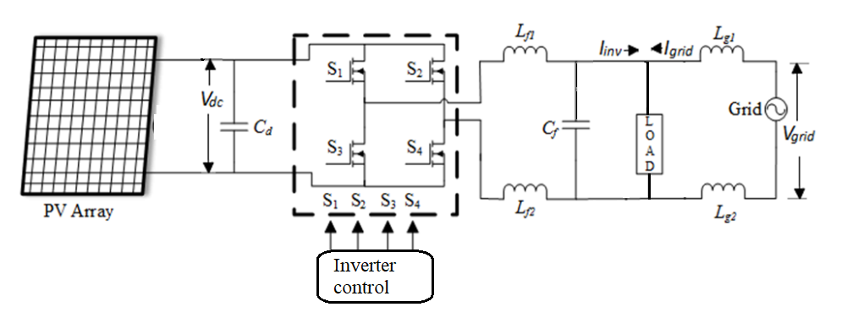

Figure 2: Circuit Diagram of Single-Stage PV System without Boost Converter

1. **Control Strategy**

The control strategy for both configurations is based on the p-q theory, which enables effective power regulation by processing real-time voltage and current feedback from the PV system and the grid. Additionally, the Incremental Conductance (IncCond) MPPT algorithm is employed to maximize power extraction under varying environmental conditions [12]. The p-q theory facilitates active and reactive power compensation, ensuring stable grid interaction and minimizing power fluctuations [13].

For the single-stage inverter topology, the control algorithm directly manages the DC-to-AC conversion process. In contrast, in the boost-assisted topology, the control system coordinates both the boost converter and the inverter to optimize power transfer. The effectiveness of these control strategies is analyzed through MATLAB/Simulink simulations, highlighting their impact on system stability and performance [14].

In order to share PV array power to the grid the inverter needs to be synchronized to the grid voltage. For this the 4-switch single phase inverter is controlled by hysteresis controller with reference current signal generated by modified p-q controller. The p-q controller requires reference active and reactive powers (Pref and Qref) for the generation of reference current signal The proposed modified p-q theory for the control of single-phase inverter is given in figure 3.

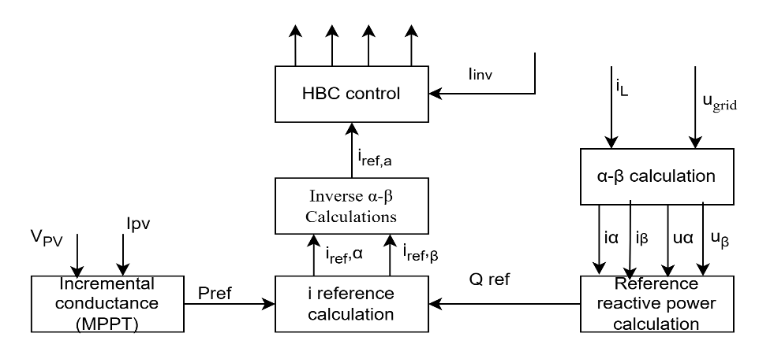

Figure 3: Modified p-q theory controller

The Pref is generated by the Incremental conductance MPPT technique with feedback signals from voltage and current and PV array. The figure 4 represents the Incremental conductance MPPT technique for generation of Pref signal.

The reference power generation is expressed as

$P_{ref}= V_{k}.I_{k}$ (1)

Here, $V_{k} and I_{k}$ are the updated PV voltage and current values [12] [13]. The change in voltage signal is expressed as:

$V_{k}=V_{k-1}+ α \left\{\begin{matrix}If dV ≠0 \& \frac{dI}{dV} < \frac{-I}{V} \\ If dV=0 \& dI>0 \end{matrix}\right.$ (2)

$V_{k}=V_{k-1}- α \left\{\begin{matrix}If dV ≠0 \& \frac{dI}{dV} > \frac{-I}{V} \\ If dV=0 \& dI<0 \end{matrix}\right.$ (3)

$V_{k}=V_{k-1} \left\{\begin{matrix}If dV ≠0 \& \frac{dI}{dV} = \frac{-I}{V} \\ If dV=0 \& dI=0 \end{matrix}\right.$ (4)

Here $V_{k-1}$ is previous value of PV array voltage, $dV$ is change in PV array voltage, $dI$ is change in PV array current and $α$ is the change in voltage factor given as:

$α=N \left|\frac{dP}{dV}\right|$ (5)

Here, N is the multiplication factor tuned as per the response of the MPPT module updated accordingly [14]. The Qref signal is generated by the grid voltage (ugrid) and load current (iL) signals expressed as:

$Q_{ref}= u_{β}i_{α}-u_{α}i_{β}$ (6)

The αβ voltage and current signals are generated by 90degress ($\frac{π}{2}$) phase shift to the measured signals ugrid and iL expressed as:

$\left[\begin{matrix}u_{α} \\ u_{β}\end{matrix}\right]= \left[\begin{matrix}u_{grid}(wt) \\ u_{grid }\left(wt+\frac{π}{2}\right)\end{matrix}\right]$ (7)

$\left[\begin{matrix}i_{α} \\ i_{β}\end{matrix}\right]= \left[\begin{matrix}i_{L}(wt) \\ i_{L }\left(wt+\frac{π}{2}\right)\end{matrix}\right]$ (8)

From the given equations the reference αβ current signals are generated as:

$\left[\begin{matrix}i_{α, ref} \\ i_{β, ref}\end{matrix}\right]= \frac{1}{u_{αβ}^{2}}\left[\begin{matrix}u_{α} & {-u}_{β} \\ u_{β} & u_{α}\end{matrix}\right] \left[\begin{matrix}P_{ref} \\ Q_{ref}\end{matrix}\right]$ (9)

Here, $u_{αβ}^{2}= u_{α}^{2}+ u_{β}^{2}$. From the equation (9) the $i_{α, ref}$ is considered as the reference current signal ($i_{ref,a}$) for the hysteresis loop controller [15]. The hysteresis current loop controller generates gate pulses to the switches (S1-S4) by comparing the $i_{ref,a}$ and inverter current ${(i}_{inv})$.

1. **Results**

Simulations are performed using MATLAB/Simulink to compare the transient and steady-state behavior of both configurations. Key performance metrics such as efficiency, voltage stability, and power quality are analyzed. The results demonstrate that the boost-assisted system achieves better voltage regulation and improved efficiency under varying irradiance conditions. However, the single-stage system without a boost converter offers a simpler design with fewer components.

The PV array is configured based on manufacturer specifications to meet system requirements. Table 1 presents the parameters of components used in the proposed single-stage, single-phase PV inverter for grid connection. The model is updated with these parameters and simulated using a sampling time (Ts) of 1µs, ensuring high-resolution data. To ensure a fair comparison, all two models Boost-Assisted Single-Stage PV system and single-stage Incremental Conductance MPPT are simulated under identical PV array and grid conditions, with results plotted over time.

Table 1: Elements parameters

|  |  |
| --- | --- |
| **Name of the element** | **Parameters** |
| Grid | Vgrid = 230Vrms, 50Hz, Lg = 8mH |
| PV array | Vmp = 98V, Voc = 135V, Imp = 0.87A,  Isc = 1.12A, Ns = 5, Np = 7. Ppv = 2984W |
| Inverter | Cin = 600µF, Rigbt = 1mΩ, Lf = 2.8mH,  Cf = 5.5µF, Pload = 3kW |
| Control | MPPT gain = 0.1, Current gain = 2,  Hysteresis band = ±0.1 |

The figure 4 is the graph of PV array characteristics which include PV voltage at 500V and PV current at 6A during 1000W/mt2 solar irradiation.

The total power from the PV array is calculated as: $P_{pv}=V_{pv}*I_{pv}$ = 500V * 6A = 3000W

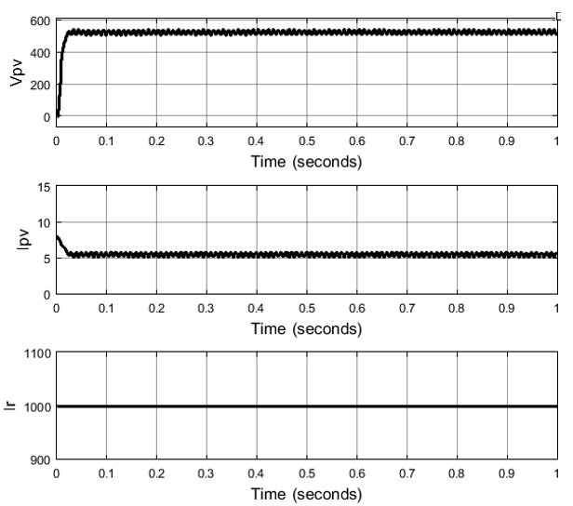

Figure 4: PV characteristics

Therefore, the maximum power that can be extracted from the PV array is 3kW. The figure 5 represents active powers of inverter, grid and load. As observed in figure 6 plots, the load demand is 3kW which is mostly compensated by the PV array with 2.87kW and the remaining 180W is taken from grid. The PV array and grid shares power to the load, compensating complete 3kW active power demand.

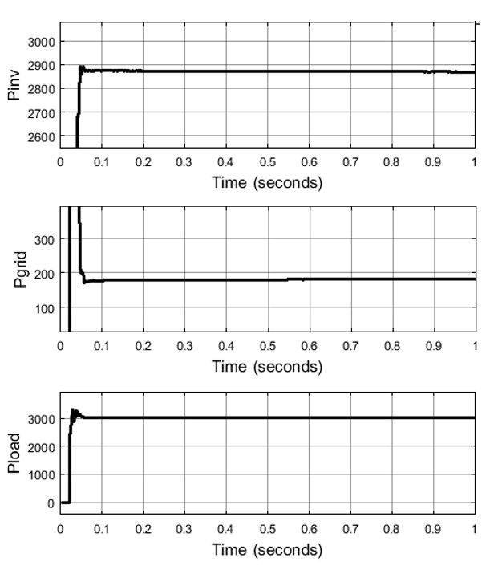

Figure 5: Active power of inverter, grid and load

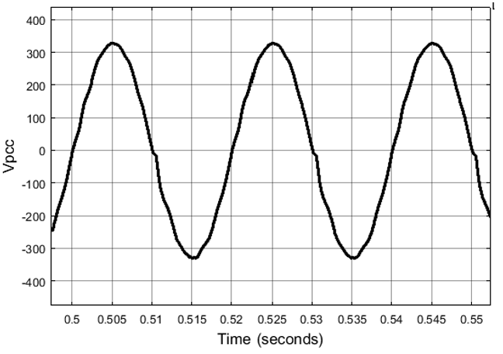

Figure 6: PCC voltage

Figure 7 presents the Total Harmonic Distortion (THD) analysis of a Boost-Assisted Single-Stage PV system with single-stage Incremental Conductance MPPT for both voltage and current waveforms. In the voltage analysis (Figure 7(a)), the FFT results indicate that the fundamental voltage is 309.8 V with a THD of 6.84% in the first case, whereas in the second case, the fundamental voltage improves to 327.3 V with a reduced THD of 4.81%, signifying better power quality. In the current analysis (Figure 7(b)), the first case shows a fundamental current of 14.41 A with a THD of 5.89%, while the second case exhibits a fundamental current of 16.06 A with a slightly increased THD of 6.06%, suggesting a minor rise in harmonic distortion. The analysis demonstrates that the system effectively enhances voltage quality by reducing THD, although a slight increase in current harmonics is observed.

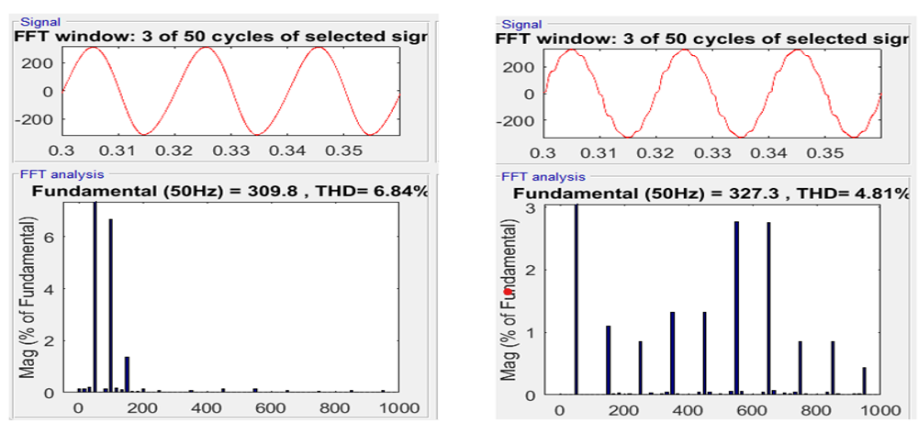

1. voltage analysis

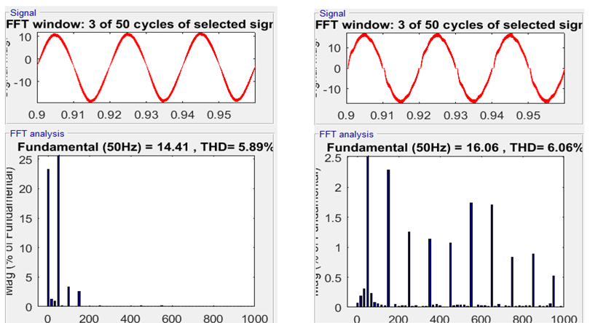

1. Current Analysis

Figure 7: Boost-Assisted Single-Stage PV system and single-stage Incremental Conductance MPPT THD analysis

The Incremental Conductance (IncCond) MPPT algorithm enhances power extraction by increasing the inverter output power (Pinv) from 2350 W to 2580 W. Additionally, it significantly improves power quality by reducing the Total Harmonic Distortion (THD) of Vpcc from 6.84% to 4.81%. While the THD of Iinv experiences a slight increase from 5.89% to 6.06%, it remains within acceptable limits in table 2.

Table 2: Analysis Comparison

|  |  |  |
| --- | --- | --- |
| **Name of the parameter** | **Conventional model** | **INC MPPT** |
| Pinv | 2350W | 2580W |
| THD of Vpcc | 6.84% | 4.81% |
| THD of Iinv | 5.89% | 6.06% |

1. **Conclusion**

This study provides a comparative analysis of single-stage and boost-assisted single-stage PV grid-connected systems, highlighting the trade-offs between simplicity and efficiency. The implementation of the Incremental Conductance (IncCond) MPPT algorithm improves inverter output power from 2350 W to 2580 W, while also enhancing power quality by reducing the Total Harmonic Distortion (THD) of Vpcc from 6.84% to 4.81%, though a slight increase in Iinv THD from 5.89% to 6.06% is observed but remains within acceptable limits. The simulation results demonstrate that the system efficiently meets the 3-kW load demand, with the PV array supplying 2.87 kW and the remaining 180 W drawn from the grid, confirming effective power sharing. The boost-assisted topology offers better voltage regulation and improved performance, whereas the single-stage system provides a simpler and cost-effective alternative. Future research can focus on hybrid control strategies and advanced filtering techniques to further enhance system efficiency and power quality.

**References**

1. M. A. Eltawil and Z. Zhao, "Grid-connected photovoltaic power systems: Technical and potential problems—A review," Renewable and Sustainable Energy Reviews, vol. 14, no. 1, pp. 112–129, 2010. doi: 10.1016/j.rser.2009.07.013.
2. H. Patel and V. Agarwal, "Maximum power point tracking scheme for PV systems operating under partially shaded conditions," IEEE Transactions on Industrial Electronics, vol. 55, no. 4, pp. 1689–1698, 2008. doi: 10.1109/TIE.2008.917118.
3. J. M. Guerrero, J. C. Vasquez, J. Matas, L. G. de Vicuna, and M. Castilla, "Hierarchical control of droop-controlled AC and DC microgrids a general approach toward standardization," IEEE Transactions on Industrial Electronics, vol. 58, no. 1, pp. 158–172, 2011. doi: 10.1109/TIE.2010.2066534.
4. N. Femia, G. Petrone, G. Spagnuolo, and M. Vitelli, "Optimization of perturb and observe maximum power point tracking method," IEEE Transactions on Power Electronics, vol. 20, no. 4, pp. 963–973, 2005. doi: 10.1109/TPEL.2005.850975.
5. H. Akagi, Y. Kanazawa, and A. Nabae, "Instantaneous reactive power compensators comprising switching devices without energy storage components," IEEE Transactions on Industry Applications, vol. IA-20, no. 3, pp. 625–630, 1984. doi: 10.1109/TIA.1984.4504460.
6. S. Kouro, J. I. Leon, D. Vinnikov, and L. G. Franquelo, "Grid-connected photovoltaic systems: An overview of recent research and emerging PV converter technology," IEEE Industrial Electronics Magazine, vol. 9, no. 1, pp. 47–61, 2015.
7. O. Tremblay, L. A. Dessaint, and A. I. Dekkiche, "A generic battery model for the dynamic simulation of hybrid electric vehicles," IEEE Transactions on Vehicular Technology, vol. 58, no. 6, pp. 2660–2668, 2009. doi: 10.1109/TVT.2008.2011385.
8. T. Kerekes, R. Teodorescu, P. Rodríguez, G. Vázquez, and E. Aldabas, "A new high-efficiency single-phase transformerless PV inverter topology," IEEE Transactions on Industrial Electronics, vol. 58, no. 1, pp. 184–191, 2011.
9. M. Calais, J. Myrzik, T. Spooner, and V. Agelidis, "Inverters for single-phase grid connected photovoltaic systems an overview," IEEE Transactions on Power Electronics, vol. 19, no. 5, pp. 1260–1269, 2004. doi: 10.1109/TPEL.2004.833451.
10. A. Chaurey and T. C. Kandpal, "A techno-economic comparison of rural electrification based on solar home systems and PV microgrids," Energy Policy, vol. 38, no. 6, pp. 3118–3129, 2010. doi: 10.1016/j.enpol.2010.01.052.
11. D. Sera, R. Teodorescu, and P. Rodriguez, "PV power tracking using a Kalman filter," IEEE Transactions on Industrial Electronics, vol. 56, no. 11, pp. 4694–4703, 2009. doi: 10.1109/TIE. 2009.2027920.
12. E. Mamarelis, G. Petrone, and G. Spagnuolo, "Design of adaptive single-input single-output MPPT for photovoltaic panels," IEEE Transactions on Industrial Electronics, vol. 61, no. 12, pp. 6822–6831, 2014.
13. D. Sera, R. Teodorescu, J. Hantschel, and M. Knoll, "Optimized maximum power point tracker for fast-changing environmental conditions," IEEE Transactions on Industrial Electronics, vol. 55, no. 7, pp. 2629–2637, 2008.
14. J. Rocabert, A. Luna, F. Blaabjerg, and P. Rodríguez, "Control of power converters in AC microgrids," IEEE Transactions on Power Electronics, vol. 27, no. 11, pp. 4734-4749, 2012.