**Battery Management Systems: Crucial Technology for Sustainable Electric Transportation**

Monika Khare1, Noorul Islam2, AvinashKumar3, Shweta Shukla4, Ansh Bhardwaj5, Ankit Kumar6, Arun Shan7

*1-7,Department of Electrical Engineering, Meerut Institute of Engineering and Technology, Meerut, India.*

|  |  |
| --- | --- |
|  | ***Abstract:*** This system allows for the monitoring of battery voltage and percentages in electric vehicles from any location worldwide. As is commonly understood, the battery is a crucial element in any system or product, as it supplies power to the entire structure. Therefore, it is essential to keep track of the battery's voltage level. It is well-known that a poor charging and discharging process can lead to battery damage or system malfunction. Most electrical and electronic devices are equipped with a Battery Management System (BMS). The BMS oversees various battery attributes, including voltage, current, temperature, and the automatic cut-off mechanism, to ensure the proper handling and storage of Lithium-Ion or Lithium Polymer batteries in vehicles. The BMS can assess the current battery condition and notify the user via a battery indicator. However, in this study, we utilized Internet of Things (IoT) technology to provide remote notifications to users. With the integration of IoT, users can now receive automatic updates. Users can check the battery status on their smartphones or computer dashboards from anywhere in the world. The Node MCU ESP8266 board is employed in an IoT-based Battery Monitoring Program to transmit battery status information to the Arduino IoT cloud. The IoT Cloud Panel displays the voltage level and battery percentage during both charging and discharging scenarios. All these processes are facilitated by software. Key words: Battery management system, state of charge, state of health, state of life.  ***Key Word****:**Battery management system, state of charge, state of health, State of life, IoT.* |

1. **Introduction**

Battery Management Systems (BMS) are crucial for monitoring and controlling battery packs in various applications such as electric vehicles, renewable energy systems, and portable electronics. Traditional BMS systems are typically limited to local monitoring and lack real-time data accessibility. Integrating the Internet of Things (IoT) into BMS enhances monitoring capabilities by enabling real-time data acquisition, remote monitoring, and predictive maintenance.

The proposed IoT-Integrated BMS leverages a microcontroller, IoT modules, sensors, and cooling mechanisms to ensure safe and efficient battery operation. By connecting the system to a cloud platform, users can monitor battery health, voltage, current, and temperature from any location.

* **PROPOSED METHODOLOGY:** Energy and environmental problems are the most dangerous problems faced by the world automotive industry to overcome these problems world has accelerated to the new energy development.
* **BATTERY MANAGEMENT SYSTEM (BMS):** Battery management system (BMS) is the crucial system in electric vehicle because batteries used in electric vehicle should not be get overcharged or over discharged. If that happens, it leads to the damage of the battery, rise in temperature, reducing the life span of the battery, and sometimes also to the persons using it. It is also used to maximize the range of vehicle by properly using the amount of energy stored in inside the battery.

Batteries in electric vehicles (EVs) degrade over time due to chemical reactions, reducing their energy storage capacity. To mitigate degradation, controlling charging and discharging profiles, especially under varying conditions, is essential. Battery life is also affected by factors like temperature fluctuations and frequent high-current charge/discharge cycles. Despite occasional safety concerns, well-designed EV systems with safety features and automatic cutoffs are generally secure. Flexible Battery Management Systems (BMS) that can cover various battery types and offer comprehensive protection have become a focus of recent EV development. State of charge is a critical parameter for safe battery charging and discharging. It represents the battery's current capacity relative to its rated capacity. SOC helps manage voltage, current, temperature, and other battery-related data. Accurate SOC calculation prevents overcharging and over discharging, which can damage batteries. Additionally, the safety and sustainability of energy storage solutions are paramount concerns, especially in applications like electric vehicles, renewable energy grids, and portable electronic gadgets.

# Literature Survey

This section will provide a quick overview of the available literature on Battery Management System (Crucial Technology for Sustainable Electric Transportation)

T. Sirisha et al. in [1] discuss the importance of battery monitoring for electric vehicles and introduces a Battery Management System (BMS) that can help ensure the safety and optimal performance of the battery system.The BMS is designed to monitor the battery at all times and measure the temperature at each battery cell during charging and discharging. The State of Charge (SOC) estimation is implemented using Coulomb counting method and the State of Health (SOH) of the battery is determined using CCCV. The paper also discusses the use of IoT to automatically store the battery, temperature, and voltage data on the website of Thing Speak. The authors emphasize the importance of thorough investigation of batteries to quickly address any problems that may arise. Overall, the paper provides a comprehensive overview of the development of a BMS for electric vehicles and highlights the importance of battery monitoring for the safety and performance of electric vehicles. The authors emphasize the importance of thorough investigation of batteries to quickly address any problems that may arise. Overall, the paper provides a comprehensive overview of the development of a BMS for electric vehicles and highlights the importance of battery monitoring for the safety and performance of electric vehicles.

Raj Patel et al. in [2] provides an overview of Battery Management System (BMS) technologies used in Electric Vehicles (EV) and Energy Storage Systems. The paper discusses the importance of BMS in controlling and monitoring, charging and discharging of batteries and maintaining reliability and safety. The key components of BMS, including feedback and control systems, cell voltage feedback, temperature feedback, and power misfits are explained. The paper also covers State of Charge (SOC), State of Health (SOH), Thermal management, and Battery SOC modelling. Overall, the paper provides a comprehensive understanding of BMS technologies and their importance in EV and Energy Storage Systems. A battery management system consists of: (1) a battery-level monitoring system (2) an optimal charging algorithm and (3) a cell/thermal balancing circuitry. The voltage, current and temperature measurements are used to estimate all crucial states and parameters of the battery system, such as the battery impedance and capacity, state of health, state of charge, and the remaining useful life.

1. **MEHODOLOGY**

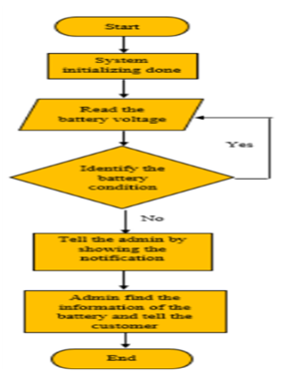

Figure 1: Flow Chart of IoT based battery management system.

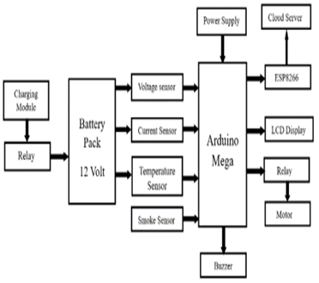

Figure 2: Block diagram of IoT based battery management system

### Circuit Diagram (Explanation):

1. **Power Input:** AC voltage stepped down by the transformer and regulated to DC. (12V Step-Down Transformer)
2. **Microcontroller:** Central unit that receives input from sensors and controls output devices.
3. **LCD Display:** Shows battery status and warnings.
4. **Cooling Fan and Buzzer:** Managed by the microcontroller to ensure temperature control and alert notification.
5. **Battery Pack:** Supplies power to the BMS and is monitored for voltage and temperature.

#### ****Power Supply and Voltage Regulation****

* The **step-down transformer** (12V) converts high-voltage AC (like 230V) to a low-voltage DC output.
* A **rectifier circuit** and **voltage regulator** further convert this DC voltage to a stable 5V or 12V required by the   
   microcontroller and cooling fan.

#### ****Microcontroller Unit (MCU)****

* The heart of the system is the **Microcontroller (ATmega328P)**, which:
* Continuously monitors battery voltage and temperature.
* Processes sensor data to make decisions.
* Controls the **cooling fan** and **buzzer**.
* Communicates battery status via the **LCD display**(HD44780)

#### ****Battery Monitoring****

The BMS measures the **voltage of each cell** individually to detect. The voltage of each **18650 Lithium-Ion cell** is measured using voltage dividers or dedicated battery monitoring ICs.

* **Overvoltage:** Prevents overcharging.
* **Under voltage:** Prevents deep discharge.
  + - **Overcurrent:** Protects against excessive current flow. This data is processed and displayed on the **16x2 LCD screen.**

#### ****Display and Alerts****

* The microcontroller updates the **16x2 LCD Display** with real-time data, including voltage, current, charge percentage, and error messages.
* If a critical situation is detected (like over-voltage or overheating), the **Buzzer**(**5V Active Buzzer Module)** is activated to alert the user.

#### ****Protection and Safety Measures****

* The microcontroller performs real-time monitoring and triggers the **Cooling Fan** if the temperature exceeds the safe limit.
* If the voltage drops too low or rises too high, the microcontroller cuts off the battery from the load to protect it.
* The **Toggle SwitchSPST (Single Pole Single Throw)**acts as a master power control to completely disconnect the system.

#### ****Cooling and Thermal Management****

* The **DC Brushless Fan (12V)** kicks in when the temperature sensor signals overheating.
* This fan helps dissipate heat from both the transformer and the power electronics.

1. **Arduino Programming:**

Write Arduino code to read voltage, current, and temperature values from sensors. Implement algorithms to Calculate individual cell voltages, total pack voltage, state of charge (SoC), state of health (SoH), and temperature. Set up thresholds for overcharging, over-discharging, over current, and high-temperature protection. Implement a Communication protocol to send data to the IoT platform.

1. **IoT Integration:**

Set up an account on your chosen IoT platform and create a new project. Configure the IoT module (ESP8266, ESP32) to connect to your Wi-Fi network and the IoT platform. Send sensor data (voltage, current, temperature) to the IoT platform using the chosen communication protocol. Implement a secure method for receiving commands from the IoT platform to control charging and discharging processes.

**d. User Interface and Remote Monitoring:**

Create a web interface or mobile app using the IoT platform's tools to remotely monitor the battery status.

Implement user interaction for setting custom parameters or receiving notifications/alerts.

#### ****e. User Interface and Feedback****

* **The LCD Display shows:**
  + Battery voltage and capacity.
  + Charging or discharging status.
  + Fault conditions (like over-temperature or low voltage).
* The **Buzzer** gives an audible warning in case of faults.

**IV. EXPERIMENTAL RESULTS**

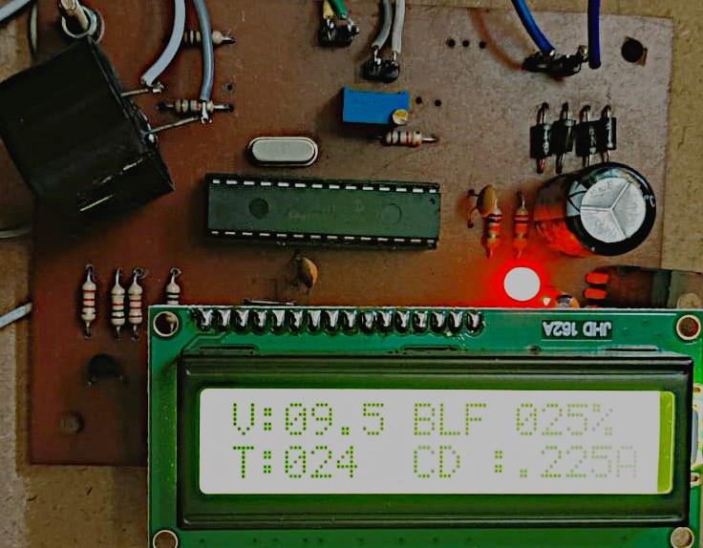

Figure 3: shows the results of Iot based battery management system

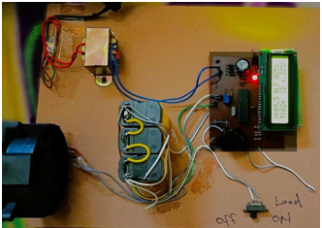

Figure 4: Circuit Diagram

1. **Implementation Results and Analysis**

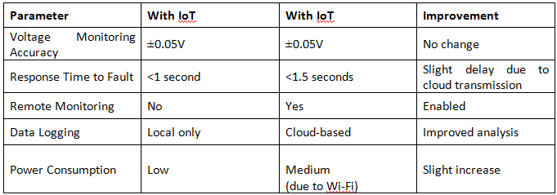

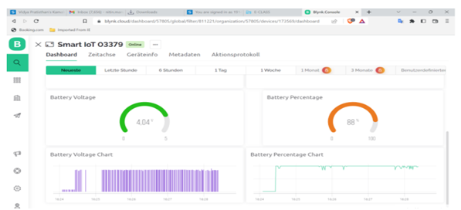

* Integrating IoT technology into the BMS significantly improved usability and control, particularly in applications where remote monitoring is critical (e.g, electric vehicles). The system became more user-friendly by allowing users to monitor battery health and receive alerts from anywhere. The slight increase in power consumption due to the Wi-Fi module is acceptable, considering the enhanced functionality. Additionally, cloud-based data storage allows for long-term performance tracking, which can be invaluable for predictive maintenance and performance optimization.

|  |  |  |  |
| --- | --- | --- | --- |
| **Feature** | **Traditional BMS** | **IoT-Enabled BMS** | **Improvement** |
| Monitoring Capability | Local Only | Global Access | Remote Control |
| Real-Time Alerts | Buzzer Only | Push Notifications | Enhanced Safety |
| Historical Data Logging | Manual | Automated (Cloud) | Data-Driven Insights |
| Maintenance Prediction | No | Yes | Proactive Maintenance |
| Cost Efficiency | High | Medium | Increased Value |

**VI. Future Prospects and Recommendations**

The future of IoT-integrated BMS technology holds significant potential, driven by advancements in sensor technology, wireless communication, and data analytics. Key areas of development include:

* **Predictive Maintenance:** Leveraging machine learning to predict battery health and lifespan based on real-time data patterns.
* **Enhanced Data Security:** Implementing robust encryption protocols to protect transmitted data from cyber threats.
* **Adaptive Thermal Management:** Utilizing AI algorithms to optimize fan speed and energy usage based on dynamic conditions.
* **Seamless Integration with Smart Grids:** Enabling automatic load balancing and energy management in renewable energy systems.
  1. **Conclusion**

# In conclusion, this paper comprehensively discusses IoT-based battery management system(BMS) technologies. The development of an embedded battery monitoring system for electric vehicles was covered in this project. This will enable online monitoring of battery performance degradation. It represents the battery's current capacity relative to its rated capacity. SOC helps manage voltage, current, temperature, and other battery-related data. Accurate SOC calculation prevents overcharging, over-discharging and Overcurrent, which can damage batteries.

**Acknowledgement**

We would like to express our heartfelt gratitude to our mentors and faculty members for their invaluable guidance and unwavering support throughout this project. Their insightful feedback and constant encouragement inspired us to elevate the quality of our work. We also wish to thank our colleagues and friends for their technical assistance and collaborative spirit during the research process.

Lastly, we are deeply thankful to our families for their steadfast support and understanding, which allowed us to fully dedicate ourselves to this research. Their encouragement was crucial to the successful completion of this article.

**References**

[1] T.Sirisha, A.SaiVenkataSowmya, M.Vaishnavi, M.Katyayani, P. Naveen Kumar, "Battery Management System and State of Charging (Soc) Development For

[2] Raj Patel, Seema Talmale, " Battery Management System – Hardware Design" International Research Journal of Engineering and Technology (IRJET), Volume: 09 Issue: 04, Apr-2022

[3] Muhammad Nizam, Hari Maghfiroh, Rizal Abdulrozaq Rosadi, and Kirana D.U. Kusumaputri, "Battery Management System Design (BMS) for Lithium-Ion Batteries”, AIP Conference, April-2020, doi.org/10.1063/5.0000649.

[4] Harish N, Prashal and Dr. D. Sivakumar “IOT Based Battery Management System”, International Journal of Applied Engineering Research, Volume 13, Number 8 (2018) pp. 5711-571, ISSN 0973-4562

[5] S.Prabakaran, N.Ashok ,D.Arunkumar, And D.Ariharan, "Smart Battery Management System for

ElectricVehicles using IoT Technology", International Journal of Creative Research Thoughts (IJCRT), Volume II,issue 4 April 2023, ISSN: 2320-2882

[6] P. Zhang, et al., "IoT-Based Battery Management System for Electric Vehicles," IEEE Transactions on Industrial Electronics, vol. 68, no. 3, pp. 2194-2203, 2021.

[7] R. Singh and A. Gupta, "Advanced Battery Monitoring Techniques for Electric Vehicles," Journal of Power Sources, vol. 470, pp. 228-237, 2020.

[8] J. Chenetal., "Real-Time IoT Monitoring for BMS using MQTT Protocol," International Journal of Electronics, vol. 110, no. 6, pp. 1054-1062, 2022.

[9] M. Williams and S. Brown, "Data Analytics in IoT-Enabled BMS Systems," Smart Systems Research, vol. 12, no. 4, pp. 182-191, 2023.